The role of prophylactic cranial irradiation within a combined modality therapy for prevention of brain metastases in patients with stage III non-small cell lung cancer

Ahmed Z Alattar ¹, Ahmad Al-Hosainy¹, Nashwa Nawwar¹ and Inas M. Elfiki²

¹Clinical Oncology & Nuclear Medicine, Faculty of Medicine, Zagazig University Zagazig, Egypt
² Radiology Departments, Faculty of Medicine, Zagazig University Zagazig, Egypt
ahmedenbedo@hotmail.com

Abstract: Introduction: Prophylactic cranial irradiation (PCI) is not a standard practice in locally advanced non-small cell lung cancer (LAD-NSCLC) due to the lack of studies showing a survival benefit, and due to neurotoxicity of whole brain irradiation. The aim of PCI in LAD-NSCLC is to increase the freedom from relapse without severe toxicities. Relapse pattern and late toxicities in long term survivors were analyzed after the introduction of PCI following potentially curative treatment for LAD-NSCLC.
Methods: Sixty-eight patients with stage III A/III B NSCLC were treated with induction chemotherapy (phase 1) and chemoradiotherapy (phase II). PCI was routinely offered during the second phase of the study accrual. Patients were randomized into two groups. Group A included 35 patients (who have received PCI at a total radiation dose of 30Gy (2Gy per daily fraction) over a 3 week period, starting one day after the last chemotherapy cycle, and group B included 33 patients who did not receive PCI. MRI was performed to long term survivors in both groups.
Results: Introduction of PCI reduced the rate of brain metastases as first site of relapse from 38% (group B) to 10% (Group A) at 5 years (P = 0.005), and that of overall brain relapse from 58% (Group B) to 13% (Group A) (P < 0.001). The effect of PCI was also observed in the good-prognosis subgroup of patients who had a partial response or complete response to induction chemotherapy, with a reduction of overall brain relapse from 48% + 12% to 8% ± 8% at 5 years (P = 0.0005).
Conclusion: PCI at a moderate radiation dose reduced brain metastases in LAD-NSCLC to a clinically significant extent, comparable to that in limited-disease small cell lung cancer.
[Ahmed Z Alattar, Ahmad Al-Hosainy, Nashwa Nawwar and Inas M. Elfiki The role of prophylactic cranial irradiation within a combined modality therapy for prevention of brain metastasis in patients with stage III non-small cell lung cancer Cancer Biology 2015;5(3):167-177]. (ISSN: 2150-1041). http://www.cancerbio.net. 14.doi:10.7537/marscbj050315.14.

Key words: PCI, Locally advanced -NSCLC.

Introduction
SCLC accounts for about 85% of all lung cancers, and the 5-year survival of patients with metastatic NSCLC is less than 10% ^{(1, 2)}. Locally advanced LA-NSCLC; stage III A and III B comprises approximately 31–44 % of NSCLC and has become a focus for combined-modality trials for many years ⁽³⁾. The standard of care for stage III unresectable NSCLC disease is combined chemoradiotherapy (Chem RT) ⁽⁴⁻⁷⁾. The risk of developing brain metastases (BM) in patients with early stage NSCLC is 10 %. ⁽⁸⁾. However, the risk of BM after treatment for LA-NSCLC is much higher, ~ 30–50 % ⁽⁹⁾. Patients with locally advanced, non-squamous lung cancer, especially lung adenocarcinoma, had a higher prevalence of BM ^{(10–14)}. Following potentially curative treatment for NSCLC, overall brain relapse rates range from 21% to 54%, and the brain is the first site of relapse in 15% to 30% of cases ^{(3, 4,6)}. Hence, treatment strategies to reduce the risk of brain metastases are needed in order to optimize the efficacy of multimodality protocols for LAD-NSCLC. According to the Radiation Therapy Oncology Group (RTOG), the encountered chemotherapy combination do not have a significant influence on the risk of brain metastases ^{(4,6,7)}. Randomized trials have proved that prophylactic cranial irradiation (PCI) can significantly reduce the risk of brain metastases to less than 10% to 15% ^{(7, 15)}. The fact that no survival advantage has been demonstrated so for could be attributed to the relatively poor local and systemic treatment results ⁽¹⁵⁻¹⁷⁾. PCI is not a standard practice in NSCLC due to the lack of studies showing a survival benefit, and due to concerns about the potential neurotoxicity of whole brain irradiation. RTOG 0214 trial assessed the effects of PCI on overall survival and toxicity in patients with stage III NSCLC who are treated with more modern and effective multimodality regimens, and who have no extra cranial diseases progression 4 months after completion of their initial treatment ⁽¹⁸⁾. In this study, we evaluated the effect of PCI at a total dose of 30 Gy (2 Gy per daily fraction) in patients with stage IIIA/IIIB NSCLC, after induction chemotherapy and concurrent chemoradiotherapy.

Patients and methods
Patients selection:
Eligible patients had histologically proven NSCLC, they had to have stage IIIA/IIIB disease according to the classification system developed by American joint committee on cancer staging system for lung cancer (AJCC, 2002)⁽¹⁹⁾. They had Karnofesky score performance status (KPS) > 70, age between 18 and 70 years, no prior treatment for lung cancer, no other concurrent or previous malignancy, normal CBC, LFT, KFT. The following examinations were performed; complete physical examinations, computed tomography scan (CT) of the chest & upper abdomen, and MRI of brain; radionuclide bone scan, and cardiopulmonary function tests. All patients provided written consent before study entry, and were randomized after induction chemotherapy (4th cycle) into two groups: Group A: included 35 patients who have received PCI. Group B: included 33 patients who did not receive PCI. From January 2008 to August 2013, 68 patients were entered into this study in Clinical Oncology & Nuclear Medicine and Radiology Departments, Zagazig University .
Induction chemotherapy:
Cisplatin 60 mg/m² as a one-hour infusion with adequate hydration protocol on days 1 and 8. Adequate anti-emetics (dexamethasone 8 mg, ranitidine 50 mg and ondansetron 8mg) were given intravenously with the 'cisplatin' "dose and on the following day. Etoposide was given at a dose of 150 mg/m² in 500 mL of 0.9% normal saline over 1-hour infusion on days 3, 4 and 5. Most patients were hospitalized for chemotherapy treatment.
Chemoradiotherapy:
A total dose of 60 Gy was delivered to the primary tumor and mediastinum, at 2 Gy per fraction, 5 days a week using Co⁶⁰ machine. Regional lymphatics including the supraclavicular lymph nodes when the primary tumor was in the upper lobes or mainstem bronchus were included in the initial radiation volume. The field included a 2-cm margin on the ipsilateral hilar lymph nodes and a 1 -cm margin on the contralateral hilar lymph nodes. The subcarinal lymph nodes were included to 5cm below the carina. The regional lymphatics were treated to a total dose of 50 Gy at 2 Gy per fraction followed by a boost dose to the primary neoplasm and all lymph nodes > 2.5 cm in diameter visualized on CT scan before chemotherapy. The boost dose included a 2.5-cm margin around the radiologically visible tumor, and the dose was continued to 60 Gy. The spinal cord dose was limited to 45Gy. Simultaneous chemotherapy was started on day 2 of radiation (cisplatin 50mg/m² on days 2 and 9, and etoposide 100mg/m² on days 4, 5, and 6) every 21 days.
PCI:
Prophylactic cranial irradiation was started after the end of the 4th chemotherapy cycle on day 9 of thoracic radiation therapy, over a period of three weeks, a total dose of 30Gy (2 Gy per daily fraction) was delivered via 2 parallel opposing lateral fields with Co⁶⁰ machine to the brain and the meninges above the foramen magnum.
Post program therapy:
At any time during chemotherapy or radiotherapy, patients who experienced a progressive disease discontinued the program and alternative treatment or best supportive care was offered to them. At the end of radiotherapy, patients who achieved a complete response were followed up without treatment and patients who achieved a partial response were proposed to receive maintenance chemotherapy for 2 cycles of cisplatine/etoposide.
Response evaluation:
Responses were assessed using standard WHO criteria ⁽²⁰⁾. CXR, CBC, LFT, and RFT should be done before each cycle during induction chemotherapy. CT scans of the chest and a bronchoscopy were repeated after induction chemotherapy and at the end of concurrent chemo-radiotherapy.
Follow up:
All patients were followed up every 2 months during the first two years and every3 months thereafter. Physical examinations, complete blood cell count, and serum chemistry, CXR and abdominal ultrasonography, were performed before each visit. CT to the chest and MRI to the brain were done every 6 months. Bronchoscopy done once annually or if tumor relapse
MRI scans:
On the day of neuro-psychological examination, T₂- and T₁ weighted MRI studies without and with gadollinum contrast were performed using GE Medical System Signa Contour 0.5 tesla unit with a standard head coil. White matter abnormalities in the T2-weighted images were graded according to the criteria of ⁽²¹⁾ Slotman et al.: as follows: Grade 0, no periventricular hyper intensity; grade 1, discontinuous periventricular, hyper intensity, rounded hyperintense foci seen at the angles of the frontal horns bilaterally with caps of hyper intensity surrounding the occipital horns medially and laterally or streaks of hyper intensity extending along the atria of the lateral ventricles; grade 2, continues periventricular hyper intensity of variable thickness with smooth lateral margins surrounding the ventricles; grade 3, peri-ventricular halo, i.e., a band of hyper intensity of variable thickness with smooth lateral margins surrounding the ventricles; grade 4, diffuse white matter hyper intensity extending from the ventricular lining to the cortico-medullary junction. In addition, the following parameters for the width of the ventricular system were determined for the different patients : width of the third ventricle; frontal horn index; and cella media index. These measures were compared with the age-dependent normal ranges of healthy persons ⁽²²⁾.

Statistical analysis:
The time-dependent probabilities of cerebral metastases as the isolated site of first relapse were estimated using the Kaplan-Meier product-limit method and compared using the log-rank test ⁽¹⁾. The association between patient characteristics and response to induction chemotherapy on the hand and the survival times and times to brain relapse on the other were analyzed using the cox proportional hazards model.

Results:
Patients characteristics are shown in table (1).

Table 1. Patients characteristics
 | Group A; With PCI |  | Group B; Without PCI |  | p-value
 | n=35 | % | N=33 | % | p-value
Sex
Male | 29 | 82.9% | 28 | 84.8% | 0.824
Female | 6 | 17.1% | 5 | 15.2% | 0.824
KPS
90 – 100 | 15 | 42.9% | 14 | 42.4 | 0.971
70 – 80 | 20 | 57.1% | 19 | 57.6 | 0.971
Histopathology
Squamous | 12 | 34.3% | 14 | 42.4% | 0.490
Adenocarcinoma | 16 | 45.7% | 13 | 39.4% | 0.598
Large cell | 7 | 20% | 6 | 18.2% | 0.849
AJCC Stage
IIIA | 18 | 51.4% | 15 | 45.5% | 0.622
IIIB | 17 | 48.6% | 18 | 54.5% | 0.622
Age
Mean ± SD | 55.45 ± 10.72 |  | 53.72 ± 11.79 |  | 0.535
Median (range) | 57 (36 – 70) |  | 55 (32 – 69) |  | 0.535

Tumor response: At the end of induction chemotherapy
 | Group A; With PCI (n=35) |  | Group B; Without PCI (n=33) |  | p-value
NR | 9 | 25.7% | 8 | 24.2% | 0.889
OAR | 26 | 74.3% | 25 | 75.8% | 0.889
CR | 3 | 8.6% | 2 | 6.1% | 0.671
PR | 23 | 65.7% | 23 | 69.7% | 0.671

Response after phase II (Chemoradiotherapy)
 | Group A; With PCI (n=35) |  | Group B; Without PCI (n=33) |  | p-value
NR | 4 | 11.4% | 3 | 9.1% | 0.751
OAR | 31 | 88.6% | 30 | 90.9% | 0.751
CR | 4 | 11.4% | 3 | 9.1% | 0.722
PR | 27 | 77.2% | 27 | 81.8% | 0.722
Abbreviations: NR: no response OAR: over all response rate CR: complete response PR: partial response

Effectiveness of PCI
The probability of brain relapse as first failure is shown in Fig (1) for patients in both groups. The introduction of PCI profoundly reduced the risk of cerebral metastasis as the isolated first failure from 28% ± 8%, 28% ± 8%, 28% ± 8% and 38% ± 11% at 2, 3, 4, and 5 years, respectively, to 10% ± 6% at 2, 3, 4 and 5 year (P = 0.005). The response to induction chemotherapy and the application of PCI were significantly associated with favorable survival. The relative risk of death was reduced to 0.32 (95% CI, 0.23 to 0.712; P = .004) for patients with a partial response (PR) or complete response (CR) to induction chemotherapy. However, the relative risk of death was reduced to 0.48% (95CL,0.23 to 0.89, P=0.03) for patients who received PCI Overall survival was 46% ± 5%, 36% ± 5%, and 31% ± 5% at 2, 3, 4 and 5 years, respectively for all patients in both groups. The probabilities of survival at 2 and 4 years were 54 ± 6% and 51 ± 6%, respectively, for the patients who had a partial or complete response to induction chemotherapy, and 61% ± 7% and 56% ± 8% for patients with PCI. Overall brain relapse were 45% ± 19%, 51% ± 10%, 51% ± 10%, and 58% ± 11% at 2, 3, 4 and 5 years, respectively in Group (B), and 8% ± 5%, 11% ± 6%, 11% ± 6% and 13% ± 6% at 2, 3, 4 and 5 years, respectively in group A (P< 0.001), Fig (2). PCI reduced the relative risk of overall brain relapse to 0.12 (95% CI, (0.03 to 0.39).

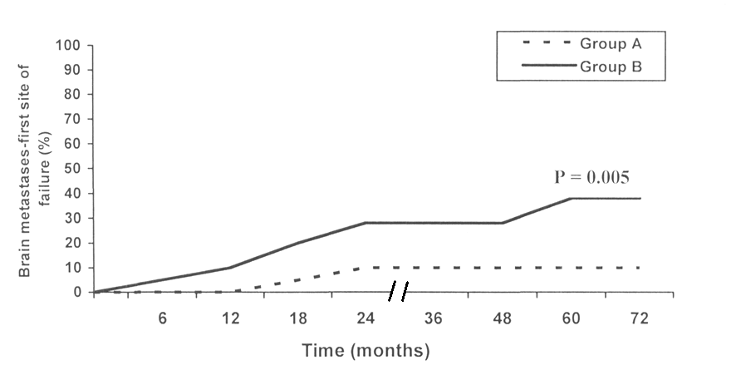
Fig. (1): Brain relapse as first failure in both groups.

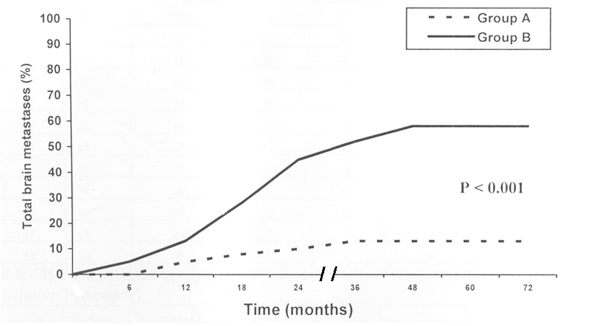
Fig. (2): Overall brain relapse as any component of failure in both groups.

In patients with PR/CR to induction chemotherapy, the risk of overall brain relapse was 32% ± 11%, 38% ± 11%, 38% ±11% and 48% + 12% at 2, 3, 4 and 5 years, respectively, in Group B and 10%, 8% ± 8%, and 8% + 8% at 2, 3, 4 and 5 years, respectively, in Group A (P = 0.0005, log rank test).

MRI abnormalities in long term survivor
There were nineteen (19) long-term survivors, thirteen of these patients received PCI (group A) and 6 did not (group B). Patients treated with PCI had higher grade white matter abnormalities than patients who were not treated with PCI, as detected by T₂-weighted MRI (P = 0.04), and fig 3a,b,c.Grade 4 white matter abnormalities were detected in 3 of thirteen patients in group A and zero of six patients in group B (fig.3 a,b,c). A pathologic cella media or frontal horn index or an increased width of the third ventricle was observed in 8 of thirteen patients treated with PCI (Group A) (fig 3a,b,c).

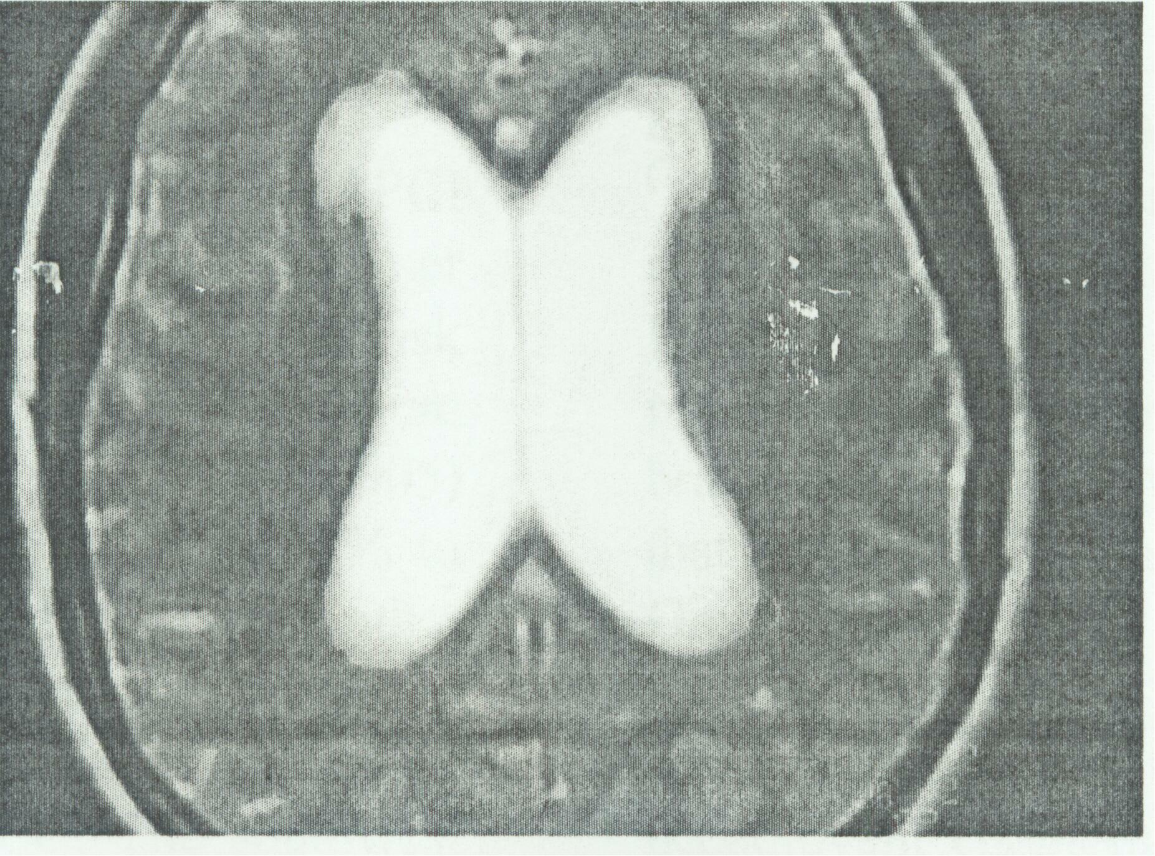
Fig (3A): Axial T2-w MRI shows discontinuous high signal intensity lesion at peri-ventricular region (grade I)

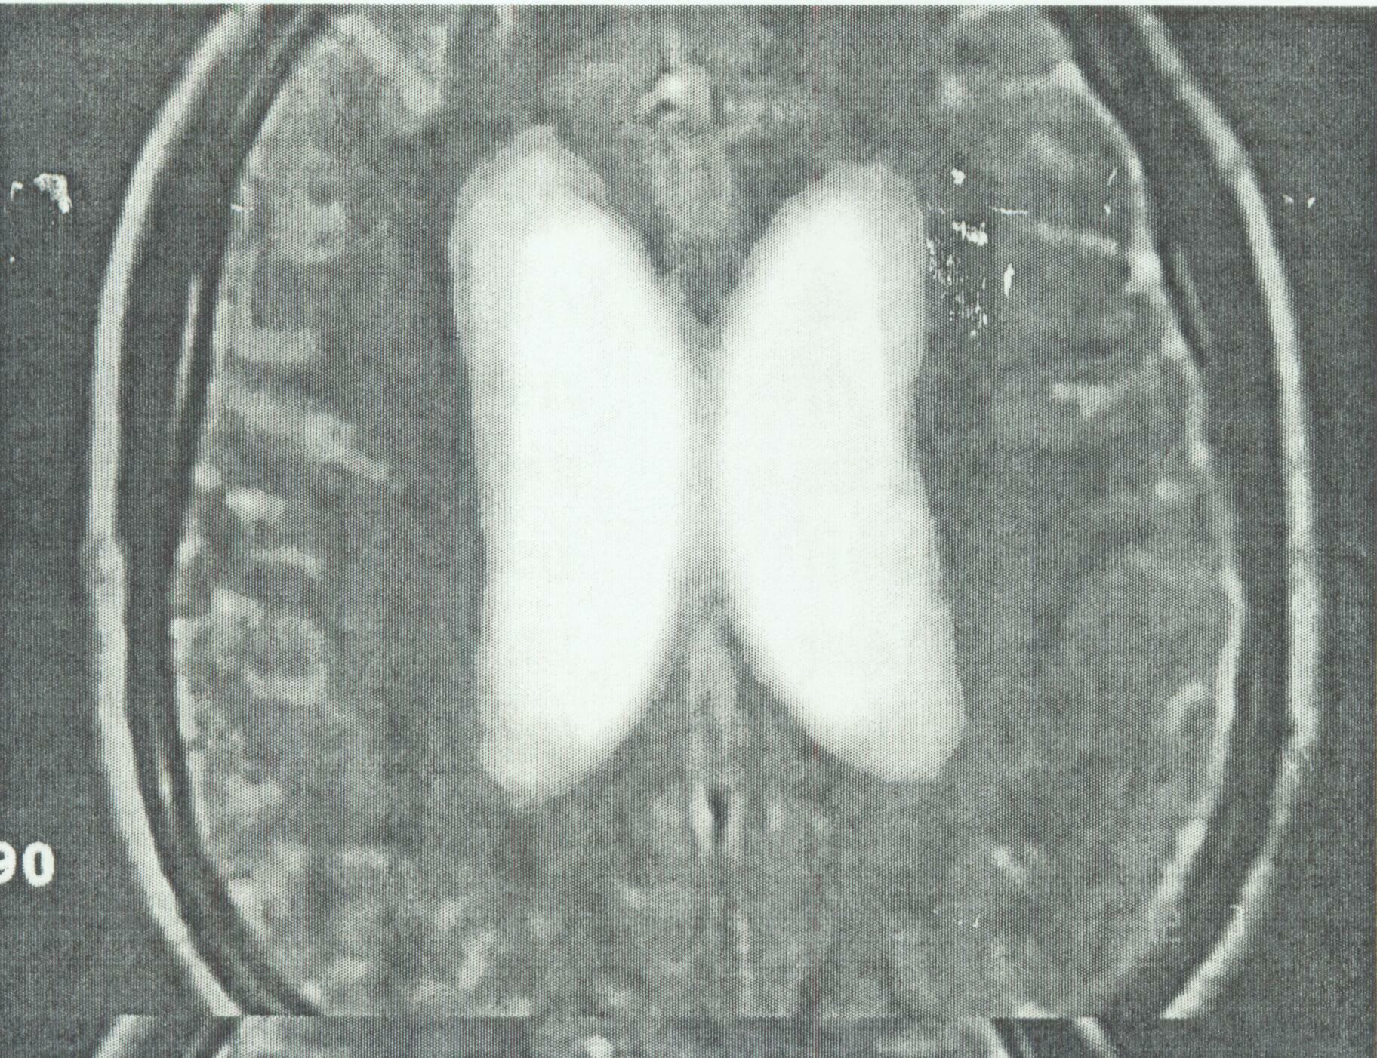
Fig (3B): Axial T2-w MRI of brain shows continuous band of high signal intensity lesion at peri-ventricular region (grade II).

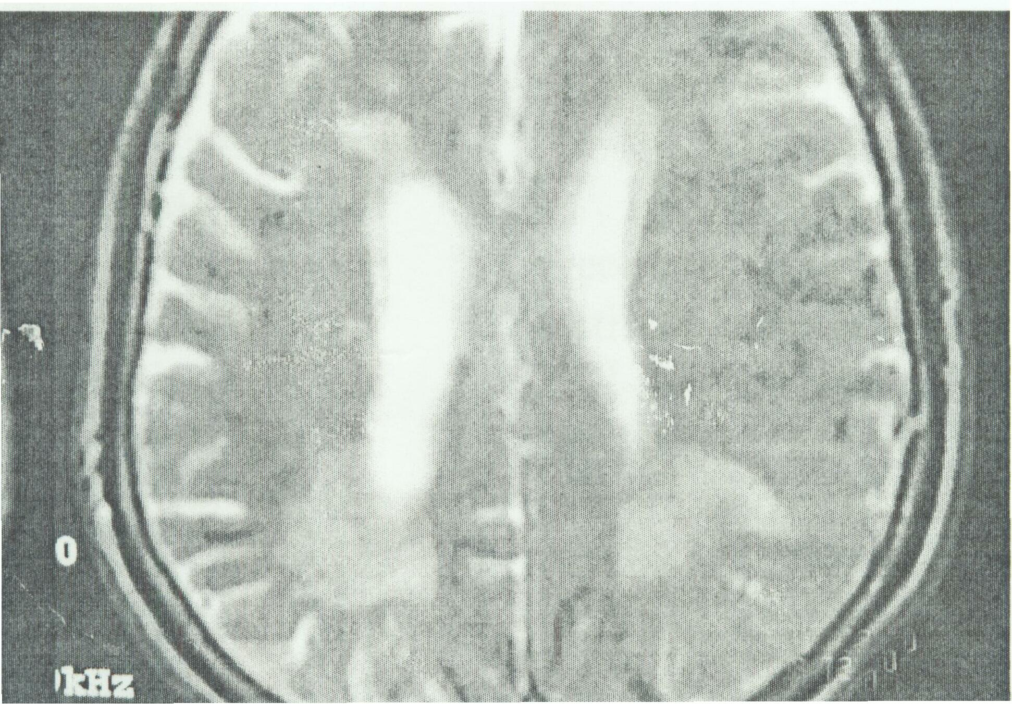
Fig (3C): Axial T2-w MRI of brain shows confluent areas of high signal intensities lesions at peri-ventricular region mainly at parieto-occipital regions (grade III).

Discussion
The potential benefit of PCI is a reduction in the significant morbidity of brain metastases, which includes neurological symptoms, neurocognitive impairment, and reduction in performance status. However; this must compared with the toxicities of PCI: the early of these include headache, fatigue, alopecia, nausea, vomiting and insomnia ⁽²³⁾, and the delayed toxicities; the most concerning side-effects are neurocognitive decline and decreased quality of life ^{(24–26)}. Patients with asymptomatic brain metastases are worked up for radical radiotherapy, have been reported at between 4.8% and 14% ^{(27–30)}; however, there are no reports looking at the incidence of symptomatic brain metastases following radical treatment. As relapse rates in the brain as first site have not changed after application of PCI it is omitted in NSCLC treatment regimens in many reports. In the SWOG study, the first recruited patients were treated with 37.5 Gy in fractions of 2.5 Gy which caused increased death rate, obliged the committee to reduce the dose 30 Gy in 2 Gy fractions for all further patients ⁽³⁵⁾. In this study, the inclusion of PCI at a moderate dose of 30 Gy (2Gy per daily fraction led to a reduction of the risk of brain metastases as isolated first failure from 38% to 10% at 5 years (P = 0.005) and of overall brain relapse from 58% to 13% (P < 0.001). Two other nonrandomized multimodality trials have also given data on PCI in patients with locally advanced NSCLC. The South Western Oncology Group delivered 36Gy in 2Gy daily fractions in their phase II trial of neoadjuvant chemoradiation and resection two of 108 patients treated with PCI and 24 of 108 patients who did not receive PCI developed brain metastases ⁽¹⁴⁻¹⁶⁾. Although not statistically significant, the overall brain metastasis rate was halved by PCI in that study. The Cancer and Leukemia Group B delivered 30Gy at 2Gy per fraction to patients with large cell or adenocarcinoma in a phase II trial of neoadjuvant chemoradiation followed by resection for LAD-NSCLC. Patients who received PCI did fail by brain relapse ^{(36,)}. Reports of three randomized trials of PCI in patients with LAD-NSCLC; all found a trend for a reduced risk of brain metastases after PCI but no effect on survival ^{(18,19)}. PCI at a low dose of 20Gy in 2Gy fractions halved the incidence of brain metastases from five of 70 to two of 60 in squamous cell carcinoma and from five of 19 to 6 of 14 in adenocarcinoma (^{37, 38)}. The Radiation Therapy Oncology Group randomly assigned 187 patients with inoperable or resected adenocarcinoma and large cell carcinoma with hilar or mediastinal lymph node metastases to PCI treatment (30Gy in 10 fractions) or no prophylactic treatment to the brain. Inoperable patients were treated with standard radiotherapy to the primary tumor and the mediastinum; patients with resectable tumors received post-operative chest radiotherapy. The incidence of brain metastases was non significantly halved from 18 of 93 to eight of 94 by PCI and the actuarial risks of brain metastases were 30% and 15% at 2 years without and with PCI, respectively ⁽¹⁹⁾. In the latter study, Brain metastases had been observed in 10.7% of patients over 2 years follow-up, while in the RTOG 8% of patients in group (A) had developed brain metastases ⁽³⁷⁾.
The 30 Gy dose of PCI in 10 fractions: reduced the risk of brain metastases from 40% to 8% at 2 years (P = 002) and from 38% to 0% in patients with squamous cell carcinoma (P = 0.01) ^{(19, 38)}. Yokes et al ⁽⁷⁾ reported that introduction of PCI in 75 patients with stage III A and III B reduced the rate of brain metastases as first site of relapse from 30% to 8% at 4 years (P = .005) and that of overall brain relapse from 54% to 13% (P < 0.001). The effect of PCI was also observed in the good-prognosis subgroup of 47 patients who had a partial response or complete response to induction chemotherapy with a reduction of brain relapse as first failure from 23% to 10% at 4 years (P = 0.01). These results are comparable to the results in the study of Stuschke et al ⁽¹⁴⁾. The main aim of the use of PCI in LAD-NSCLC is to increase relapse free survival at any site without inducing severe toxicities. In patients with good local control and no distant metastases; PCI may improve cure rates ⁽³⁹⁻⁴¹⁾. PCI has a palliative effect and reduces the high incidence of symptomatic brain metastases from over 50% to less than 20%^{, (42)}. In the RTOG-0214 reported by Gore et al ^{(43,44)}, is the only randomized, controlled trial to investigate PCI in LA-NSCLC in the modern era of combined-modality therapy. In RTOG 0214, patients with stage IIIA to IIIB NSCLC were eligible if they had stable disease or better after potentially curative therapy, defined as high-dose thoracic radiation therapy (RT; i.e., >30 Gy) or surgery ⁽⁹⁾. The inclusion eligibility did not select the highest-risk population. Firstly, all kinds of NSCLC histology were included. Secondly, locoregional and extracranial distant relapse remains the major concern of the eligible stage IIIB and non-radically treated stage IIIA. Complete resection is a major curative therapy. Yet, only approximately 35 % of all patients underwent surgery, and the proportion of complete resection was not provided. Besides, it is debatable to define RT > 30 Gy as a potentially curative therapy. Patients were randomized between PCI (30 Gy in 15 fractions) or non-PCI groups. However, the trial was closed due to poor accrual (358/1058 patients needed). The results showed a significant reduction in the incidence of BM from 18 to 7.7% in the PCI group at 1 year (HR 0.43 in favor of PCI, 95% CI 0.23–0.78, p = 0.004) and non significant trend towards an increased relapse-free survival at 1 year (51.2 and 56.4% for observation and PCI, respectively, p = 0.11). There was no significant difference in OS between the two groups (hazard ratio0.97, 95% CI 0.74–1.30, p = 0.86). As a result, these findings failed to confirm the role of OS in PCI in patients with NSCLC: It is likely that locoregional and extracranial control was so poor that BM lacked the opportunity to manifest themselves ⁽⁴³⁾, a large study including 2,360 patients with lung cancer ⁽⁴⁵⁾ reported that there was a significant decrement in OS associated with PCI, with a 2-year OS of 14% vs. 28% and a 5-year OS 5% vs. 12% in PCI vs. non-PCI groups (p= 0.01). A meta-analysis by xie et al. ⁽⁴⁶⁾ provided additional insights into use of PCI in patients with NSCLC. The analysis included 12 clinical studies (6 RCTs and 6 non RCTs), involving a total of 1,718 patients with NSCLC. All trials compared treatment of NSCLC with and without PCI. As shown by the meta-analysis, PCI reduced the risk of brain metastases as compared with patients who did not receive PCI (OR = 0.30, p=0.00001). However, the HRs for OS favored non-PCI modality (HR = 1.19, p = 0.004). In addition, the data currently available are not sufficient and convincing enough to make a definitive conclusion about the effect of PCI on toxicity and radiation dose in patients with NSCLC. Thus, it remains unclear whether PCI could cause toxicity and result in a decline in neurocognitive function (NCF) or quality of life (QOL)

Some trials that showed a significant reduction in the incidence of BM with PCI used different regimens. The Umsawasdi et al. ⁽⁴⁷⁾ trial used 30 Gy in 10 fractions over two weeks and the Cox et al [48] trial 20 Gy in ten fractions over two weeks. The 49. Mira et al 50. Mira et al (1990) used 37.5 Gy in 15 fractions for the first 34 patients and 30 Gy in 15 fractions for the remaining 77 patients; there was no significant difference in MS between the two PCI regimens used. The differences in inclusion criteria made any comparison between the trials inappropriate. In addition, no randomized trial had compared these (or any other) PCI regimens head-to-head; hence, it was not possible to conclude which was more effective.A commonly applied dose for PCI in the past NSCLC studies was 30 Gy in 15 fractions ⁽³⁴⁾. Once diagnosed, BMs are mostly treated with whole brain radiotherapy, having a response rate of 45%–81% in NSCLC ^{(24,25)}. The overall survival of NSCLC patients with BM is poor, reported to be 3–6 months, despite medical treatment ⁽⁵¹⁻⁵³⁾. Specific phenotypic characteristics may serve as surrogate prognostic factors. Earlier studies correlated the presence of BM with advanced stage, NSCLC histotypes, and delay of lung radiotherapy, younger age, and large tumor size 54–58. In ding et al, ⁽⁵⁹⁾ of the 217 patients, 53 (24.4%) developed BM at some point during their clinical course, and 32 (14.7%) recurred in the brain as their first site of failure, and 15 (6.9%) recurred in the brain as their exclusive site of failure. The 1-, 3-, and 5-year actuarial risk of developing BM were 9.2 %, 24.2%, and 31.5%, respectively. The median time from surgery to onset of BM was 16 months (range, 2.5–68.5 months), longer than the reported 5.7–11.7 months ⁽⁶⁰⁻⁶²⁾. In Stage IIIB NSCLC patients treated with PCI, lower BM and longer survival resulted from immediate concurrent chemoradiotherapy rather than induction chemotherapy-first regimens, which indicated the benefit of earlier PCI without delay because of induction protocols ⁽⁶³⁾. BM has a major effect on morbidity and mortality ^{(61,64)}. Robnett et al. reported that the sequence of chest irradiation can influence the risk of brain recurrences: the rate of BM is 27% in patients receiving induction chemotherapy before thoracic RT compared with 15% in patients who are treated with concurrent chemoradiation ⁽⁶⁵⁾. The 2-year actuarial rate of BM is 39% versus 20%. While, PCI reduces the rate of brain relapse, but its effect to improve the survival without quality of life impairing side effects depend on radiation toxicities and the other treatments for symptomatic brain metastases. Whole cranial irradiation with 36 Gy in 3 Gy per fraction lead to local control rate less than 20%, for manifest brain metastases,⁽⁶⁶⁾. Of note, it is known since the early 70s that a pre-existing vascular damage is accelerated by radiation and assuming that more than 95% of all SCLC/NSCLC patients are smokers, a possible underlying cause of this age-related PCI toxicity may be the higher incidence of hypertension and/or (cerebral) arthrosclerosis in these patients ⁽⁶⁷⁾. It has to be noted that there was no evidence for reduced QoL after PCI in patients with advanced-stage NSCLC ⁽⁶⁸⁾. On the way to find a subgroup in the NSq group that might benefit from PCI, it is important to mention that tumor size and lymph node status are the key determinants for assessing the risk of BM in NSCLC ^{(69,70)}. In this regard, an analysis by Ding and colleagues revealed that nearly 60% of patients with NSCLC stage IIIA-N2 developed BM within 5 years if more than 30% of all excised lymph nodes were affected ⁽⁵⁹⁾. If less than 30 % were affected, they saw that roughly 30% of patients had BM. Their data suggest that patients with NSq-NSCLC with N≥2 and >30% affected nodes might benefit from PCI. Consequently, it should now be tested if the (putatively) low toxicities of novel PCI-treatment modalities (such as IMRT) could provide a benefit to this subgroup ⁽⁵⁹⁾. Wang et al. reported that a greater number of mediastinal lymph nodes and nodal regions with metastases predicted a higher risk of BM for stage III-N2 NSCLC ⁽⁷¹⁾. Systemic chemotherapy has reduced the risk of extra cranial metastases. Combined-modality therapy significantly increases survival. Some studies employing multimodality therapy have reported median survival ranging from 20 to 43 months and 3-year survival rates of 34–63 % for LA-NSCLC ^{(61,71)}. However, chemotherapy has limited impact on BM because drugs do not penetrate the blood–brain barrier (BBB), which leaves the brain relatively under treated ^{(31,72)}. Surgery and stereotactic radiotherapy with and without whole cranial irradiation can lead to local control rate more than 50% ^{(73,74)}. On the basis of results from the present study, we also have to conclude that PCI has some adverse effects on normal brain after long-term follow-up. T₂-weighted MRI showed a high sensitivity and revealed abnormalities of higher grade in the group (A) of patients treated with PCI compared to the group (B) treated without PCI.
Stuschke et al. ⁽¹⁴⁾ in their study T2-weighted magnetic resonance imaging revealed white matter abnormalities of higher grades in patients who received PCI than in those who did not. Li et al. concluded that: in patients with fully resected postoperative pathologically confirmed stage IIIA–N2 NSCLC and high risk of cerebral metastases after adjuvant chemotherapy, PCI prolongs DFS and decreases the incidence of brain metastases. In their trial 156 patients were randomly assigned (81 to PCI group and 75 to control group). The PCI group had significantly lengthened DFS compared with the control group, with a median DFS of 28.5 months versus 21.2 months [hazard ratio (HR), 0.67; 95% confidence interval (CI) 0.46–0.98; P = 0.037]. PCI was associated with a decrease in risk of brain metastases (the actuarial 5-year brain metastases rate, 20.3% versus 49.9%; HR, 0.28; 95% CI 0.14–0.57; P < 0.001). The median OS was 31.2 months in the PCI group and 27.4 months in the control group (HR, 0.81; 95% CI 0.56–1.16; P = 0.310). While main toxicities were headache, nausea/vomiting and fatigue in the PCI group, they were generally mild ⁽⁷⁵⁾.

In conclusion patients with LA-NSCLC treated on multimodality protocols that have high loco-regional control rates have high risks of brain metastases as the isolated first failure or of overall brain metastases. The respective risks were 34 % and 58 % in this study. PCI at a total dose of 30Gy in conventional fractionation effectively decreased the high risk of brain metastases by more than 45%. This study supported the use of PCI for patients with LA-NSCLC to increase the freedom from brain relapse without producing severe toxicities and to improve overall survival

References
- Siegel R, Ward E, Brawley O, Jemal A (2011) Cancer statistics, 2011: the impact of eliminating socioeconomic and racial disparities on premature cancer deaths. CA Cancer J Clin 61: 212–36.
- Govindan R, Page N, Morgensztern D, Read W, Tierney R, et al. (2006) Changing epidemiology of small-cell lung cancer in the United States over the last 30 years: analysis of the surveillance, epidemiologic, and end results database. J Clin Oncol 24: 4539–44.
- Jemal A, Murray T, Ward E, et al. Cancer statistics, 2005. CA Cancer .1 Clin2005;55: 10-30.
- Dillman RO, Hcrndon J, Seagren SI., et al. Improved survival in stage III non-small-cell lung cancer: seven-year follow-up of cancer and leukemia group B (CALGB) 8433 trial. J Natl Cancer Inst 1996; 88: 1210-1215.
- Sause W, Kolesar P, Taylor SI, et al. Final results of phase III trial in regionally advanced unresectable non-small cell lung cancer: Radiation therapy Oncology Group, Eastern Cooperative Oncology Group, and Southwest Oncology Group, Chest 2000; 117:358-364.
- Curran WJ, Scott CB, Langcr CJ, et al. Long-term benefit is observed in a phase 111 comparison of sequential vs concurrent chemo-radiation for patients with unresected stage III NSCLC: RTOG 9410. Proc. Am Soc Clin Oncol 2003 (abstr 2499); 22: 621.
- Yokes E, Herdon JE, Kelley MJ, et al. Induction chemotherapy followed by concomitant chemo-radiotherapy versus chemo-radiotherapy alone for regionally advanced unresectable non-small cell lung cancer: initial analysis of a randomized phase III trial. J Clin Oncol 2004; 22 (Suppl): Abstract 7005.
- Schouten LJ, Rutten J, Huveneers HAM, Twijnstra A: Incidence of brain metastases in a cohort of patients with carcinoma of the breast, colon, kidney, and lung and melanoma. Cancer 2002, 94:2698–2705.
- Komaki R, Scott CB, Sause WT, Johnson DH, Taylor SG: Induction cisplatin/ vinblastine and irradiation vs. irradiation in unresectable squamous cel lung cancer: failure patterns by cell type in RTOG 88–08/ECOG 4588. Int J Radiat Oncol Biol Phys 1997, 39:537–544.
- Bajard A, Westeel V, Dubiez A. Multivariate analysis of factors predictive of brain metastases in localized non-small cell lung carcinoma. Lung Cancer. 2004;45:317–323.
- Mujoomdar A, Austin J, Malhota R, et al. Clinical predictors of metastatic disease to the brain from non-small cell lung carcinoma: Primary tumor size, cell type, and lymph node metastases. Radiology. 2007;242:882–888.
- Shi A, Digumarthy S, Temel J, Halpern EF, Kuester LB, Aquino SL. Does initial staging or tumor histology better identify asymptomatic brain metastases in patients with non-small cell lung caner? J Thorac Oncol. 2006;1:205–210.
- Andre F, Grunenwald D, Pujol JL, et al. Patterns of relapse of N₂ non-small cell lung carcinoma patients treated with preoperative chemotherapy: should prophy-lactic cranial irradiation be reconsidered? Cancer 2001; 91: 2394-2400.
- Stuschke M, Eberhardt W, Pottgen C, ct al. Prophylactic cranial irradiation in locally advanced non-small-cell lung cancer after multimodality treatment: long-term follow-up and investigations of late neuropsychologic effects, J Clin Oncol 1999; 17:2700-2709.
- Lester JF, MacBeth FR. Coles B. Prophylactic cranial irradiation for preventing brain metastases in patients undergoing radical treatment for non-small-cell lung cancer: a cochrane review. Int J Radiat Oncol Biol Phys 2005; 63: 690-694.
- Arriagada R, Le Pcchoux C, Bacza MR. Prophylactic cranial irradiation in high-risk non-small cell lung cancer patients. Lung Cancer 2003; 42 (Suppl 2): S41-S45.
- Budach W, Belka C. Palliative percutaneous radiotherapy in non-small-cell lung cancer. Lung Cancer 2004; 45 (Suppl 2): S239-S245.
- Fournel P, Robinet G, Thomas P, et al. Randomized phase III trial of sequential chemoradiotherapy compared with concurrent chemoradiotherapy in locally advanced non-small-cell lung cancer: Group Lyon-Saint-Etienne d'Oncologie Thoracique-Group Francis de Pneumo-Cancerologic NPC 95-01 Study. J. Clin Oncol 2005; 23: 5910-5917.
- Greene FL, American Joint Committee on Cancer, American Cancer Society. AJCC Cancer Staging Manual. 6th ed. New York: Springer-Verlag; 2002.
- Turrisi III AT. Updates and Issues in lung Cancer. Presented at American Society of Therapeutic Radiology and Oncology Spring Refresher Course, Chicago, IL, 2004.
- Slotman B, Faivre Finn C, Kramer G, et al. Prophylactic Cranial Irradiation in Extensive Small-Cell Lung Cancer. N Engl. J. Med., 2007;357:664-72.
- Umsawasdi T, Valdivieso M, Chen TT, et al: Role of elective brain irradiation during combined chemo-radiotherapy for limited disease non-small cell lung cancer, J Neuroncol 2: 253-259, 1984.
- Le Pechoux C, Dunant A, Senan S, Wolfson A, Quoix E, Faivre-Finn C, et al. Standard-dose versus higher-dose prophylactic cranial irradiation (PCI) in patients with limited-stage small-cell lung cancer in complete remission after chemotherapy and thoracic radiotherapy (PCI 99-01, EORTC 22003-08004, RTOG 0212, and IFCT 99-01): a randomized clinical trial. Lancet Oncol 2009;10:467–74.
- Corn B, Moughan J, Knisely PS, Fox SW, Chakravarti A, Yung WK, et al. Prospective evaluation of quality of life and neurocognitive effects in patients with multiple brain metastases receiving whole brain radiotherapy with or without thalidomide on Radiation Oncology Group (RTOG) trial 0118. Int J Radiat Oncol Biol Phys 2008;71:71–8.
- Sun A, Bae K, Gore EM, Movsas B, Wong SJ, Meyers CA, et al. Phase III trial of prophylactic cranial irradiation compared with observation in patients with locally advanced non-small-cell lung cancer: neurocognitive and quality-of-life analysis. J Clin Oncol 2011;29:279–86.
- Chang EL, Wefel JS, Hess KR, Allen PK, Lang FF, Kornguth DG, et al. Neurocognition in patients with brain metastases treated with radiosurgery or radiosurgery plus whole brain irradiation: a randomized controlled trial. Lancet Oncol 2009;10:1037–44.
- Germain F, Wai ES, Berthelet E, Truong PT, Lesperance M. Brain metastasis is an early manifestation of distant failure in stage III nonsmall cell lung cancer patients treated with radical chemoradiation therapy. Am J Clin Oncol 2008;31: 561–6.
- Win T, Laroche CM, Groves AM, Nathan J, Clements L, Screaton NJ. The value of performing head CT in screening for cerebral metastases in patients with potentially resectable non-small cell lung cancer: experience from a UK cardiothoracic centre. Clin Radiol 2004;59:935–8.
- Hochstenbag MM, Twijnstra A, Hofman P, Wouters EF, ten Velde GP. MR-imaging of the brain of neurologic asymptomatic patients with large cell or adenocarcinoma of the lung. Does it influence prognosis and treatment? Lung Cancer 2003;42:189–93.
- de Cos Escuin JS, Menna DM, Gonzalez MA, Quirantes JZ, Vicente CD, Calvo MC. Silent brain metastasis in the initial staging of lung cancer: evaluation by computed tomography and magnetic resonance imaging. [In Spanish.] Arch Bronconeumol 2007;43:386–91
- Andre F, Grunenwald D, Pujol JL, et al. Patterns of relapse of N2 nonsmall-cell lung carcinoma patients treated with preoperative chemotherapy: should prophylactic cranial irradiation be reconsidered? Cancer 2001;91:2394-400.
- Gaspar LE, Chansky K, Albain KS, et al. Time from treatment to subsequent diagnosis of brain metastases in stage III non-small-cell lung cancer: a retrospective
- Frank A. Giordano1, Grit Welzel1, Yasser Abo-Madyan1,2, Frederik Wenz1 Potential toxicities of prophylactic cranial irradiation Transl Lung Cancer Res 2012;1(4):254-262
- Stuschke M, Eberhardt W, Pöttgen C, et al. Prophylactic cranial irradiation in locally advanced non-small-cell lung cancer after multimodality treatment: long-term follow-up and investigations of late neuropsychologic effects. J Clin Oncol 1999;17:2700-9.
- Miller TP, Crowley JJ, Mira J, et al. A randomized trial of chemotherapy and radiotherapy for stage III Non-small cell lung cancer. Cancer Therapeutics 1998;1:229-36.
- Eric K, and Made R. Handbook of Evidence Based Radiation Oncology. 1st. ed New York : Springes-Verlage; 2007: 157-172.
- Russell AH, Pajak TE, Selim HM, et al: Prophylactic cranial irradiation for lung cancer patients at high risk for development of cerebral metastasis: Results of a prospective randomized trial conducted by the Radiation Therapy Oncology Group. Int J Radiat OncolBiol Phys 21: 637-643, 1991.
- Umsawasdi T, Valdivieso M, Chen TT, et al: Role of elective brain irradiation during combined chemo-radiotherapy for limited disease non-small cell lung cancer, J Neuroncol 2: 253-259, 1984.
- Law A, Daly B, Madscn M, ct al: High incidence of isolated brain metastases following complete response in advanced non-small cell lung cancer: A new challenge. Proc Am Soc Clin Oncol 16: 447a, 1997 (abstr 1604).
- Cox JD, Scott CB, Emami B, et al: Addition of chemotherapy to radiation therapy alters failure patterns by cell type within non-small cell carcinoma of lung analysis of Radiation Therapy Oncology Group trials. Lung Cancer 18: 126, 1997 (suppl 1).
- Arriagada R, LeChcvalicr T, Boric F, et al: Prophylactic cranial irradiation for patients with small-cell lung cancer in complete remission. J Natl Cancer Inst 87: 183-190, 1995.
- Pen Land SK, Socinski MA. Management of unresectable stage III non-small cell lung cancer: The role of combined chemoradiation. Semin Radiat Oncol 2004; 14:326-334.
- Gore EM, Bae K, Wong SJ, Sun A, Bonner JA, et al. (2011) Phase III comparison of prophylactic cranial irradiation versus observation in patients with locally advanced non-small-cell lung cancer: primary analysis of radiation therapy oncology group study RTOG 0214. J Clin Oncol 29: 272–8.
- Gore EM, Paulus S, Wong A, Sun G, Bonner JA, et al. (2012) Phase III Comparison of Prophylactic Cranial Irradiation Versus Observation in Patients with Locally Advanced Non-small Cell Lung Cancer–An Updated Analysis of RTOG 0214. Int J Radiat Oncol Biol Phys 84: S103–S103.
- Corradetti MN. Xanthopolous E, Cheng S (2012) An Analysis of Survival After Prophylactic Cranial Irradiation for Non-small Cell Lung Cancer. Int J Radiat Oncol Biol Phys 84: S599–S600.
- Shuan-shuan Xie1., Ming Li1., Cai-cun Zhou2 , Xiao-lian Song1 Prophylactic Cranial Irradiation May Impose a Detrimental Effect on Overall Survival of Patients with Non small Cell Lung Cancer: A Systematic Review and Meta-Analysis*, ChJuly 2014 | Volume 9 | Issue 7 | e103431ang-hui Wang1
- Umsawasdi T, Valdivieso M, Chen TT, Barkley HT Jr, Booser DJ, et al. (1984) Role of elective brain irradiation during combined chemoradiotherapy for limited disease non-small cell lung cancer. J Neurooncol 2: 253–9. and the
- Cox JD, Stanley K, Petrovich Z, Paig C, Yesner R (1981) Cranial irradiation in cancer of the lung of all cell types. JAMA 245: 469–72.
- Mira JG, Taylor SL, Stephens RL, Chen T (1988) Simultaneous chemotherapyradiotherapy with prophylactic cranial irradiation for inoperable adeno and large cell lung carcinoma: a Southwest Oncology Group Study. Int J Radiat Oncol Biol Phys 15: 757–61.
- Mira JG, Miller TP, Crowley JJ (1990) Chest irradiation vs. chest irradiation plus chemotherapy with or without prophylactic brain radiotherapy in localized nonsmall lung cancer: a Southwest Oncology Group Study. Int J Radiat Oncol Biol Phys 19: 145
- Addeo R, Caraglia M, Faiola V, et al. Concomitant treatment of brain metastasis with whole brain radiotherapy [WBRT] and temozolomide [TMZ] is active and improves quality of life. BMC. 2007;7:18.
- Ma S, Xu Y, Deng Q, Yu X. Treatment of brain metastasis from nonsmall cell lung cancer with whole brain radiotherapy and Gefitinib in a Chinese population. Lung Cancer. 2009;65:198–203.
- Jacot W, Quantin X, Boher JM, et al. Brain metastases at the time of presentation of non-small cell lung cancer: A multi-centric AERIO* analysis of prognostic factors. Br J Cancer. 2001;84:903–909.
- Arrieta O, Saavedra-Perez D, Kuri R, et al. Brain metastasis developmentand poor survival associated with carcinoembryonic antigen (CEA) level in advanced non-small cell cancer: A prospective analysis.BMC Cancer. 2009;9:119.
- Robnett T, Machtay M, Stevenson J, et al. Factors affecting the risk of brain metastases after definitive chemoradiation for locally advanced non-small-cell lung carcinoma. J Clin Oncol. 2001;19:1344–1349.
- Bajard A, Westeel V, Dubiez A. Multivariate analysis of factors predictive of brain metastases in localized non-small cell lung carcinoma. Lung Cancer. 2004;45:317–323.
- Mujoomdar A, Austin J, Malhota R, et al. Clinical predictors of metastatic disease to the brain from non-small cell lung carcinoma: Primary tumor size, cell type, and lymph node metastases. Radiology. 2007;242:882–888.
- Shi A, Digumarthy S, Temel J, Halpern EF, Kuester LB, Aquino SL. Does initial staging or tumor histology better identify asymptomatic brain metastases in patients with non-small cell lung caner? J Thorac Oncol. 2006;1:205–210.
- Ding X, Dai H, Hui Z, et al. Risk factors of brain metastases in completely resected pathological stage IIIA-N2 non-small cell lung cancer. Radiat Oncol 2012;7:119.
- Carolan H, Sun AY, Bezjak A, Yi QL, Payne D, Kane G, Waldron J, Leighl N, Feld R, Burkes R: Does the incidence and outcome of brain metastases in locally advanced non-small cell lung cancer justify prophylactic cranial irradiation or early detection? Lung Cancer 2005, 49:109–115.
- Chen AM, Jahan TM, Jablons DM, Garcia J, Larson DA: Risk of cerebral metastases and neurological death after pathological complete response to neoadjuvant therapy for locally advanced nonsmall-cell lung cancer. Cancer 2007, 109:1668–1675.
- Gaspar LE, Chansky K, Albain KS, Vallieres E, Rusch V, Crowley JJ, Livingston RB, Gandara DR: Time from treatment to subsequent diagnosis of brain metastases in stage III non-small-cell lung cancer: A retrospective review by the Southwest Oncology Group. J Clin Oncol 2005, 23:2955–2961.
- Topkan E, Parlak C, Kotek A, Yuksel O, Cengiz M, Ozsahin M, Pehlivan B: Impact of Prophylactic Cranial Irradiation Timing on Brain Relapse Rates in Patients with Stage IIIB Non-small-cell Lung Carcinoma Treated with Two Different Chemoradiotherapy Regimens. Int J Radiat Oncol Biol Phys 2012, 83:1264–1271.
- Mamon HJ, Yeap BY, J nne PA, Reblando J, Shrager S, Jaklitsch MT, Mentzer S, Lukanich JM, Sugarbaker DJ, Baldini EH: High risk of brain metastases in surgically staged IIIA non-small-cell lung cancer patients treated with surgery, chemotherapy, and radiation. J Clin Oncol 2005, 23:1530–1537.
- Robnett TJ, Machtay M, Stevenson JP, Algazy KM, Hahn SM. Factors affecting the risk of brain metastases after definitive chemoradiation for locally advanced non-small-cell lung carcinoma. J Clin Oncol. 2001;19:1344–1349
- Schrump AN, Altorki NK, Hcnschkc CL. Non-small cell lung cancer. In: Resenberg SA, eds. Cancer : Principles and practice of oncology, 7th ed. Philadelphia : Lippincott Williams and Wilkins, 2005.
- Hopewell JW, Wright EA. The nature of latent cerebral irradiation damage and its modification by hypertension. Br J Radiol 1970;43:161-7.
- Sun A, Bae K, Gore EM, et al. Phase III trial of prophylactic cranial irradiation compared with observation in patients with locally advanced non-small-cell lung cancer: neurocognitive and quality-of-life analysis. J Clin Oncol 2011;29:279-86.
- Hubbs JL, Boyd JA, Hollis D, et al. Factors associated with the development of brain metastases: analysis of 975 patients with early stage nonsmall cell lung cancer. Cancer 2010;116:5038-46.
- Mujoomdar A, Austin JH, Malhotra R, et al. Clinical predictors of metastatic disease to the brain from nonsmall cell lung carcinoma: primary tumor size, cell type, and lymph node metastases. Radiology 2007;242:882-8.
- Wang S, Ye X, Ou W, Lin Y, Zhang B, Yang H: Risk of cerebral metastases for postoperative locally advanced non-small-cell lung cancer.Lung Cancer 2009, 64:238–243
- Cox JD, Scott CB, Byhardt RW, Emami B, Russell AH, Fu KK, Parliament MB, Komaki R, Gaspar LEW: Addition of chemotherapy to radiation therapy alters failure patterns by cell type within non-small cell carcinoma of lung: analysis of radiation therapy oncology group trials. Int J Radiat Oncol Biol Phys 1999, 43:505–509
- Albain KS, Rusch VW, Crowlcy JJ, et al: Concurrent cisplatin/ctoposide plus chest radiotherapy followed by surgery for stages IIA (N2) and IIIB non-small-cell lung cancer: Mature results of Southwest Oncology Group phase II study 8805. J Clin Oncol 13: 1880-1892, 1995.
- Eberhardt W, Wilkc H, Stamafis G, et al: Preoperative chemotherapy followed by concurrent chemoradiation therapy based on hyperfractionated accelerated radiotherapy and definilivc surgery in locally advanced non-small-cell lung cancer: Mature results of a phase II trial J Clin Oncol 16: 622-634, 1998.
- N. Li, Z.-F. Zeng, S.-Y. Wang , W. Ou1, et al: Randomized phase III trial of prophylactic cranial irradiation versus observation in patients with fully resected stage IIIA–N2 nonsmall-cell lung cancer and high risk of cerebral metastases after adjuvant chemotherapy: Ann Oncol (2015) 26 (3): 504-509. doi: 10.1093/annonc/mdu567 First published online: December 15, 2014

