**Comparative study between c-kit and DOG-1 immunohistochemical expression in GISTs**

Omnia MK Rizk, Ayman M Elsaka

Pathology Department, Faculty of Medicine, Tanta University, Egypt

[omnia\_kamelrizk@outlook.com](mailto:omnia_kamelrizk@outlook.com" \t "_blank)

**Abstract:** The diagnosis of GISTs shows controversy in their diagnosis, so pathologists commonly employ a panel of immunohistochemical markers. However, making the diagnosis can be difficult for the c-kit negative cases and c-kit positive cases that exhibit the same morphological pattern of other mesenchymal tumors and also stain c-kit positive. This work aimed to compare between the immune-histochemical expression of c-kit and DOG-1 and their diagnostic efficacy in GISTs using the percentage ratio score and intensity score. **Results;** Out of the 70 cases, only 54/70 cases were positive in both markers, 4/70 cases were negative for c-kit. Those cases were stained by other markers as (SMA and CD34) to confirm the diagnosis, resulting that, the c-kit negative cases considered as GISTs. Immunohistochemical results of c-kit revealed significant co-relation between the marker percentage score with WHO classification, and stage. Also, significant co-relation between the marker intensity with cell type, WHO classification and stage was detected. Immunohistochemical results of DOG-1 revealed significant co-relation between the marker percentage score with WHO classification, but, no significant association with stage. On the other hand, significant co-relation between the marker intensity with WHO classification and stage was detected. Significant co-relation between c-kit intensity and DOG-1 intensity were noticed but no significant co-relation between c-kit ratio score and DOG-1 ratio score. **Conclusion:** Both the sensitivity and specificity of DOG-1 were 100% compared to 93.10% and 66.67% of c-kit, respectively. DOG-1 have diagnostic accuracy 100% compared to 82.98% for c-kit. These results may magnify the importance of DOG-1 in that may be able to pick up a large numbers of c-kit negative cases and diagnose them as GIST. DOG1 immune-staining in mesenchymal tumors could be one of the best recommended markers to differentiate between GISTs & other tumors.

[Omnia MK Rizk. **Comparative study between c-kit and DOG-1 immunohistochemical expression in GISTs.** *Cancer Biology* 2017;7(1):54-62]. ISSN: 2150-1041 (print); ISSN: 2150-105X (online). <http://www.cancerbio.net>. 8. doi:[10.7537/marscbj070117.08](http://www.dx.doi.org/10.7537/marscbj070117.08).

**Key words:** GIST, c-kit, DOG-1

**1. Introduction:**

Gastro-intestinal stromal tumors (GIST) constitute 1-3% of all gastrointestinal malignancies and is the most common mesenchymal tumor of the gastrointestinal tract *(Zhong et al., 2013).* Relative incidence in Egypt about 2.5% of all gastrointestinal tumors and 0.3% of all malignancies. They arise from interstitial cells of Cajal (ICC) or their stem cell precursors which are normally are part of the autonomic nervous system of the intestine and serves as a pacemaker function in controlling motility *(Nakhla et al., 2012).* GISTS can occur anywhere along the digestive tract but are most commonly arise from the stomach, closely followed by the small bowel. They are uncommon in the large bowel and rectum and rare in the esophagus*(Liegl et al., 2009).*Subsequent studies have confirmed that 85% to 90% of GISTs have activating mutations in KIT or the homologous RTK platelet derived growth factor receptor alpha (PDGFRA) gene *(Heinrich et al., 2003a and Heinrich et al., 2003b).* C-kit protein (CD117) has been shown to be a relatively specific immunohistochemical marker for GIST *(Medeiros et al., 2004).* Pathological diagnosis of GISTs is based on histological findings and immunohistochemical demonstration of the c-kit protein *(Kang et al., 2011).* Until recently, c-kit immunohistochemistry has been the main tool for the verification of GIST. The problems in the current immunohistochemical identification of GIST include c-kit negative GISTs *(Lasota et al., 2008)*. C-kit-negative GISTs account for about 5% of cases and cause diagnostic difficulties. A correct diagnosis of GISTs is important for therapeutic reasons regardless of c-kit expression *(Kang et al., 2011).* Recent studies have suggested that antibodies against DOG-1(Discovered on GISTs-1) have superior sensitivity and specificity compared with c-kit, and that these antibodies could serve as specific immunohistochemical markers for GIST (*Espinosa et al., 2008 and Jung et al., 2011).* DOG-1 antibodies are more sensitive than KIT antibodies in detecting tumors of gastric origin, tumors with epithelioid morphology, and tumors harboring PDGFRA mutation. Furthermore, DOG-1 immunoreactivity is rarely observed in other mesenchymal and non mesenchymal tumor types *(Lee et al., 2010).* The high expression of DOG-1 in GISTs indicates its importance in the tumorigenesis and tumor developments, and DOG-1 may be a potential marker for tumor diagnosis. The high sensitivity and specificity makes DOG-1 an important diagnose evidence *(Sun et al., 2012).*

This work aimed to compare the sensitivity and specificity of DOG-1 with that of c-kit in gastrointestinal stromal tumors and to define the diagnostic utility of both DOG-1 and c-kit in gastrointestinal stromal tumors using the collected data.

**2. Material and methods**

This retrospective study was performed on paraffin blocks of 70 cases of Gastro-intestinal stromal tumor specimens of Egyptian patients, obtained during the period between 2008 to 2015. These cases were previously diagnosed as GIST by relative histo-pathological examination using ordinary hematoxylin and eosin stains (H&E) and clinical data. All cases were obtained from Pathology Department -Faculty of medicine -Tanta University, Pathology Department-Tanta Cancer Centre and Private laboratories.

**2.1 Histopathological study;** paraffin blocks of cases were cut by ordinary microtone to usual histologic sections 3-5 micron in thickness for H&E staining. Cases were reviewed for definite tumor cell typing (spindle, epithelioid, or mixed), tumor cellularity, nuclear atypia (mild, moderate and marked according to (Strickland et al., 2001), necrosis, mitotic rate [expressed as the number of mitotic figures/ 50 high-power fields (HPFs) in the most mitotic area, using a 40 objective and a 10 ocular; field size 0.25mm2]. Grading was done according to WHO grading system (2000), risk stratification was performed according to the NIH risk table of GIST (Joensuu, 2008) and staging of cases was done according to AJCC (2010) as published in the work Demetri et al. (2010).

**2.2 Immunohistochemical staining:**

Immunohistochemical staining was performed using the streptavidin-biotin immunoperoxidase technique. The UltraVision Detection Kit (TP-015-HD, Lab Vision, USA) was used according to the manufacturer’s protocol. The used primary antibodies included:

Rabbit polyclonal antibody (c-kit antibody, **#**A4502), used at dilution 1:200 and obtained from DakoCorporation. Positive control is GIST. Rabbit monoclonal antibody (DOG-1 antibody, # SP31), used at dilution 1:50 and obtained from Lab Vision Corporation. Positive control is GIST. Each staining run included both external positive and negative control slides to confirm that the correct procedure has been followed and the staining system worked properly. Incubation period was over night at room temperature for both markers. Negative controls were prepared by omission of the primary antibodies.

**2.2. a Interpretation of immunohistochemical staining:**

**2.2. b Evaluation of both c-kit immune-staining and DOG-1:** Expression was assessed in both the cytoplasm and the cyto-membrane. The scoring systems were performed according to:

1. **Liegl et al.,*****(2009)***: subdividing positive cells into five categories:

Score 0: no staining, score 1+: the number of positive cells < 5%, score 2+: the number of positive cells 5%-25%, score 3+: the number of positive cells 25%- 50%, score 4+: the number of positive cells >50%. S.

1. **Kang et al**.**, *(2011):*** intensity were classified into four categories: Negative, weak, moderate, and strong.
2. **El Rebey and Aiad, (2014)**: comparing expression of dog1 and c-kit scores with clinico-pathologic parameters were lumped together as low scores (scores 0, 1, 2) and high scores (scores 3, 4) for statistical purpose.

# 2.3 Statistical presentation and analysis of the present study was conducted using the Statistical Package of Social Sciences (SPSS Inc., Chicago, Illinois, USA) software for windows, version V.20. The mean, standard deviation, chi-square test, analysis of variance (ANOVA) tests (f), and linear correlation coefficient (r) were calculated. Differences were considered significant when *P*-value was < 0.05.

**3. Results:**

**3.1 Histopathological results:**

According to the morphologic features of GIST there were 44/70 lesions (63%) of spindle cell type, included [Hypercellular spindle cell, Palisaded and vacuolated spindle cell, signet ring cell type**,** Sarcomatous spindle cell, Sclerosing spindle cell, gastrointestinal autonomic nerve tumors (GANT)**].** 14/70 lesions (20%) of epithelioid cell type, included [hypercellular epithelioid, Sarcomatous epithelioid and cytotoxic T-lymphocytes rich GIST] and 12/70 lesions (17%) of mixed type, included [GISTs with a rhabdoid cells**.** Out of the 70 cases there were 30/70 cases (43%) showed mitotic activity ≤5/50 hpf included cases with no mitotic activity and 40/70 lesions (57%) showed mitotic activity >5/50 hpf. Also, 14/70 cases (20%) showed distant metastasis mainly to liver and 2/70 cases (3%) showed nodal metastasis**.**

The studied cases of GIST were classified according to the WHO classification (2000) and Joensuu 2008 risk stratification system as shown in diagrams,1-2. Then they were categorized according to AJCC (2010) as shown in diagram-3.

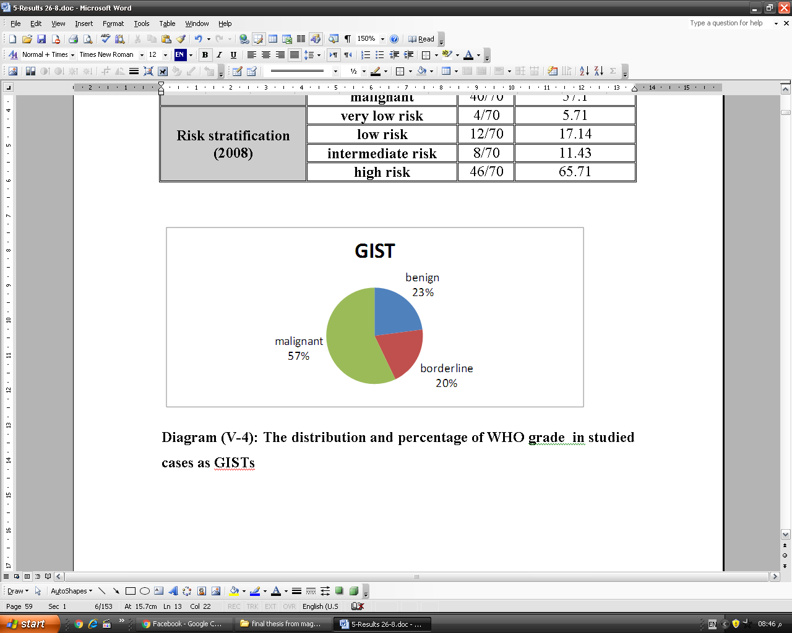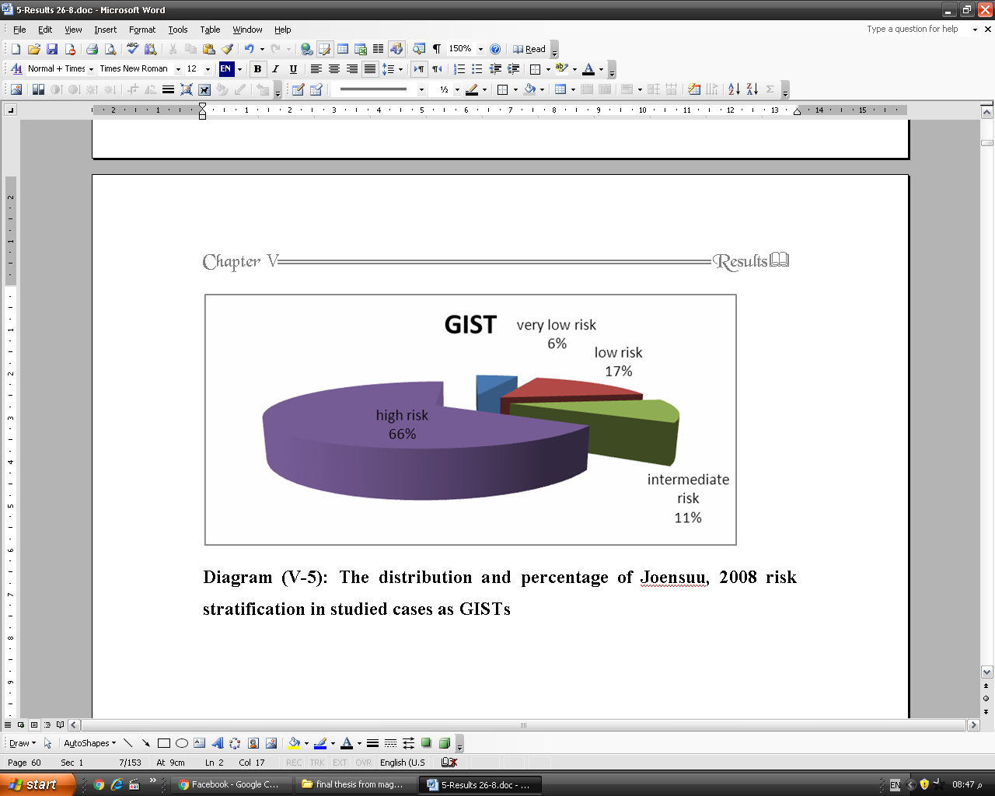

**1**

**2**

**Diagram-1: WHO classification of studied cases.**

**Diagram-2: Risk stratification of studied cases**

**Diagram-3: Staging of studied cases**

**3.2 Immunohistochemical results:**

**Table-1: Immunohistochemical expression of c-kit and DOG-1 in the studied GISTs**

|  |  |  |  |  |  |  |  |
| --- | --- | --- | --- | --- | --- | --- | --- |
| **Item** |  | **GIST** | | **Item** | | **GIST** | |
| **No.** | **%** | **No.** | **%** |
| **C-kit** | Negative | 4/58 | 6.90 | **DOG-1** | Negative | 0/58 | 0.00 |
| Positive | 54/58 | 93.10 | Positive | 58/58 | 100.00 |
| **C-kit staining ratio score** | Low (0,1,2) | 12/58 | 20.69 | **DOG-1 staining ratio score** | Low (0,1,2) | 6/58 | 10.34 |
| High (3,4) | 46/58 | 79.31 | High (3,4) | 52/58 | 89.66 |
| **C-kit staining intensity** | Negative | 4/58 | 6.90 | **DOG-1 staining intensity** | Negative | 0/58 | 0.00 |
| Weak | 10/58 | 17.24 | Weak | 6/58 | 10.34 |
| Moderate | 30/58 | 51.72 | Moderate | 12/58 | 20.69 |
| Strong | 14/58 | 24.14 | Strong | 40/58 | 68.97 |

After using the immunohistochemical markers (c-kit and DOG-1) on the 70 cases which previously diagnosed as GISTs by H&E and clinical data, it was founded that 54/70 cases ***only*** were positive for both markers, Those negative cases either for c-kit or DOG-1 were stained by other markers as (SMA & CD34) for confirming the diagnosis, resulting that four cases showed positive reaction for SMA &/ or CD34 and so, they were considered as GISTs**.** The remaining 12 cases showed negative reaction for SMA and CD34, so considered as non GISTs, and they were excluded from the immunohistochemical results analysis as well as from statistical analysis**.** C-kit expression in the studied cases (Figs. 1a, 2a-3a) was found to be mainly cytoplasmic and some cases showed mixture of cytoplasmic & membranous reactivity also, Golgi zone accentuation was observed in some cases and was always accompanied by cytoplasmic reactivity **(**table-2). DOG-1 expression (Figs. 1b, 2b, 3b) was found to be mainly membranous staining, some cases showed cytoplasmic staining and mixture of cytoplasmic & membranous reactivity (Table-2).

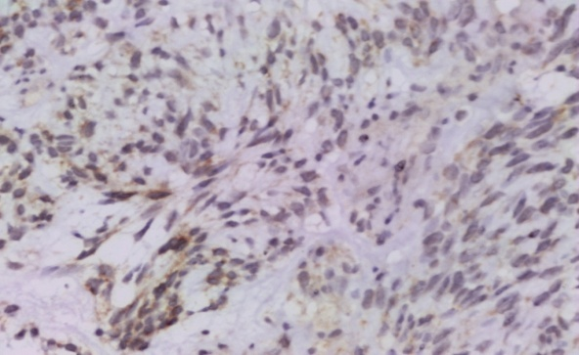

**Fig. 1-a:** Benign GIST showing cytoplasmic positivity for C-KIT Score (2+) /weak intensity (Immunoperoxidase X 200).

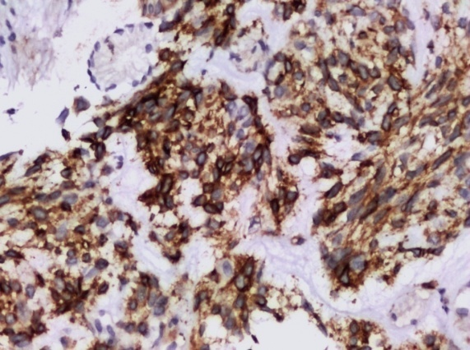

**Fig. 1-b:** Same case showing membranous & cytoplasmic positivity for DOG1 Score (3+) /Strong intensity (Immunoperoxidase X 200).

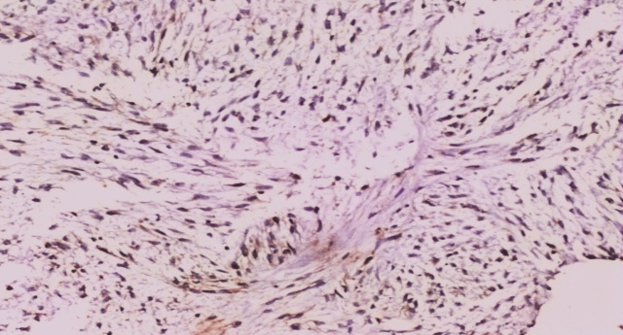

**Fig. 2-a:** Borderline GIST showing cytoplasmic positivity for weak C-KIT score + 2/weak intensity (Immunoperoxidase X 100).

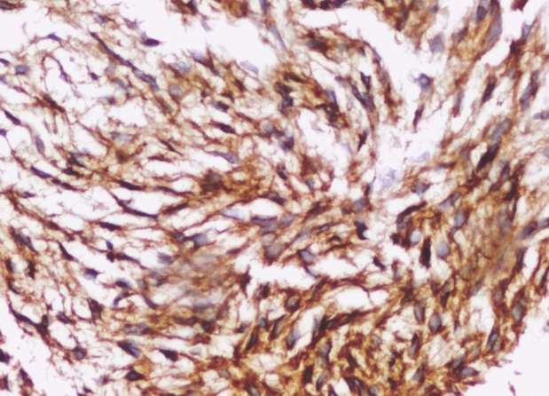

**Fig. 2-b:** Same case showing cytoplasmic positivity for DOG1 Score (3+) /moderate intensity (Immunoperoxidase X 200).

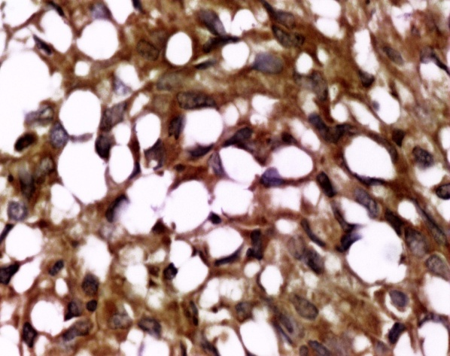

**Fig. 3-a:** Malignant GIST (signet ring variant) showing cytoplasmic positivity for C-KIT Score (4+) /strong intensity (Immunoperoxidase X 400).

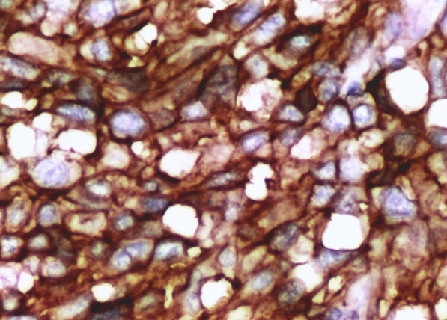

**Fig. 3-b:** Same case showing membranous positivity for DOG1 Score (4+) /strong intensity (Immunoperoxidase X 400).

**3.3 Comparison between c-kit& DOG1 expression in GISTs**

Out of 58 GIST cases, all the 54 c-kit-positive tumors also expressed DOG-1 positive. **According to the staining score (Table-2),** out of 46 cases of high score c-kit, (42 cases expressed high score DOG-1 and 4 cases expressed low score Dog-1). While, out of the 12 cases with low score c-kit (10 cases expressed as high score DOG-1). **And, according to the staining intensity (Table-3),** out of 10 cases of weak staining c-kit, (2 cases showed strong DOG-1 stain, 6 cases showed moderate DOG-1 stain and 2 cases showed weak DOG-1 stain), out of 30 cases of moderate staining c-kit, (24 cases showed strong DOG-1 stain, 4 cases showed moderate DOG-1 stain and 2 cases showed weak DOG-1 stain) and all 14 cases of strong staining c-kit showed strong DOG-1 stain. On the other hand, all the fourc-kit negative tumors expressed DOG-1 positive. **According to cell type (Table-4);** All epithelioid cell lesions 12/12 stained with high score DOG-1 and c-kit, all mixed cell lesions 10/10 stained with high score DOG-1, and all lesions stained with low score DOG-1were spindle cell type**. According to WHO classification (2000, Table-5);** All borderline GISTs were strong DOG1. Most of malignant GISTs were strong DOG1 (26/34), but only eight cases of them were strong c-kit. Co-relations between WHO prognostic group and c-kit or DOG1 immune-staining intensity were significant as *P* value < 0.05. **According to risk stratification (Table-6);** All very low risk GISTs were low c-kit score, but high DOG-1 score. All intermediate GISTs were high c-kit score and high DOG1 score. Co-relations between risk stratification and C-kit or DOG1 immune-staining ratio score were significant as *P* value < 0.05. **According to the stage of studies GISTs (Table-7);** Most of cases at all stages expressed with high score c-kit except cases staged l A, most of them expressed with low score c-kit. Also, cases at all stages expressed with high score DOG1 but 50% of cases staged l expressed with high score DOG1 and the other 50% expressed with low score. Significant co-relation between stage and c-kit immune-staining ratio score was detected as *P* value <0.05, but no significant co-relation between stage with DOG1 immune-staining ratio score as *P* value >0.05.

**Table-2: Comparison between c-kit and DOG1 ratio score expression in studied GISTs.**

|  |  |  |  |  |  |  |  |  |
| --- | --- | --- | --- | --- | --- | --- | --- | --- |
| **DOG-1 staining ratio** | **C-kit staining ratio** | | | | | | **chi-square** | |
| **Low (0,1,2)** | | **High (3,4)** | | **Total** | |
| **N** | **%** | **N** | **%** | **N** | **%** | **X2** | ***P*-value** |
| **Low (0,1,2)** | 2 | 3.45 | 4 | 6.90 | 6 | 10.34 | 0.59 | 0.443 |
| **High (3,4)** | 10 | 17.24 | 42 | 72.41 | 52 | 89.66 |
| **Total** | 12 | 20.69 | 46 | 79.31 | 58 | 100.00 |

**Table-3: Comparison between c-kit and DOG1 staining intensity in studied GISTs.**

|  |  |  |  |  |  |  |  |  |  |  |
| --- | --- | --- | --- | --- | --- | --- | --- | --- | --- | --- |
|  | **C-kit staining intensity** | | | | | | | | | |
| **DOG-1 staining intensity** | **Negative** | | **Weak** | | **Moderate** | | **Strong** | | **Total** | |
| **N** | **%** | **N** | **%** | **N** | **%** | **N** | **%** | **N** | **%** |
| **Negative** | 0 | 0.00 | 0 | 0.00 | 0 | 0.00 | 0 | 0.00 | 0 | 0.00 |
| **Weak** | 2 | 3.45 | 2 | 3.45 | 2 | 3.45 | 0 | 0.00 | 6 | 10.34 |
| **Moderate** | 2 | 3.45 | 6 | 10.34 | 4 | 6.90 | 0 | 0.00 | 12 | 20.69 |
| **Strong** | 0 | 0.00 | 2 | 3.45 | 24 | 41.38 | 14 | 24.14 | 40 | 68.97 |
| **Total** | 4 | 6.90 | 10 | 17.24 | 30 | 51.72 | 14 | 24.14 | 58 | 100.00 |
| **chi-square** | **X2** | | 32.549 | | | | | | | |
| ***P*-value** | | 0.000\* | | | | | | | |

**Table-4: Co-relation between c-kit & DOG1 ratio score expression and cell type**.

|  |  |  |  |  |  |  |  |  |
| --- | --- | --- | --- | --- | --- | --- | --- | --- |
|  | **Histological cell type** | | | | | | **Chi-square** | |
| **C-KIT staining ratio** | **Spindle** | | **Epithelioid** | | **Mixed** | |
| **N** | **%** | **N** | **%** | **N** | **%** | **X2** | ***P*-value** |
| **Low** | 8 | 66.67 | 0 | 0.00 | 4 | 33.33 | 7.540 | 0.023\* |
| **High** | 28 | 60.87 | 12 | 26.09 | 6 | 13.04 |
| **Total** | 36 | 62.07 | 12 | 20.69 | 10 | 17.24 |
| **DOG-1 staining ratio** | **N** | % | **N** | **%** | **N** | **%** | **X2** | ***P*-value** |
| **Low** | 6 | 100 | 0 | 0.00 | 0 | 0.00 | 6.141 | 0.046\* |

**Table-5: Co-relation between c-kit & DOG1 staining intensity with WHO classification.**

|  |  |  |  |  |  |  |  |  |
| --- | --- | --- | --- | --- | --- | --- | --- | --- |
|  | **WHO classification** | | | | | | **Chi-square** | |
| **C-KIT staining intensity** | **Benign** | | **Borderline** | | **Malignant** | |
| **N** | **%** | **N** | **%** | **N** | **%** | **X2** | ***P*-value** |
| **Negative** | 2 | 50.00 | 0 | 0.00 | 2 | 50.00 | 21.496 | <0.001\* |
| **Weak** | 6 | 60.00 | 0 | 0.00 | 4 | 40.00 |
| **Moderate** | 6 | 20.00 | 4 | 13.33 | 20 | 66.67 |
| **Strong** | 0 | 0.00 | 6 | 42.86 | 8 | 57.14 |
| **DOG1 staining intensity** | **N** | % | **N** | **%** | **N** | **%** | **X2** | ***P*-value** |
| **Negative** | 0 | 0.00 | 0 | 0.00 | 0 | 0.00 | 18.453 | <0.001\* |
| **Weak** | 4 | 66.67 | 0 | 0.00 | 2 | 33.33 |
| **Moderate** | 6 | 50.00 | 0 | 0.00 | 6 | 50.00 |
| **Strong** | 4 | 10.00 | 10 | 25.00 | 26 | 65.00 |

**Table -6: Co-relation between C-KIT& DOG1 ratio score expression and risk stratifications.**

|  |  |  |  |  |  |  |  |  |  |  |
| --- | --- | --- | --- | --- | --- | --- | --- | --- | --- | --- |
|  | **Risk stratification** | | | | | | | | | |
| **Very low risk** | | **Low risk** | | **Intermediate risk** | | **High risk** | | **Chi-square** | |
| **C-KIT staining ratio** | **N** | **%** | **N** | **%** | **N** | **%** | **N** | **%** | **X2** | ***P*-value** |
| **Low** | 4 | 33.33 | 4 | 33.33 | 0 | 0.00 | 4 | 33.33 | 20.562 | <0.001\* |
| **High** | 0 | 34.78 | 6 | 13.04 | 8 | 17.39 | 32 | 69.57 |
| **Total** | 4 | 6.90 | 10 | 17.24 | 8 | 13.79 | 36 | 62.07 |
| **DOG-1 staining ratio** | **N** | % | **N** | **%** | **N** | **%** | N | % | **X2** | ***P*-value** |
| **Low** | 0 | 0.00 | 4 | 66.67 | 0 | 0.00 | 2 | 33.33 | 9.672 | 0.022\* |
| **High** | 4 | 7.69 | 6 | 11.54 | 8 | 15.38 | 34 | 65.38 |
| **Total** | 4 | 6.90 | 10 | 17.24 | 8 | 13.79 | 36 | 62.07 |

**Table-7: Co-relation between c-kit& DOG1 ratio score expression with stage.**

|  |  |  |  |  |  |  |  |  |  |  |  |  |  |  |
| --- | --- | --- | --- | --- | --- | --- | --- | --- | --- | --- | --- | --- | --- | --- |
| **C-KIT stain ratio** | **Stage** | | | | | | | | | | | | | |
| **Stage I** | | **Stage IA** | | **Stage IB** | | **Stage II** | | **Stage IIIA** | | **Stage IIIB** | | **Stage IV** | |
| **N** | **%** | **N** | **%** | **N** | **%** | **N** | **%** | **N** | **%** | **N** | **%** | **N** | **%** |
| **Low score** | 0 | 0.00 | 8 | 66.67 | 0 | 0.00 | 0 | 0.00 | 0 | 0.00 | 2 | 16.67 | 2 | 16.67 |
| **High score** | 4 | 8.70 | 4 | 8.70 | 6 | 13.04 | 2 | 4.35 | 2 | 4.35 | 16 | 34.78 | 12 | 26.09 |
| **Total** | 4 | 6.90 | 12 | 20.69 | 6 | 10.34 | 2 | 3.45 | 2 | 3.45 | 18 | 31.03 | 14 | 24.14 |
| **chi-square** | **X2** | | | | 19.821 | | | | | | | | | |
| ***P*-value** | | | | 0.003\* | | | | | | | | | |
| **DOG1 stain** | **N** | **%** | **N** | **%** | **N** | **%** | **N** | **%** | **N** | **%** | **N** | **%** | **N** | **%** |
| **Low score** | 2 | 33.33 | 2 | 33.33 | 0 | 0.00 | 0 | 0.00 | 0 | 0.00 | 2 | 33.33 | 0 | 0.00 |
| **High score** | 2 | 3.85 | 10 | 19.23 | 6 | 11.54 | 2 | 3.85 | 2 | 3.85 | 16 | 30.77 | 14 | 26.92 |
| **Total** | 4 | 6.90 | 12 | 20.69 | 6 | 10.34 | 2 | 3.45 | 2 | 3.45 | 18 | 31.03 | 14 | 24.14 |
| **chi-square** | **X2** | | | | 9.664 | | | | | | | | | |
| ***P*-value** | | | | 0.140 | | | | | | | | | |

**3.4 Diagnostic efficacy of c-kit & DOG1 in GISTs (Tables 8&9)**; As regards to c-kit immune staining results, the PPV for the diagnosis of GIST was 81.82%. The NPV was 85.71%. The overall diagnostic accuracy was determined to be 82.98%, with a sensitivity and specificity of 93.10 % and 66.67 % respectively. And for DOG1, the PPV for the diagnosis of GIST was 100%. The NPV was 100 %. The overall diagnostic accuracy was determined to be 100 %, with a sensitivity and specificity of 100 % for both.

**Table-8: Diagnostic efficacy of c-kit**.

|  |  |  |  |  |  |  |  |  |  |  |  |  |
| --- | --- | --- | --- | --- | --- | --- | --- | --- | --- | --- | --- | --- |
| **C-kit** | **Type of tumor** | | | | | | | | | **Chi-square** | | |
| **GIST** | | | **Control group** | | | **Total** | | |
| **N** | | **%** | **N** | | **%** | **N** | | **%** | **X2** | | ***P*-value** |
| **Negative** | 4 | | 6.90 | 24 | | 66.67 | 28 | | 29.79 | 39.562 | | <0.001\* |
| **Positive** | 54 | | 93.10 | 12 | | 33.33 | 66 | | 70.21 |
| **Total** | 58 | | 100.00 | 36 | | 100.00 | 94 | | 100.00 |
| **Sens.** | | **Spec.** | | | **PPV** | | | **NPV** | | | **Accuracy** | |
| 93.10 | | 66.67 | | | 81.82 | | | 85.71 | | | 82.98 | |

**Table-9: Diagnostic efficacy of DOG-1.**

|  |  |  |  |  |  |  |  |  |  |  |  |  |
| --- | --- | --- | --- | --- | --- | --- | --- | --- | --- | --- | --- | --- |
| **DOG-1** | **Type of tumor** | | | | | | | | | **Chi-square** | | |
| **GIST** | | | **Control group** | | | **Total** | | |
| **N** | | **%** | **N** | | **%** | **N** | | **%** | **X2** | | ***P*-value** |
| **Negative** | 0 | | 0.00 | 36 | | 100.00 | 36 | | 38.30 | 125.115 | | <0.001\* |
| **Positive** | 58 | | 100.00 | 0 | | 0.00 | 58 | | 61.70 |
| **Total** | 58 | | 100.00 | 36 | | 100.00 | 94 | | 100.00 |
| **Sens.** | | **Spec.** | | | **PPV** | | | **NPV** | | | **Accuracy** | |
| 100 | | 100 | | | 100 | | | 100 | | | 100 | |

**4. Discussion:**

In Egypt, GISTs represent 5.77%, 1.88% and 2.06% of gastric, colonic and anorectal malignant tumors respectively *(Mokhtar et al., 2007).*

Histologically, GISTs demonstrate considerable morphologic overlap with other tumors. In routine practice, the diagnosis of GISTs is based on the anatomic location of the tumor, histopathology and immunehistochemistry *(Abd El-Rehim and Gayyed, 2015).* This study included 70 cases previously diagnosed as GISTs by H&E examination, but after immunohistochemistry staining 58 cases proved to be GISTs. Screening for c-kit mutations can be helpful in diagnosis of GISTs, but is needed to aid in routine diagnosis is a marker that reliably stains GISTs that are c-kit weak/negative *(El Rebey and Aiad, 2014).* Hence, the use of another reliable, available immune histochemical marker, that is much less expensive than c-kit gene mutation analysis was unnecessary to achieve reliable, feasible, rapid and less expensive diagnosis *(Abdel-Hadi et al., 2009).* DOG-1 is strongly expressed on the surface of the neoplastic cells irrespective of mutation status, being rarely expressed in other soft tissue tumors, as demonstrated by earlier studies. In the current study, c-kit negative cases represented in 6.90% and positive cases represented in 93.10%. These results are nearly similar with that done by *Heinrich et al. (2008)* which reported that between 5% and 10% of GISTs fail to immune-staining for c-kit, *Sözütek et al. (2014)* reported that c-kit was positive in (93.7%) cases and negative in (6.3%) cases, *Miettinen et al. (2009), Kang et al. (2010) and Sun et al, (2012)*studies shown c-kit positivity 94.7%, 89.8% and 90.48% respectively. While, DOG-1expressed in all studied cases of GISTs (100%). These results were in agreement with that done by *Fatima et al. (2011),* and nearly similar to that done by (97.5%) *West et al. (2004) and Nakhla et al.(2012)* who reported immunopositivity for DOG-1 in 97.5% and 97.4%respectively. Significant correlations between c-kit and DOG-1 expression with WHO classification of the studied GISTs (*P* value < 0.05) was reported in this study. In agreement to these results, *Abdel-Hadi et al. (2009*) reported that the high c-kit immune-staining scores were significantly associated with high-risk tumors. On the contrary, *Kang et al. (2010)& El Rebey and Aiad,(2014*) reported that there is no significant correlation between c-kit or DOG-1 with risk stratification. In the current study, the intensity of staining for c-kit antibody in GISTs ranged from 6.90% of negative cases, 17.24% of weak staining cases, 51.72% of moderate staining cases to 24.14% of strong staining cases. On the contrary, the intensity of staining for DOG-1 antibody in GISTs was ranged from 10.34% weak staining, 20.69% moderate staining and 68.97% strong staining. *Nakhla et al. (2012*) study reported that, the intensity of positivity staining for c-kit antibody ranged from weakly positive in12.83%, moderately positive in 30.76% and strongly positive in 56.41% of cases. They reported intensity of positive staining for DOG-1 antibody ranged from weakly positive in 17.94%, moderately positive in 48.72% and strongly positive in 33.34%of cases. *Kang et al. (2011*) found that the overall staining intensity for DOG-1 was weak in 21%, moderate in 34% and strong in 36% of cases. *Sözütek et al. (2014)* study found that DOG1with weak stain in 36.5%, moderate stain in 36.5% and strong stain in 28% of cases. The differences between studies likely reflect among other factors, type of marker anti body and number of cases. Significant correlation between c-kit and DOG-1 expression in the studied cases with WHO prognostic groups (*P* value < 0.05). Significant correlation between c-kit and DOG-1 expression in the studied cases with stage (*P* value < 0.05), was detected. In the current study, the results demonstrated that DOG-1 is a specific and sensitive marker for GIST, as it stain all cases of GIST included in the study and didn't stain any of the other tumors tested. Immunohistochemical staining and diagnostic efficacy of DOG1was compared with that of c-kit in GISTs. DOG-1 proved to be a more specific (100% versus 66.67%) and more sensitive (100% versus 93.10%) marker than c-kit for the diagnosis of GISTs. In agreement to this study, *Espinosa et al. (2008)* demonstrated similarly superior sensitivity and specificity of these antibodies compared with KIT, DOG1 reactivity was seen in 87% of GIST cases, whereas the expression of KIT was found in 74%. *Fatima et al. (2011)* showed superior specificity and sensitivity for DOG-1 versus c-kit antibodies (100% versus 76%) and (100% versus 70%), respectively. *Abdel-Hadi et al. (2009)* showed specificity for DOG1 and c-kit antibodies (100% versus 81.8%), respectively. *El Rebey and Aiad, (2014)* showed sensitivity for DOG-1 versus c-kit antibodies (94.1% versus 68.6%), respectively.

Conclusion: DOG1 have diagnostic accuracy 100% compared to 82.98% for C-KIT. These results may magnify the importance of DOG1 in that may be able to pick up a large numbers of C-KIT-negative cases and diagnose them as GIST.

**Conflict of interest:**

There is no conflict of interest or financial ties to include.

**References:**

1. *Abd El-Rehim DM and Gayyed M (2015):* Does Immunhistochemistry for Discovered on GIST1 and Minichromosome Maintenance Protein7 Provide Additional Clinicopathological Value in Gastrointestinal Stromal Tumors?. W J Oncol; 6(3): 355-363.
2. *Abdel-Hadi M, Bessa SS and Hammam SM (2009):* Evaluation of the Novel Monoclonal Antibody against DOG1 as a Diagnostic Marker for Gastrointestinal Stromal Tumors. J Egy Nat CancInst; 21(3): 237-247.
3. *Demetri GD, von Mehren M, Antonescou CR, et al., (2015):* NCCN taskforce report: update on the management of patients with gastrointestinal stromal tumors. J Natl Compr Canc Netw; Apr;8 Suppl 2: S1-41; quiz S42-4 (abstract).
4. *El Rebey HS and Aiad HA-S (2014):* Immune-histochemichal Expression of DOG1 as a Diagnostic Marker for Gastrointestinal Stromal Tumors in Comparison to c-KIT. J AmSc; 10 (11):198-205.
5. *Espinosa I, Lee Ch, Kim M, et al.,(2008):* A Novel Monoclonal Antibody Against DOG1 is a Sensitive and Specific Marker for Gastrointestinal Stromal Tumors. Am J Surg Pathol; 32(2): 210-218.
6. *Fatima N, Cohen C and Siddiqui MT. (2011):* DOG-1 Utility in Diagnosing Gastrointestinal Stromal Tumors on Fine-Needle Aspiration. Cancer (Cancer Cytopathol); 19(3):202–208.
7. *Heinrich MC, Corless C, Demetri GD, et al., (2003A):* Kinase mutations and imatinib response in patients with metastatic gastrointestinal stromal tumor. J ClinOncol; 21:4342–4349.
8. *Heinrich MC, Corless CL, Duensing A, et al., (2003B):* PDGFRA activating mutations in gastrointestinal stromal tumors. Science; 299:708–710.
9. *Heinrich MC, Griffith DJ, Druker BJ, et al., (2008):* Inhibition of c-kit receptor tyrosine kinase activity by STI 571, a selective tyrosine kinase inhibitor. Blood; 96: 925-932.
10. *Joensuu H (2008):* Risk stratification of patients diagnosed with gastrointestinal stromal tumor. Hum Pathol; 39:1411-1419.
11. *Jung SH, Suh KS, Kang DY, et al., (2011):* Expression of DOG1, PDGFRA and P16 in Gastrointestinal Stromal Tumors. Gut and Liver, 5(2): 171-180.
12. *Kang YN, Jung HR and Hwang L (2010):* Clinico-pathological and Immune-histochemical Features of Gastointestinal Stromal Tumors. Canc Res Treat.; 42(3):135-143.
13. *Kang G., Srivastava A, Kim YE, et al., (2011):* DOG-1 and PKCh are useful in the diagnosis of KIT-negative gastrointestinal stromal tumors. Mod Pathol; 24: 866-875.
14. *Lasota J, Corless CL, Heinrich MC, et al., (2008):* Clinicopathologic profile of gastrointestinal stromal tumors (GISTs) with primary KIT exon 13 or exon 17 mutations: a multicenter study on 54 cases. Mod Pathol; 21:476–484.
15. *Lee CH, Liang CW and Espinosa I (2010):* The utility of discovered on gastrointestinal stromal tumor 1 (DOG1) antibody in surgical pathology-the GIST of it. Adv. Anat. Pathol; 17(3):222-232.
16. *Liegl B, Hornick JL, Corless CL, et al., (2009):* Monoclonal antibody DOG1.1 shows higher sensitivity than KIT in the diagnosis of gastrointestinal stromal tumors including unusual subtypes. Am J SurgPathol., 33: 437-446.
17. *Medeiros F, Corless CL, Duensing A, et al., (2004):* KIT-negative gastrointestinal stromal tumors: Proof of concept and therapeutic implications. Am J SurgPathol; 28(7): 889-894.
18. *Miettinen M, Sobin LH and Lasota J (2009):* Gastrointestinal stromal tumors presenting as omental masses-a clinicopathologic analysis of 95 cases. Am J Surg Pathol;33(9):1267–1275.
19. *Mokhtar N, Gouda I and AdelI (2007):* (eds). Malignant Digestive System Tumors. In Cancer Pathology Registry 2003-2004 and Time Trend Analysis. National Cancer Institute. Chapter 6; pp. 13-20.
20. *Nakhla GA, Hosni HN, Darweesh MF, et al., (2012):* Immunohistochemical Study of Dog 1 Protein Expression in Gastrointestinal Stromal Tumors. Academic J Canc Res; 5(2): 61-70.
21. *Sözütek D, Yanık S, Akkoca AN, et al., (2014):* Diagnostic and prognostic roles of DOG1 and Ki-67, in GIST patients with localized or advanced/metastatic disease. Int J Clin Exp Med; 7(7):1914-1922.
22. *Strickland L, Letson GD and Muro-Cacho CA (2001):* Gastrointestinal Stromal Tumors: Cancer Control; (8):252-261.
23. *Sun XW, Feng ZJ, Huang P, et al., (2012):* Expression of DOG-1, CD117 and PDGFRA in Gastrointestinal Stromal Tumors and Correlations with Clinicopathology. As Pac J CancPrev; 13:1389-1393.
24. *West RB, Corless CL, Chen X, et al., (2004):* The novel marker, DOG1, is expressed ubiquitously in gastrointestinal stromal tumors irrespective of KIT or PDGFRA mutation status. Am J Pathol; 165(1):107–113.
25. *Zhong Y, Deng M, Liu B, et al., (2013):* Primary gastrointestinal stromal tumors: Current advances in diagnostic biomarkers, prognostic factors and management of its duodenal location. Intractable & Rare Diseases Research; 2(1):11-17.

3/15/2017