The Potential Effect Of Mtdna4977 Deletion In The Development Of Prostate Cancer Among Sudanese Peopel

Linda Abdelmoniem Fadulalla

Department of Zoology Faculty of Science University of Khartoum

Abstract: Background: Cancer results from accumulation of molecular events that fundamentally change the normal properties of cells. Mitochondria play important roles in cellular energy metabolism, free radical generation, and apoptosis. There is increasing evidence that mitochondrial gene mutations are associated with various cancers. The mitochondrial DNA (mtDNA) 4977-bp deletion (DmtDNA4977 mutation) is one of the most frequently observed mtDNA mutations in human tissues and may play a role in carcinogenesis. Aim: to study the frequency of DmtDNA4977 mutation in prostate cancer tissues and benign hyperplasic prostate tissues (BHP). Methods: Thirty tissue samples of prostate were screened for the 4977 deletion using touchdown PCR. Results: The mtDNA4977 mutation was detected in both tumor 43.5% and non tumor tissues (56.5%). Conclusion: The DmtDNA4977 mutation was quite frequent in both malignant and benign tumor tissues. The DmtDNA4977 might be in effect, a reflection of the interplay between mitochondrial genome and other factors in the growing tumor.

**[**LindaAbdelmoniemFadulalla. **The Potential Effect Of Mtdna 4977 Deletion In The Development Of Prostate Cancer Among Sudanese Peopel.** *Cancer Biology* 2017;7(1):79-86]. ISSN: 2150-1041 (print); ISSN: 2150-105X (online). <http://www.cancerbio.net>. 11. doi:[10.7537/marscbj070117.11](http://www.dx.doi.org/10.7537/marscbj070117.11).

Keywords: Potential Effect; Mtdna4977; Deletion; Development; Prostate Cancer; Sudanese Peopel

Chapter One Introduction

Cancer is becoming a global health problem and the number of cancer cases in sub Saharan Africa is rising. Being an African country, Sudan has its share of cancer burden (Mohammed *et al*., 2013). According to the published data, cancer is increasing in the Sudan (Elamin *et al.,* 2015). The common risk factors, among Sudanese patient, include: age, education level and positive family history. Other factors include history of tobacco and alcohol consumption, the body mass index BMI, and occupation (Hamd and Abuidris, 2011). While the population of Sudan is moving toward cities and unhealthy lifestyles, resources and infrastructure to prevent and treat the disease lag behind including clinical and basic research (Elamin *et al.,* 2015).

1.1 Prostate carcinogenesis

The prostate is a male accessory gland in the reproductive organ, which is found in all orders of mammals, McNeal established the current and most widely accepted concept of various zones rather than lobes of the prostate (The peripheral zone, the central zone, and the transition zone) (kan, 2011). The peripheral zone comprises all the prostatic glandular tissue at the apex as well as all of the tissue located posterior near the capsule. In this zone, carcinoma, chronic prostatitis, and post inflammatory atrophy are relatively more common than in the other zones (Cohen *et al.,* 2008).

Prostate cancer is the second most common cancer among men worldwide. Occurring more frequently in the developed world, rates have also been increasing in the developing world (A. C. S., 2011). Men with a family history of the disease or of African heritage are more at risk of developing the disease; for example, in the USA, African American men are 1.6 times more likely to develop prostate cancer than Caucasian men (Ferlay *et al.,* 2014).

Prostate cancer is the most common cancer in Sudanese men, recent data showed an increased incidence among Sudanese males and it is becoming a major medical problem and gained increased attention from Sudanese urologists (Elaimam & Sharfi, 2013). Prostate cancer used to be ranked tenth among all men cancers diagnosed at Sudan Cancer Registry in 1978, less frequent than skin cancers and non-Hodgkin lymphoma (Mukhtar, 1978) and it was representing only 0.8% of all male cancers) investigated at Radiation and Isotope Center at Khartoum (RICK) (1967–84) (Hidayatalla, 1986). Recent increase, in comparison to decades ago, was reported lately in the country. Prostate cancer was the most diagnosed cancer among men in RICK during year 2000–2006 (Mohammed *et al.,* 2014). It was also the most common cancer among male patients treated at the National Cancer Institute at Gezira University NCI-UG (Abuidris *et al.,* 2010).

Different risk factors have been thought to cause prostate cancer. Previous studies have pointed towards a combination of both genetic and environmental risk factors at play (Anand *et al.,* 2008). Prostate cancer is very rare in men younger than 40, but the chance of having prostate cancer rises rapidly after the age 50. About 6 in 10 cases of prostate cancer are found in men over the age of 65 (Khan, 2011).

Different environmental factors found to affect prostate cancer. The disease is most common in North America, Northwestern Europe, Australia, and on Caribbean islands. It is less common in Asia, Africa, Central America, and South America. For example, men of Asian descent living in the United States have a lower risk of prostate cancer than white Americans, but their risk is higher than that of men of similar backgrounds living in Asia. Prostate cancer seems to run in some families, which suggests that in some cases there may be an inherited form of the disease. For example, inherited mutations of the BRCA1 or BRCA2 genes which may also increase prostate cancer risk in some men. Men with Lynch syndrome have an increased risk for a number of cancers, including prostate cancer (A.C.S., 2016 a).

1.2 Prostate specific antigen (PSA)

PSA is a glycoprotein produced primarily by the epithelial cells that line the acing and ducts of the prostate gland. PSA is concentrated in prostatic tissue, and serum PSA levels are normally very low. Disruption of the normal prostatic architecture, such as by prostatic disease, inflammation, or trauma, allows greater amounts of PSA to enter the general circulation. Elevated serum PSA level has become an important marker of many prostate diseases including benign prostatic hyperplasia, prostatitis, and prostate cancer (Ramos *et al*., 1999).

1.3 Molecular change

The vast majority of cancer cells have six different capabilities; self sufficiency in growth signals, insensitivity to anti growth signals, evasion of apoptosis, infinite replication ability, sustained angiogenesis and ability to invade tissue and metastasis (Hanahan and Weinberg, 2000).

Cancer genes can be classified into three main categories: Oncogenes were the first cancer causing genes identified and lead to unregulated cell growth (Ponder, 2001). The second category was tumor suppressor genes ( p53 gene *TP53)* are usually inactivated by loss of function mutations. The last category was mutations in genes responsible for DNA repair mechanisms often result in genetic instability leading to abnormal chromosome numbers or breaks (Jorde, 2000).

Common mutations in oncogenes and tumor suppression genes for various other cancers are surprisingly rare in primary prostate cancer (Gabriel, 2004). Many studies concur that loss of 8p12-21 is an early event in prostate carcinogenesis; homeobox gene is a candidate for the 8p1-21 locus. *NKX3.1* maps within the critical region of 8p12-21 lost in human prostate cancers (Voeller *et al.,* 1997) (Fig 1).

Among potential candidate genes, *PTEN/MMAC1* maps to 10q23, in a region that is lost in prostate carcinomas as well as several other carcinomas, including glioblastoma, breast, and endometrial cancers (Di Cristofano *et al.,* 2001). Besides *PTEN*, a second candidate gene mapping to 10q25 is *MXI1* which has also been suggested to play a role in prostate cancer since it maps to a frequently amplified region of chromosome 8q (Bubendorf *et al.,* 2000).

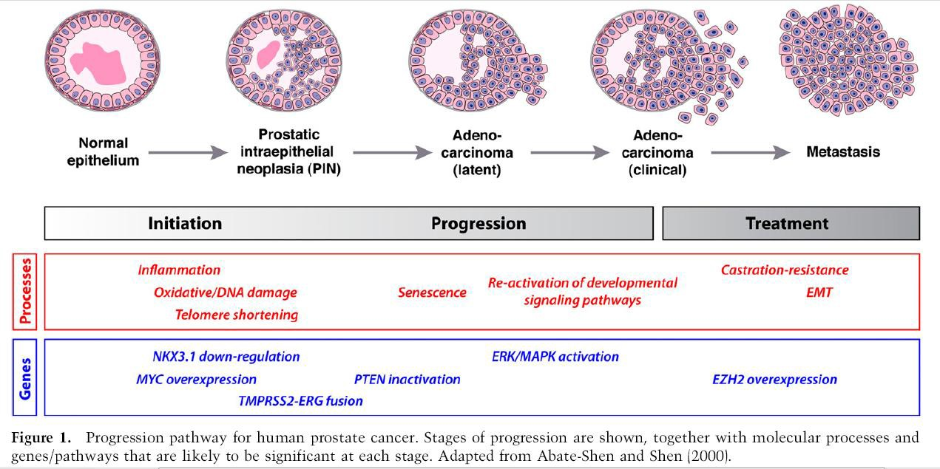

This figure adapted from (Bubendorf *et al.,* 2000).

1.4 Common deletion 4977 bp in mitochondrial DNA

Mammalian mitochondrial DNA (mtDNA) have their own genome in the form of mitochondrial DNA (mtDNA). It is a circular double stranded DNA of 16.5 Kb in size. In contrast to the nuclear DNA, mtDNA is a naked compact DNA molecule without introns and is replicated at a much higher rate without an efficient DNA repair mechanism (Green and Reed, 1998).

Mitochondria are the intracellular organelles responsible for adenosine triphosphate (ATP) synthesis through the coupling of oxidative phosphorylation (OXPHOS) to mitochondrial respiration in human and animal cells. Mitochondria are involved in apoptosis and probably also tumorigenesis (Tang and Zhang, 2005). mtDNA mutations were reported in different types of cancer and cancer cell lines. Reported sequence changes include point mutations (mostly transitions), multiple deletions and microsatellite instability in coding and noncoding regions (Czarnecka 4977*et al*, 2006). Mitochondrial DNA 4977 bp deletion (ΔmtDNA) is the mostcommon change in mtDNA and has been detected in several types of human tumors. However, little is known about this deletion of mtDNA in prostate cancer [(Yadav](http://www.ncbi.nlm.nih.gov/pubmed/?term=Yadav%20N%5Bauth%5D) and [Chandra](http://www.ncbi.nlm.nih.gov/pubmed/?term=Chandra%20D%5Bauth%5D), 2014). A 4977-bp deletion occurred between two 13bp direct repeats (8470-8482 and 13447-13459) and results in mtDNA molecules (ΔmtDNA4977) that lack all or part of a 12 gene cluster which is associated with many pathological phenotypes, such as hearing loss (Bai and Seidman, 2001), end stage renal disease (ESRD) (Rao *et al.,* 2009), and Kearnse Sayre syndrome (Mohri *et al.,* 1998).

Chapter Two

**Literature Review**

Mutations happen often, and the human body is normally able to repair most of them. A mutation may be beneficial, harmful, or make no difference at all. One of those mutations might lead to cancer. Usually, it takes multiple mutations over a lifetime to cause cancer. Somatic mitochondrial DNA (mtDNA) mutations have been increasingly observed in primary human cancer (Chatterjee *et al.,* 2006).

Many mitochondrial myopathies are characterized by mitochondrial genome deletions. Specifically, much work has been done on a 4977 bp or ―common deletion‖. This portion of the mtgenome has been deleted in many pathologic conditions, including cancer (Maki *et al.,* 2008).

The mtDNA 4977 bp deletion is one of the most frequently observed mtDNA mutations in human tissues and may play a role in the carcinogenesis of different types of tissues (Dimberg *et al.,* 2015). At the original article studied the 4977 bp deletions of mitochondrial DNA (mtDNA4977) in lung cancer, adjacent histologically normal lung tissue and its potential roles in the development of cancer, no significant difference was found in the frequency of mtDNA4977 deletions between the tumor and normal lung tissues. Thus, the deletion was thought to reflect the environmental and aging process influencing tumor progression (Dai *et al.,* 2006).

The deletion was shown to be significantly more frequent in normal tissues in comparison with paired colorectal cancer tissues in both Swedish and Vietnamese patients (Dimberg *et al.,* 2014). However, Chen *et al.,* (2011) reported that the deletion might play a role in the early stage of colorectal cancer, and it is also implicated in alteration of mtDNA content in cancer cells.

Similar higher frequency of deletion in normal tissues when compared to malignant were observed in other types of cancer including breast (Dimberg *et al.,* 2015) and oral (Shieh *et al.,* 2004) carcinogenesis. A meta-analysis study of 33 publications, in which a total of 1613 cancer cases, 1516 adjacent normal and 638 healthy controls were included, found that cancerous tissue carried a lower mtDNA 4977 bp deletion frequency than adjacent non-cancerous tissue among various types of cancer. The findings of this study provided evidence that mtDNA 4977 bp deletion is more likely to happen in cancer patient, but it is negatively selected later during tumor formation of various types of cancerous tissues (Nie *et al.,* 2013).

Other studies investigated the relationship between the 4977 bp deletion of the mtDNA and chronic cervicitis or cervix cancer and patients with chronic cervicitis had a higher frequent heteroplasmic mtDNA 4977 bp deletions. This finding supported the hypothesis that increased reactive oxygen species (ROS) production during chronic inflammation in cervix tissues leads to mtDNA mutations (Kara *et al.,* 2012).

Recently, the frequency of mitochondrial DNA (D- loop) mutations (mtDNA4977) in oral lesions among Sudanese patients was investigated. No obvious correlation between 4977 bp deletion and prognostic indicators among Sudanese with oral lesions was reported (Badie *et al.,* 2015).

On the other hand, positive correlation was reported by several studies. The incidence of the 4977 bp deletion in breast cancer (BC) tissue was significantly higher in patients with estrogen receptor (ER) positive as compared with (ER) negative (BC) tissue (Dimberg *et al.,* 2015). Deletion was found to have significant role in the development of hepatocellular carcinoma when compared to hepatocellular nodular hyperplasia (Shao *et al.,* 2004).

Deletions in the mt genome have been reported in prostate cancer (PCa) and are thought to mediate androgen independence. According to Maki *et al.* (2008), the 4977 (bp) deletion was found to be a useful biomarker in the management of PCa. It was not only considered a useful tool of disease detection but also behaves as a biosensor of premalignant and suspicious lesions indicative of disease progression. Thus authors reported that the 4977 bp may be useful in defining malignant, benign, and proximal to malignant prostate tissues (Maki *et al.,* 2008).

Cancer is a genetic disease caused by accumulation of mutation to both types of DNA ―nucleur, and mitochondrial‖ leading to unrestrained cell proliferation and neoplasm formation. The unique maternal inheritance pattern of mitochondrial DNA (mtDNA), its small genome size, lack of recombination during gametogenesis, and multiple copy number per cell, these characteristics suggest that mitochondria may undergo detectable modifications associated with malignant progression.

A 4977 bp deletion in the major arch of the mitochondrial genome is one of the most common mutations associated with a variety of human cancer. Several studies have examined the association between 4977 bp deletion in mitochondrial DNA (mtDNA), human sperm dysfunction, and prostate cancer, but none of them investigated the deletion among Sudanese prostate patients. This research indented to examine the relationship between ΔmtDNA4977 and prostate cancer in Sudanese patients.

Objective

1- To detect the 4977 bp deletions of mitochondrial DNA (ΔmtDNA4977) in malignant and benign prostate tissues from Sudanese patients.

Chapter Three Materials And Methods

**3.1 Subjects**

This study enrolled 30 tissue specimens from adult Sudanese male patients with high and moderate level of prostate specific antigen (PSA) undergoing prostoctomy or prostatic biopsy at Ibn Sena hospital from November 2015 to January 2016 and who agreed to be included this study. All participants were informed about the study and signed an inform consent. Ethical approval was obtained from the Faculty of Science. DNA was isolated from biopsy tissues using Nucleic Acid Extraction kit according to manufactures protocol. Tissue samples were firstly prepared by grinding using liquid nitrogen and a mortar and pistil.

3.2 Polymerase chain reaction (PCR)

Samples were screened first using the mitochondrial cytochrome c oxidase I (COI) gene specific primer to assess the quality of DNA (internal control). Ready master mix [amaxime PCR premix kit (i-tag)-(iNtRON Biotechnology, INC (containing already dNTPs, MgCl2, buffer, Taq polymerase)] was used for a PCR reaction performed in a volume of 25 µl, containing 1µl of DNA and 1µl of each primer (10µM) (Table 1). PCR amplification of COI region was performed using the following touchdown programme preheating at 90 °C for 2 mins followed by 35 cycles of: 45 s at 94 °C, 45 s of annealing and 1 min of extension at 72 °C, then the reaction was ended with 5 mins at 72 °C. Annealing temperature was 65 °C, decreasing by one degree per cycle for 7 cycles until the annealing temperature of 58 °C was reached. The programme was then continued using final temperature for annealing step during the remaining cycles. PCR products were then run on 3 % agarose electrophoresis and visualized under UV light.

To screen for the 4977 bp deletion, the same previous condition was used following touchdown PCR programme. Final PCR products were then electrophoresed in a 3% agarose gel. The presence of the 4977 bp deletion was indicated by the appearance of a 358-bp band. The 4977 detection was only performed when COI amplification was positive and all PCR experiments included a negative control with no template DNA.

**Table1.** Sets of primer sequences used in the study

|  |  |
| --- | --- |
| **Primer name** | **Primers sequences** |
| CO I F | CTAACAGACCGCAACCTCAA |
| CO I R | TACCTATGTATCCAAATGGT |
| DelF | ACCCTATTGCACCCCCTCTAC |
| DelR | CTTGTCAGGGAGGTAGCGATG |

Chapter Four Results And Discussion

The study investigated 30 subjects of varying ages ranging between 50 to 85 years with a mean age of 69 years undergoing prostoctomy or prostatic biopsy. 39% (n=13) biopsies were found to be malignant and 61% (n=17) were benign hyperplasic prostate tissues (BHP).

Patients with malignant tumors were older (mean=71 years) than patients with BHP (mean=63 years) with age range of 50 to 85 years and 55 to 85 years respectively. However, no significant difference was observed regarding the age at presentation between the two groups (p value= 0.17) (Table 2).

In this study, the relationship of 4977 bp mtDNA deletions with prostate cancer was addressed.

A PCR reaction was adopted after Chen *et al.* (2011) to produce PCR products in the case of mtDNA4977 deletion. The PCR reaction produced the expected 358 bp band (Fig. 2), while the absence of the deletion (or negative results) was considered true- when the amplification of the internal control mitochondrial COI was positive. All 30 samples successfully produced the COI region product of 189bp band size and hence used for further mtDNA4977 analysis (Fig. 3).

Of the 30 prostate tissue samples, 23 (73.33%) showed the mtDNA4977 Of these 43.5% were tumor samples (n=10) while slightly higher (56.5%, n=13) presentation of benign tumors was observed (Fig. 4).

Looking at the general frequency of this deletion in other previous studies and other types of cancers, a significant increased proportion of the mtDNA4977 mutation has been reported in nasopharyngeal, esophageal cancer, stomach, thyroid, salivary gland, hepatocellular, and oral cancers (Shen *et al.*, 2011).

In the current study, the frequency of the mutation was, rather, almost similar in malignant and benign BHP tumors (76.9% and 76.4% respectively). However, in more recent studies, a decreased proportion of the DmtDNA4977 mutation in tumor tissue as compared with corresponding non-tumorous tissue has been observed in gastric, hepatocellular, oral, and skin cancers (Chuanzhong *et al.*, 2008). One possible explanation for the differences found between different tissues was the existence of tissue-specific mtDNA turnover rates and various environmental and genetic influences. Cancer cells are very mutagenic in the early stage either due to exposure to high levels of carcinogenic substances or conditions or because of lack of repair mechanism (Yusoff *et al.,* 2015). Thus the occurrence of such large deletions in prostate cancer tissue was not surprising.

Also the presence of the mutation in BHP tumors in our study can be justified by the abnormal state of those tumors. In support of that, Zhang *et al.,* (2015) found that the Δmt DNA 4977 bp copy number facilitated the progression of mitochondrial disease, thus, the deletion may not be the primary cause but a related factor, together with other genetic abnormalities lead to the emergence of clinical manifestations in patients with mitochondrial diseases including cancer.

Some authors went further and suspected that ΔmtDNA4977 accumulate from birth or earlier is likely plays a role in the development of mitochondrial disease (*Zhang et al.,* 2015). In agreement of that suggestion, in the current study, no significant differences were found between the age of subjects and the presence the mutation (*P value= 0.12)* (Table 2).

It might thus be speculated that the ΔmtDNA4977 might play critical role in early stages of prostate cancer. Yusoff *et al.* (2015) reported that only certain stages and types will be sensitive to the effects of mtDNA mutations. Changes in mtDNA may disturb several processes that lead to abnormal function of the cell, the important features of this abnormality is a malignant cell (Grzybowska *et al.,* 2012). Elevated serum PSA level is an important marker of many prostate diseases, thus I thought that such large deletions might be correlated with abnormal PSA levels. However, PSA levels were not significantly affected by the presence (PSA mean= 51) and absence (PSA mean= 41) of the mutation (*p value =0.65*).

Nevertheless and as expected, significant relationship between PSA level and prostate cancer was demonstrated in this study (p value= 0.00) supporting the increase of risk of cancer when high levels of PSA are recorded.

In this study PSA level was more than 10 in 86% of subjects with the deletion, compared to 71% of those found negative for the deletion. Reports found that when PSA is more than 10, the chance of having prostate cancer is over 50% (A.C.S., 2016 b). Similar significant raised PSA levels were found by Elamin *et al.* (2015) among Sudanese patients in comparison to normal subjects indicating that it could be a useful marker for prostate cancer.

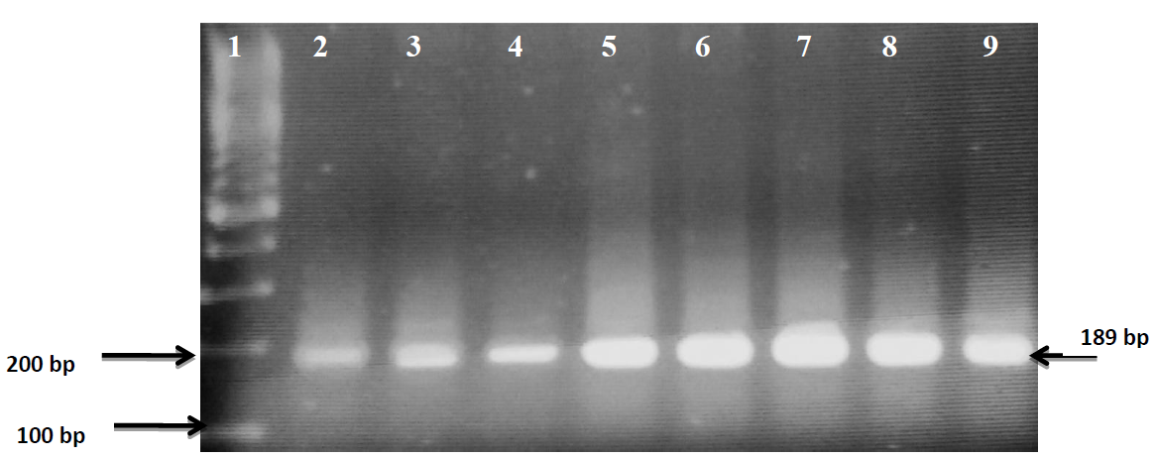

**Figure 2**. 3 % agarose gel electrophoresis of PCR products of COX I amplification lane 2, 3, 4, 5, 6, 7, 8, and 9 indicate positive results, lane 1 is 100 bp ladder.

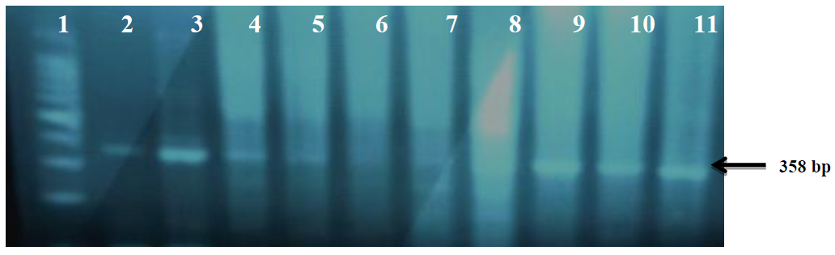

**Figure 3.** Gel electrophoresis results of the DmtDNA4977. Lane 1 is the 100 bp DNA ladder. Lanes 2, 3, 4, 5,9,10 and 11 indicate positive samples. Lane 6, 7 and 8 are negative samples. 358-bp

**Table 2:** Pathology, PSA and age of study population

|  |  |  |  |  |
| --- | --- | --- | --- | --- |
| **Tumor** | | **NO** | **Mean±S.E** | **P value** |
| **PSA** | Benign | 17 | 13.09±1.742 |  |
|  | Malignant | 13 | 95.9±16.28 |  |
|  | **Total** | 30 | 48.98±10.32 | 0.00 |
| **AGE** | Benign | 17 | 66±2.11 |  |
|  | Malignant | 13 | 71±2.56 |  |
|  | **Total** | 30 | 68±1.65 | 0.17 |

**Correlation is significant at the 0.05 level. S.E = STANDER ERROR

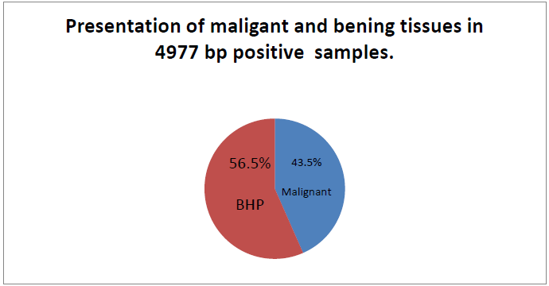

**Figure 4**: Frequency of Prostate Cancer and benign BHP tissues in 4977 bp positive samples.

In conclusion, the DmtDNA4977 mutation was detected in both malignant and non-malignant tumors of prostate tissue. Despite the suggested minor role in carcinogenesis, the exact etiological significance of this deletion needs further validation. Functional analysis in different experimental conditions would clarify possible underplaying roles of this mutation in carcinogenesis. Other large deletions should be studied in larger sample size and in different types of tumors at different stages to reach conclusion regarding the role of large mtDNA deletions carcinogenesis.

**Acknowledgment**

My best thanks, regards and respect to my supervisor, Mai Abdul Rahman Masri (Ph.D), Department of Zoology, Faculty of Science, University of Khartoum, who has been helpful, patient throughout the study. I am deeply indebted to all my family and my friends for their kind support till the end of this work.

References

1. Abuidris, D.; Omran, M.; El Gaylani, E.; El Haj, A., (2010). The impact of trus in detection of prostate cancer in Gezira, Sudan*. Gezira J. Health Sci* 1:1-9.
2. [Anand](http://www.ncbi.nlm.nih.gov/pubmed/?term=Anand%20P%5Bauth%5D), P.; [Kunnumakara](http://www.ncbi.nlm.nih.gov/pubmed/?term=Kunnumakara%20AB%5Bauth%5D), A. B.; [Sundaram](http://www.ncbi.nlm.nih.gov/pubmed/?term=Sundaram%20C%5Bauth%5D), C.; [Harikumar](http://www.ncbi.nlm.nih.gov/pubmed/?term=Harikumar%20KB%5Bauth%5D), K. B.; [Tharakan](http://www.ncbi.nlm.nih.gov/pubmed/?term=Tharakan%20ST%5Bauth%5D), S. T.; [Bokyung Sung](http://www.ncbi.nlm.nih.gov/pubmed/?term=Sung%20B%5Bauth%5D), O. S and [Aggarwal](http://www.ncbi.nlm.nih.gov/pubmed/?term=Aggarwal%20BB%5Bauth%5D). B. B., (2008). Cancer is a Preventable Disease that Requires Major Lifestyle Changes*. Pharmaceutical Res.* 25(9): 2097–2116*.*
3. America Cancer Society. Global Cancer Fact and Figures 2nd Edition. Atlanta: *America Cancer Soceity*; (2011*).*
4. America Cancer Society (2016). The American Cancer Society is a qualified 501(c) (3) tax-exempt organization. a.
5. American Cancer Society (2016). Prostate Cancer. Cancer Information Database. b.
6. BadieI, H. D. M. A.; Abdelbadie, A.; Munsoor, M. M. and Khalid, K. E. (2015). Mitochondrial DNA 4977 bp deletion among Sudanese oral lesions. *ejpmr* 2(4*): 32-43.*
7. Bai.U. and Seidman M.D., (2001). A specific mitochondrial DNA deletion (mtDNA4977) is identified in a pedigree of a family with hearing loss*. Hearing Res*. 154(1-2):73-80.
8. Chaotterjee, A.; Mambo, E, and Sidransky, D., (2006). Mitochondrial DNA mutations in human cancer. *Oncogene* 25: 4663–4674.
9. Chen, T.; He, J.; Shen, L.; Fang, H.; Nie, H.; Jin, T.; Wei, X.; Xin, Y.; Jiang, Y.; Li, H.; Chen, G; Lu, J. and Bai, Y., (2011). The mitochondrial DNA 4977 bp deletion and its implication in copy number alteration in colorectal cancer. *Medical Genetics* 2011: 12-8.
10. Chuanzhong. Ye; Xiao-Ou; Wanqing. w; Larry. P; Regina C; Yu Tang, G; Wei Z and Qiuyin C., (2008). Quantitative analysis of mitochondrial DNA 4977- bp deletion in sporadic breast cancer and benign breast diseases. *Breast Cancer Res Treat* 108:427–434.
11. Cohen, R. J.; Shannon, B. A.; Phillips, M.; Moorin, R. E.; Wheeler, T.M. and Garrett, K.L., (2008). Central zone carcinoma of the prostate gland: a distinct tumor type with poor prognostic features. *J Urol* 179(5):1762-7.
12. Czarnecka, A. M.; Golik, P. and Bartnik, E., (2006). Mitochondrial DNA mutations in human neoplasia. *J Appl Genet* 47:67-78.
13. Dai, J. G.; Xiao, Y. B.; Min, J. X.; Zhang,G. Q.; Yao, K. and Zhou, R. J., ( 2006). Mitochondrial DNA 4977 bP deletion mutations in lung carcinoma. *Indian J. cancer* 1: 20-25.
14. Di Cristofano, A.; De Acetis, M.; Koff, A.; Cordon-Cardo, C. and Pandolfi, P.P., (2001). Cooperate in prostate cancer tumor suppression in the mouse. *Nat. Genet* 27: 222–224.
15. Dimberg, J.; Hong, T. T; Skarstedt, M.; Lofgren, S; Zar, N., and Matussek, A., (2014). Novel and Differential Accumulation of Mitochondrial DNA Deletions in Swedish and Vietnamese Patients with Colorectal Cancer. *Anticancer Res 34*: 147-152.
16. DimbergI, J.; Hong, T. T.; Nguyen, L. T. T.; Skarstedt, M.; Löfgren, S. and Matussek, A., (2015). Common 4977 bp deletion and novel alterations in mitochondrial DNA in Vietnamese patients with breast cancer. *Springerplus* 4: 58.
17. [Elamin](http://www.ncbi.nlm.nih.gov/pubmed/?term=Elamin%20A%5Bauth%5D), A.; [Ibrahim](http://www.ncbi.nlm.nih.gov/pubmed/?term=Ibrahim%20ME%5Bauth%5D), M. E.; [Abuidris](http://www.ncbi.nlm.nih.gov/pubmed/?term=Abuidris%20D%5Bauth%5D), D.; [Mohamed](http://www.ncbi.nlm.nih.gov/pubmed/?term=Mohamed%20KE%5Bauth%5D), K. E. H. and [Mohammed](http://www.ncbi.nlm.nih.gov/pubmed/?term=Mohammed%20SI%5Bauth%5D), S. I., (2015). Part I: cancer in Sudan—burden, distribution, and trends breast, gynecological, and prostate cancers. *Cancer Med* 3: 447–456.
18. Elimam, A. M. E and Sharfi, A., (2013). Incidence of Carcinoma of the Prostate in Patients with Normal Prostatic Specific Antigen Following Prostatectomy. *Global Journal of medical Res*1:25-29.
19. Ferlay J; Soerjomataram I; Ervik M; Dikshit R; Eser S, and Mathers C., (2014).. Cancer Incidence Mortality Worldwide [Internet]. *Cancer Base* 2012 v1.0.
20. Gabriel J., (2004) the application of biology to cancer nursing. *The biology of cancer.*
21. Green, D. R. and Reed, J. C., (1998). Mitochondria and apoptosis. *Science* 12:281-1309.
22. Grzybowska L; Zatkowska; and Slaska B., (2012). Mitochondrial DNA Carcinogenesis. *Molecular. Med. Rep*. 6(5): 923-930.
23. Hamad, F.A. and Abuidris, D.O., (2011). Risk factor for prostate cancer Patients among gezira state central of Sudan*. IIUM Eng. J*. 12(4).
24. Hanahan, D. and Weinberg, R.A., (2000) The hallmarks of cancer*. Cell*. 100(1):57-70.
25. Hidayatalla. A.R.E., (1986). The Radiation and Isotope Center, Khartoum, 1967- 1984. Cancer occurrence in developing countries. *IARC Scientific Publications*. 75: 82–87.
26. Jorde L.B., (2000). *Medical genetics*. 2nd ed.
27. Kara, M.; Tatar, A.; Borekci, B.; Dagli, F. and Oztas., (2012). Mitochondrial DNA 4977 Bp Deletion in chronic cervicitis and cervix cancers. *BJMG* 15/1: 25- 29.
28. Khan H.S; Zeegers M.P; Schout L.J; Vondijk B.A.C; Goldbohm R.A; Schalken J; Shajahan S; Pearlman A; Oddoux C; Vanden; Brandt P.A and Oster H., (2011). Genetic Marker Polymorphism on Chromosome 8q24 and Prostate Cancer in the Dutch Population. *Eurt Hum Genet*. 19(1):118-20.
29. Maki, J.; Robinson, K; Reguly, B.; Alexander, J; Wittock, R., (2008). Mitochondrial Genome Deletion Aids in the Identification of False- and True- Negative Prostate Needle Core Biopsy Specimens. *Ame Soci for Clin Patho* 129:57-66.
30. Mohammed, M. E.; Hassan, A. M.; Abdelhadi, H. A.; Elsadig, M. G.; Adam, D. M.; Elmamoun, K., (2014) Burden and pattern of cancer in the Sudan, 2000– 2006*. Br. J. Med. Med. Res* 4:1231–1243.
31. Mohri I.; Taniike M.; Fujimura H.; Matsuoka T.; Inui K.; and Nagai T., (1998) A case of Kearns–Sayre syndrome showing a constant proportion of deleted mitochondrial DNA in blood cells during 6 years of follow-up*. J. Neurol. Sci*. 158:106–109.
32. Mukhtar. B.I., (1978) The Sudan Cancer Registry. In: Parkin DM, editor. Cancer occurrence in developing countries. *IARC Scientific Publication*. 57: 81–85.
33. Nie, H.; Shu, H.; Vartak, R.; Milstein, A. C.; Mo, Y.; Hu, X.; Fang, H.; Shen, L.; Ding, Z., Lu, J;. and Bai,Y., (2013). Mitochondrial Common Deletion, a Potential Biomarker for Cancer Occurrence, Is Selected against in Cancer Background: A Meta-Analysis of 38 Studies <http://dx.doi.org/10.1371/journal.pone.0067953>
34. Ponder, B.A., (2001) Cancer genetics. *Nature*. 411(6835):336-41.
35. Ramos, C. G.; Carvahal, G. F.; Mager, D. E., (1999) The effect of high grade prostatic intraepithelial neoplasia on serum total and percentage of free prostate specific antigen levels*. J Urol,* 162: 1587.
36. Rao S.N., (2009). Cancer screening in end-stage renal disease. *Saudi J Kidney Dis Transpl*. 20:737–40.
37. Saeed I.E; Weng H.Y; Mohamed K.H, and Mohamed S.I., (2014). Cancer Incidence in Khartoum. sudan: first results from the cancer registry (2009- 2010). *Cancer Med*. 3(4):1075-1080.
38. Shao, J. Y.; Gao, H. Y.; Li, Y. H.; Zhang, Y.; Lu, Y. Y.; Zeng, Y. X., (2004). Quantitative detection of common deletion of mitochondrial DNA in hepatocellular carcinoma and hepatocellular nodular hyperplasia. *World J Gastroenterology* 10(11):1560-1564.
39. Shieh, D. B.; Chou, W. P.; Wel, Y. H; Wong, T. Y; and Jin*,* Y. T*., (*2004). Mitochondrial DNA 4977 bp Deletion in Paired Oral Cancer and Precancerous Lesions Revealed by Laser Microdissection and Real-Time Quantitative PCR. *Science.* 1011: 154–167.
40. Tang, L. and Zhang, Y. (2005). Mitochondria are the primary target in isothiocyanate-induced apoptosis in human bladder cancer cells. *Mol Cancer Ther* 4:1250-9.
41. Thayer R.E; Wittock R; Parr R; Zullo S; and Birch M.A., (2003). A maternalline study investigatingthe 4977-bp mitochondrial DNA deletion*. Exp Gerontol*. 2003;38: 567–571.
42. Voeller, H. J.; Augustus, M.; Madike, V.; Bova, G. S.; Carter, K. C. and Gelmann, E. P., (1997). A prostate specific homeobox gene on 8p21, is not mutated in human prostate cancers*. Cancer Res* 57: 4455–4459.
43. [Yadav](http://www.ncbi.nlm.nih.gov/pubmed/?term=Yadav%20N%5Bauth%5D), N and [Chandra](http://www.ncbi.nlm.nih.gov/pubmed/?term=Chandra%20D%5Bauth%5D), D., (2014). Mitochondrial DNA mutations and breast tumorigenesis. [*Biochim Biophys Acta* 1836(2): 336–344.](http://www.ncbi.nlm.nih.gov/entrez/eutils/elink.fcgi?dbfrom=pubmed&amp;retmode=ref&amp;cmd=prlinks&amp;id=24140413)
44. Yousoff. A.M., (2015). Role Of Mitochonrial DNA Muttion in Brain Tumers:Amini-Review. *Journal of Cancer Res and Ther*. 11(3):535-544.
45. Zhang. Y; Ma Y; Bu. D; Liu. H; Xia C; Zang.Y; Zhu. S; Pan H; Pi.P; Zhang X; Wang S; Xu Y, and Qi Y., (2015). Deletion of a 4977-bp Fragment in the Mitochondrial Genome Is Associated with Mitochondrial Disease Severity. *Plos. Org*.10:1371.

3/25/2017