**Awareness And Knowledge About Oral Cancer Among Sample Of People In Jeddah, Saudi Arabia**

Hefni Hawazen, Al Somali Zohour, Prof. Ghada Mansour

Abstract: Introduction: Oral cancer is becoming prevalent and has dramatically become one of the causes of death among human race. However, like any other cancers, early diagnosis is the key to save patients who have this kind of illness, thus the need to increase the level of knowledge and awareness of the people concerning this malady. Objective: The objective of this study was to examine the level of awareness and knowledge of oral cancer of the city of Jeddah in Kingdom of Saudi Arabia. Methodology: A questionnaire was used to collect data from a random sample of 400 people. The questionnaire included 7 questions pertaining to knowledge about oral cancer. IBM SPSS version 22 has been used to analyze the data collected. Results: In this study, we found out that people in Jeddah have a very low level of knowledge and awareness on oral cancer.

**[**Hefni Hawazen, Al Somali Zohour, Prof. Ghada Mansour. **Awareness And Knowledge About Oral Cancer Among Sample Of People In Jeddah, Saudi Arabia.** *Cancer Biology* 2017;7(1):87-90]. ISSN: 2150-1041 (print); ISSN: 2150-105X (online). <http://www.cancerbio.net>. 12. doi:[10.7537/marscbj070117.12](http://www.dx.doi.org/10.7537/marscbj070117.12).

**Keywords:** Awareness; Knowledge; Oral Cancer; People; Jeddah; Saudi Arabia

Introduction

Oral cancer is the 11th most commonly reported malignancy worldwide [1]. Although many types of cancer occur in oral cavity, about 90% of these are squamous cell carcinomas [2]. Out of the many factors associated with oral cancer, tobacco usage has been identified as the strongest. [3] Oral cancer is becoming a major health concern because of the current increase in its occurrence especially in the third world. According to worldwide statistics an estimated 263, 900 new cases were found with 128 000 deaths annually worldwide [4]. About 58% cases of oral cancer occur in South and South East Asia [5].

Oral cancer is largely preventable [6]. Early diagnosis of the malignancy significantly increase survival rates, as the mouth is effortlessly reachable for self or clinical assessment. However, oral cancer is still frequently diagnosed in advanced stages thus requiring aggressive treatment and associated morbidity, resulting in higher mortality rates than when diagnosed early [7]. One of the main reasons may be the lack of information about the causes and knowledge of signs and symptoms of oral cancer among the population. Moreover, most of oral cancers are preventable if people know which risk factors they must control or eliminate [8].

Methodology

The present survey was carried out for the whole month of March 2014. The study population included males and females with different educational levels, who had no background or knowledge of medicine and were not related to any branch of the medical sciences. A total of 400 persons were randomly selected in this study. The information was gathered by asking questions using a well-structured questionnaire covering aspects regarding knowledge about oral cancer, its types, signs, symptoms, and risk factors.

The statistical package used for this study is IBM SPSS version 22. A simple descriptive statistics was done in showing off the frequencies, counts, percentages and variations of the different variables of this study.

Results

Out of the 400 respondents, 65.50% were females and 34.50% were males (Fig 1), Saudis constituted 85% of the sample population and 15% were non-Saudis (Figure 2). Regarding their educational level, 62% had Bachelor degree, 28% were undergraduates and 10% had postgraduate studies (Figure3).

Regarding the type of cancers enumerated in the questionnaire, 46.8% reported that they have not heard about these types, 44.9 % of them said that they were familiar with lung and breast cancer, and 6% said that they are familiar with oral, breast and lung cancer. Lastly, only 2.3 % said that they know oral cancer (Figure 4).

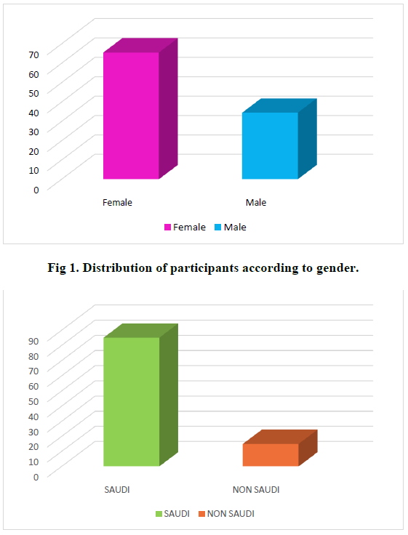

**Fig 1. Distribution Of Participants According To Gender.**



**Fig 2. Distribution Of Participants According To Nationality.**

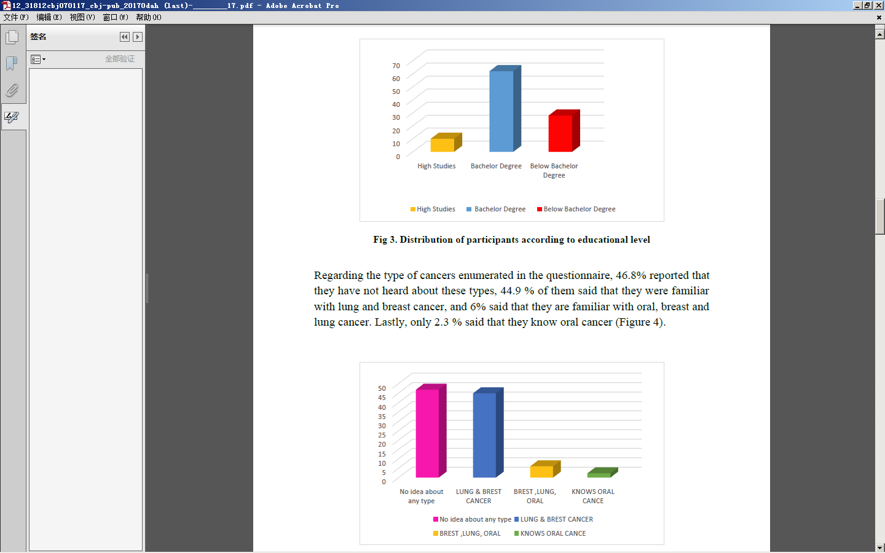

**Fig 3. Distribution Of Participants According To Educational Level**



**Fig 4. Percentage Of Cancer Awareness Among Participants**

When asked about the manifestations of oral cancer 51.5% said that they had no idea about it, 22.5% said white & red patches with bleeding, and 10 % thought ulcer is the only manifestation of oral cancer, while 16% checked all signs (Figure 5).

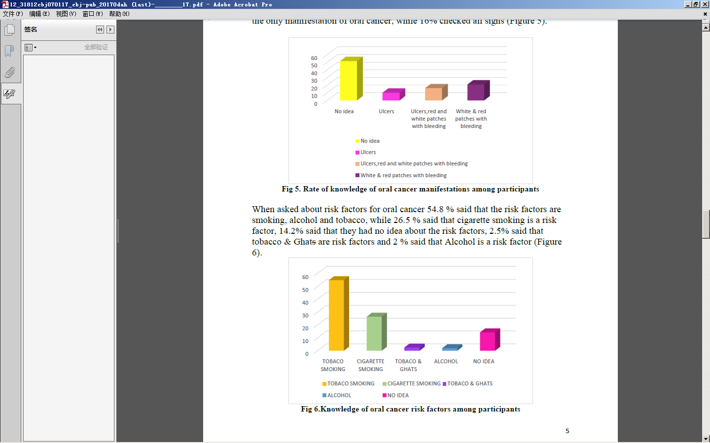

**Fig 5. Rate Of Knowledge Of Oral Cancer Manifestations Among Participants**

When asked about risk factors for oral cancer 54.8 % said that the risk factors are smoking, alcohol and tobacco, while 26.5 % said that cigarette smoking is a risk factor, 14.2% said that they had no idea about the risk factors, 2.5% said that tobacco & Ghat~~s~~ are risk factors and 2 % said that Alcohol is a risk factor (Figure 6).



**Fig 6. Knowledge Of Oral Cancer Risk Factors Among Participants**

When asked if early diagnosis of oral cancer helps in the treatment, 88% said yes, 11% had no idea, and 1 % said no (Figure 7).

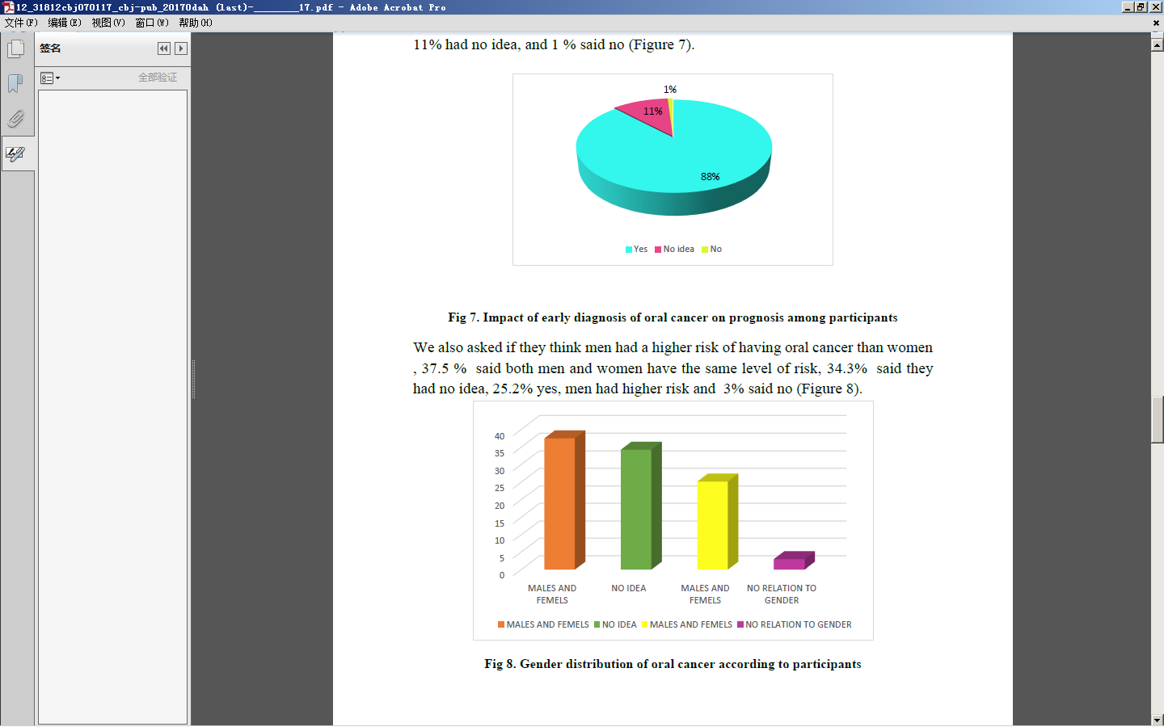

**Fig 7. Impact Of Early Diagnosis Of Oral Cancer On Prognosis Among Participants**

We also asked if they think men had a higher risk of having oral cancer than women, 37.5 % said both men and women have the same level of risk, 34.3% said they had no idea, 25.2% yes, men had higher risk and 3% said no (Figure 8).



**Fig 8. Gender Distribution Of Oral Cancer According To Participants**

We also asked if the dentist’s role in raising level of awareness on oral cancer is appreciated; and an overwhelming 82% of the respondents said yes, while 13% said that they had no idea and 5% said no (Figure 9).

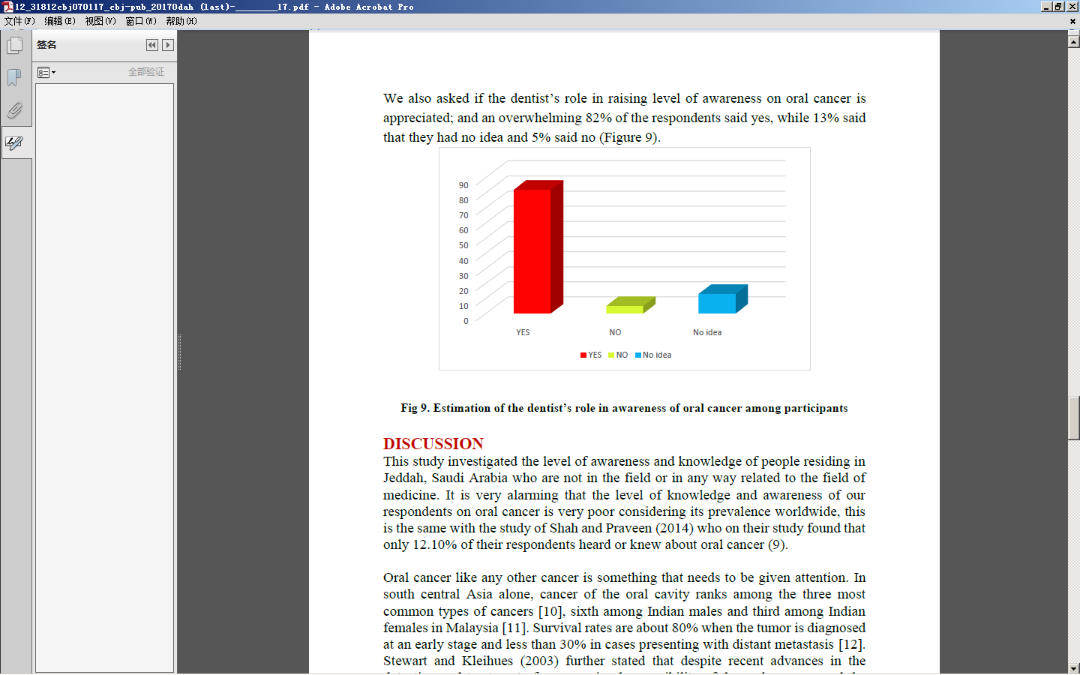

**Fig 9. Estimation Of The Dentist’S Role In Awareness Of Oral Cancer Among Participants**

Discussion

This study investigated the level of awareness and knowledge of people residing in Jeddah, Saudi Arabia who are not in the field or in any way related to the field of medicine. It is very alarming that the level of knowledge and awareness of our respondents on oral cancer is very poor considering its prevalence worldwide, this is the same with the study of Shah and Praveen (2014) who on their study found that only 12.10% of their respondents heard or knew about oral cancer (9).

Oral cancer like any other cancer is something that needs to be given attention. In south central Asia alone, cancer of the oral cavity ranks among the three most common types of cancers [10], sixth among Indian males and third among Indian females in Malaysia [11]. Survival rates are about 80% when the tumor is diagnosed at an early stage and less than 30% in cases presenting with distant metastasis [12]. Stewart and Kleihues (2003) further stated that despite recent advances in the detection and treatment of cancer, visual accessibility of the oral mucosa, and the scientific knowledge on cancer risk factors, oral cancer carries a low survival rate (near 50%) [13].

Unfortunately, the majority of our respondents said that they don’t have any idea about the signs of oral cancer. But positively, few were correct when they said that white and red patches with bleeding may be a sign for this illness. This is supported by the National Institute of Dental and Craniofacial Research stating that two lesions that could be precursors to cancer are leukoplakia (white lesion) and erythroplakia (red lesion) [14]. The institute also reports that possible signs and symptoms of oral cancer that patients may report include a lump or thickening in the oral soft tissues, soreness or a feeling that something is caught in the throat, difficulty chewing or swallowing, ear pain, difficulty moving the jaw or tongue, hoarseness, numbness of the tongue or other areas of the mouth, or swelling of the jaw that causes dentures to fit poorly or become uncomfortable [14].

Our respondents were able to point out that smoking is a risk factor. This is in agreement with the study of Monteiro, et al [15]. In addition, alcohol was recognized to a slighter scale as a risk factor. This trend was also reported by other authors [16- 20]. Early diagnosis is indeed a key to elevate the survival rate of patients who are having oral cancer and this is agreed upon by the majority of our respondents. This fact has always been reported by medical practitioners. Soares et al (2014) stated that early diagnosis is essential and it reduces rates of morbidity, mortality and mutilation, and increases the quality of life of patients and lowers treatment costs [21].

Due to the opportunity of routinely examining the oral cavity, the dentist has the chance to diagnose oral cancer even in asymptomatic patients before dissemination occurs to adjacent tissues [21]. This role of the dentist in raising the level of knowledge and awareness of the people on oral cancer fact has been tremendously agreed upon by 81% of our respondents. It is the responsibility of the dental schools to ensure the formation of a general practitioner with solid technical, scientific, humanistic, and ethical knowledge, aimed at promoting health, and emphasizing the philosophy of prevention of prevalent oral diseases [22]. We must ensure that dental students have the relevant basic knowledge on prevention and early diagnosis of oral cancer [23].

Conclusion

This study showed that many people in Jeddah, Saudi Arabia are still unaware of the basic knowledge about oral cancer. Hence, there is a clear need to enlighten and teach the public facts related to it in public education programs, using mass media.

Acknowledgement

The authors are thankful to the participants who have cooperated for the completion of the study, and to Prof. Ghada Mansour who has helped us in the design and review of the research.

References

1. Pakfetrat A, Falaki F, Esmaily H, et al (2010). Oral cancer knowledge among patients referred to Mashhad Dental School, Iran. Archives of Iranian Medicine 13: 543–548.
2. Cawson R, Odell E. Oral Cancer (2008). Cawson’s Essentials of Oral Pathology and Oral Medicine. 8th Edition; Churchill Livingston Elsevier: 277-290.
3. Johnson N. Tobacco use and Oral Cancer (2001): A Global Perspective. J Dent Educ 65:324-329.
4. Jemal A, Bray F, Center M et al (2011). Global cancer statistics. CA Cancer J Clin 61:69-90.
5. Nair U, Bartsch H, Nair J (2004). Alert for an epidemic of oral cancer due to use of betal quid substitutes ghutka and pan masala; A review of agents and causative mechanisms. Mutagenesis 19:251-262.
6. Pavia M, Pileggi C, Nobile C, et al (2006). Association between fruit and vegetable consumption and oral cancer: a meta-analysis of observational studies. Am J Clin Nutr 83: 1126-1134.
7. Shiboski C, Shiboski S, Silverman Jr S (2000): Trends in oral cancer rates in the United States, 1973-1996. Com Dent Oral Epidemiol 28: 249-256.
8. Warnakulasuriya S, Harris C, Scarrott D, et al. (1999). An alarming lack of public awareness towards oral cancer. Br Dent J 187:319-322.
9. Shah S, Praveen B (2014). Awareness of oral cancer in rural Bangalore population: A questionnaire based study. International Journal of Scientific Study 1: 14-16.
10. Reddy B, Doshi D, Reddy M, et al (2012). Oral cancer awareness and knowledge among dental patients in South India. J Cranio Maxill Surg 40: 521-524.
11. Malaysian National Cancer Registry (MNCR) (2003). Cancer statistics. Ministry of Health Malaysia.
12. Petti S, Scully C (2007). Oral cancer knowledge and awareness: primary and secondary effects of an information leaflet. Oral Oncol 43: 408-415.
13. Stewart BW, Kleihues P (2003). World Cancer Report. International Agency for Research on Cancer, Geneva, Switzerland.
14. Monteiro L, Salazar F, Pacheco J, et al. (2012). Oral cancer awareness and knowledge in the city of Valongo, Portugal. Int J Dent 2012: 1-8.
15. National Institute of Dental and Craniofacial Research (2013). Detecting Oral Cancer: A guide for healthcare professionals. Available at: [http://www.nidcr.nih.gov/oralhealth/topics/oralcancer/detectingoralcancer.ht](http://www.nidcr.nih.gov/oralhealth/topics/oralcancer/detectingoralcancer.htm) [m](http://www.nidcr.nih.gov/oralhealth/topics/oralcancer/detectingoralcancer.htm)
16. Warnakulasuriya S, Harris C, Scarrott D, et al (1999). An alarming lack of public awareness towards oral cancer. Br Dent J 187:319–322.
17. Prayman E, Yang Y, and Wamakulasuriya S (2009). Oral cancer awareness of patients attending health centers in Trinidad. Int J Clin Dent 2:1–12.
18. Cruz G, Le Geros R, Ostroff J, et al (2002). Oral cancer knowledge, risk factors and characteristics of subjects in a large oral cancer screening program. JADA 133:1064–1071.
19. Room R, Babor T, Rehm J. Alcohol and public health (2005). Lancet 365: 519 – 530.
20. Rogers SN, Hunter R, and Lowe D (2011). Awareness of oral cancer in the Mersey region. Br J Oral Maxillofac Surg 49:176–181.
21. Soares TRC, Carvalho MEA, Pinto LSS, et al (2014). Oral cancer knowledge and awareness among dental students. Br J Oral Sc 13:28-33.
22. Brazil Ministry of Education (2002). National Council of Education. Resolution CNE/CES. Board of Higher Education. National Curriculum Guidelines for Undergraduate Dentistry. Official Federal Gazette.
23. Dib LL, Souza RS, Tortamano N (2005). Evaluation of the knowledge about oral cancer among undergraduate dental students of different units at University Paulista. Rev Inst Cienc Saude. 23: 287-295.

3/25/2017