**Vitamin H And Hteir Role In Ruminant: *A Review***

Hamed Amini Pour

Young Researchers Club, Sarab Branch, Islamic Azad University, Sarab, Iran.

[khamed_jackson@yahoo.com](mailto:khamed_jackson@yahoo.com)

**Abstract:** Biotin, also known as Vitamin H or Coenzyme R, is a water-soluble [B-complex vitamin](http://en.wikipedia.org/wiki/B_vitamins) founded with [Bateman](http://en.wikipedia.org/wiki/Bateman) in 1916. It is composed of an [uredo](http://en.wikipedia.org/w/index.php?title=Ureido&action=edit&redlink=1) ring fused by a [tetrahydrothiophene](http://en.wikipedia.org/wiki/Tetrahydrothiophene) ring. A [valeric acid](http://en.wikipedia.org/wiki/Valeric_acid) substituent is attached to one of the carbon atoms of the tetra hydrothiophene ring. Biotin is a [coenzyme](http://en.wikipedia.org/wiki/Coenzyme) in the [metabolism](http://en.wikipedia.org/wiki/Metabolism) of [fatty acids](http://en.wikipedia.org/wiki/Fatty_acid), [isoleucine](http://en.wikipedia.org/wiki/Isoleucine), and [valine](http://en.wikipedia.org/wiki/Valine), and it plays a role in [gluconeogenesis](http://en.wikipedia.org/wiki/Gluconeogenesis). Biotin is vital for cell growth, the production of fatty acids, and the metabolism of fats and [amino acids](http://en.wikipedia.org/wiki/Amino_acids). It plays a role in the [citric acid cycle](http://en.wikipedia.org/wiki/Citric_acid_cycle), that is the process with which biochemical energy is generated during [aerobic respiration](http://en.wikipedia.org/wiki/Cellular_respiration). Biotin not only assists in diversion metabolic reactions but also helps to transfer [carbon dioxide](http://en.wikipedia.org/wiki/Carbon_dioxide). Biotin may also be helpful in keeping a steady [blood sugar](http://en.wikipedia.org/wiki/Blood_sugar) level. Biotin is often advocated for strengthening hair and nails. As a consequence, it is found in many cosmetics and health products for the hair and skin, though it cannot be absorbed through the hair or skin itself. Biotin scarcity is rare because, in general, intestinal bacteria produce biotin in excess of the body's daily requirements. For which reason, statutory agencies in many countries, for example the USA and Australia, don't prescribe an advocated daily intake of biotin. Therefore, a number of [metabolic disorders](http://en.wikipedia.org/wiki/Biotin#Metabolic_disorders) in that an individual's metabolism of biotin is abnormal exist. Incidence of biotin scarcity has-been found occasionally when humans and animals have consumed excessive quantities of raw eggs that contain a biotin completing factor (avidin). Likewise, biotin scarcity is reported in children by inborn errors of metabolism when there are insufficient biotin-dependent enzymes. Such cases in children respond dramatically to high-level dietary supplementations by biotin.

**[**Hamed Amini Pour. **Vitamin H And Hteir Role In Ruminant: *A Review*.** *Cancer Biology* 2017;7(4):53-56]. ISSN: 2150-1041 (print); ISSN: 2150-105X (online). <http://www.cancerbio.net>. 8. doi:[10.7537/marscbj070417.08](http://www.dx.doi.org/10.7537/marscbj070417.08).

**Keywords:** Vitamin H; Hteir Role; Ruminant; Review

**1. Introduction**

Vitamins are defined as a group of complex organic compounds current in nominal amounts in natural foodstuffs that are essential to normal mal metabolism and lack of which in the diet causes deficiency diseases. Vitamins consist of a mixed group of chemical compounds and are not related to each other as are proteins, carbohydrates, and fats. Their classification together depends not on chemical characteristics but on function. Vitamins are differentiated from the trace elements, also present in the diet in small quantities, by their organic nature.

Vitamins are required in trace amounts in the diet for health, growth, and reproduction. Omission of a single vitamin from the diet of a species that requires it will produce deficiency signs and symptoms. Many of the vitamins function as coenzyme others have no such role, but perform certain essential functions. Some vitamins deviate from the preceding definition in that they don't always need to be constituents of food. Certain substances that are considered to be vitamins are synthesized by intestinal tract bacteria in quantities that are often adequate for body needs. However, an obvious distinction is made between vitamins and substances that are synthesized in tissues of the body. Ascorbic acid, for example, can be synthesized by most species of animals, except when they are young or under stress conditions. Likewise, in most species, niacin can be synthesized from the amino acid tryptophan and vitamin D from action of ultraviolet light on precursor compounds in the skin. Thus, under certain conditions and for specific species, vitamin C, niacin, and vitamin D would not always fit the classic definition of a vitamin.

Classically, vitamins have been divided into two groups based on their solubility's in fat solvents or in water. Thus, fat-soluble vitamins include A, D, E, and K, while vitamins of the B-complex and C are classified water soluble. Fat-soluble vitamins are found in foodstuffs in association with lipids. The fat-soluble vitamins are absorbed along with dietary fats, apparently by mechanisms similar to those involved in fat absorption. Conditions favorable to fat absorption, such as adequate bile flow and good micelle formation, also favor absorption of the fat-soluble vitamins (Scott et al., 1982).

**2. Chemical structure**

The chemical structure of biotin in metabolism includes a sulfur atom in its ring And a transverse bond across the ring (Fig.1 and 2). The empirical formula for biotin is C11H18O3N2S. Biotin is a fusion of an imidazolidone ring with a tetrahydrothiophene ring bearing a valeric acid side chain. It is a monocarboxylic acid with sulfur as a thioether linkage. Biotin, with its rather unique structure, contains three asymmetric carbonations, and therefore eight different isomers are possible. Of these isomers only one contains vitamin activity, *d*-biotin. The stereoisomer *l*-biotin is inactive.

Biotin crystallizes from water solution as long, white needles. Its melting point is 232 to 233oC. Free biotin is soluble in dilute alkali and hot water and practically insoluble in fats and organic solvents. Biotin is quite stable under ordinary conditions. It is destroyed by nitrous acid, other strong acids, strong bases, and formaldehyde and is inactivated by rancid fats and choline (Scott et al., 1982). It is gradually destroyed by ultraviolet radiation.

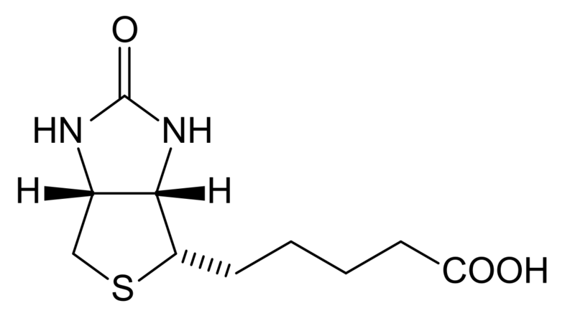

Figure 1: Chemical structure of Vitamin B12 from [www.wikipedia.org/wiki/Vitamin](http://www.wikipedia.org/wiki/Vitamin) B8

Figure 2: Aspect 2 chemical structure of Vitamin B8 from [www.wikipedia.org/wiki/Vitamin](http://www.wikipedia.org/wiki/Vitamin) B8

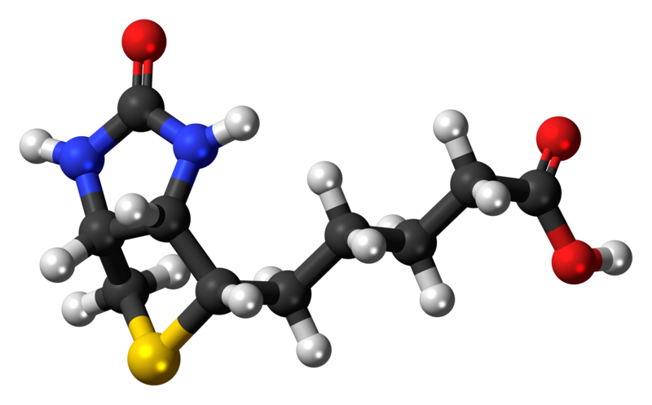

**3. Metabolism**

Biotin exists in natural materials in both bound and free forms, with much of the bound biotin apparently not available to animal species. For poultry, often less than one-half of the microbiologically determined biotin in a feedstuff is biologically available (Scott, 1981).

Naturally occurring biotin is found partly in the Free State (fruit, milk, vegetables) and partly in a form bound to protein in animal tissues, plant seeds, and yeast. Variation in availability appears to be due to differential susceptibilities to digestion of the biotin-protein linkages in which the vitamin is found in natural products. Those linkages involve the formation of covalent bonds between the carboxyl group of the biotin side-chain with the amino acid lysine or to protein.

Biotinidase, present in pancreatic juice and intestinal mucosa, releases biotin from biocytin during the luminal phase of proteolysis. In most species that have been investigated, physiological concentrations of biotin are absorbed from the intestinal tract by a sodium-dependent active transport process that is inhibited by desthiobiotin and biocytin (Said and Derweesh, 1991). Absorption of biotin by a Na+-dependent process was noted to be higher in the duodenum than the jejunum, which was in turn higher than that in the ileum, and it was concluded that the proximal part of the human small intestine was the site of maximum transport of biotin (Said et al., 1988).

The few studies conducted in animals on biotin metabolism revealed that biotin is absorbed as the intact molecule in the first third to half of the small intestine (Bonjour, 1991). There is also absorption of biotin from the hind gut of the pig, with disappearance of between 50 and 61% of infused biotin between the cecum and feces that was accompanied by more than a fourfold increase of plasma biotin concentration and more than a six fold increase of urinary biotin excretion (Barth et al.1986).

Kopinski and Leibholz (1985) reported that postileal absorption was 10 to 15% of that from the small intestine after oral ingestion. Eighty percent of a labeled biotin dose infused into the cecum of mini-pigs appeared in portal blood (Drouchner and Volker, 1984) with the largest proportion appearing in feces. Using 14C-labeled biotin, Kopin-ski et al. (1989a, b) reported similar findings in that absorption of free biotin in the postileal digestive tract was about 8% as efficient as that from a similar labeled dose of orally administered biotin.

Kopinski et al. (1989c) observed that even with extensive microbial synthesis of biotin in the postileal tract, low concentrations of biotin in plasma and tissue, and the presence of deficiency signs indicated that postileal synthesized biotin is of limited benefit to the pig. Scholtissek et al. (1990) suggested that under basal conditions, 1.7 to 17% of the requirement for biotin is provided by colonic bacteria.

Biotin appears to circulate in the bloodstream both free and bound to a serum glycoprotein, which also has biotinidase activity, catalyzing the hydrolysis of biocytin. In humans, 81% of biotin in plasma was free and the remainder bound (Mock and Malik, 1992).

Information is very limited on biotin transport, tissue deposition, and storage in animals and humans.

Mock (1990) reported that biotin is transported as a free water-soluble component of plasma, is taken up by cells via active transport, and is attached to its apoenzymes.

Said et al. (1992) reported that biotin is transported into human liver via a specialized carrier-mediated transport system. This system is Na+-gradient dependent and transports biotin via an electro neutral process.

Disappearance of an intravenous dose of radioactive biotin from blood of biotin-deficient rats was more rapid than for controls (Petrelli et al., 1979).

Also, rate and extent of deposition into deficient liver, particularly mitochondrial and cytosolic fractions, were favored. This research supports the concept of homeostatic mechanisms responding to provide biotin in relation to needs. All cells contain some biotin, with larger quantities in the liver and kidneys. Intracellular distribution of biotin corresponds to known localization of biotin-dependent enzymes (carboxylases).

Investigations into biotin metabolism in animals and humans are difficult to interpret, as biotin-producing microorganisms exist in the intestinal tract distal to the cecum. Often, the amount of biotin excreted in urine and feces together exceeds total dietary intake, whereas urinary biotin excretion is usually less than intake. 14C-labeled biotin showed that the major portion of intra peritoneally injected radioactivity was excreted in the urine and none in the feces or expired as CO2 (Lee ET al.1973).

In rats and pigs, biliary excretion of biotin and metabolites was negligible (Zempleni et al., 1997).

The brush border of the kidney cortex has a sodium-biotin transport system similar to that in the intestinal mucosa, thus providing for resorption of free biotin filtered into the urine. It is only when this re sorption mechanism is saturated that there will be significant excretion of biotin. Efficient conservation of biotin, together with the recycling of biocytin released from the catabolism of biotin-containing enzymes, may be as important as intestinal bacterial synthesis of the vitamin in meeting biotin requirements (Bender, 1992).

**4. Function**

Biotin is an essential coenzyme in carbohydrate, fat, and protein metabolism. It's involved in conversion of carbohydrate to protein and vice versa as well as conversion of protein and carbohydrate to fat. Biotinalso plays an important role in maintaining normal blood glucose levels from metabolism of protein and fat when dietary intake of carbohydrate is low. Biotin functions as a carboxyl carrier in 4 carboxylase enzymes: pyruvate carboxylase, acetyl CoA carboxylase, propionyl CoA carboxylase, and 3-methylcrotonyl CoA carboxylase. As a component of these carboxylating enzymes, there's the capacity to transport carboxyl units and to fix carbon dioxide in tissue. Biotin serves as a prosthetic group in a number of enzymes in which the biotin moiety functions as a mobile carboxyl carrier. The biotin prosthetic group is linked covalently to the ε-amino group of a lysyl residue of the biotin-dependent enzyme.

**Effects of Deficiency**

*Ruminants*

Biotin is important for normal function of the thyroid and adrenal glands, the reproductive tract, and the nervous system. However, the effect of biotin deficiency on the cutaneous system is most dramatic since a severe dermatitis is the major obvious clinical sign of deficiency in live- stock and poultry.

Biotin deficiency, identified by hindquarter paralysis, decreased urinary excretion of biotin, and correction of the problem with biotin injections was reported in calves (Wiese et al., 1946). Flipse et al. (1948) reported a potassium-biotin interrelationship in calves, with the result that calves fed purified diets low in potassium and biotin developed pro- gressive paralysis of the hind legs that spread to the forelegs, neck, and respiratory system. Death may result within 12 to 24 hours of the first signs; however, the condition can be cured by injections of potassium salts or biotin.

Due to ruminal and intestinal synthesis of biotin, a need for supple- mental sources was at one time not expected for ruminants. Never the- less, promising preliminary results in preventing lameness in dairy cattle by biotin supplementation were reported Frigg et al., 1993).

Successful biotin treatment of dairy cows with claw problems was reported with Nietlis-Bash and Triebel (1988).

In biotin-deficient dairy cows, the hoof horn is of poor quality, soft, and crumbling, by no distinct separation of keratinizing and cornified cells. This results in the omission of the granular layer at the epidermis of the bulb of the heel. Decreased stabilizing filaments in the upper spiny layer of the hoof corium in biotin-deficient cows reveals the depressed hormone-like activity of biotin in the synthesis of protein (Budras et al., 1997).

Increased plasma biotin levels have been associated with hardness and conformational changes in the bovine hoof. Dairy cows supplemented by 20 mg of biotin per cow over an 11-month period expressed a steepened angle of the dorsal border and height of the heel; length of the diagonal and size of the ground surface increased (Distl and Schmid, 1994).

The hardness of the hoof was also significantly greater in the biotin-treated group. Greenough et al. (1999) reported that biotin supplementation (20 mg/day) to dairy cows not only reduced hoof lesions, but significantly increased milk production.

Beef cattle suffer from a common hoof defect known as sandcracks that are vertical fissures in the hoof. These tend to be more prevalent in older, heavier cows and often result in chronic lameness problems in beef cattle. Biotin supplementation in 15 beef cow herds in which 37.2% of the cows were affected with sandcracks dramatically reduced the pro- portion of affected cows (Campbell et al., 1995).

This study indicates that biotin supplementation appears to improve hoof quality by lowering the number of sandcracks per cow and decreases occurrence of other hoof defects, such as broken toes and abnormal coronary bands. Feeding dairy and beef cows 20 mg/day of supplemental biotin resulted in reduced incidence of hoof lesions and increased milk production (Seymour, 1999).

**References**

1. Barth, C.A., Frigg, M., and Hagemeister, H. (1986). *J. Anim. Phys. Anim. Nutr.* *55,* 128.
2. Bender, D.A. (1992). Nutritional Biochemistry of the Vitamins, p. 294. Cambridge University Press, Cambridge, England.
3. Bonjour, J.P. (1991). *In* Handbook of Vitamins 2nd Ed. (L.J. Machlin, ed.), p. 403. Marcel Dekker, New York.
4. Budras, K.D., Hochstetter, T., Muelling, Ch., and Natterman, W. (1997). *J.* *Dairy Sci. 80*(Suppl. 1), 192.
5. Campbell, J., Greenough, P.R., and Petrice, L. (1995). Western College of Vet. Med. University of Saskatchewan, Saskatoon, Canada.
6. Distl, O., and Schmid, D. (1994). *Tierarzliche Umschauy 49,* 581.
7. Drouchner, W., and Völker, L. (1984). Proc. TAD Symposium, Cattle and Pig Diseases. *Cuxhaveny 1,* 105.
8. Flipse, R.J., Huffman, C.F., Duncan, G.W., and Thorp, F. (1948). *J. Anim. Sci.*7, 525.
9. Frigg, M., Straub, O.C., and Harmann, D. (1993). *Int. J. Vit. Nutr. Res. 63,* 122.
10. Greenough, P.R., Gay, J.M., Dobson, R.C., and Gay, C.C. (1999). *J. Dairy Sci.82* (Suppl. 1.), 34 (Abstr).
11. Kopinski, J.S., and Leibholz, J. (1985). *Proc. Nutr. Soc. Aust. 10,* 170.
12. Kopinski, J.S., Leibholz, J., and Love, R.J. (1989a). *Brit. J. Nutr. 62,* 767.
13. Kopinski, J.S., Leibholz, J., and Love, R.J. (1989b). *Brit. J. Nutr. 62,* 781.
14. Kopinski, J.S., Leibholz, J., Bryden, W.L., and Fogarty, A.C. (1989c). *Brit. J.Nutr. 62,* 751.
15. Lee, H.M., McCall, N.E., Wright, L.D., and McCormick, D.B. (1973). *Proc. Soc. Exp. Biol. Med. 142,* 642.
16. Mock, D.M. (1990). *In* Nutrition Reviews, Present Knowledge in Nutrition (R.E. Olson, ed.), p. 189. Nutritional Foundation, Washington, D.C.
17. Mock, D.M., and Malik, M.I. (1992). *Am. J. Clin. Nutr. 56,* 427.
18. Nietlis-Bash, C., and Triebel, D.F. (1988). *Die Gruene 116,* 28.
19. Petrelli, F., Moretti, P., and Paparelli, M. (1979). *Mol. Biol. Rep. 4,* 247.
20. Said, H.M., Hoefs, J., Mohammadkhani, R., and Horne, D.W. (1992). *Gas- troenterology 102,* 2120.
21. Said, H.M., and Derweesh, I. (1991). *Am. J. Phys. 261,* R94.
22. Said, H.M., Redha, R., and Nylander, W. (1988). *Gastroenterology 95,* 1312.
23. Scholtissek, J., Barth, C.A., Hagemeister, H., and Frigg, M. (1990). *Br. J. Nutr.64,* 715.
24. Scott, M.L. (1981). *Feedstuffs 53*(8), 59.
25. Scott, M.L., Nesheim, M.C., and Young, R.J. (1982). Nutrition of the Chicken, p. 119. Scott, Ithaca, New York.
26. Seymour, W.M. (1999). *In* Proc. “Tri-state Dairy Nutrition Conference,” p. 43, Grand Wayne Center, Fort Wayne, Indiana.
27. Wiese, A.C., Johnson, B.C., and Nevens, W.B. (1946). *Proc. Soc. Exp. Biol.* *Med. 63,* 521.
28. Zempleni, J., Green, G.M., Spannagel, A.W., and Mock, D.M. (1997). *J. Nutr.* *127,* 1496.

12/25/2017