Signet ring carcinoma of the stomach: impact on prognosis and outcome

Khalid Rezk**1,** Hanna A Worth2**,** Mayada F. Sedik.2 and Refaat A.**2**

1Surgical Oncology Department, South Egypt Cancer Institute, Assuit, Egypt

2Medical Oncology Department, South Egypt Cancer Institute, Assiut University, Egypt

[rezk.khalid@gmail.com](mailto:rezk.khalid@gmail.com)

Abstract: Background: Signet ring cell carcinoma (SRC) of the stomach is a histological type based on microscopic characteristics. SRC's clinicopathological characteristics and prognosis are still controversial. This study compared the clinicopathological features and prognosis of patients with SRC carcinoma with those with non-signet ring cell carcinoma of the stomach (NSRC) Patients and methods: We retrospectively analyzed data from 109 patients who had gastric carcinoma, including 30 SRC and 79 NSRC. Results: No significant differences existed with respect to age, tumour size, depth of invasion and lymph node metastasis between the patients with SRC histology and NSRC. The overall survival not affected by different histopathological types of gastric carcinoma (P= 0.699). Conclusion: Patients with SRC histology do not have a worse prognosis than those with NSRC.

**[**Khalid Rezk**,** Hanna A Worth, Mayada F. Sedik.and Refaat A. Signet ring carcinoma of the stomach: impact on prognosis and outcome**.** *Cancer Biology* 2018;8(3):9-13]. ISSN: 2150-1041 (print); ISSN: 2150-105X (online). <http://www.cancerbio.net>. 2. doi:[10.7537/marscbj080318.02](http://www.dx.doi.org/10.7537/marscbj080318.02).

Keyword: gastric cancer, prognosis, signet ring cell carcinoma.

1- Introduction

Worldwide, gastric cancer is the fourth commonest cancer in terms of incidence and the third commonest cause of cancer-related deaths, with an estimated 952,000 new cases and 723,000 deaths every year [1].

Gastric cancer can be classified histologically into various types. Signet ring cell carcinoma is a distinct histological type with cells containing abundant intracytoplasmicmucin. Additionally, although the incidence of gastric cancer is decreasing, the proportion of signet ring cell cancer (SRC) in gastric cancer was reported to be increasing in recent years. It has been reported that 3.4% to 29 % of gastric cancers are signet ring cell carcinomas [2].

Although some studies have reported on the clinicopathological features and prognosis of signet ring cell carcinoma of the stomach, results have been inconsistent, with some studies reporting a better prognosis compared with other gastric cancers and others reporting a worse prognosis [3].

Based on histologic findings that SRC is poorly cohesive and has a propensity to invade via submucosal and subserosal routes, worse prognosis of SRC or diffuse-type gastric cancer has been suggested by early Western studies [4]. However, several noncomparative Asian studies have begun to question this idea [[5](https://www.ncbi.nlm.nih.gov/pmc/articles/PMC5389602/),6] and only a large-volume study from the United States demonstrated that after adjusting for age, SRC does not necessarily portend a worse prognosis [7].

2. Patients and methods

All patients are evaluated properly for accurate staging and underwent all routine lab. Investigations as abdominal us, MSCT pelviabdomin and chest and upper endoscopy in addition to endoscopic US and PET/CT in some selected cases.

Among 109 patients who were diagnosed with gastric cancer 34 patients underwent curative surgery. 10 patients underwent total gastrectomy and D2 lymphadenectomy (4 laparoscopic and 6 open surgery), 14 patients underwent distal radical gastrectomy (10 laparoscopic and 4 open surgery),10 subtotal radical gastrectomy (4 laparoscopic and 6 open surgery). All patients had a feeding jejonostomy for early enteral feeding.

All patients candidates for surgery by initial imaging had a diagnostic laparoscopy, 31 patients out of 109 had peritoneal and omental deposits by and were ruled out of surgery.

Postoperative specimens are properly evaluated for pathological staging as T, N, and safety margins.

Statistical analysis

Data was analyzed by SPSS version 21 (IBM Inc., USA). Data were described as frequencies (percentages). Differences in distributions between the variables examined were analyzed by chi-square test. PFS and overall survival were detected in both groups. Survival analysis was done using Kaplan-Meier method to determine OS and PFS. Log rank (Mantel-Cox) test was used to examine difference between survivals of different groups. Probability (p-value) equal or less than 0.05 was considered significant.

3. Results

We retrospectively analyzed data from 109 patients who had gastric carcinoma, including 30 SRC and 79 NSRC. A total of 30 patients diagnosed as SRCC, 22 patients were males and 8 Females. The mean age of the patients was 31.2 ± 9.5 years. The clinicopathological characteristics of 30 patients with SRC and 79 patients with NSRC were compared (Table 1). No significant differences existed with respect to age, tumor size, depth of invasion and lymph node metastasis.

**Table 1. Clinicopathological findings in patients with signet ring cell carcinoma and non-signet ring cell carcinoma of the stomach**

|  |  |  |  |  |
| --- | --- | --- | --- | --- |
|  |  | Non Signet ring carcinoma  (n = 79) | Signet ring carcinoma  (n = 30) | P-value |
| Age in years | Mean ± SD | 51.564 ± 13.1 | 48.00 ± 11.4 | = 0.197* |
| Sex | Female | 50 (63.3%) | 22 (73.3%) | = 0.323** |
|  | Male | 29 (36.7%) | 8 (26.7%) |
| Primary Tumour T3  Classification T4 |  | 35 (44.3%)  44 (55.7%) | 14 (46.7%)  16 (53.3%) | = 0.825** |
| Regional LN Classification | N0 | 27 (34.2%) | 14 (46.7%) | = 0.405** |
| N1 | 13 (16.5%) | 2 (6.7%) |
| N2 | 22 (27.8%) | 9 (30.0%) |
| N3 | 17 (21.5%)ذ | 5 (16.6%) |

*T-test analysis was used to compare the mean difference between the two groups

**Chi-square Test analysis was used to compare the difference in proportions

As shown in table 2 the site of metastasis not affected by different histopathological types of gastric carcinoma except ascites which occurred more with SRC with significant pvalue (P= 0.031).

**Table 2. Metastasisof signet ringcell carcinoma and adenocarcinoma**

|  |  |  |  |  |
| --- | --- | --- | --- | --- |
|  |  | Adenocarcinoma  (n = 79) | Signet ring carcinoma  (n = 30) | P-value* |
| Metastasis | No | 31 (39.2%) | 13 (43.3%) | = 0.430 |
| Yes | 48 (60.8%) | 17 (56.7%) |
| HFLS | No | 54 (68.4%) | 26 (86.7%) | = 0.053 |
| Yes | 25 (31.6%) | 4 (13.3%) |
| Ascites | No | 73 (92.4%) | 23 (76.7%) | = 0.031 |
| Yes | 6 (7.6%) | 7 (23.3%) |
| Omental Metastasis | No | 58 (74.4%) | 20 (66.7%) | = 0.485 |
| Yes | 21 (26.6%) | 10 (33.3%) |
| Lung Metastasis | No  Yes | 72 (91.1%)  7 (8.9%) | 25 (83.3%)  5 (16.7%) | = 0.202 |

The overall survival at one year (NSRC=18% & SRC=17%)) and at two years (NSRC=5% & SRC =4%) with insignificant p value (P= 0.699) (Fig. 1). Also progression free survival not affected in both groups (P= 0.494) (Fig. 2).

Ten patients (33.3%) with SRC of the stomach underwent curative surgery while 24patients (30.4%) with NSRC underwent curative surgery.

4. Discussion

SRC of the stomach is a histological type based on microscopic characteristics. SRC's clinicopathological characteristics and prognosis are still controversial [3].

The incidence of SRCC is found in 8% to 30% of gastric cancers [8]. In this study, 27.5% of the total patients had SRC.

Earlier reports showed that SRC type gastric cancer appears to be more frequent in female patients [[6](https://link.springer.com/article/10.1007/s10120-013-0234-1)]. The reason SRC gastric cancers are predominant in younger and female patients remains unclear. There is a theory that histology may be influenced by sex hormones but more research is needed to investigate the association between age, sex and gastric cancer histopathological type [[9](https://link.springer.com/article/10.1007/s10120-013-0234-1)]. In our study the SRC was more common in males (73.3%) than females (26.7%) and this was also similar to the demographics reported in the previous studies [[6,7](https://link.springer.com/article/10.1007/s10120-013-0234-1)].

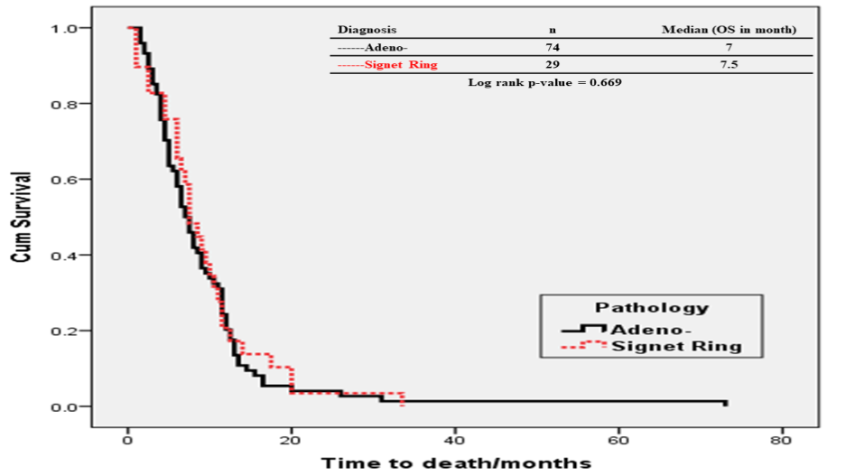

Figure1: The overall survival of the two pathological group

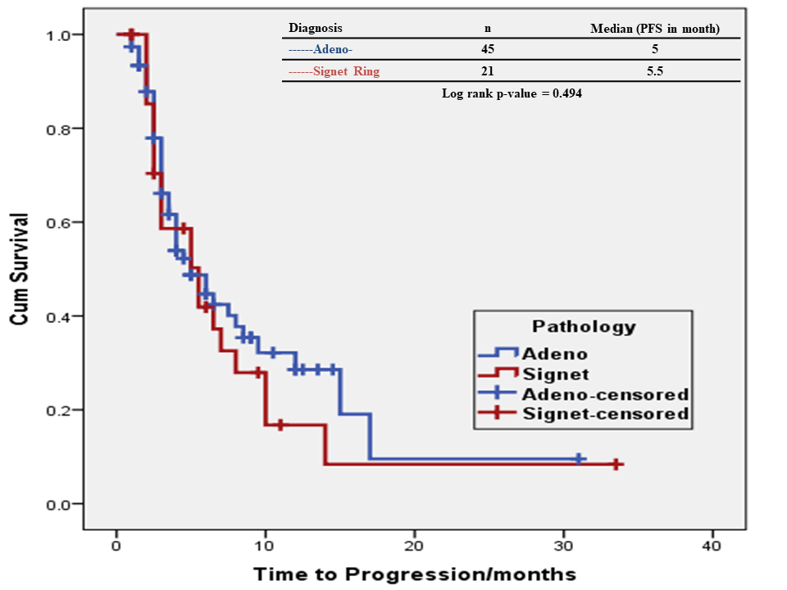

Figure2: The progression free survival of the two pathological group

Conversely, in advanced gastric cancer, the prognosis of SRC is more controversial and is commonly thought to be poor. This was first suggested in retrospective studies [10,11,12].

Liu X et al., reported that 5-yr survival rate of patients with SRC was 36.2%, which was significantly shorter than that in patients with NSRC. Multivariante analysis showed that signet ring cell was an independent prognostic factor. However, this result could be related to the higher proportion of advanced stage tumors among SRC patients. In order to exclude the influence of disease stage at the time of presentation, they performed a subgroup analysis by tumor stage, which showed no significant differences in overall survival rates between SRC and NSRC in stage I and II. However, in stage III tumors, the prognosis was poorer in SRC than NSRC [[13](ttp://www.jcancer.org/v08p3396.htm%22%20\l%20%22B)]. while we found no significant difference among the types of advanced gastric carcinoma. Our results were similar to those of Jiang et al. who reported no significant difference in survival between SRC and non-SRC patients with advanced gastric cancer [[14](http://www.jcancer.org/v08p3396.htm)].

Asian researchers found that SRC is not necessarily prognostically worse than non-SRC. However, heterogenecity of the patients included in the study and the small sized group including unresected or non-curatively resected cases, early-stage disease, and even metastatic disease. In addition, most studies compared SRC with heterogeneous non-SRC tumors after merging them into a single group.

In order to accurately clarify the prognosis of SRC Stage-adjusted analysis is mandatory, which may explain why Western countries that have low EGC prevalence have reported that SRC has a poor prognosis. However, Asian countries with their highly accepted early detection programs, a standardized surgical procedure, and prevailing adjuvant therapy have recently criticized this idea.

They have tried to compare the prognosis between SRC and non-SRC; however, the small sample size has been a limitation.

A recent American study utilizing Surveillance, Epidemiology, and End Results data adopted stage adjustment to overcome these limitations and demonstrated that SRC is not a negative prognostic indicator.

However, concerns exist regarding the reliability of staging and the application of the exact definition of SCS as a large proportion of the patients did not undergo surgical resection.15

Several studies strongly suggested a poor prognosis in cases of SRC, including a French study, which also suggested that the prognostic predictors in SRC differed from those in non-SRC.

According to the French study, SRC histology was a poor prognostic factor. Several case reports also expressed concerns about the risk of SRCs in EGC.

39 cases of overt bone metastasis were reported by Kobayashi in patients with EGC, most of whom had SRCs and poorly differentiated carcinomas.16

**In conclusion**

We found that patients with SRC histology do not have a worse prognosis than those with NSRC carcinoma of the stomach.

Results should be confirmed by prospective studies and larger sample size.

References

1. World Health Organization. GLOBOCAN 2012: estimated cancer incidence, mortality and prevalence worldwide in 2012—stomach cancer. World Heal Organ. 2015. http://globocan.iarc.fr/Pages/fact_sheets_cancer.aspx. Accessed October 5, 2015.
2. Siegel R, Ma J, Zou Z, Jemal A. Cancer statistics, 2014. CA Cancer J Clin 2014; 64:9–29.
3. Chen J, Cai R, Ren G, Zhao J, Li H, Guo C, He W, Wu X, Zhang W. Differences in clinicopathological characteristics and computed tomography findings between signet ring cell carcinoma and nonsignet ring cell carcinoma in early and advanced gastric cancer. Cancer Med. 2018 Apr;7(4):1160-1169. doi: 10.1002/cam4.1417. Epub 2018 Mar 13.
4. Piessen G, Messager M, Leteurtre E, Jean-Pierre T, Mariette C. Signet ring cell histology is an independent predictor of poor prognosis in gastric adenocarcinoma regardless of tumoral clinical presentation. Ann Surg 2009; 250:878–887.
5. Hyung WJ, Noh SH, Lee JH, Jean-Pierre T, Mariette C. Early gastric carcinoma with signet ring cell histology. Cancer 2002; 94:78–83.
6. Kunisaki C, Shimada H, Nomura M, Matsuda G, Otsuka Y, Akiyama H. Therapeutic strategy for signet ring cell carcinoma of the stomach. Brit J Surg 2004; 91:1319–1324.
7. Taghavi S, Jayarajan SN, Davey A, Willis AI. Prognostic significance of signet ring gastric cancer. J Clinic Oncol 2012; 30:3493–3498.
8. Pernot S, Voron T, Perkins G, Lagorce-Pages C, Berger A, Taieb J. Signet-ring cell carcinoma of the stomach: Impact on prognosis and specific therapeutic challenge. World J Gastroenterol. 2015 Oct 28;21(40):11428-38. doi: 10.3748/wjg.v21.i40.11428.
9. Matsuyama S, Ohkura Y, Eguchi H, Kobayashi Y, Akagi K, Uchida K. Estrogen receptor beta is expressed in human stomach adenocarcinoma. J Cancer Res Clin Oncol. 2002;128(6):319–24. doi: 10.1007/s00432-002-0336-3.
10. Cunningham SC, Kamangar F, Kim MP, Hammoud S, Haque R, Maitra A, Montgomery E, Heitmiller RE, Choti MA, Lillemoe KD, Cameron JL, Yeo CJ, Schulick RD. Survival after gastric adenocarcinoma resection: eighteen-year experience at a single institution. J Gastrointest Surg 2005; 9: 718-725 [PMID: 15862270DOI: 10.1016/j.gassur.2004.12.002].
11. Hochwald SN, Kim S, Klimstra DS, Brennan MF, Karpeh MS. Analysis of 154 actual five-year survivors of gastric cancer. JGastrointest Surg 2000; 4: 520-525 [PMID: 11077328].
12. Kunz PL, Gubens M, Fisher GA, Ford JM, Lichtensztajn DY, Clarke CA. Long-term survivors of gastric cancer: a California population-based study. J Clin Oncol 2012; 30: 3507-3515 [PMID: 22949151 DOI: 10.1200/JCO.2011.35.8028].
13. Liu X, Cai H, Sheng W, Yu L, Long Z, Shi Y, Wang Y. Clinicopathological Characteristics and Survival Outcomes of Primary Signet Ring Cell Carcinoma in the Stomach: Retrospective Analysis of Single Center Database. PLoS One. 2015 Dec 7;10(12).
14. Jiang CG, Wang ZN, Sun Z. Liu FN, Yu M, Xu HM. Clinicopathologic characteristics and prognosis of signet ring cell carcinoma of the stomach: results from a Chinese mono-institutional study. J Surg Oncol. 2011;103:700-703.
15. Chon, H.J., Hyung, W.J., Kim, C., Park, S., Kim, J.H., Park, C.H., Ahn, J.B., Kim, H., Chung, H.C., Rha, S.Y. and Noh, S.H., 2017. Differential prognostic implications of gastric signet ring cell carcinoma: stage adjusted analysis from a single high-volume center in Asia. Annals of surgery, 265(5), p.946.
16. Kang, S.H., Kim, J.S., Moon, H.S., Lee, E.S., Kim, S.H., Sung, J.K., Lee, B.S. and Jeong, H.Y., 2017. Signet ring cell carcinoma of early gastric cancer, is endoscopic treatment really risky?. Medicine, 96(33).

7/3/2018