**Lymph node ratio as prognostic factor in patients with stage III rectal carcinoma**

Nehal El-Mashad M.D.1, Mohamed A Alm El-Din M.D. 1,Wael Wahid Mayah M.D. ²,5, Boshra El-Sayed Hussein M.D. ², Ali M Turki M.D.3, Sherif El-Saadany M.D.²,4 Wael M. Elmashad M.D 6

1 Department of Clinical Oncology, Faculty of Medicine, Tanta University, Egypt

2 Department of Tropical Medicine and Infectious Diseases, Faculty of Medicine, Tanta University, Egypt

3 Department of General Surgery, Faculty of Medicine, Tanta University, Egypt.

4 Faculty of Dentistry, King Abdulaziz University, Jeddah, Saudi Arabia

5Fakeeh College for Medical Sciences, Jeddah, Saudi Arabia

6 Physiology Department, Faculty of Medicine, Tanta University Hospital, Egypt

[almeldin@gmail.com](mailto:almeldin@gmail.com)

**Abstract: Introduction:** Although the predictive and prognostic importance of total number of infiltrated lymph nodes in rectal cancer is well established, the role of lymph node ratio (LNR) is yet to be defined.

**Objective:** To test the prognostic value of LNR in patients with rectal cancer. **Patients and Methods:** Data of 232 patients with stage III rectal adenocarcinoma who were treated at the department of Clinical Oncology, Tanta University Hospital from January 2008 to December 2012 was retrospectively analyzed. Only data of 107 were eligible for our study. The cut-off values of LNRs were statistically calculated as 0.21, 0.32, and 0.61 dividing the patients into four groups (LNR 1-4). **Results:** A higher LNR value is significantly correlated with higher tumor grade (P= 0.004), margin involvement, local recurrence and distant metastasis (P = <0.001). Overall Survival (OS) for all patients is 93.2%. Patients with < 12 resected lymph nodes (LNs) have significantly shorter OS (86.1%) than those with ≥12 resected LNs (100%) P value = 0.024. According to LNR, OS for patients with LNR1, LNR2, LNR3 is 100% as compared to 83.3% in those with LNR4 (P value = 0.073). Patients with < 12 resected LN have significantly shorter DFS (16.8 %) than those with ≥12 resected LN (90.7%) P value < 0.001. Similarly, patients with LNR4 have significantly shorter DFS as compared to the three other groups (LNR1-3). **Conclusions:** Higher LNRs (more than or equal to 0.61) have strong independent prognostic impact in stage III rectal cancer, and should be considered for treatment decision making.

[Nehal El-Mashad, Mohamed A Alm El-Din, Wael Wahid Mayah, Boshra El-Sayed Hussein, Ali M Turki, Sherif El-Saadany, Wael M. Elmashad. **Lymph node ratio as prognostic factor in patients with stage III rectal carcinoma.** *Cancer Biology* 2018;8(3):47-55]. ISSN: 2150-1041 (print); ISSN: 2150-105X (online). <http://www.cancerbio.net>. 9. doi:[10.7537/marscbj080318.09](http://www.dx.doi.org/10.7537/marscbj080318.09).

**Keywords:** Rectal cancer, Lymph node ratios.

**1. Introduction**

Rectal tumor is the third most basic malignancy and third driving reason for cancer-related death (1). Complete total mesorectal excision (TME) based surgery is considered the backbone of treatment (2). Unfortunately, recurrence rate after curative surgery is still high (3). High tumor stage and grade, positive lymph node, their total number removed either negative or involved, involved surgical margins, either lymphovascular or perineural invasion have a prognostic impact for recurrence (4). The number of regional LNs involved is an important determinant of disease outcomes (5).

Patients who have received preoperative radiotherapy face a problem due to inadequate lymph nodes excision, which is reflected on TNM staging and in turn patients' prognosis (6).

Lymph node ratio (LNR) is defined as “lymph node metastases (LNM) number divided by the whole number of excised LNs”, is associated with bad prognosis in esophageal and gastric cancers (7,8). Stage III colon cancer bad prognosis is also positively affected by higher LNRs (9).

This study was aimed to assess the stage III rectal cancer outcomes in relation to LNR. We hypothesized that LNR would predict oncological outcomes in those patients.

**2. Patients and Methods**

**Patients**

We retrospectively reviewed data of 232 rectal cancer patients who were treated at the department of Clinical Oncology, Tanta University Hospital from January 2008 to December 2012. They underwent preoperative concomitant chemo-radiotherapy followed by TME for rectal cancer. 125 patients were excluded who had either stage I, II, IV at time of diagnosis or whom not being followed up. Finally, 107 stage III cancer rectum patients were studied.

**Methods:**

**Radiotherapy**

Preoperative pelvic radiotherapy 45 Gy over 25 fractions followed by boost 540 cGy in three fractions. Oral capecitabine “825 mg/m², twice daily” as radio sensitizer, continued in weekends, has been administered for all patients concomitantly with radiotherapy.

**Surgery**

Depending on the evaluation of surgeons, TME with either low anterior resection or abdominoperineal resection was done 6 to 8 weeks after radiochemotherapy. 2-4 weeks following surgery, adjuvant chemotherapy started.

**Lymph node staging:**

Based on the American Joint Committee on Cancer (AJCC), the lymph nodes staging was done (10).

**LNR grouping:**

LNR cut-off values were 0.21, 0.32, and 0.61. The patients were classified into four groups:

Group 1 (LNR1, n = 18) as LNRs < 0.21

Group 2 (LNR2, n = 16) for LNRs between 0.21-0.32

Group 3 (LNR3, n = 41) for LNRs of 0.32-0.61

Group 4 (LNR4, n =32) for LNRs > 0.61.

**Follow-up strategy:**

Physical examination, serum carcinoembryonic antigen (CEA) and have been done at three months interval in the first 2 years then every six months. Abdominopelvic computerized tomography (CT), chest X-ray and/or CT if suspicious at six months interval in the first two years then annually during period of follow-up (11).

Newly developed pelvic mass during follow-up period confirmed either by biopsy or by a continuous increase of the size in the 3-6 month radiologic examinations referred as local recurrence (LR). On the other hand, systemic failure or metastasis documented either with pathologically or radiologically prove. Sustained elevation of serum CEA level considered as a disease recurrence.

**Survival analysis:**

Disease-free survival (DFS) is determined as the interval between proved pathological examination dates until either proven local or distant metastasis. On the other hand, overall survival (OS) is calculated from same dates till the date of last follow-up.

Histopathological characteristics as “tumor stage, lymph node involvement, presence of lympho-vascular invasion, tumor grade”, DFS and OS of the four LNRs groups were statistically correlated.

**Statistical Methods:**

All data were fed to the computer then analysis with IBM SPSS software package version 20.0 (Armonk, NY: IBM Corp). The Kolmogorov- Smirnov, Shapiro and D’agstino test was used to ensure the normality of distribution of variables, Chi-square test (Fisher or Monte Carlo) were assessed categorical variable between groups. Comparison between the four different LNR categories was done using ANOVA for normally distributed data while Kruskal Wallis was used for not normally distributed data. Student t-test or Mann Whitney test was used to compare between Recurrence and non-recurrence cases also between died and survived cases. Kaplan-Meier method was assessed for diseases and overall free survival. Significance o was judged at the 5% level.

**3. Results**

One-hundred and seven patients with stage III rectal cancer who underwent curative TME based surgery with regional LNs dissection following preoperative concomitant chemo-radiotherapy were included in the analysis. Distribution of the studied cases according to different parameters is expressed in Table 1.

**Table (1): Distribution of the studied cases according to different parameters (n= 107)**

|  |  |
| --- | --- |
|  | **No. (%)** |
| **Positive LN** |  |
| Mean ± SD. | 5.3 ± 2.8 |
| Median (Min. – Max.) | 5(1 – 12) |
| **Resected LN** |  |
| Mean ± SD. | 11.8 ± 3.2 |
| Median (Min. – Max.) | 12(4 – 20) |
| ≥ 12 | 69 (64.5%) |
| < 12 | 38 (35.5%) |
| **LNR** |  |
| Mean ± SD. | 0.5 ± 0.3 |
| Median (Min. – Max.) | 0.4(0.1 – 1) |
| LNR 1 | 18(16.8%) |
| LNR 2 | 16(15%) |
| LNR 3 | 41(38.3%) |
| LNR4 | 32(29.9%) |

A higher LNR value is statistically significantly associated with high tumor grade (P= 0.004), margin involvement (P <0.001) Table 2, elevated CEA during follow-up period (Table 3), local recurrence and distant failure (Table 4).

**Oncologic outcomes**

Thirty-Six (33.6%) patients had treatment failure (13.1%) from them with a local recurrence and 16 (15 %) with systemic disease metastasis during the follow-up interval. Six patients (5.6%) developed both local and systemic recurrence, 4 (3.72%) died during follow-up (Table 4).

Treatment failure was significantly associated with older age ≥ 60 (P <0.004), distance from anal verge ≤ 5 cm (P <0.001), margin involvement (P <0.001), grade III tumors, T4 tumors and < 12 resected LN (P <0.001) (Table 5).

Although only 4 patients (3.72%) died during follow-up, mortality was significantly associated with older age ≥ 60 (P <0.001), distance from anal verge ≤ 5 cm (P¬0.016), margin involvement (P=0.004), Grade III tumor (P=0.009), < 12 resected LN (P= 0.014) (Table 6).

**Overall Survival (OS):**

OS for all patients is 93.2% with mean time of 48.883 months (Figure 1), patients with < 12 resected LN have significantly shorter OS (86.1%) than those with ≥12 resected LN (100%) P value = 0.024, (Figure 2). On the other hand, LNR groups have no OS statistically significant impact in rectal cancer patients LNR1, LNR2, LNR3 is 100% and LNR4 is 83.3 % (P value = 0.073) (Figure 3).

**Disease Survival (DFS):**

DFS for all patients is 62.2% with mean time of 38.284months (Figure 4), patients with < 12 resected LN have significantly shorter DFS (16.8 %) than those with ≥12 resected LN (90.7%) with P value < 0.001 (Figure 5). Also, Higher LNR has statistically significant shorter DFS with LNR1 is 88.9%, LNR2 is 100%, LNR3 is 85.1% and LNR4 is 7.3 %( P value = (<0.001) (Figure 6).

**Table (2): Relation between LNR and different parameters (% from total)**

|  |  |  |  |  |  |  |
| --- | --- | --- | --- | --- | --- | --- |
|  | **Total**  **(n = 107)** | **LNR** | | | | **p** |
|  | **LNR 1**  **(n = 18)** | **LNR 2**  **(n = 16)** | **LNR 3**  **(n = 41)** | **LNR 4**  **(n = 32)** |
| **Age (years)** | 60.3 ± 12.4 | 58.3 ± 8.7 | 57.6 ± 10.6 | 59.2 ± 12.5 | 64 ± 14.4 | 0.228 |
| < 60 | 45(42.1%) | 8(7.5%) | 8(7.5%) | 19(17.8%) | 10(9.3%) | 0.513 |
| ≥ 60 | 62(57.9%) | 10(9.3%) | 8(7.5%) | 22(20.6%) | 22(20.6%) |
| **Sex** |  |  |  |  |  |  |
| Male | 70 (65.4%) | 12 (11.2%) | 14 (13.1%) | 24 (22.4%) | 20 (18.7%) | 0.218 |
| Female | 37 (34.6%) | 6 (5.6%) | 2 (1.9%) | 17 (15.9%) | 12 (11.2%) |
| **Distance from anal verge** |  |  |  |  |  |  |
| ≤ 5 cm | 39 (36.4%) | 4 (3.7%) | 4 (3.7%) | 9 (8.4%) | 22 (20.6%) | <0.001* |
| > 5 cm | 68 (63.6%) | 14 (13.1%) | 12 (11.2%) | 32 (29.9%) | 10 (9.3%) |
| **Pathological type** |  |  |  |  |  |  |
| Adenocarcinoma | 99 (92.5%) | 12 (11.2%) | 16 (15.0%) | 41 (38.3%) | 30 (28.0%) | <0.001* |
| Mucoid | 8 (7.5%) | 6 (5.6%) | 0 (0.0%) | 0 (0.0%) | 2 (1.9%) |
| **Margin involvement** |  |  |  |  |  |  |
| Both margins are free | 79 (73.8%) | 16 (15.0%) | 16 (15.0%) | 35 (32.7%) | 12 (11.2%) | <0.001* |
| One or both margins are involved | 28 (26.2%) | 2 (1.9%) | 0 (0.0%) | 6 (5.6%) | 20 (18.7%) |
| **Type of operation** |  |  |  |  |  |  |
| Low anterior resection | 62 (57.9%) | 16 (15.0%) | 11 (10.3%) | 18 (16.8%) | 17 (15.9%) | 0.009* |
| Abdomino- perineal resection+ colostomy | 45 (42.1%) | 2 (1.9%) | 5 (4.7%) | 23 (21.5%) | 15 (14.0%) |
| **Grade** |  |  |  |  |  |  |
| II | 73 (68.2%) | 14 (13.1%) | 14 (13.1%) | 31 (29.0%) | 14 (13.1%) | 0.004* |
| III | 34 (31.8%) | 4 (3.7%) | 2 (1.9%) | 10 (9.3%) | 18 (16.8%) |
| **T Tumor** |  |  |  |  |  |  |
| T2 | 2 (1.9%) | 0 (0.0%) | 0 (0.0%) | 2 (1.9%) | 0 (0.0%) | 0.077 |
| T3 | 33 (30.8%) | 10 (9.3%) | 6 (5.6%) | 11 (10.3%) | 6 (5.6%) |
| T4 | 72 (67.3%) | 8 (7.5%) | 10 (9.3%) | 28 (26.2%) | 26 (24.3%) |
| **N Stage (ypN)** |  |  |  |  |  |  |
| N1 | 30 (28.0%) | 18 (16.8%) | 6 (5.6%) | 6 (5.6%) | 0 (0.0%) | <0.001* |
| N2 | 77 (72.0%) | 0 (0.0%) | 10 (9.3%) | 35 (32.7%) | 32 (29.9%) |

Qualitative data were described using number and percent and was compared using Chi square or Monte Carlo test. While normally quantitative data was expressed in mean ± SD and was compared using ANOVA test, abnormally distributed data was expressed in median (Min. – Max.) and was compared using Kruskal Wallis test

*: Statistically significant at p ≤ 0.05

**Table (3): Relation between LNR and different parameters (% from total)**

|  |  |  |  |  |  |  |
| --- | --- | --- | --- | --- | --- | --- |
|  | **Total**  **(n = 107)** | **LNR** | | | | **p** |
|  | **LNR 1**  **(n = 18)** | **LNR 2**  **(n = 16)** | **LNR 3**  **(n = 41)** | **LNR 4**  **(n = 32)** |
| **Pre/therapy HB** | 11.4 ± 1.7 | 11.3 ± 1.6 | 10.7 ± 1.3 | 11.9 ± 1.7 | 11.2 ± 1.7 | 0.045* |
| **CEA** |  |  |  |  |  |  |
| **Pre therapy** | 2.7(0 – 30) | 2(0 – 6) | 2.9(1 – 15) | 2(1 – 30) | 2.5(1 – 13) | 0.682 |
| ≤ 5 (mcg/L) | 91 (85.0%) | 16 (15.0%) | 14 (13.1%) | 35 (32.7%) | 26 (24.3%) | 0.923 |
| > 5 (mcg/L) | 16 (15.0%) | 2 (1.9%) | 2 (1.9%) | 6 (5.6%) | 6 (5.6%) |
| **Post therapy** | 2(0 – 28) | 2(0 – 3) | 1.5(1 – 2) | 2(0.7 – 28) | 5(1 – 11) | 0.002* |
| ≤ 5 (mcg/L) | 89(83.2%) | 18(16.8%) | 16(15.0%) | 37(34.6%) | 18(16.8%) | <0.001* |
| > 5 (mcg/L) | 18(16.8%) | 0(0.0%) | 0(0.0%) | 4(3.7%) | 14(13.1%) |
| **CA19.9** |  |  |  |  |  |  |
| Pre therapy | 11(0.6 – 100) | 14(0.6 – 65) | 9.5(2 – 30) | 12(5 – 100) | 9(4 – 40) | 0.535 |
| Post therapy | 7(1 – 70) | 6(1 – 34) | 6.5(2 – 30) | 8(4 – 70) | 8.5(3 – 39) | 0.178 |
| **Therapy PS** |  |  |  |  |  |  |
| Pre | 1(1 – 1) | 1(1 – 1) | 1(1 – 1) | 1(1 – 1) | 1(1 – 1) | 1.000 |
| Post | 1(1 – 5) | 1(1 – 2) | 1(1 – 2) | 1(1 – 2) | 1(1 – 5) | 0.054 |

Qualitative data were described using number and percent and was compared using **Chi square or Monte Carlo test**. While normally quantitative data was expressed in mean ± SD and was compared using **ANOVA test**, abnormally distributed data was expressed in median (Min. – Max.) and was compared using **Kruskal Wallis test**

*: Statistically significant at p ≤ 0.05

**Table (4): Relation between LNR and treatment outcomes (% from total)**

|  |  |  |  |  |  |  |
| --- | --- | --- | --- | --- | --- | --- |
|  | **Total**  **(n = 107)** | **LNR** | | | | **p** |
|  | **LNR 1**  **(n = 18)** | **LNR 2**  **(n = 16)** | **LNR 3**  **(n = 41)** | **LNR 4**  **(n = 32)** |
| **Treatment Failure** | 36(33.6%) | 2(1.9%) | 0(0.0%) | 6(5.6%) | 28(26.2%) | <0.001* |
| **DFS** | 29.5 ± 12.9 | 31.8 ± 12.3 | 33.8 ± 10.5 | 35.2 ± 9.9 | 18.8 ± 11.5 | <0.001* |
| **Occurrence of local recurrence alone** | 14(13.1%) | 2 (1.9%) | 0 (0.0%) | 0 (0.0%) | 12(11.2%) | <0.001* |
| **Occurrence of distant metastases alone** | 16(15%) | 0 (0.0%) | 0 (0.0%) | 4(3.7%) | 12(11.2%) | <0.001* |
| **Both local and distant failure** | 6(5.6%) | 0 (0.0%) | 0 (0.0%) | 2 (1.9%) | 4(3.7%) | <0.001* |
| **Mortality** | | | | | | |
| **Survived** | 103(96.3%) | 18(16.8%) | 16(15%) | 41(38.3%) | 28(26.2%) | 0.036* |
| **Death** | 4(3.7%) | 0(0%) | 0(0%) | 0(0%) | 4(3.7%) |
| **OS** | | | | | | |
| **OS** | 40(6 – 50) | 36(23 – 48) | 32.5(20 – 48) | 38(24 – 50) | 44.5(6 – 48) | 0.370 |

Qualitative data were described using number and percent and was compared using **Chi square or Monte Carlo test**. While normally quantitative data was expressed in mean ± SD and was compared using **ANOVA test**, abnormally distributed data was expressed in median (Min. – Max.) and was compared using **Kruskal Wallis test**

*: Statistically significant at p ≤ 0.05

**Table (5): Relation between Treatment Failure and different parameters (n= 107)**

|  | **Occurrence of recurrence** | | **p** |
| --- | --- | --- | --- |
|  | **No**  **(n = 71)** | **Yes**  **(n = 36)** |
| **Age (years)** | 57.8 ± 10.7 | 65 ± 14.3 | 0.004* |
| < 60 | 35(49.3%) | 10(27.8%) | 0.033* |
| ≥ 60 | 36(50.7%) | 26(72.2%) |
| **Sex** |  |  |  |
| Male | 46(64.8%) | 24(66.7%) | 0.847 |
| Female | 25(35.2%) | 12(33.3%) |
| **Distance from anal verge** |  |  |  |
| ≤ 5 cm | 17(23.9%) | 22(61.1%) | <0.001* |
| > 5 cm | 54(76.1%) | 14(38.9%) |
| **Margin involvement** |  |  |  |
| Both margins are free | 69(97.2%) | 10(27.8%) | <0.001* |
| One or both margins are involved | 2(2.8%) | 26(72.2%) |
| **Type of operation** |  |  |  |
| Low anterior resection (LAR) | 45(63.4%) | 17(47.2%) | 0.110 |
| Abdomino- perineal resection+ colostomy (APR) | 26(36.6%) | 19(52.8%) |
| **Pathological type** |  |  |  |
| Adenocarcinoma | 67(94.4%) | 32(88.9%) | 0.438 |
| Mucoid | 4(5.6%) | 4(11.1%) |
| **Grade** |  |  |  |
| II | 61(85.9%) | 12(33.3%) | <0.001* |
| III | 10(14.1%) | 24(66.7%) |
| **T Tumor** |  |  |  |
| T2 | 0(0%) | 2(5.6%) | 0.001* |
| T3 | 29(40.8%) | 4(11.1%) |
| T4 | 42(59.2%) | 30(83.3%) |
| **N Stage (ypN)** |  |  |  |
| N1 | 24(33.8%) | 6(16.7%) | 0.062 |
| N2 | 47(66.2%) | 30(83.3%) |
| **Resected LN** |  |  |  |
| ≥ 12 | 63(88.7%) | 6(16.7%) | <0.001* |
| < 12 | 8(11.3%) | 30(83.3%) |

Qualitative data were described using number and percent and was compared using Chi square test or Fisher Exact test, while normally quantitative data was expressed in mean ± SD and was compared using student t-test, abnormally distributed data was expressed in median (Min. - Max.) and was compared using Mann Whitney test

*: Statistically significant at p ≤ 0.05

**Table (6): Relation between mortality and different parameters (n= 107)**

|  | **Mortality** | | **p** |
| --- | --- | --- | --- |
|  | **Survived**  **(n = 103)** | **Died**  **(n = 4)** |
| **Age (years)** | 59.5 ± 12.1 | 78.5 ± 1.7 | <0.001* |
| < 60 | 45(43.7%) | 0(0%) | 0.137 |
| ≥ 60 | 58(56.3%) | 4(100%) |
| **Sex** |  |  |  |
| Male | 66(64.1%) | 4(100%) | 0.296 |
| Female | 37(35.9%) | 0(0%) |
| **Distance from anal verge** |  |  |  |
| ≤ 5 cm | 35(34%) | 4(100%) | ­0.016* |
| > 5 cm | 68(66%) | 0(0%) |
| **Pathological type** |  |  |  |
| Adenocarcinoma | 97(94.2%) | 2(50%) | 0.027* |
| Mucoid | 6(5.8%) | 2(50%) |
| **Margin involvement** |  |  |  |
| Both margins are free | 79(76.7%) | 0(0%) | 0.004* |
| One or both margins are involved | 24(23.3%) | 4(100%) |
| **Type of operation** |  |  |  |
| Low anterior resection (LAR) | 62(60.2%) | 0(0%) | 0.029* |
| Abdomino- perineal resection+ colostomy (APR) | 41(39.8%) | 4(100%) |
| **Grade** |  |  |  |
| II | 73(70.9%) | 0(0%) | 0.009* |
| III | 30(29.1%) | 4(100%) |
| **T Tumor** |  |  |  |
| T2 | 2(1.9%) | 0(0%) | 0.351 |
| T3 | 33(32%) | 0(0%) |
| T4 | 68(66%) | 4(100%) |
| **N Stage (ypN)** |  |  |  |
| N1 | 30(29.1%) | 0(0%) | 0.575 |
| N2 | 73(70.9%) | 4(100%) |
| **Resected LN** |  |  |  |
| ≥ 12 | 69(67%) | 0(0%) | 0.014* |
| < 12 | 34(33%) | 4(100%) |

Qualitative data were described using number and percent and was compared using Chi square test or Fisher Exact test, while normally quantitative data was expressed in mean ± SD and was compared using student t-test, abnormally distributed data was expressed in median (Min. - Max.) and was compared using Mann Whitney test

*: Statistically significant at p ≤ 0.05

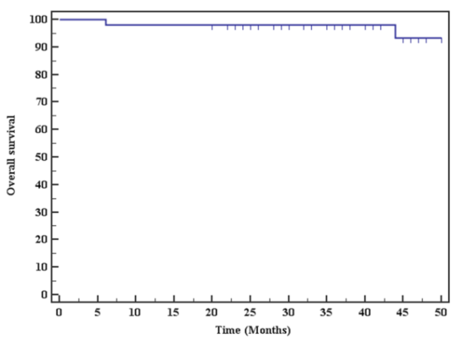

Figure (1): Kaplan-Meier survival curve for Overall survival with mean 48.883 (93.2%).

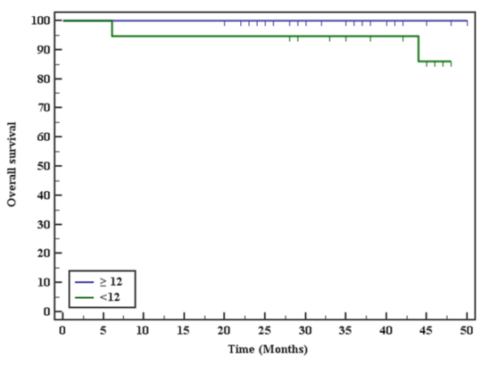

|  |  |  |  |
| --- | --- | --- | --- |
| **Resected LN** | **Mean** | **%** | **Log rank** |
| **< 12** | **45.455** | **86.1** | **5.123\***  **(0.024*)** |
| **≥ 12** | **50.0** | **100.0** |

Figure (2): Overall survival for resected LN

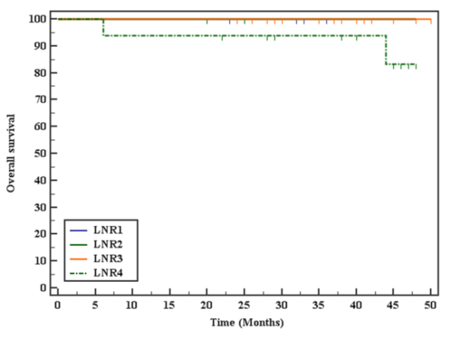

|  |  |  |  |
| --- | --- | --- | --- |
| **LNR** | **Mean** | **%** | **Log rank** |
| 1 | 48.0 | 100.0 | 6.974  (0.073) |
| 2 | 48.0 | 100.0 |
| 3 | 50.0 | 100.0 |
| 4 | 44.958 | 83.3 |

Figure (3): Kaplan-Meier survival curve for Overall survival with LNR

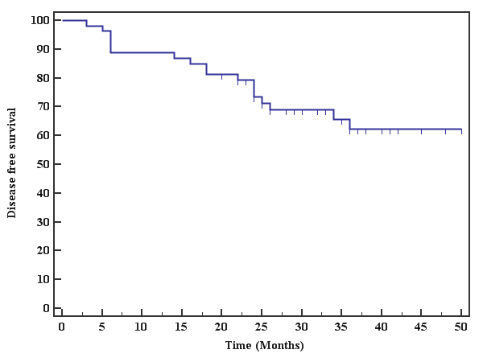

|  |  |  |
| --- | --- | --- |
|  | **Mean** | **%** |
| **Disease free survival** | 38.284 | 62.2 |

Figure (4): Kaplan-Meier survival curve for disease free survival (DFS) for all rectal cancer patients

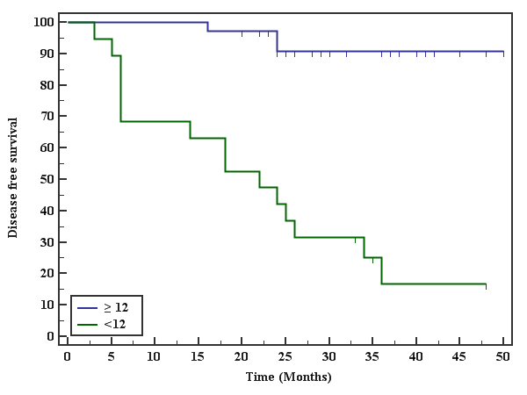

**Disease free survivalwithresected LN**

|  |  |  |  |
| --- | --- | --- | --- |
| **Resected LN** | **Mean** | **%** | **Log rank** |
| ≥ 12 | 47.359 | 90.7 | 61.236*  (<0.001*) |
| < 12 | 22.684 | 16.8 |

Figure (5): Kaplan-Meier survival curve for disease free survival with resected LN

**4. Discussion**

Quality of life of rectal cancer patientsis an important part of primary treatment outcomes. The most important prognostic factors for rectal cancer are both the degree of bowel wall penetration and nodal involvement (12). TNM staging system has been corner stone for assessing rectal cancer patient’s prognosis. Adequate lymph nodes has an impact on improve rectal cancer patient’s survival (13). Survival impact occurred with twelve or more lymph nodes excised (14).

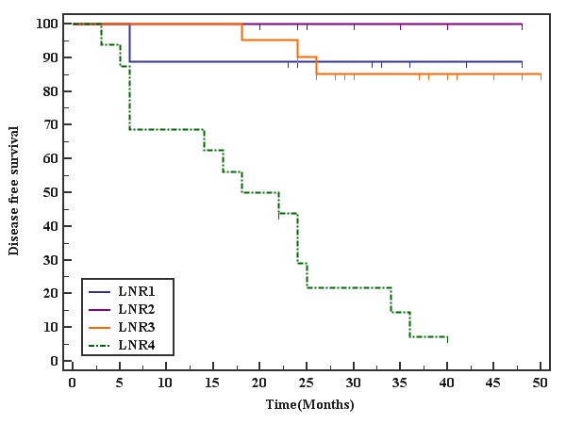

**Disease free survival with LNR**

|  |  |  |  |
| --- | --- | --- | --- |
| **LNR** | **Mean** | **%** | **Log rank** |
| 1 | 43.333 | 88.9 | 80.102*  (<0.001*) |
| 2 | 48.0 | 100.0 |
| 3 | 45.933 | 85.1 |
| 4 | 19.344 | 7.3 |

Figure (6): Kaplan-Meier survival curve for disease free survival with LNR

Neo-adjuvant chemo-radiotherapy has become state of art in locally advanced rectal cancer management, which may reduce local recurrence (15) without increase the incidence of postoperative complications (16). Preoperative radiotherapy has an important value for the patients (17) especially if down-staging achieved (18). Surgeons face difficulty to excise adequate lymph nodes number especially after radiation therapy (19), as only third of them can get ≥12 lymph nodes. In this situation, real value of lymph nodes cannot be expressed in N stage (20).

LNR is an area which remains controversial. An increase in the number of metastatic nodes as well as a decrease in the number of harvested nodes increases the LNR. An increasing number of positive nodes have also been shown to have poor oncology outcomes (14). Researcher has been studied the prognostic value of LNR for colorectal cancer. The present study excludes colon cancer because the modality of treatment for rectal tumors differs and radiation may interfere with adequate lymph nodes excision.

We demonstrated that, LNR may improve nodal stage system in prediction of outcomes as higher ratio can predict increase risk of disease recurrence for stage III rectal cancer. Previous studies proved the positive impact of LNR for rectal cancer patients (21, 22, 23), especially with more than 12 lymph nodes harvest (24).

Our results are matched with other studies, which focused only on rectal cancer (25, 26, 27, 28, 29, 30) proved the LNR’s survival impact. As regards OS, our data showed non statistically significant shorter survival with higher LNR. Resenburg et al. (27) investigated one of the largest studies on LNR in colorectal cancer patients over 25-years. They used the cutoff values of 0.17, 0.41 and 0.69 for the analysis. This study is carried on 1,263 patients demonstrated that the higher LNR was directly related to poor survival. They included all staged colorectal cancers for their analysis. There was no further subdivision on rectal cancers undergoing anterior resections and abdominoperineal resections. We focus was on LNR in only stage III rectal cancers, which underwent TME based surgery.

Peschaud et al. (28) studied 307 rectal cancer patients, reported LNR as an independent factor for prognosis, regardless the number of LN excised. Some limitations apply to their results as they mixed rectal tumor sites in data interpretation (27,28), upper rectal cancer patients are included which is biologically different from low and mid rectum (30), had a short median follow-up with less than 60 months (26, 27,28,29,30), no data express the surgical technique used, or even use of TME or not (27). Our data prove that regardless adequate number of excised lymph node. Also, LNR cannot offer a better staging system if 12 lymph nodes or more are harvest. As a fact, the excised number of lymph node is indirect proportionate to radiation therapy sensitivity. So, N stage cannot represent outcomes prediction. Our results are in line with those listed by Rosenberg and his colleagues (27) and Peschaud et al (28), which detect the importance of LNR regardless the number of resected LN.

We are presenting LNR as a clinical useful tool, an easy applicable way to detect oncological outcomes. As lymph node harvest is multifactorial, varying from surgeon's experience, techniques to anatomical variation and also neoadjuvant radio/chemoradiotherapy. More studies and efforts are needed to detect the LNR clinical potency for rectal cancer.

**Conclusions:**

Higher LNRs (more than or equal to 0.61) have strong independent prognostic impact in stage III rectal cancer, and should be considered for treatment decision making. Further studies are needed on larger number of patients with stage III rectal cancer to validate our results.

**Conflict of interest**

The authors declared no conflict of interest

**Corresponding author:**

Mohamed A. Alm El-Din, M.D.

Associate Professor of Clinical Oncology

Department of Clinical Oncology

Tanta University Hospital

[almeldin@gmail.com](mailto:almeldin@gmail.com)

**Reference:**

1. Siegel R, Desantis C, Jemal A. Colorectal cancer statistics, 2014. CA Cancer J Clin. 2014 Mar-Apr; 64(2):104-17. doi: 10.3322/caac.21220. Epub 2014 Mar 17.
2. Bertelsen CA, Neuenschwander AU, Jansen JE, Wilhelmsen M, Kirkegaard-Klitbo A, Tenma JR, et al. Disease-free survival after complete mesocolic excision compared with conventional colon cancer surgery: a retrospective, population-based study. Lancet Oncol. 2015 Feb;16(2):161-8. doi: 10.1016/S1470-2045(14)71168-4. Epub 2014 Dec 31.
3. Cihan S, Kucukoner M, Ozdemir N, Dane F, Sendur MA, Yazilitas D, et al. Recurrence risk and prognostic parameters in stage I rectal cancers. Asian Pac J Cancer Prev 2014; 15(13):5337‑41.
4. McArdle CS, Hole DJ. Emergency presentation of colorectal cancer is associated with poor 5‑year survival. Br J Surg 2004; 91(5):605‑9.
5. Gao P, Song YX, Wang ZN, Xu Y, Tong L, Sun J, et al. Is the prediction of prognosis not improved by the seventh edition of the TNM classification for colorectal cancer? Analysis of the Surveillance, Epidemiology, and End Results (SEER) database. BMC Cancer 2013; 13: 123.
6. Joseph NE, Sigurdson ER, Hanlon AL, Wang H, Mayer RJ, et al. Accuracy of determining nodal negativity in colorectal cancer on the basis of the number of nodes retrieved on resection. Ann Surg Oncol 2003; 10(3): 213-218.
7. Ooki A, Yamashita K, Kobayashi N Katada N, Sakuramoto S, Kikuchi S, et al. Lymph node metastasis density and growth pattern as independent prognostic factors in advanced esophageal squamous cell carcinoma. World J Surg. 2007 Nov; 31(11):2184-91. Epub 2007 Aug 24.
8. Yamashita K, Ooki A, Sakuramoto, Kikuchi S, Katada N, Kobayashi N, et al. Lymph node metastasis density (ND)-factor association with malignant degree and ND40 as “non-curative factor” in gastric cancer. Anticancer Res 2008; 28(1B): 435–41.
9. Chen SL, Steele SR, Eberhardt J Zhu K, Bilchik A, Stojadinovic A. Lymph node ratio as a quality and prognostic indicator in stage III colon cancer Ann Surg. 2011; 253(1):82–7.
10. Edge SB, Byrd DR, Compton CC, Fritz AG, Greene FL, Trotti A (eds): AJCC Cancer Staging Manual. 7th edition. Springer, New York, NY, 2010.
11. [Guideline] National Comprehensive Cancer Network. NCCN Clinical Practice Guidelines in Oncology. Rectal Cancer. Available at <http://www.nccn.org/professionals/physician_gls/PDF/rectal.pdf>. Version 3.2017 — March 13, 2017; Accessed: November 8, 2017.
12. Shin JY, Hong KH. Prognostic Significance of Lymph Node Ratio in Stage III Rectal Cancer. J Korean Soc Colo proctol. 2011; 27(5): 252–259.
13. Onitilo AA, Stankowski RV, Engel JM, Doi SA. Adequate lymph node recovery improves survival in colorectal cancer patients. J Surg Oncol. 2013; 107(8): 828-834.
14. Kanemitsu Y, Komori K, Ishiguro S, Watanabe T, Sugihara K. The relationship of lymph node evaluation and colorectal cancer survival after curative resection: a multi-institutional study. Ann Surg Oncol.2012; 9(7): 2169-2177.
15. Sauer R, Liersch T, Merkel S, Fietkau R, Hohenberger W, Hess C, et al. Preoperative versus postoperative chemoradiotherapy for locally advanced rectal cancer: results of the German CAO/ARO/AIO-94 randomized phase III trial after a median follow-up of 11 years. J Clin Oncol. 2012; 30(16): 1926-1933.
16. Sauer R, Fietkau R, Wittekind C, Rödel C, Martus P, Hohenberger W, et al. Adjuvant vs. neo adjuvant radiochemotherapy for locally advanced rectal cancer: the German trial CAO/ARO/AIO-94. Colo rectal Dis. 2003; 5(5): 406-415.
17. Park JH, Yoon SM, Yu CS, Kim JH, Kim TW, et al. Randomized phase 3 trial comparing preoperative and postoperative chemoradiotherapy with capecitabine for locally advanced rectal cancer. Cancer. 2011; 117(16): 3703-3712.
18. Du CZ, Li J, Cai Y, Sun YS, Xue WC,Gu J. Effect of multidisciplinary team treatment on outcomes of patients with gastrointestinal malignancy. World J Gastroenterol. 2001; 17(15): 2013-2018.
19. La Torre M, Mazzuca F, Ferri M, Mari FS, Botticelli A, Pilozzi E, et al. The importance of lymph node retrieval and lymph node ratio following preoperative chemoradiation of rectal cancer. Colorectal Dis. 2013; 15(7): e382-e388.
20. Wang H, Safar B, Wexner SD, Denoya P, Berho M. The clinical significance of fat clearance lymph node harvest for invasive rectal adenocarcinoma following neoadjuvant therapy. Dis Colon Rectum. 2009; 52(10): 1767-1773.
21. Allaix ME, Arezzo A, Cassoni P, Mistrangelo M, Giraudo G, Morino M. Metastatic lymph node ratio as a prognostic factor after laparoscopic total mesorectal excision for extraperitoneal rectal cancer. Surg Endosc. 2013; 27(6):1957-67.
22. Tayyab M, Sharma A, Macdonald AW, Gunn J, Hartley JE, Monson J. Prognostic significance of lymph node ratio in patients undergoing abdominoperineal resection of rectum. Langenbeck's Archives of Surgery. 2012; 397(7): 1053-1057.
23. Junginger T, Goenner U, Lollert A, Hollemann D, Berres M, Blettner M. The prognostic value of lymph node ratio and updated TNM classification in rectal cancer patients with adequate versus inadequate lymph node dissection. Tech Coloproctol. 2014; 18(9):805-11.
24. Klos CL, Bordeianou LG, Sylla P, Chang Y, Berger DL. The prognostic value of lymph node ratio after neoadjuvant chemoradiation and rectal cancer surgery. Dis Colon Rectum. 2011;54(2):171-5.
25. Edler D, Ohrling K, Hallström M, Karlberg M, Ragnhammar P. The number of analyzed lymph nodes - a prognostic factor in colorectal cancer. Acta Oncol. 2007; 46(7):975-81.
26. Peng JJ, Xu Y, Guan ZQ, Zhu J, Wang M, Cai G, et al. Prognostic significance of the metastatic lymph node ratio in node-positive rectal cancer. Ann Surg Oncol. 2008 Nov; 15(11):3118-23.
27. Rosenberg R, Friederichs J, Schuster T, Gertler R, Maak M, Becker K, et al. Prognosis of patients with colorectal cancer is associated with lymph node ratio. A single-center analysis of 3026 patients over a 25-year time period. Ann Surg. 2008 Dec; 248(6):968-78.
28. Peschaud F, Benoist S, Julié C, Beauchet A, Penna C, Rougier P, et al. Prognosis of patients with colorectal cancer is associated with lymph node ratio: a single-center analysis of 3026 patients over a 25-year time period. Ann Surg. 2008 Dec; 248(6):1067-73.
29. Kim YS, Kim JH, Yoon SM, Choi EK, Ahn SD, Lee SW, et al. Lymph node ratio as a prognostic factor in patients with stage III rectal cancer treated with total mesorectal excision followed by chemoradiotherapy. Int J Radiat Oncol Biol Phys. 2009 Jul 1; 74(3):796-802.
30. Priolli DG, Cardinalli IA, Pereira JA, Alfredo CH, Margarido NF, Martinez CA. Metastatic lymph node ratio as an independent prognostic variable in colorectal cancer: study of 113 patients. Tech Coloproctol. 2009; 13(2):113–121.

8/29/2018