**Immunohistochemical expression of 5-Hydroxymethylcytosine (5hmC) and mutational analysis of IDH1 gene in patients with diffuse astrocytoma WHO grade II: clinical value and impact on survival**

Fatma Gharib1, Omnia Abd –El-Fattah1, Yomna zamzam2, Ayman Elsaka2 and Mona Mohamed Watany3

**1**Departments of Clinical Oncology, **2** Pathology and

**3** Clinical Pathology, Tanta University Hospitals, Egypt.

[omniaabdelfattah@yahoo.com](mailto:omniaabdelfattah@yahoo.com)

**Abstract:** **Background:** Diffuse astrocytoma (WHO grade II) is a primary low-grade, slow growing tumor, but has high recurrence rate. The 2016 edition of WHO classification, classified gliomas according to histopathologic appearance and molecular parameters. 5-Hydroxymethylcytosine (5hmC) is considerable epigenetic marker. Regulation of 5hmC in malignant glioma may represent an important determinant of tumor differentiation and aggressive behavior. **Aim:** our study measured the level of 5hmC in diffuse astrocytoma WHO grade II and analyze its relationship with other molecular markers to investigate their potential roles as prognostic indicator for astrocytoma patients. **Patients & Methods:** This prospective study included 55 adult patients with histologically confirmed grade II astrocytoma on the basis of WHO grading system. Those patients treated at Tanta University Hospitals through the period from January 2015 to June 2018. **Results:** low level of 5hmC was significantly associated with tumor size ≥5cm (P < 0.001), but there was nonsignificant correlation between 5hmc level and age, gender, location and extent of resection. Also, there is significant correlation between high level of 5hmC and presence of isocitrate dehydrogenase1(IDH1) mutation, low level Ki-67 and low level of P53 (P <0.001, P=0.007 and P=0.001 respectively). Univariate analysis revealed significant correlation between overall survival and 5hmC, IDH1 status and Ki-67.

**Conclusion** Molecular classification may frame diffuse infiltrating astrocytomas into variable pathogenic and prognostic groups, to allow better treatment strategies.

**[**Fatma Gharib, Omnia Abd –El-Fattah, Yomna zamzam, Ayman Elsakaand Mona Mohamed Watany. **Immunohistochemical expression of 5-Hydroxymethylcytosine (5hmC) and mutational analysis of IDH1gene in patients with diffuse astrocytoma WHO grade II: clinical value and impact on survival.** *Cancer Biology* 2018;8(3):70-76]. ISSN: 2150-1041 (print); ISSN: 2150-105X (online). <http://www.cancerbio.net>. 12. doi:[10.7537/marscbj080318.12](http://www.dx.doi.org/10.7537/marscbj080318.12).

**Key words:** Diffuse astrocytoma WHO grade II. 5-Hydroxymethylcytosine**.** isocitrate dehydrogenase1 mutation**.**

**1. Introduction**

Diffuse astrocytoma (WHO grade II) is primary low-grade brain tumor (1). Astrocytoma grade II is relatively slow growing tumor, but with high recurrence rate due to diffuse infiltration of brain tissue and intrinsic malignant potential to transform into high-grade astrocytoma (2).

The 2007 WHO classification system has combined tumor nomenclature with implied grading system so, histologic diagnosis directly correlates with tumor histologic grade (3). This classification system is based on microscopic characteristics of gliomas which limit adequate assessment of prognosis and planning of treatment. It becomes obvious that different molecular alterations underlie different glioma subtypes (4).

The 2016 WHO splits the traditional principle of diagnosis based on histologic criteria only and integrates molecular markers (5).

The 5hmC is DNA pyrimidine nitrogen base. It is formed from the DNA base cytosine by adding methyl group and then hydroxy group. It is principal in epigenetics, because hydroxymethyl group on the cytosine can possibly switch a gene on and off. highest level of 5hmC is present in central nervous system (6).

The 5hmC is not only an intermediate of DNA demethylation, but also acts as stable epigenetic marker. Considerable evidence detected that, 5hmC globally decreased in most malignancies, including gliomas (7).

Reduction of 5hmC was closely associated with higher pathological grades and shorter survival in gliomas (4).

In current study, we measured the level of 5hmC in diffuse astrocytoma, grade II and analyzed its relationship with other molecular markers to investigate their potential roles as prognostic indicator for astrocytoma.

**2. Patients and Methods**

Our prospective study included 55 adult patients with histologically confirmed grade II astrocytoma (8). Those patients treated at Tanta University Hospitals (from January 2015 to June 2018).

The inclusion criteria were grade II astrocytomas, intracranial localization and age ≥ 18 years. Clinical data including gender, karnofasky performance status, age, tumor location (supra- or infratentorial), treatment (gross total resection, partial resection or biopsy), radiotherapy and survival were tabulated.

Tumor specimens were obtained by surgical resection (including biopsy). Written informed consent for use of the specimens. Formalin-fixed, paraffin-embedded specimens were pathologically examined.

All patients underwent computed tomography (CT) planning for three-dimensional conformal radiotherapy with 6 MV linear accelerator photon beams. Radiotherapy dose was 54 Gy/30 fractions in 1.8 Gy/ fraction, 5 fractions a week over 6 weeks. All patients received dehydrating measures during radiotherapy then gradually withdrawn. After completion of therapy, patients were observed at 3-month intervals during the first 3 years then at 6-month intervals. Survival was calculated from date of diagnosis to either date of death or last follow-up.

**Immunohistochemistry for 5hmC**

Active Motif, Rixensart, Belgium dilution 1:1000, P53 (DO-7, Dako, Carpinteria, CA, USA; dilution 1:100) and KI67 (MIB-1, Dako, Glostrup, Denmark; dilution 1:50) was performed in tissue sections of glioma samples.

Paraffin embedded tissue blocks were cut to 4μm sections and deparaffinized and rehydrated using xylene and ethanol; 3% H2O2 in phosphate buffered saline (PBS) was used to inactivate the endogenous peroxidase. The slides were blocked with goat serum to reduce nonspecific binding and then incubated with primary 5hmC (1:1000 dilution) antibody overnight at 4 °C. Diaminobenzidine (DAB) substrate was used for detection and hematoxylin was used for counterstaining. The samples were then mounted for visualization.

Each stained slide was individually reviewed and scored by 2 independent observers. All studied markers were nuclear localization. Microscopic areas with highest labeling intensity were chosen for calculation using image J analysis.

The 5hmC staining was scored using a 9-point scale based on the product of staining intensity (no staining = 0, weak staining = 1, moderate staining = 2, strong staining = 3), and staining extent (% of positive cells; <5% = 0, 5%–30% = 1, 30%–60% = 2, >60% = 3). To facilitate statistical analysis, samples were divided into 2 groups according to staining scores. Group 1 had no or weak staining with the scores of 0 to 3. Group 2 had moderate and strong staining with the scores from 4 to 9 (**Figure 1**). P53 or KI-67 labeling index (LI) was defined as the percentage of immunoreactive tumor cell nuclei (**Figure 2**). For statistical analysis, cutoff value of L1 for P53 and KI67 was 10% and 4% respectively according to previous reports.

|  |  |
| --- | --- |
|  |  |

**Fig. 1: Immunoexpression of 5hmC: astrocytoma grade II score 9 X 200**

|  |  |
| --- | --- |
| **H:\3.png** | **H:\4.png** |

**Fig.2: P53 score 18% (2a) and KI67 score 7% (2b) astrocytoma grade II (X 200)**

**Methodology of detection of IDH1 mutation**

Genomic DNA was extracted from peripheral blood samples collected on K3EDTA using PureLink™ genomic DNA Kit (Carlsbad, USA) according to manufacturer illustration.

The DHT1 gene was amplified using 400 nM of each primer f: CGGTCTTCAGAGAA GCCATT and r: GCAAAATCACATTATTGCCAAC, 30 ng DNA and 12.5 ul of 2X taq based master mix in a total reaction volume of 25 ul. Thermal profile was initial denaturation at 95o followed by 35 cycles of 94o for 30 sec, 48oc for 1 min and 72oc for 1 min with final extension at 72oc for 10 min (biometra thermal cycler, Germany). The PCR product (fragment of 129 bp) was visualized by 2% agarose gel electrophoresis stained with ethidium bromide.

The PCR product was purified before the cycle sequencing reaction using QIAquick PCR Purification Kit (Qiagen, GmbH, Germany) according to manufacturer protocol.

Sanger Sequencing; the cycle sequencing reaction was carried out using big dye terminator sequencing kit v3.1 (applied biosystems, Foster City, USA), 3.2 pmol of the forward primer and 3 ul of the purified PCR product in total reaction volume of 20 ul. 25 cycles of denaturation at 96oc for10 sec, annealing at 48 oc for 5 sec and extension at 60 oc for 4 min were run. Sequences were determined using the ABI 3100 Genetic Analyzer (Applied Biosystems).

**Statistical analysis**

Survival was assessed and compared by Kaplan-Meier and log-rank test. P-values < 0.05 were considered significant. Overall Survival was calculated from date of diagnosis to either date of death or last follow-up.

**3. Results**

**Patients´ clinicopathological features**

Our study included 55 patients, diagnosed pathologically to have type II astrocytoma. The mean age was 40 years (range 19-61 years). Male patients represented 65.4% of all patients (36/55). Female represented 34.6%.

Most of astrocytoma located in supratentorial area (61.8%) while 38.9% located in other sites. Tumor size was < 5cm in 36 patients (65.4%) and ≥ 5cm in 19 patients (34.6%). Seventeen patients (30.9%) undergone gross total resection (GTR), while subtotal resection (STR) reported in 69.1% of all patients. High 5hmc score was detected in 69.1% of cases. Thirty -four (61.8%) patients has Ki-67≤4 and 67.3% had P53 <10 (**Table1**)

Thirty of the studied patients (54.5%) had different IDH1 mutations. Table (2) summarized the types and frequencies of the detected mutations in IDH1 codon 132.

**Table (1): Clinicopathological features of the patients**

|  |  |
| --- | --- |
| **Patient characters** | **Number (%)** |
| Mean age (range) | 40 (19-61) |
| **Age**  >40  <40 | 27 (49)  28 (51) |
| **Gender**  Male  Female | 36 (65.4)  19 (34.6) |
| **Location**  Supratentorial  Other | 34 (61.8)  21 (38.9) |
| **Tumor size**  ≥5cm  <5cm | 36(65.4)  19 (34.6) |
| **Extent of resection**  GTR  STR | 17 (30.9)  38 (69.1) |
| **5hmc score**  0-3  4-9 | 17 (30.9)  38 (69.1) |
| **IDH1**  Mutant type  Wild type | 30 (54.5)  25 (45.5) |
| **Ki-67**  ≤4  >4 | 34 (61.8)  21 (38.2) |
| **P53**  ≤10  >10 | 37 (67.3)  18 (32.7) |

Low 5hmc score was significantly associated with tumor size ≥ 5cm (***P***< 0.001), while association of 5hmc level and age, gender, location and extent of resection was non-significant (**Table 3).**

We reported significant correlation between high level of 5hmC and presence of IDH1 mutation, low level Ki-67 and low level of P53 (**P**<0.001, **P**=0.007 and **P**=0.001 respectively) (**Table 4)**.

**Table (2): The detected mutations in IDH1 codon 132**

|  |  |  |
| --- | --- | --- |
| **Nucleotide Change** | **Number** | **%** |
| G395A | 26/30 | 86.67% |
| C394T | 2/30 | 6.67% |
| C394A | 1/30 | 3.33% |
| C394G | 1/30 | 3.33 |

**Table (3): Correlation of 5hmC and clinicopathological features.**

|  |  |  |  |
| --- | --- | --- | --- |
| **Prognostic factors** | **5hmC score** | | ***P* value** |
| **(0-3)** | **(4-9)** |
| **Age**  ≤40: >40 | 8:9 | 20:18 | 0.702 |
| **Gender**  Male: female | 13:4 | 23:15 | 0.360 |
| **Location**  Supratentorial: other | 8:9 | 26:12 | 0.132 |
| **Size**  **<**5 cm³: ≥ 5 cm³ | 0:17 | 36:2 | 0.001 |
| **Resection**  Total: subtotal | 6:11 | 11:27 | 0.638 |

**Table (4): Correlation of 5hmC and other molecular markers**

|  |  |  |  |
| --- | --- | --- | --- |
| **Molecular marker** | 5hmC score | | ***P* value** |
| (0-3) | (4-9) |
| **IDH1**  Mutation: wild type | 2:15 | 28:10 | <0.001 |
| **Ki 67 label index**  ≤4: >4 | 6:11 | 28:10 | 0.007 |
| **P53 label index**  ≤10:>10 | 6:11 | 31:7 | 0.001 |

**Survival analysis**

The mean disease-free survival was 32 months (**95% CI** 29.6:34.3) with 2- year DFS was 81%. Univariate analysis indicated that, high 5hmc level, IDH1 mutant type and Ki-67≤4 was significantly associated with better overall survival. Patients with P53<10 had longer survival but not statistically significant.

**Overall survival and 5hmC level:**

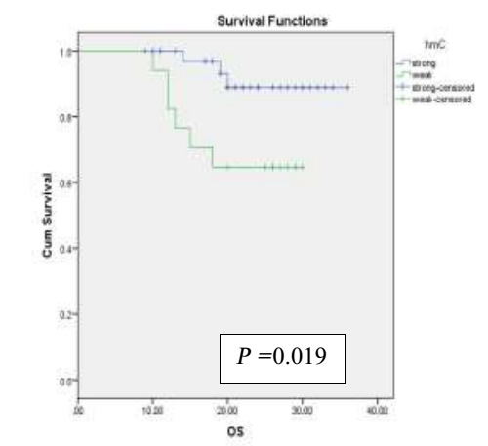

Figure (3): The 2-year overall survival rate was 88.9% and 64.7% for high and low level 5hmc respectively.

**Overall survival and IDH1 mutation**

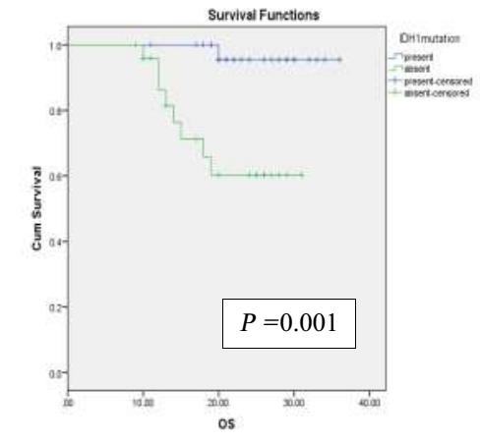

Figure (4): The 2-year survival rate was 95% and 60.3% for mutant IDH1 and wild type respectively

**Overall survival and Ki-67**

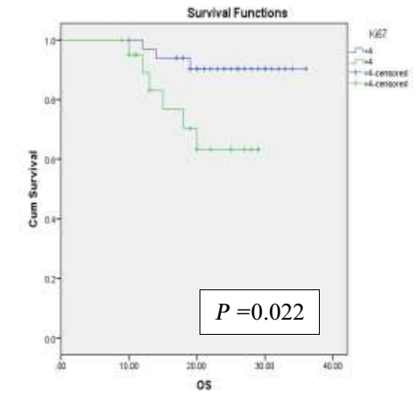

Figure (5): The 2-year survival rate was 90.3% and 63.3% for Ki-67≤4 and Ki-67>4 respectively

**Overall survival and P53**

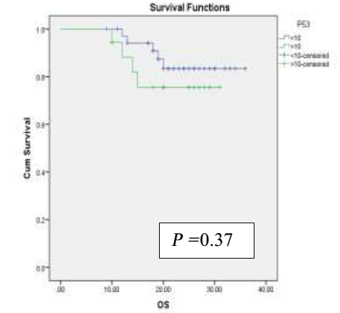

Figure (6): The 2-year survival rate was 83.4% and 75.6% for P53≤10 and P53>10 respectively.

**4. Discussion**

Central nervous system tumors have recently been classified by focus on molecular pathology rather than histopathology (9). Isocitrate dehydrogenase and 5hmc are considered as significant prognostic biomarkers in gliomas (10,11,12).

Maximal resection for patients with low-grade glioma, is associated with better survival (13).

Recently, both clinical and molecular factors should be taken into account when deciding postsurgical treatment for patients with grade II or III gliomas with radiotherapy and chemotherapy (14,15).

In the current study, we measured the level of 5hmc in diffuse astrocytoma and we observed significant correlation between OS and 5hmC. The 2-year OS for patients with strong 5hmc was 88.9%. Consistent with our findings, Brent et al 2012 and Zhang et al 2016 evaluated 5hmC by IHC in considerable groups of gliomas and found that 5hmC reduction was obviously associated with shortened survival of glioma patients (16).

The 2-year OS in the current study was 83.4% for patients with P53 <10 in contrast with Ständer et al, 2004 who did not report this prognostic relevance this may be due to the difference in the WHO classification that the patients based on (17).

About 54.5% of the studied patients had mutated IDH1, this less than reported by Hartmann et al among their studied patients (18).

Our study reported significant correlation between IDH1 and survival in contrast with Aibaidula et al 2017 who failed to detect this significance in low grade glioma (19). As consistent with our results, IDH1 mutations as favorable prognostic marker has been explained in several studies (20-22).

There is significant correlation between level of 5hmc and tumor size, presence of IDH mutation, low level Ki-67 and low level of P 53, which agrees with other studies (22-25).

**Conclusion**

Low level of 5hmC was associated with reduced survival in type II astrocytoma, suggesting that the mechanisms responsible for regulating 5hmC may represent potential future therapeutic target.

**Conflict of interest**

The authors declare that they have no conflict of interest.

**References**

1. Forst DA, Nahed BV, Loeffler JS, Batchelor TT. Low-grade gliomas. Oncologist. 2014 Apr; 19(4):403-13.
2. Lind-Landström T, Habberstad AH, Sundstrøm S, Torp SH. Prognostic value of histological features indiffuseastrocytomas WHO grade II. Int J Clin Exp Pathol. 2012; 5(2): 152-8.
3. Louis DN, Perry A, Reifenberger G, von Deimling A, Figarella-Branger D, Cavenee WK, Ohgaki H, Wiestler OD, Kleihues P, Ellison DW. The2016World Health Organization Classification of Tumors of the Central Nervous System: a summary. Acta Neuropathol. 2016 Jun;131(6):803-20.
4. Zhang F, Liu Y, Zhang Z, Li J, Wan Y, Zhang L, Wang Y, Li X, Xu Y, Fu X, Zhang X, Zhang M, Zhang Z, Zhang J, Yan Q, Ye J, Wang Z, Chen CD, Lin W, Li Q.5- hydroxymethylcytosine loss is associated with poor prognosis for patients with WHO grade II diffuse astrocytomas. Sci Rep. 2016 Feb 11;6:1-14.
5. Masui K, Mischel PS, Reifenberger G. Molecular classification of gliomas. Handb Clin Neurol. 2016;134:97-120.
6. Renciuk D1, Blacque O, Vorlickova M, Spingler B. Crystal structures of B-DNA dodecamer containing the epigenetic modifications 5-hydroxymethylcytosine or 5-methylcytosine. Nucleic Acids Res.2013 Nov;41(21):9891-900.
7. Sun W, Zang L, Shu Q, Li X. From development to diseases: the role of 5hmC in brain. Genomics. 2014 Nov;104(5):347-51.
8. Louis DN, Ohgaki H, Wiestler OD, Cavenee WK: WHO Classification of Tumors of the Central Nervous System, 4th edition IARC: Lyon; 2007.
9. Rogers TW, Toor G, Drummond K, Love C, Field K, Asher R, Tsui A, Buckland M, Gonzales M. The 2016 revision of the WHO Classification of Central Nervous System Tumours: retrospective application to a cohort of diffuse gliomas. J Neurooncol. 2017 Dec 7. 131(6):803-20.
10. Louis DN, Ohgaki H, Wiestler OD, Cavenee WK (WHO Classification of Tumours of the Central Nervous System, 5th edition IARC, Lyon; 2016.
11. Wang J, Zhao YY, Li JF, Guo CC, Chen FR, Su HK, Zhao HF, Long YK, Shao JY, To Ss, Chen ZP. IDH1 mutation detection by droplet digital PCR in glioma. Oncotarget. 2015 Nov 24;6(37):39651-60.
12. Kraus TF, Globisch D, Wagner M, Eigenbrod S, Widmann D, Münzel M, Müller M, Pfaffeneder T, Hackner B, Feiden W, Schüller U, Carell T, Kretzschmar HA. Low values of 5-hydroxymethylcytosine (5hmC), the "sixth base," are associated with anaplasia in human brain tumors. Int J Cancer. 2012 Oct 1;131(7):1577-90.
13. Michael J Strong, Juanita Garces, Juan Carlos Vera, Mansour Mathkour, Noah Emerson and Marcus L Ware. Brain Tumors: Epidemiology and Current Trends in Treatment Brain Tumors Neurooncol 2015, 1(1):1000-102.
14. Cohen AL, Holmen SL, Colman H. IDH1 and IDH2 mutations in gliomas. Curr Neurol Neurosci Rep. 2013 May;13(5):345-351.
15. van den Bent MJ, Smits M, Kros JM, Chang SM. Diffuse Infiltrating Oligodendroglioma and Astrocytoma. J Clin Oncol. 2017 Jul 20;35(21):2394-2401.
16. Brent A. Orr1, Michael C. Haffner, William G. Nelson, Srinivasan Yegnasubramanian. Decreased 5-Hydroxymethylcytosine Is Associated with Neural Progenitor Phenotype in Normal Brain and Shorter Survival in Malignant Glioma. Charles G. Eberhart. PLoS ONE 2012; 7(7):1-11.
17. Ständer M, Peraud A, Leroch B, Kreth FW. Prognostic impact of TP53 mutation status for adult patients with supratentorial World Health Organization Grade IIastrocytoma or oligoastrocytoma: a long-term analysis. Cancer. 2004 Sep; 1028-35.
18. Hartmann, C. et al. Type and frequency of IDH1 and IDH2 mutations are related to astrocytic and oligodendroglial differentiation and age: a study of 1,010 diffuse gliomas. Acta Neuropathol 2009; 118, 469–474.
19. Aibaidula A, Chan AK, Shi Z, Li Y, Zhang R, Yang R, Li KK, Chung NY, Yao Y, Zhou L, Wu J, Chen H, Ng HK. Adult IDH wild-type lower-grade gliomas should be further stratified. Neuro Oncol. 2017 Oct 1;19(10):1327-1337.
20. Sanson M, Marie Y, Paris S, Idbaih A, Laffaire J, Ducray F, El Hallani S, Boisselier B, Mokhtari K, Hoang-Xuan K, Delattre JY. Isocitrate Dehydrogenase 1 Codon 132 Mutation Is an Important Prognostic Biomarker in Gliomas. J Clin Oncol 2009; 27: 4150-4154.
21. Reuss DE, Sahm F, Schrimpf D, Wiestler B, Capper D, Koelsche C, Schweizer L, Korshunov A, Jones DT, Hovestadt V, Mittelbronn M, Schittenhelm J, Herold-Mende C, Unterberg A, Platten M, Weller M, Wick W, Pfister SM, von Deimling A. ATRX and IDH1-R132H immunohistochemistry with subsequent copy number analysis and IDH sequencing as a basis for an "integrated" diagnostic approach for adult astrocytoma, oligodendroglioma and glioblastoma. Acta Neuropathol. 2015 Jan;129(1):133-46.
22. Ichimura K, Narita Y, Hawkins CE. Diffusely infiltrating astrocytomas: pathology, molecular mechanisms and markers. Acta Neuropathol. 2015 Jun;129(6):789-808.
23. Kraus TF, Globisch D, Wagner M, Eigenbrod S, Widmann D, Münzel M, Müller M, Pfaffeneder T, Hackner B, Feiden W, Schüller U, Carell T, Kretzschmar HA. Low values of 5-hydroxymethylcytosine (5hmC), the "sixth base," are associated with anaplasia in human brain tumors. Int J Cancer. 2012 Oct 1;131(7):1577-90.
24. Müller T, Gessi M, Waha A, Isselstein LJ, Luxen D, Freihoff D, Freihoff J, Becker A, Simon M, Hammes J, Denkhaus D, zur Mühlen A, Pietsch T, Waha A. Nuclear exclusion of TET1 is associated with loss of 5-hydroxymethylcytosine in IDH1 wild-type gliomas. Am J Pathol. 2012 Aug;181(2):675-83.
25. Zhang F, Liu Y, Zhang Z, Li J, Wan Y, Zhang L, Wang Y, Li X, Xu Y, Fu X, Zhang X, Zhang M, Zhang Z, Zhang J, Yan Q, Ye J, Wang Z, Chen CD, Lin W, Li Q. 5-hydroxymethylcytosine loss is associated with poor prognosis for patients with WHO grade II diffuse astrocytomas. Sci Rep. 2016 Feb 11;6:20882.

9/25/2018