**Assessment of Sentinel Lymph Nodes in Early Breast Carcinoma**

Alaa Abbass Sabry, Medhat Mohamed Helmy, Karim Fahmy Abd-Elmoaty and Ahmed Farag Nasr

*General Surgery Department, Faculty of Science, Ain Shams University, Cairo, Egypt*

email:doctorahmednasr@gmail.com

**Abstract: Background and Aims:** Sentinel lymph node biopsy is the best method for assessment of axillary involvement in early stages of breast cancer. It helps in determining nodal status and staging of the disease as the sentinel lymph node is the first site to receive metastases from primary site of tumor. The main function of SLNB is to anatomically classify patients to determine the treatment algorithm and prognosis. The previous studies established this method of biopsy as the effective way to give standard care of axillary condition in patients with early breast cancer and clinically negative ALNs. Accuracy of axillary staging is very important to compare the treatment results among the studies. Using methylene blue as a one of many dyes used in this biopsy to find the sentinel lymph node. Methylene blue dye (MBD) is the one of the least risk of anaphylaxis, the cheapest and widely available. **Aim of the Work:** We assessed the role of sentinel lymph node detection in early breast carcinoma management, assessed methylene blue dye in sentinel lymph node biopsy and its complications and detected axillary level of SLN. **Methods:** This was a prospective study, included 50 female Egyptian patients with early breast carcinoma (T1, T2) stage and clinically negative axilla by palpation (N0) or high grade ductal carcinoma in situ. **Results:** The rate of SLN detection was 84%, sensitivity of methylene blue dye was 93.31%, specificity was 93.1%.Complications of methyline blue dye were observed in 10 patients (20%).More than one lymph node was sometimes found in SLNB specimen.Level of axillary LN (where SLN was detected in 42 cases) was 33 cases at level I, 8 cases at level II and one case had SLN at level III and also another SLN at level II**.** Surgical procedures for axilla were 22 cases underwentALND and 28 cases underwent only SLNB with P- value = 0.00001.Complications of the surgery were observed in 15 patients (30%). **Conclusion:** In most of early stage breast cancer patients, SLNB is used instead of ALND and has the same disease free survival rate and much improve in quality of life as it results in a significant reduction of postoperative morbidities. Skip metastases rarely detected in early stage breast cancer patient. The learning curve was clearly observed and the rate of SLN detection increased with experience.

**[**Alaa Abbass Sabry, Medhat Mohamed Helmy, Karim Fahmy Abd-Elmoaty and Ahmed Farag Nasr. **Assessment of Sentinel Lymph Nodes in Early Breast Carcinoma.** *Cancer Biology* 2019;9(2):9-13]. ISSN: 2150-1041 (print); ISSN: 2150-105X (online). <http://www.cancerbio.net>. 2. doi:[10.7537/marscbj090219.02](http://www.dx.doi.org/10.7537/marscbj090219.02).

**Keywords**: Methylene blue dye (MBD), sentinel lymph node (SLN), sentinel lymph node biopsy (SLNB), axillary lymph node dissection (ALND).

**1. Introduction:**

The lymph node that situate as first receiver site in line of lymphatic drainage from the site of a primary tumor is called Sentinel Lymph Node (SLN), a concept established since 1977 by Cabanas, who introduced the sentinel lymph node biopsy (SLNB) in penile carcinoma (1)*.*

Axillary nodal staging has great importance in patients with breast cancer. This was initially performed as axillary lymph node dissection (ALND). This procedure has changed since randomized trials showed that sentinel lymph node biopsy (SLNB) reflects the overall axillary lymph node (ALN) status. There is no difference in regional control, disease free survival (DFS) and overall survival (OS) between SLNB and ALND in patients with clinically negative nodes (2).

Veronesi found that SLNB was the safe and accurate method of screening axillary nodes for metastasis in women with early breast tumors (3). Nowadays, SLNB has replaced axillary dissection in early stage breast carcinoma in clinically tumor-free patients (4). The proper selection of patients with a low probability of ALN metastasis increase and therefore might not even require a SLNB.

In many developing countries, including Egypt, only methylene blue dye is available for SLNB (5). Blue dye carries a risk of allergic reactions in around 1% of the patients for the whole spectrum and 0.2% for severe reactions. Methylene blue dye used for SLN detection is highly dependent on experience of the surgeon and the guidance of devices such as a gamma probe used in radioisotope guided SLNB and obviously relies on visual detection of the SLN (6).

The main function of SLNB is to anatomically classify patients to determine the treatment algorithm and prognosis. Accuracy of axillary staging is very important to compare the treatment results among the studies. In 1960, TNM staging system for breast cancer published by UICC. Revisions to the staging system were updated in 1962 and the 8th edition was published in 2018 (7).

Management of early stage breast carcinoma always includes surgical removal of the breast tumor and removal of some axillary lymph nodes. Surgery alone results in long-term survival for some patients. Systemic therapy and local radiation have significant improvement of the chances of long-term survival depending on the stage of disease and biologic subtype of breast carcinoma. Therefore, the systemic therapy found having more benefits than surgery alone. Systemic therapies include hormone therapy (tamoxifen and aromatase inhibitors), chemotherapy, and targeted therapy such as trastuzumab (8).

**Aim of work:**

Assess the role of sentinel lymph node detection in early breast carcinoma management, assess methylene blue dye in sentinel lymph node biopsy and its complications and detect axillary level of SLN.

**2. Patients and Methods:**

This is a prospectivestudy, conducted in the surgery department at Tanta Cancer Center after ethical committee approval of faculty of medicine, Ain Shams university in the duration from March 2018 to February 2019, including 50 patients with early breast carcinoma.

*Inclusion Criteria:* Early breast carcinoma (T1, T2) stage with clinically negative axilla by palpation (N0) or High grade ductal carcinoma in situ.

*Exclusion Criteria:* Tumor size T3, T4 stage, Inflammatory breast carcinoma,Clinically positive axilla,Multicentric disease,Prior breast +/- axillary surgery,Pregnancy orMale breast carcinoma.

*Study Tools:* Methylene blue dye 2%.

*Pre operative preparation:* History taking, triple assessment of each patient and patient consent and counselling for operation.

**Operative:**

Supine position with ipsilateral arm abducted to 90° on an arm board. Sterilization and towelling.Examination of breasts before incision.Injection of 5 ml of Methylene blue dye 2% 30 minutes before operation in dual site injection (peritumoral & subareolar).Breast massage after injection of dye.General anaesthesia.Single dose antibiotic at induction of anaesthesia ( Cephalosporin 1gm).All clinically poorly localized tumors were marked by a needle under U/S or mammographic control.Small incision for SLN biopsy. Identification of SLN. Detection of level of SLN. Removal of dyed nodes. Assessment of SLN pathology by frozen section.Dissection of axillary LNs if SLN positive.Removal of breast mass by wide local excision, conservative breast surgery, mammoplasty or mastectomy according to size of mass to breast size and patient desire.Insertion of a drain.Haemostasis.Suturing of the wound.

*Post operative care:* Short hospital stay (1-2 days). Physical therapy and early mobilization of limb. Wound care. Assessment of drain color and amount and left it for 2 weeks. Medications ( antibiotic, analgesics and antiedemetous drugs). Complications of dye.

Statistical analysis was done on a personal computer using statistical package for social sciences (IBM SPSS VERSION 20. 0). Data was presented and suitable analysis was done according to the type of data obtained for each parameter.

**3. Results:**

The blue-stained sentinel node was identified in 42 of 50 cases (84%) (table 1), sensitivity of dye was 93.31%, specificity was 93.1%, positive predictive value was 85.71%, negative predictive value was 96.43% and accuracy was 92.86%. The false negative was one case (2.38%).

Table 1: Pathological results of stained and non stained LNS

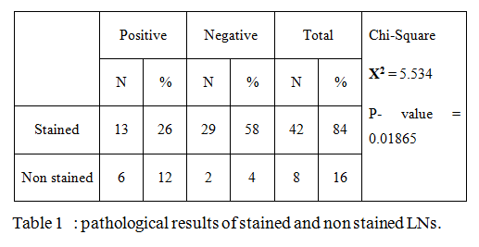

More than one lymph node was sometimes found in SLN biopsy specimen. From a total of 42 cases of successful identification, 80 SLNs were identified and examined, 13 cases had only one SLN per case, 21 cases had 2 SLNs per case, 7 cases had 3 SLNs per case and one case had 4 SLNs per case. The mean number was 1.9 node per case.

A learning curve was clearly observed; the rate of SLN detection increased with experience. SLNs were detected only in 13 cases (76.47%) of the first 17 cases, in 14 cases (82.35%) of the second 17 cases and in 15 cases (93.75%) of the last 16 cases. Also duration of SLN detection decreased with experience. In 42 cases with SLN detected, mean of duration was 20 minutes in 1st 14 cases, mean was 16 minutes in 2nd 14 cases and was 13 minutes in last 14 cases.

Pathological results according to level of axillary LN where SLN was detected shown in (table 2). We detected skip metastases in our study.

Table2: Pathological results of SLN according to level where it detected

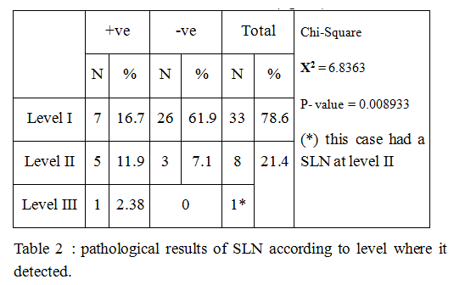

Frozen section was done for SLN biopsy in 42 cases where SLN was detected (table 3).

Table 3: Final pathology of SLN compared to frozen Section

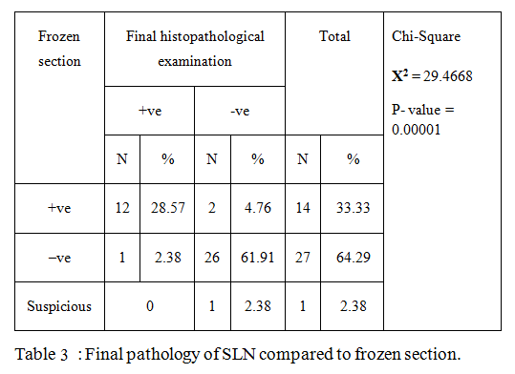

Surgical procedures for axilla were 22 cases underwentALND and 28 cases underwent only SLNB (table 4).

Table 4: Pathology results of LN in ALND and SLNB

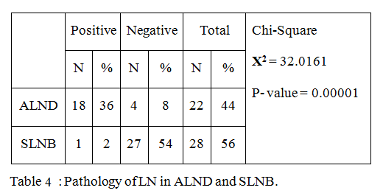

Complications of the surgery were observed in 15 patients (30%) in form of seroma in 7 cases (14%) (5 cases after ALND and 2 cases after SLNB), lymphedema in 4 cases (8%) who underwent ALND, thoracodorsal bundle injury in 2 cases (4%) who underwent ALND, wound dehiscence and infection in one case (2%) after SLNB and skin necrosis in one case (2%) after ALND.

Complications of methyline blue dye were observed in 10 patients (20%) in form of green stained urine for 2 days postoperatively in 7 cases (14%), blue staining of the wound that disappear completely in a week in 2 cases (4%) and only one case developed allergy to dye (2%).

**4. Discussion:**

Sentinel lymph node biopsy is the standard method for the examination and staging of axilla of the breast cancer patients. This is the best method for identifying the axillary involvement. Various dyes used to find the sentinel lymph node. However, using methylene blue dye (MBD) has a low risk of anaphylaxis, cost effective and widely available. The study of ***Stradling et al., 2002*** (9) revealed 5 necrotic lesions (21%) when 3ml to 5ml of MBD (full strength 1%, 10mg/ml) was injected in 24 patients. Parenchyma and the skin were injected with methylene blue dye. This research finds that methylene blue is safe with mild cpmplications. No anaphylactic reaction to methylene blue for sentinel lymph node mapping was reported. Complications of methyline blue dye were observed in 10 patients (20%).

***Zaazou et al., 2017*** (10) state that with methylene blue dye, the sensitivity and specificity are 88.2% and 86.7% respectively whereas the accuracy, false negative rate, negative predicted value, and rate of metastasis are 95.3%, 11.8%, 92.8%, and 26.5% respectively. In our study, The rate of SLN detection was 84%, sensitivity of dye was 92.31%, specificity was 93.1%, positive predictive value was 85.71%, negative predictive value was 96.43% and accuracy was 92.86%. The false negative was one case (2.38%). This can be compared with other reports revealing 0-17% false negative results. These false negative outcomes could be due to the insufficient experience of the surgeons with the sentinel lymph node biopsy procedure in addition due to the result of tumor infiltration of the primary node draining the tumor.

***Klimberg et al., 2015*** (11) found that no difference in accuracy between subareolar injection of dye and peritumoral injection. Central injection is easy and avoids the necessity for image-guided injection of non palpable breast lesions. In our study, we used a dual site injection method that achieve benefits of both techniques of injection site.

***Fenaroli et al., 2004*** (12) revealed that axillary dissection can be spared in SLNB in about half of cases of early breast cancer. From this, it can be clarified that the SLNB permits the planning of therapy in accordance with the degree of the patient’s disease. In our study, Surgical procedures for axilla were 22 cases underwent axillary lymph node dissection, 8 cases of them were non stained nodes (6 cases were positive and 2 cases were negative by histopathological examination) and 14 cases were positive frozen section of SLN (12 cases were positive and 2 cases were negative by histopathological examination) and 28 cases underwent only sentinel lymph node biopsy, 27 cases of them were negative frozen section (only one case of these 27 cases was positive by histopathological examination) and one case was suspicious that revealed negative in final histopathological examination (P- value = 0.00001).

In our study, the highest number of SLN (s) detected is 4 and this was only in one case. The extreme number was given by ***Giuliano et al., 2014*** (13) that was 8 SLNs.

Interestingly, different authors have reported different rates of incidence of skip metastases. In ***Lloyd's*** ***2009*** (14) study, the 1.6% of the whole group and the 3.2% of the positive node group showed positive LNs in Level II - III with no metastasis in Level I, whereas in other studies the incidence was 5.5% and 8.7% and 7.9% and 14.6%, respectively. In our study, Level of axillary LN (where SLN was detected in 42 cases) was 33 cases at level I, 8 cases at level II ( 5 of them were positive) and one case (2.38%) had SLN at level III which had metastases and also another SLN at level II so this case underwent ALND (p – value = 0.008933).

The low identification rate found in several studies could be due to the initial experience of the surgeon ***Sohail et al., 2010*** (15). In our study, The learning curve was clearly observed and the rate of SLN detection increased with experience.

**Conclusion:**

The Sentinel Lymph Node (SLN) is the first lymph node to receive lymphatic drainage from the site of a primary tumor and Sentinel lymph node biopsy (SLNB) is a minimally invasive procedure to stage the axilla in patients with breast cancer, SLNB results in a significant reduction of postoperative morbidity and improved quality of life. ALND has more complications than SLNB as lymphedema and injury to long thoracic nerve and thoracodorsal bundle. Various dyes are used in this biopsy to show the sentinel lymph node. However, methylene blue dye (MBD) has a low risk of anaphylaxis, cost effective and widely available.

The rate of SLN detection was 84%. The nodal involvement in early stage of breast cancer is only 19 of 50 cases (38%) were involved with metastases.

As more doing SLNB and detection of SLN, the learning curve was clearly observed and the rate of SLN detection increased with experience.

SLNB used instead of ALND in about most of cases of early breast cancer. From this, it can be clarified that the SLNB permits the planning of therapy in accordance with the degree of the patient’s disease.

**References:**

1. Si-Qi Qiua, Guo-Jun Zhang, Liesbeth Jansen, et al. Evolution in sentinel lymph node biopsy in breast cancer. Critical Reviews in Oncology / Hematology. 2018;123:83–94.
2. Krag D.N, Anderson S.J, Julian T.B, et al. Sentinel-lymph-node resection compared with conventional axillary-lymph node dissection in clinically node-negative patients with breast cancer: overall survival findings from the NSABP B-32 randomised phase 3 trial. Lancet Oncol.2010;11: 927–933.
3. Veronesi U, Luini A, Galimberti V, et al. A randomized comparison of sentinel-node biopsy with routine axillary dissection in breast cancer. N Engl J Med. 2013;349(6):546-53.
4. Lyman GH, Temin SF, Edge SB, et al. American Society of Clinical Oncology Clinical P. Sentinel lymph node biopsy for patients with early-stage breast cancer: American Society of Clinical Oncology clinical practice guideline update. J ClinOncol. 2014; 32(13):1365-1383.
5. Li J, Jia S, Zhang W, et al. Partial axillary lymph node dissection inferior to the intercostobrachial nerves complements sentinel node biopsy in patients with clinically node-negative breast cancer. BMC Surg.2015;15,:79.
6. Ang C.H, Tan M.Y, Teo C, et al. Blue dye is sufficient for sentinel lymph node biopsy in breast cancer. Br. J. Surg.2014; 101,383–399.
7. Haffty BG, Buchholz TA and Perez CA. Early stage breast cancer. In: Halperin EC, Perez CA, Brady LW, editors. Principles and practice of radiation oncology. 5th ed. Philadelphia: Lippincott company; 2018;1175–1291.
8. Burstein H. J, Axelrod P. A, Garcia-Young J.A, et al. Adjuvant Endocrine Therapy for Women With Hormone Receptor–Positive Breast Cancer: American Society of Clinical Oncology Clinical Practice Guideline Focused Update. Journal of Clinical Oncology. 2014; 29-32.
9. Stradling B, Aranha G, Gabram S. Adverse skin lesions after methylene blue injections for sentinel lymph node localization. Am J Surg. 2002;184(4):350-352.
10. Zaazou M, Khaled M, Merhem I, et al. Sentinel Lymph Node Biopsy Using Methylene Blue Dye in Early Breast Cancer. Is It Truly Reliable.2017;23.
11. Klimberg VS, Rubio IT, Henry R, et al. Subareolar versus peritumoral injection for location of the sentinel lymph node. Ann Surg. 2015; 229:860–864.
12. Fenaroli P, Merson M, Giuliano L, et al. Population-based sentinel lymph node biopsy in early invasive breast cancer. Eur J SurgOncol. 2004;30(6):618-623.
13. Giuliano, L.D. Bosserman, S.B. Edge, et al., Reply to I.A. Voutsadakis et al and A. Goyal et al, J. Clin. Oncol. 2014;32: 3902-3904.
14. Lloyd R, Waits Jr. D, Schroder A, et al. Axillary dissection for breast carcinoma. The myth of skip metastasis, Am. Surg. 2009;55: 381-384.
15. Sohail A, Asim M, Shakir J, et al. Evaluation of Sentinel Lymph Node Biopsy with Methylene Blue Dye in Early Carcinoma Breast. Pakistan J Med Heal Sci. 2010;4(3):233-236.

4/9/2019