**Role of Minimal Invasive Techniques in Detection of Cancer Stem Cells Related Genes (CSCs) in Breast Masses**

Nagham N Omar1, Mohammed Zidan1, Heba M Saad Eldien2, Maha Salah Elnaggar3,Hayam Yahia Hamed1.

**1** Radiology department, Faculty of Medicine, Assiut University, Egypt.

**2** Histology and Cell Biology department, Faculty of Medicine, Assiut University, Egypt

**3**Clinical Oncology department, Faculty of Medicine, Assiut University, Egypt.

[naghamnomar@gmail.com](mailto:naghamnomar@gmail.com)

**Abstract: Aims:** To study the role of minimal invasive techniques in the diagnosis of breast masses and detection of breast cancer stem cells (CSCs) related genes in correlation with different interventional breast sampling. **Materials & Methods:** This prospective study includes one hundred (100) cases of breast lumps in female patients of different age groups. The detailed history of the patient i.e. age, sex, site and other findings were recorded. In these cases fine needle aspiration biopsy (FNAB) and true cut needle biopsy (TCNB) were obtained for which histopathology and hormonal receptors study were done associated with real time PCR study for suitable samples to detect the breast CSCs (Periostin and AGBL2). **Results:** True cut needle biopsy (TCNB) gave correct histopathological diagnosis in 100% in addition to hormonal receptor detection with adequate number of cores; it also could identify breast cancer stem cells related genes. On the other side fine needle aspiration cytology (FNAC), however it gave the correct diagnosis in 76.9%, it has no role neither in hormonal receptor study nor in identification of cancer stem cells related genes (AGBL and PERIOSTIN). Regarding breast CSCs, we found Significant up regulation of Periostin was observed in 23.3% of cases. However Significant up regulation of AGBL was observed in 10% only of cases. We found a positive correlation between CD44+ CD24- expression and Periostin up regulation. **Conclusion:** In accordance with recent publications, we conclude that CNB is far superior to FNAC in the diagnostic approach of breast cancer as regard histopathology, hormonal receptor study and identification of cancer stem cells related genes. Results indicate that the aberrant gene expression of periostin in breast cancer tissue may induce significant biological effects. The present study found that AGBL2 was highly expressed in CSC and could be a potential biomarker for the lymph node metastasis and chemotherapy resistance of breast cancer tumors. The underlying genetic mechanism of periostin and AGBL2 in regulating the breast cancer CSC is still unclear and needs further investigation.

**[**Nagham N Omar, Mohammed Zidan, Heba M Saad Eldien, Maha Salah Elnaggar, Hayam Yahia Hamed. **Role of Minimal Invasive Techniques in Detection of Cancer Stem Cells Related Genes (CSCs) in Breast Masses.** *Cancer Biology* 2019;9(2):54-63]. ISSN: 2150-1041 (print); ISSN: 2150-105X (online). <http://www.cancerbio.net>. 10. doi:[10.7537/marscbj090219.10](http://www.dx.doi.org/10.7537/marscbj090219.10).

**Keywords:** Role; Minimal; Invasive; Technique; Detection; Cancer Stem Cells Related Genes (CSCs); Breast

**I. Introduction**:

The breast has always been symbol of womanhood and ultimate fertility. As a result, both disease and surgery of the breast evoke a fear of mutilation and loss of feminity (1). Breast disease is highly presentable in outpatient departments.

In the last days, the increased use of screening mammography with the early detection of breast cancer, together with the recently gained understanding of the biology has contributed to the wide use of minimally invasive techniques for the proper diagnosis of breast lesions.

Stem cells which represent only a very small percentage of the total tumor mass, have been found to be the source of some, and possibly most, cancers(2).

Breast cancer stem cells are a small group of tumor cells with the capacity to self-renew, a strong ability to form solid breast tumors, and the ability to differentiate into a relatively quiescent primitive group of cancer cells that are considered the underlying factor of tumor recurrence and the main reason that breast cancers resist therapies(3).

Following a better understanding of cancer stem cell theory, stem cell-related genes in malignant tumors have gained more academic attention. There are stem cells related genes such as periostin and AGBL2.

Recently it has been found that periostin allows cancer stem cells to maintain thus blocking periostin’s function may prevent metastasis.

Minimal invasive techniques provide increased patient comfort, excellent cosmetic result and minimal morbidity. They are also responsible for decreased costs and better medical care by allowing an informed discussion of breast cancer therapy and planning of surgery with an emphasis on negative margins and the dissection of the sentinel node. These techniques include Fine-Needle Aspiration Cytology, Core-Needle biopsy and vacuum assisted biopsy (4).

In our study we used both ultrasound guided FNAC and CNB to identify the role of minimal invasive techniques in the histopathological diagnosis, hormonal receptor study of breast lesions and tried to make a correlation between CSCs percentage and the Periostin and AGBL2 gene expression status in tumor tissue, and evaluate the clinical implications of Periostin and AGBL2 in breast cancer.

**2. Materials & Methods:**

This prospective study includes one hundred (100) cases of breast lump in female patients in different age groups. The detailed history of the patient i.e. age, sex, site and other findings were recorded. In these cases, relevant clinical examination, routine laboratory investigations and radiological examinations were done. This study was conducted at the Diagnostic Radiology Department, Assiut University Hospital from October 2016 to March 2018.

* Inclusion criteria:
* Patients in different age groups with undiagnosed palpable or image detected breast lesions.
* Exclusion criteria:
* Acute illness is excluded from the study on the basis of the clinical picture.
* Patients with severe uncorrectable bleeding diathesis.
* Pre-procedure assessment:

Before FNAC or biopsy was obtained sonomammography was done to assess the breast lesion and apply BIRAD system to identify the nature of the lesion.

The Device used in all examinations was Logic P6 PRO GE healthcare with convex and linear array probes.

Laboratory evaluation of the prothrombin time, concentration and platelet count were checked to exclude bleeding diathesis.

Both FNAC and core biopsy were obtained simultaneously in the same session after obtaining informed consent.

* **Technique**

Biopsies were performed with the freehand technique under real-time ultrasound guidance. In each patient, the biopsies were performed by the same interventional radiologist who is experienced in biopsy taking.

Biopsy procedures were performed under sterile conditions. The transducer was covered with a sterile plastic cover. To prevent image degradation, ultrasound gel was placed inside the sterile cover to provide acoustic coupling. In addition, sterile gel was placed on the skin ‘s surface after sterilization of the skin by betadine and alcohol.

Hand sterilization was done carefully by hand washing with water and medical soap followed by hand rubbing with alcohol. Then sterile gloves were used.

1. **Fine Needle Aspiration Cytology:**

* Needle used: 20-gauge needle (0.9×40 or 0.9×80 mm) attached to 10-ml plastic syringe.
* No anesthetic was required.
* Number of slides obtained: 8-12 clean dry slides.
* After the needle entered the lesion, the plunger was retracted to create a negative pressure in the syringe. The needle was further pushed into the lesion and moved back and forth several times maintaining the negative pressure to suck the material. After 20-30 passes or as soon as any material or blood was seen in the hub of the needle, the needle was detached after aspiration and air was sucked into the syringe, the needle was reattached and the material was ejected forcefully onto 8-12 clean dry slides. The smears were processed by both dry and wet preparations. Dry preparation was done by dryness and methanol fixation. Wet preparation was done by 95% ethanol.
* Dry and wet preparations were examined by conventional cytology.

**For cytological evaluation**, dry preparations were stained by May-Grunwald-Giemsa stain. Wet preparations were stained by Papanicolaou stain. The slides of all cases were examined by conventional cytology to determine the cytomorphological features. These features included adequacy, cellularity, arrangement of cells, and nuclear as well as cytoplasmic features.

2. **Trucut Core Needle Biopsy:**

* Needle used: Semi-Automatic biopsy gun 16 G and 18G (Magnum; Bard, Covington, GA) with different needle lengths according to depth of the lesion.
* Number of cores obtained: 3-5 cores were routinely obtained.
* After sterilization of the skin, local anesthetic was injected subcutaneous over the targeted lesion. Using a scalpel, a small skin incision (2 mm) was made through which a cutting biopsy needle was inserted and under real-time ultrasound guidance, the tip of the biopsy needle was obliquely advanced to the target. As the needle advanced through tissues, jiggling of the needle had improved its visualization. Ideally, the tip of the needle and the targeted lesion could be visualized in the same imaging plane but if the angle of the needle was such that it would miss the target, the angle was corrected. In case of superficial breast lesions that would be pushed out of the way by the needle tip, the experienced interventional radiologist applied firm pressure, fixing the lesion in place while puncturing it with the biopsy needle. After entering the lesion, an appropriate needle throw (1.5 or 2.2 cm) was selected to avoid penetration. Three-four samples were routinely obtained from each selected case and preserved in a 10% formalin solution for histologic studies and in saline for genetic study. The puncture site was compressed by hand for at least 30 minutes to stop bleeding.

**Real time PCR for estimation of Periostin and AGBL2**

**I- RNA Extraction:**

By using Genezol™ CT RNA Extraction Reagent (Puregene Genetix Brand, USA, catalog No.PG-100103). RNA isolation was performed in Tissue Culture and Molecular Biology Unit (TCMB) in an RNase-free, environment and all steps were performed at room temperature.

1. One hundred mg breast tissue homogenized in 1 ml Genezol™ using sterile mortar and pestle. The homogenate was incubated for 5 min. at room temperature, then it was centrifuged at 12,000 x g for 10 min at 4 ºC, then the supernatant was collected and transferred to a fresh eppendorf.
2. Two hundred of chloroform was added to the supernatant, shaked vigorously for 15 seconds and stored at room temperature for 2 min., and then was centrifuged at 12, 000 x g for 15 min at 4 ºC. After centrifugation, the aqueous phase was transferred to a fresh eppendorf.
3. Half ml of isopropyl alcohol was added to the aqueous phase eppendorf, then mixed gently by inverting, 3~5 times. The eppendorf was incubated at room temperature for 10 min. After incubation, the eppendorf was centrifuged at 12, 000-x g for 10 min at 4 ºC, and then the supernatant was discarded. Then, 1ml of 75% ethanol was added to wash the RNA pellet. It was centrifuged at 7, 500 x g for 5 min., then the supernatant and ethanol were carefully discarded and the RNA pellet was dried in air for 5 min.
4. The RNA pellet was dissolved in 800 l DEPC-treated water byincubation at 56 ºC for 10 min.
5. Total RNA concentrations were determined using a nanodrop spectrophotometer (SPECTROstar® Nano (Microplate and cuvette Spectrophometer, BMG LABTECH, Germany).
6. The RNA was stored at -80°C until reverse transcription.

**II- Reverse transcription (DNA synthesis):**

The cDNA synthesis kit (High-Capacity cDNA Reverse Transcription Kit, applied biosystems, California, USA., catalog no.4368814) was used to obtain the cDNA samples needed for quantitative real-time PCR (qRT-PCR) (according to the manufacturer’s instructions).

**III- Q PCR reaction:**

Under sterilized condition qPCR was prepared using (Thermo Scientific Maxima SYBR Green PCR Master Mix (2X) kit, USA, Catalog no. #K0251). Ice was used to thaw the master mix on it.

* 1. All solutions were vortexed briefly (SCILOGEX MX-S, Berlin, Germany) after thawing.
  2. The reaction
  3. master mix was prepared by adding the following components (except template DNA) for each 10 μl reaction to a tube at room temperature: Maxima SYBR Green qPCR Master Mix (2X) + ROX Solution

**Primer design**

The primers were obtained from (Invitrogen, UK). Primers were designed using the Primer - Blast program from the National Center for Biotechnology Information and reconstructed according to manufacturer’s instructions. About 0.25 μl of amplification primer w.

* 1. The master mix was thoroughly mixed and appropriate volumes were dispensed into PCR tubes.
  2. Template DNA was added (2 l/reaction) to the individual PCR tubes containing the Master mix.
  3. The reactions were gently mixed without creating bubbles, which would interfere with fluorescence detection.
  4. The thermal cycler (Applied Biosystems Step One Plus™Real-Time PCR Systems, California, USA) was programmed to 95˚C for 2 minutes, followed by 40 cycles of 95˚C for 25 seconds then 60˚C for 1 minute.

**Calculation of the result:**

At the end of the reactions, the analysis of the results of the real time PCR reaction was done by the aid of Applied Bio system Step One Plus software using Comparative Ct (ΔΔCt) method (Livak and Schmittgen, 2001). The comparative Ct method is a mathematical model that calculates changes in gene expression as a relative fold difference between an experimental and calibrator (control) sample.

The comparative CT method was applied to transform the obtained threshold cycle (CT) values in relative quantities. The quantities obtained were then normalized against internal control genes, referred to as housekeeping genes (GAPDH).

Gene expression was evaluated based on fold differences in gene transcription levels of each of two target genes (periostin and AGBL) compared to the levels in negative control samples as follows:

**Delta Ct for cases**

Sample = mean Ct of target gene (periostin and AGBL) – mean Ct of reference gene (G6PDH).

**Delta Ct for the control sample = mean Ct of target gene – mean Ct of reference gene.**

**Delta delta Ct = delta Ct of the case – delta Ct of the control.**

**Mean fold change of the target gene = 2-delta delta Ct.**

The patients proved to be malignant, ER and PR and Herneu will performed on the biopsy by immunohistochemistry and confirmation of Herneubt SICH was done if indicated. Then complete staging was done by chest and abdominal Computed tomography and bone scan. Then patients will receive neoadjuvant or adjuvant chemotherapy. Surgery were performed to all the patients either modified radical mastectomy or conservative breast surgery. Chemotherapy will be in the form of AC 4 cycles followed by 4 cycles of Taxotere ± trastuzumab (when indicated).

**3. Results**

Total 100 patients with breast lump were included in this study. Mean age of the patients was 36.15±9.75 years.

Histopathological diagnosis of breast lesions by TCNB are shown 32(32%) malignant and 68(68%) as benign (table 1).

|  |  |  |
| --- | --- | --- |
| Breast Lesion | N | % |
| Malignant | 32 | 32 |
| Benign | 68 | 68 |

Result of FNAC taking histopathology as gold standard.

True positive (TP) were recorded as 26(26%), false positive (FP) (0%), false negative (FN) 8(8%) and true negative (TN) as 66(66%), sensitivity was 83.33%, specificity was 100%, positive predictive value (PPV) was 100% and negative predictive value (NPV) was 89.18 %. ( table2)

|  |  |  |  |
| --- | --- | --- | --- |
| Results Of Fnac | Results Of Histopathology | | Total |
| Positive (%) | Negative (%) |
| Positive | True Positive  26% | False Positive  0% | (26)% |
| Negative | False Negative  8% | True Negative  66% | 74% |
| Total | 34% | 66% | 100% |

Sensitivity=83.33% Specificity=100%

Positive predictive value=100%

Negative predictive value=89.18

As FNAB isolated cells were found to have no role in immune receptor study, in our study they also have no role in genetic study due to poor RNA ratio. So directed our concern to the study of the immunereceptor and genetic study of the32 histopathologically proved malignant patients by TCNB, and the following are their demographic data.

About 62.5% patients belong to age group above 50 years and 37.5 % patients belong to age group below 50 years Fig.1.

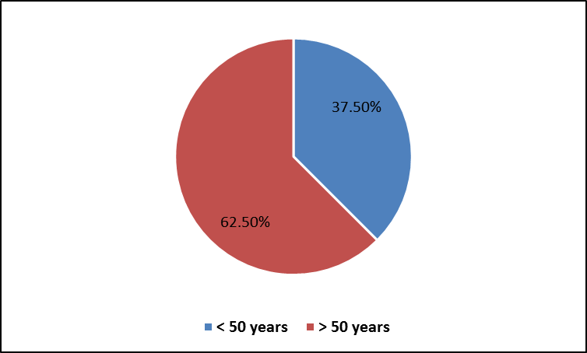

**Fig. 1: Age distribution**

Out of the 100 patients with breast masses 32 patients were proved to have infiltrating duct carcinoma, 40% of patients with age group > 50 years presented by US detected left sided breast mass and 22% of the same age group presented by US detected right breast mass, but 28% of patients with age group below <50 years presented with left sided breast mass and 9% presented by right sided breast mass.

As regard LN metastases 47% of patients with age group>50 years had positive LN metastases and 16% with the same age group had –ve LN metastases but those of age group <50 years: 37% were +ve and none of them had –ve LNsFig.2.

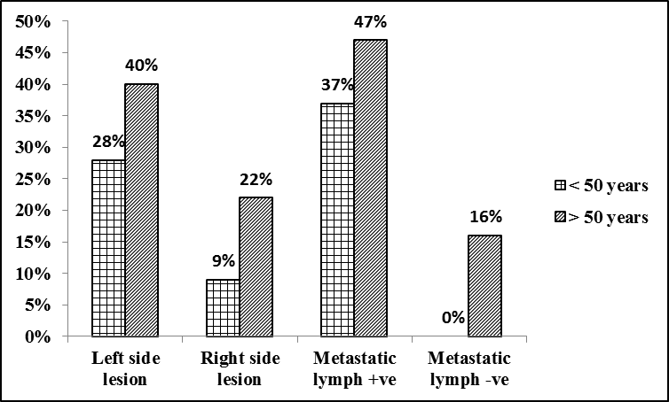

**Fig.2: percent of side lesion and metastatic lymph node in relation to age distribution (n=32).**

The histopathological examination of all our patients underwent US guided TCNB for highly suggestive malignant mass was cancer breast of invasive ductal carcinoma (IDC) type **Fig.3.**

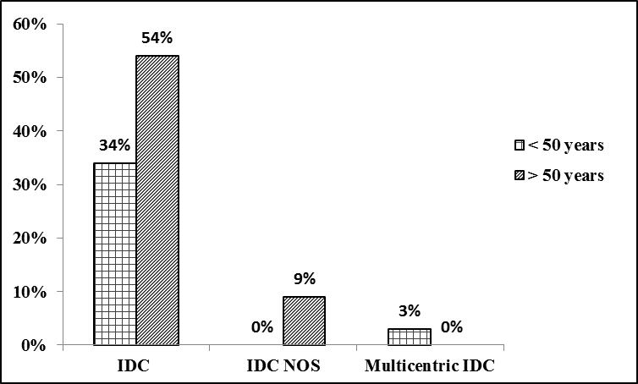

**Fig.3: percent of histopathological changes in relation to age distribution (n=32).**

Our patients underwent molecular study for hormonal receptors, patient with age group>50 years were 57% ER+ve,6%ER –ve, 54%PR+ve,9%PR+ve,6% Her2 +ve,56%Her2-ve.

Patients with age group <50years 34%ER+ve,6%ER -ve, 31%PR+ve, 6%PR-ve, 6%Her2+ve, 31%Her2-ve **Fig.4.**

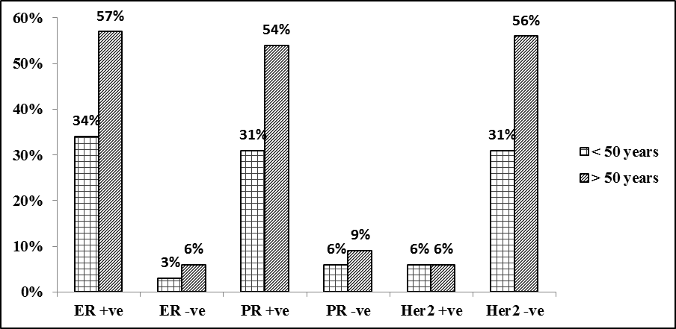

**Fig.4: percent of hormonal changes in relation to age distribution (n=32).**

In our study we used two types of true cut needle sizes 16x10 & 18x10 to evaluate the minimal numbers of cores required for both histopathological and molecular study. We used needle size 16x10 in 84%of our cases and needle size 18x10 in 16% of cases.

14 patients (44% of our patients) were prepared for neoadjuvant chemotherapy due to multicentricity and advanced stage of the disease **Fig.5.**

POSTN mRNA expression was seemed to be highly expressed in breast cancer tissue (75%). The cases with high POSTN expression intended to develop into lymph node (table 1). Spearman correlation regression analysis showed that POSTN expression has a linear correlation to lymph node metastasis and needle size (P = 0.031 and 0.031).

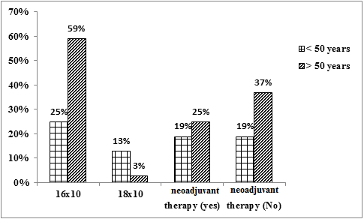

**Fig. 5: percent of needle size and neoadjuvant therapy in relation to age distribution (n=32).**

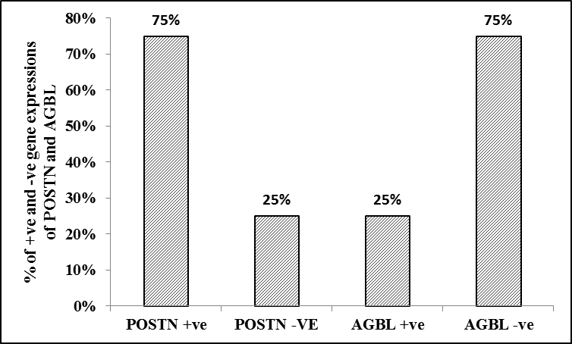

**Fig. 6: percent of positive and negative expressions of POSTN and ABGL in human breast cancer (n=32).**

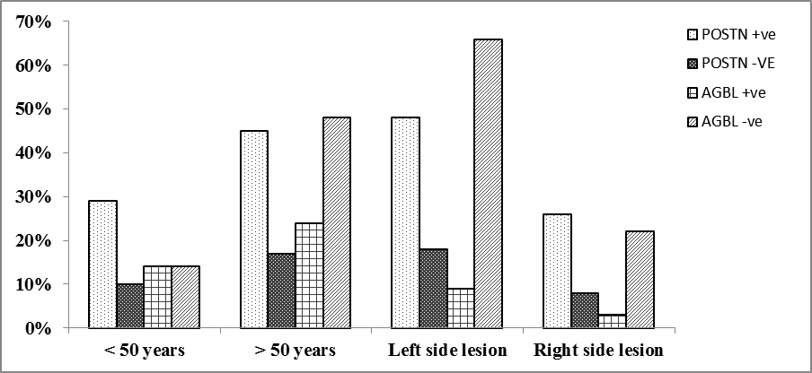

**Fig.7: percent of age distribution and side lesions in relation to positive and negative expressions of POSTN and ABGL in human breast cancer (n=32).**

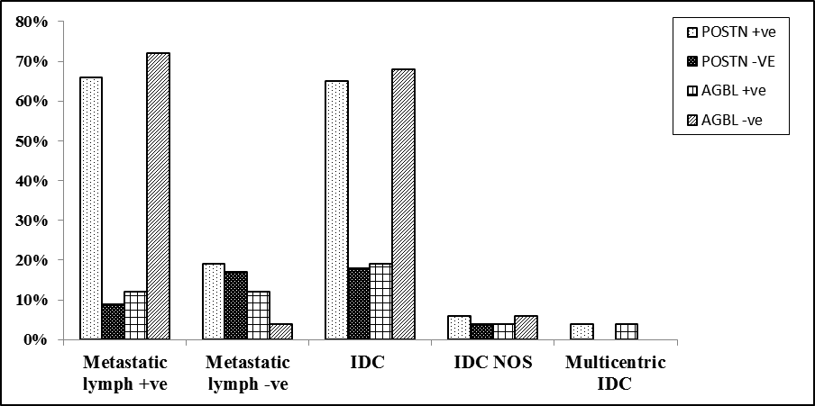

**Fig.8: percent of metastatic lymph node and tumor stage in relation to positive and negative expressions of POSTN and ABGL in human breast cancer (n=32).**

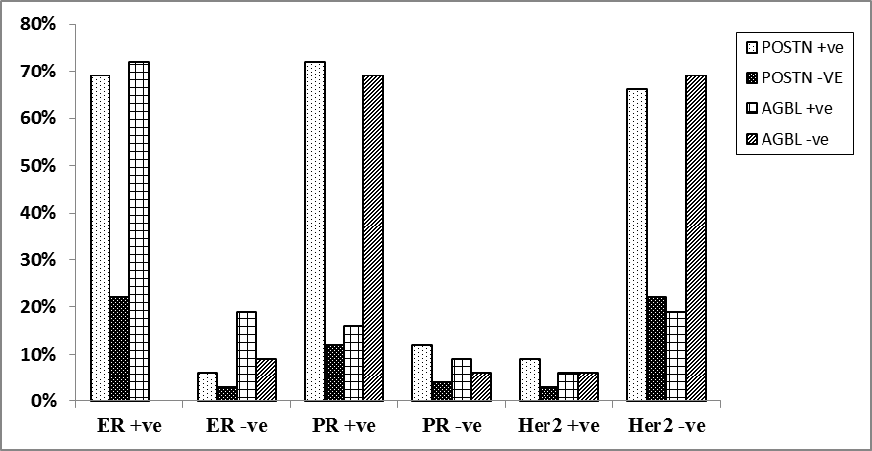

**Fig.9: percent of hormonal changes in relation to positive and negative expressions of POSTN and ABGL in human breast cancer (n=32).**

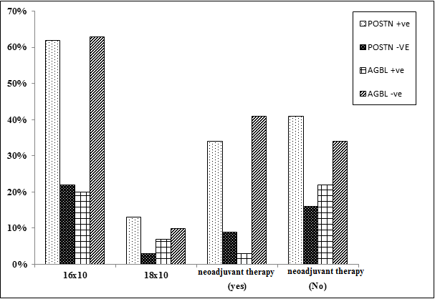

**Fig.10: percent of needle size and neoadjuvant therapy in relation to positive and negative expressions of POSTN and ABGL in human breast cancer (n=32)**

Spearman correlation regression analysis showed that AGBL2 expression has an inverse correlation to lymph node metastasis (P = 0.020).

The cases with high AGBL2 expression intended to develop into ER positive.

**Table 3: Correlations between POSTN expression and clinical-pathological features (n = 32)**

|  |  |  |  |  |
| --- | --- | --- | --- | --- |
| **Variable** | **N** | **POSTN+** | **POSTN-** | ***P*-value** |
| **Age:**  **> 50 years**  **< 50 years** | 20  12 | 15  9 | 5  3 | 0.668 |
| **Side of lesion:**  **Left side**  **Right side** | 22  10 | 16  8 | 6  2 | 0.512 |
| **Metastatic nodes:**  **Positive**  **Negative** | 27  5 | 21  3 | 6  2 | 0.367 |
| **Tumor stage:**  **IDC**  **IDC NOS**  **Multicentric IDC** | 28  3  1 | 21  2  1 | 7  1  0 | 0.564 |
| **Size of needle:**  **16x10**  **18x10** | 27  5 | 20  4 | 7  1 | 0.633 |
| **ER:**  **Positive**  **Negative** | 29  3 | 22  2 | 7  1 | 0.592 |
| **PR:**  **Positive**  **Negative** | 27  5 | 23  4 | 4  1 | 0.599 |
| **Her2:**  **Positive**  **Negative** | 4  28 | 3  21 | 1  7 | 0.746 |
| **Neoadjuvanttherapy:**  **Yes**  **No** | 14  18 | 11  13 | 3  5 | .504 |

**Table 4: Correlations between AGPL expression and clinicopathological features (n = 32)**

|  |  |  |  |  |
| --- | --- | --- | --- | --- |
| **Variable** | **N** | **AGPL+** | **AGPL-** | ***P*-value** |
| **Age:**  **> 50 years**  **< 50 years** | 20  12 | 4  4 | 16  8 | 0.332 |
| **Side of lesion:**  **Left side**  **Right side** | 22  10 | 1  7 | 21  3 | 0.705 |
| **Metastatic nodes:**  **Positive**  **Negative** | 27  5 | 4  4 | 23  1 | 0.009 |
| **Tumor stage:**  **IDC**  **IDC NOS**  **Multicentric IDC** | 28  3  1 | 6  1  1 | 22  2  0 | 0.550 |
| **Size of needle:**  **16x10**  **18x10** | 27  5 | 6  2 | 20  3 | 0.385 |
| **ER:**  **Positive**  **Negative** | 29  3 | 23  0 | 6  3 | 0.524 |
| **PR:**  **Positive**  **Negative** | 27  5 | 5  3 | 22  2 | 0.296 |
| **Her2:**  **Positive**  **Negative** | 4  28 | 2  6 | 2  22 | 0.254 |
| **Neoadjuvant therapy:**  **Yes**  **No** | 14  18 | 1  7 | 13  11 | 0.047 |

**Table 5: Spearman correlation analysis between clinico-pathological features and periostin expression**

|  |  |  |
| --- | --- | --- |
| **Clinical-pathological features** | **p-value** | **POSTN expression**  **(Spearman correlation, *r*)** |
| **Age** | 0.076 | 0.165 |
| **Side of lesion** | 0.062 | 0.067 |
| **Metastatic lymph nodes** | 0.031 | 0.231 |
| **Size of needle** | 0.031 | 0.271 |
| **ER** | 0.086 | 0.187 |
| **PR** | 0.191 | 0.012 |
| **Her2** | 0.064 | 0.072 |

**Table 6: Spearman correlation analysis between clinicopathological features and AGPL expression**

|  |  |  |
| --- | --- | --- |
| **Clinical-pathological features** | **p-value** | **AGPL expression**  **(Spearman correlation, *r*)** |
| **Age** | 0.086 | 0.191 |
| **Side of lesion** | 0.112 | 0.016 |
| **Metastatic lymph nodes** | 0.020 | 0.292 |
| **Size of needle** | 0.231 | 0.071 |
| **ER** | 0.049 | 0.201 |
| **PR** | 0.089 | 0.182 |
| **Her2** | 0.058 | 0.009 |

Total patients number is 32

The mean age was 58.44 ± 14.58 years (range from 31 to 80 years)

For follow up 24 months the 32 patients diagnosed as breast cancer had 100% overall survival (OS) and 76.4 % disease free survival (DFS) as showed in figure (11).

Analysis showed that 8 ( 25%) patients have disease recurrence 1 of them had AGBL positive expression none of them had AGBL negative (P value 0.565), regarding POSTN expression 5 patients were POSTN +ve while only 1 patient was POSTN –ve (P value 1.0). (Figure 12)





**Figure 11: 24 months overall survival curve and Disese free survival curve for pateints diagnosed as IDC (n=32)**



**Figure 12: Disease progression pateints according tp AGPL and POSTN expression (n=32)**

**4. Discussion**

Excisional biopsy is considered to be the gold standard for the diagnosis of breast lump. Emphasis has been placed now-a-days on improving method for establishing a definitive diagnosis of breast mass prior to surgery(5).

Along with advancements in breast cancer screening, image-guided percutaneous biopsy methods have flourished and continue to be modified to yield higher accuracy with fewer underestimations and false-negative findings and as a result are the preferred method of obtaining a diagnosis for suspicious breast lesions(6).

The use of minimal invasive techniques is responsible for decreased costs and better medical care by allowing an informed discussion of breast cancer therapy and planning of surgery with an emphasis on negative margins and the dissection of the sentinel node, this beside increased patient comfort, excellent cosmetic result and minimal morbidity.

In this study we used US guided minimal invasive techniques to correlate the role of both FNAC and CNB in the histopathological diagnosis of breast masses and detection of breast CSC related genes and their relationship with the histopathological and clinical data of the same patients.

In our study one hundred (100) female patients presented by palpable and non-palpable breast masses that underwent FNAC and TCNB, multiple difficulties faced us to do VACCUM biopsy technique so not included in our study.

FNAC is a diagnostic and therapeutic procedure, in which utility is not only restricted to confirming the diagnosis of malignancy in clinically or radiologically suspicious lesions, but also to corroborate the impression of a benign process and to avoid unnecessary surgery as well as for treatment of clinically symptomatic cystic lesions(7–9).

The sensitivity, specificity, and accuracy of FNA for breast tumors ranged from 82 to 98%, from 77 to 100%, and from 79 to 97%, respectively in the literature(7,10,11).

In this study, FNAC of 100 patients who presented by breast lumps showed a sensitivity of 83.33%, specificity of 100 and the positive predictive value was 100%.

Based on literature and our experience in this study we can say that in many cases, FNAB was not conclusive, and therefore, we proceeded with the US guided CNB, with which enough material was collected for histological examination, enabling us to direct patients to surgery or follow-up.

Several studies compared the accuracy of FNAC and CNB obtained from the same lesions in the same setting, usually by the same groups of operators, indicated that in general, CNB showed higher specificity, sensitivity, lower suspicious, and inadequate rates (10,12).

The 32 patients proved to be malignant by Core needle biopsies were confirmed by post-operative follow up of their data obtained so sensitivity, specificity and diagnostic accuracy all 100%.

So, from our results we can say that TCNB is superior to FNAC in diagnosis of breast lesions, however FNAC has many advantages that make the radiologist, pathologist and surgeon use in many conditions.

The histopathological examination of the core biopsies of all 32 patients proved to be of invasive ductal carcinoma type (IDC).

CSCs are a subpopulation of tumor cells that can drive tumorigenesis via their abilities to self-renew and differentiate, whereas their counterpart non-CSCs are not tumorigenic and are thought to not contribute substantially to tumor metastasis.

Tumor stem cells have been found to be the source of most cancers and the culprit of tumor recurrence, metastasis, and drug resistance(13).

In this study, we used quantitative RT-PCR to assess AGBL2 and periostin gene expression in breast cancer tissue from clinical specimens which obtained by US guided FNAC and TCNB then sorted using flow cytometry.

FNA biopsies have no role in detection of these genes due to poor RNA ration resulting from decreased cellularity compared to TCN biopsy, We correlated Periostin and AGBL2 expression, hormonal markers, histological stage, lymph node metastasis, clinical stage and outcome of treatment.

In a recent study, AGBL2 was reported as a bridge between cancer stem cell and metastasis (14). No studies to date, however, have examined the relationship among expression of AGBL2 and breast cancer chemotherapy sensitivity, and the clinical implications of breast cancer.

The AGBL2 protein was observed to be expressed significantly higher in cancerous tissues than tumor adjacent tissues. Moreover, AGBL2 protein was found to be related to clinical stage, histological stage, and lymph node metastasis. (2).

The other studies showed significant increased expression of POSTN in breast cancers relative to corresponding normal tissues, which is consistent with the results obtained by us ((15).

The present study we found that AGBL2 and periostin were highly expressed in cancer breast tissue and could be a potential biomarker for the lymph node metastasis and chemotherapy resistance of breast cancer tumors. The underlying genetic mechanism of AGBL2 and periostin in regulating the breast cancer is still unclear and needs further investigation.

Tumor metastasis is the most common cause of cancer-associated mortality. To give rise to the outgrowth of metastatic tumors in a new organ microenvironment, cancer cells have to overcome various types of stresses and several rate-limiting steps. Most disseminated cancer cells are destroyed during metastasis formation and only a small subset of cancer cells is able to survive and colonize in a new environment. Specialized tumor microenvironments called metastatic niches are thought to be responsible for nurturing disseminated cancer cells from micro metastases to full macro metastases.

Recent studies have shown that there may be a direct link between cancer stem cells (CSCs) and their metastatic niches. Identifying the limiting factors that regulate the properties of CSCs and their colonization of metastatic niches is therefore important for developing strategies to treat patients with metastatic tumors. In a recent issue of Nature, *Huelsken* and colleagues (16) provide new insight into how signals from the metastatic niche affect CSC self-renewal and metastatic colonization.

In this study: Tissue samples were stained with hematoxylin and eosin to determine the histological type and tumor grade. Immunohistochemical examination of Her2neu showed that reaction was located in the membrane of the breast cells. ER and Progesterone receptor showed that reaction was located in the nuclei of the breast cells as illustrated in table (1), POSTN mRNA expression was seemed to be highly expressed in breast cancer tissue (75%). The cases with high POSTN expression intended to develop into lymph node (. Spearman correlation regression analysis showed that POSTN expression has a linear correlation to lymph node metastasis and needle size (P = 0.031 and 0.031).

AGBL2 mRNA expression was seemed to be low expressed in breast cancer tissue (25%). The cases with low AGBL2 expression intended to develop into lymph node. Spearman correlation regression analysis showed that AGBL2 expression has an inverse correlation to lymph node metastasis (P = 0.020).

The cases with high AGBL2 expression intended to develop into ER positive. Spearman correlation regression analysis showed that AGBL2 expression has a linear correlation to ER positive cases (P = 0.049). The cases with negative AGBL2 expression intended to develop into Her2neu negative. Spearman correlation regression analysis showed that negative AGBL2 expression has a linear correlation to Her2neu negative cases (P = 0.058).

**5. Conclusion**

In conclusion, because of the variety and complexities of the diseases that affect it, the breast is the most frequently biopsied organ so findings suggest the need for further efforts to educate practitioners and patients about the numerous advantages of MIBB for the evaluation of suspicious image detected breast lesions. Achieving a reduction in the rate of open surgical biopsy should remain a priority in health care delivery, which could eliminate many unnecessary operations in women.

In accordance with recent publications, we conclude that, especially at a time when expenditure is constantly reviewed, CNB is far superior to FNAC in the diagnostic approach of breast cancer and, especially in cases of doubt; it is preferable to proceed directly with CNB, which may also determine additional prognostic and predictive markers.

Beside decreased sensitivity and specificity of FNAC in histopathological diagnosis of breast masses, it is also not suitable for the study of CSCs related genes due to poor RNA ratio isolated after flowcytometry.

Results indicate that the aberrant gene expression of periostin in breast cancer tissue may induce significant biological effects. The present study found that AGBL2 was highly expressed in CSC and could be a potential biomarker for the lymph node metastasis and chemotherapy resistance of breast cancer tumors.

We only had 24 months of follow up. A larger number of the pateints and more time of follow up of pateintsis recommended for the correlation between periostein and AGBL2 expression and the overall survival and disease free survival.

The underlying genetic mechanism of periostin and AGBL2 in regulating the breast cancer CSC is still unclear and needs further investigation.

**References**

1. Kadam AB, Maniyar SS. Comparison between role of ultrasound and x-ray mammography in diagnosis of breast masses. IJHSR. 2014;4:75–81.
2. Zhang H, Ren Y, Pang D, Liu C. Clinical implications of AGBL2 expression and its inhibitor latexin in breast cancer. World J Surg Oncol. 2014;12(1):1–7.
3. Wang J, Cao MG, You CZ, Wang CL, Liu SL, Kai C, et al. A preliminary investigation of the relationship between circulating tumor cells and cancer stem cells in patients with breast cancer. Cell Mol Biol (Noisy-le-grand). 2012;58: OL1641--5.
4. Vargas HI, Agbunag R V, Khalkhali I. Luncheon Seminar m State of the Art of Minimally Invasive Breast Biopsy : Principles and Practice. 2000;7(4).
5. Saha A, Mukhopadhyay M, Das C, Sarkar K, Saha AK, Sarkar DKR. FNAC versus core needle biopsy: A comparative study in evaluation of palpable breast lump. J Clin Diagnostic Res. 2016;10(2): EC05-EC08.
6. Vandromme MJ, Umphrey H, Krontiras H. Image-guided methods for biopsy of suspicious breast lesions. J Surg Oncol. 2011;103(4):299–305.
7. Arisio R, Cuccorese C, Accinelli G, Mano MP, Bordon R, Fessia L. Role of fine-needle aspiration biopsy in breast lesions: Analysis of a series of 4,110 cases. Diagn Cytopathol. 1998;18(6):462–7.
8. Pacinda SJ, Ramzy I. Fine-needle aspiration of breast masses: A review of its role in diagnosis and management in adolescent patients. J Adolesc Heal [Internet]. 1998;23(1):3–6. Available from: http://www.sciencedirect.com/science/article/pii/S1054139X97002711
9. Alexander PW, Pommier F, Waldemar A. Palpable by Triple. 2015.
10. Caro I. Scar sarcoidosis. Cutis. 1983;32(6):531–3.
11. Ishikawa T, Hamaguchi Y, Tanabe M, Momiyama N, Chishima T, Nakatani Y, et al. False-positive and false-negative cases of fine-needle aspiration cytology for palpable breast lesions. Breast Cancer [Internet]. 2007;14(4):388–92. Available from: http://dx.doi.org/10.2325/jbcs.14.388
12. Westenend PJ, Sever a R, Beekman-De Volder HJ, Liem SJ. A comparison of aspiration cytology and core needle biopsy in the evaluation of breast lesions. Cancer Cytopathol. 2001;93(2):146–50.
13. Liu R, Wang X, Chen GY, Dalerba P, Gurney A, Hoey T, et al. The prognostic role of a gene signature from tumorigenic breast-cancer cells. N Engl J Med. 2007;356(3):217–26.
14. Sahab ZJ, Hall MD, Sung YM, Dakshanamurthy S, Ji Y, Kumar D, et al. Tumor suppressor RARRES1 interacts with cytoplasmic carboxypeptidase AGBL2 to regulate the $α$-tubulin tyrosination cycle. Cancer Res. 2011.
15. Ratajczak-wielgomas K, Grzegrzolka J, Piotrowska A. Periostin expression in cancer-associated fibroblasts of invasive ductal breast carcinoma. 2016;2745–54.
16. Wang Z, Ouyang G. Periostin: a bridge between cancer stem cells and their metastatic niche. Cell Stem Cell. 2012;10(2):111–2.

5/4/2019