**Dosimetric comparison between VMAT and 7 fields IMRT in preoperative hypofractionated radiotherapy for rectal cancer**

Ehab Saad1,2, Khaled Elshahat2,3, Hussein Metwally2,4

1 Department of Clinical Oncology, and nuclear medicine, Cairo University, Egypt

2 Department of Radiation Oncology, Dar Al Fouad Hospital, Egypt

3 Department of Clinical Oncology, Azhar University, Egypt

4Department of Clinical Oncology, Fayoum University, Egypt

[hussein.metwally@hotmail.com](mailto:hussein.metwally@hotmail.com)

**Abstract: Introduction:** The hypo-fractionated short course radiotherapy has been considered as preoperative treatment in patients with locally advanced rectal cancer (LARC). The aim of this study is to compare the dosimetric differences between volumetric modulated arc therapy (VMAT), 7 fields intensity modulated radiotherapy (IMRT), regarding the target coverage and preservation of organs at risk (OARs) in patients with locally advanced rectal cancer planned for neoadjuvant short course radiotherapy. **Methods**: Thirty LARC patients were retrospectively evaluated in this study. For each patient dual Arc VMAT and 7 fields IMRT plans were generated. In all patients, the target consisted of clinical target volume (CTV) including pelvic LNs and the whole rectum with the mesorectum. Planning target volume (PTV) was created from the CTV with a margin of 5mm in all directions. The dose prescription was 25 Gy in 5 fractions in 5 successive days. OARs were delineated: bladder, small bowel, bilateral femoral heads and pelvic bone marrow (PBM). Conformity index (CI) and homogeneity index (HI) for both plans were compared. The dose-volume histogram (DVH) of PTV and OARs for both techniques was compared. **Results:** No significant difference between RA and IMRT plans in PTV25Gy coverage. (p = 0.72764). Both CI and HI are better with VMAT than IMRT. The maximum and minimum bladder doses are less with VMAT compared to IMRT. The mean dose to femurs, bowel and pelvic bone marrow were significantly less with VMAT. **Conclusion:** In preoperative hypofractionated radiotherapy of LARC, VMAT technique can offer better conformity and homogeneity than IMRT with better OARs preservation. Further randomized clinical trials are needed to translate this dosimetric data into significant clinical benefit.

**[**Ehab Saad, Khaled Elshahat,, Hussein Metwally. **Dosimetric comparison between VMAT and 7 fields IMRT in preoperative hypofractionated radiotherapy for rectal cancer.** *Cancer Biology* 2019;9(2):64-70]. ISSN: 2150-1041 (print); ISSN: 2150-105X (online). <http://www.cancerbio.net>. 10. doi:[10.7537/marscbj090219.10](http://www.dx.doi.org/10.7537/marscbj090219.10).

**Key words:** Rectal cancer, Preoperative radiotherapy, VMAT, IMRT

**1. Introduction**

Locally advanced rectal cancer (LARC) is considered a common oncological problem in most of the countries. Both local and distant spread can affect the patient survival and quality of life. The neoadjuvant concurrent chemo-radiotherapy (CCRT), followed by radical surgery by total mesorectal excision (TME) has been considered the standard approach for treatment. Many studies have shown that the neoadjuvant CCRT resulted in less local recurrence rate with less acute and chronic toxicities as compared to adjuvant CCRT. Neoadjuvant CCRT also has the advantages ofincrease the possibility of sphincter preservation operations [1,2].

The short course of neoadjuvant radiotherapy in rectal carcinomawas proved to be efficacious in the Scandinavian studies, which reported less local recurrences and better overall survival, compared to long course radiotherapy. It is now used as a standard protocol in many radiotherapy centers [3,4].

For many years and till now, three-dimension conformal radiotherapy (3D-CRT) has been used as the preferred technique of radiotherapy for patients with rectal cancer in many centers; however, the resultant acute and late bowel toxicity remains a challenge as it affects the quality of life, especially with the addition of concomitant chemotherapy [5].

Many studies have found a relationship between the volume of irradiated bowel and the risk of gastro-intestinal toxicity [6–9].

Many planning studies identified the dosimetric advantages of IMRT and VMAT over 3D CRT in PTV coverage and also preservation of organs at risk (OARs). Both techniques have the advantage of generating concave isodose lines around the OARs, and thus improving the therapeutic ratio, through more homogenous dose to the target volume and less dose to the surrounding risk structures [10].

The aim of this study is to identify the optimal radiotherapy technique of short course neoadjuvant radiotherapy to patients with LARC through dosimetric comparison between volumetric modulated arc therapy (VMAT), and 7-field intensity modulated radiotherapy (7F-IMRT), regarding the target coverage and organs at risk preservation.

**2. Patients and Methods**

**Patient characteristics**

Thirty patients with LARC who already received neoadjuvant chemoradiotherapywere retrospectively evaluated in the study. There were 17 males and 13 females. The median age was 58 years (range 33 - 70 years). All patients had pathologically confirmed adenocarcinoma by colonoscopic biopsy. 14 patients hadstage cT2-4bN0M0 and the other 16were staged cT3-4bN1a-1bM0 according to the AJCC/UICC TNM (2010) staging system. The median tumor length was 4.5 cm (range from 3 cm to 9 cm) and the median distance fromthe anal verge was 4 cm (range from 1 cm to 9 cm).

**CT simulation**

Each patient was simulated in head first supine position. Computed tomographic images with a thickness of 3 mm were taken from upper abdomen to 5 cm below the ischialtuberosities with immobilization by a custom vacuum immobilization device. I.V contrast was given. CT images were imported to the treatment planning system (TPS) and fusion with PET/CT or MRI was done whenever possible.

**Delineation of target volume and OAR**

Delineation of the gross target volume (GTV) was donebased on the data obtained from the diagnostic CT and MRI. CTVincluded thewhole rectum and lymph nodes at risk including internal iliac, obturator, and presacral lymph nodes. It also included the sacral foramina, coccyx and at least 1cm of the posterior bladder at middle and lower pelvic regions. In male patients, the posterior prostate and seminal vesicles were included, and in female patients, the posterior of vaginal wall and cervix were addedto CTV. The cranial border for CTV was at the aorta bifurcation and its caudal border was at the anal verge covering the recto-sigmoid junction. PTV was created by adding 5mm around CTV. The following organs at risk (OAR) were delineated: the small bowel, the bladder, and the femoral heads, and the pelvic bone marrow. The small bowel was delineated2 cm above the PTV.

**Treatment planning**

For each patient dual Arc VMAT and 7 fields IMRT plans were generated and optimized with similar planning objectives to each patient. For all patients,the prescription was 25 Gy in 5 fractions in 5 successive days. The treatment plan was analyzed in terms of their dose-volume histograms, target volume covered by 95% of the prescription dose (V 95%), and maximum and mean structure doses (Dmax and Dmean). Calculation of all plans was done by 10MV photon using AAA.

Planning objectives for OARs were defined as follows. Small bowel: 5% of the volume (D5) should be ≤50 Gy, max dose (Dmax) ≤ 55 Gy. Bladder dose: D5 ≤ 50 Gy, Dmax ≤ 55 Gy. Femoral heads: D5 ≤ 45 Gy. The pelvic bone marrow dose was analyzed with different dose volume objectives since there is no exact dose volume objective of sparing level has been recommended.

**Plan evaluation andcomparison**

All plans were evaluated based on dose-volume histogram (DVH) scoring values of PTV and OARs. PTV is evaluated using the conformity index (CI), homogeneity index (HI), and dose gradient index of the dose distribution.

For OARs, Small bowel was evaluated by the mean dose. The bladder avoidance was evaluated using maximum dose. For assessment of the femoral heads and PBM the mean doses for both VMAT and IMRT plans were calculated and compared.

**Statistical analysis**

If p-value is <0.05, it was considered statistically significant. The statistical values were calculated using SPSS (version 16.0.0, SPSS, Chicago, USA).

**3. Results**

**PTV 25 Gycoverage:**

The 95% coverage of VMAT PTV 25Gy plan showed mean dose of 24.64 Gy (SD±0.52), median dose of 24.45 Gy, minimum dose recorded 24.28 Gy (97.12%) and maximum dose recorded 25.6Gy (102.4%). Meanwhile 95% of IMRT 25 Gy plans showed mean dose of 24.23 Gy (SD±043), median dose of 24.31 Gy, minimum value recorded 23.83 (95.32%) and maximum value recorded 26.1 Gy (104.4%). There is no significant difference between VMAT and IMRT plans in PTV 25 coverage. (p = 0.72764). **(Figure.1)**

**Conformity Index (CI).**

Conformity index of IMRT plans showed mean value of 0.89(SD ±0.056) median value0.82, minimum value0.78 and maximum value 0.93 mean while conformity index of VMAT plans showed mean value of 0.97(SD ±0.036), median value of 0.95, minimum value of 0.93 and maximum value of 0.98 results. (p = 2.29369E-21). There is significant difference in favor of VMAT technique.

**Homogeneity index (HI):**

Homogeneity index of IMRT plans showed mean value of 0.19(SD ±0.023) median value 0.1, minimum value0.07 and maximum value 0.20 mean while Homogeneity index of VMAT plans showing mean value of 0.132(SD ±0.13), median value of 0.13, minimum value of 0.10 and maximum value of 0.16. Also there is significant difference in favor of VMAT.

**Bladder comparison between IMRT and VMAT**

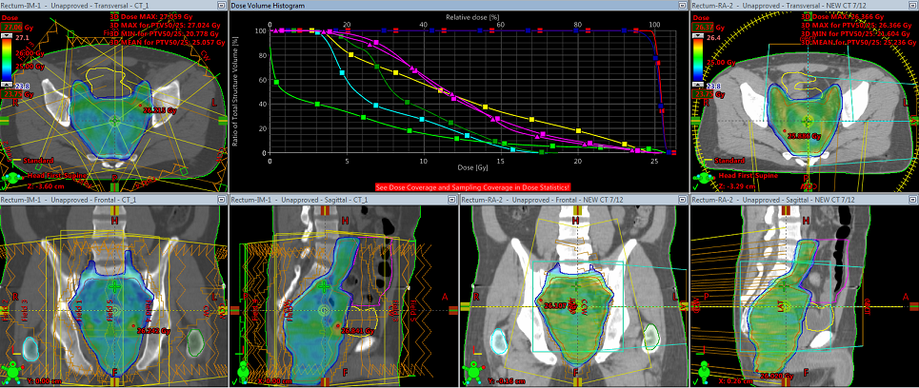

Figure.1: The different views for comparison between IMRT and VMAT plans for target volume coverage

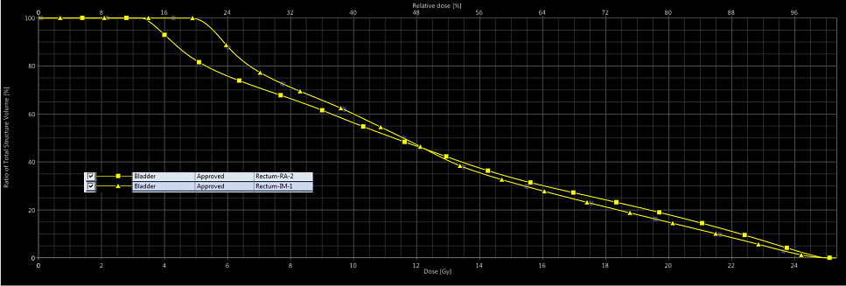

Figure 2: Bladder dose comparison for both plans

The maximum dose of the urinary bladder in IMRT plans showed mean value of 21.26 Gy (SD ±0.669), median value of 18.15Gy, minimum value of 15.43GY and maximum value of 16.90Gy, meanwhile the urinary bladder maximum dose in VMAT plans showing mean value of 16.80Gy (SD ±2.915), median value of 15.45Gy, minimum value of 14.14Gyand maximum value of 18.91 Gy, comparing this data together, There is significant difference in favor of VMAT technique. **(Figure.2).**

**Both Femoral heads**

Right femur head and neck mean dose in IMRT plans showed mean value of 12.93 Gy (SD ±3.71), median value of 12.16Gy, minimum value of 12.54 Gy and maximum value of 12.34 Gy, meanwhile mean dose VMAT plans showing mean value of 11.95 Gy (SD ±3.42), median value of 10.81Gy, minimum value of 4.80Gy and maximum value of 16.39Gy. There is significant difference in favor of VMAT technique. Left femur head and neck mean dose in IMRT plans showed mean value of 12.32 Gy (SD ±4.86), median value of 10.63Gy, minimum value of 15.39 Gy and maximum value of 16.34 Gy, meanwhile mean dose VMAT plans showing mean value of 11.95 Gy (SD ±3.27), median value of 11.81Gy, minimum value of 5.79Gy and maximum value of 16.81, The significant difference was in favor of VMAT technique. **(Figure.3)**

**Bone marrow mean dose:**

Bone marrow mean dose in IMRT plans showed mean value of 15.88Gy (SD ±2.75), median value of 15.30Gy, minimum value of 14.3Gy and maximum value of 16.34 Gy, meanwhile mean dose VMAT plans showed mean value of 13.08 Gy (SD ±2.731), median value of 12.45Gy, minimum value of 10.89Gy and maximum value of 14.6.91Gy, There is significant difference in favor of VMAT technique. (p = 1.08849E-8). **(Figure.4)**

**Bowel volume 195ccdose:**

Bowel mean dose in IMRT plans showed mean value of 12.49GY (SD ±5.33), median value of 12.92Gy minimum value of 3.20Gy and maximum value of 20.74 GY, meanwhile bowel mean dose in VMAT plans showing mean value of 11.78Gy (SD±4.20), median value of 11.085Gy, minimum value of 4.70GYand maximum value of 14.57GY, comparing these data together showing significant difference in favor of VMAT technique. (p = 0.00464). **(Figure.5).**

|  |  |
| --- | --- |
|  |  |

Figure.3: Both femoral Heads mean dose for both plans

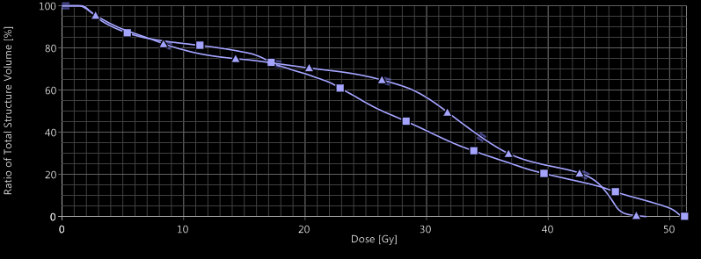

Figure.4: Bone marrow dose for both plans

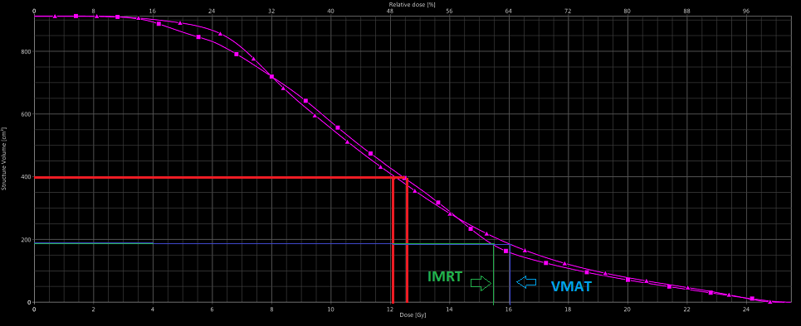

Figure.5.: The comparison between volume of 195cc of bowel in IMRT and VMAT plan

**4. Discussion**

Radiotherapy is necessary to control the rectal cancer locally in the pelvis. Combination of radiotherapy and surgery reduced the local relapse rate from 46% to 37% in comparison to surgery alone [11-13]. However, the radiotherapy related toxicity is a major concern especially with the addition of chemotherapy [14]. Advanced radiotherapy techniques can reduce the irradiation of OAR [15].

The expanding use of neoadjuvant short course radiotherapy to LA rectal cancer highlights the need for choosing the best technique of radiotherapy, that can lower the dose to OAR to reduce the late effects of radiotherapy especially with the use of such high dose per fraction in the short course.

VMAT and IMRT were confirmed to have dosimetric advantages over 3D conformal technique in neoadjuvant radiotherapy of rectal carcinoma. In many studies evaluating pelvic malignancies, VMAT had better OAR protection than IMRT, with the advantages of less monitor units, less treatment time and higher dose rate [16,17]. This was comparable with our results which confirmed better PTV coverage using VMAT technique in comparison to IMRT. This was evidenced by better CI and HI.

The major concern during preoperative radiotherapy of rectal cancer is to avoid radiation enteritis [18]. The volume of irradiated small intestine was found to have a significant correlation with the incidence of diarrhea in patients with locally advanced rectal cancer in the neoadjuvant setting [19].

Another study in anal canal cancer patients treated with chemoradiation showed significant dosimetric difference between VMAT and VMAT in small intestine sparing in favor of VMAT which reduced significantly V35 - V45 of small bowel [20]. This data is compatible with our results which showed less bowel mean dose in VMAT plans (11.78Gy), than bowel mean dose in IMRT plans (12.49Gy) with significant p value p = 0.005). However another study evaluating patients with locally advanced rectal cancer treated with neoadjuvant radiotherapy with simultaneous integrated boost, showed that there is no significant difference between VMAT and 7 fields IMRT in reduction of the irradiated small bowel volume [21].

The irradiated bladder volume may not have a significant clinical benefit due to relatively high tolerance of the bladder and relatively lower dose given in the rectal cancer in comparison to escalated doses as given in prostate cancer. Our study showed a difference between VMAT and IMRT in bladder preservation in favor of VMAT. VMAT had less maximum dose to the urinary bladder with a mean value of 16.80Gy (SD ±2.915), in comparison to IMRT plans showing mean value of 21.26 Gy (SD ±0.6). Our data is compatible with another study done by Wolff HA et al, which compared between VMAT and IMRT in patients with locally advanced rectal cancer, and revealed that bladder volume V40 is significantly less in VMAT than IMRT plans [9]. A different result was published by Myerson et al, who did not find a significant difference in bladder volume, V15, V30, V40, V50, V55, and Dmax of the bladder between VMAT and IMRT in treatment of anorectal cancer [22].

Reduction of the dose to the head and neck of femur may reduce the risk of avascular necrosis. In our analysis, the mean dose to the proximal femur was significantly less in VMAT (11.95Gy, SD ±3.27 than IMRT (12.32Gy, SD ±4.86). A similar published study found that Dmax and V30 of the bilateral proximal femurs and the V40 of the right proximal femur were significantly reduced by VMAT in comparison to IMRT. (P < 0.01) [10].

Many studies revealed a correlation between the hematological toxicity and the BM dosimetric parameters in anal cancer patients [23].

Our data showed that bone marrow mean dose in IMRT plans had mean value of 15.88Gy (SD ±2.75), which is significantly higher than mean dose of VMAT plans 13.08 Gy (SD ±2.731). Similar results was reported in a another study, in which VMAT had better PBM preservation than IMRT in patients with cervical cancer receiving pelvic LNs irradiation and the bone marrow mean and D40% dose with VMAT and IMRT were 30.128±1.94, 34.399±2.09; 32.216±2.72 and 37.397±2.87 respectively [24].

**Conclusion**

In preoperative short course radiotherapy for locally advanced rectal cancer, VMAT has dosimetric advantage than IMRT in PTV coverage and OAR sparing, with less treatment time and MU. However further clinical trials with long term follow up are needed to translate this dosimetric advantage into clinical benefit.

This study was done in the Department of Radiation Oncology, Dar Al Fouad Hospital, Egypt.

Conflict of interest notification: No authors have any conflicts of interest.

**References**

1. Sauer R, Becker H, Hohenberger W, et al. Preoperative versus postoperative chemoradiotherapy for rectal cancer. *N Engl J Med*. Epub ahead of print 2004. DOI: 10.1056/NEJMoa040694.
2. Sauer R, Fietkau R, Wittekind C, et al. Adjuvant vs. neoadjuvant radiochemotherapy for locally advanced rectal cancer: The German trial CAO/ARO/AIO-94. *Color Dis*. Epub ahead of print 2003. DOI: 10.1046/j.1463-1318.2003.00509.x.
3. Trial SRC. Improved survival with preoperative radiotherapy in resectable rectal cancer. Swedish Rectal Cancer Trial. *N Engl J Med*. Epub ahead of print 1997. DOI: 10.1056/NEJM199704033361402.
4. Martling A, Holm T, Johansson H, et al. The Stockholm II trial on preoperative radiotherapy in rectal carcinoma: Long-term follow-up of a population-based study. *Cancer*. Epub ahead of print 2001. DOI: 10.1002/1097-0142(20010815)92:4<896::AID-CNCR1398>3.0.CO;2-R.
5. Sauer R, Liersch T, Merkel S, et al. Preoperative versus postoperative chemoradiotherapy for locally advanced rectal cancer: Results of the German CAO/ARO/AIO-94 randomized phase III trial after a median follow-up of 11 years. *J Clin Oncol*. Epub ahead of print 2012. DOI: 10.1200/JCO.2011.40.1836.
6. Baglan KL, Frazier RC, Yan D, et al. The dose-volume realationship of acute small bowel toxicity from concurrent 5-FU-based chemotherapy and radiation therapy for rectal cancer. *Int J Radiat Oncol Biol Phys*. Epub ahead of print 2002. DOI: 10.1016/S0360-3016(01)01820-X.
7. Tho LM, Glegg M, Paterson J, et al. Acute small bowel toxicity and preoperative chemoradiotherapy for rectal cancer: Investigating dose-volume relationships and role for inverse planning. *Int J Radiat Oncol Biol Phys*. Epub ahead of print 2006. DOI: 10.1016/j.ijrobp.2006.05.005.
8. Robertson JM, Lockman D, Yan D, et al. The Dose-Volume Relationship of Small Bowel Irradiation and Acute Grade 3 Diarrhea During Chemoradiotherapy for Rectal Cancer. *Int J Radiat Oncol Biol Phys*. Epub ahead of print 2008. DOI: 10.1016/j.ijrobp.2007.06.066.
9. Wolff HA, Wagner DM, Conradi LC, et al. Irradiation with protons for the individualized treatment of patients with locally advanced rectal cancer: A planning study with clinical implications. *Radiother Oncol*. Epub ahead of print 2012. DOI: 10.1016/j.radonc.2011.10.018.
10. Liu M, Liu B, Wang H, et al. Dosimetric comparative study of 3 different postoperative radiotherapy techniques (3D-CRT, IMRT, and RapidArc) for II-III stage rectal cancer. *Med (United States)*. Epub ahead of print 2015. DOI: 10.1097/MD.0000000000000372.
11. Gray R, Hills R, Stowe R, et al. Adjuvant radiotherapy for rectal cancer: A systematic overview of 8507 patients from 22 randomised trials. *Lancet*. Epub ahead of print 2001. DOI: 10.1016/S0140-6736(01)06409-1.
12. Myerson RJ, Tan B, Hunt S, et al. Five fractions of radiation therapy followed by 4 cycles of FOLFOX chemotherapy as preoperative treatment for rectal cancer. *Int J Radiat Oncol Biol Phys*. Epub ahead of print 2014. DOI: 10.1016/j.ijrobp.2013.12.028.
13. Pieterse AH, Stiggelbout AM, Baas-Thijssen MCM, et al. Benefit from preoperative radiotherapy in rectal cancer treatment: Disease-free patients’ and oncologists’ preferences. *Br J Cancer*. Epub ahead of print 2007. DOI: 10.1038/sj.bjc.6603954.
14. Fiorica F, Cartei F, Licata A, et al. Can chemotherapy concomitantly delivered with radiotherapy improve survival of patients with resectable rectal cancer? A meta-analysis of literature data. *Cancer Treatment Reviews*. Epub ahead of print 2010. DOI: 10.1016/j.ctrv.2010.03.002.
15. Samuelian JM, Callister MD, Ashman JB, et al. Reduced acute bowel toxicity in patients treated with intensity-modulated radiotherapy for rectal cancer. *Int J Radiat Oncol Biol Phys*. Epub ahead of print 2012. DOI: 10.1016/j.ijrobp.2011.01.051.
16. Cozzi L, Dinshaw KA, Shrivastava SK, et al. A treatment planning study comparing volumetric arc modulation with RapidArc and fixed field IMRT for cervix uteri radiotherapy. *Radiother Oncol*. Epub ahead of print 2008. DOI: 10.1016/j.radonc.2008.06.013.
17. Vieillot S, Azria D, Lemanski C, et al. Plan comparison of volumetric-modulated arc therapy (RapidArc) and conventional intensity-modulated radiation therapy (IMRT) in anal canal cancer. *Radiat Oncol*. Epub ahead of print 2010. DOI: 10.1186/1748-717X-5-92.
18. Natrah MS, Ezat SWP, Syed MA, et al. Quality of Life in Malaysian Colorectal Cancer Patients : A Preliminary Result. *Asian Pacific J Cancer Prev*. Epub ahead of print 2012. DOI: 10.7314/apjcp.2012.13.3.957.
19. Gunnlaugsson A, Kjellén E, Nilsson P, et al. Dose-volume relationships between enteritis and irradiated bowel volumes during 5-fluorouracil and oxaliplatin based chemoradiotherapy in locally advanced rectal cancer. *Acta Oncol (Madr)*. Epub ahead of print 2007. DOI: 10.1080/02841860701317873.
20. Devisetty K, Mell LK, Salama JK, et al. A multi-institutional acute gastrointestinal toxicity analysis of anal cancer patients treated with concurrent intensity-modulated radiation therapy (IMRT) and chemotherapy. *Radiother Oncol*. Epub ahead of print 2009. DOI: 10.1016/j.radonc.2009.07.006.
21. Cilla S, Caravatta L, Picardi V, et al. Volumetric Modulated Arc Therapy with Simultaneous Integrated Boost for Locally Advanced Rectal Cancer. *Clin Oncol*. Epub ahead of print 2012. DOI: 10.1016/j.clon.2011.07.001.
22. Myerson RJ, Garofalo MC, El Naqa I, et al. Elective Clinical Target Volumes for Conformal Therapy in Anorectal Cancer: A Radiation Therapy Oncology Group Consensus Panel Contouring Atlas. *Int J Radiat Oncol Biol Phys*. Epub ahead of print 2009. DOI: 10.1016/j.ijrobp.2008.08.070.
23. Bazan JG, Luxton G, Mok EC, et al. Normal tissue complication probability modeling of acute hematologic toxicity in patients treated with intensity-modulated radiation therapy for squamous cell carcinoma of the anal canal. *Int J Radiat Oncol Biol Phys*. Epub ahead of print 2012. DOI: 10.1016/j.ijrobp.2011.12.072.
24. Deng X, Han C, Chen S, et al. Dosimetric benefits of intensity-modulated radiotherapy and volumetric-modulated arc therapy in the treatment of postoperative cervical cancer patients. *J Appl Clin Med Phys* 2017; 18: 25–31.

5/20/2019