**The Role of Diffusion MRI in differentiation between benign and malignant Bone Tumors**

Ahmed Mostafa Mohamed, Samer Malak Botros, Ahmed Mohamed Osman, Haidy Alaa El-Hadidy

Radiodiagnosis Department, Faculty of Medicine, Ain Shams University, Egypt

[haidyalaa@hotmail.com](mailto:haidyalaa@hotmail.com)

**Abstract: Aim of the Work:** Is to assess the ability of diffusion MRI in differentiation between benign & malignant bone tumors and to correlate diffusion patterns & Apparent diffusion coefficient (ADC) values of different lesions with their pathological nature. **Patients and Methods:** A prospective study was conducted on thirty patients with clinically suspected and radiologically proven bone tumor. The patients were referred to the MRI unit in Ain Shams University from the surgery and radiotherapy departments. These patients were selected on clinical bases indicating or suggesting presence of bony tumors as a primary diagnosis. The patients were investigated using 1.5 Tesla magnetic resonance device. They were subjected to conventional MRI and dynamic contrast enhancement (DCE) MRI. **Results:** The ADC values of solid malignant tumors (n= 11) ranged from 0.56 to 1.48 x 10-3 mm2/s, with mean ADC (1.04 x 10-3 mm2/s) were significantly lower than that of the benign bony tumors (n=19) which ranged from 1.36 to 2.6 x 10-3mm2/s, with mean ADC (1.96 x 10-3 mm2/s). Diffusion weighed imaging with ADC values measurement were able to discriminate between benign and malignant lesions with sensitivity of 90.9% specificity of 89.5% and diagnostic accuracy of 90%. The results according to ROC curve for the discrimination between benign and malignant lesions using the ADC value showed that the best cut-off criterion is ADC of 1.18 with overall sensitivity of 81.8% specificity of 84.2% and diagnostic accuracy of 83.3%. **Conclusion:** We proved high specificity and sensitivity of DWI as a complementary sequence with conventical MRI and ADC value measurements in discrimination between benign and malignant bone tumors with significant cut-off value, making it a noninvasive tool for increasing the accuracy in identifying bone lesions. Also, they can be used in the follow up of tumors and their response to therapy. However, further studies with larger patient groups are needed to find an optimal cut‑off ADC value for differentiation between begin and malignant bone tumors.

**[**Ahmed Mostafa Mohamed, Samer Malak Botros, Ahmed Mohamed Osman, Haidy Alaa El-Hadidy. **The Role of Diffusion MRI in differentiation between benign and malignant Bone Tumors.** *Cancer Biology* 2019;9(2):85-95]. ISSN: 2150-1041 (print); ISSN: 2150-105X (online). <http://www.cancerbio.net>. 13. doi:[10.7537/marscbj090219.13](http://www.dx.doi.org/10.7537/marscbj090219.13).

**Keywords:** Magnetic Resonance Imaging (MRI) - Bone tumors - Diffusion weighted imaging (DWI) - Apparent diffusion coefficient (ADC) – Dynamic study- Dynamic contrast enhancement (DCE).

**1. Introduction**

Worldwide, cancer is the second cause of death following heart disease, accounting for 23% of all deaths. Primary malignancy of bone and joints is ranked as third leading cause of death in patient with cancer who is younger than 20 years **(1)**.

Improvement of treatment and outcome of bone tumors requires development of diagnostic tools that can help in differentiation between benign and malignant lesions in a noninvasive and reliable manner **(****2).**

Radiographs provide critical information regarding lesion location, margin, matrix mineralization, cortical involvement and adjacent periosteal reaction **(3).**

Most bone tumors have classical radiographic appearances and they can be diagnosed and correlated with patient age and clinical data. MRI can detect non-mineralized tumor tissue, evaluate the local extent of a malignant process for staging and assess bone tumor therapeutic responses. However, lesions of high T2 signal and low enhancement constitute diagnostic challenge in daily practice **(****4 & 5).**

In addition, a few benign and malignant tumors show atypical features and need further investigation. Some benign lesions in patients with known primary malignancies also constitute a diagnostic problem **(6).**

MRI is the most sensitive imaging modality for detection of bony tumors.

It is considered the gold standard for characterization of these lesions and can detect occult intra-medullary lesions with negative bone scan **(7).**

Diffusion-weighted magnetic resonance imaging (DWI) is a recent addition to the MR sequences conventionally employed. DWI provides qualitative and quantitative functional information concerning the microscopic movements of water at the cellular level **(8).**

Diffusion MRI measures the random movements of water molecules in the body (Brownian motion). Water molecule motion is assessed in vivo in the extracellular, intracellular, and transcellular compartments, as well as in the intravascular compartment (microcirculation-perfusion) **(****9).**

Restriction of water-molecule diffusion within biological tissues correlates negatively with tissue cellularity and membrane integrity **(10).**

Restriction is greater in highly cellular tissues that have intact cell membrane and a small extracellular compartment.

Tumors differ regarding their cellular characteristics and the differences can serve to differentiate tumor types **(11 & 12).**

The advantage of evaluating diffusion is the ability to probe the Apparent diffusion coefficients (ADC) cellularity of neoplasm, different ADC values corresponding to changes in restricted diffusion **(13 & 14).**

The purpose of this prospective study is to elucidate the ability of diffusion MRI in differentiation between benign & malignant bone tumors and to correlate diffusion patterns & ADC values of different lesions with their pathological nature.

**2. Patients and Methods**:

This was a prospective study conducted on 30 patients selected on clinical bases indicating or suggesting presence of bony tumors as a primary diagnosis. The patients were referred from the surgery and radiotherapy departments to MRI unit in Ain Shams University. The patients were investigated using 1.5 Tesla magnetic resonance device. The study was approved by the Ethics Board of Ain Shams University.

Patients age range from 5 to 62 years, patient included in our study were classified according to the pathological and radiological criteria into two groups: Benign bone tumors (19 patients) & malignant bone tumors (11 patients).

**Patients**

**Inclusion Criteria:**

Age group: all age group, both sexes were included, bone tumors as a primary diagnosis, which were suspected clinically and were seen on radiographs.

**Exclusion Criteria:**

Patient with contra indication to MRI: e.g.: pacemaker, metallic implant, severe claustrophobia, patients with contra-indications to contrast media (e.g. severe renal impairment, hypersensitivity).

**Methods**

The evaluation of patients started with reviewing all patient's clinical data and plain radiographs. Then the patients underwent Conventional and DCE-MRI studies prior to surgery. Sedatives/hypnotics were used in some patients to reduce anxiety and movement.

* + - 1. **Conventional & Diffusion MRI:**

All examinations were performed on a 1.5 Tesla MR scanner (Achieva; Philips Medical Systems, Bothell, WA, USA) using surface array coil & spine radio-frequency. Patients with known primary malignancy received gadolinium as a routine protocol in our MRI unit. The patients were positioned supine. The MR protocol consisted exclusively of the following sequences: conventional TI, T2, STIR and diffusion weighted echoplanar imaging (EPI) and contrast enhanced T1W images.

## DW EPI using different b values including 0 s/ mm², 500 s/ mm², and 1000 s/ mm². For each DW-EPI sequence and a pixel-by-pixel apparent diffusion coefficient (ADC, unit ×10−3 mm2/s) was automatically calculated with multiple b-values.

* + - 1. **Image interpretation:**

Characterization of different bone tumors will be determined in one lesion per patient by diffusion MRI, correlation with ADC map values, lesion size and relative signal intensity.

The lesion were determined on DWI and ADC map by using the conventional MR images as a guide, Signal intensity of the lesion on DWIs (b1000) is determined: either hypo intense (free diffusion) or hyper intense (restricted diffusion).

Measurements of the apparent diffusion coefficient (ADC) were made using electronic cursor on the ADC map in different regions of interest (ROI) of the lesions and in comparable contralateral regions of normal tissue. The ADC values were expressed in 10−3mm2/s.

The ROI for each lesion was placed 3 times, and then the mean ADC value for the lesion was calculated.

Both solid parts and cystic parts of the tumors were assessed. ROI was placed inside the solid part of the tumor and in the center of the cystic area.

* + - 1. **Correlation of Radiological findings**

With final diagnosis: MRI findings have been correlated with the pathological results of either surgical excision or needle biopsy.

**Statistical analysis**

Recorded data were analyzed using the statistical package for social sciences, version 20.0 (SPSS Inc., Chicago, Illinois, USA). Quantitative data were expressed as mean± standard deviation (SD). Qualitative data were expressed as frequency and percentage.

Receiver-operating characteristic (ROC) curve analysis was used to examine the value of the ADC for discrimination between benign malignant lesions. The diagnostic value of a restricted DWI pattern was examined with classification of lesions into benign or malignant by biopsy.

Independent-samples t-test of significance was used when comparing between two means. Chi-square (x2) test of significance was used to compare proportions between qualitative parameters. Evaluation of Diagnostic Performance was used Receiver operating characteristic (ROC curve) analysis.

The following diagnostic indices were then calculated: sensitivity, specificity, positive predictive value, negative predictive value, positive likelihood ratio, negative likelihood ratio, correct classification rate, and misclassification rate.

**3. Results**

According to results of lesion biopsy, 11 (33.6%) patients were proved to be malignant and the other 19 (63.3%) were proved to be benign, in which 12 (40%) patients out of 30 showed restricted diffusion and 18(60%) showed facilitated diffusion. 10 (90.9%) out of the 12 patients, which proved to be malignant according to biopsy results, showed restricted diffusion the P-value is statistically significant (p <0.001) **Table 1**. with median ADC value 1.04 (0.56–1.48). while 17 (89.5%) out of the 19 patients, which proved, to be benign by the biopsy showed facilitated diffusion with median ADC value of 1.96 (1.5–2.6) and the P-value is statistically significant (p < 0.021) **(Cases 1- 4).**

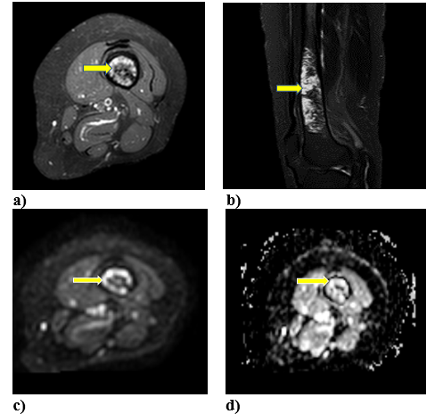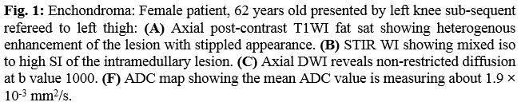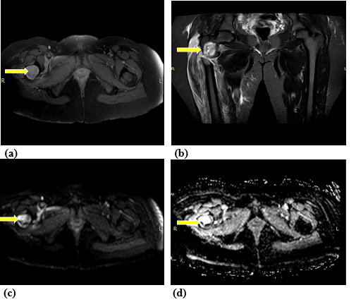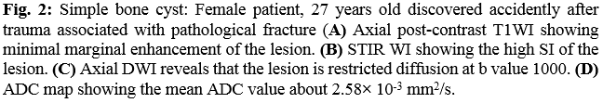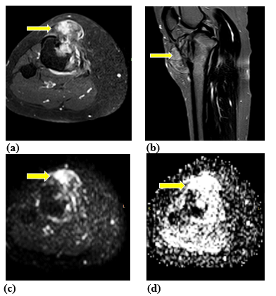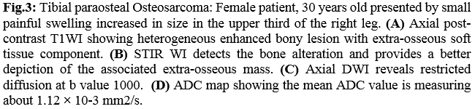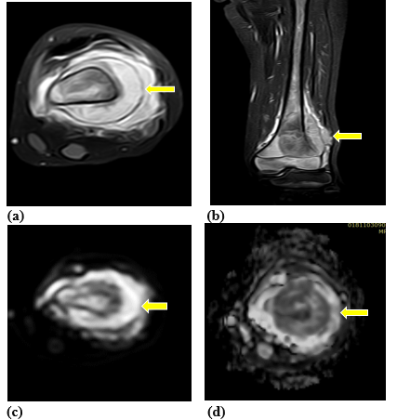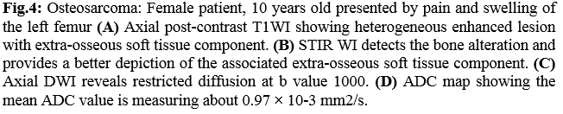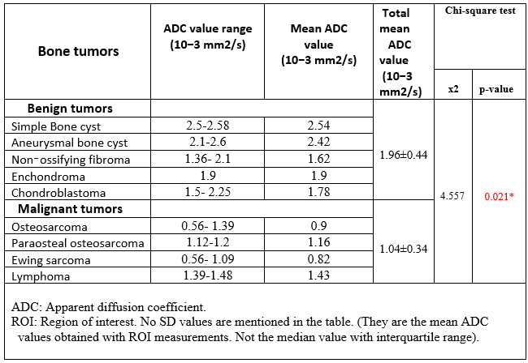

Tables & figures show the diagnostic value of a restricted pattern by DWI for the discrimination between benign and malignant lesions. Receiver operating characteristics (ROC) curve was used to define the best cut off value of ADC value which was <1.18 with sensitivity of 81.8%, specificity of 84.2%, positive predictive value of 75%, negative predictive value of 88.9% and diagnostic accuracy of 83.3%, also diffusion weighed imaging show sensitivity of 90.9%, specificity of 89.5%, positive predictive value of 83.3%, negative predictive value of 94.4% and diagnostic accuracy of 90%.

**Table (2):** Comparison between malignant and benign lesions according to diffusion weighted imaging

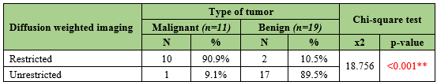

DWI & ADC values are used in discrimination between benign and malignant bone tumors, as malignant bone tumors usually have mean ADC values less than 1.04 x 10 -3 mm2/s. While benign tumors have mean ADC value 1.96 x 10 -3 mm2/s.

Also, they can be used in evaluation of cystic lesions (without the use of contrast media) as cystic lesions usually have mean ADC value more than 2.38 x10 -3 mm2/s.

Statistical analysis for the ADC values measured in the solid part of the bone tumor, revealed that there was a significant statistical difference between benign and malignant lesions (P =<0.021).

**Table(3):** Receiver-operating characteristic(ROC) curve for of lesions using ADC value and diffusion weighted imaging

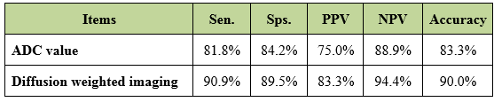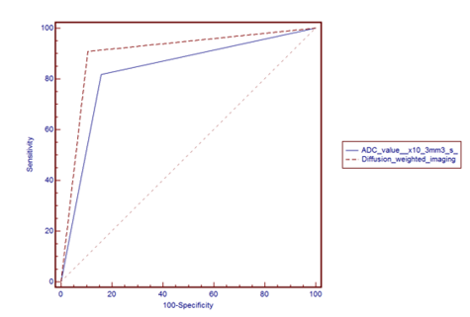

**4. Discussion**

Magnetic resonance (MR) imaging is considered the most advanced and sensitive imaging technique for evaluating changes in bone marrow, characterization of musculoskeletal lesions particularly in defining their composition, extent, compartmental involvement, and relationship to the adjacent viscera and neuro vasculature**.** This permits the precise evaluation of the aggressiveness of different lesions through detection of their extent.

DW-MRI is no enhanced functional MR imaging technique. Diffusion relies on selective excitation of the water resonance and generation of a contrast image that depends on differential nuclear relaxation times and self-diffusion coefficients. It reflects the microstructural characteristics, physiological state of the tissues and reflects microscopic water diffusion using a pair of strong diffusion gradients **(Zampa et al., 2010) (15).**

DWI was developed to map the apparent diffusion coefficient (ADC)**,** which is a quantitative measure of the Brownian motion, low ADC values in a lesion reflect a highly cellularity, where as high ADC values reflects a cellular regions **(Subhawong et al., 2016) (16).**

The potential additional value of diffusion lies in that it provides functional tissue information which can be combined with MR imaging anatomy to improve lesion characterization. Many tumors have certain entities on multimodal diagnostic imaging, however surgical biopsy is so far the only way to establish diagnosis with confidence.

The purpose of this study was to assess the ability of diffusion MRI in differentiation between benign & malignant bone tumors, also to correlate diffusion patterns, ADC values of different lesions & to guide invasive diagnostic measures for limiting the number of patients with benign diseases who undergo biopsy.

In our study subcentimetric lesions were omitted due to small ROI which would not give valuable results. **(Park et al., 2007) (17)** discussed that small lesions have degree of diffusively similar to surrounding normal tissue & may not be distinguished by DWIs & ADC. This was in agreement with **Padhiani et al., 2017(18),** most recent studies which suggest a cut off value of 2 cm as minimum diameters of lesion.

In our study one of the pitfalls of visual assessment of DWI is that an area with long T2relaxation time may remain high signal and mistaken for restricted diffusion. This false impression was corrected with ADC value measurement which proved to be more accurate in judging lesions.

In our study, we noticed that benign cysticlesions that showed high signal intensity which persist with high b values due shine through effect simulate more aggressive tumors with true restriction, but usually had high mean ADC values (2.38 x 10-3 mm2/s). This result was attributed to T2 shine through effect similar to the results of **(Kotb et al, 2014) (19)**.

Similar to **Lang et al.,2017(10)** we found low signal intensity in necrotic tumors in patients who received chemotherapy on DWIs, indicating rapid diffusion of water molecules because of loss of membrane integrity. In our study this was demonstrated in one case of Ewing sarcoma in which the signal intensity of the lesion decreased on DWIs (at b =1000 s/mm2) indicating more free water diffusion caused by cell necrosis, similarly, ADC values significantly increased. Our finding is like that observed by **Einarsdottir et al., 2004(20), Hayashida et al., 2016 (21) & Abeer et al., 2018(22).**

In our study, we had 2 cases of lymphoma showed restricted & non-restricted diffusion. The mean ADC value was 1.43. This was not in agreement with **Guo et al., 2002(23)** who stated that lymphoma has lower ADC values in comparison with other tumors.

In our study, we found that, the ADC values of solid malignant tumors (n= 11 ranged from 0.56 to 1.48 x 10-3 mm2/s, with mean ADC (1.04 x 10-3 mm2/s) were significantly lower than that of the benign bony tumors (n=19) which ranged from 1.36 to 2.6 x 10-3 mm2/s, with mean ADC (1.96 x 10-3 mm2/s).

Diffusion weighed imaging was also able to discriminate between benign and malignant lesions with sensitivity of 90.9% specificity of 89.5% with diagnostic accuracy of 90%. The results according to ROC curve for the discrimination between benign and malignant lesions using the ADC value showed that the best cut-off criterion is ADC of 1.18 with overall sensitivity of 81.8% specificity of 84.2% with diagnostic accuracy of 83.3%.

This finding indicated that a lower ADC value with high signal intensity on DWI of solid components can serve as a useful criterion for predicting malignancy in bone lesions, and that higher ADC value may be an effective method for predicting the presence of benign lesions. **Ahlawat et al.,2015 (24)** found that quantitative ADC values have predictive value for the characterization of bone lesion in agreement with **Khoo et al., 2015(8).**

According to **Neubauer et al., 2012(25)**, mean ADC value 1.03 x 10-3 mm2/s is a strong indicator of malignancy at the first diagnosis; which match with our study results. **Pekcevik et al., 2014(4)** noted some overlap in distinguishing benign and malignant lesion and stated acut-off value of 1.37 with a sensitivity of 90 %, a specificity of 92.9%, and an accuracy of 92% using ADC values in the discrimination between benign and malignant bone lesions. However, our study showed that for the discrimination between benign and malignant bone tumors using the ADC, the best cut-off value was<1.18x 10-3 mm2/s, and this means that less than or equal to1.18 x 10-3 mm2/s is indicating malignant result. Therefore, in our study, we found that ADC value was able to distinguish benign from malignant high signal intensity on DWI and this was agreement with **Padhani et al., 2017(25)** who highlighted the necessity of correlating high b-value DW images with corresponding ADC values to prevent misinterpretation due to T2 shine-through.

In addition, we found that the ADC value could monitor tumor response to therapy as agreed by **Einarsdottir et al., 2004. (22)**

The development of specific guidelines for diffusion imaging & ADC measurement checklists for results reporting may facilitate comparison of study results and help in applying ADC measurement for characterization of tumors in clinical sitting **(Vermoolen et al., 2012) (26)**.

In conclusion, we proved high specificity and sensitivity of DWI as a complementary sequence with conventional MRI and ADC value measurements in discrimination between benign and malignant bone tumors with significant cut-off value, making it a noninvasive tool for increasing the accuracy in identifying bone lesions.

However, further studies with larger patient groups are needed to find an optimal cut‑off ADC value for differentiation ADC value for differentiation between begin and malignant bone tumors.

**References**:

1. Siegel R, Naishdham D, Jemal A. Cancer statistics, 2013. CA Cancer J Clin. 2013; 63(1): 11-30.
2. Wang J, Takashima S, Takayama F, et al. Head and neck lesions characterization with diffusion-weighted echo-planar imaging. Radioloy 2001; 220:621-30.
3. George C, Nomikos, Mark D Murphey. Primary Bone tumors of lower extremities Radiologic clinics of North America 2002; 40: 971-990.
4. Pekcevik Y, Kahya MO, Kaya A et al, Diffusion weighted magnetic resonance imaging in the diagnosis of bone tumors: preliminary results. J Clin Imag Sci2014; p: 3:63.
5. Hayashida Y, Hirai T, Yakushiji T, Katahira K, Shimomura O, Imuta M, et al. Evaluation of diffusion, weighted imaging for the D.D of poorly contrast-enhanced and T2-prolonged bone masses: Initial experience. J Magnetic Resonance Imaging. 2006; 23: 377-82.
6. Yakuhiji T, Oka K, Sato H, Yorimitsu S et al. Characterizaion of chondroblasticosteosarcoma: Gadolinium-enhanced versus diffusion-weighted MR imaging. J Magnetic Resonance Imaging. 2009; 29:895-900.
7. Kaplan PA, Helms CA, Dussalt R et al., Tumors. In: Kaplan PA,1 Kaplan PA, Helms CA, Dussalt R et al., editors. Musculoskeletal MRI. Philadelphia, London, New York: WB Saunders Company 2001; ch (7): 23-150.
8. Khoo MY, Tyler PA, Saifuddin A, Padhani AR. Diffusion weighted imaging (DWI) in musculoskeletal MRI: a critical review. Skeletal Radiol 2011; 40:665–81.
9. Baur A and Reiser MF. Diffusion-weighted imaging of the musculoskeletal system in humans. Skeletal Radiology 2000; 29(10): 555-620.
10. Lang P, Honda G, Roberts T. Musculoskeletal neoplasm: peri-neoplastic edema versus tumor on dynamic post-contrast MR imaging with spatial mapping of instantaneous enhancement rates. Radiology 2017; 197: 831-39.
11. Costa FM, Ferreira EC, Vianna EM. Diffusion-weighted magnetic resonance imaging for the evaluation of musculoskeletal tumors. Magnetic Resonance Imag­ing Clinic N Am 2011;19 (1): 159–180.
12. Van Rijswijk CS, Kunz P, Hogendoorn PC, et al. Diffusion weighted MRI in the characterization of soft-tissue tumors. J Magn Reson Imaging 2002;15(3):302-7.
13. Pearce T, Philip S, Brown J, Koh DM, Burn PR: Bone metastases from prostate, breast and multiple myeloma: differences in lesion conspicuity at short-tau inversion recovery and diffusion-weighted MRI. Br J Radiology 2012; 85:1102-1106.
14. Jaramilo D: Whole-body MR. imaging, bone diffusion imaging: how and why? Pediatric Radiology 2010; 40: 978-984.
15. Zampa V, Roselli G, Beltrami G, MRI of bone tumors: advances in diagnosis and treatment assessment. 10.2217/IIM.10.28 © 2010 Future Medicine Ltd Imaging Med. 2010:2(3), 325–340 ISSN 1755-5191.
16. Subhawong Ty K, Jacobs MA, Fayad LM. Insights into Quantitative Diffusion Weighted MRI for Musculoskeletal Tumor Imaging. AJR Am J Roentgenol 2014; 203:560-72.
17. Park MJ, Cha ES, Kang BJ, et al. The role of diffusion -weighted imaging and the apparent diffusion coefficient (ADC) values for breast tumors. Korean J Radiol2007; 8(5): 390-396.
18. Padhani AR, Khoo MY, Tyler PA, Saifuddin A. Diffusion weighted imaging (DWI) in musculoskeletal MRI 2017: a critical review.
19. Kotb S, Sultan A, Elhawary G, et al. WHO classification of soft tissue and bone tumors, 2013. Value of diffusion weighted MRI in differentiating benign from malignant bony tumors and tumor like lesions. The Egyptian Journal of Radiology and Nuclear Medicine 2014; 45, 467–476.
20. Einarsdottir H, Karlssom M, Wejde J, et al. Diffusion-weighted MRI of soft tissue tumors. Eur Radiol 2004; 14:959–63.
21. Hayashida Y, Yakushiji T, Awai K, Katahira K, Nakayama Y, Shimomura O. Monitoring therapeutic responses of primary bone tumors by diffusion-weighted image: initial results. Eur Radiol 2016;16(12):2637–43.
22. Abeer MA, Ayman MI, Noha MO et al. The Role of Advanced Techniques of MRI in Evaluation of Pediatric Bone Tumors, The Egyptian Journal of Hospital Medicine April 2018; Vol. 71 (7): 3585-3590.
23. Guo AC, Cummings TJ, Dash RC. Lymphomas are high grade astrocytomas: comparison of water diffusibility and histological characteristics radiology 2002;224: 83-177.
24. Neubauer H, Evangelista L, Hassold N, et al. Diffusion weighted MRI for detection and differentiation of musculoskeletal tumors and tumor like lesions in pediatric age patients. World J Pediatric 2012; 8:342-349.
25. Padhani AR, Khoo MY, Tyler PA, Saifuddin A. Diffusion weighted imaging (DWI) in musculoskeletal MRI 2017: a critical review.
26. Vermolen MA, Kwee TC, Nievelstein RA, Apparent diffusion coefficient measurements in the differentiation between benign and malignant lesions a systematic review. Insight imaging 2012 August;3(4):395-409.

5/25/2019