**Retrospective analysis of management and pattern of failure in metastatic prostatic cancer at Assiut university oncology department as a model of low income city (single center experience)**

Amin AF, Abdlftah ON, Mohammed ZS, El-Nagger MS

Department of Clinical Oncology and Nuclear Medicine, Faculty of Medicine, Assiut University, Assiut, Egypt

Email: [abeeramin210@yahoo.com](mailto:abeeramin210@yahoo.com)

**Abstract: Aim of work:** To evaluate management and pattern of failurein Metastatic Prostatic Cancer at Assuit university oncology department in period from (2009-2019) as a model of low income city and evaluate difference in disease presentation and management in comparison with high income countries. **Patients and methods:** Data of 111 patients with metastatic prostatic cancer presented to clinical oncology department, Assiut University Hospital during the period (2009 -2019) were reviewed as regard patients characteristic, management and pattern of failure. **Results**: The mean age of cases is 71 years, the most common age group is (64 to 73 years) represented in 43% of patients followed by age group (74 to 83 years) in 30% of patients. Thirty percentage had chronic diseases (most of them 20% have hypertension or diabetes mellitus or both).The most common presenting symptoms were urine retention in 25% of patients, followed by bone pain in 23% of patients. The most common pathology was prostatic adenocarcinoma and the most common Gleason score was 7 which detected in 30% of patients, followed by G.S ≤6 (grade group 1) presented in 21% of patients, and G.S 9 or 10 (grade group 5) was in 20% of patients. As regard to Response to hormonal treatment 58% of patients the disease was stable, while disease progression occurred in 41% who were diagnosed to have CRPC by assessment of testosterone level, Median progression free survival among enrolled patients after hormonal deprivation therapy was 11 months (95%CI= 9-16). It was noticed that patients received combined hormonal therapy had significantly higher median overall survival (68 month (95%CI= 66-88) in comparison to those received single agent (65 month (95%CI=64-67)) (P< 0.001) .Twenty four Patients who showed progression after castration received chemotherapy .Response to chemotherapy was assessed after a follow up period of 12 months and found that; among 24 cases received chemotherapy, disease progression occurred in 92% of them, while in 8% was stationary., median progression free survival among enrolled patients after chemotherapy was 8 months (95%CI= 7-11). Elderly (70-83years) unfit Patients to ordinary treatment plan which represent 9% of newly metastatic prostate cancer and 70% of them had bone secondary considered for ADT with radiotherapy to the prostate (3600GY/6sesion/6week). Median overall survival was 24±4.65 months. **Conclusion**: Our study on metastatic prostatic patients as a model of patient in developing countries has shown that Androgen deprivation therapy seems to be an effective initial treatment and had a progression free survival and overall survival comparable to developed countries , while ADT with EBRT to the primary tumor in Elderly Patients not fit for ordinary treatment plane seems to be a good treatment option in developing countries due to its feasibility and affordable cost of our health care system , however, There was a need for novel therapeutic strategies to be available at our institute to improve patient outcomes in mCRPC.

[Amin AF, Abdlftah ON, Mohammed ZS, El-Nagger MS, **Retrospective analysis of management and pattern of failure in metastatic prostatic cancer at Assiut university oncology department as a model of low income city (single center experience)**. Cancer Biology 2021;11(4):1-5]. ISSN: 2150-1041 (print); ISSN: 2150-105X (online). http://www.cancerbio.net [1.doi](http://www.sciencepub.net/nature.%20%20x.doi):[10.7537/marscbj110421.01.](http://www.dx.doi.org/10.7537/marscbj110421.01)

**Keyword:** Metastatic Cancer Prostate, Management, Pattern of failure

**1. Introduction**:

In Egypt Prostate cancer is the fourth common male cancer incidence after (liver, bladder, lung) it represent 3.5% of new cases and Prostate cancer related death is 2.5% in men**.** Prostate cancer had higher prevalence in the developed countries. One of the explanation of these differences in the incidence rates due to differences in the use of diagnostic testing e.g. PSA test **[1]**.

Treatment of non-metastatic prostatic cancer includes active surveillance, radical prostatectomy, radiotherapy, and adjuvant androgen deprivation treatment. Choice of treatment option depends on patient age, performance status, tumor grade and stage **[2]**.

Treatment of metastatic prostate cancer includes androgen deprivation therapy, palliative local radiotherapy, chemotherapy and supportive treatment.

Radical therapy to the prostate impacts survival, especially in patients with low metastatic burden (1–3 skeletal lesions without any visceral metastases). many men have symptomatic disease progression and require palliative surgical intervention, which is less in patients treated with initial radical prostatectomy compared to systemic therapy alone [**3]**.

Patients with low-volume metastatic prostate cancer considered for androgen deprivation therapy with radiotherapy to the prostate based on results from phase 3 STAMPEDE trial. In which 2061 patients were randomized to androgen deprivation therapy with or without radiotherapy to the prostate (55 Gy /20 session / 4 weeks or 36 Gy /6 session / 6 weeks). Radiotherapy to the prostate improved the PFS&OS in patients with low metastatic burden **[4]**.

Most of patients with metastases had an initial response to androgen-deprivation therapy but a high percentage had progressed to castration-resistant prostate cancer within a median of one year **[5]**.

Since 2010, new treatments for mCRPC increased from one drug (docetaxel) to six, expanding treatment options and offer the possibility to combine therapies for mCRPC **[6]**.

In a phase 2 study, patients with mCRPC who were pretreated with chemotherapy (most of them received abiraterone or enzalutamide) were given the poly ADP-ribose polymerase (PARP) inhibitor Olaparib. Response to Treatment was markedly improved in patients with tumors carrying a homologous recombination repair (HRR) mutation. **[7]**.

**2. Patients and methods**

A retrospective analysis for all patients' data with histologically confirmed metastatic prostate cancer presented to clinical oncology department, Assiut University Hospital in the period (2009 to 2019), the total number of cases was one hundred and eleven patients.

All patient data reviewed for: history, physical examination, PSA, and testosterone & Follow up reported Imaging. CT, MRI, bone scan or PET CT to assess initial disease, type of metastasis, and disease volume.

All patient data reviewed thoroughly as regard different treatment modalities: (Surgery, hormonal therapy, Chemotherapy and Radiation therapy). Response, Progression-free survival and Overall survival to each treatment line were recorded.

**Statistical Analysis:**

Descriptive statistics were used as mean, median and percentage (%). The survival curves were estimated using the Kaplan–Meier method. Analyses were performed using SPSS software version 20.

**3. Results:**

Mean age of cases was 71 years (SD ± 8.055), the most common age group was (64 to 73 years) represented in 43% of our cases then age group (74 to 83 years) in 30%, while 21% of cases are in age group (53 to 63).

As regard to comorbidities in patients in this study, 30% had other chronic diseases (most of them 20% have hypertension or diabetes mellitus or both). Fig (1)

The most common pathology was prostatic adenocarcinoma in (96%) of patients, most common Gleason score was G.S 7 was detected in 30%, followed by G.S ≤6 in 21% of patients.

All patients received: surgical castration with Bicalutamide in 49% of patients, followed by Combined Goserline and bicalutamide in 34% of patients. Response to hormonal treatment Among 111 patients in study group; was 58% of patients was stable, while disease progression occurred in 41% who were diagnosed to have CRPC by assessment of testosterone level, while in 1% of patients was missed. Median progression free survival among enrolled patients after hormonal deprivation therapy was 11 months (95%CI= 9-16). Fig (2) while Median overall survival was 66 months (95%CI= 65-67). It was noticed that patients received combined hormonal therapy had significantly higher median overall survival (68 month (95%CI= 66-88) in comparison to those received single agent (65 month (95%CI=64-67)) (P< 0.001) Fig (3).

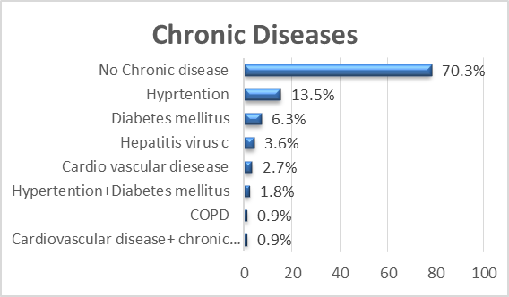

Figure 1:Comorbidities in patients in our study.

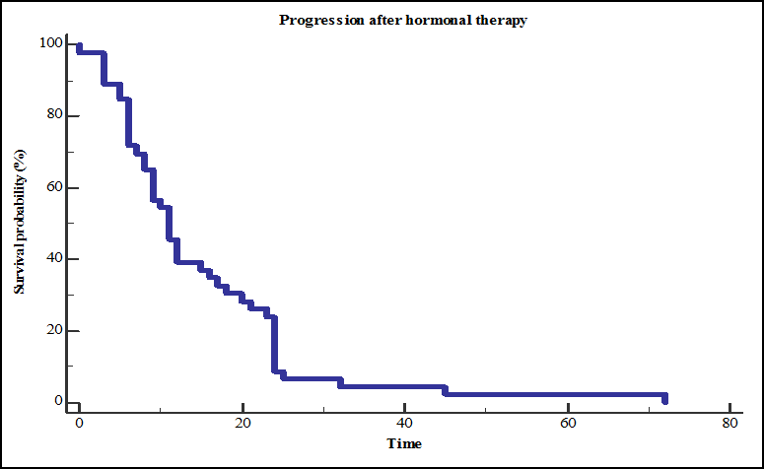

Figure 2: Kaplan-Meier curve for PFS after hormonal therapy.

Twenty four CRPC patients received chemotherapy in the form of (Docetaxel plus Prednisone), disease progression occurred in 92% of them, while in 8% was stationary. Median progression free survival among our CRPC patients after chemotherapy was 8 months (95%CI= 7-11) Fig (4).

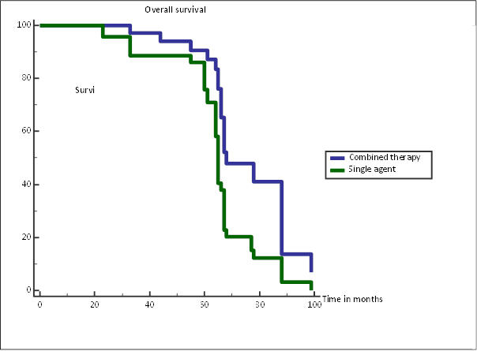

Fig (3) Kaplan-Meier curve for over-all survival after hormonal therapy

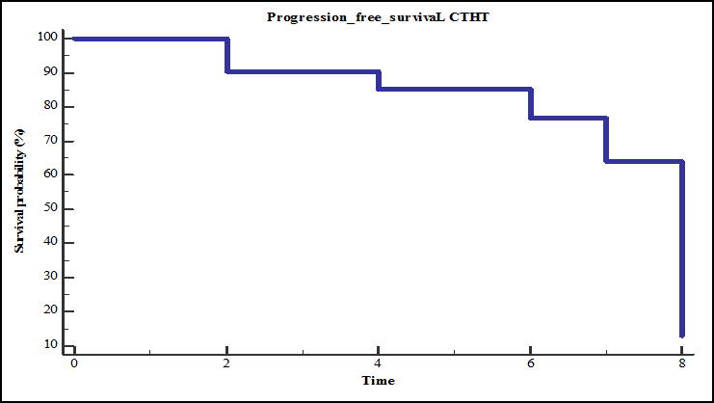

Figure 4: Kaplan-Meier curve for PFS after chemotherapy

Patients with CRPC significantly have poorer survival outcomes, Survival chance decreases by 4.065 times in CRPC cases Table (1).

Table (1): survival outcomes in Patients with CRPC

|  |  |  |  |
| --- | --- | --- | --- |
| Variable | Beta coefficient | Significance | Effect on Survival Chance |
| CRPC | -1.402 | 0.001 | -4.065 |

Elderly (70-83years) unfit Patients to ordinary treatment plan which represent 9% of newly metastatic prostate cancer and 70% of them had bone seconderies considered for ADT with radiotherapy to the prostate (3600GY/6sesion/6week). Median overall survival was 24±4.65 months.

**4. Discussion:**

In our study we revised all metastatic prostate cancer cases in Assiut university hospital retrospectively in the period from 2009 to 2019 for incidence, patients’ characteristics, presenting symptoms, associated chronic diseases, pathology, Gleason score, disease volume and metastatic sites, treatment types and response to treatment.

The total number of cases is one hundred and eleven, we founded that the incidence of metastatic prostate cancer in oncology department in Assiut University is 1.24% of all cancer patients presented to the department in last ten years. Mean age of our patients with metastatic prostate cancer was 71 years, and most cases 73% in age group 63 to 83 years old. This was compatible with the age of patients in developed countries as the most common age ≥65 years and is rare ≤ 50 years of age **[8].** Most of the studies agreed with our result with the median age of 70 years **[9, 10]**.

In present study the percentage of metastatic prostate cancer patients that are smokers was lower than those who were nonsmokers, (45% versus 55% of patients).This result agrees withJiménez-Mendoza et alwho found that smokers have lower incidence of PC than never smokers and This was explained by increase in smoking cessation once PC diagnosed or other chronic disease **[11]**.

Most of epidemiological studies have not found a relationship between smoking and prostate cancer, However some cohort studies have found that heavy smokers had 2-3 times higher risk to develop prostate cancer **[12]**.

Our results showed 30% of patients had other chronic diseases; the most found chronic diseases were hypertension and diabetes mellitus. Which agreed with another study as the prevalence of comorbidity in prostate cancer patients was (30.5%) [**13],** while in United States, The most prevalent types of chronic conditions were cardio metabolic and respiratory chronic conditions in (54%) of patients with prostate cancer **[10].**

The majority of cases in our study had prostatic adenocarcinoma (95.5%) as the most frequent pathology and this result agrees with global prostate cancer patient’s characteristics, as 93.75% of cases was prostatic adenocarcinoma [14].

Most patients in present study presented with high volume metastasis (65%) of patients, the majority of metastasis were bone metastasis in (73%) of patients, which agree with incidence reported by ***Gandalia et al 2014*** **[15].**

Androgen deprivation therapy is the most effective initial treatment to patients of metastatic prostate cancer, but almost all patients will be CRCP within 18–24 months of ADT **[16].**

In our study all patients received androgen deprivation therapy in the form of: surgical castration with Bicalutamide in 49% of patients, or by Combined Goserline and Bicalutamide in 34% of patients.

Response to hormonal treatment Among 111 patients in study group; was 58% of patients was stable, while disease progression occurred in 41% who were diagnosed to have CRPC by assessment of testosterone level .

Median overall survival was 66 months (95%CI= 65-67). It was noticed that patients received combined hormonal therapy had significantly higher median overall survival (68 month (95%CI= 66-88)) in comparison to those received single agent (65 month (95%CI=64-67)) (P< 0.001), our results for ADT alone was comparable was global OS data from different trials where OS ranges from 54 to 71 months for the ADT alone **[17-19]**.

As regard Median progression free survival among enrolled patients after hormonal deprivation therapy it was 11 months (95%CI= 9-16) which was nearly the same to that reported by ***Fiazi et al 2017[5]*** but still lower to than that reported by ***Sharifi et al 2005[20]****.*

The two major line of therapy for mCRPC include cytotoxic chemotherapy and androgen-targeted therapies. Docetaxel and prednisone is the standard first-line chemotherapy in CRPC in comparison with the previous standard regimen **[18, 21]**. In the present study 24 patients who progressed to CRPC received chemotherapy treatment which was the available treatment in our hospital at that time, in the form of combination of (Docetaxel/prednisolone). Median progression free survival among enrolled patients after chemotherapy was 8 months (95%CI= 7. 7-11), our results were consistent with results that reported by Kawahara, while in another study, PFS was 6.1 months for patients on Docetaxel and Prednisone. **[22]**

Based on the 2017 Advanced Prostate Cancer Consensus Conference, 90% of experts agreed that in men with mCRPC who have progressed following AR-targeted therapy, docetaxel would be the best treatment option and In patients previously treated with docetaxel, switching to cabazitaxel would be preferable based on the CARD trial, as cabazitaxel improved PFS and OS compared to alternative AR-targeted therapy in patients previously exposed to docetaxel **[26]**, in our study no availability of cabizataxel so we only Use docetaxel or Local radiotherapy to prostate and continue ADT[23]

In our study elderly (70-83years) Patients unfit to ordinary treatment plane which represent 9% of newly metastatic prostate cancer and most of them (70% ) of them had bone seconderies considered for ADT with radiotherapy to the prostate (3600GY/6sesion/6week). Median overall survival was 24± 4.65 months this result consistent with that reported by ***Christopher et al*[4]** that an EBRT improved OS, prostate cancer-specific survival, progression-free survival in patients with low metastatic burden.

**Limitations**

Retrospective nature of the study, our work is coming from single institution which may not reflect the exact figures about PCA in our country, and novel therapeutic strategies were not available in our health care system to improve patient outcomes in mCRPC at our institute.

Despite of these limitations, our study was able to maximize the utility of available information to present a comprehensive picture of patients’ characteristics and different treatment modalities available in our institution and impact of treatment.

**Conclusion**:

Our study on metastatic prostatic patients as a model of patient in developing countries has shown that Androgen deprivation therapy seems to be an effective initial treatment and had a progression free survival and overall survival comparable to developed countries , while ADT with EBRT to the primary tumor in Elderly Patients not fit for ordinary treatment plane seems to be a good treatment option in developing countries due to its feasibility and affordable cost of our health care system , however, There was a need for novel therapeutic strategies to be available at our institute to improve patient outcomes in mCRPC

**References**

1. Egypt-Glopal Cancer Observatory; International Agency for Research OF Cancer, WHO. (2021(
2. Abraham J, Gulley J and Allegra G. (2014) The Bethesda handbook of clinical oncology. 4th ed. Philadelphia: Lippincott Williams & Wilkins, a Wolters Kluwer business, p.193.
3. Sooriakumaran P. (2017) Testing radical prostatectomy in men with prostate cancer and oligo metastases to the bone: a randomized controlled feasibility trial. BJU International, 120, E8-E20

# Christopher C, Nicholas D James, Christopher D Brawley, et al. (2018) Radiotherapy to the primary tumor for newly diagnosed, metastatic prostate cancer (STAMPEDE): a randomized controlled phase 3 trial, the lancet volume 392, Issue10162, P2353-2366, December 01

1. Fizazi K, Tran N, Fein L, et al. (2017) Abiraterone plus Prednisone in Metastatic, Castration-Sensitive Prostate Cancer. New England Journal of Medicine, 377, 352-360.
2. Sartor O, Vogelzang Nj, Sweeney C, et al.( 2018) Radium-223 Safety, Efficacy, and Concurrent Use with Abiraterone or Enzalutamide: First U.S. Experience from an Expanded Access Program. Oncologist, 23, 193-202.
3. Clarke N, Wiechno P, Alekseev B et al. (2018) Olaparib combined with abiraterone in patients with metastatic castration-resistant prostate cancer: a randomized, double-blind, placebo-controlled, phase 2 trial. The Lancet Oncology, 19, 975-986.
4. Rucci N. and Angelucci A (2014) Prostate cancer and bone: the elective affinities. Biomed research international, 2014.
5. Reyad AY, Ezz El Din MM, Mosalam Na. (2018) Retrospective Analysis of Clinico-Epidimological Factors in Prostatic Cancer. The Egyptian Journal of Hospital Medicine, 73, 6075-6081.
6. Raval AD, Madhavan S, Mattes MD et al. (2016) Association between types of chronic conditions and cancer stage at diagnosis among elderly Medicare beneficiaries with prostate cancer. Population health management, 19, 445-453
7. Jiménez-Mendoza E, Vázquez-Salas Ra, Barrientos-Gutierrez T, et al. (2018) Smoking and prostate cancer: a life course analysis. BMC cancer, 18, 160.
8. David Schottenfeld and Joseph F.Frauman. (2006): cancer epidemiology and prevention. Prostate cancer; pp.1128-1150.
9. Edwards, BK, Noone, Am, Mariotto AB, et al. (2014) Annual Report to the Nation on the status of cancer, 1975‐2010, featuring prevalence of comorbidity and impact on survival among persons with lung, colorectal, breast, or prostate cancer. Cancer, 120, 1290-1314
10. Alizadeh M. and Alizadeh S. (2014) Survey of clinical and pathological characteristics and outcomes of patients with prostate cancer. Global journal of health science, 6, 49.
11. Gandaglia G, Abdollah F, Schiffmann J, et al. (2014) Distribution of metastatic sites in patients with prostate cancer: a population‐based analysis. The Prostate, 74, 210-216.
12. Dong L, Zieren RC, Xue W, et al. (2019) Metastatic prostate cancer remains incurable, why? Asian journal of urology, 641-26.
13. James ND, Spears MR, Clarke NW, et al. (2015) Survival with newly diagnosed metastatic prostate cancer in the “docetaxel era”: data from 917 patients in the control arm of the STAMPEDE trial. Eur Urol.; 67:1028–38.
14. Tannock I, DE Wit R, Berry WR, et al. (2004) Docetaxel plus prednisone or mitoxantrone plus prednisone for advanced prostate cancer. New England Journal of Medicine, 351, 1502-1512
15. Damodaran S, Kyriakopoulos CE, Jarrard DF. (2017)Newly diagnosed metastatic prostate cancer – has the paradigm changed? Urol Clin North Am. Nov; 44(4): 611–621.
16. Sharifi N, Dahut WL, Steinberg SM, et al. (2005) a retrospective study of the time to clinical endpoints for advanced prostate cancer. BJU Int. Nov; 96(7):985–9.
17. Kawahara T, Miyoshi Y, Sekiguchi Z, et al. (2012) Risk factors for metastatic castration-resistant prostate cancer (CRPC) predict long-term treatment with docetaxel. PLoS One, 7, e48186.
18. Gillessen S, Attard G, Beer T, et al. Management of patients with advanced prostate cancer: the report of the Advanced Prostate Cancer Consensus Conference APCCC 2017. Eur Urol. 2018; 73:178–211.
19. De Wit R, de Bono J, Sternberg CN, et al. Cabazitaxel versus abiraterone or enzalutamide in metastatic prostate cancer. N. Engl J Med. 2019; 381:2506–18

11/3/2021