**Oral cancer, our experience in improving quality of patient’s life.**

wael Al-shelfa(1), Shymaa yahia(2), Salina Saddick(3), Salah Mansour(1), Alaa Khalil(1), Ehab Elnakoury(4), Mahmoud Sadek.(5) , Hazem nour(1).

(1)department of surgery, Zagazig university, Egypt.

(2) Department of microbiology, Zagazig university, Egypt.

(3)department of Biological science, faculty of science, King abdulaziz university, KSA.,

(4) Department of medical oncology, Azhar university, Egypt,

(5) Surgery department, SGH, Jeddah.

**Address of correspondence:**

Dr. Wael Al-Shelfa,

Ass. Professor of Surgery ,Zagazig University Zagazig , Egypt.

1. Mail : [Waelshel74@yahoo.com](mailto:Waelshel74@yahoo.com)

**Abstract:**

***Background***: Oral cancer or mouth cancer is a malignant growth located in the oral cavity, which could be primary, secondary, or extension from surrounding organs. It most commonly involves the tongue, floor of the mouth, cheek, gums, lips, palate, or mandible. In our study we used 4th version of University of Washington Quality of Life Questionnaire (UW-QOL v4), twelve domains were included: pain, appearance, activity, recreation, swallowing, chewing, speech, shoulder, taste, saliva, mood, and anxiety. The aim of this work is to describe our experience to improve quality of life of oral cancer patients after surgical, neoadjuvant, or adjuvant therapy.

***Patients and methods***: sixty eight patients with different types of oral cancer, tongue n=28, lips n=12, floor of the mouth n=12, oropharynx n=5, vestibule of the mouth n=3 mandible n=3, cheek mucosa n=2, gum n=2, palate n=1.most of them had surgery.

***Results***: Forty two patients of 68 patients with oral cancer recruited in our study had surgery, pre and postoperative assessment of QoL using UW-QoL questionnaire was done, and the score is repeated every 3 months, also, patients who presented at advanced stage, and had radio and/or chemotherapy, were assessed at similar intervals.

***Conclusion***: surgical treatment has a better chance to improve QoL in oral cancer patients than neoadjuvant therapy; pain, appearance, chewing, recreation, speech, and anxiety were the most important domains to improve after surgery in our study.

[wael Al-shelfa, Shymaa yahia, Salina Saddick, Salah Mansour,Alaa Khalil,Ehab Elnakoury, Mahmoud Sadek ,Hazem nour. **Oral cancer, our experience in improving quality of patient’s life.**Cancer Biology 2023;13(3):6-11]. ISSN: 2150-1041 (print); ISSN: 2150-105X (online). <http://www.cancerbio.net>  [02.doi](http://www.sciencepub.net/nature.%20%20x.doi):[10.7537/marscbj130323.02.](http://www.dx.doi.org/10.7537/marscbj130323.02)

**Kay word** : oral cancer, Quality of Life, tongue.

**Introduction:**

Oral canceris a type of head and neck cancer, which is caused by any cancerous growth in oral cavity.(1)

Oral cancer deaths increases from 84000 in 1990 up to 135000 deaths in 2013.(2), with five year survival rates in the united states are 63%. (3)

Early symptoms include persistent patches either red or white, ulcer, increasing swelling, unusual oral bleeding, and sudden tooth mobility without cause.(4)

Late symptoms include persistent pain, referred pain, cervical lymphadenopathy, otalgia, trismus, dysphagia, dysesthesia of the tongue or lips.(4)

Prognosis depends on stage and overall health. Grading of the invasion front of the tumor is a very important prognostic parameter.(5)

The measurement of health-related quality of life (HRQoL) is gaining importance as a valuable outcome measure, particularly in the oral cancer area. It is a concept that reflects a subjective measurement of health status, assessed by disease-specific questionnaires, which provide valuable information by interpreting functional status in scope of patients life.(6)

Disease-free survival of the patient is the primary intention of cancer treatment, however, quality of life is now seen as an essential secondary outcome, therefore; assessment of pre- and postoperative quality of life in oncologic patients has become an important aim of the therapeutic approach.(7)

In our study we aimed at assessment of (HRQoL) of oral cancer patients, 1-2 years after treatment.

**Patients and methods:**

We conducted this prospective study in Saudi German hospital, Jeddah, and Zagazig university hospital, between April 2014 to March 2017. We recruited patients presenting with features of oral cancer. Diagnosis was based on clinical criteria of oral malignancies; (pain, ulcers, masses, and neck swelling), proved by histopathological studies. We did not excluded patients with locally advanced disease, and recurrent disease. The study was approved by the local ethical committee.

An informed consent form all patients were obtained, and all patients received a formal letter explaining the study, 35 questionnaire and an additional questionnaire exploring the social and educational status. Patients who were not able to fill in the questionnaire themselvesdue to language were not excluded from the study.

In our study we used version 4 of University of Washington Quality of Life Questionnaire (UW-QoL v4), which consists of 12 single question domains, these having between 3 and 6 response options that are scaled evenly from 0 , the worst, to 100, the best, according to the hierarchy of response. These domains include pain, appearance, activity, recreation, swallowing, chewing, speech, shoulder, taste, saliva, mood, and anxiety.

It is time consuming and a logistical challenge to ensure patients self-complete questionnaires before treatment and at regular intervals, 3 months, subsequently.

We assessed the quality of life of oral cancer patients undergoing treatment in surgical oncology unit, Zagazig university hospitals, and in Saudi-German hospital, Jeddah, from April 2014 to March 2017. The study gathered information from 68 patients with different types of oral cancer; tongue n=28, lips n=12, floor of the mouth n=12, oropharynx n=5, vestibule of the mouth n=3 mandible n=3, cheek mucosa n=2, gum n=2, palate n=1.

Most patients underwent surgery n=42, 38 of them had surgery at time of presentation, 4 had surgery post chemoradiation. 32 patients (47%) were classified as T1 to T2, 14 patients (20%) were classified as T3, 22 patients (33%) were classified as T4.

A Likert-scale score allowed assigning ratings from 0 to 100 for each possible answer, and higher scores indicates improvement of Quality of Life.

At 1 year follow up, 8 patients died, 6 patients could not be contacted, the remaining 54 patients contacts us for the UW-QoL questionnaire.

**Microbiological studies:**

Cancer patients remain at substantial risk for developing serious infections despite significant advances in cancer therapy and supportive care .treatment of the these malignant conditions by cytoxic chemotherapy and radiotherapy has become increasingly effective ,but it associated with significant side effects ,also neutropenia is still the most common predisposing factor for developing of infections in the cancer patients

The patients involved in this study are evaluated for the risk of infection (oral infections ,blood stream infections )and its effect on quality of life .

Blood samples were withdrawn from feverish patients. The patients developed oral infections were swabed for the lesion. The bacterial pathogens were identified after appearance of growth on sub cultured ,plated of blood and oral swab by standard microbiological and biochemical testslike catalase,oxidase ,motility tests,and haemolysis on blood .Preliminary examination of fungal colony on SDA through gram stained smear ,formation of germ tube ,and morphology on KOH stained smear .

The Prevalent bacterial pathogens isolated were Staphylococcus aureus, Escherichia coli, Staphylococcus epidermidis, Pseudomonas aeruginosa, Klebsiella pneumonia, Proteus mirabilis, Proteus vulgaris and the fungal pathogens were Candida albicans, Aspergillus fumigatus. The predominant gram negative bacteria, Pseudomonas aeruginosa and Klebsiella pneumonia were isolated from blood and oral cavity of treated cases respectively. The predominance of gram positive bacteria (Staphylococcus aureus and Staphylococcus epidermidis) were observed in blood of chemotherapy, radio chemotherapy cases and oral cavity of radiotherapy, radio chemotherapy treated cases. the presence of C. albicans fungi as most significant oral cavity pathogens in the patients.

**Statistical analysis :**

All values are presented as mean, median, (range), or percentage. The primary outcomes of this study were to evaluate the improvement in quality of life for patients with several types of oral cancer, with 1-3 years follow up. Continuous data were compared using the unpaired *t-*testor Mann-Whitney tests. Categorical variable were evaluated using Chi-Square. Survival analysis was performed, as the lesion has high death rate. The data was analyzed using the statistical package SPSS for windows; SPSS 8.0 software (1997) Statistical significance was determined a prior at ≤ 0.05.

**Results:**

We recruited 68 patients with several types of oral cancer, figure (1-2).

Demographic and the primary site of oral cancer patients are illustrated in table (1), all variables werematched regarding age, sex, type of treatment, survival, and P-value.

Overall 61% were males, 39% were females. The mean age was 63.7 (standard deviation (sd): 11.8) years in our patients.

Over 60% of our patients were belonged to the lowest social class.

The most frequent location of oral cancer was the tongue (41%), unfortunately, stage IV was the most prevalent.

The most common treatment was surgery (61%), with or without adjuvant chemo- radiation.

**Table (1) Demographic and medical variables**

|  |  |  |  |  |  |  |  |  |  |
| --- | --- | --- | --- | --- | --- | --- | --- | --- | --- |
| *Tongue cancer* | *Lips* | *Floor of the mouth* | *Oro-pharynx* | *Vestibule of the mouth* | *mandible* | *Cheek mucosa* | *Gum* | *palate* |  |
| *Age 34-66* | *56-69* | *49-58* | *32-47* | *55-68* | *50-53* | *44-50* | *61-63* | *54* |  |
| *Sex F=16*  *M=12* | *F=4*  *M=8* | *F=3*  *M=9* | *F=0*  *M=5* | *F=0*  *M=3* | *F=0*  *M=3* | *F=1*  *M=1* | *F=2*  *M=0* | *F=1*  *M=0* |  |
| *Surgery 24* | *9* | *2* | *1* | *1* | *2* | *2* | *1* | *0* |  |
| *Radioth. 4* | *3* | *10* | *4* | *2* | *1* | *0* | *1* | *1* |  |
| *Chemoth. 3* | *3* | *8* | *3* | *2* | *1* | *0* | *1* | *1* |  |
| *Survival 27* | *11* | *10* | *4* | *2* | *1* | *2* | *1* | *1* |  |
| *p-value 0.004* | *0.005* | *0.005* | *0.07* | *0.09* | *0.12* | *0.15* | *0.15* | *0.19* |  |

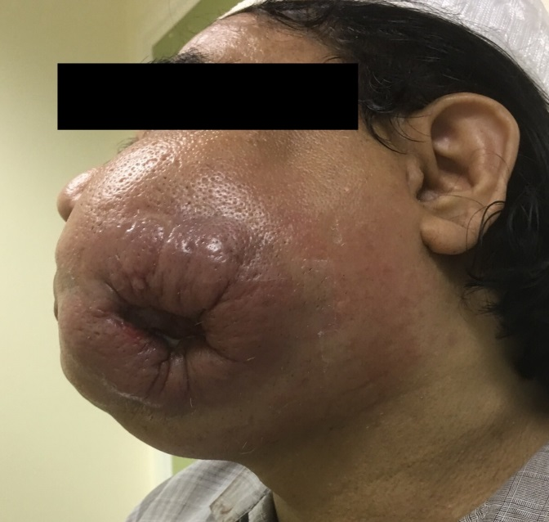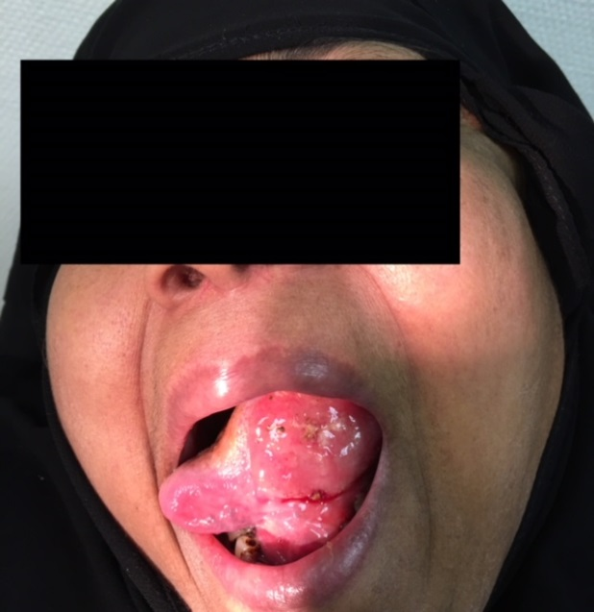

**Figure (1)**cancer mandible.**Figure (2)**cancer tongue,(preoperative)

Surgical excision of the tumor was done for 42 cases (62%). Several procedures were done; glossectomy in our study either partial or hemiglossectomywith neck dissection. Figure (3-6). Partial mandibulectomy with bone graft. Time interval to radiotherapy post- surgical radical excision is 6-8 weeks.

Conventional fractionation of radiotherapy administering 1.8-2.0 Gy per day, with five fractions per week, is our standard therapeutic schedule of radiotherapy for oral cancer patients, with total dose of 60.0 Gy to 70.0 Gy.

Systemic chemotherapy was received before surgery or in combination with radiotherapy. The combination used was cisplatin and 5-fluorouracil via intravenous infusion.

8 patients died due to delayed presentation and co-morbidities.

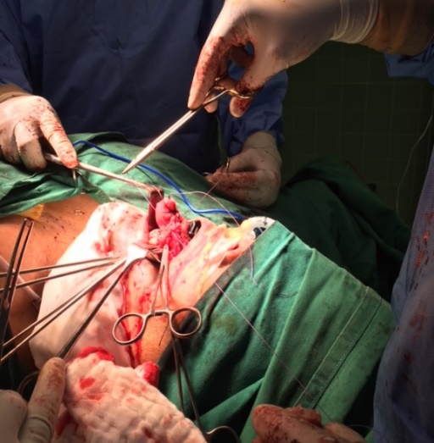 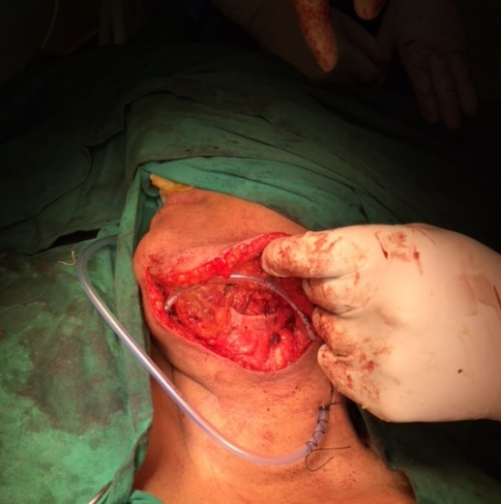

**Fifure (3)** cancer of the floor of the mouth.**Figure (4)**neck dissection.

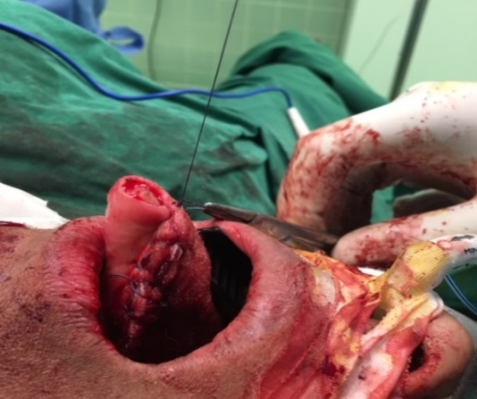 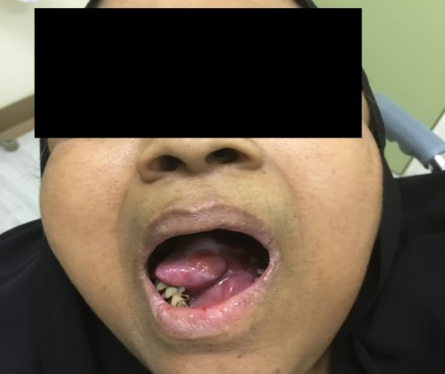

**Figure (5)**hemiglossectomy, intraoperative.**Figure (6)**hemiglossectomy, postoperative.

**Presentation of domain score:**

**Table (2)** illustrates how basic University of Washington –Quality Of Life, (UW-QoL), data can be presented. Data shown in the table represents our use of UW-QoL questionnaire with our oral cancer patients. Our primary treatment was by surgery, with or without adjuvant radiotherapy. Number of patients with their score for each domain is illustrated in the table with the main of each score and percentage of the best response. 68 patients were included in the study, with data collected from 9- 24 months after treatment, for patients with different scores; we were close to highest score.

**Table (2)** illustrates how basic University of Washington –Quality Of Life, (UW-QoL), data can be presented. Data shown in the table represents our use of UW-QoL questionnaire with our oral cancer patients.

|  |  |  |  |  |  |  |  |  |  |  |  |  |  |  |
| --- | --- | --- | --- | --- | --- | --- | --- | --- | --- | --- | --- | --- | --- | --- |
|  |  | | UW-QoL scores | | | | | | | | | |  |  |
| Domain | **No** | | **0** | **25** | **30** | | **50** | | **70** | **75** | | **100** | **Mean** | **Best score %** |
| Pain | **68** | | **2** | **5** |  | | **6** | |  | **20** | | **35** | **82** | **51** |
| Appearance | **68** | | **3** | **7** |  | | **12** | |  | **27** | | **19** | **70** | **26** |
| Activity | **68** | | **4** | **6** |  | | **10** | |  | **18** | | **30** | **75** | **44** |
| Recreation | **68** | | **3** | **8** |  | | **9** | |  | **21** | | **27** | **71** | **39** |
| Swallowing | **68** | | **11** |  | **12** | |  | | **17** |  | | **28** | **72** | **41** |
| Chewing | **56** | | **12** |  |  | | **16** | |  |  | | **28** | **81** | **50** |
| Speech | **62** | | **10** |  | **13** | |  | | **15** |  | | **24** | **72** | **35** |
| Shoulder | **42** | | **6** |  | **4** | |  | | **11** |  | | **21** | **78** | **50** |
| Taste | **36** | | **2** |  | **6** | |  | | **14** |  | | **14** | **72** | **39** |
| Saliva | **22** | | **1** |  | **3** | |  | | **8** |  | | **10** | **68** | **45** |
| Mood | **24** | | **3** | **3** |  | | **6** | |  | **6** | | **6** | **62** | **25** |
| AAnxiety | **26** | **5** | |  | | **7** | |  | **6** | |  | **8** | **61** | **30** |

**Discussion:**

The use of UW-QoL questionnaire have been widely used to compare between general and patients, estimates the impact of the disease, and provide data about the effectiveness of the treatment and health care.(8)

In our study we did not share control group, which is shared by many other studies done before, however, in some of them it was not statistically significant.

Assessment of quality of life (QOL), is a complex issue for specific evaluation of different domains (pain, saliva, speech, swallowing, etc.) and variations with socio-demographic and clinical conditions.

We observed that most of our patients presented with a better quality of their life’s after surgery and radiotherapy, also for down staging of the disease. This observation is consistent with that of several studies with fluctuation of quality of life levels, which depended on type of treatment, stage of the disease, domain, and socio-demographic status. (9)

Clinical characteristics and a better quality of life for oral cancer patients was better with combined therapy. (as opposed to surgical treatment only), for advanced cases, which adversely affected the quality of life, and it was matched with previous studies.(10)

Oropharyngeal cancer patients had worse quality of life than oral cancer patients, however, for oral cancer patients, there is no consensus about whether the location of the tumor affects quality of life in the literature.(11)

By time, we noticed that quality of life improves since treatment, and this improvement was for many domains, however, this was not in line with studies done by *Hassel et al. (2012), Linsen et al. (2009).* (12)

Our patients were evaluated for 9-24 months after treatment which could be sufficient for allowing patients time to adapt to their new situation, patients with high scores on these domains are more likely to report better life satisfaction.(13)

We observed that pain, chewing, and shoulder stiffness were the highest rated domains and scores, in each domain, half of the sampled patients show 100% improvement of their quality of life with significant increase in their quality of life with significant p value *(p≤0.0025)*.This observation is consistent with that of several studies highlighting fluctuations of quality of life levels depending on treatment type and phase. (9)

On the other hand, mood, appearance, and anxiety were the lowest rated domains and scores, only one fourth of the sampled patients show 100% improvement of their quality of life with insignificant p value *(p≥0.005).*This was in line with the study done by Rogers et al. (14)

We gathered information of patients at 1-2 years follow up, in order to appraise overall changes in the long run. By time, the comparison between baseline and follow-up information resulted in higher quality of life patterns, indicating that patients tend to return to their former quality of life ratings and answers, so, we registered a quite good indications of improved standards for surviving patients.

Female sex, older age, higher cancer stage and combination treatment were found, in our study, to be associated with symptomatic problems, low rates, and low scores of quality of life questionnaire, also, reported by *de Graeff et al*. (15)

Dental care, specific target site of irradiation significantly affected parameters of domains in our study, however, we did not find significant change of domains with radiation dose or its combination with chemotherapy. Similar results was reported by Huguenin et al. (16)

**Conclusion :**

Our study shows that oral cancer survivors lived with a better and improved quality of life as compared with time of their first presentation. Surgical treatment is considered as the best chance for patients for a better quality of life. Cancer stage and socio-economic factors were important factors correlated with the health-related quality of life.

UW-QoL questionnaire is a feasible, well accepted, and easily answered by patients.

The adoption of a quality of life assessment as a standard procedure in hospital settings will improve subsequent patient management.

**Reference:**

1. Werning, John W, (May 16, 2007). Oral cancer: diagnosis, management, and rehabilitation. P 1. ISBN 978-1-58890-309-9.
2. GBD 2013 Mortality causes of death collaborators (2015). The Lancet. 385(9963): 117-71.
3. SEER Stat Fact Sheets: Oral Cavity and Pharynx cancer. NCI. Retrieved 18 June 2014.
4. RavikiranOngole , Praveen BN, (2014).Textbook of Oral Medicine, Oral Diagnosisand Oral Radiology. Elsevier India P.387.
5. Sawair, Faleh A., Irwin, Christopher R., Gordon, Derek J., Leonard, Alan G., Stephenson, mike, Napier, Seamus S, (2003). Invasive front grading: reliability and usefulness in the management of oral squamous cell carcinoma, Journal of Oral pathology and medicine. 32(1):1-9.
6. Antonio LL, Zimmerman GJ, Cella DF, Long SA. Quality of life and functional status measures in patients with head and neck cancer. Arch Otolaryngol Head and neck Surg. 1996; 122:482-7.
7. Smith GI, Yeo D, Clark J, Choy ET, Gao K, Oates Jet al. Measures of health-related quality of life and functional status in survivors of oral cancer who have had defects reconstructed with radial forearm free flaps. Br J Oral MaxillofacSurg 44:187-192, 2006.
8. Brazier JE, Roberts J, The estimation of a preference-based measure of health from SF-12. Med Care. 2004;42:851-9.
9. McDonough E, Varvares MA, Dunphy FR, Dunleavy T, Dunphy CG, Boyd JH. Changes of quality of life scores in a population of patients treated for squamous cell carcinoma of the head and neck. Head Neck. 1996;185(6):487-93.
10. Infante-Cossio P, Torres-Carranza E, Cayuela A, Hens-Aumente E, Pastor-Gaitan P, Gutierrez-Perez JL. Impact of treatment on quality of life for oral and oropharyngeal carcinoma. Int J Oral Maxillofac Surg. 2009; 38:1052-8.
11. Chandu A, Smith AC, Rogers SN. Health-related quality of lifein oral cancer: a review. J Oral Maxillofac Surg. 2006; 64:495-502.
12. Hassel AJ, Danner D, Freir K, Hofele C, Becker-Bikowski K, Engel M. Oral health-related quality of life and depression/anxiety in long term recurrence-free patientsafter treatment for advanced oral squamous cell cancer. J Carcinomaxillofac Surg. 2012; 40:99-102.
13. LlewellynCD, Weinman J, McGurk M. a cross-sectional comparison study f cognitive and emotional well-being in oral cancer patients. Oral Oncol. 2008;44: 124-32.
14. Rogers SN, Humphirs G, Lowe D, Brown JS, Vaughan ED. The impact of surgery for oral cancer on quality of life as measured by the medical outcomes short form 36. Oral oncl. 1998; 34(3) : 171-9.
15. De Graeff A, de Leeuw JRJ, Ros WJG, Hordijk, Blijham GH, Winnubst JAM. Long-term quality of life of patients with head and neck cancer. Laryngoscope 2000; 110: 98-106.
16. Huguenin PU, Taussky D, Moe K, Meister A, Baumert B, Lutolf UM, et al. Quality of life in patients cured from a carcinoma of the head and neck by radiotherapy: the importance of the target volume. Int J RadiatOncolBiolPhys 1999; 45: 47-52

9/21/2023