An International Journal

Cancer Biology

ISSN: 2150-1041 (print); 2150-105X (online)

Volume 15 - Number 2 (Cumulated No. 58), June 25, 2025

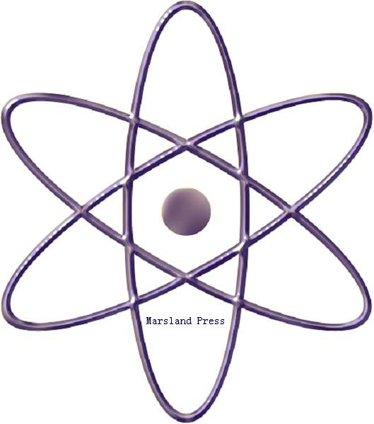

Marsland Press

310 West 18th Street, New York, NY 10011, USA

http://www.cancerbio.net
http://www.sciencepub.net
editor@sciencepub.net
editor@sciencepub.net

718-404-5362

Cancer Biology

ISSN: 2150-1041 (print); ISSN: 2150-105X (online); Quarterly

CANCER BIOLOGY is a peer reviewed international journal that considers full-length articles and Mini Reviews in a broad range of cancer research, from those elucidating advances in understanding the disease processes of cancer to those helping to establish new paradigms in the diagnosis, treatment, and prevention of cancers. Examples of areas covered by Cancer Biology are: Molecular and cellular mechanisms of cancer biology, such as apoptosis, cell cycle/checkpoint regulation, the genetics and epigenetics of tumorigenesis, angiogenesis and lymphangiogenesis, invasion, metastasis, and host immune responses to cancer. Experimental therapeutics for cancers, including the elucidation of mechanisms for the sensitivity and the resistance to current cancer therapies, identification of new therapeutic targets, and development of new cancer therapies.

Marsland Press
310 West 18th Street, New York, NY 10011, USA
Telephone: (718) 404-5362; (347) 321-7172
E-mails: editor@sciencepub.net; sciencepub@gmail.com;
Website: http://www.cancerbio.net

© 2025 Marsland Press

