A Modified lentiviral vector construction system

Bo Song, JingWei Liu, XiuFang Chen, YuMing Xu*

Department of Neurology, the First Affiliated Hospital, Zhengzhou University, Zhengzhou, 450052, China
Xuyuming@zzu.edu.cn
Abstract: Objective: To develop a lentiviral vector system, which can be used to co-express multiple genes of interest, such as siRNAs cassettes, reporter gene and resistant gene simultaneously and to facilitate to titrate lentiviral vector stock with TCID₅₀ method. Method: Synthesis new multiple cloning sites（MCS）to replace the original MCS of pLKO-1-puro and produced an intermediate plasmid pLKO-1-puro-MCS; Destination plasmid pLKO-M was constructed through transfering the CMV promoter-GFP-IRES element into pLKO-1-puro-MCS; The support plasmid pENTR-U6-20 was produced through transfering the siRNA-Expression cassette of pSilencer 2.0 into pENTR-U6-con. pLKO-M was cotransfected with pCMV-dR8.2 dvpr and pCMV-VSVG into 293T cells to produce lentiviral vectors. Harvest the virus 72 hours after contransfection and titrate it on Vero cells with TCID₅₀ method.Result: Restriction enzyme digestion analysis of pLKO-M showed that it was constructed successfully; restriction enzyme digestion analysis and sequencing result of pENTR-U6-20 indicated that it is constructed successfully. The GFP gene in pLKO-M can express normally and the titre caculated with TCID₅₀ method is 6.47X10⁶ IU/ml. Conclusion: The multiple gene coexpressing system which contains two plasmid, pLKO-M and pENTR-U6-20, was established and the titre of pLKO-M virus can be measured with TCID₅₀ method. [Life Science Journal. 2010; 7(2): 42 – 46] (ISSN: 1097 – 8135).
Keywords: gene therapy; lentiviral vector; siRNA; titration method.

1. Introduction
Lentiviral vectors has many advantages, such as the ability to infect dividing and nondividing cells, the ability to integrate with host cell genome and express transgenes stably, and triggering elicit little or no immune reactions1- 5. (Lentiviral vectors can efficiently deliver genes to postmitotic neuronal cell types offering long-term expression, can be generated in high titers, and do not give immunological complications. Various animal studies have demonstrated the effectiveness of these vectors to deliver therapeutic genes into the nervous system, as well as to model human diseases6.
The study results of its application in neurological disordes, especially Parkinson’s disease is encouraging⁷⁻ ¹¹. But there are two important issues that should have reaserchers’ attentions, one issue is that the pathogenesis of neurological disorder involves more than one single gene.The other one is that we lack rapid and stable titration method of lentiviral vector stock. A new lentiviral vector should be reconstruct ed, which can co-express more than one gene and contains an more direct reporter gene tol simplify the titration procedure.
For this purpose, the research developed a multiple gene co-expressing lentiviral vector construction system which consists of two plasmid, pENTR-U6-20 and pLKO-M .Using this system, we planed to construct lentiviral vectors that could co-express more than one single siRNA, GFP and gene of interest and construct a standard titrate method based on GFP expression, with TCID₅₀ method. We hope that this system would be a useful tool to study neurological disorders.
2. Materials and Methods
2.1 Plasimids. Lentiviral backbone plasmid pLKO-1-puro(figure 1),helper plasmid pCMV-dR8.2 dvpr and pCMV-VSVG, pENTR-U6-con (figure2), pGFP-IRES and pSilencer 2.0 are all kindly provided by proffessor ZhiQiang Han from ZhengZhou university and propagated in E.coli strain DH5α.
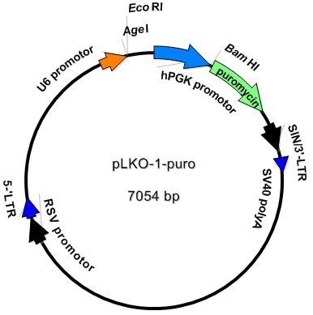
Figure 1: The map of pLKO-1-puro plasmid

2.2. Cell culture. 293T cells and Vero cells were purchased from ShangHai cell bank and cultured in Minimum Essential Medium (Invitrogen) supplemented with 10% (v/v) fetal bovine serum (FBS) and 2 mM glutamine (Invitrogen), 5% CO₂, humidified atmosphere at 37 ºC in an incubator (SanYo, Japan)

2.3. Construction of intermediate plasmid pLKO-1-puro-MCS: Design and synthesis the following two oligonucleotides which is complimentary to each other at the restriction enzyme recognition sites:
MCS1: 5‘CCGGTGAATTCTCTAGAGTCGACACGCGT3’ (with a sticky end attached to the 5’ end whch is complementary with AgeI digested end, it contains the following restriction sites: 5’ MluI、Sal、XbaI、EcoRI and AgeI ‘3.)
MCS2：5‘AATTACGCGTGTCGACTCTAGAGAATTCA3’ (with a sticky 5’ end that is complementary with EcoRI digested end, it contains the following restriction sites: 5’AgeI、EcoRI、XbaI、SalI and MluI ‘3).
Annealing the two strands and ligate it with AgeI and EcoRI digested plasmid pLKO-1-puro with T4 DNA ligase (Takara) to produce pLKO-1-puro-MCS. Then transform E.coli strain DH5α with traditional Calcium chloride transformation method, screen positive clonies with EcoRI、XbaI、SalI、MluI plus BamHI digestion analysis.

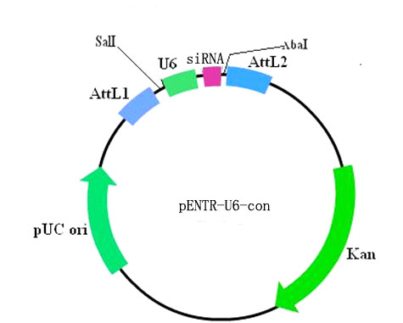
Figure 2: The map of pENTR-U6-con

2.4. construction of destination plasmid pLKO-M: Design primers that is specific to the CMV promotor-GFP-IRES-MCS element of the pGFP-IRES:
GXbaI: 5‘GCTTCTAGATCAATATTGGCCATTAGCCATATTA’3 (with a XbaI restriction site and 3 protective base attached to the 5’ end)
GSalI：5‘ACTGTCGACGATCCCGGGTTGTGGCAAGCT’3 (with a SalI restriction site and 3 protective base attached to the 5’ end) Amplify the element with PrimeStar HS polymerase (Takara), the PCR parameters used in this step is:94 ºC 4 min-94 ºC 30 sec -58 ºC 30sec-72 ºC 2min - 72ºC 5 min - 4ºC indefinite .Perform electropheresis in 1% agarose gel, harvest the 2.4kb PCR product. Digest the PCR doduct and pLKO-1-puro-MCS with XbaI and SalI, then ligate them to construct pLKO-M. Transform DH5α, screen positive clonies with XbaI and SalI digestion.
2.5. Construction o support plasmid pENTR-U6-20: Design primers that is specific to the siRNA expression cassette of pSilencer2.0:
INPTEN1:5‘CAAGTCGACGAATTCCCCAGTGGAAAGACGCGC 3’
(with a SalI restriction site and 3 protective base attached to the 5’ end).
INPTEN2: 5‘ACCTCTAGACCAAGCTTTTCCAAAAAACTACCG 3’ (with a XbaI restriction site and 3 protective base attached to the 5’ end)
Amplify the siRNA expression element which with PrimeStar HS polymerase (Takara), the PCR parameters used in this step is: 94 ºC 4 min-94 ºC 30 sec -58 ºC 30sec-72 ºC 30 sec-72ºC, 5min-4 ℃ indefinite. The siRNA expression cassette is about 421bp，Harvest the 421bp PCR product , digest the PCR product and pENTR-U6-con with SalI and XbaI, then ligate them to produce pENTR-U6-20. Transform DH5α, screen positive clonies with XbaI and SalI digestion analysis. Select one positive colony and sequence with hU6 Forward sequencing primer 5’TGGACTATCATATGCTTACCGT 3’, align the sequencing result with original siRNA expression cassette of plasmid pSilencer2.0.
2.6. Production of lentiviral vectors. Grow 293T cells in a 100 mm culture dish .When the cells is about 90% confluence ,Cotransfect 3 microgram pLKO-M、22.67μg helper plasmid pCMV-dR8.2 dvpr and 0.33μg envelope plasmid pCMV-VSVG(the proportion between three plasmid is: pLKO-M : pCMV-dR8.2 dvpr : pCMV-VSVG =9:8:1) with lipofectin 2000 (Invitrogen) following the protocols provided in the user’s manual. 48 hours after cotransfection, observe green fluorescence under inverted fluorescent microscope (Nicon) to estimate transfection efficiency. 72 hours after cotransfection, transfer the culture medium from the culture dish into a 15ml tube. Centrifuge at 3000 rpm, 4 ºC for 10 minutes and filtrate with a 0.45 μm filter(Millipore) to clarify the viral stock solution. Then concentrate it through centrifuging at 4℃，25000rpm for 90 minutes in an ultraspeed centrifuger(Beckman). Remove supernant and resusspensed with fresh medium. Store the viral solution at -80 ℃。
2.7. Titration of viral stock solution with TCID₅₀ method: The method used here is derived from TCID₅₀ method that is used to titrate adenoviral stock solution¹². Briefly , grow Vero cells in two 96-wells culture plates with 10⁴ cells in each well. Serially dilute vector stock solution with fresh medium in 1.5 ml EP tube, from 10⁻¹ to 10⁻¹⁰ . Infect the Vero cells in each well with 100 μl of the last 8 serial dilutions. Incubate at 37℃ for 48 hours, then observe green fluorescence under inverted fluorescent microscope, count positive wells in each plates and calculate the titre in each 96-well culture plates use this formula T = 10^{1+1 + d(S-0.5)}IU/ ml, and the mean of two culture plates is the final titre of the stock solution.

3. Result
3.1. Construction of intermediate plasmid pLKO-1-puro-MCS: Digest pLKO-1-puro-MCS with EcoRI、XbaI、SalI、MluI plus BamHI produced four 750bp segments, as showed in the electropherogram of digestion product, which indicated that it was constructed successfly(see figure 3).
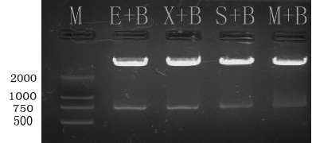
Figure 3: Electropherogram of digestion product of pLKO-1-puro-MCS；M：Marker DL2000；B：BamHI；X：XbaI；S：SalI；M：MluI.

3.2. Construction of plasmid pLKO-M: Digestion of pLKO-M with XbaI and SalI produced a 2.4kb segment which should be the CMV promotor-GFP-IRES-MCS element. Electropheresis of digestion product showed that pLKO-M was successfully (see figure 4). The recombinant lentiviral vector pLKO-M have some new features that was shown in figure 5.
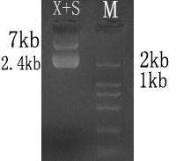
Figure 4: Electropherogram of XbaI and SalI digestion product of pLKO-M

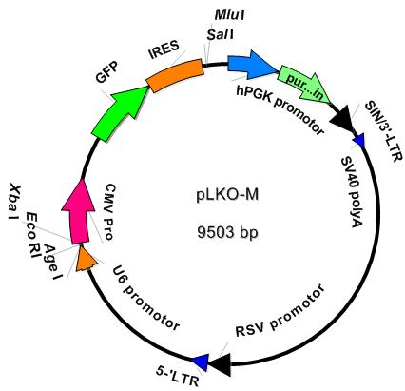

Figure 5: The map of recombinant lentiviral vector pLKO-M.

3.3. Construction of support plasmid pENTR-U6-20: The siRNA expression cassette of pSilencer2.0 was successfully amplified and cloned into plasmid pENTR-U6-CON, and confirmed by restriction digestion analysis and sequencing. Electropheresis of XbaI and SalI digestion product of pENTR-U6-20 produced a 421bp DNA segment(see figure 6) which should be the siRNA expression cassette of pSilencer2.0, and it is confimed by sequencing result. The features of pENTR-U6-20 was showed in figure 7.
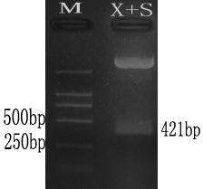
Figure 6: Electropherogram of XbaI and SalI digestion product of pENTR-U6-20.

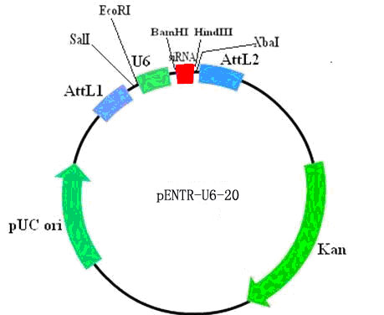
Figure 7: The map of pENTR-U6-20.

3.4. Production of lentiviral vectors. 36 hours after contransfection of 3 plasmid into 293T cells, green fluorescence appeared; 48 hours later, the green fluorescence became very obvious and bright （see figure 8）. 72h after transfection, about 9ml of virus was harvested. After centrifugation at 4℃，25000 rpm for 90 minutes, remove the supernant and and resuspensed the pellet with 900 μl of fresh medium.

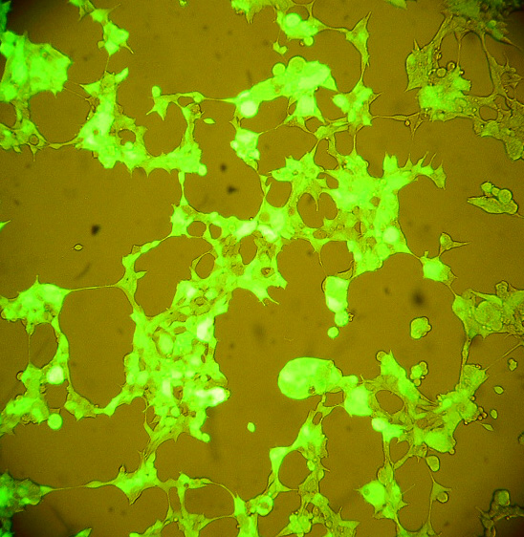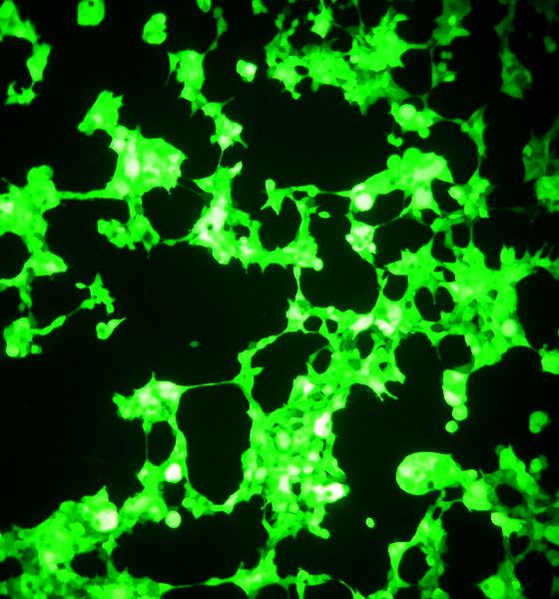
A:(×100) B:(×100)
Figure 8: 48 houres after contransfection into 293T cells.figure A is dark field, figure B is light field.

3.5 Titration of viral stock solution with TCID₅₀ method. Green fluorescence appeared 48 hours after infection Vero cells in 96-well culture plates with serial dilutions of lentiviral stock. GFP- positive wells can be determined and counted without difficulty. According to the formula provided above, the titre calculated on one culture plate ≈7.94X10⁶IU/ml and the other one≈5.01X10⁶IU/ml. The final mean titre of lentiviral stock solution was 6.47X10⁶ IU/ml.

Discussion
Multiple gene co-expression lentiviral vectors had been used in the study of neurological disorders, but there is no report of multiple siRNA co-expression or siRNA and gene of interest coexpression lentiviral vectors¹³⁻¹⁹. This kind of vectors are more useful than single gene expressing vectors. we developed this system that can be used to construct multilple siRNA, GFP and gene of interest co-expression lentiviral vectors. This system has the following features:
1): Features of pLKO-M: As shown in figure 1 and figure5, pLKO-M was derived from pLKO-1-U6-puro, it contains U6 promotor-(AgeI-EcoRI-XbaI) element and CMV promoter-GFP-IRES-(SalI-MluI) element. U6 promotor can initiate siRNA expression and IRES element can mediate translation of two proteins from one mRNA. So it is possible to clone a siRNA into the AgeI-EcoRI-XbaI site to down-regulate a target gene and clone the CDS of a gene of interest to up-regulate it. Down regulation and up regulation of specific genes are two most important strategies of gene therapy which involves different mechanisms, apply those two strategies simultaneously may produce synergistic effect which is more effective than using either strategy alone. Lentiviral vector pLKO-M can be used to apply those two strategies simultaneously throught one vector. The GFP gene is driven directly by CMV promoter and as a reporter gene to facilitate researches. So, this vector itself is a siRNA, GFP and gene of interest coexpression lentiviral vector.
2)Fetures of support plasmid pENTR-U6-20: As indicated in figure 2 and figure 7, the support plasmid pENTR-U6-20 and its precursor pENTR-U6-Con are derived from the pENTR-U6 which is the entry plasmid of Gateway cloning system. The plasmid pENTR-U6 is a linear ready-to-use plasmid easier to use, but not reproducible. However, pENTR-U6-Con is a circular and reproducible plasmid that can be used repeatedly. The restriction sites in pENTR-U6-20 is compatible with pSilencer2.0 and pSilencer3.0, so siRNAs of target genes can be designed directly using Ambion’s online siRNA design program, which made siRNA designing became more simple and easier, and also decreased the probabilities of making mistakes greatly. Support plasmid pENTR-U6-20 maintained the Gateway cloning elements attL1 and attL2, so siRNAs in this plasmid can be transferred directly to any destination plasmid of Gateway cloning system. Because the restriction sites(EcoRI and XbaI) flanking the U6 promotor-siRNA element is compatible with pLKO-M, so siRNA expression cassettes in pENTR-U6-20 can be transferred directly into pLKO-M and other vectors that have EcoRI and XbaI sites.
Titration method of lentiviral vectors derived from pLKO-M. The tritration method for lentiviral vectors can be divided into functional and non-functional methods. Nonfuntional method is usually based on detection of viral RNA or viral proteins and will detect inactivated and defective virus can not accurately reflect the functional units; The functional method is usually based on detection of reporter gene product, such as neomycin, puromycin or GFP, it will reflect the quatity of infectious viral particles²⁰⁻²². TCID₅₀ method is functional method and had became the standard titration method of adenoviral vectors. Titration of adenoviral vectors with TCID₅₀ method is based on observing cytopathic effect (CPE). Cytopathic effect (CPE) is an infection marker of adenoviral vectors, through observing CPE and count positive wells of a 96-well culture dish, we can calculate the titre of adenoviral vectors. But lentiviral vector does not produce cytopathic effect, so we should find other infection marker to count positive wells and calculate the final titre. The GFP gene in vectors derived from pLKO-M is driven directly by CMV promoter and can express GFP 48 hours after infection of host cells, so it is an excellent infection marker that can be used to titrate lentiviral vectors. This experiment proved that GFP can be used to determine positive wells in 96-well culture dish directly under an inverted fluorescent microscope. As an infection marker to titrate lentiviral vector, GFP is more labour-saving than other kinds of reporter genes and more timesaving than observing CPE because standard TCID₅₀ method requires observing CPE for at least ten days¹¹.
Lentiviral vectors have been widely used in the study of neurologic disorders, and researchers are now developing more useful vectors and strategies of gene therapy. This research presented a strategy to construct multiple gene coexpression lentiviral vectors and provided a optional tool to study neurological disorders.

References
- Naldini L, et al.In vivo gene delivery and stable transduction of nondividing cells by a lentiviral vector. Science 272, 263-7 (1996).
- Naldini L, Blomer U, Gage FH, Trono D, Verma IM.Efficient transfer, integration, and sustained long-term expression of the transgene in adult rat brains injected with a lentiviral vector. Proc Natl Acad Sci U S A 93, 11382-8 (1996).
- Kafri T, van Praag H, Ouyang L, Gage FH, Verma IM.A packaging cell line for lentivirus vectors. J Virol 73, 576-84 (1999).
- Abbas-Terki T, Blanco-Bose W, Deglon N, Pralong W, Aebischer P.Lentiviral-mediated RNA interference. Hum Gene Ther 13, 2197-201 (2002).
- Abordo-Adesida E, et al.Stability of lentiviral vector-mediated transgene expression in the brain in the presence of systemic antivector immune responses. Hum Gene Ther 16, 741-51 (2005).
- Gene therapy for neurodegenerative diseases based on lentiviral vectors. Prog Brain Res. 175: 187-200(2009).
- Dowd E, et al.Lentivector-mediated delivery of GDNF protects complex motor functions relevant to human Parkinsonism in a rat lesion model. Eur J Neurosci 22, 2587-95 (2005).
- Kordower JH, et al.Neurodegeneration prevented by lentiviral vector delivery of GDNF in primate models of Parkinson's disease. Science 290, 767-73 (2000).
- Brizard M, Carcenac C, Bemelmans AP, Feuerstein C, Mallet J, Savasta M.Functional reinnervation from remaining DA terminals induced by GDNF lentivirus in a rat model of early Parkinson's disease. Neurobiol Dis 21, 90-101 (2006).
- McCoy MK, Ruhn KA, Martinez TN, McAlpine FE, Blesch A, Tansey MG.Intranigral lentiviral delivery of dominant-negative TNF attenuates neurodegeneration and behavioral deficits in hemiparkinsonian rats. Mol Ther 16, 1572-9 (2008).
- Matsukawa N, et al.Overexpression of D2/D3 receptors increases efficacy of ropinirole in chronically 6-OHDA-lesioned Parkinsonian rats. Brain Res 1160, 113-23 (2007).
- Zhang XZ, et al.[Quality control of clinical-grade recombinant adenovirus used in gene therapy]. Zhonghua Yi Xue Za Zhi 84, 849-52 (2004).
- Yu X, et al.Lentiviral vectors with two independent internal promoters transfer high-level expression of multiple transgenes to human hematopoietic stem-progenitor cells. Mol Ther 7, 827-38 (2003).
- Jones S, et al.Lentiviral vector design for optimal TCR gene expression in the transduction of PBL and TIL. Hum Gene Ther (2009).
- Yang S, et al.Development of optimal bicistronic lentiviral vectors facilitates high-level TCR gene expression and robust tumor cell recognition. Gene Ther 15, 1411-23 (2008).
- Semple-Rowland SL, Eccles KS, Humberstone EJ.Targeted expression of two proteins in neural retina using self-inactivating, insulated lentiviral vectors carrying two internal independent promoters. Mol Vis 13, 2001-11 (2007).
- Khare PD, et al.Durable, safe, multi-gene lentiviral vector expression in feline trabecular meshwork. Mol Ther 16, 97-106 (2008).
- Chen HH, et al.Detection of dual-gene expression in arteries using an optical imaging method. J Biomed Opt 9, 1223-9 (2004).
- Azzouz M, et al.Multicistronic lentiviral vector-mediated striatal gene transfer of aromatic L-amino acid decarboxylase, tyrosine hydroxylase, and GTP cyclohydrolase I induces sustained transgene expression, dopamine production, and functional improvement in a rat model of Parkinson's disease. J Neurosci 22, 10302-12 (2002).
- Geraerts M, Willems S, Baekelandt V, Debyser Z, Gijsbers R.Comparison of lentiviral vector titration methods. BMC Biotechnol 6, 34 (2006).
- Jin D, et al.CD38 is critical for social behaviour by regulating oxytocin secretion. Nature 446, 41-5 (2007).
- Delenda C, Gaillard C.Real-time quantitative PCR for the design of lentiviral vector analytical assays. Gene Ther 12 Suppl 1, S36-50 (2005).

4/20/2010

