Taxonomic Diversity of Understorey Vegetation in Kumaun Himalayan Forests

Geeta Kharkwal ¹, Poonam Mehrotra ², Yaswant Singh Rawat ¹

1 Department of Botany, DSB Campus, Kumaun University, Nainital, Uttarakhand 263002, India；² Department of Botany, Bundelkhand University, Jhasi, Uttarakhand 263002, India
geetakh@gmail.com

Abstract: Taxonomic diversity of understorey vegetation (herb species) was studied in two evergreen forests, viz. oak and pine in the Kumaun Himalaya. In terms of taxonomic diversity, Asteraceae and Lamiaceae were the two dominant families in the sampling forest types. Maximum number of species was found at hill base and minimum at hill top in both the forests. The number of families, genera and species ratio observed for pine forest was of course higher with compared to the oak forest showed about the higher taxonomic diversity. Perennials form had higher contribution as compared to annuals forms indicated better ability to store up soil. Very few species (9 species) were found to be common indicates higher dissimilarity in both type of forests. Species richness (per m2) was higher in the pine forest than the oak forest. A high value of beta-diversity in the oak forest point out that the species composition varied from one stand to another. However, low concentration of dominance value in the pine forest with compare to the oak forest point towards the dominance, which is shared by many species. [Life Science Journal. 2010; x(x):xx–xx] (ISSN: 1097 – 8135).

Keywords: Species richness; beta-diversity; taxonomic diversity; forest

1. Introduction
The pattern and relationships between species diversity and ecosystem functioning are the current areas of great ecological interest throughout the world. Species diversity incorporates two components (Stirling and Wilsey, 2001); evenness (how evenly abundance or biomass is distributed among species) and richness (number of species per unit area). High evenness can increase invasion resistance, below-ground productivity and reduce total extinction rates (Smith et al., 2004). The spatial variations in biodiversity generally include species diversity in relation to size of the area, relationship between local and regional species diversity and diversity along gradients across space, and environmental factors such as latitude, altitude, depth, isolation, moisture and productivity (Gaston, 2000). In addition, species richness of a taxon is not only sufficient to express diversity but the equitability is also a important factor because communities however vary in properties of the total importance of the species and share their functional contribution (Tilman, 2000).
A fundamental characteristic of mountain ecosystems is to the drastic change in vegetation as well as in climatic conditions from the base to the summit of the mountain. Elevation gradients create varied climates, along with resultant soil differentiation; promote the diversification of plant species (Brown, 2001). Many studies have investigated on species richness along elevation gradient across habit and taxa (Sanders et al., 2003), as part efforts to understand ecosystem effects on biodiversity and maintenance of biodiversity (Gytnes and Vetaas, 2002). Furthermore, the observation relations between species distribution and elevation bands may also help to understand the possible effects of climate change, e.g. by providing baseline information to measure the effect of climate change and anthropogenic changes on vegetation.
The forest herbs, which play important role for rural communities for example, the livestock totally dependent on them for fodder and as traditional medicines, have been hardly studied from diversity standpoint (Singh and Singh 1987). Quantitative information on the forest floor species of the Central Himalaya region is generally lacking except for studies done by Rawat and Singh (1989), and Singh and Singh (1992). Interestingly, most of the recent major field experiments addressed questions relating to species diversity which has been carried out in grasslands. But forest herbs of the Himalayan region remain poorly studied.
In the present study we investigate herb species richness (spermatophyte) in terms of taxonomical diversity and species composition in relation to oak and pine forests in Central Himalayan forests.
2. Material and Methods
The study area is located between 29°21′ and 29°24′ N latitudes, and between 79°25′ and 79°29′E longitudes, in the elevational belt of 1600-1950 m asl around Nainital town in Kumaun region of Central Himalaya. The two major forest types, viz., Quercus leucotrichophora (oak) and Pinus roxburghii (pine) were selected for this study. The climate is monsoon temperate. The mean monthly temperature ranged from 11.5ºC (January) to 18.4ºC (June). The rocks of study area belongs to krol series which is a sequence of limestone, grey and greenish grey and purple slates, siltstones (Valdia, 1980). Soil texture is sandy clay and it is acidic in nature. The sites having minimal biotic disturbances in terms of grazing or herbage removal were selected. The site variations due to the canopy changes are presented in Table 1. For detailed studies of plant biodiversity and other vegetational parameters, selected sites were divided into three stands, viz., hill base, hill slop and hill top (HB, HS and HT, respectively).
Table 1
Certain characteristic of study sites

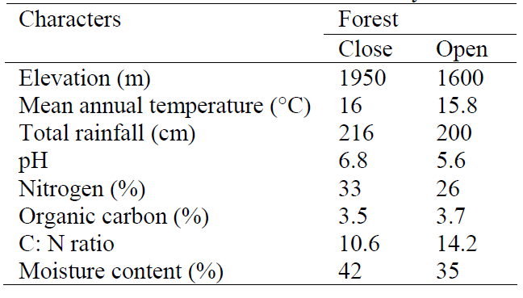
Phytosociological analysis of the herb species in each forest site was carried out by randomly placed 20, 1×1 m² quadrats during the peak growth month (September). Diversity was calculated by using Shannon-Wiener index (1963) as:
H΄ = -

where, Ni is the total number of species i and N is the number of individuals of all species in that site. Concentration of dominance was measured by Simpson’s Index (1949) as: C = Σ (Ni/N)2 where Ni and N are the same as for the Shannon-Weiner information function. Beta-diversity was calculated following Whittaker (1975) as: β = Sc/s where, Sc is the total number of species encountered in all quadrats and s is the average number of species per quadrat. Equitability or Evenness was calculated to represent the distribution of individuals among the species (Whittaker, 1972) as: E = S / (log Ni - log Ns) where, S is the total number of species, Ni is the number of individuals of most important species, Ns is the number of individuals of least important species and E is the evenness index.
3. Results
The forest herbs species in the oak and pine forests belongs to 21 families. The total number of species present in the oak forest and pine forest was 32 and 41, respectively.

Table 2
Taxonomic distribution of species
(G, Genus; S, Species)
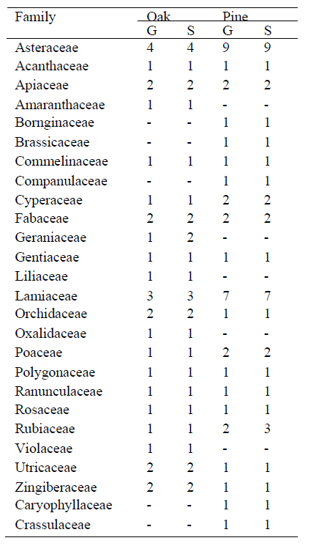
Table 2 depicts diversity of the Angiosperm family in both forest sites. In the oak forest, Asteraceae was represented by four species, followed by Lamiaceae (3 spp.), Fabaceae, Orchidaceae, Utricaceae, Zingiberaceae, Apiaceae and Geraniaceae (2 spp. each) and remaining 13 families were represented by one species each. Taxonomically, Asteraceae was the dominant family (with 4 genera), followed by Lamiaceae (with 3 genera), Apiaceae, Fabaceae, Orchidaceae, Utricaceae and Zingiberaceae (with 2 genera each) and remaining 14 families were represented by single genus only.
In the pine forest, Asteraceae was represented by nine species followed by Lamiaceae (7 spp.), Rubiaceae, (3 spp.), Fabaceae, Poaceae, Apiaceae, and Cyperaceae (2 spp. each) and remaining 14 families were represented by single species. Taxonomically, Asteraceae (with 9 genera) was the most diverse family followed by Lamiaceae, (with 7 genera), Apiaceae, Poaceae, Rubiaceae and Cyperaceae (with 2 genera each) and remaining 13 families were each represented by a single genus (Table 2).
The number of species varied spatially in both forests. In oak forest it varied from 15 (HT) to 30 (HB) and in pine forest from 12 (HT) to 23 (HB). Across the forests, maximum species were present in oak forest (at HB, 30) as compared to pine forest (at HB, 23). Species richness was higher (7.4) at HB and lower at HT (5.0) in oak forest. Similar pattern was found in pine forest, i.e., maximum species richness was at HB (10.5) and minimum at HT (4.7).

Table 3
Comparison of diversity indices
(Sp, species number; Sr, speceis richness; Bd, beta-diversity; H', diversity; Cd, concentration of dominance; E, evenness/equitability)
Indices | Oak forest |  |  | Pine forest
Indices | HB | HS | HT | HB | HS | HT
Sp | 30 | 23 | 15 | 23 | 17 | 12
Sr | 7.4 | 6.9 | 5.0 | 10.5 | 6.5 | 4.7
Bd | 4.5 | 4.6 | 4.6 | 2.8 | 2.9 | 2.8
H' | 4.2 | 4.2 | 3.5 | 4.4 | 4.0 | 3.4
Cd | 1.4 | 0.1 | 0.1 | 0.1 | 0.2 | 0.1
E | 31.7 | 27.1 | 17 | 27.3 | 27.4 | 31.4

Among the both forest site, species richness value was maximum in pine forest at HB (10.5) and minimum in oak forest at HB (7.4). Beta diversity showed pronounced effect at both sites. The value for oak forest varied marginally from 4.5 (HB) to 4.6 (HS), respectively. While for pine forest, it remained approximately same at all sub-sites. Between the forests, the value was higher in oak forest than pine forest. The lowest value of beta-diversity in oak forest was observed at HB (4.5) and for pine forest at HS (2.8). Equitability/evenness value ranged from 17.0 (HT) to 31.7 (HB) in the oak forest. A reverse pattern was observed in the pine forest (31.4 at HT and 27.3 at HB).
Table 4.
Forest wise ratio of species, genera and family
(F, Family; G, Genus; S, Species)
Forest | F:G | F: S | G: S
Oak | 1.2 | 1.3 | 1.0
Pine | 1.4 | 1.5 | 1.1

The concentration of dominance fluctuated from 0.1 to 1.4 in oak and from 0.1 to 0.2 in pine forest (Table 3). It was comparatively higher in the oak forest. The low value of concentration of dominance indicates that the dominance is shared by many species. The ratio of family to species, family to genera and genera to species for the both forests indicated higher taxonomic diversity in pine forest than that in the oak forest (Table 4). Percent contribution of perennial herbs is maximum in oak forest than the pine forest (Figure 1).

Figure 1. Percent contribution by life forms in oak and pine forests

4. Discussions
The changes in topography, altitude, precipitation, temperature and soil conditions contribute to the diverse bioclimate that results in a mosaic of biotic communities at various spatial and organizational levels. Diversity represents the number of species, their relative abundance, composition, interaction among species and temporal and spatial variation in their properties. Where richness and evenness coincide, i.e., a high proportion of plant species in the vegetation are restricted, community of that area is supposed to have evolved through a long period of environmental stability.
The observation in the present study showed that the oak forest was typically moister than the pine forest which is consistent with the study of Saxena and Singh (1982). Pine forest was about 25% more diverse (40 spp.) in comparison to the oak forest (32 spp.).
Asteraceae was the dominant family in pine forest because most of the species of the family are primary successionals and have different types of growth forms. This family showed basal as well as erect forms in which basal forms emerged near the ground-level with well-developed petioles and formed a short-umbrella (Mehrotra, 1998). They can tolerate cool temperatures to high irradiances with low density of herb cover. However, erect forms are less able to capitalize on the spring window of light than any other form. This showed that the different growth forms reflect a mixed type of forest response (harsh dry to mesic). Moreover, basal forms of Violaceae showed affinity to mesic and cold conditions under the oak forest. Few species are able to tolerate the entire spectrum of environment and range throughout the gradient (Brown, 2001).
Our study showed that perennials gained dominance over annuals in oak forest as well as pine forest (Figure 1). Perennial have ability to conserve soil and with their extensive root systems of perennial grasses they also add more organic matter to the soil than annuals which can be more favourable for plant growth. Singh and Singh (1987) observed that annuals colonize and dominate the early stages of succession. Annuals to perennials species ratio are higher at primary successional site than climax stage. Species richness generally increases during secondary succession when environmental and edaphic conditions are favourable with low fluctuations.
The above results indicate that the oak forest makes climax stage for succession. The evenness and β-diversity showed similar values in sub-sites of oak as well as pine forests. The high values of beta-diversity indicate that the species composition varied from one stand to another.
Equitability/evenness varied in pine forest with respect to sub-site from 27.3 (HB) to 31.4 (HT) (Table 3). This was because of the conditional presence or absence of functional relationship of species. Comparatively higher value of equitability in pine forest with respect to oak forest indicated that the individual herb species distribution is higher. This may perhaps due to intermediate level of disturbance.
The allocation of species in the Kumaun Central Himalaya is mainly governed by moisture and temperature gradients that incorporate the effect of many physical factors. Moustafa (1990) found that the association of community types is the result of the performance of the species in response to the environmental conditions that prevail in a particular forest type. Tewari (1982) assumed that the temperature gradient is the net product of elevation and aspect; while moisture gradient is a function of slope degree, soil texture and nature of soil surface.
In addition to that, hierarchical diversity concerns taxonomic differences at other than the species level. Pielou (1975) and Magurran (1998) suggested that hierarchical (taxonomic) diversity would be higher in an area in which the species are divided amongst many genera as opposed to one in which most species belong to the same genus, and still higher as these genera are divided amongst many families as opposed to few. The families, genera and species ratio was observed maximum in the pine forest as compared to the oak forest in the present study (Table 4), indicating diverse taxonomic vegetation in the pine forest.

Acknowledgements:
Authors are grateful to the Department of Science and Technology, Government of India for financial support to carry out this work.

Corresponding Author:
Dr. Geeta Kharkwal
Department of Botany
DSB Campus, Kumaun University
Nainital, Uttarakhand 263002, India
E-mail: geetakh@gmail.com

References
Stirilng G, Wilsey B. Emprical relationships between species richness, eveness and proporational diversity. Am Nat 2001;158(3):286-99.
Smith MD, Wilcox JC, Kelly T, Knapp AK. Dominance not richness determines invasibility of tallgrass prairie. Oikos 2004;106(2):253–62.
Gaston K J. Global pattern in biodiversity. Nature 2000;405(1):220-7.
Tilman D. Causes, consequences and ethics of biodiversity. Nature 2000;405(4):208-11.
Brown J. Mammals on mountainsides: elevational patterns of diversity. Global Ecology and Biogeography 2001;10(1):101-9.
Sanders NJ, Moss J, Wagner D. Pattern of ant species richness along elevational gradients in an arid ecosystem. Global Ecology and Biogeography 2003;10(2):77-100.
Grytnes JA, Vetaas OR. Species richness and altitude: A comparison between null models and interpolated plant species richness along the Himalayan altitudinal gradient, Nepal. The Am Nat 2002;159(3):294-304.
Singh JS, Singh SP. Forest vegetation of the Himalaya. Bot Rev 1987;52(2):80-192.
Rawat YS, Singh JS. Forest floor, litter falls, nutrient return in central Himalayan forests. Vegetatio, 1989;82(2):113-29.
Singh JS, Singh SP. Forest of Himalaya: Structure, Functioning and Impact of man. Gyanodaya Prakashan, Nainital, India, 1992.
Valida KS. Geology of Kumaun lesser Himalaya, Wadia Institute of Himalaya Geology, Dehradun, India, 1980;291.
Shannon CE, Wienner W. The mathematical theory of communication. Univ. Illinois Press, Urbana, 1963.
Simpson EH. Measurement of Diversity. Nature 1949;163(2):688-91.
Whittaker RH. Community and Ecosystems. IInd ed. McMillan, New York, 1975.
Whittaker RH. Evolution and measurement of species diversity. Taxon 1972;21:213-51.
Saxena AK, Pandey P, Singh JS. Biological Spectrum and other structural functional attributes of the vegetation of Kumaun Himalaya, Vegetatio 1982;49(1):111-9.
Mehrotra P. Adaptive significance of leaf in relation to other parts in oak forest herbs of Kumaun Himalaya, Ph. D. Thesis, Kumaun University, Nainital, India, 1988.
Moustafa AA. Environmental Gradient and Species Distribution on Sinai Mountains. Ph. D. Thesis, Botany Department, Faculty of Science, Suez Canal University, Egypt, 1990;115.
Tewari JC. Vegetational analysis along altitudinal gradients around Nainital, Ph. D. Thesis, Kumaun University, Nainital, 1982;570.
Pielou EC. Ecological Diversity. Wiley, New York, 1975;165.
Magurran AE. Ecological Diversity and Its Measurement. Princeton University Press, Princeton, New Jersey, 1988;179.

