Mouse Osteoblast Cell Sensitivity to the AC
Magnetic Field at 14 Hz
Hsien-Chiao Teng*, Shen Cherng**

* Department of Electrical Engineering, Chinese Military Academy, Fengsang, Taiwan (HCT), R O C;
** Department of Electrical Engineering, Cheng Shiu University, Niau Sung, Taiwan (SC), R O C, scteng@cc.cma.edu.tw; cherngs@csu.edu.tw.

Abstract: Since the surface electrical current of the attached mouse osteoblast cell monolayer in a culture plate could induce magnetic fluctuation, power density spectrum of the geomagnetic fluctuation (GF) recorded at the sample rate 2000 times per second illustrated the signal to noise ratio (SNR) spectrum in a frequency interval (0 ~ 60 Hz) for the mouse osteoblast cells system. In contrary to the background, 14±2 Hz was an intrinsic signal within cells. We exposed cells into a constant extremely low frequency (ELF) magnetic field (~ 50 m Gauss) at 14 Hz for 60 minutes, 20% modulation of the gap junction intracellular communication (GJIC) within mouse osteoblast cells was observed from the analysis of Lucifer yellow fluorescence microscopic image while comparing with the control group. Cellular response, GJIC modulation caused by the ELF magnetic field applied through ac function generator and solenoid coil was relied on the resonance within cells at intrinsic frequency. [Nature and Science 2003;1(1):27-31].

Key words: power sensitive spectrum, signal to noise ratio, GJIC

Introduction
The attention of the reaction of ELF magnetic field for biological system has been discussed a lot. Researches have focused on two major concerns for twenty years. The first one is public concern about hazard and health effect. The other one is the scientific interest, which goes further to answer if biological system reacts to ELF magnetic field; even ELF provides less energy than thermal motion (Adair, 1991; 1992; 1994). However, no clinical evidence has shown any human health effect by ELF magnetic field and no mechanism can clearly explain every observed biological effect for the biological system under ELF magnetic field (Takebe, 1999; Adair, 1994; EPRI, 1994). In addition, some experimental observations reported in a laboratory cannot be duplicated in another laboratory. The confliction of the unduplicated experimental observations makes the study of biological effect under ELF magnetic field more difficult. Nevertheless, if ELF magnetic field influences the cell membrane surface electrical current, the form of the reaction of the biological system under ELF magnetic field can be electrical signals. Eugene recognizes deterministic, stochastic, fractal and chaotic signals (Eugene, 2001) as four different type biological signals. A deterministic signal is one whose values in the future can be predicted if enough information about its past is known. Stochastic signals are signals for which it is impossible to predict an exact future value even if one knows it’s entire past history. Fractal signals have the property that they look very similar at all levels of magnification, which is referred as scale-invariance. Chaotic signals are deterministic signals with sensitive dependence on some conditions that cannot be predicted exactly in the future. Therefore, we assume the signals from cells induced membrane surface electrical current can affect geomagnetic fluctuation B(t). In addition, we can measure B(t) by using the probe of gauss-meter, transform it to oscilloscope voltage as V(t) and digitally record it at the rate of 2000 times in a second. Mathematically, we write it as follows:
V(t) = { V₁,V₂,……….V_{N-1}, V_{N} }
Take the autocorrelation coefficients of V(t)
$R_{q}=\left(\frac{1}{N}\right)\underset{p=1}{\overset{N}{Σ}}V_{p}V_{p+q}$
Perform the Fourier expansion of R_{q}
$S_{k}=\sum_{q=1}^{N}{R_{q}e^{\frac{i2π\text{kq}}{N}}}$
S_{k} is the component at frequency k and the unit of is watt per frequency.
ω_{k} =$\frac{2π}{N}$k (fundamental frequencies) for V_{p} ; $i=\sqrt{−1}$.
If N~ ∞,
$S(ω)=\int_{−∞}^{∞}{R(τ)e^{−i\text{ωτ}}dτ}$ (1)
$R(τ)=\frac{1}{2π}\int_{−∞}^{+∞}{S(ω)}e^{−i\text{ωτ}}dω$ (2)
$R(τ)=\left\langle V(t+τ)V(t)\right\rangle$， τ is the time interval and S(ω) is the average power for V(t). Equations (1) and (2) are the Fourier transform pairs and V(t) is a stationary process which means changing the original point of V(t) will not affect the statistical characteristics. Contrarily, $\int_{−∞}^{+∞}{S(ω)}dω$ is the total energy of the system, the power of the signal can be calculated from power density spectrum and the SNR of the intrinsic signal can be calculated. In this report, we take N=2000 and calculate the SNR spectrum of the mouse osteoblast cells system from 5 to 60 Hz. Relying on surface electrical current distribution induced within cells, ELF magnetic field may cause gap junctional intracellular communication (GJIC) modulation (Hart, 1996). Since GJIC is affiliated with many pathological endpoints (Trosko, 1990, 2001; Upham, 1998), we use GJIC as a factor to evaluate the ELF magnetic field reaction for mouse osteoblast cell system. Scrape loading dye transfer of Lucifer yellow is used to measure gap junction intracellular communication (GJIC) modulation under the exposure of ELF magnetic field. The intrinsic resonance detected in SNR spectrum of the mouse osteoblast cells system is very likely to be a chaotic signal, which is not fully predictable.
Materials and Methods
For the diameter of the culture dish used was 3.5 cm, we used a simple 5-cm radius helical coil, which is wrapped with 200 turns 0.45-mm diameter cooper string around a plastic cylinder tube connected to the function generator for input ELF signals. The whole system was placed in an incubator. The incubator controlled the environment at 5% CO₂ at 98% relative humidity. Another sham field chamber was exactly same as the ELF incubator only with no exposure to the ELF. The cell culture dishes were placed perpendicular to the input ELF. The function generator generated the ELF signal through the solenoid applied to the cells located in the center of the solenoid for sixty minutes.

Cell Culture
Mouse osteoblastic MC3T3-E1 cell line was obtained from: D.T. Yamaguchi, Research Service and Geriatrics Research, Education, and Clinical Center, VAMC, West Los Angeles, California, USA. It was cultured in D-medium (Formula 78-5470EF, GIBCO, Grand Island, NY), supplemented with 5% fetal bovine serum (GIBCO) and 50 µg/ml gentamicin. The cells were incubated at 37˚C in a humidified atmosphere containing 5% CO₂ and 95% air and were fed or split every two to three days. Upon confluency, the osteoblastic cells could be induced to differentiate by the addition of 50 g/ml ascorbic acid alone or ascorbic acid plus 7 mM ß-glycerophosphate (ß-GP) to the medium for 1 month.

Detection SNR of Intrinsic
We used a probe of Gauss-meter to measure the B_{cigf}(t), which is the coupled fluctuation of geomagnetic field and cells induced magnetic fields. The probe was located vertically 10⁻⁴ meter to the mono-layer of the cells attached at the culture dish. The Gauss-meter was manufactured by F.W. Bell Company (series of 9550) in Florida, USA. Oscilloscope transformed B_{cigf}(t) to electrical voltages as V_{cigf}(t). The oscilloscope was manufactured by Agilent Company (54621A). By using the software also provided by Agilent Company, we collected the digital V_{cigf}(t) from the oscilloscope. In contrast, V_{gf}(t) and V_{migf}(t) were also measured. V_{gf} was only earth magnetic fluctuation and m V_{migf} was the magnetic fluctuation of the medium in culture plate without cells. Matlab and Fortran computer languages were used for power density spectrum analysis. The sample rate was taken 2000 times in a second. The following steps identified intrinsic frequency and its SNR:
Let ω = {1 Hz, 2 Hz, …20 Hz, 21 Hz, 22 Hz……….58 Hz, 59 Hz} denote the set of frequency ω_{i} of the given test signal. Sine(ω_{i}t), simulated by Matlab software, from 1 Hz to 59 Hz, where ω₁ = 1 Hz, ω₂ = 2 Hz, ω₃ = 3 Hz,….. ω₅₀ = 50 Hz, …ω₅₉ = 59 Hz, respectively.
1. Take the maximum V_{max} from V_{gf}(t)
- Add sine(ω_{i}t) with amplitude V_{max} to V_{gf}(t) and name the result as V_{gftest}(t).
- Perform autocorrelation and Fourier transform to get the power density spectrum (PDS) of V_{gftest}(t).
- Calculate the SNR, which can be represented as S_{max}(ω_{i}) for each ω_{i} from PDS of V_{gftest}(t) to get SNR spectrum. Be noted that (a) the power of the signal is defined as the area under the frequency at ω_{i,} and (b) the power of the noise is defined as the total power of the V_{gf}(t), and (c) the SNR is defined as the power of the signal divided by the power of the noise.
- Repeat step 2, step 3 and step 4 with the amplitudes 0.7 V_{max}, 0.4 V_{max}, 0.03 V_{max}, respectively for the given test signal at every frequency ω_{i} to get S_{0.7}(ω_{i}), S_{0.4}(ω_{i}) and S_{0.03}(ω_{i}).
- Assume ${\text{pX}}^{2}+\text{qX}+r=0$, using square curve for fitting data,
pS_{0.7}(ω_{i})² + q S_{0.7}(ω_{i})+ r = 0
pS_{0.4}(ω_{i})² + q S_{0.4}(ω_{i})+ r = 0
pS_{0.03}(ω_{i})² + q S_{0.03}(ω_{i})+ r = 0
Since there are three unknowns p, q and r, with three known equations, we can easily calculate the value of r, which is the SNR of the intrinsic frequency ω_{i} at the amplitude of test signal ω_{i} equals to zero. After we found the intrinsic frequency, we expose cells at intrinsic frequency provided by function generator in the center of solenoid. We used the same steps to calculate the SNR of intrinsic for the observations of V_{cigf}(t) and V_{migf}(t).

Bioassay of GJIC
The scrape load/dye transfer (SL/DT) technique was used to measure GJIC. After exposure to either sham or ELF, the cells were rinsed with phosphate buffered saline (PBS), and a PBS solution containing a small molecular weight fluorescent dye, 4% concentration Lucifer yellow fluorescence dye is injected into the cells by a scrape using a scalpel blade. Afterwards the cells were incubated for 3 min and extra cellular dye was rinsed off and fixed with 5% formalin. We then measured the area of the dye migrated from the scrape line using digital images taken by an epifluorescent microscope and quantitated with Nucleotech image analysis software (Upham, 1998) for the GJIC images.

Results
Figure 1 is the figure of V_{cigf}. Figure 2 has shown the correlation between the SNR and the amplitude of the test signal while fitting curves for V_{cigf}, V_{migf} and V_{gf}. The intercept of the curve was at 0.005, which is the intrinsic SNR value for the test signal at 14 Hz. Therefore, if 14 Hz modulates GJIC, GJIC modulation can work as an index to find the biological effect at intrinsic ELF. We demonstrated the GJIC fluorescent image in Figure 3 and Figure 4. Since the GJIC in cells was quantified with the measurement of the average distance of dye migration, GJIC was reported as a fraction of the control (FOC) in Figure 5. An FOC value equals to 1.0 indicates normal GJIC. The FOC value less than 1.0 indicates inhabitation. All experiments were done at least triplicate and the results were reported as mean ± standard deviation at the 95% confidence interval. When the 14 Hz ELF was applied vertically to the cell, we observed 20% inhibition of the GJIC within cells.
Volt
Figure 1. Measured V_{cigf} voltage
Sec

Figure 2. The signal to noise ratio fitting curve of the applied ELF test signal at 14 Hz. The intercept of the fitting curve is at 0.005 for V_{cigf.}

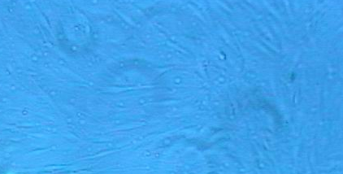
Figure 3a. The monolayer of the mouse osteoblast cells.

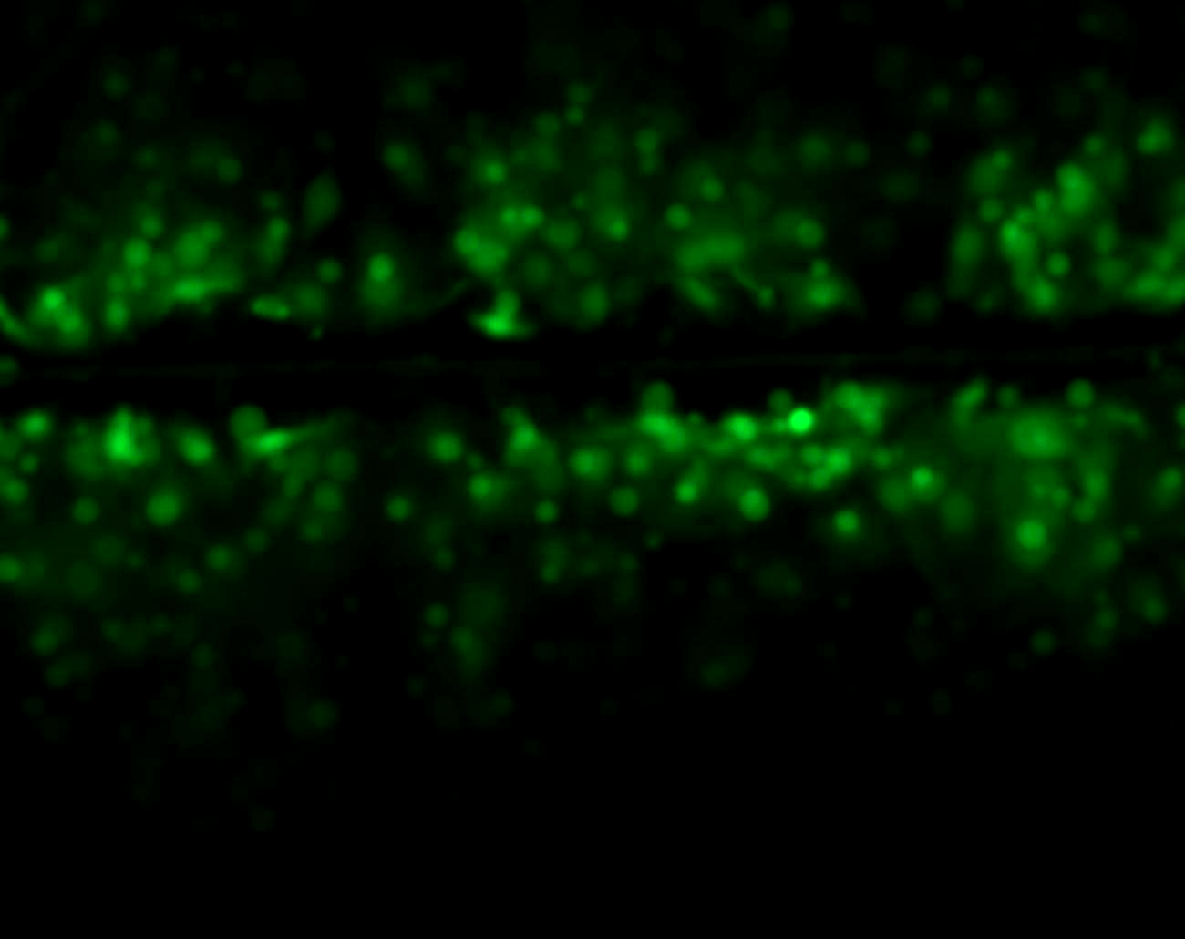
Figure3b. Fluoresce image of the GJIC of the cells in control.

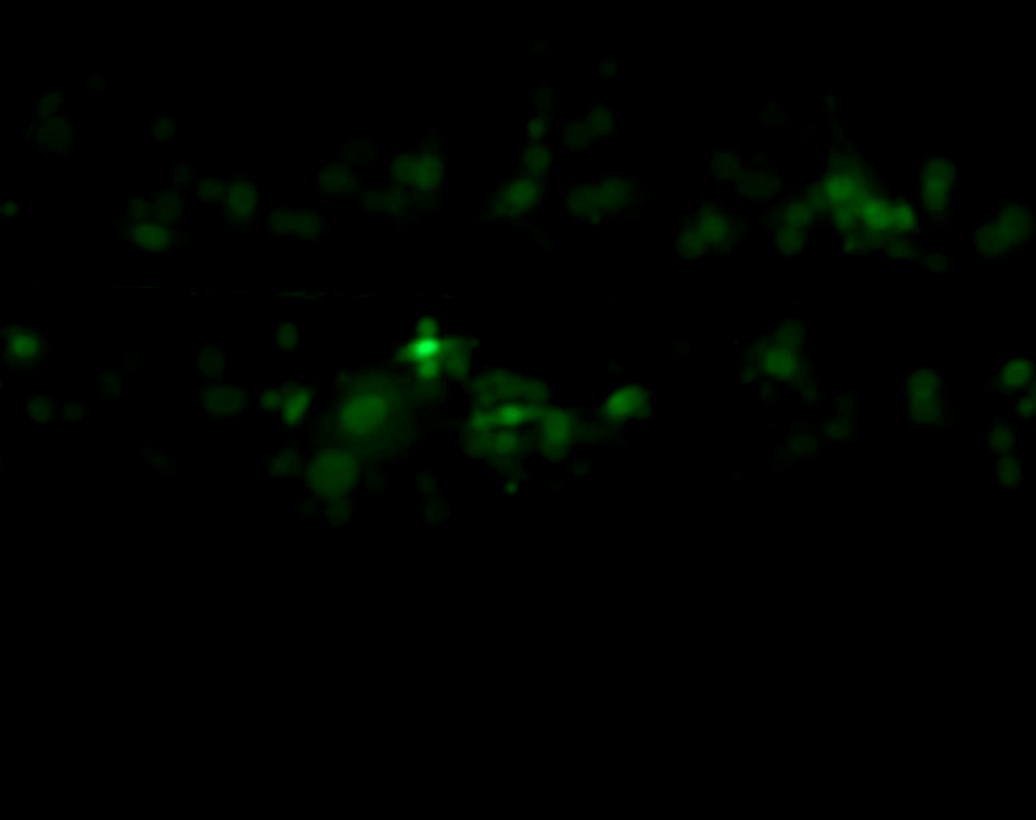
Figure 4. Fluoresce image of the GJIC of the cells under the exposure of 14 Hz ELF magnetic field.

Figure 5. The FOC result of the GJIC Assay at 14 Hz ELF Exposure.

Discussion
The cell-induced current density in a 3.5 cm diameter cultured dish is proportional to the geomagnetic fluctuation, which fluctuates between 20 mGauss and 100 mGauss. The calculated intracellular/intercellular electrical current within a 3.5 cm diameter cell culture dish with confluent cells is about 10 ^{–9} Amp (Hart, 1996) under geomagnetic fluctuation. This report demonstrates test signals with defined amplitudes for detecting the signals buried in the V_{cigf} (t) and V_{migf} (t) providing evidence that V_{cigf} (t) affected the GJIC within cells. This study therefore, shows the mouse osteoblast cells could be a nonlinear system that can sense ELF signals and the intrinsic ELF signal is about 300 times less than the noise, which is ambiguous to obtain from direct measurement but can be detected by the help of V_{cigf} (t) with GJIC assay. Furthermore, Gap Junctional Intracellular Communication can be a target in which ELF acts on to cause the cell system responded. It is linked PDS to the degree modulation of GJIC within mouse osteoblast cells by using the amount of Lucifer yellow dye transfer area to indicate the modulation of GJIC due to the presence and absence of the ELF. The present results then indicated that the SNR analysis of the ELF signals buried in V_{cigf} can refer to the degree of modulation of GJIC within cells in the culture dish. Particularly, ELF at 14 Hz in cell system might be linked to ion cyclotron resonance (Liboff, 1991) and the calcium oscillation hypothesis (Fewtrell, 1993; Glaser, 1998).

Conclusion
We concluded that the cell induced electrical surface current on mouse osteoblast cells monolayer membrane attached to the cell culture plate under the influence of geomagnetic fluctuation created specific V_{cigf} (t). If we exposed the mouse osteoblast cells into intrinsic ELF at 14 Hz, it would modulate the GJIC within cells. Therefore, ELF 14 Hz is one of the intrinsic frequencies within mouse osteoblast cell system. Even though Adair (1991) criticized the resonance mechanisms, using the ion cyclotron resonance hypothesis, parametric resonance, electromagnetic coupling hypothesis, and the stochastic resonance mechanism may still validated to explain our experimental and calculated results. The major concern for this report, not only was the geomagnetic fluctuation affected cell system, but also we observed that the SNR of the intrinsic frequency, which power was so low as 200 to 300 times less than noise at 14 Hz. Since we exposed intrinsic frequency buried in the V_{cigf} and used the scrape load/dye transfer (SL/DT) technique to obtain the corresponding degree of modulation of GJIC, geomagnetic fluctuation and intrinsic ELF played the roles of adjusting GJIC within cells. Even we still question how cells can find the optimization between the V_{cigf} and the applied ELF signal that we see the GJIC modulation for cell system, we recognize geomagnetic fluctuation affected the intrinsic frequencies within the cells as well.

Correspondence to:
Shen Cherng, P.E., M.D., Ph.D.
Associate Professor
Department of Electrical Engineering
Cheng Shiu University,
840 Cheng Ching Road, Niau Sung
Kaohsiung, Taiwan 833
Email: cherngs@csu.edu.tw; cherng@msu.edu

References
Adair RK. Constraints on biological effects of weak extremely low frequency electromagnetic field. Physical Rev A 1991;43:1039-48.
Adair RK. Criticism of Lednev’s mechanism for the influence of weak magnetic fields on biological systems. Bioelctromagneics 1992;13:231-5.
Adair RK. Biological responses to weak 60 Hz electrical and magnetic fields must vary as the square of the field strength. Proc Natl Acad Sci 1994;91:9422-5.
EPRI. Biology and electric and magnetic fields: biological mechanisms of interaction. Printed by Gradint Corporation, Cambridg, Massachusetts, USA. 1994.
Eugene N. Biomedical signal processing and signal modeling. A Wiley-Interscience Publication, John Wiley & Sons, Inc. New York, NY, USA. ISBN 0-471-34540-7.
Fewtrell C. Calcium oscillation in non-excitable cells. in Ann Rev of Physiology, Editor Hoffman JF, Annual Review, Inc. Palo Alto. 1993;55:427-54.
Glaser R, Michalsky M, Schamek R. Is the Ca⁺² transport of human erythrocytes influenced by ELF- and MF-electromagnetic fields? Bioelectrochemistry and Bioenergetics, 1998;47:311-8.
Hart F. Cell culture dosimetry for low frequency magnetic fields. Bioelectromagnetics 1996;17:48-57.
Kaiser F. External signals and internal oscillation dynamics: biophysical aspects and modeling approaches for interactions of weak electromagnetic fields at the cellular level. Bioelectrochemistry and Bioenergetics 1996;41:3-18.
Liboff AR, Parkinson WC. Search for ion cyclotron resonance in an Na⁺- transport system. Bioelectromagnetics, 1991;12:77-83.
Takb H, Shiga T, Kato M, Masada E. Biological and Health effects from exposure to power line frequency electromagnetic fields – confirmation of absence of any effects at environmental field strengths. IOS Press, Ohmsha, ISBN 4-274-90402-4C3047, 1999.
Trosko JE, Chang CC, Madhukar BV. Modulation of intercellular communication during radiation and chemical carcinogenesis. Radiation Research 1990;123:241-51.
Trosko JE, Chang CC. Role of stem cells and gap junctional intercellular communication in human carcinogensis. Radiation Research 2001;155:175-80.
Upham BL, Deocampo ND, Wurl B, Trosko JE. Inhibition of gap junctional intracellular communication by perfluorinated fatty acids is dependent on the chain length of the fluorinated tail. Int J Cancer 1998;78:491-5.

