An In Vivo Evaluation of an Aqueous Extract of Uncaria Tomentosa on the Morphology on the Labeling of Blood Constituents
with ^{99m} Technetium

Gláucio F. Diré ¹, Hayden P. Honeycutt ², Maria L. Gomes ¹, Elaine A. C. Lima ¹,
Deise M. M. Mattos ¹ , Mario Bernardo-Filho ^{1, 3}

(1. Universidade do Estado do Rio de Janeiro, Instituto de Biologia Alberto Alcantara Gomes, Departamento de Biofisica e Biometria, Av. 28 de setembro n 87, 20551-030, Rio de Janeiro, Brasil;
2. University of North Carolina, School of Pharmacy, Chapel Hill 27599-7360, North Carolina, USA;
3. Instituto Nacional do Câncer, Coordenadoria de Pesquisa, Praça Cruz Vermelha, 23, Rio de Janeiro,
RJ, Brasil, 20230-130. E-mail: Bernardo@uerj.br)

Abstract: Uncaria tomentosa (Cat’s Claw, Unha de Gato) is a commonly used medicinal plant, which has demonstrated to have antioxidant and antimutagenic properties. Blood cells (BC) labeling with ^{99m}Tc(technetium-99m) has progressed around the world. The influence of drugs on the labeling of blood elements with ^{99m}Tc has been reported. The purpose of this study was to examine the effect of Unha de Gato extract on the radiolabeling of blood elements with ^{99m}Tc and on the morphology of red blood cell (RBC). Extract (32 mg/mL) was prepared with NaCl (0.9%). The extract was administered to the animals via gavage (for seven days). Blood was withdrawn and it was incubated with stannous chloride for one hour followed by the addition of ^{99m}Tc. Plasma (P) and BC were separated. P and cell (C) were precipitated with 5% trichloroacetic acid (TCA) and soluble fraction (SF) and insoluble fraction (IF) were obtained. The percentage of radioactivity (%ATI) was determined. For the morphology the smears were evaluated and RBCs were analyzed. We can conclude that Uncaria extract was not capable to alter the radiolabeling of blood elements with ^{99m}Tc and the morphology of red blood cells. We suggest that the studied natural product, may be heavily metabolized by the liver, resulting in inactive metabolites that do not alter the labeling procedure and the morphology of RBCs. [Nature and Science, 2004,2(1):6-10].

Key words: Unha de Gato; red blood cells; plasma proteins; technetium-99m

1 Introduction

Many plant species are used medicinally. In Brazil there are many vegetables that are traditionally used in folk medicine. Uncaria tomentosa (Unha de Gato) from Rubiaceae family is a plant from the Peruvian Amazon. Cat’s Claw is a commonly used medicinal plant for a variety of indications including, rheumatoid and osteoarthritis, sinusitis, rhinitis, tonsillitis, and cutaneous abscesses. It has previously been demonstrated to have immunostimulant, antioxidant, and more recently antimutagenic properties. It has been demonstrated that Uncaria has a potential antiviral and immunomodulating activity (Williams, 2001). The biodistribution of the radiopharmaceuticals can be altered by natural and synthetic drugs as well as the radiolabeling of blood elements with technetium-99m (99mTc) (Diré, 2001; Mattos, 1997, 2000, 2002; Vidal, 1998). When a radionuclide have its capability to bind to blood elements altered by drugs therapy, the process of labeled red blood cells may be repeated, resulting in an additional radiation dose to the patient (Early, 1995; Hesselewwod, 1994).
99m Tc has been the most utilized radionuclide in nuclear medicine procedures and it has also been used in basic research (Early, 1995; Gutfilen, 1996; Mattos, 2001; Saha, 1998). The wide utilized in nuclear medicine is due to its optimal physical characteristics (half-life of 6 h, gamma rays energy of 140 keV and minimal dose to the patients), convenient availability from 99Mo/99mTc generator and negligible environmental impact. Nearly almost all scanning devices currently in use are optimized for detecting the eletromagnetic emission from this radionuclide (Early, 1995; Hesselewwod, 1994).
There are many applications of 99mTc-labeled red
blood cells (RBC). The most important is in cardiovascular nuclear medicine, where one tries to image the heart to determine its functional status as a pump, to calculate the left ventricular function by measuring the ejection fractions, and to evaluate wall motion abnormalities. Some other applications are in the detection of gastrointestinal bleeding, and in the determination of the RBC mass in patients (Early, 1995; Hesselewwod, 1994). The labeled process with 99mTc depends on a reducing agent and stannous ion (Sn2+), mainly as stannous chloride, is usually used for this purpose (Early, 1995; Gutfilen, 1993, 1996; Hesselewwod, 1994; Saha, 1998; Sampson, 1996). When whole blood is used in the labeling of RBC with 99mTc, radioactivity is found on blood cells, however it is also bound on plasma proteins. This labeling process depends on optimal stannous chloride concentration and stannous and pertechnetate ions across the RBC membrane, probably spending energy and the radionuclide is mainly bound to hemoglobin molecule (Gutfilen, 1996; Hesselewwod, 1994; Hladik, 1987). Several of the cellular labeling steps have been well characterized. The band-3 anion transport system and calcium channels may be the ways that 99mTc and Sn+2, respectively, reach the interior of the RBC (Gutfilen, 1996; Srivastava, 1984). If one damages the RBC, one can do selective spleen imaging since damaged cells are rapidly sequestrated by the spleen. RBC has been labeled with 99mTc for in vitro in vivo or in vivo/ in vitro techniques (Srivastava, 1984).
Plasma proteins (PP) have also been labeled with the referred radionuclide. 99mTc -labeled PP has been used to locate placenta, to evaluate the cardiac function and pulmonary perfusion, to determine blood volume and to study the gastrointestinal protein loss (Early, 1995; Hesselewwod, 1994).
The labeling of red blood cells with 99mTc has been influenced by patient medications, by the labeling conditions (Early, 1995; Hesselewwod, 1994; Santos, 1995) or by the presence of extracts of plants, as Paullinia cupana (Mattos, 2002), Maytenus ilicifolia (Mattos, 2000), Thuya occidentalis (Mattos, 1997), Nicotiana tabacum (Vidal, 1998), and. Nevertheless, there is not a well established in vitro/in vivo model to study the interaction of therapeutic drugs with radiopharmaceutica-
ls (Early, 1995; Sampson, 1996; Santos, 1995). Then, we have evaluated the influence of an Uncaria extract (i) on the labeling of blood elements with 99mTc and (ii) on the morphology of RBC.

2 Material and Methods

2.1 Plant material
A commercial dried powder of Unha de Gato was obtained from the Laboratory Herbarium, Laboratório Botânico, Brazil, Lot 923661 (June, 2001 and validity June 2004). To prepare the solution which was considered like 100% it was diluted 320 mg of Uncaria into 10 mL of saline solution (NaCl 0.9%) obtained a solution 100% (32 mg/mL).
2.2 Animals
Male Wistar rats (200-250 g) from Universidade do Estado do Rio de Janeiro were used. The animals received a standard pellet rat diet and water, they were maintained under constant environmental conditions (22±5°C, 12 h of light/dark cycle).
In six male Wistar rats were administered 1 mL of Unha de Gato solution via oral gavage for seven days. Similarly, six other male rats were treated with normal saline to serve as control.
2.3 Study protocol
Samples of heparinized (0.5 mL) blood were withdrawn from animals and incubated with 0.5 mL of stannous chloride (1.2 μg/mL), as SnCl2.2H2O for 1 h at room temperature. After this period of time, 99mTc (0.1 mL), as sodium pertechnetate, was added and the incubation continued for another 10 min. These samples were centrifuged and plasma (P) and blood cells (BC) were separated. Samples (20 μl) of P and BC were precipitated with 1 mL of trichloroacetic acid (TCA) 5% and soluble fraction (SF) and insoluble fraction (IF) were separated. The radioactivity in P, BC, IF-P, SF-P, IF-BC and SF-BC were determined in a well counter. After that, the % of radioactivity (%ATI) was calculated. A statistical analysis (Mann Whitney and Kruskal Wallis tests) was utilized to compare the experimental data.
For the morphology study, the blood was collected from the same rats treated with Unha de Gato and saline solution. Blood smears were prepared, dried, fixed and staining. Five slides per rat were analyzed for a total of 60 slides. Five frames were evaluated per slide andthemorphology of the red blood cells observed in each frame was quantitatively analyzed under optical microscope by Image Pro-Plus software.

3 Results

Samples of whole blood from the animals (control
and treated with uncaria extract) were incubated with SnCl2 for 1h and after with 99mTcO4Na. Blood smears were prepared, dried, fixed and staining. After that, the morphology of RBC was evaluated under optical microscope (x1000) (Figure 1, 2).
Table 1 has shown the effect of uncaria (in vivo) on the labeling of red blood cells (BC), insoluble fraction of the red blood cells (IF-C) and in the insoluble fraction of the plasma (IF-P) with 99mTc. The analysis of the results indicates that the referred extract is not capable to reduce the labeling efficiency of blood elements with 99mTc.
Table 2 has shown the morphology of red cells of the blood withdrawn from animals that have received the extract (7 days), by gavage via. The analysis of the results indicates that there is no alteration in the morphometric analysis (p>0.05) when the control group was compared with the treated one.

4 Discussion

Many authors have described a great number of drugs which can be due to the causes of some diseases of red cells (Bernardo, 1994; Braga, 2000; Sampson, 1996). There are evidences that drugs can affect either radiolabeling or biodistribution of blood cells in the context of the nuclear medicine. In the literature some researches have turned their attention to in vitro testing of the drug with labeled cells (Bernardo, 1994; Braga, 2000; Hladik, 1987; Sampson, 1996).

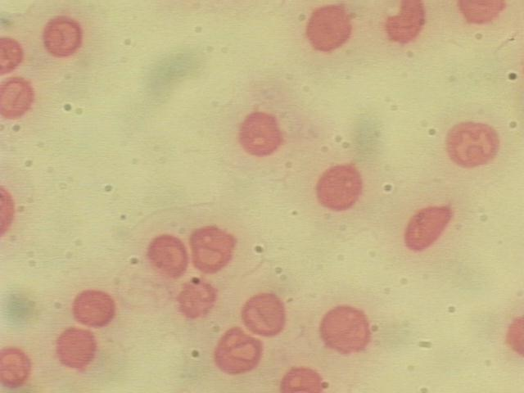
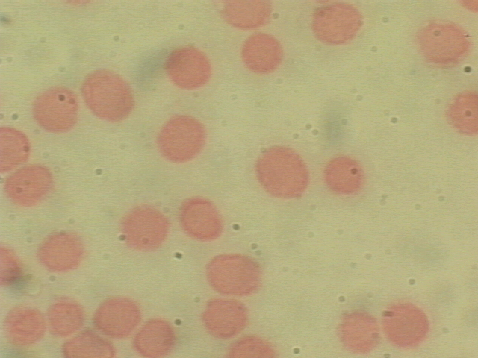
Table 1 Effect of uncaria (in vivo) on the labeling of red blood cells (BC), insoluble fraction
Figure 1 – control Figure 2 - treated

Figures 1 and 2 Photomicrography of blood smears prepared with samples of whole blood
used to label RBC with ^{99m} Tc (control and treated)
of the red blood cells (IF-C) and in the insoluble fraction of the plasma (IF-P) with ^{99m}Tc.
Sechium edule | BC | IF-C | IF-P
Control  100 % | 91.62 ± 3.90  97.01 ± 0.70 | 79.50 ± 1.84  83.30 ± 0.90 | 71.43 ± 0.37  72.70 ± 0.43
Samples of heparinized blood from animals treated with the referred extract were incubated for 1 hour with stannous chloride (1.2 μg/mL) and ^{99m}Tc, as sodium pertechnetate. These samples were centrifuged and plasma (P) and blood cells (BC) were separated. Samples (20 μl) of BC were precipitated with trichloroacetic acid (TCA) 5% and soluble (SF) and insoluble fractions (IF) were separated. The radioactivity in P, BC, SF-BC , IF-BC, SF-P and IF-P was determined in a well counter and the % of radioactivity (% ATI) was calculated. A statistical analysis (Kruskal Wallis test, n= 6) was used to compare the results. The values are averages ± SDs.

Table 2 - Effect of uncaria (in vivo) on the morphology of red blood cells (BC)
Groups | Mean of the perimeter/area
Control  Treated (100 % ) | 0.65 ± 0.04  0.63 ± 0.02
Histological evaluations were performed with blood samples treated with Uncaria for 60 min at room temperature. Blood smears were prepared, dried, fixed and staining. After that, the morphology of the red blood cells was observed under optical microscope.

The use of natural products, as medicinal plants, is very frequent in folk medicine around the world and Uncaria is utilized as a therapeutic plant due to this antiinflammatory properties such as rheumatoid and osteoarthritis, sinusitis, rhinitis, amigdalite, and cutaneous abscesses (Williams, 2001).
It has been described by our research group the effect of some natural products as Thuya occidentalis (Mattos, 1997), Nicotiana tabacum, (Vidal, 1998), Maytenus ilicifolia (Mattos, 2000) and Paullinia cupana (Mattos, 2002) on the radiolabeling of blood elements with ^{99m}Tc. These extracts are capable to reduce this labeling procedure in in vitro studies.
In the present study, uncaria extract was not capable to alter the radiolabeling of blood constituents with ^{99m}Tc like it was observed with an extract of cauliflower (leaf) (Lima, 2002). The results obtained with the quality and quantity comparison of the shape of the RBC (control and treated groups) under optical microscopy could justify the fact that uncaria extract was not capable to alter the radiolabeling procedure. In other study, Diré et al, 2001 has reported that chayote extract was able to alter de morphology of red cells. Thompson et al., 1981 studied the labeling of intact human erythrocytes with ^{99m}Tc. The analysis of the membranes of labeled erythrocytes showed that the label bear is not due to the binding of technetium to residual hemoglobin but its binding to constituent membrane proteins demonstrating the importance of the integrity of the morphology of the cells due to radiolabeling process. We can suggest that like Peumus boldus (Reiniger, 1999), the effect of uncaria could be explained by its anti-oxidant properties that can be due to the fact that uncaria may be heavily metabolized by the liver, resulting in inactive metabolites that do not alter the labeling of blood elements with ^{99m}Tc.
Many reports about medicine plants are rarely written up in the traditional medicine literature. In order to make an accurate assessment of the impact of drugs and other factors on the biological systems additional data are required (Braga, 2000, Sampson, 1996).

5 Conclusion

We can conclude that Uncaria extract was not capable to alter the radiolabeling of blood elements with ^{99m}Tc and the morphology of red blood cells. We suggest that the studied natural product, may be heavily metabolized by the liver, resulting in inactive metabolites that do not alter the labeling procedure and the morphology of red blood cells.

References
[1] Bernardo Filho M, Gutfilen B, Maciel OS. Effect of different anticoagulants on the labeling of red blood cells and plasma proteins with Tc-99m. Nucl Med Comm , 1994 , 15:730.
[2] Braga ACS, Oliveira MBN, Feliciano GD, Reninger IW, Fonseca JF, Silva CR, Bernardo-Filho M. The effect of drugs on the labeling of blood elements with technetium-99m. Curr Pharm Design , 2000 , 6:1179.
[3] Diré G, Lima E, Mattos D, Oliveira MB, Pereira MJ, Moreno, Freitas R, Gomes ML, Bernardo-Filho M. J Labeled Compds Radiopharm , 2001, Suppl 1:44.
[4] Early PJ, Sodee DB. Principles and Practice of Nuclear Medicine. Mosby-Year Book, Inc., Toronto , 1995 , 877.
[5] Gutfilen B, Bernardo-Filho M. M Rer Bras Pesq Desenvolv, 1996 , 3:93.
[6] Gutfilen B, Pontes LFS, Alencar ISC, Bernardo-Filho M. Biomed Letter , 1993 , 48:305.
[7] Hesselewwod S, Leung E. Drug interactions with radiopharmaceuticals. Eur J Nucl Med , 1994 , 21:348.
[8] Hladik III WB, Saha GB, Study KT. Essentials of Nuclear Medicine Science, Williams and Wilkings: Baltimore-London, 1987.
[9] Lima EAC, Diré G, Mattos DMM, Freitas R, Gomes ML, Oliveira MB, Faria MVC, Jales RL, Bernardo-Filho M. Effect of an extract of cauliflower (leaf) on the labeling of blood elements with
technetium-99m and on the survival of Escherichia coli AB1157 submitted to the treatment with stannous chloride. Food Chem Toxicolv , 2002;40:919-923.
[10] Mattos DMM, Gomes ML, Freitas RS, Moreno S, Lima-Filho GL, Paula EF, Jales RLC, Bernardo-Filho. Which are the most used radionuclides in the pet and in the spect techniques in the world. J Labeled Cpd Radiopharm , 2001 , Suppl 1:44.
[11] Oliveira JF, Ávila AS, Braga ACS, Oliveira MBN, Boasquevisque EM, Jales RL, Cardoso VN, Bernardo-Filho M. Effect of extract of medicinal plants on the labeling of blood elements with Technetium-99m and on the morphology of red blood cells: a study with Paullinia cupana Fitoterapia , 2002 , 73:305.
[12] Oliveira JF, Braga ACS, Ávila ASR, Araújo AC, Cardoso VN, Bezerra RJAC, Bernardo-Filho M. Assessment of the effect of Maytenus ilicifolia (espineira santa) extract on the labeling of red blood cells and plasma proteins with technetium-99m. J Ethnopharmacol , 2000 , 72:179.
[13] Oliveira JF, Braga ACS, Ávila ASR, Gutfilen B and Bernardo-Filho M. Effect of Thuya occidentalis on the labeling of
red blood cells and plasma proteins with technetium-99m. Yale J

Biol Med , 1997 , 69:489.
[14] Reiniger IW, Oliveira JF, Caldeira-de-Araújo A, Bernardo-Filho M. Appl Radiat Isto , 1999 , 51:145.
[15] Saha GB. Fundamentals of Nuclear Pharmacy. Springer-Verlag, New York , 1998 , 331 .
[16] Sampson CB. Nucl Med Commun , 1996 , 17:648.
[17] Santos JS, Paula EF, Correa TG, Freitas LC, Fonseca LM,
Gutfilen B, Bernardo-Filho M. Braz J Med Biol Res , 1995 , 41:1575.
[18] Srivastava SC, Straub RF, Richards PJ. Labeled Compds Radiopharm , 1984 , 21:1055.
[19] Vidal MV, Gutfilen B, Barbosa-da-Fonseca LM, Bernardo-Filho MM. J Exp Clin Cancer Res , 1998 , 17:41.
[20] Williams JE. Review of antiviral and immunomodulating properties of plants of the Peruvian rainforest with a particular emphasis on Una de Gato and Sangre de Grado. Altern Med Rev , 2001 , 6:567.

