L-THIA: A Useful Hydrologic Impact Assessment Model

Yongsheng Ma

( Research Scholar, Institute of Water Research, Michigan State University, MI 48823)

[Nature and Science, 2004,2(1):68-73]

Introduction
L-THIA (Long-Term Hydrologic Impact Assessment) has been developed by Purdue University (contact persons: Bernie Engel, and Jon Harbor) as a straightforward analysis tool that provides estimates of changes in runoff, recharge and non-point source pollution resulting from past or proposed land use changes. L-THIA was initially designed for planners and natural resource managers because they are familiar with land use change in a particular area, have perhaps the best access to land use information, and are often interested in environmental impacts. Whether it be past, present, or projected land use development scenarios, establishing land use areas and determ- ining CNs as input variables to runoff estimation is a task well-suited to planners and resource managers. L-THIA and many other models determine runoff from precipitation data and a land use / soils index, the Curve Number (CN), developed from real-world data by the United States Department of Agriculture, Soil Conservation Service (USDA, 1986).
It is important to consider the effects land use changes have on surface runoff, stream flow, and groundwater recharge. Expansion of urban areas significantly impacts the environment in terms of ground water recharge, water pollution, and storm water drainage. Urbanization leads to creation of impervious surfaces, which lead to an increase in surface runoff volume, this in turn contributes to downstream flooding and a net loss in groundwater recharge. Eventually loss of recharge affects residential and municipal water supplies. Minimizing the disturban- ce on an urbanizing watershed is one way of ensuring continued water supply. Since each land use has a different level of impact, careful physical planning can minimize these impacts. Although the impacts of urban sprawl on groundwater recharge and surface water quantity and quality are of considerable importance, many planners, city managers and water resource professionals lack the ability to provide estimates of the potential hydro- logic impacts of land use change.
L-THIA was developed as a straigh- tforward analysis tool to provide estimates of changes in runoff, recharge and non-point source pollution
resulting from past or proposed land use changes. It gives long-term average annual runoff for a land use configuration, based on actual long-term climate data for that area. By using many years of climate data in the analysis, L-THIA focuses on the average impact, rather than an extreme year or storm.
The SCS CN method, which is a core component of many traditional hydrologic models, has been used in a straightforward simple fashion to assess the long-term hydrological impacts of land use change.
Ref. web sites:
http://www.ecn.purdue.edu/runoff/documentation/about.html
What is L-THIA?
http://www.ecn.purdue.edu/runoff/documentation/downloads/whislthia.ppt
Why use L-THIA?
http://www.ecn.purdue.edu/runoff/documentation/downloads/yuselthia.ppt
How L-THIA works?
http://www.ecn.purdue.edu/runoff/documentation/how%20works.html
2 Runoff Basics
Runoff is that portion of precipitation that flows over land surfaces toward larger bodies of water. Before runoff can occur, rainfall must satisfy the immediate demands of infiltration, evaporation, interception, surface storage, and surface detention and/or channel detention. Some are very minor losses, e.g., interception by a corn crop is only about 0.02 inches. However, in a forested area interception may not be minor, accounting for up to 25 percent of the rainfall. For short time periods (storms) on agricultural lands:
rainfall - runoff = infiltration
This can be illustrated by a hydrograph with a steady rainfall input:
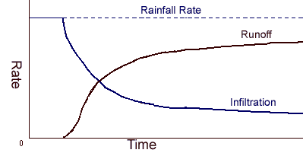
Notice that runoff is an approximate mirror image of infiltration (with some additional time-lag for overland flow travel lag).

3 Factors Affecting Runoff
There are two broad categories of factors that control runoff: rainfall (storm) characteristics and watershed physical conditions. Important rainfall character- istics include duration, amount, intensity and distribution. Key watershed factors are:
Size
For a fixed return interval, as watershed size increases, the runoff per unit area decreases. This occurs primarily because average rainfall amount decreases with increasing area; secondarily, increa- sed travel time for runoff allows more infiltration and other losses.
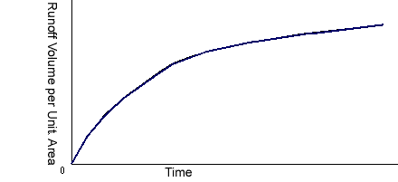
Shape
For equal sized watersheds, runoff decreases as overland flow length incr- eases. This results from the increased time of concentration. Longer duration storms, needed to produce runoff from all points in watershed, have lower average intens- ities.
Topography
Surface slopes and roughness greatly influence runoff. Seep slopes reduce time of concentration and detention volume. Roughness increases surface storage and promotes greater infiltration, both of which decrease runoff.
Soils
Watershed soils influence infiltration and deep seepage rates. Infiltration must be satisfied
before runoff begins.
Surface culture
Modern agricultural practices prom- ote infiltration, slow runoff and reduce the antecedent water content of soils prior to a storm event.
Runoff hydrograph
A graph of runoff rate vs. time is called a runoff hydrograph. The shape of a hydrograph depends on the time distribution of rainfall and upon watershed flow characteristics. However, most hydr- ographs bear some resemblance to the "typical shape" shown below:
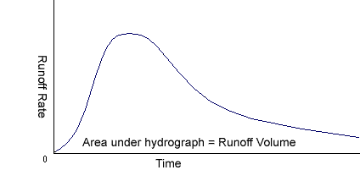
The receding limb of a hydrograph usually extends over a longer period of time than the rising limb. The area under the curve gives the volume runoff (volume/time x time = volume). In this course, we will primarily use the peak runoff rate in our problems. Since hydrographs of previous storm events are seldom available for small watersheds, estimates of peak rates and/or volume must be made using computational models rather than from statistical analyses of past records.
Ref web site:
http://www.ecn.purdue.edu/runoff/documentation/runoff.htm

4 The SCS Curve Number Method

The SCS curve number method is a simple, widely used and efficient method for determining the approximate amount of runoff from a rainfall even in a particular area. Although the method is designed for a single storm event, it can be scaled to find average annual runoff values. The start requirements for this method are very low, rainfall amount and curve number. The curve number is based on the area's hydrologic soil group, land use, treatment and hydrologic condition. The 2 former being of greatest are importance.
For detail:
http://www.ecn.purdue.edu/runoff/documentation/scs.htm
The concept of a limited recharge capacity, which is determined by ant-ecedent moisture conditions and by the physical characteristics of the drainage basin, has been elaborated by the U.S. Soil Conservation Service to a preconceived multiple correlation model in which the partial correlations are expressed in tabular form. This method is described in the S.C.S. National Engineering Handbook (1964; SCHULZE, 1966). It takes its name from the curve number
CN = 1000 / (10 + S) (1)
Where S is the recharge capacity or “potential maximum retention” at a certain time. The curve number is found from tables as a function of antecedent rainfall, land use, density of pant cover, soil type, and not readily applicable in other parts of the world. If used outside the U.S.A., they will first have to be adjusted to local conditions.
The underlying concept of the model is: I_{a} = 0.2S is an initial quantity of interception, depression storage, and initial infiltration that must be satisfied by any rainfall before runoff can occur.
The ratio of direct runoff Q and the precipitation minus the initial loss P – I_{a} equals the ratio of the actual recharge minus initial loss, P – Q - I_{a} and the mathematical model could be based.
Q / ( P - I_{a} ) = ( P – Q - I_{a} ) / S (2)
or Q = ( P - I_{a} )² / ( P - I_{a} + S )
And since I_{a} = 0.2S it follows that:
Q = (P - 0.2S )² / ( P + 0.8S ) (3)
The curve expressing the relation of Q and P depending on the parameter S (and I_{a}= 0.2S) is the only parameter in this model that determines the relationship between the amount of rainfall in one day and the corresponding daily amount of rainfall excess that will subsequently.A heterogeneous basin may be divided into sub-areas with different curve numbers. The total rainfall excess is then obtained by adding up the amounts that have been computed for the sub-areas. The basic assumption, which has been expressed in Eq. 2, is certainly open to criticism. For high values of P and Q the left hand side of Eq. 2 approaches unity, whereas the right hand side cannot exceed the value of 0.8, unless the actual recharge P-Q exceeds the recharge capacity S. This, of course, is in contradiction with the concept of recharge capacity. Substitution of Q = P - S in Eq. 3 shows that the limit is reached for P = 4.2 S. Therefore the U.S. Soil conservation Service introduced the limits P > I_{a} and S > I_{a} +F, where F = P - I_{a} - Q. It follows that S > P - Q. For high curve numbers which go with a small recharge capacity, this could imply a definite restriction to the method’s applicability.
Be transformed into direct runoff.
Curve number method: Relationship rainfall-direct runoff as dependent on the recharge capacity.

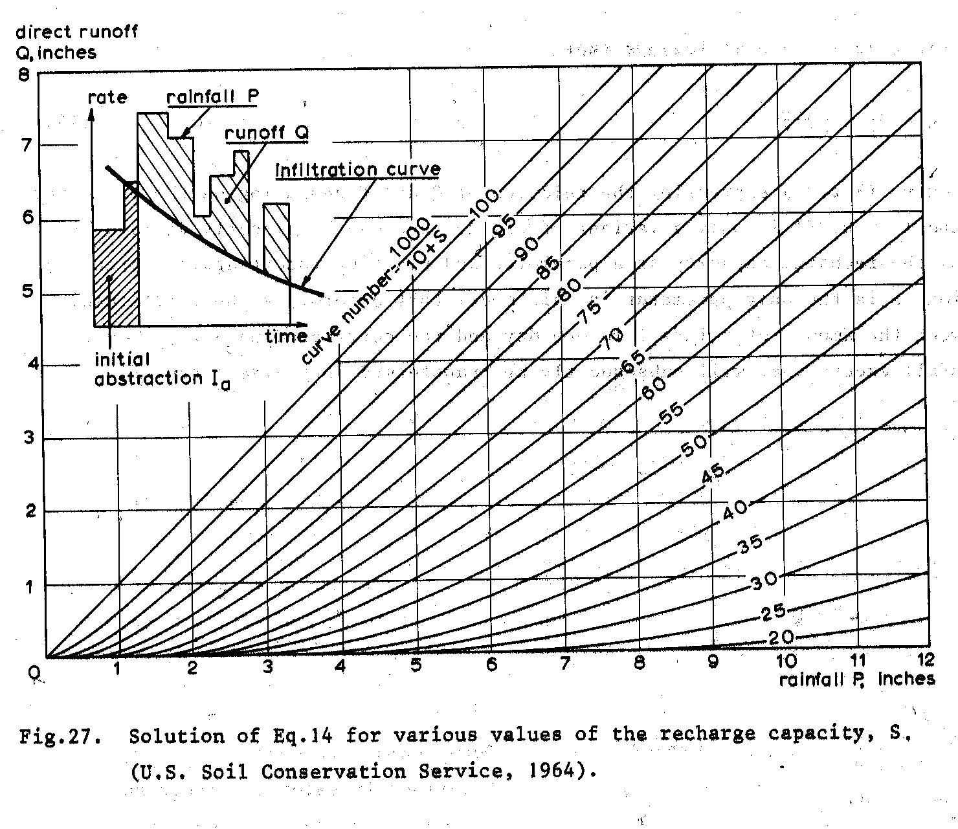

Curve number method: Relationship rainfall-direct runoff as dependent on the recharge capacity.

Solution of Eq.3 for various values of the recharge capacity, S.
(U.S. Soil Conservation Service, 1964)

Although the underlying concept is not quite sound, the method is presented here because much work has been done to correlate the one parameter S with antecedent rainfall, seasonal effects, and certain
characteristics of the soil surface and plant cover.
Ref. web sites:
http://www.ilri.nl/publications/pub16.html
About ILRI:
http://www.ilri.nl/institute/ilri.html
http://www.ecn.purdue.edu/runoff/documentation/scs.htm
http://pasture.ecn.purdue.edu/~aggrass/agnps/runoff.html#curve%20number
Derivation of SCS Curve Number Method:
http://www.engr.udayton.edu/Civil/CIE%20333%20Winter%202002/SCS_CN.htm
About TR-55:
http://www.brc.tamus.edu/epic/documentation/tr55method.html
For detail:
http://www.ecn.purdue.edu/runoff/documentation/scs.htm

5 Non-Point Source Pollution and Hydrologic Soil Groups
NPS pollution comes from many diffuse sources. It is caused by rainfall or snowmelt moving over and through the ground. Runoff after rain events pick up and carry away natural and human-made pollutants, finally depositing them into lakes, rivers, wetlands, coastal waters, and even our underground sources of drinking water. NPS pollution remains the largest source of pollution of water bodies the United States. (EPA, 1997).
For detail:
http://www.ecn.purdue.edu/runoff/documentation/nps/nps.htm
NPS Pollution - Common Sources:
http://www.ecn.purdue.edu/runoff/documentation/nps/common_nps.htm
NPS Pollution - Reducing Sources:
http://www.ecn.purdue.edu/runoff/documentation/nps/reducing_nps.htm
Soils are classified by the Natural Resource Conservation Service into four Hydrologic Soil Groups based on the soil's runoff potential. The four Hydrologic Soils Groups are A, B, C and D. Where A's generally have the smallest runoff potential and Ds the greatest.
Details of this classification can be found in ‘Urban Hydrology for Small Watersheds’ published by the Engineering Division of the Natural Resource Cons- ervation Service, United States Depar- tment of Agriculture, Technical Release–55.
Group A is sand, loamy sand or sandy loam types of soils. It has low runoff potential and high infiltration rates even when thoroughly wetted. They consist chiefly of deep, well to excessively drained sands or gravels and have a high rate of water transmission.
Group B is silt loam or loam. It has a moderate infiltration rate when thoroughly wetted and consists chiefly or moderately deep to deep, moderately well to well drained soils with moderately fine to moderately coarse textures.
Group C soils are sandy clay loam. They have low infiltration rates when thoroughly wetted and consist chiefly of soils with a layer that impedes downward movement of water and soils with moderately fine to fine structure.
Group D soils are clay loam, silt clay loam, sandy clay, silt clay or clay. This HSG has the highest runoff potential. They have very low infiltration rates when thoroughly wetted and consist chiefly of clay soils with a high swelling potential, soils with a permanent high water table, soils with a clay pan or clay layer at or near the surface and shallow soils over nearly impervious material.
For detail:
http://www.ecn.purdue.edu/runoff/documentation/hsg.html

Getting Started - A Tutorial for L-THIA
This document describes how to get started in using the L-THIA WWW system. An example application of L-THIA WWW is presented to describe how to use the system.
For detail:
http://www.ecn.purdue.edu/runoff/documentation/tutorial.htm
The model runs can be made by selecting the
input option from the menu on the left to return to the input form. There are several options of input: the basic input, detailed input, advanced input, and impervious area input.

L-THIA Input

To begin using L-THIA WWW, select the arrow to the left of the input option from the menu on the left.
Scenario Name
The scenario name will be used in tracking your L-THIA analysis.
Location
Select the location of the area being analyzed
(State and County) from pull down menus. The location information is used to select the appropriate rainfall data for running L-THIA.
Units
Select the units that will be used in describing the area you are analyzing.
Land Use
The land uses considered are selected from the SELECT LANDUSE menus. Be sure that all of the columns add to the same amount of land. You may need to click on another entry box for the last value entered to the included in the totals.
Hydrologic Soil Groups
Hydrologic soil group is a soil property that characterizes the runoff tendency of the soil. If you do not know the hydrologic soil group for an area you wish to analyze, this information can be obtained after selecting the state of interest in state field.
If the detailed input was selected, the user can define a custom land use. In the land use drop down menu, choose the custom option. In the pop-up box, enter a name for the land use and the appropriate curve number separated by a comma. The last column of the input sheet is labeled "SELECT Land Use Similar to the Custom Land Use for NPS Estimation". In this column select the land use that most closely represents the custom land use for the approximation of NPS pollution.
Ref web sites: L-THIA WWW: A short tour:
http://www.ecn.purdue.edu/runoff/documentation/downloads/lthiawww1.ppt
- The basic input and detailed input
You can select either basic or detailed input.
With the basic input the user can chose from 8 different land use types. This input form is for involved community people who many not have a background in land use planning but are concerned with development in their area. The detailed input has 13 different land use choices plus a custom field. If the custom field is chosen the user can create a new land use by defining the appropriate curve number. Land use planners, deve- lopers; landscape architects and consu- ltants are the intended users of this type of input.
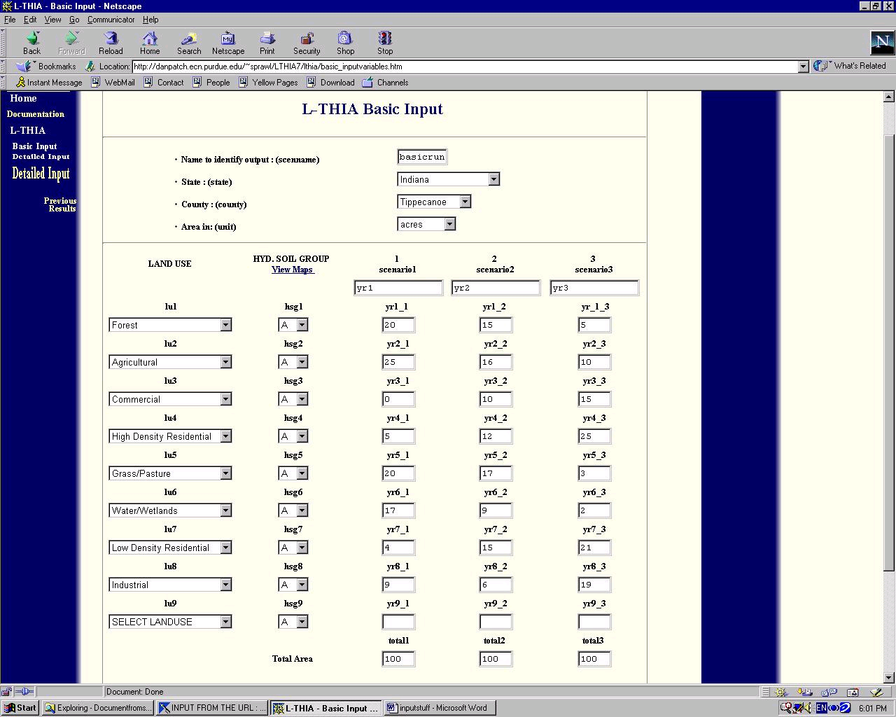

Link to L-THIA Basic Input and Detail Input:

L-THIA Basic Input:

http://www.ecn.purdue.edu/runoff/lthia/basic_input.htm

L-THIA Detailed Input:

http://www.ecn.purdue.edu/runoff/lthia/detailed_input.htm

(2) The advanced input page
The Advanced input page should be used in one or more of the following situations.
a. The user wants to calculate the NPS pollution for pollutants other than the standard pollutants
b.The user wants to enter pollutant expected mean concentration (EMC) values other than the default values for these pollutants.
c.The user wants to specify a LAND USE other than the default LAND USES for a given land area.

Link to L-THIA Advanced Input:
http://www.ecn.purdue.edu/runoff/lthia/advanced_input.htm
(3) The impervious area input
The 'Percent Impervious Area Input' of L-
THIA is best suited for urban land use change analysis.
The Curve Number (CN) Value calculated by the model for this particular input is based on the assumption that the pervious area is 'grass' in 'fair' condition.
In case the pervious area is agricu- ltural or forest for example the CN value and consequently the runoff generated will be very different. Land uses such as agriculture, also generate runoff and impact the long-term hydrology of the watershed. Converting agricultural land to urban use generates less difference in the amount of runoff than if grassland or forest is converted to higher intensity uses such as commercial or high density residential.
Link to L-THIA Impervious Input:
http://www.ecn.purdue.edu/runoff/lthia/impervious_input.htm

For how using L-THIA first to visit:
http://www.ecn.purdue.edu/runoff/documentation/lthiaurllink.htm

8 L-THIA Output

Once L-THIA runs (a few seconds), the results will appear in the WWW browser. The average annual depth of runoff for each land use and soil combination is also reported as shown.
Runoff
Average annual runoff volumes are also reported in tabular form in this section. Volumes are reported for each time period analyzed.
If you are going to want to review your data later, provide a user name and password at the bottom of the page.
The runoff depth and volume results can also be viewed in graphical form by selecting the bar chart or pie chart option from the menu on the left side of the web browser window.

Non-Point Source Pollution
Non-point source (NPS) pollution results can be obtained by selecting NPS in the menu on the left (use the mouse to click on the triangle symbol beside NPS). A list of NPS outputs will be made available as shown in the figure at the right. Select the NPS pollutant of interest and then select the format that you wish to use when viewing the data.

- Conclusion

L-THIA results can be used to aid land use planners in a variety of ways. For instance, a planner may decide to change the land use based on soil type, to minimize impact in a given area. That is because the same land use located on different hydrologic soil types has different impacts. Also, since the amount of runoff generated by different land uses is a function of the hydrologic soil type and the land use, relocating land uses based on the hydrologic soil type can in some cases significantly reduce the long-term impact of the development.
Ref. web sites:
Advanced GIS version:
http://www.ecn.purdue.edu/runoff/documentation/downloads/lthiagiswww111.avi
Field Evaluation of permeable pave- ments for storm water management:
http://www.ecn.purdue.edu/runoff/documentation/downloads/perm.pdf
Street storage for combined sewer surcharge control:
http://www.ecn.purdue.edu/runoff/documentation/downloads/street.pdf
Low impact development (LID):
http://www.ecn.purdue.edu/runoff/documentation/downloads/effect.pdf
Low impact development hydrolo-gy analysis:
http://www.ecn.purdue.edu/runoff/documentation/downloads/LID_HYDR.PDF

