Characterization of a New Species of Taxol-producing Fungus

Jingping Ge, Wenxiang Ping, Dongpo Zhou

(College of Life Sciences, Heilongjiang University, Harbin, Heilongjiang 150080, China, gejingping9178@hotmail.com

Abstract: The macroscopic features of taxol-producing fungus G1353, as well as the microscopic features such as hyphae, conidiophores, and coridia, are sufficiently different from other members of the genus Alternaria that the strain constitutes a new species. The name Alternaria taxi is proposed. [Nature and Science, 2004,2(1):85-88].

Key words: taxol; anti-cancer; fungi; Alternaria taxi

Introduction

Taxol is a compound with anti-cancer properties, and it is proving to be particularly useful against mammary and ovarian cancers (McGuire, 1989). The most common source of Taxol is the bark of trees belonging to the Taxus family including Yew trees. Unfortunately, these trees tend to be rare, slow growing, and a large amount of bark may have to be processed to obtain a small amount of the drug. Alternative sources of Taxol have been sought, and Strobel et al., were the first to isolate Taxol-producing fungi from the tree Taxus brevifolia (Strobel, 1993). Over the last decade there has been a great deal of interest in finding other fungi that produce Taxol (Zhou., 2001). In the present study, a fungus was isolated from T. cuspidatea and shown to be able to produce the drug. Characterization of this fungus has shown it to be distinct from other species and a new name is thus proposed.

2 Materials and Methods

2.1 Strains
Two thousand fungal strains were separated from the bark of T. cuspidatea collected from HePing Forestry Centre, MuLing County, Heilongjiang Province, China in 2000. Each was screened for Taxol production by TLC and results were confirmed by HPLC where appropriate. Fungal strain G1353 was shown to produce taxol (data unpublished).
2.2 Culture media
PDA medium was prepared by adding potato (200g/L), glucose (20 g/L), and agar (20 g/L), to distilled water. The potato was first washed and cut into small pieces, boiled for 30 minutes, and filtered through gauze prior to addition of the glucose and agar.
Chase Medium was prepared by adding NaNO₃ 2 g, KH₂PO₄ 1 g, KCl 0.5 g, MgSO₄ 0.5 g, FeSO₄ 0.01 g, sucrose 30 g, agar 20 g, to 1 litre of distilled water. The pH was adjusted to 7.0.
Martin Medium was prepared by adding glucose 10 g, peptone 5 g, KH₂PO₄ 1 g, MgSO_{4.}7H₂O 0.5 g, to 800 ml distilled water. After autoclaving streptomycin was added to a final concentration of 0.03%.
2.3 Microscopy
An XS-18 bright- field microscope (Jiang Nan), and an OLYMPUS BX51 fluorescent microscope were used to examine the microscopic features of the fungus. Strain G1353 was grown on PDA, Chase and Martin media at 28℃ and examined after 2, 3, 4, and 5 days. Hypha on the PDA plate were asceptically transferred to slides for cultivation (Shen, 2000).

3 Results

3.1 Colony morphology
G1353 grew fastest on the PDA medium (Table 1), and the diameter of the colony reached 6 cm after 5 days incubation at 28℃. The colony was flat, entire, and downy to woolly and was covered by brown, short, aerial hyphae in time. The surface was light brown at the start, later darkening to brown black with a light border. The reverse side was typically brown to black due to pigment production.
The height of colony was about 0.5 cm (Figures 1 and 2).

Table 1 Growth of G1353 on different media
Medium |  | Time of incubation (days)
 | 2 |  | 3 |  | 4 |  | 5
PDA |  | 1.8~2.2cm |  | 3.0~3.5cm |  | 4.5~4.9cm |  | 6.0~6.4cm
Chase |  | 1.0~1.2cm |  | 1.2~1.4cm |  | 1.4~1.6cm |  | 1.8~2.2cm
Martin |  | 0.8~1.7cm |  | 2.5~3.2cm |  | 3.2~3.5cm |  | 3.8~4.6cm

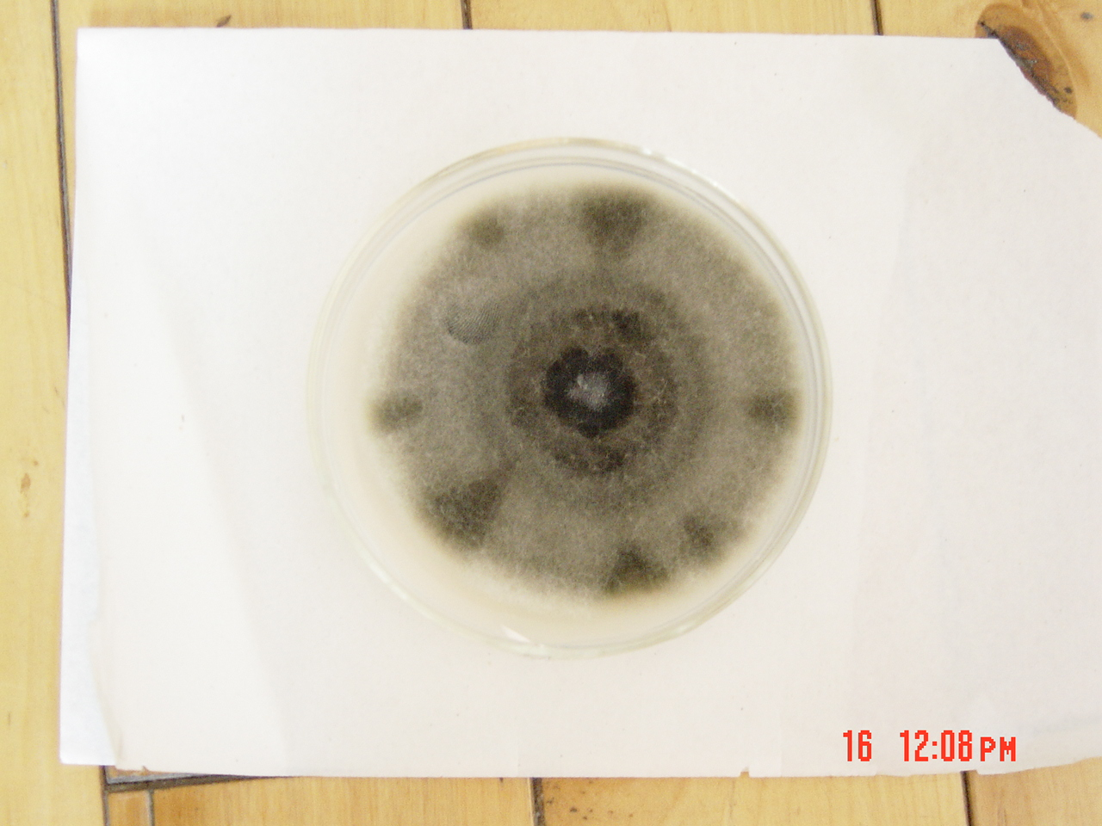
Figure 1 Face of G1353 colony on PDA media

Figure 2 Reverse side of G1353 colony on PDA media

3.2 Structure (Figures 3-10)
Most of the hyphae grew on the surface of the PDA agar, but partially in the agar. They were septate, multi-offshoot, obviously having wart. The hyphae were brown in color, tapering to colorless at their ends and 2.5~5.0μm in diameter.
Conidiophores were brown to light brown, septate, and simple, with endlong or zigzag appearance. They were 12.5~27.4 × 2.5~5.0 μm in length.
Conidiogenous cells were tubular. Conidia were produced directly by hyphae cells, and were septate and brown / light brown in color. They were large (6.0~12.4 × 18.9~33.7 μm) with both transverse (3~8) and longitudinal (0~3) septations. These conidia were observed singly or in acropetal chains (2 or 3 conidia). They were ovoid to obclavate, darkly pigmented, muriform, and smooth. The end of the conidium nearest the conidiophore is round but it tapers towards the apex. This gives the typical beak or club-like appearance of the conidia (a few had no beak), and the beaks were 2.5~3.0 × 3.0~9.0μm in size.

Figure 3 Hyphae of G1353 (Branch, sepate, 800×)

Figure 4 Wart on hyphae of G1353 (800×)

Figure 5 Color change of hyphae of G1353 (200 ×)

Figure 6 Conidiophores of G1353 (ziazag 800×)

Figure 7 Conidiophores of G1353 (endlong 800×)

Figure8 Conidia and its location of G1353 (chain 800×)

Figure 9 Conidia and its location on G1353 (800×)

Figure 10 Beak on the conidia of G1353 (800×)

4 Discussion

The colony of G1353 was flat on the surface of PDA medium. The hyphae were downy to woolly, white after two days but light brown or dark brown after five or six days. Both hyphae and conidiophores were septate. This strain bears simple large conidia, which have both transverse and longitudinal septations. These conidia were observed singly or in acropetal chains. They are ovoid to obclavate, darkly pigmented, muriform, and smooth. All of these characteristics were consistent with those of the Deuteromycotina, Hyphomycetes, Dematiaceae, Alternaria spp. (Colier, 1998; Larone, 1995; Germain, 1996). Thus, strain G1353 belongs to Alternaria spp., but has some unusual characteristics: 1) the conidiophores are simple, endlong or zigzag, 12.5~27.4 × 2.5~5.0 μm long. 2) Conidiophore cells are tubular and the conidia were directly produced by hyphae cells. 3) G1353 bears simple large conidia (6.0~12.4 × 18.9~33.7 μm) which have both transverse (3~8) and longitudinal (0~3) septations. These conidia were observed singly or in acropetal chains (2~3 conidia). They are ovoid to obclavate, darkly pigmented, muriform, smooth. 4) The end of the conidium nearest the conidiophore is round but it tapers towards the apex. This gives the typical beak or club-like appearance of the conidia (or no beak in some cases). From the above we conclude that strain G1353 is sufficiently different from other Alternaria spp. to be classified as a new species, and propose the name Alternaria taxi. Investigations into the production of taxol by this species are continuing, in the hope it can be used as a significant producer of this important anti-cancer drug.

Correspondence author:
Jingping Ge
74 Xuefu Road,
Nangang District,
College of Life Sciences, Heilongjiang University,
Harbin, Heilongjiang 150080, China
Office Telephone: 0086-451-86608586
Home telephone: 0086-451-86609178
Mobile phone: 0086-13836002907
E-mail: gejingping@0451.com Or gejingping9178@hotmail.com

References
[1] Colier L et al. Topley & Wilson Microbiology and Microbial Infections. 9th ed. Vol 4. London, Sydney, Auckland, New York, 1998.
[2] Germain G et al. Indetifying Filamentous Fungi—A Clinical
Laboratory Handbook, 1st ed. Star Publishing Company, Belmont, California,1996.
[3] Larone DH et al. Medically Important Fungi—A Guide to
Indentification, 3rd ed. ASM Press, Washington, D.C. ,1995.
[4] Shen P. Microbiology experiment (3 rd.). Beijing: Higher
press, 2000.
[5] Strobel G et al. Mycotaxon. 1993; 47:71-80.
[6] Zhou DP et al. Nolulisporium, a genus new to China. Myco-
systema, 2001, 20:148-150

