GIS Application In Watershed Management

Yongsheng Ma

(Research scholar, Institute of Water Research, Michigan State University, MI 48823)

Abstract:Traditionally watersheds were spatial extents that capture rainwater. Recently it has been identified that unless the watersheds are not managed in an integrated sustainable manner, then not only the water resources but also other resources such as vegetation, fertile soil, fauna and flora get depleted. Rational management of upper and lower parts of a watershed is equally important for the sustenance of the environment. Therefore it is extremely important to use an integrated spatial approach for managing watersheds and river basins. The remote sensing and GIS for watershed management constitutes theoretical aspects of Geographic Information Systems (GIS) & Remote Sensing and their application for watershed management. [Nature and Science, 2004,2(2):1-7]

1 Why is Watershed Important?

Watershed is an area, which catches the water from precipitation and then is drained by a river and its tributaries. It is a “resource region” where the eco-system is closely interconnected around a basic resource - water. The watershed or river basin is therefore an ideal management unit.
The watershed provides a powerful study and management unit, which integrates ecological, geographical, geological, and cultural aspects of the land. The watershed is also a useful concept for integrating science with historical, cultural, economic, and political issues. Water (movement, cycling, use, quality, etc.) provides a focus for integrating various aspects of watershed use and for making regional and global connections
Using the watershed concept, one can start with study of any number of small sub systems (e.g., a particular marsh or sub-watershed; or a particular pollutant, such as salt), and continually relate these small-scale issues to questions of larger-scale watershed system health.
We all live in a watershed. Watersheds are the places we call home, where we work and where we play. Everyone relies on water and other natural resources to exist. What you and others do on the land impacts the quality and quantity of water and our other natural resources.
Healthy watersheds are vital for a healthy environment and economy. Our watersheds provide water for drinking, irrigation and industry. Many people also enjoy lakes and streams for their beauty and for boating, fishing and swimming. Wildlife also needs healthy watersheds for food and shelter.
effective and efficient way to sustain the local economy and environmental health.
Scientists and leaders now recognize the best way to protect the vital natural resources is to understand and manage them on a watershed basis. Everything that is done in a watershed affects the watershed's system.
Ref. web site:
http://www.srnr.arizona.edu/wsm/wsm462/EvesWebPage.html

2
What Is GIS?

GIS stands for geographic information system. An information system is a computer program that manages data. A GIS, then, is a type of information system that deals specifically with geographic, or spatial, information. Like other information systems, a GIS requires lots of data that it can access, manipulate, and use to produce a product.
Geographic information describes the spatial (location) factors of an object or area. This can be simply latitude and longitude coordinates, but in most cases more complex factors are included. As for a formal definition of GIS, Worboys (1995) defines GIS as follows:
A geographic information system (GIS) is a computer-based information system that enables capture, modeling, manipulation, retrieval, anal- ysis and presentation of geographically referenc- ed data.
The definition provided by The Oak Ridge National Laboratory: GIS is “a digital representation of the landscape of a place (site, region, planet), structured to support analysis.” Under this broad definition, GIS conceivably may include process models and transport models as well as mapping and other spatial functions. The ability to integrate and analyze spatial data is what sets GIS apart from the multitude of graphics, computer-aided design and drafting, and mapping software systems.
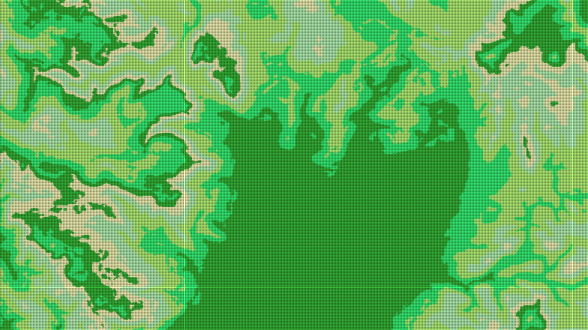
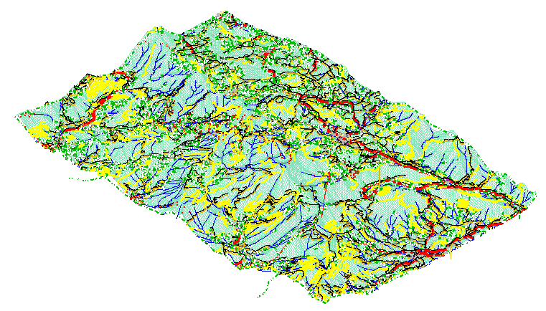

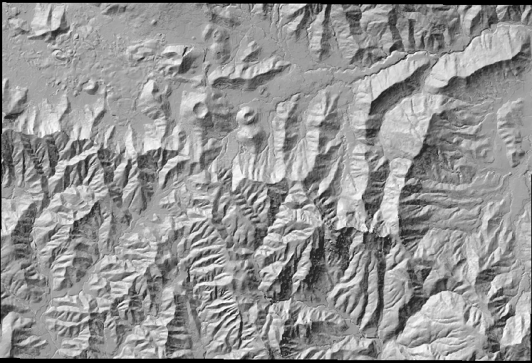

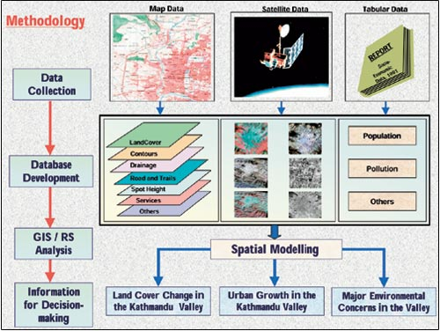
Methodology of GIS database development and analysis for the Kathmandu Valley, http://www.esri.com/news/arcnews/summer01articles/gisinhindu.html
2.1 The components of a GIS
In order to function properly, a GIS needs several basic components:
·Data -- organized in a database. The database includes the locational data (where things are located) and the spatial relationships between data features. The database may also include additional relevant information.
·Software -- a program or group of programs, such as ArcView or Arc/Info, that can access the database, manipulate the data, and produce a product. Others: Idrisi, GRASS, Erdas, etc.
·Platform -- the hardware, including disk space, terminals, network supporting devices, etc., that support the software and database.
·User -- people who operate the GIS and use its results for analysis and decision-making
The fourth, and final, component of a GIS is the user (this means you!). Without know- ledgeable, competent operators, the entire system is useless. Users that are able to creatively employ the functions of the GIS to their fullest extent (not just making maps!) justify the cost and effort required to build and maintain a GIS. The goal of this website is to help you become a competent user, so that you can utilize the power and functionality of GIS products.
2.2 Environmental application of GIS
· Best Management Practices (BMPs) for Non-point Source Pollution Control
· Storm water Management
· Watershed Management
· Spill Control Planning & Response
· Hazardous Material Management
· Air Pollution Management & Plannin
· Wetlands Delineation
· Forestry Management
· Mining & Geologic Resource Management
· Wildlife Habitat Management

3 Watershed Management Models

Below are pointers to simple overviews of various landscape/watershed simulation models. More models and more detailed descriptions may be found by browsing different on-line indexes.
http://www.cecer.army.mil/pl/catalog/index.cfm?resetsite=models
3.1 Some software in watershed management
MMS Modular Modeling System (PRMS, TOPMODEL)
Weasel The GIS Weasel (PRMS and TOPMODEL interface)
HSPF Hydrological Simulation Program--Fortran
PRMS Precipitation-Runoff Modeling System
Ref web site: http://water.usgs.gov/osw/techniques/watershed.h-
tml http://web.aces.uiuc.edu/watershed/models.htm http://web.aces.uiuc.edu/watershed/model/Intro.htm
We all have ideas about the state and history of the watershed and about how that watershed will respond to alternative land management plans. Our personal ideas are models of the world around us. These models are used to help us understand the present and predict the future. Often each of us has different views of the present and the future and we find it very difficult to communicate why in a particular set of future consequences. To help this commu-nication, it may become necessary to formalize those views and ideas for better communication between us.
Geographic information systems (GIS) allow us to formally define our understanding of the past and present state of our watershed and landscapes.
Geographic modeling systems (GMS) allow us to formally define how we believe the watershed works.
GIS is commonly accepted and often requir-ed by watershed managers. Acceptance and use of GMS technologies is growing among manag-ement groups to test the consequences of alter- ative land management scenarios.
3.2 Approaches of GIS application in watershed management
The integrated approach of GIS and Remote Sensing is being recognized universally as the unique highly effective and extremely versatile technology for evaluation, management and monitoring of natural resources and environment. With the concept of multidisciplinary integrated approach got an impetus in monitoring and management of resources and environment.
Ref. web sites: http://www.gisdevelopment.net
Florida Department of Environment Prot-ection, Watershed Management, Surface water impro- vement & Management Program (SWIM):
http://www.dep.state.fl.us/water/watersheds/swim.htm

3.2.1 Watershed management decision support system

There is a growing consensus that an effe- ctive way to control non-point source pollution and enhance the long-term sustainability of agriculture and rural communities is through locally based planning and management at the watershed scale. Coordinated resource mana-gement of a watershed requires the simultaneous consideration of physical and socioeconomic interrelationships and impacts. In order to address these considerations, it is necessary to integrate a large amount of spatial information and knowledge from several disciplines. To be useful, the information and knowledge must be made available to decision makers in a rational framework.
Advances in remote sensing, geographic information systems (GIS), multiple objective decision making, and physical simulation make it possible to develop user-friendly, interactive, decision support systems for watershed planning and management.
The goal of the study is to incorporate these advances by designing a user-friendly, interactive watershed management decision support system (WAMADSS) that identifies the relative contr- ibution of sub-watershed areas to agricultural non-point source pollution and evaluates the effects of alternative land use/management activities and practices (LUMAPs) on farm income, soil erosion and surface water quality at the watershed scale. LUMAPs to be included in WAMADSS are: crop rotations, tillage practices, conservation practices (grass waterways, terraces), pollution prevention practices (timing, rate and method of application of fertilizers and pesticides) and other landscape elements such as improved vegetative cover in riparian areas. The decision support system (DSS) adopts a landscape perspective, which is a way to view interactive parts of a watershed rather than focusing on isolated components.
The watershed management decision supp-ort system has three major components: a GIS, a modeling system, and a graphical user interface (GUI). ARC Macro Language (AML) is used to construct the GUIs, which interface the simulation models and the economic model in a seamless decision support system framework. AML handles all simulation-related activities, including generating input files, executing the environmental models, and viewing results in the GIS.
http://www.ncgia.ucsb.edu/conf/SANTA_FE_CD-ROM/sf_papers/fulcher_chris/abstract.html
http://www.gisdevelopment.net/application

3.2.2 For BMP assessment model using GIS
Best management practices (BMPs) as storm water control systems are widely used in agricultural and urban areas to prevent flooding, reduce soil loss, provide water retention, and most importantly reduce pollutant loadings to receiving water bodies (Chen et al., 1995). BMP performance varies from site to site and season to season. A user-friendly tool is needed to evaluate the performance of BMPs, project future storm water quantity and quality in drainage systems, and identify key design parameters to improve BMP pollutant removal efficiencies.
The Best Management Practices Assessment Model, BMPAM (Xue, 1995a), developed for evaluating the performance of various BMPs, was selected for this tool. A user-friendly interface for BMPAM was developed using a geographic information system (GIS) platform. Integration of GIS and BMPAM reduces the tedious work of data formatting and allows easy interpretation of model inputs and simulation results. This integrated GIS tool can analyze storm water treatment systems and water reso- urces management plans for a single watershed or a large-scale basin.
The BMPAM model, input and output data, pre- and post- processors, and the GIS-BMPAM interface are key components of the integrated GIS tool. GIS provides all required information to the other components. The input data component links with the pre- processor via the GIS user interface. Data from the pre-processor is fed into the BMPAM model. The model is executed through a system command in the GIS interface. The post-processor component displays model simulation results in various tabular and graphic formats through the GIS user interface.
For detail to see the web site:
http://www.awra.org/proceedings/gis32/xue/, Richard Z. Xue(1), Timothy J. Bechtel(2), and Zhenquen Chen(3)
3.2.3 Watershed-scale non-point source pollution modeling
Non-point Source Pollution management is highly dependent on hydrologic simulation mod- els. Evaluating alternative management strategies through experiments and a limited amount of field measurements is not feasible, and a mode-ling study is often the only viable means of providing input to management decisions. The hydrologic system was commonly simplified in the past as a “lumped model.” Under this simplification, the spatial distribution of para-meters lost their real meaning in hydrologic modeling. In contrast to this simplification, a distributed parameter model maintains the spatial distribution of the parameters. Therefore, the application of distributed parameter models is of practical necessity especially in case of the non-point source pollution management. The major disadvantage of distributed parameter models are the large amounts of time required for assembling and manipulating the input data sets. The distributed non-point source pollution models used to study pollutant transport and erosion easily generates towering amounts of data for analysis in even a small watershed. On a large non-homogeneous watershed, a complete simulation and analysis can be very time consuming.
A logical step in improving the quality of the hydrologic modeling would be the integration of spatially distributed parameter models with practical data management scheme such as the geographic information system (GIS) and database management system (DBMS). This integration of distributed hydrologic models-GIS-DBMS can be defined as a tool to collect, manage, analyze, simulate and display spatially varying information. The direct AGNPS-GIS-DBMS linkage to: (1) effectively pinpoint critical areas where resources are threatened, (2) give the necessary information instantaneously based on BMP scenario simulations for further remediation and conservation efforts, (3) provide quality information to decision-makers cost effectively, and (4) help impartially distribute incentives and regulations used for water quality management.
We can all work together to reduce and prevent non-point source pollution. Some activ- ities are federal responsibilities, such as ensuring that federal lands are properly managed to reduce soil erosion. Some are state responsibilities, for example, developing legislation to govern mining and logging, and to protect groundwater. Others are best handled locally, such as by zoning or erosion control ordinances. And each individual can play an important role by practicing conse-rvation and by changing certain everyday habits.

What is non-point source pollution?
Non-point source (NPS) pollution, unlike pollution from industrial and sewage treatment plants, comes from many diffuse sources. NPS pollution is caused by rainfall or snowmelt moving over and through the ground. As the runoff moves, it picks up and carries away natural and human-made pollutants, finally depositing them into lakes, rivers, wetlands, coastal waters, and even our underground sources of drinking water. These pollutants include:
- Excess fertilizers, herbicides, and insecticides from agricultural lands and residential areas;
- Oil, grease, and toxic chemicals from urban runoff and energy production;
- Sediment from improperly managed construction sites, crop and forestlands, and eroding stream banks;
- Salt from irrigation practices and acid drainage from abandoned mines;
- Bacteria and nutrients from livestock, pet wastes, and faulty septic systems;
Atmospheric deposition and hydro-modification are also sources of non-point source pollution.
Q: What are the effects of these pollutants on our waters?
A: States report that non-point source pollution is the leading remaining cause of water quality problems. The effects of non-point source pollutants on specific waters vary and may not always be fully assessed. However, we know that these pollutants have harmful effects on drinking water supplies, recreation, fisheries, and wildlife.
Q: What causes non-point source pollution?

A: We all play a part. Non-point source pollution results from a wide variety of human activities on the land. Each of us can contribute to the problem without even realizing it.

Ref. web sites: Department of civil and environment engineering (CEE), Old Dominion University: http://www.awra.org/proceedings/gis32/jyoon/index.html#AGNPS, Jaewan Yoon (1)
GIS/Water Resources Tools For Performing Floodplain Management Modeling Analysis:
http://www.awra.org/proceedings/gis32/woolprt3/index.html, Clarence Robbins⁽¹⁾, Stephen P. Phipps⁽²⁾
AWRA GIS Symposium On GIS and Resources Online Proceedings List:

http://www.awra.org/proceedings/gis32/index.html

EPA NPS Pollution web site:

http://www.epa.gov/owow/nps/whatis.html
3.2.4 GIS as an integrating instrument for micro-watershed planning and management
Micro-watershed planning has been conce-ived and adopted for holistic development of rain-fed farming in recent years. Watershed Management is fast becoming a blue print for agricultural development in most parts of the country today.
The ultimate goal of watershed management is to achieve and maintain a balance between resources development to increase the welfare of the population -- and resource conservation to safeguard resources for future exploitation and to maintain ecological diversity - both for ethical reasons and as an assumed prerequisite for the survival of mankind.
A micro-watershed, as defined by Bali in 1978, ranges in between 1-10 sq km or 100-1000 hectares.
For detail to see:
http://www.gisdevelopment.net
Contact person: J. G. Krishnayya Angira Baruah, E-mail: GeoConcept@vsnl.com
3.2.5 Groundwater modeling in watershed
GIS applications are beneficial in terms of watershed management issues, such as locating possible sites suitable for groundwater recharge, because:
(1) A large amount of the information required (soils, land-use, and slope maps) to evaluate potential recharge sites currently exists in digital format.
(2) GIS allows a great number of factors to be viewed on uniform media.
(3) GIS has the ability to update information on features and corresponding data. This is essential for water resource management projects
(4) A GIS database provides decision-makers with a comprehensive visual and tabular means for analyses on which to construct and support decisions.
(5) Utility of this type of database would be for regional and city planners as well as for water supply and water quality monitoring.
Groundwater modeling is an attempt to replicate the behaviors of natural groundwater or hydrologic system by defining the essential features of the system in some controlled phys- ical or mathematical manner. Modeling plays an extremely important role in the management of hydrologic and groundwater system.

- Related Technologies

4.1 Remote sensing
Remote sensing is the science and art of obtaining information about a phenomenoa without being in contact with it. Remote sensing deals with the detection and measurement of phenomena with devices sensitive to elecromag- netic energy such as:
·Light (cameras and scanners)
·Heat (thermal scanners)
·Radio Waves (radar)
For more detail to see:
http://www.geo.mtu.edu/rs/
4.2 Global positioning systems (GPS)
The NAVSTAR GPS (NAVigation Satellite Timing And Ranging) Global Positioning System (GPS) is a space-based radio-navigation and time transfer system. It is an all-weather system operated by the Department of Defense and is available world-wide 24 hours a day.
For detail to see:
http://www.dnr.state.mi.us/spatialdatalibrary and
http://www.colorado.edu/geography/gcraft/notes/gps/gps_f.html
http://www.gisdevelopment.net/aars/acrs/1997/ts2/ts2002.shtml,
Contact persons: Bhuwneshwar Prasad. Sah Kiyoshi Honda & Shunji Murai, Star/Serd, Asian Institute of Technology, E-mail :
sah@aith.ac.th,
Honda@ait.ac.th,
murai@ait.ach.th
http://helios.unive.it/~intas/brov.html
4.3 Top ten watershed lessons learned
(1) The Best Plans Have Clear Visions, Goals, and Action Items
(2)Good Leaders are Committed and Empower Others
(3) Having a Coordinator at the Watershed Level is Desirable
(4)Environmental, Economic, and Social Values are Compatible
(5) Plans Only Succeed if Implemented
(6) Partnerships Equal Power
(7)Good Tools Are Available
(8) Measure, Communicate, and Account for Progress
(9) Education and Involvement Drive Action
(10)Build on Small Successes

5 The Future of GIS Development

Many disciplines can benefit from GIS techniques. An active GIS market has resulted in lower costs and continual improvements in the hardware and software components of GIS. These developments will, in turn, result in a much wider application of the technology throughout government, business, and industry.
5.1 Global change and climate history program
Maps have traditionally been used to explore the Earth and to exploit its resources. GIS technology, as an expansion of cartographic science, has enhanced the efficiency and analytic power of traditional mapping. Now, as the scientific community recognizes the environm- ental consequences of human activity, GIS technology is becoming an essential tool in the effort to understand the process of global change. Various map and satellite information sources can be combined in modes that simulate the interactions of complex natural systems.
Through a function known as visualization, a GIS can be used to produce images - not just maps, but drawings, animations, and other cart- ographic products. These images allow resear- chers to view their subjects in ways that literally never have been seen before. The images often are equally helpful in conveying the technical concepts of GIS study subjects to non-scientists.
5.2 Adding the element of time
The condition of the Earth’s surface, atmos- phere, and subsurface can be examined by feeding satellite data into a GIS. GIS technology gives researchers the ability to examine the variations in Earth processes over days, months, and years. As an example, the changes in vegetation vigor through a growing season can be animated to determine when drought was most extensive in a particular region. The resulting graphic, known as a normalized veget-ation index, represents a rough measure of plant health.
Working with two variables over time will allow researchers to detect regional differences in the lag between a decline in rainfall and its effect on vegetation.
These analyses are made possible both by GIS technology and by the availability of digital data on regional and global scales. The satellite sensor output used to generate the vegetation graphic is produced by the Advanced Very High Resolution Radiometer or AVHRR. This sensor system detects the amounts of energy reflected from the Earth's surface across various bands of the spectrum for surface areas of about 1 square kilometer. The satellite sensor produces images of a particular location on the Earth twice a day. AVHRR is only one of many sensor systems used for Earth surface analysis. More sensors will follow, generating ever-greater amounts of data.
GIS and related technology will help greatly in the management and analysis of these large volumes of data, allowing for better understanding of terrestrial processes and better management of human activities to maintain world economic vitality and environmental
quality.
GIS could shape the future of the field of watershed management in that it allows the managers to provide communities with the tools to be informed of their watershed situation, and to realize the impacts of various actions. Citizens will be able to make decisions and take actions toward maintaining and monitoring a productive watershed system.
Ref. web site:
http://www.main.nc.us/GIS/guide/
http://www.usgs.gov/research/gis/application7.html
USGS Water, Energy, and Biogeochemical Budgets (WEBB) Program:Watershed managem-ent web site:
http://water.usgs.gov/webb/
http://water.usgs.gov/webb/map.html

http://vt.water.usgs.gov/CurrentProjects/sleepers/index.htm

http://www.awra.org/proceedings/gis32/jyoon/index.html

Verde river watershed web site:

http://www.verde.org/covers.html
GIS-related World Wide Web sites:
http://www.verde.org/00crbs41.html
Ref web sites: USGS Water, Energy, and Biogeochemical Budgets (WEBB) Program: Watershed
management web site:
http://water.usgs.gov/webb/

http://vt.water.usgs.gov/CurrentProjects/sleepers/index.htm

ESRI web site:

http://www.esri.com/data/select.html
Center for Spatial Technologies and Remote Sensing, UC, Devis,
http://www.cstars.ucdavis.edu/
Ref. web sites:
http://www.epa.gov/owow/watershed/framework.html or
Watershed Protection: A Statewide Approach EPA841-R-95-004,
http://www.epa.gov/owow/watershed/
Call 1-800-490-9198 for a free copy.
USGS Hydrologic Units Maps:
http://water.usgs.gov/GIS/huc.html
Citizen’s Guide to GIS:
http://www.main.nc.us/GIS/
EPA Home Page: http://www.epa.gov/
For detail to visit:
http://www.epa.gov/owow/lessons/

References
[1] Worboys, Michael. 1995. “GIS: A Computing Perspective.” Bristol, PA: Taylor & Francis. P1.

