Alcohol Dehydrogenase from Bacillus subtilis:

Cloning and Expression Gene in HD34 Beer Yeast

Wenxiang Ping, Jingping Ge, Zhuangwei Lou, Gang Song

(College of Life Sciences, Heilongjiang University, Harbin, Heilongjiang 150080, China, gejingping9178@hotmail.com )

Abstract: Alcohol Dehydrogenase (ADH) gene was isolated from Bacillus subtilis by PCR amplification. The 1.1kb amplified fragment was confirmed to be the ADH gene by DNA sequencing. The gene was inserted into expression plasmid pYC6/C7, transformation HD34 beer yeast, as well as some transformants with ADH activity were obtained. [Nature and Science, 2004,2(2):64-66]

Key Words: Bacillus subtilis; alcohol dehydrogenase; gene cloning; expression

1 Introduction

Alcohol Dehydrogenase （E.C.1.1.1.1, ADH） is a kind of zinc-binding enzyme with specificity (Drewkw, 1988). It uses NAD as co-factor to catalyze the reversible reaction between alcohol and aldehyde and be the most important enzyme in beer fermentation. Its positive reaction will reduce the ethanol content. Therefore this enzyme is the key one when producing low-alcohol or non-alcohol beer using microbial fermentation. In this report the ADH gene was isolated from Bacillus subtilis and transformed into HD34 Saccharomyces cerevisiae was studied, as well as the expression results.

2 Materials and Methods

2.1 Materials
2.1.1 Strains and plasmids
Bacillus subtilis, E. coli and HD34 Saccharomyces cerevisiae was provided by Microbial Laboratory of College of Life Sciences at Heilongjiang University; HD34 was used in factory, round; Cloning plasmid pBlue was benefit from Professor Zhuangwei Lou; Expression plasmid pYC6/C7 was the product of Invitrogen company.
2.1.2 Medium
LB medium: Culture E. coli and Bacillus subtilis. Ampicillin would be added in this medium to its final concentration of 100μg /mL;
YPD medium: Culture yeast. Blasticidin would be added in this medium to its final concentration of 50 μg /mL;
Induction medium: Which induces the expression of ADH gene in the yeast, upon YPD medium, 2% galactose would be added.
2.1.3 Enzyme and other reagents
Restricted endonuclease, T4 DNA ligase, Tag, Blasticidin, plasmid pYC6/C7 were the production of Invitrogen Company.
  - Methods
2.2.1 The analysis of ADH gene of Bacillus subtilis
2.2.1.1 The extraction of Bacillus subtilis genome DNA
Picking a few of Bacillus subtilis colonies with sterile toothpick and then put them into PCR tubes. The Bacillus subtilis cells could be lyzed through 90℃ amplification process, thus the genome DNA would be got, which is used as template.
2.2.1.2 Primers design and PCR
According to the sequences of ADH gene in Bacillus subtilis that published on GenBank, two primers were designed to amplify the ADH gene. Each primer was 30bp. On 5´ and 3´, SacⅠand BamHⅠwere added, respectively.
Upstream primer: AGT GAGCTC TACTTTGCTC-
TTTCGTTGTTA.
Downstream primer: GTG GGATCC AATAAGT-
CCCGAAGGAAGTCA.
Using Bacillus subtilis genome DNA as template to proceed PCR: 94℃ 1 min, 56℃ 1 min, 72℃ 3 min, 30 cycles. Template DNA 0.5 µg, primer 20 pmol, dNTP 50 µmol, 2 U Tag, total volume was 50 µl.
2.2.1.3 Cloning of PCR product
Cutting PCR products using restricted endonuclease SstⅠand XbaⅠ, then connected them to pBlue plasmid, which were cut with the same two enzymes. After screening the right clone would be got. At the same time, extracted the plasmid, cut with endomuclease and sequenced to show if the clone was right.
2.2.1.4 Sequencing
According to the methods of Sanger et al., 1977.
2.2.2 The analysis of gene expression in yeast
2.2.2.1 Transformation and expression vector construction
At the original site of plasmid pYC6/C7 there was galactose operator. Under common situation, this operator can control the expression of galactose gene. So the expression of ADH gene was controlled by GAL1 promoter and its screening maker was Bsd (anti- Blasticidin gene), i.e. the recombinant yeast only can grow under certain concentration of Blasticidin.
The ADH gene fragment cut with SstⅠand XbaⅠfrom pBlue was inserted into pYC6/C7 (4.5Kb) and then transformed into E. coli. Stored to use. This was the expression vector L.
2.2.2.2 The killing curve of Blasticidin
Picking single colony of HD34 yeast and inoculated it in 30 mL YPD broth, incubated at 28℃ with shaking till OD_{600 nm}=0.4. Pipette 200 µl and spread them on YPD plates with different concentration of Blasticidin (0, 25, 50, 75, 100, 125 µg /mL). Choosing the optimal killing concentration of Blasticidin.
2.2.2.3 Transformed yeast
Using LiAc methods to proceed transformation. Mixed 1 µg plasmid and 100 µl yeast suspension. Screening transformants on YPD plates with 50 µg/mL Blasticidin.
2.2.2.4 Cell lysis and protein preparation
Inoculated the transformants in induced medium and incubated them at 28℃ with shaking till OD_{600 nm}=0.4, harvested cells at 3000 rpm, ground cells with liquid nitrogen to lyse cells. Collected the ground products and put them into protein sorted solution.
2.2.2.5 Determination of expression product of ADH gene
Using methods of Zhongren Wang (1996) and Vallee (1955).

3 Results and Analysis

3.1 The extraction, amplification and sequence of ADH gene
After amplification of ADH gene, 1.1 kb fragments would be got, which was same with the ADH gene size published on GenBank (1182 bp), as well as the sequencing results was also the same with GenBank.
3.2 The killing curve of Blasticidin on HD34 yeast
The plasmid pYC6/C7(4.5Kb) provided by Invitrogen Company has resistant gene Bsd, which were easy to select the transformats. Most yeast was sensitive to this marker. Table 1 showed the effect of different concentration of Blasticidin on HD34 yeast, such as 0, 25, 50, 75, 100, 125 µg /mL. The results showed that 50 µg/mL Blasticidin could prevent the growth of wild-type HD34.
3.3 The transformation of HD34 yeast
Connected ADH gene to plasmid pYC6/C7 (4.5 kb) and constructed expression plasmid. Using LiAc method to tranform HD34 yeast, while using original plasmid pYC6/C7 as positive control and blank as negative control (only spread strains, no plasmid). All of them were spread on YPD plates with 50 µg/mL Blasticidin, the results were showed in Figure 1: when transforming positive control, the colonies were 188, which suggested that the transformation processes was right; the blank control was no colonies which suggested that the Blasticidin concentration was right; the reaction plate had 3640 colonies which suggested that the transformation efficiency were quite high.
3.4 Screening of transformants and identification
Selected several transformants from 2.3 and identified the true one. The results were showed in Figure 2, which was the special staining with ADH after polyacrylamide gel electrophoresis; the blue band is the ADH.
At the same time the ADH activity was also determined using the methods provided by Vallee & Hock (1955). As the expression of ADH gene were controlled by GAL1 promoter, so the expression of ADH

Table 1 The killing curve of blasticidin (HD34 yeast were plated) (µg/mL)
Concentration of Blasticidin | 0 | 25 | 50 | 75 | 100 | 125
Numbers of colonies | Many | 22 | 0 | 0 | 0 | 0
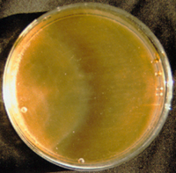
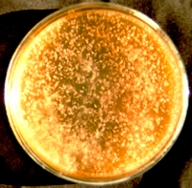
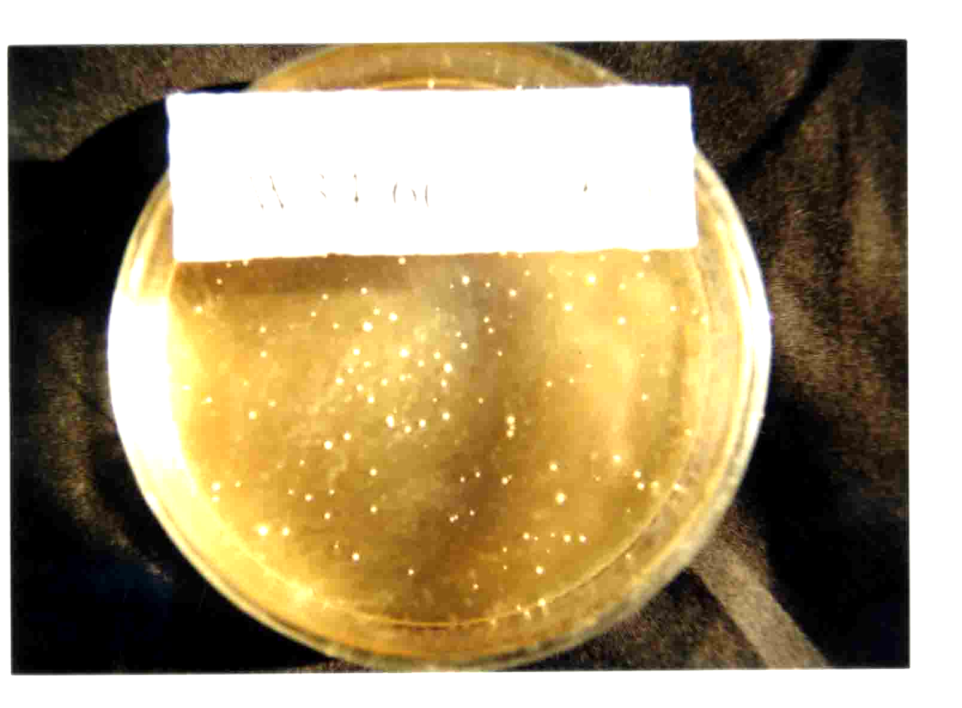

Figure 1 The plates of ADH transformating to W34 beer yeast
(The left is positive control, the middle is negative control and the right is plated with transformant)

Table 2 The activity of ADH under inducing of different concentration of galactose
(Unit／mg protein)
Strain 2% 1.5% 1.0% 0.5%
3.3 1.117 1.098 1.056 1.011
3.9 1.201 1.106 1.085 1.012
3.14 2.371 1.295 1.165 1.041
4.31 2.068 1.206 1.123 1.038
3.23 1.724 1.185 1.118 1.028
3.29 2.030 1.196 1.116 1.035

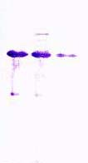

Figure 2 Polyacrylamide gel electrophoresis of expression products (the arrow is wild type which has no activity of ADH)

was determined with different concentration of galactose (Table 2). The results showed that with the increasing of galactose concentration, the ADH activity was also increased, which will reach its maximum at the 2% galactose concentration. So the ADH gene has been transformed into HD34 yeast.

References
[1] Wang Z. Plant allozyme analysis. Beijing: Science Publisher, Beijing, China ,1996.
[2] Drewkw C, Ciriacy M. Overexpression, purification and properties of alcohol dehydrogenase from Saccharomyces cerevisiase. Biochim Biophys Acta, 1988 , 950:54.
[3] Pessione E, Pergola R, Cavaletto C, et al. Purification and characterization of ADH from the budding yeast Kluyveromyces marxianus. Ital J Biochem , 1990 , 39:71.
[4] Racker E. Crystalline alcohol dehydrogenase from Baker’ yeast. J Biol Chem , 1950 , 184:313.
[5] Sanger F, Nicklen S, Coulson AR. DNA sequencing with chain terminating inhibitors. Proc Natl Acad Sci USA ,1977 , 174:5463-
5467.
[6] Sheehan M, Bailey C, Dowda B, et al. A new alcohol dehydrogenase, reactive towards methanol, from Bacillus sterothermophilus. Biochem J , 1988 , 252:661.
[7] Vallee B. Zinc, a component of yeast alcohol dehydrogenase. Proc Natl Acad Sci USA , 1955 , 41:327.

