Evolution of Technological Activities
-- An Information Ecology Perspective of an After-School Program

Shufang Shi ¹, Yong Yi ², Xianjun Wei ³

（1. College of Education, Michigan State University, East Lansing, MI 48823, USA. Email: shishufa@msu.edu
2. School of Foreign Languages, Qufu Normal University, China. Email: yiyong6456@tom.com
3. School of Foreign Languages, Shanghai Jiao Tong University, China. Email: wei2000@sjtu.edu.cn)

Abstract: Taking an information ecology perspective, we have traced the process of evolution of a technology innovation in an after-school program KLICK. KLICK is an acronym for Kids Learning In Computer Klubhouses and is a 21st Century Community Learning Centers grant awarded for groundbreaking ideas and innovative technology applications in an attempt to eliminate the digital divide for lower income urban and rural middle school students. We analyzed the features of KLICK as an information ecology and its subecologies and the interrelationships of the factors and species in the ecologies. In doing so, we found that KLICK is a huge information ecology that includes smaller ecologies. Different species are dependent on and closely related to each other. Taking a mixed method approach, we give both quantitative and qualitative analysis of the process of evolution of activities. We conclude that healthy information ecologies are characterized by technology use in a complex social matrix of forces. Once these forces are identified, innovation diffusion becomes more efficient and effective. [Nature and Science. 2004;2(3):5-18].

Key words: Information ecology, KLICK, technology, computer klubhouses (clubhouses)

1 Introduction
Technological innovation seems to remain elusive to many educators and researchers. From “Teachers and Machines” (1986) to “Oversold and Underused” (2001), Cuban argued how students and teachers have underused the available technologies in school, both in quantity, and in quality. Despite that, an increasing amount of money is being poured into technological innovation in schools each year (Presidents Committee of Advisors on Science and Technology - Panel on Educational Technology, 1997). It seems that a way to resolve this is to understand how technologies become accepted or rejected in schools. Why do some technologies become popular with educators, and others don’t? Who really controls this? This will have implications on how to plan activities, not only for school curriculum, but also for after-school programs.
To understand this, we will look at a setting that is by nature of its program, very receptive of technological innovations, and try to figure out how this happens. Specifically, we look at KLICK (Kids Learning in Computer Klubhouses) from an ecological perspective to shed light on the evolution of the KLICK activities. A technology rich after-school program KLICK is a consortium of twenty middle schools around Michigan (Zhao & Mishra, 2000; Zhao, Tan, & Mishra, 2001; Wong, Girod, Packard & others, 2000). In the process of its evolution, certain activities and ideas originated either from the KLICK Central or from the sites. Efforts are made to get these activities spread. Certain activities get selected by all sites and become popular ones while others got selected by some special groups and still others were rejected. It is essential to understand the process of this evolution so that the resources can be better directed and shaped. In this vein, the present paper will explore the following questions:
1) What are the features of KLICK information ecology?
2) How do activities evolve in this information ecology?
a) Where and how do activities originate?
b) How do they get spread? What are the channels through which they get spread?
c) How do they get selected or rejected? What are the forces?

2 Theoretical Framework

In order to understand how KLICK as technology innovation evolves, we will look at it from the information ecology perspective. Information ecology is a system of people, practices, values, and technologies in a particular local environment (Nardi, 1999). This perspective highlights the human activities that evolve around the technology rather than the technology itself. In this ecological settings, human help other humans use technology. Varies technologies are typically sought out in an information ecology system, but these technologies are carefully integrated into existing habits and practices, according to the values of the information ecology.
The notion of ecology intended to evoke an image of biological ecologies with their complex dynamics and diverse species and opportunistic niches for growth. Like their biological counterparts, information ecologies are diverse, continually evolving, and complex. “The ecological metaphor suggests several key properties of many environments in which technology is used. Information ecology is a complex system of parts and relationships. It exhibits diversity and experiences continual evolution. Different parts of ecology coevolve, changing together according to the relationships in the system. Several keystone species necessary to the survival of the ecology are present. Information ecologies have a sense of locality.”
In other words, information ecology usually demonstrates the following features. First, any change in an information ecology can be felt throughout the whole system because of the strong interrelationships and dependencies in an information ecology. Second, an information ecology is a lively, human, intensely social place, even if it incorporates very advanced technologies. It has many different resources and materials and allows for individual proclivities and interests. Third, the social and technical aspects of an environment coevolve. Different species migrate and change to fill various niches. Fourth, an information ecology is marked by the presence of a keystone species, whose presence is crucial to the survival of the ecology. Fifth, only the participants of an information ecology can establish the identity and place of the technologies that are found there. Users of technology integrate them into the settings of use in a way that makes sense for them.

3 Methods

3.1 Data sources
Site coordinator Interview: Most (16) of the site coordinators from the 20 sites were interviewed one by one by a KLICK staff (the author) within one week during the KLICK Summer Camp 2001 (29/07~03/08, 2001). Each interview is generally planed for half an hour and some turned out to be longer and some shorter. The interview was semi-structured, this is, it was conducted on the basis of a set of planed questions and informal conversations. Notes were taken. Some conversations were taped after getting permission from the interviewee and some are not.
KLICK participants interview ^{[note 2]}: Some KLICK members (students) were interviewed in a very informal way.
Emails from the site coordinator listserv (participants are all the site coordinators of 20 middles schools, referred to as sites or clubhouses, and the KLICK Central staff, referring those in Michigan State who involved in the program) and KLICK Reporters online forum (participants are the author and one or several reporters from each of the sites) are also integrated in some parts of analysis.
To better understand the roles of the KLICK central, we also looked up the documents about the job description of every staff and site coordinators, the memos for some regular meetings, the handbooks and description about the KLICK activities.
3.2 Data analysis and discussion
Taking KLICK as an information ecology and using the above data from various sources, we will start from examining the features of this ecology and its subecologies, and then discuss the evolution of activities— the various forces—some are driving ones and some seemingly trivial ones in terms of the goals/functions of each species and norms, conventions, and values in the ecology.
3.2.1 KLICK as an information ecology, its features
We believe that KLICK is an exemplar of an information ecology, demonstrating all five dimensions mentioned above.
KLICK is a system. This system is marked by strong interrelationships and dependencies among its different parts. It consists of a KLICK central office and twenty remote sites. As the headquarter of the whole KLICK project, KLICK Central is composed of its director/designer, coordinator, graduate students. It is inside another ecology, college of Education and so related to other programs in the college. It is also related to other peer after-school programs in terms of the formation of the project ideas and exchange of ideas and practices with other peers. Each site is located within a separate school district which in turn is part of a local community. These parts of the ecology are different since they all exist for its own purposes, functions and missions, but they are closely bound together by one lore: KLICK. The interrelationship of the different parts implies that it is intensely social, despite the very advanced technologies.
KLICK as a system also means that change in this ecology is systemic. When one element is changed, effects can be felt throughout the whole system. Local changes can disappear without trace if they are incompatible with the rest of the system.

KLICK exhibits diversity
The diversity of the KLICK ecology is marked by its diverse species and diverse resources. As a result of the diversity of species within this ecology, there are different interests and niches, which are fulfilled by the abundant and diverse resources. The 20 sites distributed all over Michigan in rural and inner city communities. The environments are built upon connections between schools and communities, children and adults, urban and rural, physical and virtual, through the appropriate use of technologies. In this environment, KLICK members learn to use technology—from surfing in Internet to web authoring to producing multimedia shows. The rich resources of the KLICK information ecology allow for individual proclivities and interests and provide plentiful opportunities to grow and succeed.
Diversity is necessary for the health of the ecology itself, to permit the system to survive continual and perhaps chaotic change ^{[4]}. So KLICK advocates innovations and ideas from various kinds of species.

Different parts of KLICK ecology coevolve
Offered with many toeholds, species migrate and change to fill the available niches. This lead in turn to further change, as the entire system adjusts to new constrains and possibilities ^{[4]}. For instance, new innovations are constantly introduced to site coordinators and KLICK members. KLICK klubhouse activities handbook listed about 50 activities ^{[3]}, which have been or are going to be introduced to the sites in a planed schedule. The KLICK information ecology evolves as new ideas, tools, activities, and forms of expertise from different parts arise, and the different parts of the ecology coevolve as a result.
Keystone species in KLICK information ecology
KLICK members are identified as the keystone species in the KLICK ecology ^{[note 1]}. KLICK members exist there as technology users, but their presence in this ecology is crucial to the survival of the entire ecology. Without them there will be no medium through which innovations get adapted. Some of the other species will lose their meaning of existence, that is, the niches for their existence will no longer exist.
Keystone species are not readily recognized, since they do not wear any sign to tell that their existence is important. It takes time and carefulness to get to know which the keystone species are in a specific ecology. When we add new technologies to our own information ecologies, as Nardi & O’Day said, we sometimes try to work in the absence of essential keystone species since they are often at the lowest level of the ecological system and possess the least political power. For instance, in KLICK information ecology, KLICK members as students who have the least political power in schools but are the actual users of a concerned innovation and only when they recognize the value of an innovation and that an innovation makes sense for them would they be willing to try it. If they don’t try, an innovation could not evolve.
The KLICK information ecologies have a sense of locality
One can easily tell that a site is a unique entity from its unique characteristics different from other sites--different location, different practices either stylized by its local community, or by its site coordinator or by its members, just as one can easily tell that each site is a integrative part of the larger KLICK ecology from its commonality—same software and hardware, the same philosophy, though not that visible, under the same KLICK Logo, and more.
3.2.2 Analysis of the KLICK information ecology
To make a clearer picture of the factors and their interactivities, we look at the issue from different levels: the higher level of ecology and lower level of subecologies. Taking KLICK as a complex information ecology, we recognize at least two subecologies: KLICK Central sub-ecology and 20 school district subecologies where klubhouses are embedded.
3.2.2.1 Species that consists of the KLICK central subecology
There are various species in this subecology: Designer/director of the project, project coordinator, graduate students, administrative staff, and service staff. KLICK Central is embedded in the College of Education, which in turn is a part of the university. KLICK Central is also related to other peer after school programs and the government who provides the grant.
3.2.2.2 Species that consists of the school district subecology
There are various species in the school district subecologies. There are some “official” species defined by the KLICK handbooks and each of which has its own goals and objectives defined by the project and possibly interpreted by individual species themselves. The official species are those like Site Coordinators, Advisory Board, Adult Volunteers, Mentors and Core Members (p.18). In this ecology, other species exist that are not officially a part of KLICK, including school teachers, principles, superintendents, individuals from the communities. Each species has its own goals and interests.
Activities originate from these subecologies and get spread and selected. We will discuss about this later in part 3.
3.2.2.3 The interrelationship of the KLICK Central and the Sites
The two subecologies are interrelated within the larger KLICK information ecology by the same goals, objectives or functions: to provide members an after school learning environment that is engaging, supportive, and safe.
KLICK central and the sites affect and are affected by each other. Even though there is overlapping in the goals or functions of different species in these two subecologies, there are conflicts as well.
3.2.2.4 Interrelationship among Sites
Each site is closely connected with other sites. They share information of what softwares are good or bad, how to use certain software, how other host schools manage the budget and so on. The active and exciting scene of coordinators and kids from different sites chatting and socializing during workshop time and summer camp are indications of their close relations. Some coordinators were seen carry notebooks all the time and frequently note down what other site coordinators said about some innovations.
In summary, different species has both common and diverse goals. For the co-existence of all the species in the ecology there would often be negotiation among species. The negotiation among these species involves the exercise of power, which might be institutional, political or academic and/or social or socio-cultural.
3.2.3 Evolution of activities
3.2.3.1 Define activities
An activity refers to the application of an innovation. More specifically, it is the application of a technology in a klubhouse, carrying out by KLICK members. It originates, develops, and evolves in the KLICK information ecology which provides suitable or unsuitable conditions for its evolution.
3.2.3.2 Origin of an activity
There are mainly two origins of activities: those initiated by the KLICK Central, and those initiated by a Site. The following Figure (Figure 1) depicts factors that affect the initiation of activities from the KLICK Central.
KLICK Central plays an important role in introducing new activities to KLICK sites. The developing process of activities in KLICK Central is affected by a number of factors as shown on the above Figure. It could be affected by the policy designers, this is, the project director and the project coordinator whose innovative ideas might be affected by their beliefs, knowledge and so on. It could also be affected by the sophistication of research related to the KLICK Project. KLICK Central also overlaps with another ecology, the college of education in a large university, where research and cutting edge technology plays a significant role. KLICK Central is also motivated and sustained by the 20th Century grant; consequently the innovations are affected by the current technology, budget, and resources. Any changes in these factors would affect the selection and survival of activities introduced and sustained by KLICK Central.
Activities can also be initiated by a klubhouse, its site coordinator or its core members or the two together. The initiation could also be affected by many factors as shown in the following Figure (Figure 2):

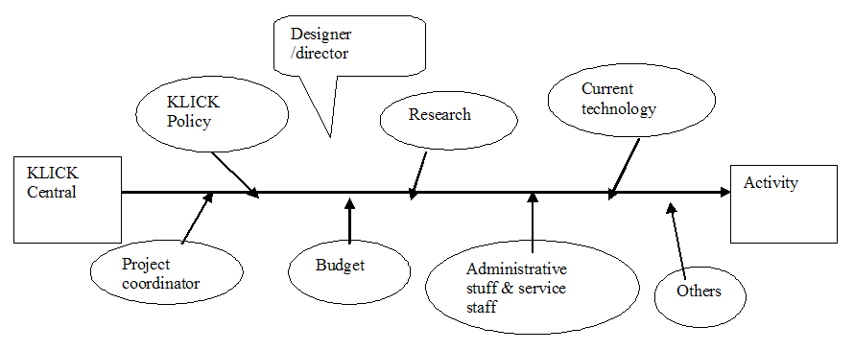

Figure 1. Origin of activities from KLICK Central

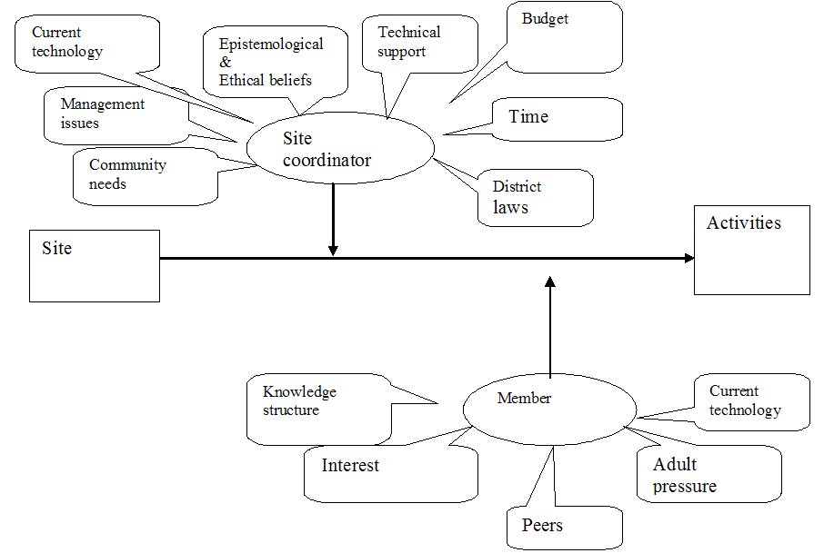

Figure 2. Origin of activities from sites

Site Coordinators bring some good ideas to KLICK. For example, the robotics curriculum, a very popular activity in KLICK, was introduced to KLICK by one of the site coordinators. Their source of ideas is influenced by factors like their epistemological and ethical beliefs, current technology, budget, management issues, technology support and time. Since site coordinators are also situated in another ecology-the school district subecology-their actions are also influenced by factors within this ecology, like community needs, district laws and other factors.
KLICK members are another source who initiates ideas in KLICK. The activities they initiate are influenced by factors like their knowledge structure, current technology, adult pressure, interest, and peers.
3.2.3.3 Spread/diffusion of an activity
The two kinds of activities initiated by KLICK central and by a klubhouse are spread through different channels. Those activities innovated by the KLICK central could be spread as Figure 3 depicts:

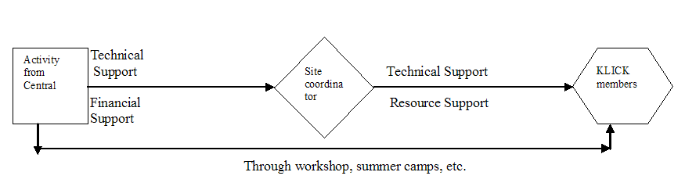

Figure 3. Spread of activities initiated by KLICK Central

KLICK Central can spread ideas directly to KLICK members, through workshop or program like Summer Camp. But more often, it first spreads idea(s) of an activity to site coordinators in the form of workshops and correspondence like emails. Site coordinators process, digest, adapt, filter, and interpret the ideas of an activity and then spread them to its KLICK members through technical support and the support of resources.
The selection of activities is also a negotiation between site coordinators and KLICK members. On the one hand, the activity that is introduced by the site coordinator (the “door keeper”) who filters what is introduced by KLICK Central will not last long if the kids do not like it. On the other hand, an activity will be discarded if a site coordinator thinks it is not good for students, no matter how much the kids love it. Playing games is one of the most popular activities among KLICK members, especially boys. However, it is a controversial activity. Some site coordinators limited the time that kids spend on playing games, and banned certain games as well. Figure 4 depicts the spread of an activity initiated by a klubhouse.

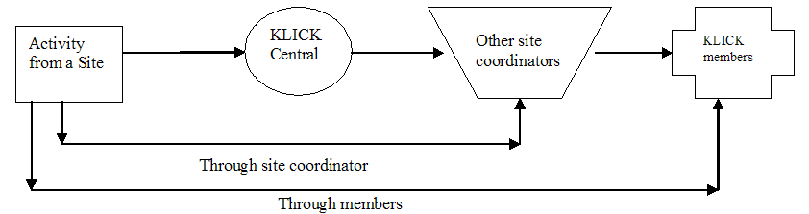

Figure 4. Spread of an activity initiated by a klubhouse

An activity initiated by a klubhouse could get spread through word of mouth, through emails by the site coordinator or by reporters, or through the newsletter of KLICK - Password Express, or through face to face meetings.
Very often, an innovation is caught by KLICK Central through any of the above mentioned channels and is traced and then featured in the newsletter and spread to site coordinators and KLICK members.
Whether this activity has been or will be caught on is not known yet. Whether it could spread or not depends on many factors. But this kind of ideas/activities will surely contribute to the pool of innovations in KLICK and it might give inspiration to other innovations in other sites some day.
There are also chances that some members initiate an activity and they spread to other members through email or other channels, without going through either the Central or through site coordinators. An example is that one member found that Morpheme is a good software to be downloaded to listen to pop music for middle school adolescents and she introduced it to her friends in other sites. It turned out that they listen to the similar list of songs and share the same “favorites”!
3.2.3.4 Survival or rejection of activities
An activity--either initiated by KLICK central or by a klubhouse gets its preliminary selection by KLICK members. They play around or try these innovations, give feedback either explicitly or implicitly, through words of mouth or other channels like email or lunch chats, which gives indication that an activity or the procedures of an activity need improvement. After getting feedback either incidentally or by formal survey, an activity is improved or changed by the Central and is put back to the klubhouse. After several rounds of back and forth, the activities get spiral improvement. Some activities might prosper and become popular ones, for instance, robotics, due to factors such as the cheap cost and many robotics training workshops and contests held by KLICK Central. Some activities get selected by some special groups since they are more suitable to the proclivities or interest of those groups, for instance, movie editing. Still others get rejected and die with or without any trace. Figure 5 depicts the process (practices or assumptions) how an activity survives or gets rejected.

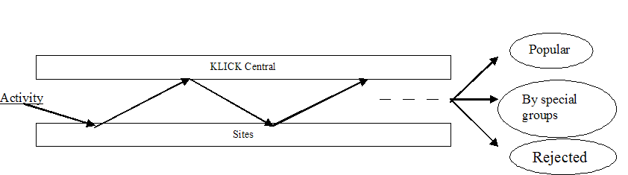

Figure 5. Survival or dying of an activity

In short, although KLICK Central does a lot to introduce many new ideas, the ultimate adoption and development of these ideas in the KLICK sites is far beyond KLICK Central’s control. The adaptation and development of the activities is a process of negotiation between the KLICK members and site coordinators, and therefore, it is also influenced by many other factors which affect the KLICK site ecology, such as the technical support, available resource, the school district laws, etc. This is consistent with the information ecology perspective, where innovation, interpretation and integration of an innovation happen at the local level. Therefore, the species and factors with most power and control over the adoption of innovations are at the lowest level of ecologies, which we have chosen to term “sub-ecologies”. KLICK members are ultimately the species that determine whether the activities survive or die.
In summary, activities are intended to be finally adapted by KLICK members, who are the medium of the survival and development of activities. The characteristics of the members themselves and the outside factors could both affect the interpretation, integration of an innovation. Only when the innovation makes sense to them could they try it and make it local according to local norms, conventions and values.
After the analysis of the evolution of activities, we can now turn to the actual activities that are going on in KLICK.
3.2.4 What kinds of activities are going on in KLICK

The activities in KLICK

Our survey (N=90) (note: 90 out of 600 samples from three schools are used in the analysis since the whole data hasn’t been input) revealed that participants were more interested in playing games (32.2%), followed by surfing on the internet (25.6%), and playing with computers (23.3%). These and other favorite activities are ranked and listed in Table 1.

Table 1. Favorite activities as reported
by participants
Activity | Percentage
Playing games | 32.2
Surfing on the Internet | 25.6
Playing with computers | 23.3
Playing with camera/pictures | 8.9
Robotics | 4.4
Working on projects | 3.3
Doing homework | 2.2
Hanging out with friends | 2.2

In addition to the activities in this table, some other activities were also mentioned as the favorite ones: email, designing web page, watching video, making movie, summer camp, chatting, etc. Table 2 shows the activities that participants spend about or more than one hour every week. The percentage column shows the percentage of participants that are engaged in the activities for that period of time a week.
Combining tables 1 and 2, we can conclude that playing games, doing homework, searching information on the web, working on projects, playing with computers, building robotics are the most popular activities in this KLICK site. The result reflects another feature of the information ecology: diversity.
Table 2. Activities that participants spend about or more than one hour every week
Activity | %
Play games | 74.4
Do homework | 61.2
Search for information on the web | 56.8
Work on projects | 46.4
Word processing | 41.9
Email | 41.5
Typing | 41.2
Chat | 35
Video editing | 28.9
Robotics | 27.5
Image editing | 26.2
Help out in my community | 26.2
3-D animation | 25.6
Web authoring | 24.1
Programming | 23.5
3-D modeling | 23.1
Flash | 21
Using a database or Spreadsheet | 20.7
PowerPoint | 16.3

Almost every kind of activity attracts some kids, though some attracts more, some less. Different kids like different activities, and every one could find his or her own proclivities in this ecology.
Next the activities in Table 2 are further characterized into the degree to which they were complex in skill, student initiated, recreational, productive, and interactive. This was done by two independent staff, who were told what the characterizations meant.
We performed a correlation statistic analysis on the data (Table 3). It seems that the percentage is significantly positively related to “student initiated”, but significantly negatively related with “productive”

and “skill complexity”. “Student initiated” is significantly positively related to “recreational” and “percentage”, but significantly negatively related to “productive”. “Productive” is significantly positively related to “skill complexity”, but significantly negatively related to “percentage” and “student initiated”. The more productive an activity is, the more skill complex it is, the less possible that it is initiated by students and the less time students spend on it. Students spend much time on the activities that are initiated by themselves. These activities are not very skill complex, usually recreational rather than productive. In short, the activities that get selected in KLICK were those that were student-initiated, less complex, and recreational.

Table 3. Correlation between different activities, the amount of time spent on the activities,
and the characteristics of the activities.
 |  | Percentage | Skill Complexity | Student Initiated | Recreational | Productive | Interactive
Percentage | Pearson Correlation | 1 | -.476 | .488 | .014 | -.580 | -.192
 | Sig. (2-tailed) | . | .039 | .034 | .955 | .009 | .430
 | N | 19 | 19 | 19 | 19 | 19 | 19
Skill Complexity | Pearson Correlation | -.476 | 1 | -.250 | .306 | .697 | .129
 | Sig. (2-tailed) | .039 | . | .301 | .202 | .001 | .600
 | N | 19 | 19 | 19 | 19 | 19 | 19
Student Initiated | Pearson Correlation | .488 | -.250 | 1 | .643 | -.540 | .284
 | Sig. (2-tailed) | .034 | .301 | . | .003 | .017 | .238
 | N | 19 | 19 | 19 | 19 | 19 | 19
Recreational | Pearson Correlation | .014 | .306 | .643 | 1 | -.119 | .417
 | Sig. (2-tailed) | .955 | .202 | .003 | . | .628 | .076
 | N | 19 | 19 | 19 | 19 | 19 | 19
Productive | Pearson Correlation | -.580 | .697 | -.540 | -.119 | 1 | .058
 | Sig. (2-tailed) | .009 | .001 | .017 | .628 | . | .814
 | N | 19 | 19 | 19 | 19 | 19 | 19
Interactive | Pearson Correlation | -.192 | .129 | .284 | .417 | .058 | 1
 | Sig. (2-tailed) | .430 | .600 | .238 | .076 | .814 | .
 | N | 19 | 19 | 19 | 19 | 19 | 19
* Correlation is significant at the 0.05 level (2-tailed).
** Correlation is significant at the 0.01 level (2-tailed).

3.2.5 Focusing on factors that affect the members’ selection of an activity
If what we have argued above is more of macro level, in this part we will focus on factors that influence the selection of an activity form the micro level: from the keystone species--KLICK members themselves. The purpose of this part is to track the factors that decide the selection or rejection of an activity or activities by KLICK members so as to get more information of the trends of the evolution of an activity or activities.
3.2.5.1 Publicity/popularity of KLICK Project in certain sites
Our survey shows that there is significant difference in the publicity/popularity of the KLICK project in two concerned schools. In school Lare, only 3% (N=30) non-KLICK participants don’t know about KLICK, while in school Lippert there are 30% (N=30) non-KLICK participants who don’t know about KLICK.
As is mentioned earlier “healthy information ecologies are sustained by the active, intelligent participation of the people who involve in them.” It is important to inquire the reasons that the KLICK project is not known in a school since activities must be known before they could possibly be accepted. The cause of this situation could be any as discussed in Part 3. For instance, it might be possible that the site coordinator is not ready to communicate and negotiate with other people in the school. Or it might be possible that the school district, or the administrative staff like the principle or others in the host school are not very positive about technology application.
The implications of this difference should be very important to the KLICK administration. It is necessary that KLICK Central makes survey and gets to know the causes and take measures according to the actual situations. The Central could help and encourage the site coordinator or the school site by providing support or by smoothing the channel from the school through which KLICK get publicized.
3.2.5.2 Short and frequent visits to klubhouses
The survey shows the time that KLICK members (N=60) spent in klubhouse on a weekly basis and the frequency of their visits to a klubhouse. Most members (57% +31%=88%) spend 1-6 hours in a klubhouse, only a small number of members spend more than 6 hours (5% + 7%), however, most members (76%) visit klubhouse more than 3 times a week, compared to 19% visit twice and 5 % visit once. This is shown in the following pie Figures Figure 6 and Figure 7.

Figure 6. Percentage of members going to the klubhouses and time spent there

Figure 7. Percentage of members and frequency of going to klubhouses

This indicates something interesting: members only stay in a klubhouse for a short period of time each time they go there, from as short as 20 minutes to as long as 2 hours. However, their visits are frequent.
The implications of this finding are that students prefer less time-consuming activities. This reflects the same results shown by the correlation table in Part 4 from the other part of samples in the same survey. It

seems that it is not that they are unable to stay there long (longer than 9 hours a week) but rather that they do not like to stay long, since their visits are highly frequent out of their own willingness – voluntary participation is one of the philosophies of the project. This should give some information to the designers/initiators of activities. Less time-consuming activities are more likely to be accepted, since it is not very meaningful for a member to go to a klubhouse just starting an activity without playing around much or finishing it. This result reflects the analysis in Part 3 why Claymation is not caught on since students “don’t want to sit there too long.” The result is also consistent with the findings in part 3 that activities get spread are those that are less complex, and hence usually less time-consuming.

3.2.5.3 Why go to klubhouses?
Our data (N=60) shows the same trend in the two schools in regard to the reasons to go to a klubhouse. The results (as shown in Figure 8) demonstrate that the majority of the KLICK members go there because they want to, as opposed to being forced to. The motivation to go to a klubhouse is they like it there (83% & 87%, from Lare and Lippert, respectively), or their friends are there or they go there to make new friends (60% & 63%). Some go there because KLICK meet their special needs: to do stuff they don’t get to do in school or they like to play with computers but they don’t have one at home (47% & 60%). Only a small part of kids go there out of parents’ requirement (13% & 17%) or teachers’ requirement (3% & 17%). Site coordinator is also a significant factor (33% & 37%)!

Figure 8. Why go to KLICK

3.2.6 Other factors related to the KLICK members that affect the choice of activities
If in the above part we make analysis of the evolution of KLICK activities from a macro level, that is, from the factors influencing the ecology and subecology into which the KLICK members are included, in this part we’ll make analysis of the selection of activities from a micro level, that is, from the attributes/factors/characteristics of the KLICK members themselves. These factors include gender, ethnicity, grade level, GPA, and how long has a member been in KLICK, and so on. In this part, we will try to find the relationship between each of the attributes/factors/characteristics of the KLICK members and the selection of each of the 19 kinds of activities (in the survey, we classify KLICK klubhouse activities into 19 categories), in order to find the pattern/tendency/probability of a certain student to choose a certain activity.
Using Logistic Regression, we play with the many variables/factors that might affect the selection of activities according to literature and to our own assumptions. We find that the variables (Gender, Ethnicity [Caucasian and non Caucasian], GPA, Grade Level [from 5th to 9th Grade] and the Duration of Being in the KLICK Project [from 1 month to more that a year]) are significantly related to a KLICK member’s selection of a particular activity. The results are as follows:
3.2.6.1 Email

Log Odds of email = -4.86 – 1.54 Gender + 0.93 Grade level

From the analysis, we can see that Gender and Grade Level are significantly (α=0.05) related to the probability of the selection of using email when a member stays in a klubhouse. Female members are more likely to do email when they go to a klubhouse compared to male members, holding grade level constant. Members of a higher grade are more likely to choose to do email compared to members of a lower grade, holding gender constant. We can compute the probability of a certain student to choose the email activity when she goes to a klubhouse. For example, for a female KLICK member (gender = 0) whose grade level is 8:

Log odds of email = -4.86 – 1.54 x 0 + 0.93 x 8 = 2.58
Odds of email = e2.58 = 13.19
Probability of email = odds / (1 + odds) = 13.19 / (1+ 13.19) = .93 = 93%

The probability for any 8th grade female KLICK member to choose email activity when she goes to a klub-
house is 93%. In the same token, we can get the probability of any 8th grade male KLICK member to choose the email activity: 74%, and any 5th grade male: 15%.
This might not be very surprising for middle school adolescents, since girls are considered more likely to choose to use correspondence to express their more delicate/emotional feelings. Higher grade members might have friends from a physically wider range so that they need more email exchanges compared to members of lower grade levels.
3.2.6.2 Image Editing
Log Odds of image editing
= -5.79 + 0.79 Grade level
From the analysis, we can see that Grade level is significantly (α=0.05) related to the probability of the choice of Image Editing. The higher a member’s grade level is, the more likely that s/he would choose Image Editing.
3.2.6.3 Web Authoring
Log Odds of web authoring
= 4.65 – 1.35 GPA – 1.34 Ethnicity

From the analysis, we can see that GPA and Ethnicity are significantly (α=0.05) related to the probability of the choice of Web Authoring activity. The lower a student’s GPA is, the more likely s/he will choose the activity of Web Authoring, holding Ethnicity constant. KLICK members of non-Caucasians are more likely to select Web Authoring compared to Caucasians, holding GPA constant.

Log Odds of Database or Spreadsheets = 0.25 – 0.12 Howlong

3.2.6.4 Using Database or Spread Sheet
From the analysis, we can see that the duration of being in the KLICK Project is significantly (α=0.05) related to the probability of the choice of using Database or Spreadsheets in a klubhouse. The longer a member has been in KLICK Project, the less likely that s/he would choose to use database or spreadsheet. New KLICK members are more likely to choose to use database or spreadsheets. We assume that new KLICK members choose this activity is not necessarily because they like it or they have more data to analyze, but simply because the activities in the klubhouse are new to them and curiosity leads them to try this or that in a more random manner. After staying longer in KLICK, they get familiar with more kinds of activities and play less with database or spread sheets.

3.2.7 Norms, conventions, values, and more
Nardi (1999, p65) mentioned a Zen saying that when we consider an object, it is what we see that makes the object beautiful and what we don't see that makes it useful. A bowl has a visible shape, color, and texture to admire, but it also sculpts out an empty space that gives the bowl its utility-this is the space where you can actually put something into the bowl. Here is part of the beautiful philosophical poem:

Thirty spokes will converge
In the hub of the wheel;
But the use of the cart
Will depend on the part
Of the hub that is void.

With a wall all around
A clay bowl is molded;
But the use of the bowl

Will depend on the part
Of the bowl that is void
…
The beautiful philosophy of the poem applies to the analysis of our information ecologies too. The part we often focus our attention on is the technology: computers, networking, applications, handheld information gadgets, instruments, monitors, widgets and infinitum. We look at the shape, color, texture, and functions of the technologies, and we think creatively about how to make them more usable, appealing, and effective. But it is in the spaces between these things that are critical and often invisible things happen. We need to be mindful of those spaces. Healthy information ecologies are characterized by technology use in a social matrix consisting of services, norms, and conventions. These establish appropriate usage, core values, support, and a growth path for users that helps them become more competent with technology over time if they so choose. These social practices are an important element of diversity in an information ecology, providing not just the actual technologies themselves, but ways to use them.
In the case of KLICK information ecology, we think hard about the technologies and work hard on the applications of those technologies. But we also need to put our heart on those invisible things—if they can be called “things” such as the norms, conventions, and values. We should value those kinds of “things” the way we value more purely technical creativity. Summer Camp, KLICK Almanac, KLICK Pumpkin Contest, holiday season greetings from both the Central and the sites, birthday announcements from the Central, email list and message exchanges among site coordinators, KLICK central stuff and KLICK members… are all the part of that is void but the useful and the critical. The harmony of Human and technology in this ecology is the tie under the lore of KLICK and is more than that.

4 Conclusion

Based on the information ecology perspective, we have traced the process of evolution of innovation in an after-school program. We analyze the features of KLICK as an information ecology and its subecologies and the interrelationships of the factors and species in the ecologies. In doing so, we found that KLICK is a huge information ecology that includes smaller ecologies, i.e. the local sites. Different species are dependent on and closely related to each other with KLICK members as keystone species. We then give an analysis of the process of evolution of activities.
Healthy information ecologies are characterized by technology use in a complex social matrix of forces. Once these forces are identified, innovation diffusion becomes more efficient and effective.

Notes
Note 1: This is somewhat different from Nardi & O’Day’s (informal) definition of keystone species. They mentioned keystone species as “…skilled people whose presence is necessary to SUPPORT (emphasis added) the effective use of technology.” (Nardi & O’Day, 1999, p54). Nardi’ & O’Day’s definition of keystone species comes from the library ecology in which librarians exist as a crucial species that support the effective running of a library. LICK is a different ecology and it is legitimate to define its keystone species according to its unique system.
Note 2: The interviews were part of the summer camp activities (2001). They were existential data to this paper.

Acknowledgement
The survey data in this paper were collected by the research team of the Kids Learning in Computer Klub house (KLICK) project. Our thanks go to the KLICK project director Dr. Yong Zhao, Coordinator Blaine V. Morrow, and other researchers Sophia Tan and Jing Lei. My thanks also go to Deping Li and Xueyan Guo for their invaluable insights for this research project.

Correspondence to:
Shufang Shi
813B Cherry Lane
Michigan State University
East Lansing, Michigan 48823, USA
Telephone: (517) 355-8169
Email: shishufa@msu.edu

References
[1] Cuban L. Oversold & Underused, Computers in the Classroom. Harvard University Press, Cambridge, Mass, USA. 2002.
[2] Cuban L. Teachers and Machines: The Classroom Use of Technology Since 1920. Teachers College Press. New York, NY, USA. 1986.
[3] Distributed Education and Indiana University: Strategic Pathways and Windows of Opportunity. Final Report of the President's Advisory Committee on Distance Education. (Blaise Cronin, chair) November 1997.
[4] KLICK Activities Handbook. KLICK National Headquarters, East Lansing, Michigan, USA. 2000.
[5] Morrow BV, Shi S (Eds). KLICK Almanac-Daily Curriculum Ideas with a technology Focus. Libraries Unlimited Inc. CT: Westport (in press).
[6] Nardi BA, O’Day V. Information Ecologies: Using Technologies with Heart. 1999.
[7] KLICK Site Coordinator’s Handbook. KLICK National Headquarters, East Lansing, Michigan, USA. 2000.
[8] Wong D, Packard B, Girod M, et al. The Opposite of Control: A Deweyan Perspective on Intrinsic Motivation in "After 3" Technology Programs. Computers in Human Behavior 2000;16(3):313-38.
[9] Zhao Y. Information Technology as Language: New Perspectives on IT Education. In Dong YQ (Ed). Selected Papers of the International Conference on IT Education. Northeast China Normal University, Changchun, China. 2001.
[10] Zhao Y, Tan SH, Mishra P. Teaching and learning: whose computer is it? Journal of Adolescent & Adult Literacy 2001;44(4):348-54.

