Studies on the Texture and Tissue of Carrot Processed
by High Pressure
Shulai Xu
(Food Engineering College, Harbin Commerce University, Harbin, Heilongjiang 150076, China)

Abstract: Processing vegetables by high pressure is an advanced technology. In this study, ten carrot samples have been processed under high pressure, and were treated at the diverse pressure for different time respectively. Furthermore, the slices of the carrot before and after high pressure processing (HPP) have been made and observed by microscope. The results showed that in general the texture and tissue of carrot could not be damaged by high pressure, but visible changes just at ultra high pressure (more than 600 MPa) for 5 min or at 400 MPa for longer time (more than 20 min). The conclusion is that processing carrot at 400 MPa for 20 min or 500 MPa for 5 min is the practicable technology. [Nature and Science 2004;2(3):62-65].

Key words: texture; tissue; carrot; high pressure

1 Introduction

High pressure processing (HPP) is an advanced food processing technology. Compared to other methods, HPP offers several advantages: reducing process time; minimal heat penetration/heat damage problems; freshness; well retaining flavor and no vitamin loss. Compared with traditional thermal processing, the functionality alterations of HPP are minimal (Tewari et al. 1999). Therefore, more and more people pay attention to this technology. At present, some products have appeared, such as syrup, confiture, etc. (FDA, 2000).
Recent years in China, the overseas and domestic scholars began to research on processing and preservation fresh vegetables by HPP, and have made a lot progresses (Xu et al., 2003). In 2000, the American Department of Defense once sponsored $2.3 million, three-year effort to develop the use of ultrahigh-pressure technology to produce high-quality and shelf-stable food products, such as soups, potatoes, and cheese products - for both military and civil markets (FUP news, 2000). Vegetables after processed by high pressure, pathogenic microorganisms have been inactivated and their nutritional and sensory characteristics were almost completely retained. Furthermore, their breath was weakened and the fresh vegetables after HPP can be preserved for longer time (Xu, 2003).
On the other hand, HPP can sometimes affect the vegetables’ qualities, because the tissues of vegetables are so tender that they can be easily damaged (Prestamo et al., 1998). Therefore, to get the practicable technology, it is necessary to observe the tissue and cells of vegetables after HPP in order to know their changes under high pressure. In this study, carrot, as an example of root vegetables (stem vegetables and fruit vegetables will be introduced in other studies), was treated at diverse pressure for different time. The slices of carrot before and after HPP were made and observed by microscope. The study is important for us to well know the mechanism of HPP and to get the rational parameters of preserving vegetables by HPP.

2 Materials and Methods

2.1 Materials
The carrot was purchased in local supermarket and was absorbed in prime condition with dimethylbenzene, distilled water, hematoxylin, ethanol, acetic acid glacial.
2.2 Instruments and Equipments
High Pressure Equipment (DL700 - 0.55×1.5, Da Long Ultra High Pressure Equipment Factory, Shanghai, China) had a vessel capacity 350 ml, maximum pressure of 700 MPa. Pressure was increased within 2 min.

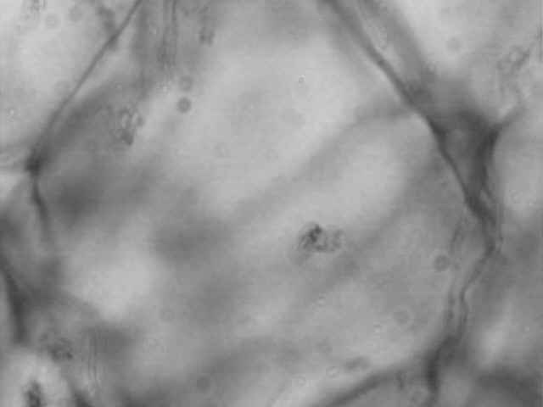
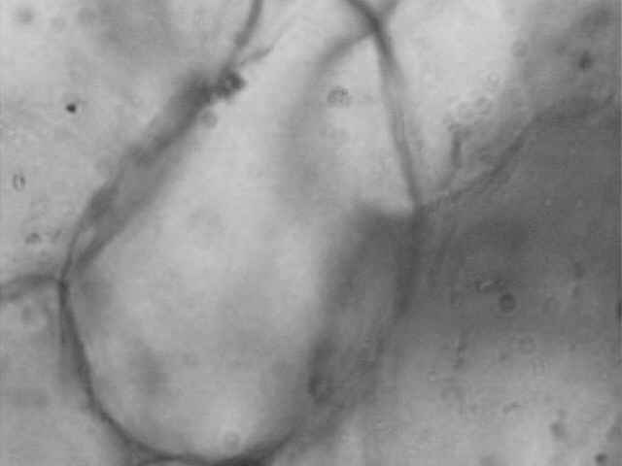

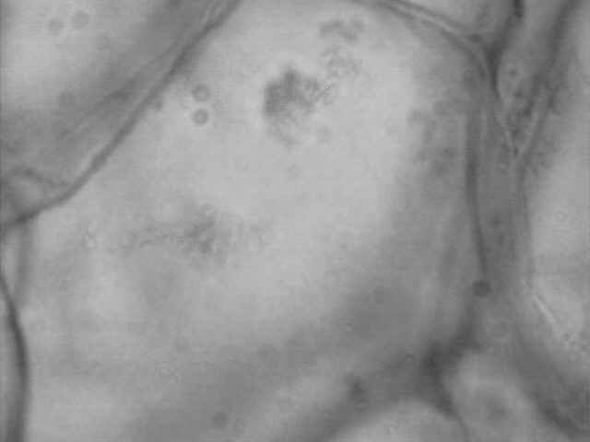
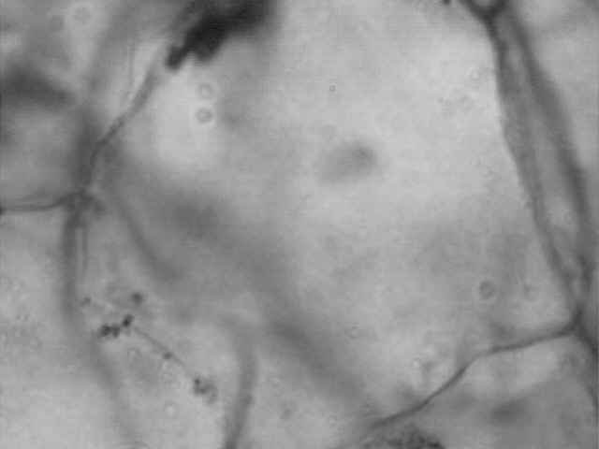
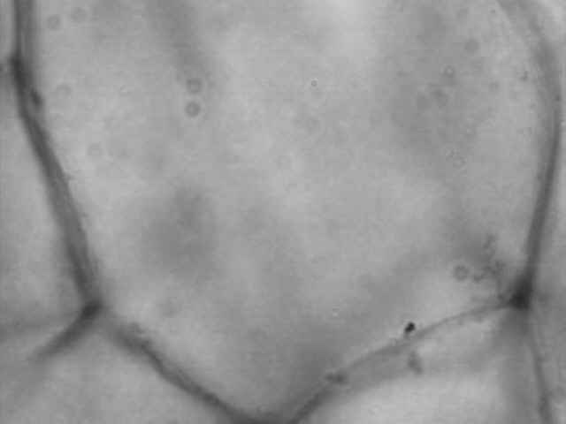
A. contrast
F. 600 MPa
D. 400 MPa
E. 500 MPa
C. 300 MPa
B. 200 MPa
Figure 1. The cells and tissue of carrot processed at diverse pressure for 5 min

3 Observations and Analysis

3.1 The observation and analysis of tomatoes’ tissue processed at diverse pressure
In general, the cells of vegetables are round. Because of their extrusion and collision, their shape is usually polyhedron, which is composed of eight hexagons and six squares. The cells of carrot untreated by high pressure were typical polyhedron (Figure 1A), their edges and corners were clear, and the single cell was full.
The cellular pictures of carrot treated at 200, 300 MPa for 5 min were shown in Figure 1B and C, their shapes corresponded to the swollen glossy appearance of the cell surfaces in raw materials. The shape and cubage had no obvious changes, which indicated that low pressure for short time could not damage carrot’s tissue.
When the samples were processed at 400 and 500 MPa for 5 min, the cells were still intact and keeping original shape (Figure 1D and E), but their cubage had reduced a little. This demonstrated that pressure (400~500 MPa) couldn’t obviously influence on the cellular structure.
While the pressure up to 600 MPa, we observed that the cellular structure changed and some migration of soluble components occurred (Figure 1F), the cell damage was clearly shown, the collapsed cells appeared and their glossy appearance had disappeared. So the pressure (600 MPa) destroyed carrot’s cell and tissue.
3.2 The observation and analysis of carrot’s tissue processed for different time
To some extent, according to the theory of high pressure processing, the high pressure for short time has the same effect on the food materials as the low pressure for long time (Zhang et al. 2000). In order to know the processing time how to affect vegetables’ texture and tissue, we processed the samples at the pressure of 400 MPa for 5 min, 10 min, 15 min, 20 min and 25 min respectively. The pictures of their cells and tissue were shown in Figure 2.
When the processing time was 5 min （Figure 2B），the cells’ structure had no obvious changes, the appearance of cells was turgor and glossy, and the shape of cells was clear. These showed that tomatoes could keep well after high pressure treatment at these parameters.
While the processing time prolonged, the cubage of carrot cells got smaller and smaller (Figure 2C, D, E and F). This indicated that the intercellular clearance and the inner space of cells became smaller. In fact, there are lots of liquids (75%~90%) and gas which are full of the intercellular and inner space of vegetable cells, and the liquids contain water as well as other constituents such as salts, vitamins, enzymes and substrates. Under high pressure for longer time, the liquids will flow and effuse from cell wall, and the gas will be compressed. Therefore, the cells got smaller.
However, except the sample processed at pressure of 400 MPa for 25 min whose cell wall had a little collapsed and shape was not completely clear, the other cells’ shape was still intact and their appearance was glossy too. Therefore, we concluded that the texture and tissue of the carrot treated at 400 MPa for less than 20 min had no obvious changes.
Comparing pressure with time, we discovered that pressure was the main factor to damage carrot structure and tissue, because ultra high pressure could make the cells wall collapsed to destroy carrot cells, and low pressure for long time could just decrease the cells cubage, which would be restored when the pressure released. So, in order to protect vegetable from damaging, low pressure for long time is the better technology parameter.
However, if the pressure was too low, the pathogenic microorganisms and enzymes would not been inactivated and the vegetable’s breath could not been weakened. Thus, the fresh vegetables after HPP couldn’t be preserved for longer time (Xu, 2003). On the other hand, it was inefficient to process vegetables at lower pressure for a long time.
Taking pressure and time full account, we concluded that processing carrot at 400 MPa for 20 min or 500 MPa for 5 min was the practicable technology.

4 Conclusions

The texture and tissue of carrot in general cannot be damaged by high pressure, visible changes just at ultra high pressure (more than 600 MPa) for 5 min or at 400 MPa for longer time (more than 20 min). Taking pressure and time full account, we conclude that processing carrot at 400 MPa for 20 min or 500 MPa for 5 min is the practicable technology.

Correspondence to:
Food Engineering College of Harbin Commerce University
138 Tongda Street
Daoli, Harbin, Heilongjiang 150076, China
Tel/Fax: 01186-451-8483-8194
E-mail: shulai_xu@sina.com

References
[1] FDA. Kinetics of Microbial Inactivation for Alternative Food Processing Technologies High Pressure Processing 2000:2~10.
[2] Fresher. Under Pressure News. Joint Development Project With Kraft, Procter & Gamble, Conagra, and Others, 7-14-2000. Http://fresherunderpressure.com.
[3] Li J. Experiment of Modern Biology. Higher Education Publishing Company. Beijing, 2000:87~100.
[4] Prestamo G, Arroyo G. High hydrostatic pressure effects on vegetable structure. Journal of Food Science 1998;63(5):878~81.
[5] Tewari G, Jayas DS, Holley RA. Fresher Under Pressure Scientific Research High Pressure Processing of Foods: An Overview. SCIENCE DES ALIMENTS 1999;19:1~5.
[6] Xu S, Zhang S, Xi J, et al. Research Status and Development Strategy on Preservation of Cut-vegetable on High Pressure. Transactions of CSAM 2003;2(34):132~5.
[7] Xu S. Studies on the Fresh Preservation of Vegetables by High Pressure Processing. Ph.D Dissertation of Jilin University. Changchun, Jilin, China. 2003:56~62.
[8] Zhang S, Ma C, Zuo C. High Pressure Processing Technology for Food. Jilin Science Technology Press House 2000:69~97.

