Acetolactate Decarboxylase from Bacillus subtilis:
Cloning and Transformating in HD34 Yeast

Wenxiang Ping, Jingping Ge, Zhuangwei Lou, Gang Song
(College of Life Sciences, Heilongjiang University, Harbin, Heilongjiang 150080, China)
Abstract: Acetolactate decarboxylase (ALDC) gene was isolated from Bacillus subtilis by PCR amplification. The 0.8 kb amplified fragment was confirmed to be the ALDC gene by DNA sequencing. The gene was inserted into plasmid pYC6/C7 and transformed HD34 beer yeast, as well as 2008 transformants were obtained. [Nature and Science. 2004;2(3):84-86].

Key Words: Bacillus subtilis; acetolactate decarboxylase; gene cloning; transformation

1 Introduction

α-acetolactate is the middle product in the valine biosynthesis in yeast cell of beer fermentation, and also is the precursor of bi-acetyl which causes the peculiar odor of beer (spoiled rice). Acetolactate decarboxylase (ALDC) can catalyze the formation of 3-hydroxy-2-butyl-ketone through the decarboxyte. The bi-acetyl affects the beer odor and acetolactate decarboxylase exists in many kinds of bacteria but not yeast (Godtfredsen, 1983), and the foreign ALDC gene can be inserted into yeast and expressed in it. The produced ALDC can decarboxyte α-acetolactate and reduce the peculiar odor caused by bi-acetyl. In this report, ALDC was cloned from Bacillus subtilis and transformed into HD34 yeast.

2 Materials and Methods

2.1 Materials
2.1.1 Strains and plasmids
Bacillus subtilis, E. coli and HD34 Saccharomyces cerevisiae were provided by Microbial Laboratory of College of Life Sciences of Heilongjiang University (Harbin, Heilongjiang, China), and HD34 was used in factory, round. Cloning plasmid pBlue was granted from professor Zhuangwei Lou. Expression plasmid pYC6/C7 was the product of Invitrogen Corporation (Carlsbad, California, USA).
2.1.2 Medium
LB medium: E. coli and Bacillus subtilis were cultured in LB medium. Ampicillin was added in this medium to its final concentration of 100 μg/ml.
YPD medium: Yeast was cultured in YPD medium. Blasticidin was added in this medium to its final concentration of 50 μg/ml.
Induction medium: This medium was the YPD medium with 2% galactose to induce the expression of ADH gene in the yeast.
2.1.3 Enzyme and other reagents
Restricted endonuclease, T4 DNA ligase, Taq DNA polymerase, Blasticidin, plasmid pYC6/C7 were the production of Invitrogen Corporation (Carlsbad, California, USA).
2.2 Methods
2.2.1 The analysis of ADH gene of Bacillus subtilis
2.2.1.1 The extraction of Bacillus subtilis genome DNA
A few Bacillus subtilis colonies were picked with sterile toothpick and then put into PCR tubes. The Bacillus subtilis cells were lyzed through 90ºC amplification process, and the genome DNA obtained and was used as template.
2.2.1.2 Primer design and PCR
According to the sequences of ALDC gene in Bacillus subtilis published in GenBank, two primers were designed to amplify the ADH gene. Each primer was 30 bp. On 5´ and 3´, SacI and BamHI were added, respectively.
Upstream primer was AGT GAGCTC TACTTTGCT
CTTTCGTTGTTA. Downstream primer was GTG GGATCC AATAAGTCCCGAAGGAAGTCA.
Bacillus subtilis genome DNA was used as template to proceed PCR: 94ºC 1 min, 56ºC 1 min, 72ºC 3 min, 30 cycles. Template DNA was 0.5 µg, primer 20 pmol, dNTP 50 µmol, 2U Taq DNA polymerase, and total volume was 50 µl.
2.2.1.3 Cloning of PCR product
PCR products were cut using restricted endonuclease SstI and XbaI, then connected to pBlue plasmid, which were cut with the same two enzymes. After screening the right clone obtained. At the same time, the plasmid was extracted, cut with endonuclease and sequenced to show if the clone was right.
2.2.1.4 Sequencing
DNA sequencing was done according to the methods of Sanger et al., 1977.
2.2.2 Analysis of gene expression in yeast
2.2.2.1 Transformation and expression vector construction
At the original site of plasmid pYC6/C7 there was a galactose operator. Under common situation, this operator can control the expression of galactose gene. So the expression of ALDC gene was controlled by GAL1 promoter and its screening maker was Bsd (anti-Blasticidin gene). The recombinant yeast only grew under certain concentration of Blasticidin.
The ALDC gene fragment cut with SstI and XbaI from pBlue was inserted into pYC6/C7 (4.5 Kb) and transformed into E. coli, and then stored at -70ºC. This was the expression vector L.
2.2.2.2 Killing curve of Blasticidin
Single colony of HD34 yeast was picked and inoculated in 30 ml YPD broth, then incubated at 28ºC with shaking until OD_{600nm}=0.4. Pipette 200 µl and spread them on YPD plates with different concentration of Blasticidin (0, 25, 50, 75, 100, 125 µg/ml), and the optimal killing concentration of Blasticidin was chosen.
2.2.2.3 Transformed yeast
LiAc method was used to proceed transformation. HD34 yeast was picked into YPD broth and incubated at 28ºC with shaking until OD_{600nm}=0.4, and then centrifuged at 1500 rpm for 5 min. The supernatant was discarded and 40 ml 1x TE was added, and was centrifuged again. Then, 2 ml 1x LiAc/0.5x TE was added, and laid for 10 min at room temperature. Finally, the yeast suspension obtained.
Mixed 1 µg plasmid, 100 µg salmon DNA and 100 µl yeast suspension, and 700 µl 1x LiAc/40% PEG 4000/1x TE was added. Reacted at 30ºC for 30 min, then added 88 µl DMSO, put at 42ºC water bath for 7 min, centrifuged for a while and washed with 1x TE twice, then screened transformants on YPD plates with 50 µg/ml Blasticidin.

3 Results and Analysis

3.1 The extraction, amplification and sequence of ADH gene
After amplification of ALDC gene, 0.8 kb fragments obtained, which was same as the ALDC gene size published on GenBank (786 bp), as well as the sequencing results was the same as GenBank gives.
3.2 Killing curve of Blasticidin on HD34 yeast
The plasmid pYC6/C7 (4.5 Kb) provided by Invitrogen Corporation (Carlsbad, California, USA) has resistant gene Bsd, which was easy to select the transformants. Most yeast was sensitive to this marker. Table 1 shows the effect of different concentration of Blasticidin on HD34 yeast, such as 0, 25, 50, 75, 100, 125 µg/ml. The results showed that 50 µg/ml Blasticidin could prevent the growth of wild-type HD34.
3.3 The transformation of HD34 yeast
ADH gene was connected to plasmid pYC6/C7 (4.5 kb) and expression plasmid was constructed. LiAc method was used to transform HD34 yeast, while original plasmid pYC6/C7 was used as positive control and blank as negative control (only spread strains, no plasmid). All of them were spread on YPD plates with 50 µg/ml Blasticidin. The results were showed in Figure 1: when transforming was positive control, the colonies were 188, which suggested that the transformation processes was right, and the result that there was no colonies in blank control suggested that the Blasticidin concentration was right. The reaction plate had 2008 colonies, which suggested that the transformation efficiency were quite high.

Table 1. Killing Curve of Blasticidin (HD34 yeast were plated) (µg/ml)
Concentration of Blasticidin | 0 | 25 | 50 | 75 | 100 | 125
Numbers of colonies | Many | 22 | 0 | 0 | 0 | 0

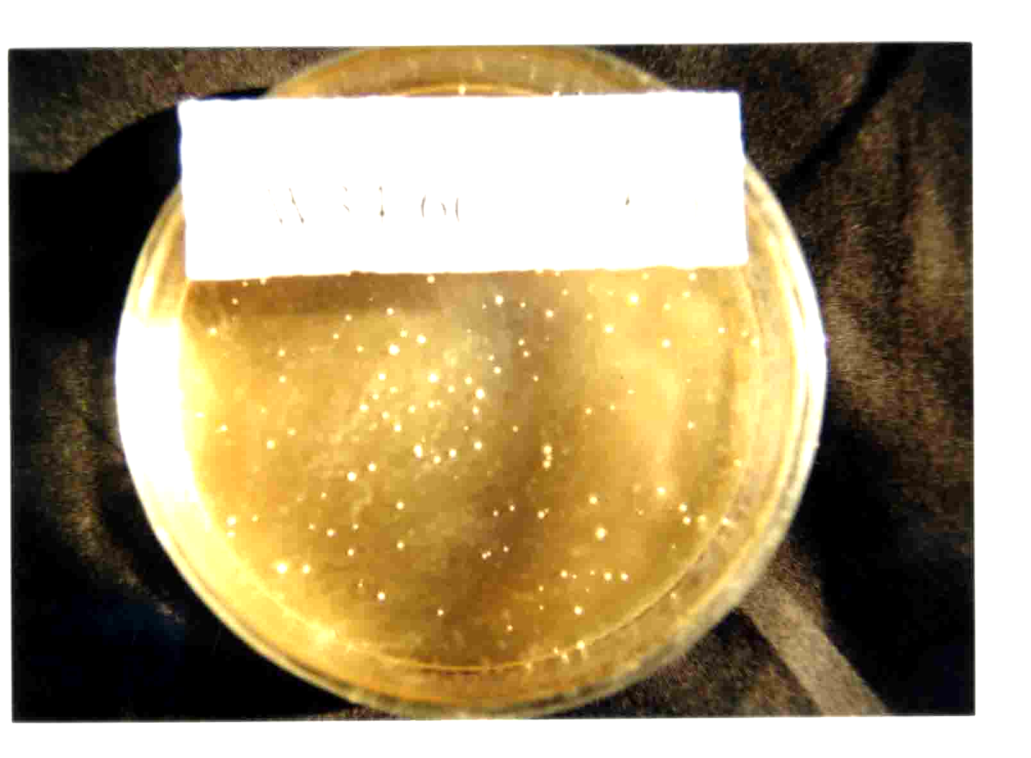
Figure 1. The Plates of ALDC Transformating to HD34 Beer Yeast
(The left is the plate plated with plasmid, the middle is control and the right is the plate plated with transformant)

Correspondence to:
Wenxiang Ping
School of Life Sciences
Heilongjiang University
Harbin, Heilongjiang 150080, China
E-mail: gejingping9178@hotmail.com

References
[1] Godtfredee SE. On the occurrence of α-acetolactate decarboxylase among microorganism. Carsberg Res Commun 1983;48:239-47.
[2] Sanger F, Nicklen S, Coulson AR. DNA sequencing with chainterminating inhibitors. Proc Natl Acad Sci USA 1977;174:5463.

