Preparation of Porcine Factor V

Qiang Zhang, Xuejun Gao, Shanshan Qian, Minyue Ma, Qingzhang Li, Yingjun Cui

(Veterinary College, Northeast Agricultural University, Harbin, Heilongjiang 150030, China)

Abstract: A rapid, simple, and reproducible method for the preparation of porcine Factor V from porcine plasma was investigated in this study. Methods: Porcine Factor V was isolated by multi-techniques including polyethylene glycol precipitation, absorption of protein on to barium citrate and DEAE-cellulose chromatography. Results: Porcine Factor V was identified by SDS-PAGE. Yields and purity of porcine Factor V were 90.2 mg/L of starting plasma and 64.4%, respectively. Conclusion: This preparative procedure is simple, high yields and suitable for mass production. [Nature and Science. 2004;2(3):87-90].

Keywords: porcine plasma; Factor V; preparation

1 Introduction

Human Factor V is a protein composed by 2196 amino acids that is secreted after a pre-propeptide processing. It is composed of triplicated A domains, a B domain, and duplicated C domains (A₁-A₂-B-A₃-C₁-C₂), and circulates at a concentration of 20 nmol/L in blood, as a large single-chain pro-cofactor with an Mr of 330,000. The pro-cofactor is activated to form Factor Va (A₁-A₂-Ca-A₃-C₁-C₂) by a number of proteases, including thrombin, Factor Xa, and plasmin (Gerry, 2002). Factor Va contributes Factor Xa receptor and catalytic effector functions to prothrombinase. The complex formation of Factor Xa and Factor Va forms prothrombinase that increases rate at which prothrombin is converted to α-thrombin by 300,000-fold greater than the rate of the reaction catalyzed by Factor Xa alone (Lisam, 2003).
The physiologic significance of Factor Va for clot formation has demonstrated that complete deficiency of Factor V results in massive hemorrhage and death. The physiologic relevance of Factor Va in the pathology of thrombosis is assured because of case reports of familial thrombophilia associated with Factor V mutations and defects in the protein C pathway. Therefore, it has important to prepare the porcine Factor V for study of Factor V and cure of thrombus diseases.
Mainly because of Factor V’s high sensitivity to proteolysis, it was not until 1979 that the first successful purification of intact bovine Factor V was reported (Rosing, 1997). Now the preparation method of human and bovine Factor V has been successfully founded except that of porcine thrombin. This study set up the preparation method of porcine Factor V.

2 Materials and Methods

2.1 Blood Collection and Plasma Preparation:
Porcine blood was collected in 2.85% trisodium citrate containing 10 mmol/L benzamidine hydrochloride (blood:trisodium citrate=8:1) from a slaughterhouse (Dongpeng Slaughterhouse, Harbin, Heilongjiang, China) and the blood red cells were removed by centrifugation at 4,000×g for 30 min at 4℃. After the centrifugation, the plasma was carefully removed by siphon and stored at -20℃.
2.2 Preparation of Porcine Factor V
2.2.1 PEG-6000 Precipitation
With constant stirring, 28 ml of 50% (w/v) PEG-6000 was added dropwise to the porcine plasma (100 ml). When the addition was completed, the plasma containing 11% PEG-6000 (w/v) was centrifuged at 4,000×g for 15 min at 4°C. The supernatant was decanted (Catherine, 1976).
2.2.2 Barium Citrate Adsorption
The 11% PEG-6000 supernatant was stirred and 320 ml of 1 mol/L BaCl₂ was added dropwise over 40 min. The supernatant was discarded, and the barium citrate pellet was resuspended in 100 ml of 25 mmol/L sodium citrate buffer containing 11% PEG-6000, pH 7.4. The barium citrate pellet was again collected by centrifugation at 4,000×g for 15 min at 4℃. Factor V was eluted from the washed barium citrate pellet by resuspending in 25 mmol/L sodium citrate buffer containing 10 mmol/L BaCl₂, pH 7.4. The suspension was centrifuged at 4,000×g for 15 min at 4℃. The supernatant, which contained Factor V, was decanted.
2.2.3 DEAE-cellulose Chromatography
The supernatant was applied to a DEAE-cellulose-32 column (30×3 cm) equilibrated with 25 mmol/L sodium citrate buffer, pH 7.4. DEAE-cellulose chromatography was performed by CDMC-21 V3.0 chromatography system (Institute of Computing Technology, Shanghai, China). The column was then washed with the same buffer, until the absorbance of the effluent at 280 nm was less than 0.02. The buffer was then changed to 25 mmol/L sodium citrate containing 0.1 mol/L NaCl, pH 7.4, until the effluent had an absorbance of less than 0.01. At this point a linear gradient of sodium chloride (0.1~0.5 mol/L) was applied to the column to elute the column. The flow rate of the column was usually 80 ml/hour. Every eluted protein fraction including Factor V was gathered (William, 1981).
2.3 Analysis of Porcine Factor V by SDS-PAGE: The molecular weight of porcine Factor V was determined by electrophoresis on 5% acrylamide-SDS gels.
2.4 The Activity of Porcine Factor V: The activity of porcine Factor V was determined by the time of fibrinogen converted to fibrin. Compared with the time which fibrinogen was catalyzed by the prothrombinase complex at present/absent of Factor V, the procoagulation activity of Factor V was analyzed.
The assay system was composed of Factor Xa (24 μg/mL), Factor V (30 μg/mL), phospholipid (70 μg/mL), Ca²⁺ (40 mmol/L) and prothrombin (500 μg/mL), and incubated at 37℃ for 40 min. Fibrinogen was added into the assay system. The time of fibrinogen converted to fibrin was recorded.
2.5 Yields of Porcine Factor V: A standard curve composed by the grads concentration of bovine serum albumin (BSA) against the OD280nm was drawn. Yields of porcine Factor V were calculated corresponding to OD280nm.
2.6 Purity of Porcine Factor V: Purity of Factor V was determined by gel imaging system (Alphalmager TM 2200).

3 Results

3.1 Results of DEAE-cellulose Chromatography
The proteins were eluted by 25 mmol/L sodium citrate buffer containing 0.1 mol/L NaCl, pH 7.4. The results of DEAE-cellulose chromatography are shown in Figure 1 and Table 1. Identified by SDS-PAGE, the protein fractions in Figure 1 are not Factor V, but other proteins (Figure 3).
The proteins eluted by 25 mmol/L sodium citrate buffer containing 0.1~0.5 mol/L NaCl, pH 7.4 are shown in Figure 2 and Table 1. Identified by SDS-PAGE, this protein fraction is porcine Factor V (Figure 3).
There were three peaks corresponding to 1, 2, 3 in Figure 1, Figure 2 and Table 1. It is suggested that porcine Factor V could be effectively isolated by DEAE -cellulose chromatography.

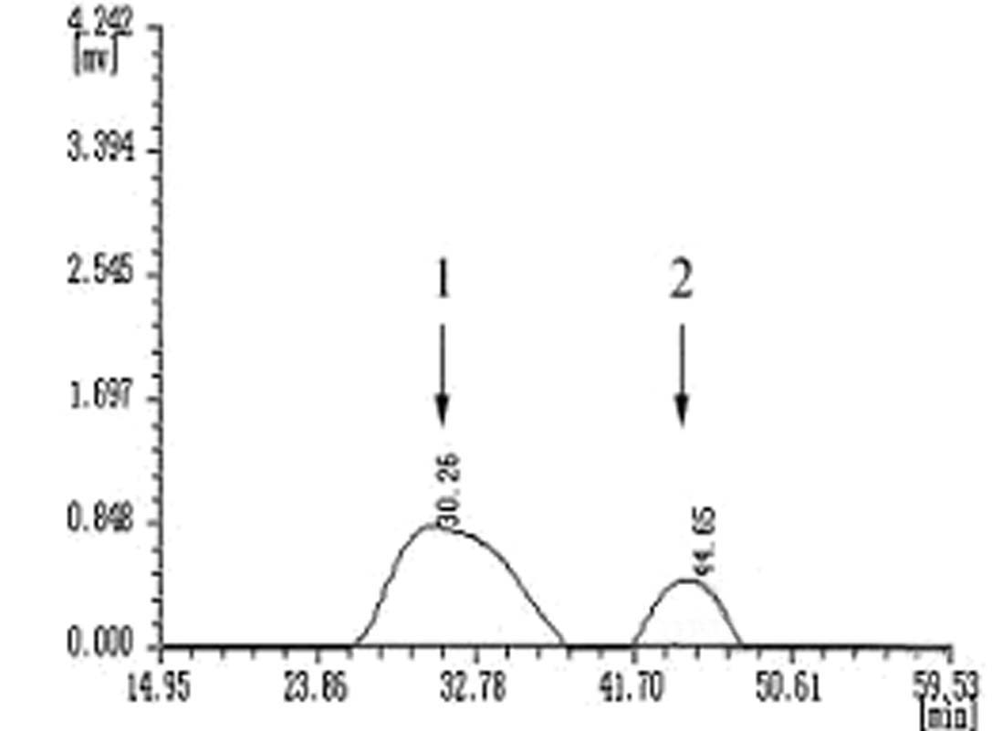 | 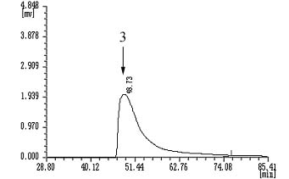
Figure 1. Eluting by 25 mmol/L sodium citrate  buffer containing 0.1 mol/L NaCl, pH 7.4 | Figure 2. Eluting by 25 mmol/L sodium citrate  buffer containing 0.1~ 0.5 mol/L NaCl, pH 7.4

Table 1. Analysis of porcine Factor V by CDMC-21 V3.0 chromatography system
ID | Reserve time (min) | Peak height (μV) | Peak acreage (μV×s)
1 | 30.260 | 942 | 487 090.8
2 | 44.653 | 378 | 108 494.0
3 | 48.733 | 2 410 | 1 208 550.4

3.2 Analysis of Porcine Factor V by SDS-PAGE
Porcine Factor V was analyzed by SDS-PAGE (Figure 3). Peak 1 and peak 2 corresponding to lane 1 and lane 2 respectively were not Factor V but other proteins. Peak 3 corresponding to lane 3 was a clear band with Mr≈330 kD representing porcine Factor V on the acrylamide-SDS gel. Porcine Factor V was prepared successfully in this study.

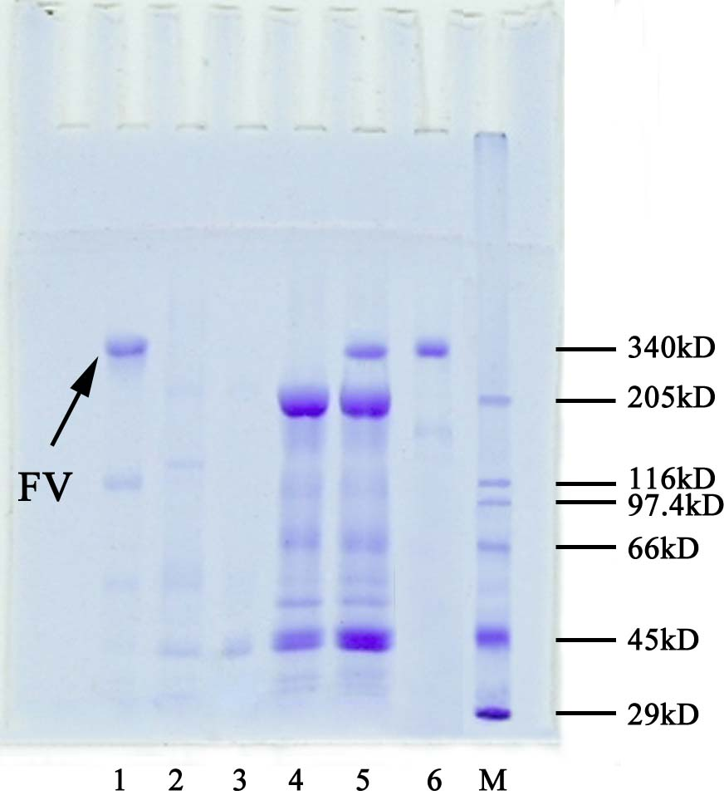
Figure 3. Analysis of porcine Factor V by SDS-PAGE  Lane 1: peak 1 (Factor V, 330 kD); lane 2: peak 2; Lane 3: peak 3; Lane 4: sample before chromatography; Lane 5: fibrinogen (340 kD); lane M: protein marker | Figure 4. The standard curve of grads BSA concentration against OD_{280nm}  c1: grads BSA concentration; c2: Factor V concentration

3.3 The Activity of Porcine Factor V
At the absent of Factor V the catalyzing time of fibrinogen by the prothrombinase complex was 2,280 s. At the present of Factor V (peak 3, 0.18 mg/mL) the catalyzing time was 77 s. The above results showed that porcine Factor V prepared in this protocol had a significant procoagulation activity.
3.4 Yields of Porcine Factor V
A standard curve of the grads concentration of bovine serum albumin (BSA) against the OD_{280nm} is shown in Figure 4. The yields of porcine Factor V was 90.2 mg/L plasma.
3.5 Purity of Porcine Factor V
Purity of porcine Factor V determined by gel imaging system (Alphalmager TM 2200, Alpha Innotech Corporation, Washington D.C, USA) was 64.4%.

4 Discussion

The preparation of porcine Factor V has always been defeated by the high sensitivity of porcine Factor V to proteolysis. It is necessary to add benzamidine hydrochloride (proteolysis inhibitor) to prevent porcine Factor V from proteolysis. PEG-6000 precipitation and barium citrate adsorption has been applied to other coagulation factors owing to their moderately operating conditions and well isolating results (Rosing, 1997). DEAE-cellulose chromatography is the focus of porcine Factor V preparation. It is an important technique to isolate coagulation factors.
The preparation procedure described in this paper yields porcine Factor V which is isolated by multi-techniques including polyethylene glycol precipitation, barium citrate absorption and DEAE-cellulose chromatography. The procedure provides overall yields of 90.2 mg of Factor V per liter of starting plasma. It has been proven to be very reproducible and given a same purity (64.4%). This preparation procedure is simple, high yields and suitable for mass production.

Correspondence to:
Xuejun Gao
59 Wood Street
Gongbin Road, Xiangfang District
Harbin, Heilongjiang 150030, China.
Telephone: 01186-451-55190635
Cellular phone: 01186-13104503278
E-mail: gaoxj5390@sina.com
Dongpo Zhou

74 Xuefu Road
College of Life Sciences
Heilongjiang University
Harbin, Heilongjiang 150080, China
E-mail: zhoudp2003@yahoo.com.cn

Acknowledgement:
This study is supported by Youth Science Fund of Heilongjiang, China (QC01C13).

References
[1] Catherine M, Smith DJ, Hanahan. An improved Factor V isolation procedure. Biochemistry 1976;15:1830-8.
[2] Gerry AF, Nicolaes, Björn D. Factor V and thrombotic disease description of a Janus-faced protein. Arterioscler Thromb Vasc Biol 2002;22:530-8.
[3] Kane WH, Majerus PW. Purification and characterization of human coagulation FactorⅤ. J Biol Chem 1981;256:1002-7.
[4] Lisam SS, Michael AB, Daniel OB et al. Factor Va heavy chain is essential for expression of cofactor activity. J Biol Chem 2003;278:28335-45.
[5] Rosing J, Tans G. Coagulation factor V: an old star shines again. Thromb Haemost 1997;1:427-33.
[6] Rosing J, Tans G. Factor V. Int J Biochem Cell Biol 1997;10:1123-6.

