Research on the Storage Methods of Lactic Acid Bacteria Strains Separated from DVS

Yanfen Liu，Xuejun Gao, Yuting Cong, Yahui Peng, YingLiu

(Veterinary College, Northeast Agricultural University, Harbin, Heilongjiang 150030, China
Liuyanfen55@163.com)

Abstract: Randomly amplified polymorphic DNA (RAPD) and morphological observation and fermentation property analysis were used to evaluate the different storage methods of three lactic acid bacteria strains separated from Directed Vat Set (DVS). Methods: Evaluate the genome change of the different samples from different periods during 4℃ storage, –80℃ storage and lyophilization using RAPD. Observe the morphological features by microscopy after recovered from different time of storage, then used each strain as a starter culture of fresh milk, observe the fermentation properties. Results: The RAPD patterns and fermentation property of the three strains all changed during 4℃ and –80℃ storage, and they all showed a good stability when stored by lyophilization. Suggests: This is the first time to use RAPD technique and fermentation property observation in lactic acid bacteria storage research work, RAPD appears to be an efficient method for evaluating of storage effect of lactic acid bacteria strains separated from DVS. [Nature and Science. 2004;2(4):49-53].

Keywords: DVS; lactic acid bacteria strains; storage method; fermentation properties; RAPD; morphological observation

1. Introduction

Lactic acid bacteria (LAB) are utilized in the production and preservation of various fermented foods (Jqrgen, 1999). Examples of such foods include yogurt, fermented milk, cheeses, fermented rice cake (puto), and various other foods of both plant and animal origin. Directed Vat Set (DVS) is a rapid, safety starter for the milk fermentation industry. But nobody knows what storage method is best for the LAB strains separated from DVS. The main aim of the present study was then to compare the storage methods of the LAB separated from DVS. Sonali Dixit, et al evaluated the genetic stability of plants regenerated from cryopreserved embryogenic tissues of Dioscorea bulbifera L. using RAPD. Finally the morphology and RAPD profiles all proved lyophilization is a proper storage method for the Dioscorea bulbifera embryogenic tissues (Sonali Dixit, 2003). This is the first time to compare different storage methods for the LAB strains separated from DVS using RAPD (Singh, 2004).

2. Materials and Methods

2.1 Strains: A Streptococcus thermophillus and two Lactobacillus which were separated from a DVS.

2.2 Separated Medium: M17 and MRS (Sandra, 1999) were used to separate the three strains.

2.3 Sugar Fermentation Experiment: To value the biochemical features of the three LAB strains by sugar fermentation experiment after separation. 12 different sugars were used in the experiment.

2.4 Storage Medium: The improved PY medium was used to stored in 4℃. 15% glycerin was added to the medium before it frozen in －80℃. Two improved silk milk media were used for Streptococcus thermophillus, Lactobacillus 1 and Lactobacillus 2 lyophilization.

2.5 Morphological Features and Fermentation Properties During Storage: The strains were recovered respectively when they were stored for 1, 5, 10, 15, 30 d in 4℃. The same work was done when the strains were stored for 1, 15, 30 d in －80℃. The strains were recovered when they were stored for 90 d by lyophilization. The recovering time was recorded respectively (when the cells of the bacteria reached 10⁸/ml), and the morphological features were observed by microscopy. Each of the three LAB strains was used as the starter culture of fresh milk respectively (there were five equals for each strain), the average time was recorded when the milk changed into solid, then the average pH and qualities of the products were observed, thus the fermentation property were evaluated. All above features of the three LAB strains when just separated were tested as control.

2.6 RAPD Analysis During Storage: The three LAB strains at different time of storage were recovered respectively, then extracted their whole genome by CTAB(Kim,1990) as samples for RAPD.
PCR program was as follows: an initial denaturation consisting of 2 min at 94℃, 35 cycles consisting of 45 s at 94℃, 30 s at 38℃, and 30 s at 72℃, and then a final extension at 72℃ for 10 min. The PCR products were electrophoresed in 1.0% agarose gels, stained with ethidium bromide, and photographed.

3. Results

3.1 Sugar Fermentation Experiment (Table 1).
The sugar fermentation experiment of bacteria is shown in Table 1.

Table 1. The sugar fermentation experiment of bacteria
 | Streptococcus thermophillus | Lactobacillus 1 | Lactobacillus 2
Lactose | ＋ | ＋ | ＋
D-Fructose | ＋ | ＋ | ＋
D(+)Xylose | － | ＋ | ＋
Sucrose | ＋ | － | ＋
Mannitol | － | － | －
D-Sorbitol | － | － | －
Maltose | － | ＋ | ＋
Glucose | ＋ | ＋ | ＋
α,α-Trehalose | － | ＋ | ＋
Esculin | ＋ | ＋ | ＋
D-Galactose | ＋ | ＋ | ＋
D-(+)-Cellobiose | ＋ | － | ＋
‘+’ represented positive; ‘－’ represented negative.

3.2 Morphological Features and Fermentation Properties During Storage
3.2.1 Morphological Features and Fermentation Properties of Streptococcus thermophillus During Storage (Table 2).
The Morphological features and fermentation properties of Streptococcus thermophillus during storage is shown in Table 2.

Table 2. Morphological features and fermentation properties of Streptococcus thermophillus during storage
Storage time (d) |  | Recovering  time (h) | Morphological features | Fermentation Properties
 |  | Recovering  time (h) | Morphological features | Milk solidified time (h) | pH | Sense
4℃  storage | 1 | 18 | Cocci, singly and in short chain | 5.5 | 4.72 | Sour, milk flavor, taste common
4℃  storage | 5 | 20 | Cocci, in chain | 6.5 | 4.73 | Sour, not in good flavor
4℃  storage | 10 | 24 | Cocci, in chain | 8 | 4.71 | Sour, taste not good
4℃  storage | 15 | 24 | Cocci, in chain | 12 | 4.71 | Sour, taste not good
4℃  storage | 30 | 24 | Cocci, in chain | 16 | 4.76 | Sour, taste bad
–80℃  storage | 1 | 18 | Cocci, singly and in short chain | 5 | 4.74 | Sour, milk flavor, taste common
–80℃  storage | 15 | 24 | Cocci, in chain | 5.5 | 4.75 | Sour, not in good flavor
–80℃  storage | 30 | 24 | Cocci, in chain | 8 | 4.73 | Sour, taste not good
lyophilization | 90 | 10 | Cocci, singly and most in short chain | 5 | 4.75 | Sour, good flavor, taste best
Control |  |  | Cocci, in singly, pairs and short chain | 5 | 4.73 | Sour, good flavor, taste best

3.2.2 Morphological Features and Fermentation Properties of Lactobacillus 1 During Storage (Table 3).
Morphological Features and Fermentation Properties of Lactobacillus 1 During Storage is shown in Table 3.

Table 3. Morphological features and fermentation properties of Lactobacillus 1 during storage
Storage time (d) |  | Recovering  time (h) | Morphological features | Fermentation Properties
 |  | Recovering  time (h) | Morphological features | Milk solidified time (h) | pH | Sense
4℃  storage | 1 | 24 | Long rod, some in chain | 13 | 4.71 | Sour, flavor like milk
4℃  storage | 5 | 28 | Long rod, some in chain | 15 | 4.73 | Sour, not good flavor
4℃  storage | 10 | 36 | Long rod, in singly and chain | 16 | 4.74 | Not sour, taste bad
4℃  storage | 15 | 48 | Long rod, in singly and chain | 18 | 4.76 | Not sour, taste bad
4℃  storage | 30 | *
–80℃  storage | 1 | 24 | Long rod, in singly and short chain | 12.5 | 4.74 | Sour, taste common
–80℃  storage | 15 | 26 | Long rod, in singly and short chain | 14 | 4.77 | Sour, no good flavor
–80℃  storage | 30 | 26 | Long rod, most in chain | 16 | 4.76 | Not sour enough
lyophilization | 90 | 10 | Long and thin rod, most singly | 12.5 | 4.71 | Sour, taste common
Control |  |  | Long and thin rod, in singly and short chain | 12 | 4.70 | Sour, taste common
*Lactobacillus 1 could not be recovered when it was store for 30 d in 4℃

3.2.3 Morphological Features and Fermentation Properties of Lactobacillus 2 During Storage (Table 4).
The morphological Features and Fermentation Properties of Lactobacillus 2 During Storage is shown in Table 4.

Table 4. Morphological features and fermentation properties of Lactobacillus 2 during storage
Storage time (d) |  | Recovering  time (h) | Morphological features | Fermentation Properties
 |  | Recovering  time (h) | Morphological features | Milk solidified time (h) | pH | Quality
4℃  storage, | 1 | 24 | Short rod, singly and in short chain | 14 | 4.72 | Not sour, good flavor
4℃  storage, | 5 | 30 | Short rod, singly and in chain | 15.5 | 4.76 | Not sour, taste common
4℃  storage, | 10 | 38 | Short rod, in short chain | 16 | 4.74 | Not sour, taste not good
4℃  storage, | 15 | 48 | Short rod, most in chain | 20 | 4.77 | Not sour ,taste not good
4℃  storage, | 30 | *
–80℃  storage | 1 | 24 | Small rod, singly and in chain | 13.5 | 4.72 | Not sour, taste common
–80℃  storage | 15 | 30 | Small rod, singly and in chain | 14 | 4.73 | Not sour, taste like milk
–80℃  storage | 30 | 30 | Small rod, singly and in chain | 16 | 4.72 | Taste not good
Lyophilization | 90 | 12 | Small rod, most in chain, less singly | 13 | 4.73 | Not sour, good flavor
Control |  |  | Small rod, most in chain, some singly | 13 | 4.72 | Not sour, good flavor
*Lactobacillus 2 could not be recovered when it was store for 30d in 4℃.

3.3 RAPD Analysis When the Strains Were Stored in 4℃
The RAPD fingerprint of Streptococcus thermophillus changed a little since 5 d during 4℃ storage compared with 1 d (Figure 1, 1). The RAPD fingerprint of Lactobacillus 1 changed a lot when stored for 10 d in 4℃ (Figure 1, 2). The RAPD fingerprint of Lactobacillus 2 changed a lot from the 15 d (Figure 1, 3). Both the two Lactobacillus could not be recovered when they were stored for 30 d in 4℃.

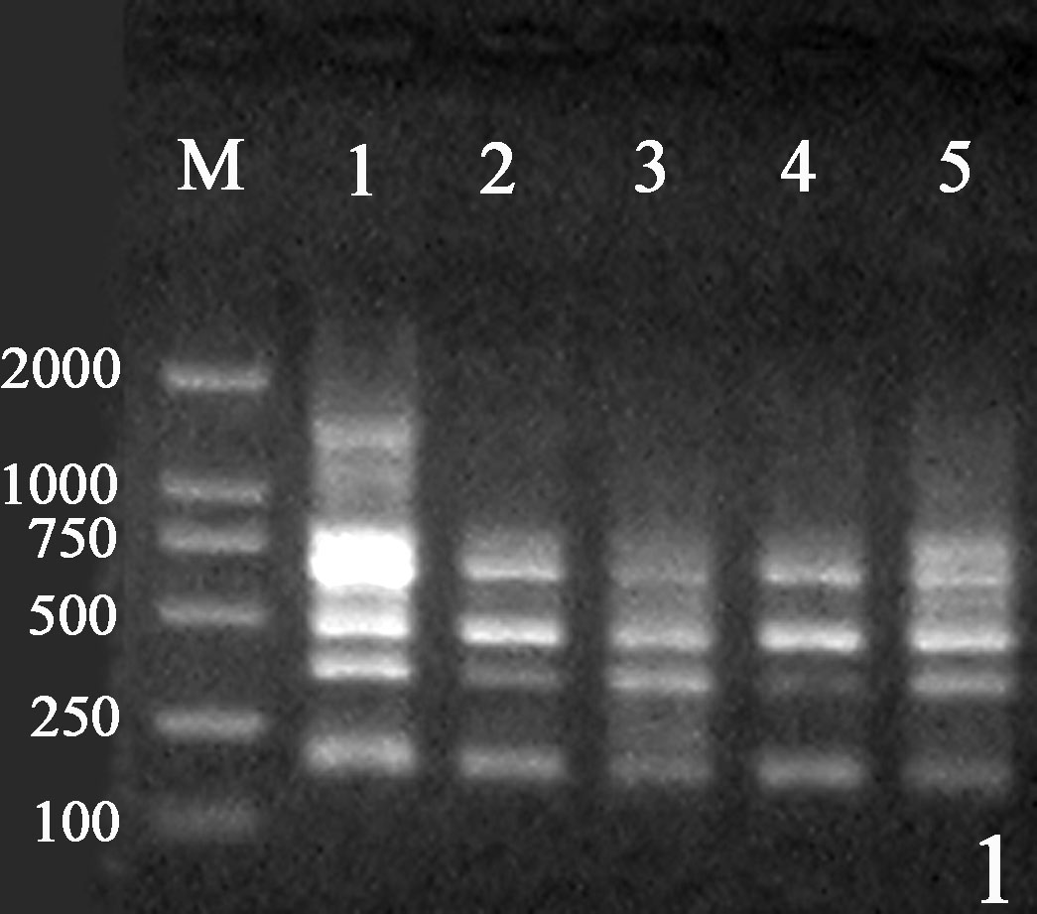 | 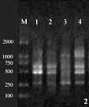 | 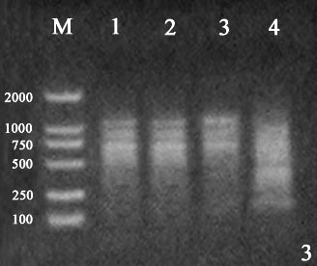
Figure 1. RAPD analysis of the strains stored for different time in 4℃. The bands were marker, stored for 1 d, stored for 5 d, stored for 10 d, stored for 15 d, stored for 30 d in proper order from left to right. (1) Streptococcus thermophillus. (2) Lactobacillus 1. (3) Lactobacillus 2.

3.4 RAPD Analysis When the Strains Were Stored in －80℃
The RAPD fingerprint of Streptococcus thermophillus changed since 15 d during －80℃ storage (Figure 2, 1). The RAPD fingerprint of Lactobacillus 1 changed a lot when stored for 15 d, no pattern produced when stored for 30 d (Figure 2, 2). The RAPD fingerprint of Lactobacillus 2 changed a lot during －80 ℃ storage, and no pattern produced when stored for 30 d (Figure 2, 3).

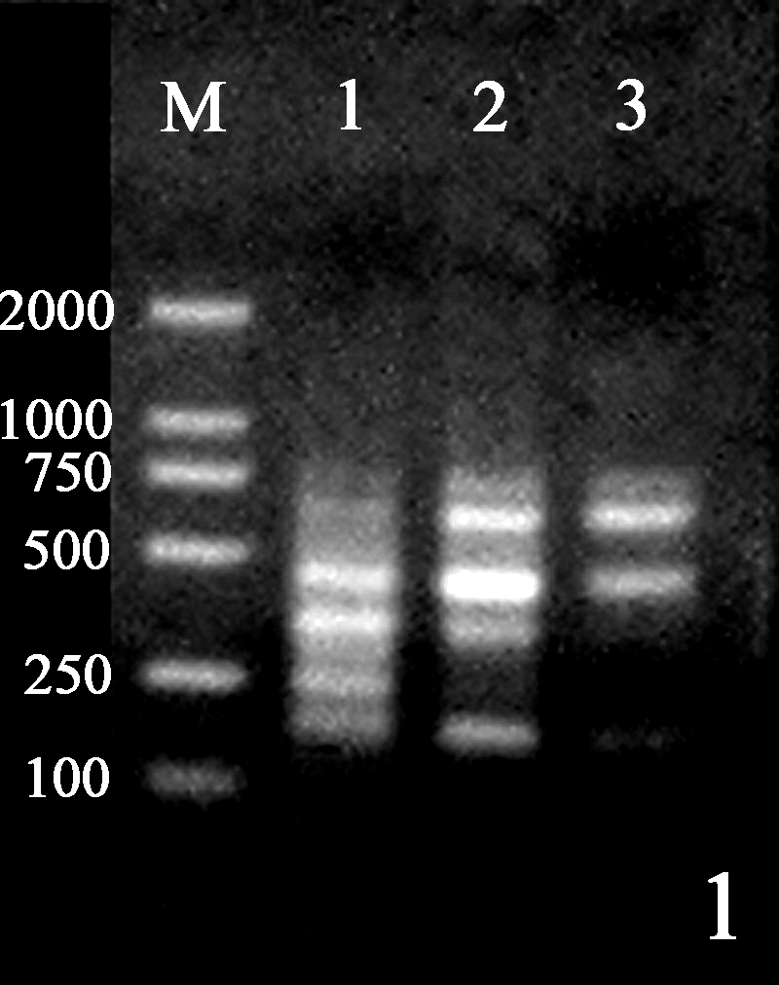 | 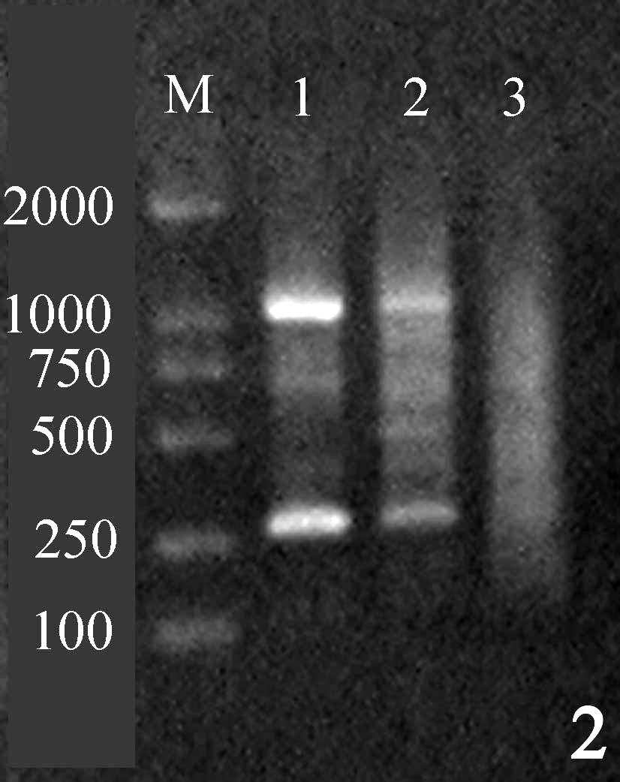 | 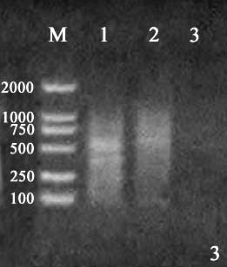
Figure 2. RAPD analysis of the strains stored for different time in －80℃. The bands were marker, stored for 1 d, stored for 15 d, stored for 30 d in proper order from left to right. (1) Streptococcus thermophillus. (2) Lactobacillus 1. (3) Lactobacillus 2.

3.5 RAPD Analysis When the Strains Were Stored by lyophilization
The RAPD fingerprint of the three strains did not change when they were stored by lyophilization (Figure 3).

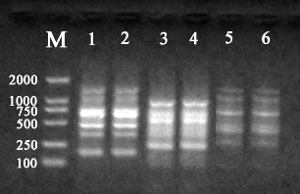
Figure 3. RAPD analysis of the strains stored by lyophilization. The bands were marker, Streptococcus thermophillus before lyophilization, Streptococcus thermophillus after lyophilization, Lactobacillus 1 before lyophilization, Lactobacillus 1 after lyophilization, Lactobacillus 2 before lyophilization, Lactobacillus 2 after lyophilization in proper order from left to right.

4. Discussion

It is known that some properties of bacteria may change when they are stored. The result of RAPD and observation of morphology and fermentation properties showed that 4℃ and －80℃ were unfit for the three strains’ long time storage, after 5 days storage the fermentation properties got worse and RAPD fingerprint changed too. However, morphological features and fermentation property and RAPD fingerprint of the three LAB strains didn’t change obviously after 90 d store by lyophilization.
RAPD is an easy and cost-effective profiling assay based on PCR with arbitrary primers that, by amplifying a set of DNA segments randomly distributed throughout the genome, can detect genetic polymorphisms. Nevertheless, RAPD techniques have some limitations concerning reproducibility and an uncertain homology of co-migrating fragments in gel electrophoresis. But most of these limitations can be minimized by carefully adjusting the reaction and detection conditions (Lusia C. Carvalho, 2004). In our work, we found that the RAPD fingerprint of the control group (three LAB strains) all are of certainty and reproducible.
Though LAB is wide spread in the natural environment and play an important role in several industrial and food fermentations, it is difficult to store them without function changes of these strains. So a perfect way to store LAB strains is very important to research a good starter culture for fermentation industry. The present study shows that lyophilization is the best choice for LAB strains storage through morphology observation and fermentation analysis and RAPD analysis. This is the first time to use RAPD technique as a tool to analysis LAB strains’ property change when they are stored.

Correspondence to:
Yanfen Liu
Wood Street 59
Gongbin Road, Xiangfang District
Harbin, Herlongjiang 150030, China.
Telephone: 01186-451-5519-0083
Cellular phone: 01186-13159846726
E-mail: liuyanfen55@163.com

Xuejun Gao
Veterinary College
Northeast Agricultural University
Harbin, Heilongjiang 150030, China
Liuyanfen55@163.com

References
[1] Kim WK, Mauthe W, Hausner G, et al. Isolation of high molecular weight DNA and double strandes RNAs from fungi. Can J Bot 1990;68:1898-902.
[2] Jqrgen J.JLEISNER, et al. Identification of lactic acid bacteria from Chili Bo, a Malaysian food ingredient. Applied and Environmental Microbiology 1999;65(2):599-605.
[3] Luisa C. Carvalho, Cristina Oliveira, Jose Carlos Goncalves, et al. RAPD assessment for identification of clonal identity and genetic stability of in vitro propagated chestnut hybrids. Plant Cell 2004;77: 23-7.
[4] Sandra Torriani, Giacomo Zapparoli, Franco Dellaglio. Use of PCR-Based Methods for Rapid Differentiation of Lactobacillus delbrueckii subsp. bulgaricus and L. delbrueckii subsp. lactis. Applied and Environmental Microbiology, 1999;4351-6.
[5] Singh SK, Upadhyay RC, Kamal S, et al. Mushroom cryopreservation and its effect on survival, yield and genetic stability. Cryo Letters 2004:23-32.
[6] Sonali Dixit, B.B.Mandal, Sangeeta Ahuja, et al. Genetic Stability Assessment of Plants Regenerated from Cryopreserved Embryogenic Tissues of Dioscorea Bulbifera L. Using RAPD, Biochemical and Morphological Analysis. Cryo Letters 2003;24: 77-84.

