Agricultural Mechanization Contribution Rate Calculation Software Package Development

Xiaojie Zong

College of Computer & Information Engineering, Zhejiang Gong Shang University, Hangzhou, Zhejiang 310035, China, ZXJ6330@163.COM

Abstract: The main purpose that calculates the contribution rate of mechanization in agriculture to the development of it is to recognize the real function of mechanization to the increasing output and income. In practice the calculation is good to know the development level, potentialities and trend of mechanization in agriculture from overall. It also offers the scientific base for decision making department to instruct and promote work of mechanization in agriculture. This paper created software specially to calculate the contribution rate of mechanization in agriculture by using economy math method, computer technology and Visual Basic 6.0 version. The software package has friendly interface, simply operating way and accurately, feasibly calculating method. It greatly changed the condition in the past which has considerable amount of data to be dealt, miscellaneous and trivial methods, and hard to seek answer, and it has very high practical value. [Nature and Science. 2004;2(4): 54-56].

Key Words: mechanization in agriculture; rate of contribution; calculation; software package

1 System function design
Begin
Identity attestation
Open data file
Choose method
Pass?
consistent with file?
Calculating
Save?

Save the result
With other method?
Continue?
End
Yes
No
Yes
No
No
Yes
No
Yes
Yes
The main function of the software is to calculate the contribution rate of mechanization in agriculture with five different methods, save its results and maintenance the system. The five methods are Solow Complementary Value Method, Cobb-Douglass Production Function Method, Data Envelopment Analysis Method, Delphi Method and Pluralistic Linear Regression Method. We studied two different instances in Solow Complementary Value Method. One side the coefficient of speed-increasing equation is constant, and the other side the coefficient is variable with time(Wang, 1996) The system flow chart of the software is showed as Figure 1.

2. System interface design
Interface design of the software is designed relying on form by using Object Oriented Programming idea. All system forms have identical style. Some interface design content will be expatiated such as identity attestation interface, main control interface and input and output interface (Evangelos, 1999; Zong, 2000).

2.1 Identity attestation interface design
An identity attestation forms is designed for system security preventint unlawful user from using the system. You must load first when you use the syetem every time. The system also offers a modified function for loading information. The user loading interface and modified logging information interface are showed as Figure 2 and Figure 3.

Figure 1. The flow chart of the software system

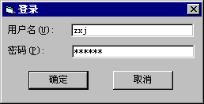
Figure 2. User logging interface
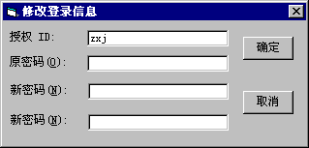
Figure 3. Modified logging information interface
2.2 Main control interface design
Main control interface design is the first step of system program design. It is connected with system holistic capability and function implement. Main control interface of the software include menu column, method selection area, function implement area and result output area. In method selection area there are five method buttons concluded. In function implement area conclude four command button such as run, close, clear screen and save. In which pressing run button can calculate the contribution rate of mechanization in agriculture, and pressing clear and save button can clear and save information of result output area. Main control interface is show as Figure 4.
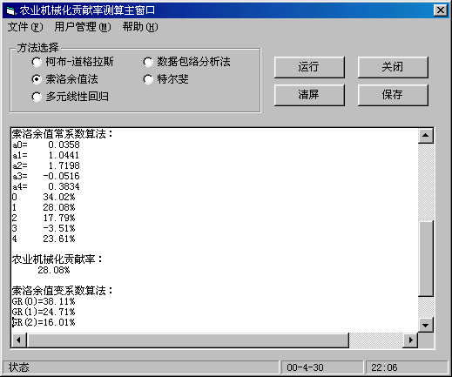
Figure 4. Main controlling interface of SCMA
2.3 Input and output interface design
Input and output interface design is a main part of system design. It often takes user much time. We will expatiate the design of input and output interface.

2.3.1 Input interface design
Input interface of the software is designed as interactive grid. Interface upside is a grid of input datum, and underside is parameter input area and command button area. For each sort of information there is an item to indicate the content and position. Otherwise input datum type can be tested automatically and user also can modify the datum.
In the system input datum can be divided into two parts. In which input datum of four methods such as Solow Complementary Value Method, Cobb-Douglass Production Function Method, Delphi Method and Pluralistic Linear Regression Method are the same kind. The file extensible name is defined .dt1. It has the same input interface showed as Figure 5. Input datum of Data Envelopment Analysis Method is the other kind. Its file extensible name is defined .dt2. Its input datum interface is showed as Figure 6.

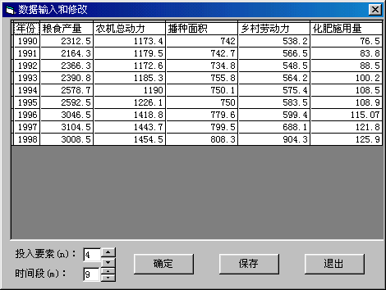
Figure 5. Input interface of SOLOW Complementary Value Method
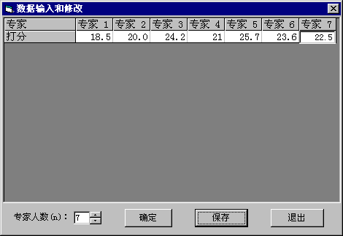
Figure 6. Input interface of Delphi Method

2.3.2 Output interface design
Output results of the system are showed underside of main control interface, which showed the parameters we calculated and some middle results. Output interface is showed as Figure 4.

3. Conclusion

The software package, which has friendly interface, simple operating way and accurate, feasible calculating method. It improves the working efficiency greatly. The calculation software offered the scientific base for decision making department to instruct and promote works of mechanization in agriculture on practice.

Acknowledgement:
This project are financially supported by Chinese Agriculture Department Soft Science program for 95: Studies on the Contribution of Mechanization in Agriculture to the Development Agriculture and Agriculture mechanization Equipment Level, China. The paper above is from soft science item of agriculture department, China.

Correspondence to:
Zong Xiaojie, Associate professor, Ph.D.
College of Computer & Information Engineering
Zhejiang Gong Shang University
Hangzhou, 310035, China
Telephone:01186-571-88215765
Cellular phone: 01186-13958043388
E-MAIL: ZXJ6330@163.COM

References
[1] Evangelos Petroutsos. Qiu ZF. Translating .Visual Basic 6 From Introduction to Mastery. Electronic Industry Publishing Company, Beijing, China, 1999.
[2] Wang FL, Dong GR. A calculation method of agricultural mechanization to agricultural production．Chinese Agriculture University Journal, Beijing, China, 1996:2.
[3] Zong XJ. Studies on the Contribution of Mechanization in Agriculture to the Development Agriculture, Ph. M Dissertation Northeast Agriculture University, Harbin, Heilongjang. 2000:27-32.

