Cosmology Based on Absolute Motion

Ken H. Seto

KHS Publishing, 260 Yorkshire Lane, Xenia, OH 45385, USA
kenseto@erinet.com; http://www.erinet.com/kenseto/book.html
Telephone: 937-3725298

Abstract: A new model of the universe called Model Mechanics was formulated. Model Mechanics explains all the forces of nature with the same mechanism and thus it is able to unite all the forces of nature naturally. In cosmology, Model Mechanics provides solutions to the following problematic cosmological observations: the observed accelerated expansion of the far reached regions of the universe disagrees with the prediction of GRT; the observed rotational curves of galaxies disagree with the predictions of GRT; the observed paths of travel of the space crafts Pioneer 10 and 11 disagree with the predictions of GRT; the observable universe appear to have a much larger horizon than it is allowed by its observed age and the GRT description of gravity gives rise to the observed flatness problem of the universe. Model Mechanics leads to a new theory of gravity called Doppler Theory of Gravity (DTG) and unites gravity with the electromagnetic and nuclear forces naturally [1,2,3]. It also leads to a complete theory of motion called Improved Relativity Theory (IRT). IRT includes Special Relativity Theory (SRT) as a subset. However, unlike SRT, the equations of IRT are valid in all environments…including gravity. Model Mechanics is based on the existence of absolute motions of objects in a stationary and structured light-conducting medium called the E-Matrix. Proposed experiments to detect absolute motions in the E-Matrix were also formulated. [Nature and Science. 2005;3(1):1-12].

Key Words: cosmology; absolute motion;model

1 Model Mechanics Description of the Current Universe

Model Mechanics supposes that a stationary substance, called the ‘E-Matrix’, occupies all of pure-space (void) in our Universe. Subsequently, we perceive the E-Matrix as space. The E-Matrix, in turn, is composed of ‘E-Strings’, which are very thin three-dimensional elastic objects, of diameter estimated at cm. The length of an E-String is not defined. Away from matter, the E-Strings are oriented randomly in all directions. This means that a slice of the E-Matrix in any direction will look the same. Near matter, the E-Strings are more organized: some emanate from the matter, and the number of these passing through a unit area followed the well-known inverse square law of physics. The E-Strings repel each other. This means that there is an unknown outside force that is compacting them together. The repulsive force and the compacting force are in equilibrium. This state of the E-Matrix allows massive matter particles to move freely within it. The motion of a matter particle or particle system in the E-Matrix is called ‘absolute motion’. The absolute motion of matter in the E-Matrix will distort the local E-Strings. The E-Strings will recover to the non-distorted state after the passage of the matter particles. Light consists of wave-packets in neighboring E-Strings. On its way toward its target, a wave-packet will follow the geometry of these neighboring E-Strings. This description of light embodies ‘duality’, i.e. light possessing properties of a mass-bearing particle as well as a wave packet.
With this description of the E-Matrix (space), the next relevant question is: What is matter? All stable and visible matter is made from three basic particles: the electrons, the up quarks, and the down quarks. The protons and neutrons in the nuclei of all the atoms are made from the up quarks and the down quarks. The electrons orbit around the nuclei to complete the picture of all the atoms. The three basic particles are, in turn, made from one truly fundamental mass-bearing particle, called the ‘S-Particle’. An S-Particle is a three-dimensional spherical object. It is repulsive to the E-Strings surrounding it and therefore its motion in the E-Matrix is maintained. An S-Particle orbiting around an E-String in the helical counterclockwise direction is an electron. This motion of the S-Particle is the fastest in the E-Matrix, and it gives rise to one unit of negative electric charge. A down quark is also an S-Particle orbiting around an E-String in the helical counterclockwise direction. The speed of its orbiting motion is only 1/3 that of the electron, giving the down quark a negative 1/3 electric charge. An up quark is an S-Particle orbiting around an E-String in the helical clockwise direction at 2/3 the speed of the electron, resulting a 2/3 positive electric charge.
There is one more stable basic particle: the electron neutrino. An electron neutrino has no detectable electric charge, and therefore it does not interact with the other three charged basic particles. It is composed of an S-Particle orbiting around an E-String in the counterclockwise direction like the electron. However, it is moving in a corkscrew like motion away from the charged basic particles. This means that the distortion in the E-Matrix created by the absolute motion of the electron neutrino will have already dissipated by the time the charged basic particles are ready to interact with it. This is the reason why the electron neutrino does not interact electromagnetically with the charged basic particles.
This simple description of all stable visible matter can answer the thorny question: What is the mass of a basic particle? The answer is: mass is the evidence of the orbiting diameter of its S-Particle. Those S-Particles that are not in a state of orbiting motion do not possess any electric charge and therefore they will not interact with the basic charged particles electrically. They will, however, interact with them gravitationally. They are the dark matters predicted by the astronomers.
The next relevant question is: what are the processes that give rise to all the forces between matter particles? The proposed answers to this question are as follows:
- All the processes of Nature are the result of matter particles reacting to the geometries of the E-Strings (i.e. distortions or waves) to which they are confined because of their orbiting motions around these E-Strings.
- Absolute motions of two objects in the same direction in the E-Matrix will cause the objects to converge to each other--an attractive force. Absolute motions of two objects in the opposite directions in the E-Matrix will cause the objects to diverge from each other--a repulsive force.
This completes the Model Mechanical description of our current universe. All the particles, all the forces and all the processes of nature can be derived from this one description. Model Mechanics replaces the math constructs of space-time and field/virtual particle with the E-Matrix and the distortions or waves in the E-Matrix. It gives rise to the following postulates:
- The E-Matrix is a stationary and structured light-conducting medium. It occupies all of pure space (pure void). It is comprised of very thin and elastic E-Strings and these E-Strings are repulsive to each other. There is an unknown compacting force that compresses these E-Strings together to form the E-Matrix.
- The S-Particle is the only truly fundamental particle exists in our universe. The different orbiting motions of the S-Particles around the E-String(s) give rise to all the visible and stable particles in our universe.
- All the processes of nature are the results of absolute motions of S-Particles or S-Particle systems in the E-Matrix.
- All the forces of nature are the results of the S-Particle or S-Particle systems reacting to the distortions or waves in the E-Strings to which they are confined. The distortions or waves in the E-Strings, in turn, are the results of the absolute motions of the interacting S-Particles or S-Particle systems in the E-Matrix.
- All the stable and visible matters are the results of orbiting motions of the S-Particles around specific E-Strings.
These postulates eliminate all the infinity problems that plagued both GRT and QM. It has the same mechanism for all the forces of nature and thus it unites all the forces of nature naturally. It gives an explanation why the force of gravity is capable of acting at a distance. It explains the provisions of the Uncertainty Principle. It explains the weird results of all quantum experiments [3]. It eliminates the need for the undetectable force messengers in Quantum Field Theories. It eliminates the need for the hypothetical and undetected Higgs particle. It explains the mass of a particle and the charge of a particle. It leads to the discovery of the CRE force, which, in turn leads to a new theory of gravity. In short, Model Mechanics gives us a unique way to achieve the elusive goal of unifying all of physics.

2 Improved Relativity Theory (IRT)

Special Relativity Theory (SRT) posits that the speed of light is a universal constant in all inertial frames, but suppose the speed of light is not a universal physical constant as asserted by the SRT, but rather a constant mathematical ratio as follows:

This new interpretation for the speed of light revives the discarded notion of absolute time and physical space. It also makes the notion of absolute time and space compatible with SRT. Based on this interpretation for light speed, a new theory has been formulated for motion: Improved Relativity Theory (IRT). IRT includes SRT as a subset, but its equations are valid in all environments—including gravity. The following is a description of IRT:
The postulates:
- The laws of physics based on a clock second and a light-second to measure length are the same for all observers in all inertial reference frames.
- The speed of light in free space based on a clock second and a light-second to measure length has the same mathematical ratio c in all directions and all inertial frames.
- The laws of physics based on a defined absolute second and the physical length of a rod is different in different frames of reference.
- The one-way speed of light in free space based on a defined absolute second and the physical length of a measuring rod has a different mathematical ratio for light speed in different inertial frames. The speed of light based on a defined absolute second and the physical length of a measuring rod is a maximum in the rest frame of the E-Matrix.

The Consequences of these Postulates:
- The speed of light is not a universal constant. It is a constant math ratio as follows:
Light path length of rod (299,792,458 m)/the absolute time content for a clock second co-moving with the rod.
The detailed explanation of this new definition:
By definition the speed of light in the rest frame of the E-Matrix is as follows:
Light path length of rod in the E-Matrix frame = 299,792,458 m.
The absolute time content for a clock second in the E-Matrix frame = 1 E-Matrix frame clock second.
Therefore the speed of light in the E-Matrix frame is: 299,792,458 m/1 E-Matrix clock second
The speed of light in any frame moving in the stationary E-Matrix is determined as follows:
The light path length of rod in the moving frame= γ (299,792,458 m)
The absolute time content for a moving clock second= γ (E-Matrix clock seconds)
Therefore the speed of light in any moving frame in the stationary E-Matrix is as follows:
γ (299,792,458 m) / γ (E-Matrix clock seconds).
This is reduced to a constant math ratio of: 299,792,458 m/1 E-Matrix clock second
- The physical length of a rod remains the same in all frames of reference. The light path length of a rod changes with the state of absolute motion of the rod. The higher is the state of absolute motion the longer is its light path length.
- The rate of a clock is dependent on the state of absolute motion of the clock. The higher is the state of absolute motion the slower is its clock rate.
- Absolute time exists. The relationship between clock time and absolute time is as follows: A clock second will contain a different amount of absolute time in different states of absolute motion (different frames of reference). The higher is the state of absolute motion of the clock the higher is the absolute time content for a clock second.
- Simultaneity is absolute. If two events are simultaneous in one frame, identical events will also be simultaneous in different frames. However the time interval for the simultaneity to occur will be different in different frames. This is due to that different frames are in different states of absolute motion.
- Relative motion between two observers A and B is the vector difference of the vector component of A's absolute motion and the vector component of B's absolute motion along the line joining A and B.

３ The Math of IRT:

3.1 The time dilation (contraction) or expansion equations:
A and B are in relative motion from observer A's point of view:
$T_{\text{ab}}=T_{\text{aa}}\left(\frac{F_{\text{aa}}}{F_{\text{ab}}}\right)$ （1）
OR
$T_{\text{ab}}=T_{\text{aa}}\left(\frac{F_{\text{ab}}}{F_{\text{aa}}}\right)$ （2）
$T_{\text{aa}}$= A clock time interval in observer A's frame as
measured by A
$T_{\text{ab}}$ = A's prediction of B's clock time interval for an
interval of $T_{\text{aa}}$ in his frame.
$F_{\text{aa}}$ = Frequency of a standard light source in A's frame as measured by A.
$F_{\text{ab}}$ = Frequency of an identical light source in B's
frame as measured by A. If $F_{\text{ab}}$ is not constant the mean value is used.
Note: Even though $T_{\text{aa}}$ and $T_{\text{ab}}$ are two different clock time intervals but both of these clock time inter-
vals contain the same amount of absolute time.

3.2 The light path length contraction or expansion equations:
$L_{\text{ab}}=L_{\text{aa}}\left(\frac{F_{\text{aa}}}{F_{\text{ab}}}\right)$ （3）
OR
$L_{\text{ab}}=L_{\text{aa}}\left(\frac{F_{\text{ab}}}{F_{\text{aa}}}\right)$ （4）
$L_{\text{aa}}$ = The light path length of a rod in A's frame as measured by A.
$L_{\text{ab}}$ = The light path length of an identical rod in B's frame as predicted by A.
Note: Even though $L_{\text{aa}}$ and $L_{\text{ab}}$ are two different light path lengths but these two light path lengths are derived from identical rods that have the same physical rod lengths. The different light path lengths are the results of different states absolute motion of the rods.

3.3 The Coordinate Transformation Equations:
$x'=\frac{f_{\text{aa}}}{f_{\text{ab}}}\left[x+t\left(f_{\text{aa}}−f_{\text{ab}}\right)λ\right]$ （5）$t'=\frac{f_{\text{aa}}}{f_{\text{ab}}}\left[t+x\left(\frac{\left(f_{\text{aa}}−\text{fab}\right)}{{λf}_{\text{aa}}^{2}}\right)\right]$ （6）OR
$x'=\frac{f_{\text{ab}}}{f_{\text{aa}}}\left[x−t\left(f_{\text{aa}}−f_{\text{ab}}\right)λ\right]$ （7）
$t'=\frac{f_{\text{ab}}}{f_{\text{aa}}}\left[t−x\left(\frac{\left(f_{\text{aa}}−f_{\text{ab}}\right)}{{λf}_{\text{aa}}^{2}}\right)\right]$ （8）
A is the observer's frame (unprimed) and B is the observed frame (primed).
$f_{\text{aa}}$ = The instantaneous frequency measurement of a standard light source in A's frame as measured by A.
$f_{\text{ab}}$ = The instantaneous frequency measurement of an identical light source in B's frame as measured by A.
$λ$= The wave length of the standard light source in A's frame as measured by A.
These coordinate transform equations are valid in all environments--including gravity. This means that IRT will give matching predictions as GRT and at the same time includes SRT as a subset.

3.4 Momentum of an object:
$p=M_{o}λ\left(F_{\text{aa}}−F_{\text{ab}}\right)$ （9）
3.5 Kinetic Energy of an object:
$K=M_{o}λ^{2}F_{\text{aa}}^{2}\left(\frac{F_{\text{aa}}}{F_{\text{ab}}}−1\right)$ （10）
3.6 Energy of a single particle:
$E=M_{o}λ^{2}F_{\text{aa}}^{2}$ （11）

3.7 Gravitational Red or Blue Shift:
${ΔF}_{\text{aa}}=F_{\text{aa}}\left(1−\left(\frac{F_{\text{ab}}}{F_{\text{aa}}}\right)\right)$ （12）
3.8 A positive value represents a red shift from A's location. A negative value represents a blue shift from A’s location.

3.9 Gravitational Time Contraction (Dilation) or Expansion:
${ΔT}_{\text{aa}}=T_{\text{aa}}\left(1−\left(\frac{F_{\text{ab}}}{F_{\text{aa}}}\right)\right)$ （13）
A positive value represents gravitational time contraction (dilation) from A's location.
A negative value represents gravitational time expansion from A's location.

3.10 The IRT procedure for determining the Perihelion precession of Mercury without recourse to GRT is:
a) Set up a coordinate system for the Sun and Mercury.
b) Use the IRT coordinate transformation equations to predict the future positions of the Sun and Mercury.
c) The perihelion shift of Mercury will be revealed when these future positions are plotted against time. Also, the value of the shift can be determined from the plot.

4 Forces Based on Absolute Motions

The idea that absolute motion of interacting particles in the same direction gives rise to an attractive force, while absolute motion of interacting particles in the opposite directions gives rise to a repulsive force, is derived from the familiar electric current experiments in parallel wires. These experiments show that when electric currents are flowing in the wires in the same direction, the wires are attracted to each other, and when the currents are flowing in the opposite direction, the wires repel each other. Figs. 1 and 2 illustrate these experiments graphically. The absolute motions of the electrons in the same direction cause a distortion in the E-Matrix that pulls the wires together-an attractive force. Conversely, the directions of absolute motion of the electrons in the opposite directions will cause a distortion in the E-Matrix that pulls the wires apart−a repulsive force.
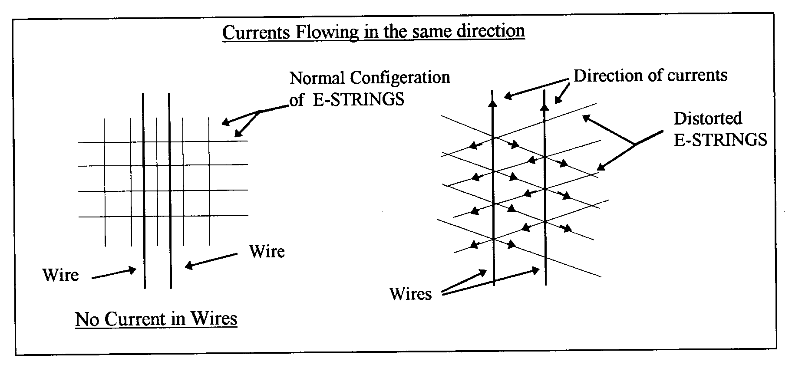
Figure 1. Currents (electrons) in the wires are flowing in the same direction, and therefore the force between the electrons is attractive. The right diagram that shows that the tension created in the E-Strings by the absolute motions of the electrons is pulling the wires together.
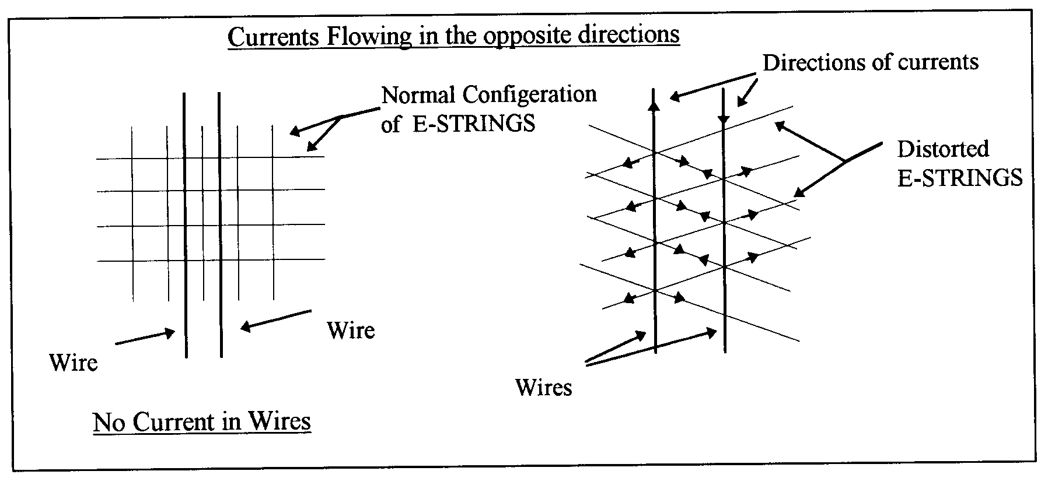
Figure 2. Currents (electrons) in the wires are flowing in the opposite direction, and therefore the force between the electrons is repulsive. The right diagram shows that the tension created in the E-Strings by the absolute motions of the electrons is pulling the wires apart.
Extending this interpretation of the electric-current experiments to include the orbiting motions of the S-Particles will enable us to explain all the nuclear forces between the interacting up quarks and down quarks [1,2]. This interpretation becomes the most important concept of Model Mechanics and it enables Model Mechanics to unite all the forces of nature naturally.

5 The CRE Force

Current physics posits that there are four forces of Nature: the electromagnetic force, the nuclear weak and strong forces, and gravity. Model Mechanics posits that there is a fifth force of Nature; the new force being the CRE force. As the name implies, the CRE force between any two objects is repulsive. While the CRE force is new to physical theory, it is not new to experience; it is what we commonly refer to as ‘inertia’. In other words, the resistance between two objects to change their state of absolute motion is the CRE force between them. The CRE force between any two objects is always repulsive, and it is derived from the diverging structure of the E-Matrix.
To understand the CRE force, recall the inverse square law of physics. This law states that the intensity of light, gravity and electromagnetic force decreases with increasing distance from the source is inversely proportional to . The geometry of neighboring E-Strings emanating from any two objects also obeys the inverse square law. This means that each object will follow the diverging geometry of these neighboring E-Strings. Therefore, their path of motions in the E-Matrix will have a tendency to diverge from each other. This repulsive effect is identified as the CRE force. The CRE force between any two objects is not constant; it increases with the square of the distance between the objects. The CRE force is not the cosmological constant that Einstein inserted into his original GRT field equations. Although the cosmological constant is repulsive, it is not the CRE force predicted by Model Mechanics for the simple reason that it is constant.
The CRE force played an important role in the formation of our Universe, and is continuing to do so today. The repulsive CRE force, along with the attractive electromagnetic force between gravitating objects shaped the primeval Universe into the Universe that we see today. The CRE force also played an important role in the manifestation of the nuclear weak force. Without the CRE force, there would be no nuclear weak force. It is the CRE force that initiates the radioactive decay of atoms. Perhaps, the most important function of the CRE force will be a role, in combination with the electromagnetic force, in the processes of life.
Model Mechanics predicted the repulsive CRE force in 1993. However, it was not discovered until 1998 when two independent groups of astronomers discovered that the Universe at the far reached regions is in a state of accelerated expansion. This observation is in direct conflict with the prediction of GRT. In order to explain this observation astronomers are now re-introducing the discarded repulsive Cosmological Constant to the GRT equation. The CRE force eliminates the need for this ad hoc approach.

６ Doppler Theory of Gravity (DTG)

Newton posited that gravity is a force, but he did not provide a mechanism for it. Newton’s gravity model involved the unexplained phenomenon of action at a distance, which was troublesome for the physicists of his time. Also, Newton’s equation for gravity was eventually found to be slightly inconsistent with observations. Recognizing the deficiencies in Newton’s theory, Einstein formulated GRT, which is not a theory of force, but rather a theory of space-time, amounting to an extension of SRT to include gravity. IRT is a completed new theory of relativity. It includes SRT as a subset and its equations are valid in all environments including gravity. It gives the same correct predictions for gravity as does GRT, but it avoids the following problematic predictions of GRT:
- The expansion rate of the Universe as predicted by GRT does not match what is currently observed. GRT predicts that the expansion of the Universe is slowing down, and yet observation confirms that the expansion is speeding up.
- The galactic rotational curves as predicted by GRT do not match those that are currently observed.
- The path of travel of Pioneer 10 as predicted by GRT does not match what is observed.
- GRT predicts the existence of black holes and singularities. If these absurd objects exist, they should be as abundant as the stars, and yet none them have been positively detected.
- GRT fails to predict the existence of dark matter and dark energy.
Model Mechanics also gives rise to a new theory of gravity called Doppler Theory of Gravity (DTG). Like Newton’s theory, DTG also treats gravity as a force but with an identified mechanism. Based on the provisions of Model Mechanics, the mechanism of gravity between two objects A and B moving in the stationary E-Matrix is as follows:
- If both A and B are moving absolutely in the same direction, this gives rise to an attractive force because A’s absolute motion distorts the surrounding stationary E-Matrix and B's absolute motion is confined to follow the distortion created by A; conversely, B’s absolute motion distorts the surrounding stationary E-Matrix and A's absolute motion is confined to follow the distortion created by B.
- The global structure of the stationary E-Matrix is divergent. Both A and B are confined to this global divergent structure as they travel in the stationary E-Matrix. This gives rise to the repulsive CRE force between A and B globally.
The force of gravity between A and B is the combined result of items (1) and (2). It is noteworthy that gravity is the sum of an attractive and a repulsive force acting on both A and B. This explains why the force of gravity is so weak compared to the electromagnetic and nuclear forces.
The above description for gravity suggests that the Newtonian equation for gravity can be modified to make it consistent with observations. The following is a modified Newtonian equation based on the above description for the force of gravity:

$F=\frac{G∗M_{a}M_{b}\left(j_{a}\right)⋅\left(±j_{b}\right)}{\left(r^{2}\right)\left({\text{DF}}_{a}\right)}$ （14）
$F$ = The force of gravity between A and B as determined by A
= Universal gravitational constant m³/s²*kg
$M_{a}$= Mass of object A in kg
$M_{b}$= Mass of object B in kg
= Dot product of the directional vectors $j_{a}$ and$j_{b}$. [Note: This dot product can be positive or negative.]
$r$= Distance in meters between A and B
${\text{DF}}_{a}$= Doppler Factor as determined by A
$${\text{DF}}_{a}={F_{\text{aa}}}/{F_{\text{ab}}}$$
$F_{\text{aa}}$= Frequency of a standard light source in A’s own frame as measured by A.
$F_{\text{ab}}$= Frequency of an identical standard light source in B's frame as measured by A. If is not constant, a mean value is used.
The dot product in this new equation expresses the concept that not all objects in the Universe attract each other gravitationally. A positive dot product represents an attractive force, but a negative dot product represents a repulsive force. Those objects that have the same direction of absolute motion are attracted to each other, but those objects that have absolute motions in the opposite direction exert a repulsive force on each other. Assuming the Big Bang model is correct then the dot product of the vectors for all local regions of the Universe is +1. This means that gravity in the local region is attractive. The dot product for a distant region, say beyond the radius of the observable Universe, is -1. Therefore, gravity for all those distant regions is repulsive.

7 Model Mechanics Explains the Problematic Cos-
mological Observations

One of the most pressing problems of the Standard Big Bang Model is the observed horizon problem. The age of our universe is determined to be 14 billion years old in all directions and yet we observe the horizon for the opposite regions of our universe to be 28 billion years apart. This means that these opposite regions of our universe cannot be in contact with each other at the Big Bang and this is known as the horizon problem. Cosmologists invented the ad hoc Inflation hypothesis to explain the horizon problem. Model Mechanics explains the horizon problem naturally without resorting to the ad hoc Inflation hypothesis. The earth is in a state of absolute motion in the E-Matrix. This motion curves the E-Strings surrounding the earth. What we perceive as normal and straight E-Strings are actually severely curved E-Strings. In other words, when we look up in the sky we are actually receiving light from these curved E-Strings. This means that no matter what direction we look we are looking into the same curved E-Strings and thus the same region of the universe. This means that the perceived opposite regions of the universe are really the same region and therefore the perceived horizon problem was never existed. As it turns out, there is a perfect physical example of this phenomenon. The medical device gastroscope made of fiber optics, allows a physician to examine the interior of a patient’s stomach is such an example. No matter how the physician curves the eyepiece, he will still be seeing the same picture of the stomach.
In 1998 two independent groups of astronomers discovered that the far reached regions of the universe are in a state of accelerated expansion motion. This discovery is contrary to the predictions of GRT that predicts that the expansion of the universe should be slowing down. Astronomers revived the once discarded repulsive Cosmological Constant to explain the observed accelerated expansion. They posited that the universe is filled with a form of dark energy called Quintessence and this dark energy has the anti-gravity effect that gives rise to the Cosmological Constant. Model Mechanics predicted the accelerated expansion for those far reached regions of the universe in 1993. The basis for this Model Mechanical prediction is that gravity at those regions is repulsive with respect to us as described in the DTG equation. The repulsive CRE force of DTG can be considered as the dark energy posited by the astronomers.
Another problem arise from the GRT description of gravity is called the flatness problem. The flatness problem is that the observable universe appears to exist between an open and a closed universe. In an open universe, the matter density is less than the critical value and thus the gravitational braking effect is not able to halt the Big Bang expansion. This means that the universe will keep on expanding forever. In a closed universe the matter density is greater than the critical value and thus the gravitational braking effect will be able to halt the Big Bang expansion. This means that the universe will re-collapse before any galaxy would have time to form. In order for our universe to exist between an open and a closed universe the matter density must be fine tuned to be within one part in 10⁵⁰ f the critical density value when the universe was a fraction of a second old. The inability of the Big Bang theory to explain why this degree of fine-tuning existed is what is known as the flatness problem. In Model Mechanics (DTG), gravity is the result of two gravitating objects having the same direction of absolute motions in the E-Matrix less the repulsive CRE force that exists between them. This description of gravity avoids the flatness problem completely.
The observed rotational curves of galaxies disagree with the predictions of GRT. These observed anomalous rotational curves correspond to curves for galaxies that are much more massive than the observed visible matters for these galaxies. The observed path of travel of the Pioneer 10 spacecraft disagrees with the predicted path given by GRT. Pioneer 10 was observed to be in a state of accelerated motion toward the sun. Astronomers explain both of these anomalous observations by claiming the existence of a dark matter in space although such an existence of dark matters are not within the framework of GRT or the Standard Model. Model Mechanics explains both of these anomalous observations by positing the existence of a dark matter in the form of free non-orbiting S-Particles. In the case of Pioneer 10, the sun and all the planets contain a concentration of free non-orbiting S-Particles. When Pioneer 10 is outside the solar system the effect of these concentrations of free S-Particles contribute to an extra attractive force on the spacecraft and causes it to accelerate toward the sun.

8 Proposed Experiments To Detect Absolute Mo-
tions

Model Mechanics is based on the existence of the E-Matrix. Therefore absolute motions of objects in the E-Matrix should be detectable. However, numerous past attempts to detect absolute motion were failures. The most notable of these is the Michelson-Morley Experiment (MMX) [2]. In this experiment a light beam was split into two parts that were directed along the two arms of the instrument at right angles to each other, the two beams being reflected back to recombine and form interference fringes. Any shift in the interference fringes as the apparatus is rotated would mean the detection of absolute motion of the apparatus. To everyone's chagrin, the MMX produced a null result. However, the MMX null result does not mean that there is no absolute motion of the apparatus. In their interpretation of the MMX null result Michelson-Morley failed to ask the relevant question: What is the direction of absolute motion of the apparatus with respect to the defined horizontal plane of the light rays that will produce a null result for all the orientations of the horizontal arms? The answer to this question is: If the apparatus is moving vertically then a null result will be obtained for all the orientations of the horizontal arms. What this mean is that the MMX as designed is not capable of detecting the absolute motion of the apparatus. In order to detect absolute motion using the MMX, the plane of the arms must be oriented vertically. This conclusion is supported by the observed gravitational red shift (gravitational potential) in the vertical direction.
The new interpretation of the MMX null result gives rise to a new concept for the propagation of light as follows:
How does light get from point A to point B? The current assumption is that, locally, light travels in a straight line towards the target, and that, in a train of light pulses, the first pulse hits the target is the first one the source generated. These assumptions both make sense if the target is stationary relative to the light pulses, but if the target moves the second assumption could be erroneous. Fig 3 describes a thought experiment that is currently used by physicists to derive the time dilation equation. A light clock is constructed of two mirrors parallel to each other with light pulses bouncing between them. In one period of the clock, a light pulse travels up to the top mirror and returns back to the bottom mirror. The diagram shows that the light pulse is presumed to travel a slant path when the light clock is in motion. This is not a realistic description of the actual event. It raises the question: How does light know when to follow a vertical path and when to follow one of the infinite numbers of slant paths? It is more realistic to say that light will always follow the perpendicular path on its way to the upper mirror. The reason is that the vertical path is the direction where all the light pulses are directed. Figure 4 shows this: the first pulse of a train of pulses follows the original path AB, but the pulse detected at “E” travels the path CE.

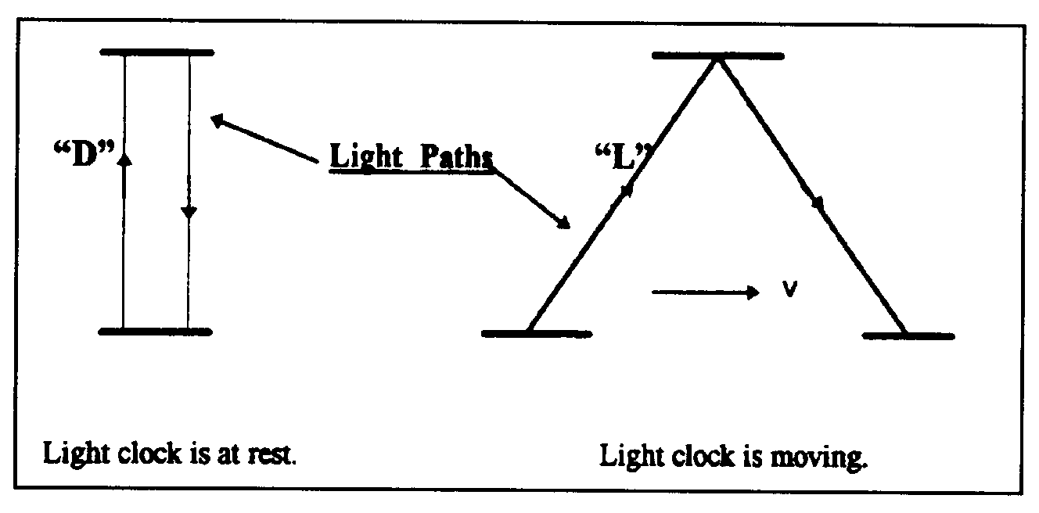
Figure 3. Light paths in a light clock at rest and in motion.

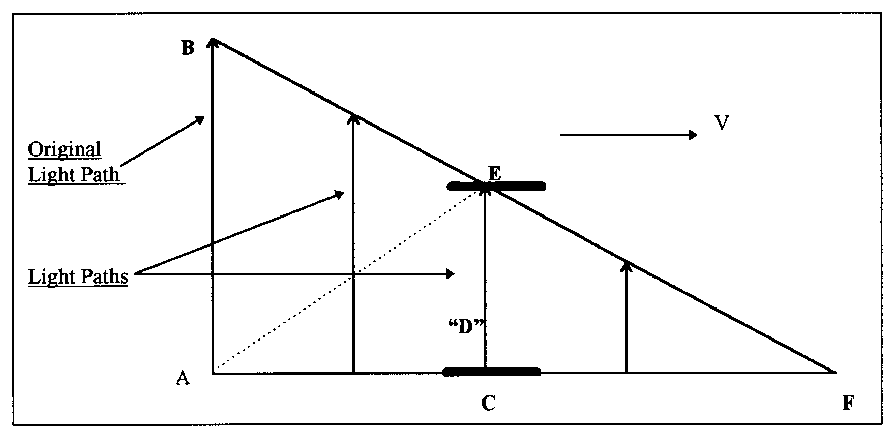
Figure 4. Current physics says that AE is the path that light follows to the upper mirror and the angle of this path is depended on the length AC that is depended on the speed of the light clock.
With this description of the light paths, the first pulse is never detected at “E." The light pulse detected at “E” is generated by the source at a later time. It turns out that this description of light paths is also capable of giving us the time dilation equation by using the Pythagorean theorem. The reason is that the original light path (AB) is equal to the assumed light path (AE) and both are the radii of a light sphere at the point of origin “A". It is noteworthy that as the speed of the mirrors approaches light speed a light pulse will take a longer time to reach the upper mirror. When the mirrors are moving at the speed of light, no light pulse is able to reach the upper mirror at all. Current physics interprets this situation as time standing still at the speed of light. The new interpretation is that time keeps on ticking at all speeds of the light clock. The amount of time (duration) passed depends on the length of the original light path AB divided by the speed of light ‘c’. This new interpretation suggests that absolute time for a moving frame is not slowed or dilated as currently assumed. The specific amount of absolute time (duration) required for light to travel the original light path AB is equal in all frames. A light clock runs slow when it is in motion because it is not catching the first light pulses, but rather some later one. The lower elapsed time recorded by a moving clock because the passage of time is not fully detected when the clock is in a state of motion.
The new interpretation of the MMX null result and the new concept for the propagation of light enable us to design the following experiments to detect absolute motion:

Experimental Set Up:
- Two sets of cesium clocks A1, A2 and B1, B2 are located at the middle of a 120 meters long straight rail track. Distances of 25 meters and 50 meters on both sides of the mid-point are marked off with a physical ruler.
- Each set of clocks is equipped with a laser light sources and a beam splitter that splits the laser beam into two continuous beams. One beam goes to detector “A” and the other goes to detector “B”.
- Each set of clocks is equipped with a shutter that allows the two laser beams to pass through it for any desired time intervals.
- Each set of clocks is equipped with a circular surface detector and the detecting surface can vary from 3 mm to 20 cm in diameter.
- Each set of clock is equipped with a reflecting mirror.
- A1 and B1 are not running. A2 and B2 are synchronized and running.

Experiment Group #1: To Detect The Absolute Motion of the Distant Clock at 50 Meters
- Move both sets of clocks simultaneously in the opposite directions at a rate of 10 meters/day (1 day = 86,400 seconds) and stop them at the 25 meters marks (after 2.5 days). The clocks are now 50 meters apart.
- Both detecting surfaces are set at 3mm in diameter.
- Do the following experiments from A’s location.
- A trial of the experiment is consisted of an opening and closing of the shutter for a specific time interval. The following trials at the following time intervals are made: 1 second, 2 seconds, 3 seconds, 4 seconds, 5 seconds, 6 seconds, 7 seconds, 8 seconds, 9 seconds and 10 seconds. The trials are conducted from A’s location.
- Laser beam A will activate and de-activate clock A1 for each trial and the results are identified as T’a1, T’a2, T’a3, T’a4, T’a5, T’a6, T’a7, T’a8, T’a9 and T’a10.
- Laser beam B will activate and de-activate clock B1 for each trial and the results are identified as T’b1, T’b2, T’b3, T’b4, T’b5, T’b6, T’b7, T’b8, T’b9 and T’b10.
- The difference in activation time between clocks A1 and B1 for each trial is identified as follows: ∆T’1, ∆T’2, ∆T’3, ∆T’4, ∆T’5, ∆T’6, ∆T’7, ∆T’8, ∆T’9, and ∆T’10.
- Increase the detecting surface to 20 cm in diameter then perform a trial using the 1-second time interval to establish that there is no difference in activation time between A1 and B1 for this large detecting surface. Now reduce the diameter of the detecting surface gradually to find the diameter where the activation time between A1 and B1 start to show a difference. Call this critical diameter$D_{\text{50}}$.
- Cover the detecting surface completely with a 20 cm diameter dish. A slit of 2mm wide is cut from the center of the dish to the outer rim of the dish. Slowly rotate the dish to find the direction of absolute motion of the detector. That direction is evident when the slit is in line with the direction of absolute motion of the detector and activates the clock B1 for the same amount of time as the shutter opening and closing at A’s location.
- Repeat the above experiments from the “B” location.

The SRT Predictions For Group #1 Experiments:
  - The activation time for the B1 clock is the same as that for the A1 clock for all trials.
  - The difference in activation time between A1 and B1 is zero for each trial. ∆T’1=∆T’2=∆T’3=∆T’4=∆T’5=∆T’6=∆T’7=∆T’8=∆T’9=∆T’10=0.
  - Increase the diameter of the detecting surface will have no effect on activation time on the B1 clock for each trial.
  - There is no absolute motion of clock B1 and therefore there is no direction of absolute motion.
  - Repeating the above experiments from the B location will get the same results as above.

The Model Mechanical Predictions For Group #1 Experiments:
- The activation time for the B1 clock is less than that for the A1 clock for each trial. This is due to the B1 clock is in a state of absolute motion in the vertical direction while the laser is in transit from A to B.
- The difference in activation time between A1 and B1 is the same for each trial and it is greater than zero.
- Increase the diameter of the detecting surface will bring the activation time for the B1 clock equal to that of the A1 clock.
- The absolute motion of the clock B1 ($V_{\text{50}}$) can be calculated using the following equation:
- $V_{\text{50}}$$=\frac{D_{\text{50}}}{2{ΔT}^{'}1}$ （15）
- The direction of absolute motion of the B1 clock is vertical.
- Repeating the above experiments from the “B” location will get the same results as above.

Experiment Group #2: Measure the One-Way and Two-Way Speed of Light at 50 Meters
- The clocks A2 and B2 are 50 meters apart and are still synchronized according to SRT and Model Mechanics.
- Measure the one-way speed of light using clocks A2 and B2 from the “A” location.
- Measure the one-way speed of light using clocks B2 and A2 from the “B” location.
- Measure the two-way speed of light using clock A2.
- Measure the two-way speed of light using clock B2.

The SRT Predictions For Group #2 Experiments:
- The one-way speed of light is c as measured from the “A” location.
- The one-way speed of light is c as measured from the “B” location.
- The one-way speed of light is isotropic.
- The two-way speed of light is c using clock A2.
- The two-way speed of light is c using clock B2.
- The two-way speed of light is isotropic.

The Model Mechanical Predictions For Group #2 Experiments:
- The value for the one-way speed of light is less than c as measured from the “A” location.
- The value for the one-way speed of light is less than c as measured from the “B” location.
- The one-way speed of light is isotropic. In other words, the value for the one-way speed of light from A→B is equal to from B→A.
- The calculated value for the one-way speed of light can be make to equal to c by reducing the measured flight time by a factor of (∆T’1).
- The two-way speed of light is c using clock A2.
- The two-way speed of light is c using clock B2.
- The two-way speed of light is isotropic.

Experiment Group #3: To Detect The Absolute Motion Of The Distant Clock At 100 Meters
- Move both sets of clocks at the 25 meters marks simultaneously in the opposite directions at a rate of 10 meters/day and stop them at the 50 meters marks (after 2.5 days). The clocks are now 100 meters apart.
- Both detecting surfaces are set at 3mm in diameter.
- Do the following experiments from A’s location.
- A trial of the experiment is consisted of an opening and closing of the shutter for a specific time interval. The following trials at the following time intervals are made: 1 second, 2 seconds, 3 seconds, 4 seconds, 5 seconds, 6 seconds, 7 seconds, 8 seconds, 9 seconds and 10 seconds. The trials are conducted from A’s location.
- Laser beam A will activate and de-activate clock A1 for each trial and the results are identified as T”a1, T”a2, T”a3, T”a4, T”a5, T”a6, T”a7, T”a8, T”a9 and T”a10.
- Laser beam B will activate and de-activate clock B1 for each trial and the results are identified as T”b1, T”b2, T”b3, T”b4, T”b5, T”b6, T”b7, T”b8, T”b9 and T”b10.
- The difference in activation time between clocks A1 and B1 for each trial is identified as ∆T”1, ∆T”2, ∆T”3, ∆T”4, ∆T”5, ∆T”6, ∆T”7, ∆T”8, ∆T”9, and ∆T”10.
- Increase the detecting surface to 20 cm in diameter then perform a trial using the 1-second time interval to establish that there is no difference in activation time between A1 and B1 for this large detecting surface. Now reduce the diameter of the detecting surface gradually to find the diameter where the activation time between A1 and B1 start to show a difference. Call this critical diameter$D_{\text{100}}$.
- Cover the detecting surface completely with a 20 cm diameter dish. A slit of 3mm wide is cut from the center of the dish to the outer rim of the dish. Slowly rotate the dish to find the direction of absolute motion of the detector. That direction is evident when the slit is in line with the direction of absolute motion of the detector and activates the clock B1 for the same amount of time as the shutter opening and closing at A’s location.
- Repeat the above experiments from the “B” location.

The SRT Predictions For Group #3 Experiments:
- The difference in activation time between A1 and B1 is zero for each trial. ∆T”1=∆T”2=∆T”3=∆T”4=∆T”5=∆T”6=∆T”7=∆T”8=∆T”9=∆T”10=0.
- Increase the diameter of the detecting surface will have no effect on activation time on the B1 clock for each trial.
- There is no absolute motion of clock B1 and therefore there is no direction of absolute motion.
- Repeating the above experiments from the B location will get the same results as above.

The Model Mechanical Predictions For Group #3 Experiments:
- The activation time for the A1 clock is greater than that for the B1 clock for each trial. This is due to the B1 clock is in a state of absolute motion in the vertical direction while the laser is in transit from A to B.
- The difference in activation time between A1 and B1 is the same for each trial.
- ∆T”1=∆T”2=∆T”3=∆T”4=∆T”5=∆T”6=∆T”7=∆T”8=∆T”9=∆T”10
- Increase the diameter of the detecting surface will bring the activation time for the B1 clock equal to that of the A1 clock.
- The absolute motion of the clock B1 ($V_{\text{100}}$) can be calculated using the following equation:
$V_{\text{100}}$$=\frac{D_{\text{100}}}{2{ΔT}^{\text{\} \} 1\} \} \} \{}}}$ （16）
- The direction of absolute motion of the B1 clock is vertical.
- Repeating the above experiments from the “B” location will get the same results as above.

Experiment Group #4: To Measure The One-Way And Two-Way Speed Of Light
  - The clocks A2 and B2 are 100 meters apart and are still synchronized according to SRT and Model Mechanics.
  - Measure the one-way speed of light using clocks A2 and B2 from the “A” location.
  - Measure the one-way speed of light using clocks B2 and A2 from the “B” location.
  - Measure the two-way speed of light using clock A2.
  - Measure the two-way speed of light using clock B2.

The SRT Predictions For Group #4 Experiments:
- The one-way speed of light is c as measured from the “A” location.
- The one-way speed of light is c as measured from the “B” location.
- The one-way speed of light is isotropic.
- The two-way speed of light is c using clock A2.
- The two-way speed of light is c using clock B2.
- The two-way speed of light is isotropic.

The Model Mechanical Predictions For Group #4 Experiments:
- The value for the one-way speed of light is less than c as measured from the “A” location.
- The value for the one-way speed of light is less than c as measured from the “B” location.
- The one-way speed of light is isotropic. In other words, the value for the one-way speed of light from A→B is equal to from B→A.
- The calculated value for the one-way speed of light can be make to equal to c by reducing the measured flight time by a factor of (∆T”1).
- The two-way speed of light is c using clock A2.
- The two-way speed of light is c using clock B2.
- The two-way speed of light is isotropic.

９ Conclusions:

Model Mechanics leads to a new theory of relativity called IRT. IRT includes SRT as a subset. However, its equations are valid in all environments—including gravity. Model Mechanics also give rise to a new theory of gravity called DTG. Both IRT and DTG give matching predictions as GRT but they avoid the problematic predictions of GRT. A new interpretation of the MMX null results leads to a new concept for the propagation of light. This, in turn, enables us to design viable experiments to detect absolute motion. Performing these designed experiments will confirm the existence of absolute motion that, in turn, will provide a way to unify all of physic.

Correspondence to:
Ken H. Seto
KHS Publishing
260 Yorkshire Lane
Xenia, OH 45385, USA
Telephone: 937-372-5298
Email: kenseto@erinet.com
http://www.erinet.com/kenseto/book.html

References
- Seto KH. Unification of Physics. Journal of the Theoretics. pp 5-11, ttp://www.journaloftheoretics.com/Links/Papers/Seto.pdf
- Seto K.H. Unification of Physics. http://www.geocities.com/kn_seto/2005Unification.pdf
- Seto KH. The Physics of Absolute Motion. ISBN0-9647136-1-6, KHS Publishing, pp 57-70, http://www.erinet.com/kenseto
/book.html

