Physics and Cosmology Based on Absolute Motion

Ken H. Seto

KHS Publishing, 260 Yorkshire Lane, Xenia, OH 45385, USA; kenseto@erinet.com; http://www.erinet.com/kenseto/book.html; Telephone: 937-372-5298

Abstract: A new model of the universe called Model Mechanics has been formulated. Model Mechanics explains all the forces of nature with the same mechanism and thus it is able to unite all the forces of nature naturally. Model Mechanics enables us to describe all the processes and interactions in terms of absolute motion of S-Particle or S-Particle systems (a new description of matter) in the E-Matrix (a new description of physical space). Gravity is the attractive force between two objects having the same direction of absolute motion in combination with the repulsive CRE force creates by the same absolute motion of the objects. This explains why the force of gravity is so weak compared to the other forces. [Nature and Science. 2005;3(2):5-20].

Key Words: Physics and cosmology； Absolute motion

Introduction

A new model of the universe called Model Mechanics has been formulated. Model Mechanics explains all the forces of nature with the same mechanism and thus it is able to unite all the forces of nature naturally. In cosmology, Model Mechanics provides solutions to the following problematic cosmological observations: the observed accelerated expansion of the far reached regions of the universe; the observed rotational curves of galaxies disagree with the predictions of GRT; the observed paths of travel of the space crafts Pioneer 10 and 11 disagree with the predictions of GRT and the observable universe appear to have a much larger horizon than it is allowed by its observed age.
Model Mechanics leads to a new theory of gravity called Doppler Theory of Gravity (DTG) and unites gravity with the electromagnetic and nuclear forces naturally [1,2]. It also leads to a complete theory of motion called IRT (Improved Relativity Theory). IRT includes SRT as a subset. However, unlike SRT, the equations of IRT are valid in all environments, including gravity.
Model Mechanics is based on the existence of absolute motions of objects in a stationary and structured light-conducting medium called the E-Matrix. New interpretations of past experiments such as the Michelson-Morley experiment (MMX) [3] enables us to conclude that on earth the direction of absolute motion is in the vertical direction. Based on that interpretation, proposed new experiments to detect absolute motions in the E-Matrix have been formulated.

Model Mechanics Description of The Current Universe
Model Mechanics supposes that a stationary substance, called the ‘E-Matrix’, occupies all of pure-space (void) in our Universe. Subsequently, we perceive the E-Matrix as space. The E-Matrix, in turn, is composed of ‘E-Strings’, which are very thin three-dimensional elastic objects, of diameter estimated at cm. The length of an E-String is not defined. Away from matter, the E-Strings are oriented randomly in all directions. This means that a slice of the E-Matrix in any direction will look the same. Near matter, the E-Strings are more organized: some emanate from the matter, and the number of these passing through a unit area followed the well-known inverse square law of physics. The E-Strings repel each other. This means that there is an unknown outside force that is compacting them together. The repulsive force and the compacting force are in equilibrium. This state of the E-Matrix allows massive matter particles to move freely within it. The motion of a matter particle or particle system in the E-Matrix is called ‘absolute motion’. The absolute motion of matter in the E-Matrix will distort the local E-Strings. The E-Strings will recover to the non-distorted state after the passage of the matter particles. Light consists of wave-packets in neighboring E-Strings. On its way toward its target, a wave-packet will follow the geometry of these neighboring E-Strings. This description of light embodies ‘duality’, i.e. light possessing properties of a mass-bearing particle as well as a wave packet.
With this description of the E-Matrix (space), the next relevant question is: What is matter? All stable and visible matter is made from three basic particles: the electrons, the up quarks, and the down quarks. The protons and neutrons in the nuclei of all the atoms are made from the up quarks and the down quarks. The electrons orbit around the nuclei to complete the picture of all the atoms. The three basic particles are, in turn, made from one truly fundamental mass-bearing particle, called the ‘S-Particle’. An S-Particle is a three-dimensional spherical object. It is repulsive to the E-Strings surrounding it and therefore its motion in the E-Matrix is maintained. An S-Particle orbiting around an E-String in the helical counterclockwise direction is an electron. This motion of the S-Particle is the fastest in the E-Matrix, and it gives rise to one unit of negative electric charge. A down quark is also an S-Particle orbiting around an E-String in the helical counterclockwise direction. The speed of its orbiting motion is only 1/3 that of the electron, giving the down quark a negative 1/3 electric charge. An up quark is an S-Particle orbiting around an E-String in the helical clockwise direction at 2/3 the speed of the electron, resulting a 2/3 positive electric charge.
There is one more stable basic particle: the electron neutrino. An electron neutrino has no detectable electric charge, and therefore it does not interact with the other three charged basic particles. It is composed of an S-Particle orbiting around an E-String in the counterclockwise direction like the electron. However, it is moving in a corkscrew like motion away from the charged basic particles. This means that the distortion in the E-Matrix created by the absolute motion of the S-Particle of the electron neutrino will have already dissipated by the time the charged basic particles are ready to interact with it. This is the reason why the electron neutrino does not interact electromagnetically with the charged basic particles.
This simple description of all stable visible matter can answer the thorny question: What is the mass of a basic particle? The answer is: mass is the evidence of the orbiting diameter of its S-Particle. Those S-Particles that are not in a state of orbiting motion do not possess any electric charge and therefore they will not interact with the basic charged particles electrically. They will, however, interact with them gravitationally. They are the dark matters predicted by the astronomers.
The next relevant question is: what are the processes that give rise to all the forces between matter particles? The proposed answers to this question are as follows:
- All the processes of Nature are the result of matter particles reacting to the geometries of the E-Strings (i.e. distortions or waves) to which they are confined because of their orbiting motions around these E-Strings.
- Absolute motions of two objects in the same direction in the E-Matrix will cause the objects to converge to each other--an attractive force. Absolute motions of two objects in the opposite directions in the E-Matrix will cause the objects to
diverge from each other--a repulsive force.
This completes the Model Mechanical description of our current universe. All the particles, all the forces and all the processes of nature can be derived from this one description. Model Mechanics replaces the math constructs of space-time and field/virtual particle with the E-Matrix and the distortions or waves in the E-Matrix. The math of the Standard Model is compatible with Model Mechanics and therefore we can use it in combination with the Model Mechanical interpretations to give us better explanations for all the processes of nature.

IRT: Improved Relativity Theory
Special Relativity Theory (SRT) posits that the speed of light is a universal constant in all inertial frames, but suppose the speed of light is not a universal physical constant as asserted by the SRT, but rather a constant mathematical ratio as follows:
This new interpretation for the speed of light revives the discarded notion of absolute time and physical space. It also makes the notion of absolute time and space compatible with SRT. Based on this interpretation for light speed, a new theory has been formulated for motion: Improved Relativity Theory (IRT). IRT includes SRT as a subset, but its equations are valid in all environments—including gravity. The following is a description of IRT:

The Postulates of IRT:
- The laws of physics based on a clock second and a light-second to measure length are the same for all observers in all inertial reference frames.
- The speed of light in free space based on a clock second and a light-second to measure length has the same mathematical ratio c in all directions and all inertial frames.
- The laws of physics based on a defined absolute second and the physical length of a rod is different in different frames of reference.
- The one-way speed of light in free space based on a defined absolute second and the physical length of a measuring rod has a different mathematical ratio for light speed in different inertial frames. The speed of light based on a defined absolute second and the physical length of a measuring rod is a maximum in the rest frame of the E-Matrix.

The Consequences of these Postulates:
- The speed of light is not a universal constant. It is a constant math ratio as follows:
Light path length of rod (299,792,458 m)/the absolute time content for a clock second co-moving with the rod.
The detailed explanation of this new definition:
By definition the speed of light in the rest frame of the E-Matrix is as follows:
Light path length of rod in the E-Matrix frame = 299,792,458m.
The absolute time content for a clock second in the E-Matrix frame = 1 E-Matrix frame clock second.
Therefore the speed of light in the E-Matrix frame is: 299,792,458m/1 E-Matrix clock second
The speed of light in any frame moving in the stationary E-Matrix is determined as follows:
The light path length of rod in the moving frame= γ (299,792,458m)
The absolute time content for a moving clock second= γ (E-Matrix clock seconds)
Therefore the speed of light in any moving frame in the stationary E-Matrix is as follows:
γ (299,792,458m) / γ (E-Matrix clock seconds).
This is reduced to a constant math ratio of: 299,792,458m/1 E-Matrix clock second
- The physical length of a rod remains the same in all frames of reference. The light path length of a rod changes with the state of absolute motion of the rod. The higher is the state of absolute motion the longer is its light path length.
- The rate of a clock is dependent on the state of absolute motion of the clock. The higher is the state of absolute motion the slower is its clock rate.
- Absolute time exists. The relationship between clock time and absolute time is as follows: A clock second will contain a different amount of absolute time in different states of absolute motion (different frames of reference). The higher is the state of absolute motion of the clock the higher is the absolute time content for a clock second.
- Simultaneity is absolute. If two events are simultaneous in one frame, identical events will also be simultaneous in different frames. However the time interval for the simultaneity to occur will be different in different frames. This is due to that different frames are in different states of absolute motion.
- Relative motion between two observers A and B is the vector difference of the vector component of A's absolute motion and the vector component of B's absolute motion along the line joining A and B.

The Math of IRT:
- The time dilation (contraction) or expansion equations:
A and B are in relative motion from observer A's point of view:
$T_{\text{ab}}=T_{\text{aa}}\left(\frac{F_{\text{aa}}}{F_{\text{ab}}}\right)$ （1）
OR
$T_{\text{ab}}=T_{\text{aa}}\left(\frac{F_{\text{ab}}}{F_{\text{aa}}}\right)$ （2）

$T_{\text{aa}}$= A clock time interval in observer A's frame as measured by A
$T_{\text{ab}}$ = A's prediction of B's clock time interval for an interval of $T_{\text{aa}}$ in his frame.
$F_{\text{aa}}$ = Frequency of a standard light source in A's frame as measured by A.
$F_{\text{ab}}$ = Frequency of an identical light source in B's frame as measured by A. If $F_{\text{ab}}$ is
not constant the mean value is used.
Note: Even though $T_{\text{aa}}$ and $T_{\text{ab}}$ are two different clock time intervals but both of these clock time intervals contain the same amount of absolute time.
- The light path length contraction or expan-
sion equations:
$L_{\text{ab}}=L_{\text{aa}}\left(\frac{F_{\text{aa}}}{F_{\text{ab}}}\right)$ （3）
OR
$L_{\text{ab}}=L_{\text{aa}}\left(\frac{F_{\text{ab}}}{F_{\text{aa}}}\right)$ （4）
$L_{\text{aa}}$ = The light path length of a rod in A's frame as measured by A.
$L_{\text{ab}}$ = The light path length of an identical rod in B's frame as predicted by A.
Note: Even though $L_{\text{aa}}$ and $L_{\text{ab}}$ are two different light path lengths but these two light path lengths are derived from identical rods that have the same physical rod lengths. The different light path lengths are the results of different states absolute motion of the rods.
- The Coordinate Transformation Equations:
$x'=\frac{f_{\text{aa}}}{f_{\text{ab}}}\left[x+t\left(f_{\text{aa}}−f_{\text{ab}}\right)λ\right]$ （5）
$t'=\frac{f_{\text{aa}}}{f_{\text{ab}}}\left[t+x\left(\frac{\left(f_{\text{aa}}−\text{fab}\right)}{{λf}_{\text{aa}}^{2}}\right)\right]$ （6）
OR
$x'=\frac{f_{\text{ab}}}{f_{\text{aa}}}\left[x−t\left(f_{\text{aa}}−f_{\text{ab}}\right)λ\right]$ （7）
$t'=\frac{f_{\text{ab}}}{f_{\text{aa}}}\left[t−x\left(\frac{\left(f_{\text{aa}}−f_{\text{ab}}\right)}{{λf}_{\text{aa}}^{2}}\right)\right]$ （8）
A is the observer's frame (unprimed) and B is the observed frame (primed).
$f_{\text{aa}}$ = The instantaneous frequency measurement of a standard light source in A's
frame as measured by A.
$f_{\text{ab}}$ = The instantaneous frequency measurement of an identical light source in B's
frame as measured by A.
$λ$= The wave length of the standard light source in A's frame as measured by A.

These coordinate transform equations are valid in all environments--including gravity. This means that IRT will give matching predictions as GRT and at the same time includes SRT as a subset.
- Momentum of an object:
$p=M_{o}λ\left(F_{\text{aa}}−F_{\text{ab}}\right)$ （9）
- Kinetic Energy of an object:
$K=M_{o}λ^{2}F_{\text{aa}}^{2}\left(\frac{F_{\text{aa}}}{F_{\text{ab}}}−1\right)$ （10）
- Energy of a single particle:
$E=M_{o}λ^{2}F_{\text{aa}}^{2}$ （11）
- Gravitational Red or Blue Shift:
${ΔF}_{\text{aa}}=F_{\text{aa}}\left(1−\left(\frac{F_{\text{ab}}}{F_{\text{aa}}}\right)\right)$ （12）
A positive value represents a red shift from A's location. A negative value represents a
blue shift from A's location.
- Gravitational Time Contraction (Dilation) or Expansion:
${ΔT}_{\text{aa}}=T_{\text{aa}}\left(1−\left(\frac{F_{\text{ab}}}{F_{\text{aa}}}\right)\right)$ （13）
A positive value represents gravitational time contraction (dilation) from A's location.
A negative value represents gravitational time expansion from A's location.
- The IRT procedure for determining the perihelion precession of Mercury without recourse to GRT is:
a) Set up a coordinate system for the Sun and Mercury.
b) Use the IRT coordinate transformation equations to predict the future positions of the Sun and Mercury.
c) The perihelion shift of Mercury will be revealed when these future positions are plotted against time. Also, the value of the shift can be determined from the plot.

Forces Based on Absolute Motions
The idea that absolute motion of interacting particles in the same direction gives rise to an attractive force, while absolute motion of interacting particles in the opposite directions gives rise to a repulsive force, is derived from the familiar electric current experiments in parallel wires. These experiments show that when electric currents are flowing in the wires in the same direction, the wires are attracted to each other, and when the currents are flowing in the opposite direction, the wires repel each other. Figures 1 and 2 illustrate these experiments graphically. The absolute motions of the electrons in the same direction cause a distortion in the E-Matrix that pulls the wires together--an attractive force. Conversely, the directions of absolute motion of the electrons in the opposite directions will cause a distortion in the E-Matrix that pulls the wires apart−a repulsive force.

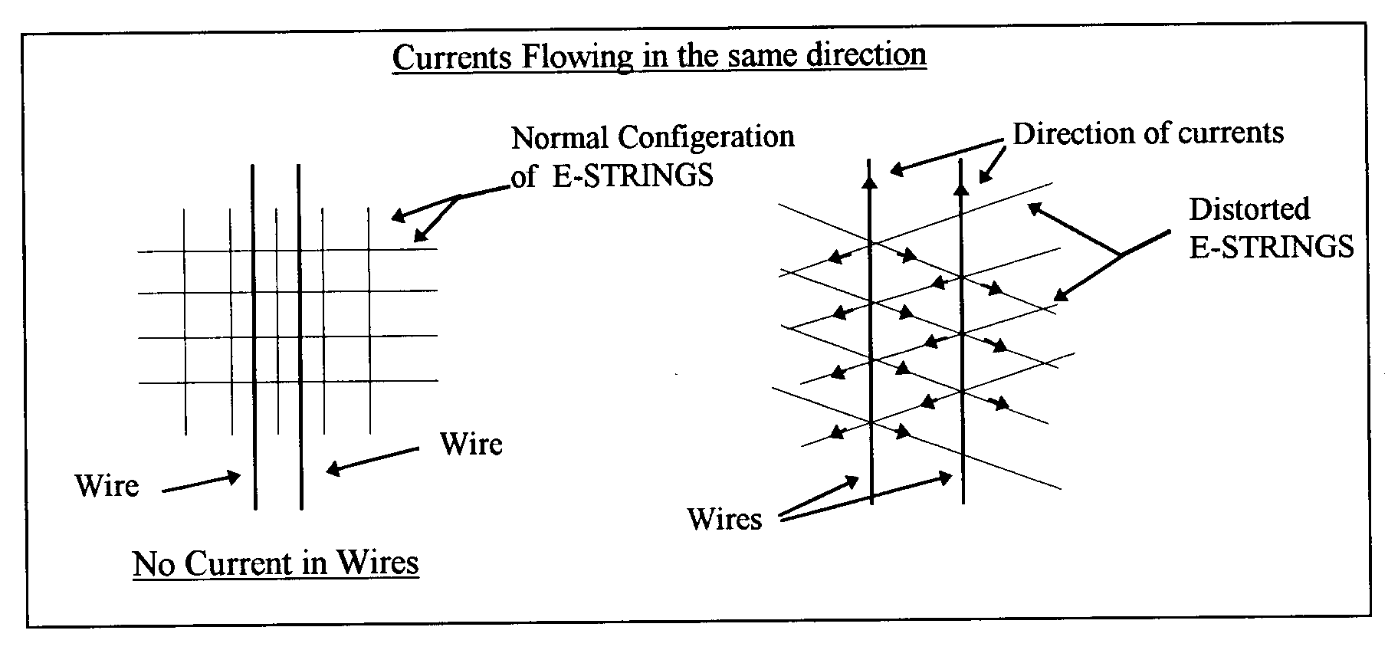
Figure 1. Currents (electrons) in the wires are flowing in the same direction, and therefore the force between the electrons is attractive. The right diagram that shows that the tension created in the E-Strings by the absolute motions of the electrons is pulling the wires together.

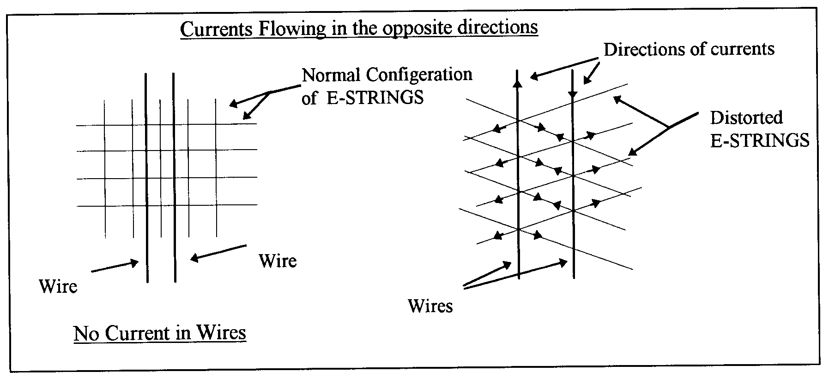
Figure 2. Currents (electrons) in the wires are flowing in the opposite direction, and therefore the force between the electrons is repulsive. The right diagram shows that the tension created in the E-Strings by the absolute motions of the electrons is pulling the wires apart.

Extending this interpretation of the electric-current experiments to include the orbiting motion of the S-Particles will enable us to explain all the nuclear forces between the interacting up quarks and down quarks [1,2]. This interpretation becomes the most important concept of Model Mechanics and it enables Model Mechanics to unite all the forces of nature naturally.

The CRE Force
Current physics posits that there are four forces of Nature: the electromagnetic force, the nuclear weak and strong forces, and gravity. Model Mechanics posits that there is a fifth force of Nature; the new force being the CRE force. As the name implies, the CRE force between any two objects is repulsive. While the CRE force is new to physical theory, it is not new to experience; it is what we commonly refer to as ‘inertia’. In other words, the resistance between two objects to change their state of absolute motion is the CRE force between them. The CRE force between any two objects is always repulsive, and it is derived from the diverging structure of the E-Matrix.
To understand the CRE force, recall the inverse square law of physics. This law states that the intensity of light, gravity and electromagnetic force decreases with increasing distance from the source is inversely proportional to . The geometry of neighboring E-Strings emanating from any two objects also obeys the inverse square law. This means that each object will follow the diverging geometry of these neighboring E-Strings. Therefore, their path of motions in the E-Matrix will have a tendency to diverge from each other. This repulsive effect is identified as the CRE force. The CRE force between any two objects is not constant; it increases with the square of the distance between the objects. The CRE force is not the cosmological constant that Einstein inserted into his original GRT field equations. Although the cosmological constant is repulsive, it is not the CRE force predicted by Model Mechanics for the simple reason that it is constant.
The CRE force played an important role in the formation of our Universe, and is continuing to do so today. The repulsive CRE force, along with the attractive electromagnetic force between gravitating objects shaped the primeval Universe into the Universe that we see today. The CRE force also played an important role in the manifestation of the nuclear weak force. Without the CRE force, there would be no nuclear weak force. It is the CRE force that initiates the radioactive decay of atoms. Perhaps, the most important function of the CRE force will be a role, in combination with the electromagnetic force, in the processes of life.
Model Mechanics predicted the repulsive CRE force in 1993. However, it was not discovered until 1998 when two independent groups of astronomers discovered that the Universe at the far reached regions is in a state of accelerated expansion. This observation is in direct conflict with the prediction of GRT. In order to explain this observation astronomers are now re-introducing the discarded repulsive Cosmological Constant to the GRT equation. The CRE force eliminates the need for this ad hoc approach.

Doppler Theory of Gravity (DTG)
Newton posited that gravity is a force, but he did not provide a mechanism for it. Newton’s gravity model involved the unexplained phenomenon of action at a distance, which was troublesome for the physicists of his time. Also, Newton’s equation for gravity was eventually found to be slightly inconsistent with observations. Recognizing the deficiencies in Newton’s theory, Einstein formulated GRT, which is not a theory of force, but rather a theory of space-time, amounting to an extension of SRT to include gravity. IRT is a completed new theory of relativity. It includes SRT as a subset and its equations are valid in all environments…including gravity. It gives the same correct predictions for gravity as does GRT, but it avoids the following problematic predictions of GRT:
- The expansion rate of the Universe as predicted by GRT does not match what is currently observed. GRT predicts that the expansion of the Universe is slowing down, and yet observation confirms that the expansion is speeding up.
- The galactic rotational curves as predicted by GRT do not match those that are currently observed.
- The path of travel of Pioneer 10 as predicted by GRT does not match what is observed.
- GRT predicts the existence of black holes and singularities. If these absurd objects exist, they should be as abundant as the stars, and yet none them have been positively detected.
- GRT fails to predict the existence of dark matter and dark energy.
Model Mechanics also gives rise to a new theory of gravity called Doppler Theory of Gravity (DTG). Like Newton’s theory, DTG also treats gravity as a force but with an identified mechanism. Based on the provisions of Model Mechanics, the mechanism of gravity between two objects A and B moving in the stationary E-Matrix is as follows:
- If both A and B are moving absolutely in the same direction, this gives rise to an attractive force because A’s absolute motion distorts the surrounding stationary E-Matrix and B's absolute motion is confined to follow the distortion created by A; conversely, B’s absolute motion distorts the surrounding stationary E-Matrix and A's absolute motion is confined to follow the distortion created by B.
- The global structure of the stationary E-Matrix is divergent. Both A and B are confined to this global divergent structure as they travel in the stationary E-Matrix. This gives rise to the repulsive CRE force between A and B globally.
The force of gravity between A and B is the combined result of items (1) and (2). It is noteworthy that gravity is the sum of an attractive and a repulsive force acting on both A and B. This explains why the force of gravity is so weak compared to the electromagnetic and nuclear forces.
The above description for gravity suggests that the Newtonian equation for gravity can be modified to make it consistent with observations. The following is a modified Newtonian equation based on the above description for the force of gravity:
$F=G∗M_{a}M_{b}\left(j_{a}\right)⋅\left(±j_{b}\right)/\left(r^{2}\right)\left({\text{DF}}_{a}\right)$ （14）
$F$ = The force of gravity between A and B as determined by A
= Universal gravitational constant m³/s²*kg
$M_{a}$= Mass of object A in kg
$M_{b}$= Mass of object B in kg
$\left(j_{a}\right)⋅\left(j_{b}\right)$= Dot product of the directional vectors $j_{a}$ and$j_{b}$. [Note: This dot product can be positive or negative.]
$r$= Distance in meters between A and B
${\text{DF}}_{a}$= Doppler Factor as determined by A
$${\text{DF}}_{a}={F_{\text{aa}}}/{F_{\text{ab}}}$$
$F_{\text{aa}}$= Frequency of a standard light source in A’s own frame as measured by A.
$F_{\text{ab}}$= Frequency of an identical standard light source in B's frame as measured by A. If is not constant, a mean value is used.
The dot product $\left(j_{a}\right)⋅\left(j_{b}\right)$ in this new equation expresses the concept that not all objects in the Universe attract each other gravitationally. A positive dot product represents an attractive force, but a negative dot product represents a repulsive force. Those objects that have the same direction of absolute motion are attracted to each other, but those objects that have absolute motions in the opposite direction exert a repulsive force on each other. Assuming the Big Bang model is correct then the dot product of the vectors for all local regions of the Universe is +1. This means that gravity in the local region is attractive. The dot product for a distant region, say beyond the radius of the observable Universe, is -1. Therefore, gravity for all those distant regions is repulsive.

The Electromagnetic Force
This is the force observed between charged particles. It was determined that like-charged particles exert a repulsive force on each other while unlike charged particles exert an attractive force on each other. The reader will recall that a charged particle is the result of a clockwise or counterclockwise orbiting motion of its S-Particle around a specific E-String. A clockwise orbiting motion of the S-Particle gives rise to a positively charged particle. A counterclockwise orbiting motion of the S-Particle gives rise to a negatively charged particle. The charges between the interacting particles determine whether the force between them is attractive or repulsive. The following diagrams describe the electromagnetic force in Model Mechanical terms:

Interaction Between Negatively Charged Particles
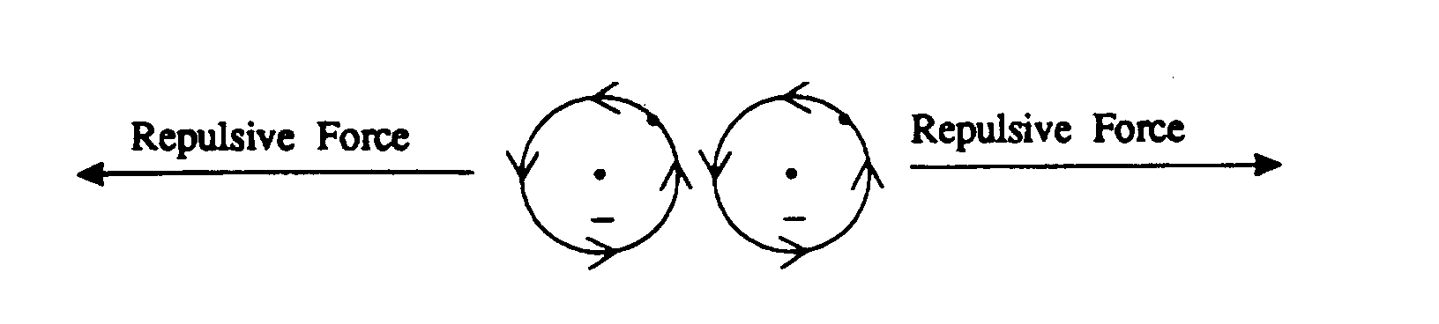

Figure 3. The force exerts on each other by two negatively charged particles. In this case, the S-Particles are traveling in the opposite directions and therefore the force between these particles is repulsive.

Interaction Between Positively Charged Particles

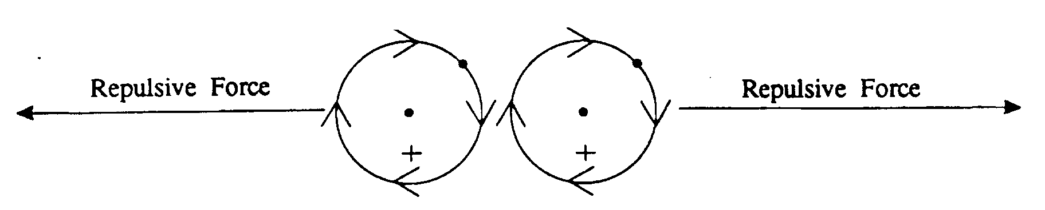
Figure 4. The force exerts on each other by two positively charged particles. In this case, the S-Particles are traveling in the opposite directions and therefore the force between the resulting particles is repulsive.

Interaction: Negatively and Positively Charged Particles

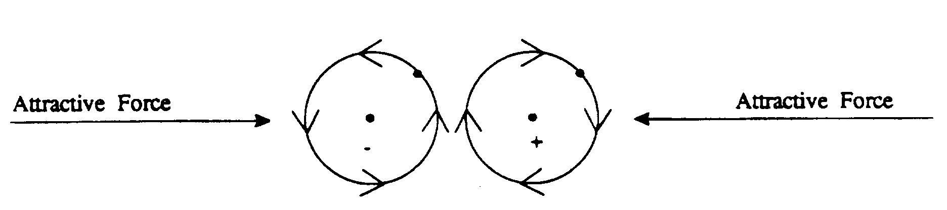

Figure 5. The force exerts on each other by a negatively and a positively charged particle. At the nearest point of approach the S-Particles are traveling in the same direction and therefore the force between them is attractive.

Note: The net attractive or repulsive force between any two interacting charged particles is not a constant force. The net force is determined by the direction of orbiting motions of their S-Particles at the closet point of approach. When the S-Particles are moving in the same direction at the closest point of approach then the net force between the charged particles is attractive. Conversely, when the S-Particles are moving in the opposite directions then the net force between the charged particles is repulsive. It is noteworthy to point out that the force between any two charged particles is alternating between attractive and repulsive for one complete orbit of their S-Particles. This property of the electromagnetic force is due to the fact that the direction of orbiting motions of the S-Particles is alternating between the same direction and opposite directions. This unique characteristic of the electromagnetic force agrees with Maxwell’s equation that the propagation of the electromagnetic force is alternating between the electric field and magnetic field.
The above diagrams illustrate how the electromagnetic force is manifested between charged particles. This force is long range because the distortions created in the E-Strings are long range. This description of the electromagnetic force eliminates the need for the complicated and abstractive quantum mechanical explanation. In addition, this explanation has no infinities to contend with because the electric charge is not within the particle itself. Therefore, there is no need for the dubious renormalization procedure to get rid of the infinities as in the quantum mechanical description of this force.

The Nuclear Strong Force
This force is responsible for binding the protons and the neutrons in the nucleus. At a more fundamental level, this force is responsible for the binding of the quarks of the protons and neutrons to form the nucleus. According to quantum mechanics the nuclear strong force is manifested by the exchange of messenger particles known as gluons.
The Model Mechanical description of the nuclear strong force is very simple. It is caused by the absolute motion (V_{suq} and V_{sdq}) of the S-Particles of the quarks in the protons and neutrons. This description of the nuclear strong force raises the question: Since the quarks in the protons and neutrons are negatively and positively charged particles, how do they manage to stick to each other? The answer is stacked-interaction. When two particles of the same charge are stacked on top of each other, their S-Particles are traveling in the same direction. Therefore, they exert an attractive force on each other. The following diagrams illustrate the stack interaction concept.

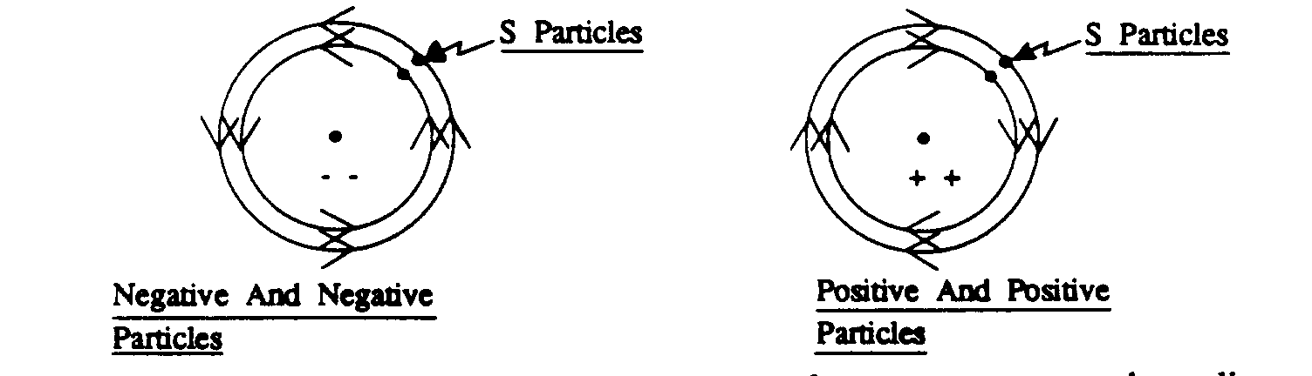

Figure 6. The stacked interactions of two similarly charged particles. The negative particles would be the down quarks and the positive particles would be the up quarks.

Note: All quarks of the same family have the same orbital diameter. The different orbital diameters shown here are served to illustrate the stacked-interactions. The negative and negative particle interaction is the stacked-interaction of the down quarks. The positive and positive interaction is the stacked-interaction of the up quarks.

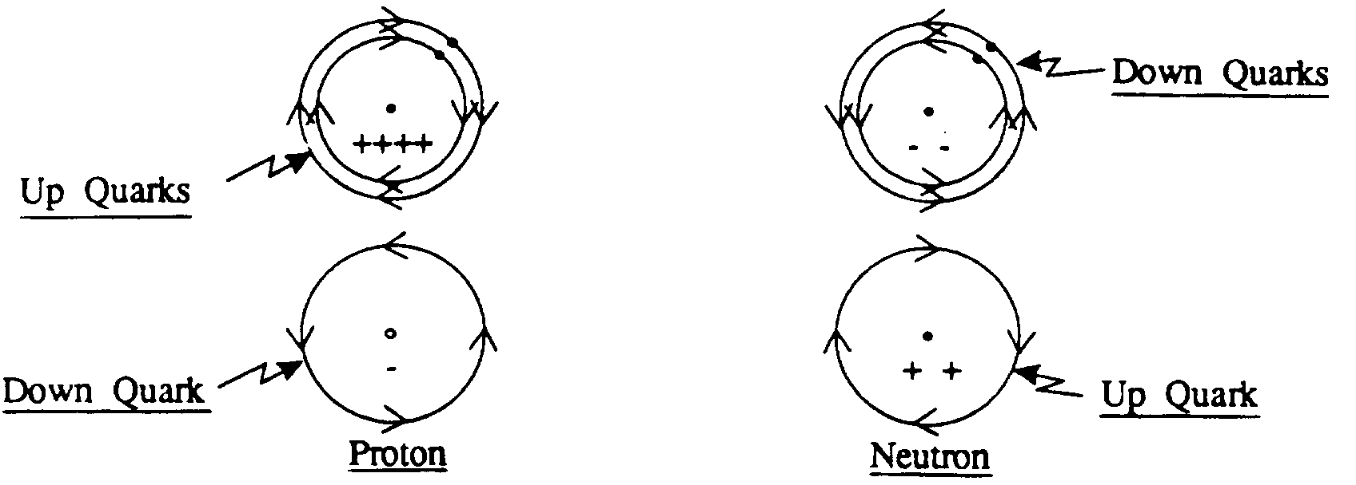

Figure 7. The stacked-interactions and the electromagnetic interactions in a proton and a neutron.
Note: The proton is formed by the stacked interaction of the up quarks and the electromagnetic interaction between the stacked up quarks and the down quark. The neutron is formed by the stacked interaction of the down quarks and the electromagnetic interaction between the stacked down quarks and the up quark.
It is noteworthy to point out that the attractive stacked-interactions are effective only within a short distance of 10⁻¹³ cm. At a greater distance than that the stacked-quarks exert a repulsive force on each other. This is the exact behavior of the nuclear strong force that we observed in the laboratory. Another peculiar property of the nuclear strong force is that it becomes stronger when the interacting particles are being pulled apart. This peculiar property is also predicted by Model Mechanics as follows: When the stacked particles are pulled apart the E-Strings surrounding them becomes more distorted. Therefore, the energy required to pull them further apart will be increased accordingly.

The Nuclear Weak Force
Quantum Mechanics describes this force as the force that causes the decaying processes of all the unstable particles through time. The quantum mechanical process for the weak force involves a process called the spontaneous breaking of symmetry. This process gives rise to the weak force messengers W⁺, W⁻ and Z⁰. These are virtual particles whose brief existence is financed by the uncertainty of energy and time relationship. Also, this description of the nuclear weak force depends on the existence of yet another class of particles known as the Higgs particle. The Higgs particle is necessary because it is the mechanism that imparts mass to the weak force messengers.
Model Mechanics gives a much simpler description of the weak force. In the case of a heavy nucleus, such as a uranium nucleus, the decay is the result of the de-coupling of the stacked-interactions by a combination of neutron captures follow by the repulsive CRE force. The processes involved are as follows:
- A free neutron is captured by a decaying nucleus
- The stacked interactions at the site of neutron capture are weakened. This enables the repulsive CRE force to de-couple the weaken stacked-interactions and give rise to the nuclear weak force.
- In the case of a subatomic particle, the decaying process is different. The best known subatomic particle-decaying process is the neutron decay, also known as the beta decay. Quantum Mechanics does not specify when a free neutron will decay or why it will decay in about sixteen minutes. On the other hand, Model Mechanics is capable of describing the neutron decay process in detail. The following diagrams will help the reader to visualize the processes involved.
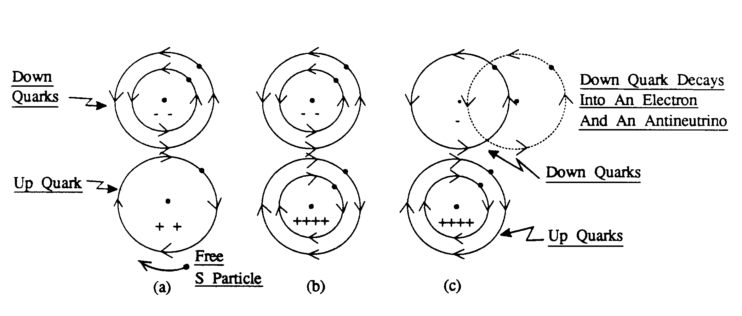
Figure 8. Schematic diagrams for the neutron decay process (Beta decay)
- The up quark in an unbounded neutron exerts an attractive force on any free S-Particles that are traveling in the same direction as its S-Particle. When a free S-Particle follows the orbit of the orbiting S-Particle of the up quark, it becomes an up quark. This new up quark immediately forms a stacked interaction with the original up quark.
- The down quark between the two-stacked up quarks is pulled closer to them because it feels the force from both of them.
- This has the effect of moving the stacked down quarks laterally relative to each other. When the lateral movement is greater than the radius of the down quark, the force between the stacked down quarks becomes repulsive. This causes the down quark that feels less attractive force from the two stacked up quarks to peel away. The peel away down quark will then interact with a free S-Particle to give an electron and an antineutrino.

The decaying process for a subatomic particle such as a muon is different from that for a neutron. It was found that a muon at a speed closed to that of light would have a much longer decay length than that of a muon at the rest frame of the laboratory. When these decay lengths are converted to decay times they agree with the SRT time dilation equation. This led physicists to claim that the muon decaying process is a proof of the time dilation concept of SRT. The Model Mechanical explanation of the muon decay process is as follows:
- The orbit of the muon’s S-Particle is unstable and it will decay into a stable orbit of the electron. The muon takes the same amount of absolute time to decay in both cases. The different decay lengths observed are due to the different states of absolute motion of the muon.
- When a muon is at the rest frame of the laboratory, its state of absolute motion is almost the same as that of the laboratory. Therefore, it is observed to have a very short decay length.
- When the muon is accelerated to a speed close to that of light, the difference in the state of absolute motions between the accelerated muon and the laboratory muon is close to the speed of light. Therefore the accelerated muon is observed to have a very long decay length compared to the laboratory muon. This observed difference in decay lengths is interpreted as time dilation by current physics.

Model Mechanics Explains The Problematic Cosmological Observations
One of the most pressing problems of the Standard Big Bang Model is the observed horizon problem. The age of our universe is determined to be 14 billion years old in all directions and yet we observe the horizon for the opposite regions of our universe to be 28 billion years apart. In fact if all the regions are included the observed horizon of the universe is estimated to be 46 billion years. This means that these opposite regions of our universe cannot be in contact with each other at the Big Bang and this is known as the horizon problem. Cosmologists invented the ad hoc Inflation hypothesis to explain the horizon problem. Model Mechanics explains the horizon problem naturally without resorting to the ad hoc Inflation hypothesis. The earth is in a state of absolute motion in the E-Matrix. This motion curves the E-Strings surrounding the earth. What we perceive as normal and straight E-Strings are actually severely curved E-Strings. In other words, when we look up in the sky we are actually receiving light from these curved E-Strings. This means that no matter what direction we look we are looking into the same curved E-Strings and thus the same region of the universe. This means that the perceived opposite regions of the universe are really the same region and therefore the perceived horizon problem was never existed. As it turns out, there is a perfect physical example of this phenomenon. The medical device gastro-scope made of fiber optics, allows a physician to examine the interior of a patient’s stomach is such an example. No matter how the physician curves the eyepiece, he will still be seeing the same picture of the stomach.
In 1998 two independent groups of astronomers discovered that the far reached regions of the universe are in a state of accelerated expansion motion. This discovery is contrary to the predictions of GRT that predicts that the expansion of the universe should be slowing down. Astronomers revived the once discarded repulsive Cosmological Constant to explain the observed accelerated expansion. They posited that the universe is filled with a form of dark energy called Quintessence and this dark energy has the anti-gravity effect that gives rise to the Cosmological Constant. Model Mechanics predicted the accelerated expansion for those far reached regions of the universe in 1993. The basis for this Model Mechanical prediction is that gravity at those regions is repulsive with respect to us as described in the DTG equation. The repulsive CRE force of DTG can be considered as the dark energy posited by the astronomers.
Another problem arise from the GRT description of gravity is called the flatness problem. The flatness problem is that the observable universe appears to exist between an open and a closed universe. In an open universe, the matter density is less than the critical value and thus the gravitational braking effect is not able to halt the Big Bang expansion. This means that the universe will keep on expanding forever. In a closed universe the matter density is greater than the critical value and thus the gravitational braking effect will be able to halt the Big Bang expansion. This means that the universe will re-collapse before any galaxy would have time to form. In order for our universe to exist between an open and a closed universe the matter density must be fine tuned to be within one part in${\text{10}}^{\text{50}}$of the critical density value when the universe was a fraction of a second old. The inability of the Big Bang theory to explain why this degree of fine-tuning existed is what is known as the flatness problem. In Model Mechanics (DTG), gravity is the result of two gravitating objects having the same direction of absolute motions in the E-Matrix less the repulsive CRE force that exists between them. This description of gravity avoids the flatness problem completely.
The observed rotational curves of galaxies disagree with the predictions of GRT. These observed anomalous rotational curves correspond to curves for galaxies that are much more massive than the observed visible matters for these galaxies. The observed path of travel of the Pioneer 10 spacecraft disagrees with the predicted path given by GRT. Pioneer 10 was observed to be in a state of accelerated motion toward the sun. Astronomers explain both of these anomalous observations by claiming the existence of a dark matter in space although such an existence of dark matters is not within the framework of GRT or the Standard Model. Model Mechanics explains both of these anomalous observations by positing the existence of a dark matter in the form of free non-orbiting S-Particles.

Unification of Physics
Special Relative Theory (SRT) rejects the notion of absolute time and space. Also, SRT advanced the concept of energy and mass equivalency, which includes the idea that mass is convertible to energy and vice versa. These two concepts have been the foundation of theoretical physics developments for the past century. The results of these theoretical developments gave rise to the two pillars of modern physics: General Relativity Theory (GRT) and Quantum Mechanics (QM). GRT describes the large-scale universe including gravity while QM describes the microscopic universe including the electromagnetic and nuclear forces. Efforts to unify the electromagnetic force with the nuclear force have had some successes. The electro-weak theory unites the electromagnetic force with the nuclear weak force. However, this unification remains dubious because it depends on the existence of a hypothetical particle called the Higgs particle. So far, physicists have not been able to find this hypothetical particle in the accelerators around the world. In fact, physicists at CERN are coming to the conclusion that the Higgs does not exist. There were also some successes in the effort of unifying the electro-weak force with the nuclear strong force. The resulting theory is called Grand Unification Theory (GUT). GUT predicts that the proton is not permanently stable. This led physicists around the world rushed to find evidence of proton decay. However, so far no evidence of proton decay was found. Attempts to unify gravity with the electromagnetic force and the nuclear forces were complete failures. There is no viable theory of quantum gravity.
The unification problems described above are the direct consequences of the foundations of modern physics, which deny the existence of absolute time and physical space (absolute space). The irony is that both GRT and QM contain math constructs that resemble physical space. The math construct space-time in GRT and the math construct field/virtual particle in QM are such examples. The difference between these math constructs and physical space is that the math constructs have no physical constraints. This lack of physical constraints leads to the infinity problems that plagued both GRT and QM. In GRT the lack of constraint leads to the infinity problems at the singularity where the theory breaks down completely. The other problem is that GRT gives no explanation why the force of gravity is capable of action-at-a-distance. In QM the lack of physical constraint leads to infinity problems during the formulation of the theories of electromagnetic and nuclear forces. This was especially true in the case of the theory of quantum electrodynamics (QED). In QED the electric change of a particle is resided within the particle. This leads to the infinity problems during the early development of QED. The infinity problem of QED was resolved by a dubious mathematical procedure called renormalization. A number of physicists, including Paul Dirac consider the renormalization technique a mathematical trick. He made the following comments during a lecture given in New Zealand in 1975:
"I must say that I am very dissatisfied with the situation, because this so-called 'good theory' does involve neglecting infinities which appear in its equations, neglecting them in an arbitrary way. This is just not sensible mathematics. Sensible mathematics involves neglecting a quantity when it turns out to be small.”
Model Mechanics replaces the math constructs of space-time and field/virtual particle with the E-Matrix and the distortions or waves in the E-Matrix. It gives rise to the following postulates:
- The E-Matrix is a stationary and structured light-conducting medium. It occupies all of pure space (pure void). It is comprised of very thin and elastic E-Strings and these E-Strings are repulsive to each other. There is an unknown compacting force that compresses these E-Strings together to form the E-Matrix.
- The S-Particle is the only truly fundamental particle exists in our universe. The different orbiting motions of the S-Particles around the E-String(s) give rise to all the visible and stable particles in our universe.
- All the processes of nature are the results of absolute motions of S-Particles or S-Particle systems in the E-Matrix.
- All the forces of nature are the results of the S-Particle or S-Particle systems reacting to the distortions or waves in the E-Strings to which they are confined. The distortions or waves in the E-Strings, in turn, are the results of the absolute motions of the interacting S-Particles or S-Particle systems in the E-Matrix.
- All the stable and visible matters are the results of orbiting motions of the S-Particles around specific E-Strings.
These postulates eliminate all the infinity problems that plagued both GRT and QM. It has the same mechanism for all the forces of nature and thus it unites all the forces of nature. It gives an explanation why the force of gravity is capable of acting at a distance. It explains the provisions of the Uncertainty Principle. It explains the weird results of all quantum experiments [3]. It eliminates the need for the undetectable force messengers in QM. It eliminates the need for the hypothetical and undetected Higgs particle. It explains the mass of a particle. It explains the charge of a particle. It leads to the discovery of the CRE force, which, in turn leads to a new theory of gravity. In short, Model Mechanics gives us a unique way to achieve the elusive goal of unifying all of physics.

Proposed Experiments To Detect Absolute Motions
Model Mechanics is based on the existence of the E-Matrix. Therefore absolute motions of objects in the E-Matrix should be detectable. However, numerous past attempts to detect absolute motion were failures. The most notable of these is the Michelson-Morley Experiment (MMX) [3]. In this experiment a light beam was split into two parts that were directed along the two arms of the instrument at right angles to each other, the two beams being reflected back to recombine and form interference fringes. Any shift in the interference fringes as the apparatus is rotated would mean the detection of absolute motion of the apparatus. To everyone's chagrin, the MMX produced a null result. However, the MMX null result does not mean that there is no absolute motion of the apparatus. In their interpretation of the MMX null result Michelson-Morley failed to ask the relevant question: What is the direction of absolute motion of the apparatus with respect to the defined horizontal plane of the light rays that will produce a null result for all the orientations of the horizontal arms? The answer to this question is: If the apparatus is moving vertically then a null result will be obtained for all the orientations of the horizontal arms. What this mean is that the MMX as designed is not capable of detecting the absolute motion of the apparatus. In order to detect absolute motion using the MMX, the plane of the arms must be oriented vertically. This conclusion is supported by the observed gravitational red shift (gravitational potential) in the vertical direction.
The new interpretation of the MMX null result gives rise to a new concept for the propagation of light as follows:
How does light get from point A to point B? The current assumption is that, locally, light travels in a straight line towards the target, and that, in a train of light pulses, the first pulse hits the target is the first one the source generated. These assumptions both make sense if the target is stationary relative to the light pulses, but if the target moves the second assumption could be erroneous. Figure 9 describes a thought experiment that is currently used by physicists to derive the time dilation equation. A light clock is constructed of two mirrors parallel to each other with light pulses bouncing between them. In one period of the clock, a light pulse travels up to the top mirror and returns back to the bottom mirror. The diagram shows that the light pulse is presumed to travel a slant path when the light clock is in motion. This is not a realistic description of the actual event. It raises the question: How does light know when to follow a vertical path and when to follow one of the infinite numbers of slant paths? It is more realistic to say that light will always follow the perpendicular path on its way to the upper mirror. The reason is that the vertical path is the direction where all the light pulses are directed. Figure 10 shows this: the first pulse of a train of pulses follows the original path AB, but the pulse detected at “E” travels the path CE.
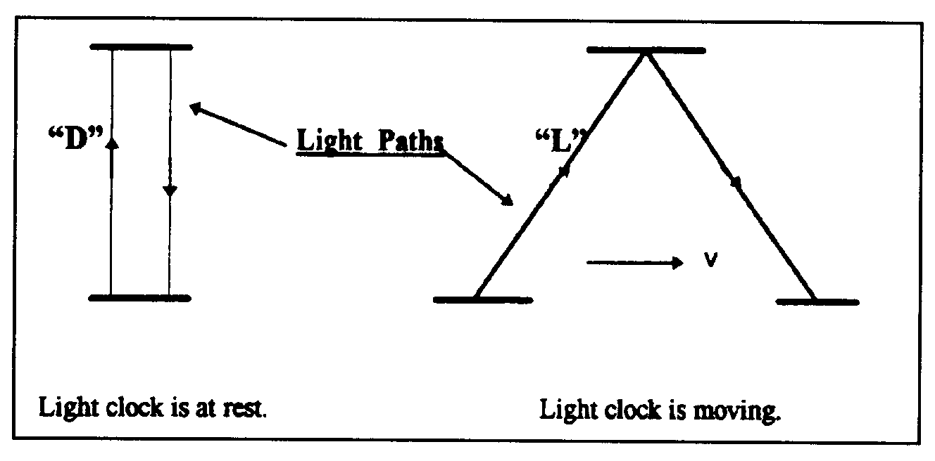
Figure 9. Light paths in a light clock at rest and in motion.
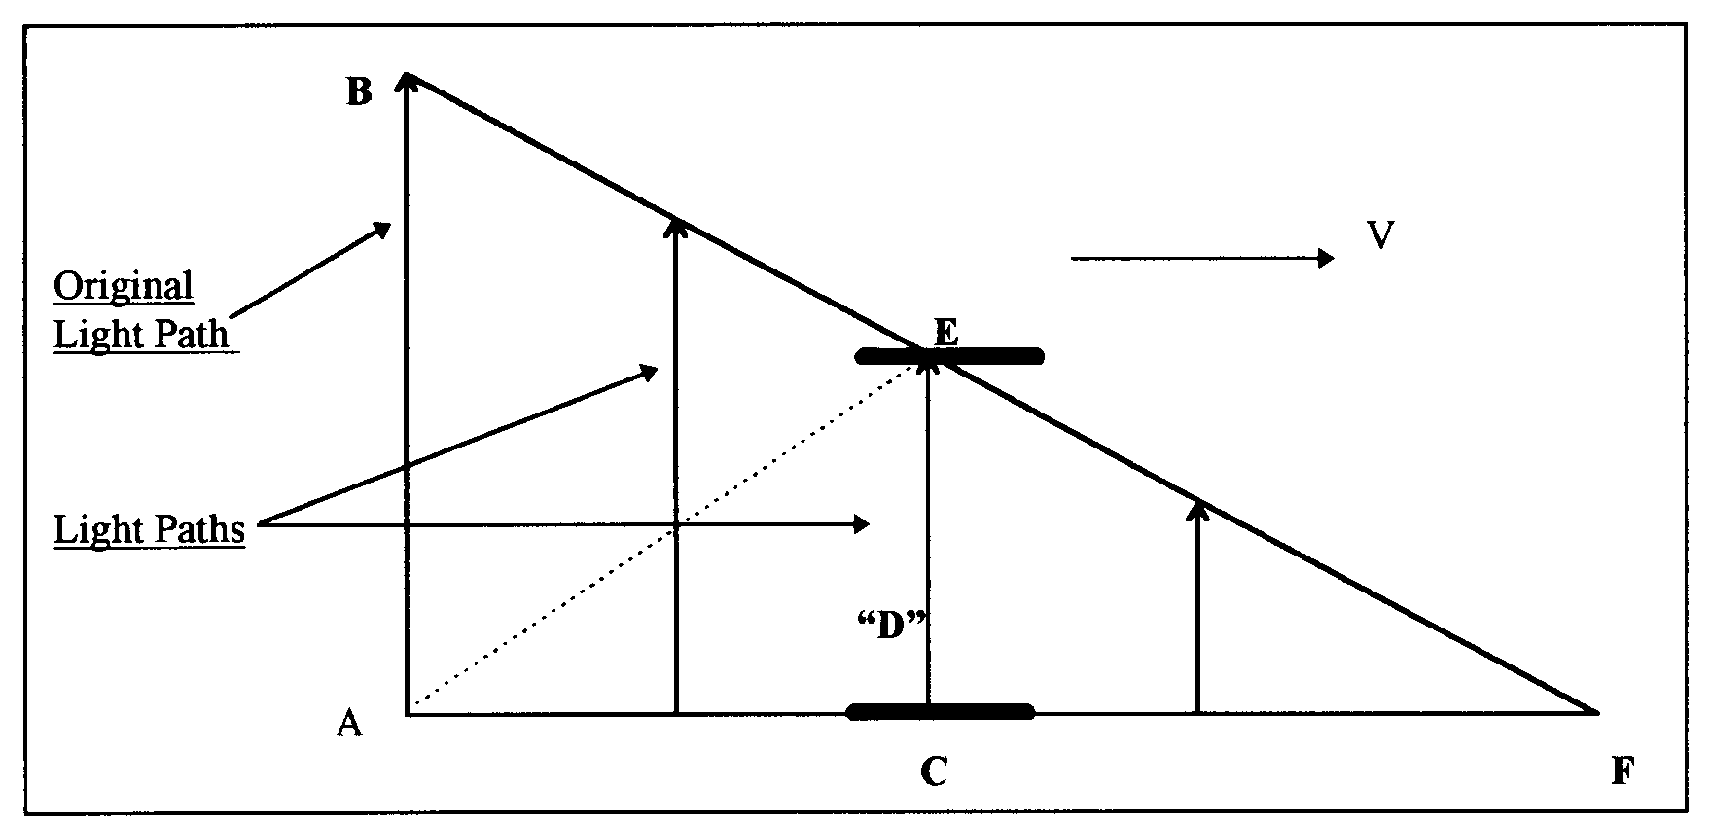
Figure 10. Current physics says that AE is the path that light follows to the upper mirror and theangle of this path is depended on the length AC that is depended on the speed of the light clock.

With this description of the light paths, the first pulse is never detected at “E." The light pulse detected at “E” is generated by the source at a later time. It turns out that this description of light paths is also capable of giving us the time dilation equation by using the Pythagorean theorem. The reason is that the original light path (AB) is equal to the assumed light path (AE) and both are the radii of a light sphere at the point of origin “A". It is noteworthy that as the speed of the mirrors approaches light speed a light pulse will take a longer time to reach the upper mirror. When the mirrors are moving at the speed of light, no light pulse is able to reach the upper mirror at all. Current physics interprets this situation as time standing still at the speed of light. The new interpretation is that time keeps on ticking at all speeds of the light clock. The amount of time (duration) passed depends on the length of the original light path AB divided by the speed of light ‘c’. This new interpretation suggests that absolute time for a moving frame is not slowed or dilated as currently assumed. The specific amount of absolute time (duration) required for light to travel the original light path AB is equal in all frames. A light clock runs slow when it is in motion because it is not catching the first light pulses, but rather some later one. The lower elapsed time recorded by a moving clock because the passage of time is not fully detected when the clock is in a state of motion.
The new interpretation of the MMX null result and the new concept for the propagation of light enable us to design the following experiments to detect absolute motion:

Experimental Set Up:

- Two sets of cesium clocks A1, A2 and B1, B2 are located at the middle of a 120 meters long straight rail track. Distances of 25 meters and 50 meters on both sides of the mid-point are marked off with a physical ruler.
- Each set of clocks is equipped with a laser light sources and a beam splitter that splits the laser beam into two continuous beams. One beam goes to detector “A” and the other goes to detector “B”.
- Each set of clocks is equipped with a shutter that allows the two laser beams to pass through it for any desired time intervals.
- Each set of clocks is equipped with a circular surface detector and the detecting surface can vary from 3 mm to 20 cm in diameter.
- Each set of clock is equipped with a reflecting mirror.
- A1 and B1 are not running. A2 and B2 are synchronized and running.

Experiment Group #1: To Detect The Absolute Motion Of The Distant Clock At 50 Meters
- Move both sets of clocks simultaneously in the opposite directions at a rate of 10 meters/day (1 day = 86,400 seconds) and stop them at the 25 meters marks (after 2.5 days). The clocks are now 50 meters apart.
- Both detecting surfaces are set at 3mm in diameter.
- Do the following experiments from A’s location.
- A trial of the experiment is consisted of an opening and closing of the shutter for a specific time interval. The following trials at the following time intervals are made: 1 second, 2 seconds, 3 seconds, 4 seconds, 5 seconds, 6 seconds, 7 seconds, 8 seconds, 9 seconds and 10 seconds. The trials are conducted from A’s location.
- Laser beam A will activate and de-activate clock A1 for each trial and the results are identified as T’a1, T’a2, T’a3, T’a4, T’a5, T’a6, T’a7, T’a8, T’a9 and T’a10.
- Laser beam B will activate and de-activate clock B1 for each trial and the results are identified as T’b1, T’b2, T’b3, T’b4, T’b5, T’b6, T’b7, T’b8, T’b9 and T’b10.
- The difference in activation time between clocks A1 and B1 for each trial is identified as follows: ∆T’1, ∆T’2, ∆T’3, ∆T’4, ∆T’5, ∆T’6, ∆T’7, ∆T’8, ∆T’9, and ∆T’10.
- Increase the detecting surface to 20 cm in diameter then perform a trial using the 1-second time interval to establish that there is no difference in activation time between A1 and B1 for this large detecting surface. Now reduce the diameter of the detecting surface gradually to find the diameter where the activation time between A1 and B1 start to show a difference. Call this critical diameter$D_{\text{50}}$.
- Cover the detecting surface completely with a 20 cm diameter dish. A slit of 2mm wide is cut from the center of the dish to the outer rim of the dish. Slowly rotate the dish to find the direction of absolute motion of the detector. That direction is evident when the slit is in line with the direction of absolute motion of the detector and activates the clock B1 for the same amount of time as the shutter opening and closing at A’s location.
- Repeat the above experiments from the “B” location.

The SRT Predictions For Group #1 Experiments:
  - The activation time for the B1 clock is the same as that for the A1 clock for all trials.
  - The difference in activation time between A1 and B1 is zero for each trial. ∆T’1=∆T’2=∆T’3=∆T’4=∆T’5=∆T’6=∆T’7=∆T’8=∆T’9=∆T’10=0.
  - Increase the diameter of the detecting surface will have no effect on activation time on the B1 clock for each trial.
  - There is no absolute motion of clock B1 and therefore there is no direction of absolute motion.
  - Repeating the above experiments from the B location will get the same results as above.

The Model Mechanical Predictions For Group #1 Experiments:
- The activation time for the B1 clock is less than that for the A1 clock for each trial. This is due to the B1 clock is in a state of absolute motion in the vertical direction while the laser is in transit from A to B.
- The difference in activation time between A1 and B1 is the same for each trial and it is greater than zero.
- Increase the diameter of the detecting surface will bring the activation time for the B1 clock equal to that of the A1 clock.
- The absolute motion of the clock B1 ($V_{\text{50}}$) can be calculated using the following equation:
$V_{\text{50}}$$=\frac{D_{\text{50}}}{2ΔT1}$ （15）
- The direction of absolute motion of the B1 clock is vertical.
- Repeating the above experiments from the “B” location will get the same results as above.

Experiment Group #2: To Measure the One-Way and Two-Way Speed of Light at 50 Meters Apart
- The clocks A2 and B2 are 50 meters apart and are still synchronized according to SRT and Model Mechanics.
- Measure the one-way speed of light using clocks A2 and B2 from the “A” location.
- Measure the one-way speed of light using clocks B2 and A2 from the “B” location.
- Measure the two-way speed of light using clock A2.
- Measure the two-way speed of light using clock B2.

The SRT Predictions For Group #2 Experiments:
- The one-way speed of light is c as measured from the “A” location.
- The one-way speed of light is c as measured from the “B” location.
- The one-way speed of light is isotropic.
- The two-way speed of light is c using clock A2.
- The two-way speed of light is c using clock B2.
- The two-way speed of light is isotropic.

The Model Mechanical Predictions For Group #2 Experiments:
- The value for the one-way speed of light is less than c as measured from the “A” location.
- The value for the one-way speed of light is less than c as measured from the “B” location.
- The one-way speed of light is isotropic. In other words, the value for the one-way speed of light from A→B is equal to from B→A.
- The calculated value for the one-way speed of light can be make to equal to c by reducing the measured flight time by a factor of (∆T’1).
- The two-way speed of light is c using clock A2.
- The two-way speed of light is c using clock B2.
- The two-way speed of light is isotropic.

Experiment Group #3:To Detect The Absolute Motion Of The Distant Clock At 100 Meters

Move both sets of clocks at the 25 meters marks simultaneously in the opposite directions at a rate of 10 meters/day and stop them at the 50 meters marks (after 2.5 days). The clocks are now 100 meters apart.
- Both detecting surfaces are set at 3mm in diameter.
- Do the following experiments from A’s location.
- A trial of the experiment is consisted of an opening and closing of the shutter for a specific time interval. The following trials at the following time intervals are made: 1 second, 2 seconds, 3 seconds, 4 seconds, 5 seconds, 6 seconds, 7 seconds, 8 seconds, 9 seconds and 10 seconds. The trials are conducted from A’s location.
- Laser beam A will activate and de-activate clock A1 for each trial and the results are identified as T”a1, T”a2, T”a3, T”a4, T”a5, T”a6, T”a7, T”a8, T”a9 and T”a10.
- Laser beam B will activate and de-activate clock B1 for each trial and the results are identified as T”b1, T”b2, T”b3, T”b4, T”b5, T”b6, T”b7, T”b8, T”b9 and T”b10.
- The difference in activation time between clocks A1 and B1 for each trial is identified as ∆T”1, ∆T”2, ∆T”3, ∆T”4, ∆T”5, ∆T”6, ∆T”7, ∆T”8, ∆T”9, and ∆T”10.
- Increase the detecting surface to 20 cm in diameter then perform a trial using the 1-second time interval to establish that there is no difference in activation time between A1 and B1 for this large detecting surface. Now reduce the diameter of the detecting surface gradually to find the diameter where the activation time between A1 and B1 start to show a difference. Call this critical diameter$D_{\text{100}}$.
- Cover the detecting surface completely with a 20 cm diameter dish. A slit of 3mm wide is cut from the center of the dish to the outer rim of the dish. Slowly rotate the dish to find the direction of absolute motion of the detector. That direction is evident when the slit is in line with the direction of absolute motion of the detector and activates the clock B1 for the same amount of time as the shutter opening and closing at A’s location.
- Repeat the above experiments from the “B” location.

The SRT Predictions For Group #3 Experiments:
- The difference in activation time between A1 and B1 is zero for each trial. ∆T”1=∆T”2=∆T”3=∆T”4=∆T”5=∆T”6=∆T”7=∆T”8=∆T”9=∆T”10=0.
- Increase the diameter of the detecting surface will have no effect on activation time on the B1 clock for each trial.
- There is no absolute motion of clock B1 and therefore there is no direction of absolute motion.
- Repeating the above experiments from the B location will get the same results as above.

The Model Mechanical Predictions For Group #3 Experiments:
- The activation time for the A1 clock is greater than that for the B1 clock for each trial. This is due to the B1 clock is in a state of absolute motion in the vertical direction while the laser is in transit from A to B.
- The difference in activation time between A1 and B1 is the same for each trial.
- ∆T”1=∆T”2=∆T”3=∆T”4=∆T”5=∆T”6=∆T”7=∆T”8=∆T”9=∆T”10
- Increase the diameter of the detecting surface will bring the activation time for the B1 clock equal to that of the A1 clock.
- The absolute motion of the clock B1 ($V_{\text{100}}$) can be calculated using the following equation:
            - $V_{\text{100}}$$=\frac{D_{\text{100}}}{2{ΔT}^{'}1}$ （16）
- The direction of absolute motion of the B1 clock is vertical.
- Repeating the above experiments from the “B” location will get the same results as above.

Experiment Group #4: Measure the One-Way and Two-Way Speed of Light at 100 meters
- The clocks A2 and B2 are 100 meters apart and are still synchronized according to SRT and Model Mechanics.
- Measure the one-way speed of light using clocks A2 and B2 from the “A” location.
- Measure the one-way speed of light using clocks B2 and A2 from the “B” location.
- Measure the two-way speed of light using clock A2.
- Measure the two-way speed of light using clock B2.

The SRT Predictions For Group #4 Experiments:
- The one-way speed of light is c as measured from the “A” location.
- The one-way speed of light is c as measured from the “B” location.
- The one-way speed of light is isotropic.
- The two-way speed of light is c using clock A2.
- The two-way speed of light is c using clock B2.
- The two-way speed of light is isotropic.

The Model Mechanical Predictions For Group #4 Experiments:
- The value for the one-way speed of light is less than c as measured from the “A” location.
- The value for the one-way speed of light is less than c as measured from the “B” location.
- The one-way speed of light is isotropic. In other words, the value for the one-way speed of light from A→B is equal to from B→A.
- The calculated value for the one-way speed of light can be make to equal to c by reducing the measured flight time by a factor of (∆T”1).
- The two-way speed of light is c using clock A2.
- The two-way speed of light is c using clock B2.
- The two-way speed of light is isotropic.

Conclusions:

Model Mechanics enables us to describe all the processes and interactions in terms of absolute motion of S-Particle or S-Particle systems (a new description of matter) in the E-Matrix (a new description of physical space). The unique structure of the E-Matrix led to the discovery of the CRE force, a repulsive component of gravity. The CRE initiates the nuclear weak force and participates in all the processes of nature. The absolute motion of S-Particles or S-Particle systems in the E-Matrix in the same direction gives rise to an attractive force, while absolute motion of S-Particle or S-Particle systems in the opposite directions gives rise to a repulsive force. Gravity is the attractive force between two objects having the same direction of absolute motion in combination with the repulsive CRE force creates by the same absolute motion of the objects. This explains why the force of gravity is so weak compared to the other forces. The electromagnetic force and the nuclear weak and strong forces are also the result of absolute motion between the interacting S-Particles. These forces are the results of the interacting particles reacting to the distortions or waves in the E-Strings to which they are confined. A candidate unification of all physics is achieved with this simple description of the current universe.
Model Mechanics gives new interpretations for the MMX null results and that, in turn, leads to a new concept for the propagation of light. This enables us to design viable experiments to detect absolute motion. Performing these designed experiments will confirm the existence of the E-Matrix frame and will also provide a way to unify all of physics.

References
[1] Seto KH. Unification of Physics. Journal of the Theoretics. pp 5-11. http://www.journaloftheoretics.com/Links/Papers/Seto.pdf
[2] Seto KH. The Physics of Absolute Motion. ISBN0-9647136-1-6, KHS Publishing, pp 57-70. http://www.erinet.com/kenseto/book.html
[3] Michelson AA, Morley EW. On the Relative Motion of the Earth And the Luminiferous Ether. Am J Sci. Third Series 1887;34:333-45.

