Vaccination against Schistosoma mansoni Infection by DNA Encoding SM 21.7 Antigen

Mahmoud H. Romeih^{1*}, Ahmed M. Hanem^{1**}, Tarek S. Abou Shousha T.S², Mohamed A. Saber¹

Biochemistry and Molecular Biology ¹ and Pathology ² Departments, Theodor Bilharz Research Institute, Giza, Egypt
Present address: * Biochemistry and Molecular Biology Department, Michigan State University, USA; ** Food Science and Human Nutrition, Michigan State University, USA
romeih@msu.edu; ahmedha@msu.edu

Abstract: The current focus of schistosomiasis research is to develop a vaccine that will significantly reduce the incidence of disease. Immunization with DNA is a new trend in vaccine development that could enhance the safety and efficacy of currently used vaccines. The immunogenicity and protective efficacy of a DNA vaccine encoding the antigen SM21.7 was evaluated in C57 BL/6 and Swiss albino mice. The ORF of SM21.7 has been cloned into the eukaryotic expression vector pcDNA 1/Amp under control of CMV late enhancer promoter. The groups of mice were vaccinated intramuscularly with SM21.7-pcDNA1 and boosted twice shown high and specific humoral response in comparison with control (blank pcDNA1/Amp). The level of anti SM21.7 antibody in immunized mice at weeks 3, 6 and 9 intervals post- immunization was significantly higher than in control group. The maximum level of antibodies was obtained at 7 weeks post - challenge infection. Sera from immunized mice could recognize the SM21.7 protein and the specific antibodies were able to mediate a significant killing of schistosomula using peritoneal macrophages as effector cells. In contrast the preimmune sera and sera control serum had no specific reactivity to SM21.7 protein.

Immunization with SM21.7- pcDNA conferred a significant level of protection against challenge (41, 53%) in Swiss Albino and C57BL/6 mice respectively. Histopathological examination of the vaccinated liver revealed a decreased in the number, size and change in the cellular of the granuloma compared to the control infected liver. In addition reductions in worm viability, worm fecundity and egg hatching ability have been observed following challenge with Schistosoma mansoni cercariae. The number of eggs in the liver and intestine was reduced by 62% and 67% respectively compared to control group. The results suggested that SM21.7 might be a candidate antigen for the generation of antipathology vaccine against schistosomes. [Nature and Science. 2005;3(2):28-35].

Keywords: Schistosoma mansoni; DNA vaccine, pcDNA1/Amp, 21.7kDa schistosomula protein; DNA immunization; and vaccine

1. Introduction
Schistosomiasis caused by blood flukes of the genus Schistosoma is the second most important parasitic disease of humans. The World Health Organization has estimated that 200 million people are infected worldwide in 74 countries and a further 600 million are at risk of this disease (Chisel et al., 2000; WHO, 2002). In terms of control strategies for schistosomiasis, enormous efforts have been made to develop effective anti-schistosome vaccines, but none is available at the present time (Shuxian et al., 1998). The complexity of the schistosome and the life cycle of this parasite may, at least partly, contribute to the difficulties associated with vaccine development. Pathology and morbidity in this chronic disease result from the host immune inflammatory response to parasite eggs trapped in the liver and other organs (Berqiust, 1998; Capron et al., 2001).
The development of the drug praziquantel (Davis and Wegner, 1979) and what proved to be of equal importance, its drastic reduction in price, rapidly made chemotherapy the cornerstone of control (WHO 1985,1993) leading to a dramatic reduction of morbidity in endemic areas (WHO, 1985; WHO, 2001). However, chemotherapy does not affect transmission of the infection and high re-infection rates, even after mass treatment, limit the success by demanding frequently re-scheduled treatments. For this reason, a complimentary approach that can be integrated with chemotherapy, i.e. vaccination, is very much needed (Bergquist 1992).
Vaccination can either be targeted towards the prevention of infection or to the reduction of parasite fecundity. A reduction in worm numbers is the "gold standard" for anti-schistosome vaccine development but, as schistosome eggs are responsible for both pathology and transmission, a vaccine targeted on parasite fecundity and egg viability also appears to be entirely relevant (Taylor 2002).
Recently, a significant effort has been made to develop a protective vaccine against schistosome infections, and several vaccine candidate have been identified (Ahmed et al., 2001; Da’dara et al., 2001; Zhang et al., 2001; Dupre et al., 2001; Capron et al., 2001; McManus, 2000; Waine and McManus, 1997; Shuxian et al., 1998), but as the efficacy of any of these against schistosomiasis remains uncertain, the identification and characterization of new anti-schistosome vaccine molecules remains a priority. The development of vaccine remains to be an important long-term and remain a challenging goal in the control of schistosomiasis (Hafalla et al., 1999).
DNA vaccine is an attractive and novel immunization strategy against a wide range of infectious diseases and tumers. Injection of plasmid DNA as vaccine was first demonstrated to be effective using influenza as model, where it was shown that DNA encoding nucleoprotein (NP) induced cytotoxic T-lymphocytes (CTLs) and cross-strain protection of mice (Ulmer et al., 1993). The effectiveness of DNA vaccines against viruses, parasites, and cancer cells has been demonstrated in animal models (Tuteja, 1999). It has been shown that DNA immunization induces both antigens - specific cellular and humoral immune response (Ramsay et al., 1999; Alarcon et al., 1999; Gurnathan et al., 2000; Kowalaczyk, 1999). Nucleic acid vaccination against schistosomiasis has lately been investigated using a panel of plasmid encoding schistosome antigenic proteins such as Sjc 26 GST, Sj79 (Zhou et al. 1999a, Zhang et al, 2001), Schsitosoma japonicum paramyosine (Yang et al., 1995; Zhou et al., 1999b), and Schsitosoma m 23, 28 GST from Schsitosoma mansoni (Dupre et al., 1997).

One of the major goals in our laboratory is to develop a protective vaccine against Schsitosoma mansoni infection. Intramuscular immunization with SM21.7 protein induced a strong immune response that resulted in a significant reduction in the number of the adult worm (40, 71%) in Swiss Albino and C57BL/6 mice respectively (Ahmed et al., 2001). In this study to evaluate the immunogenicity and protective efficacy of SM21.7 as a DNA vaccine. The ORF of SM21.7 Schsitosoma mansoni antigen was clones into the pcDNA 1/Amp vector. Vaccination with the naked DNA encoding SM21.7 induced significant levels of specific IgG antibody responses and it has been successful in inducing significant levels of protection in two strains of mice as being assessed histopathologically and parasitologically.

2. Materials and Methods

2.1 Parasites and animals

An Egyptian strain of Schistosoma mansoni cercariae and naive female Swiss albino mice and C57 BL/6 (6 – 8 weeks of age), were obtained from the Schistosome Biological Supply Program, Theodor Bilharz Research Institute, Giza, Egypt. The animals were separated in groups of twenty and they kept under standard laboratory conditions and used for vaccine trials.

2.2 Construction and preparation of SM21.7 plasmid DNA
The SM21.7-pcDNA plasmid encoding the full length SM21.7 was used throughout these experiments. The cDNA containing the entire coding region of SM21.7, which has been isolated from schistosomula cDNA library (Ahmed et al., 2001). The ORF was excised from the recombinant pBluescript vector using polymerase chain reaction (Saiki et al., 1988). A pair of primers was synthesized according to the DNA sequence of the SM21.7, BamH1 adaptors linked to forward and reverse primers and the Kozark sequence was added to the position of initiator. The forward primer was 5′CATCTGGATCCATGGATAGTCC and the reverse 5′ TAACGGATCCCTAGTTACTTGG. The amplified sequence was ligated into the eukaryotic expression pcDNA1/Amp expression vector (Invitrogen, Corp, SanDiago, CA), which was previously digested with BamH1 and treated with alkaline phosphates. The structure was verified by restriction digestion and sequencing. Large-scale preparation of the plasmid was carried out by using the alkali lysis method, followed by double banding on CsCl-EtBr gradient (Sambrook et al., 1989). Then DNA was resuspended in phosphate buffer saline (PBS) for vaccination.

2.3 DNA vaccination
The groups of female Swiss albino and C57BL/6 mice were vaccinated by intramuscular injection. Two groups of each strain were used, three weeks after the first injection the groups of mice were subsequently boosted with 100 μg/ml of DNA, and after another 3 weeks, mice were boosted a second time with 50 μg/ml of DNA (He et al., 1997). The mice were challenged with 100 Schsitosoma mansoni cercariae by tail immersion method and perfused 7 weeks later (Duvall and DeWitt, 1967). Blood samples were collected from tail veins of all mice prior to immunization and thereafter at 3, 6 and 9 weeks intervals, as well as finally at 7 weeks post-challenge. Pooled serum samples were prepared from each group by mixing an equal volume of serum from each group, then used for ELISA and western blots analysis.

2.4 Antibody assay
To determine, the presence of SM21.7 antibody titer in collected sera from mice vaccinated with SM21.7-pcDNA1 and control (pcDNA1/amp alone). The preimmune and post vaccination sera were tested for specific immunoglobulin G (IgG) by an enzyme linked immunosorbant assay (ELISA) and Western blot analysis. The antigen used in ELISA was SM21.7 KDa purified protein, expressed in pET-3a expression vector and partially purified as described previously by Ahmed et al., (2001). SWAP was prepared to detect the specific antibodies of SM21.7-pcDNA1 by Western blot analysis.
ELISA was carried out in micrometer plates coated with purified SM21.7 antigen (3μg/well) prepared in PBS. The protocol of Zhang et al. (1998) was followed to detect the SM21.7 specific antibodies. The secondary antibody used in the ELISA was alkaline phosphatase-conjugated goat anti-mouse immunoglobulin G (Serotec Ltd, England).

2.5 Western blot analysis
Western blot analysis was performed as described by Yang et al., (1995). Briefly, SWAP was separated by 8% SDS-polyacrylamide gel (Laemmli, 1970), and transferred to a nitrocellulose membrane using a Bio-Rad protein transfer unit (Mini-gel). The nitrocellulose membranes were blocked in TBST (10 mM Tris-HCl pH 8.0, 150 mM NaCl, 0.05% Tween 20) containing 3% bovine serum albumin (BSA) for 3 hours. Blots were probed with sera from mice immunized with the SM21.7-pcDNA1 parallel to pcDNA1/Amp as a control for 2 3 hours with gentle shaking at RT. Then blots were washed four times in TBST and incubated with alkaline phosphatase conjugated anti-serum for 1 hour. After incubation, the blots were washed in TBST and soaked in alkaline phosphatase substrate solution 5-bromo-4-chloro-3-indolyl-1-phosphate (BCIP) and nitroblue tetrazolium (NBT).

2.6 Infection and determination of worm burden
Three weeks after final boosting vaccinated and control mice groups were challenged with 100 Schsitosoma mansoni cercariae by tail immersion (Olivier and Stirwalt, 1952). The percentage of the resistance was calculated by perfusion of the adult worms from the portal veins at 7 weeks after challenge infection. The worm reduction rate (% protection) was calculated and the livers, spleen and intestines were collected and the eggs were counted according to the method described by Shuxian et al. (1997).

2.7 Enumeration of eggs in liver and intestine
Whole livers and intestines, of vaccinated and control mice were weighed and a known portion (0.5 g) was removed to a screw cap glass tube and frozen until digestion. For digestion 5ml of 5% KOH (potassium hydroxide) was added to each tube and incubated at 37 °C until the tissue was completely digested (10-12 hr). A 50 μl of the digest was placed on a glass slide and eggs were counted under a microscope (Liu et al., 1995). Total egg counts were expressed for each group of mice as the mean number of eggs /gram of mouse liver or intestine.

2.8 Histopathlogical examination
After scarification of different groups of animals, part of the liver tissue was immediately fixed in 10% buffered formalin solution and processed in paraffin blocks. 5μm thick sections were cut on albuminized glass slides and stained by Hematoxyline and eosine for routine histopathological examination, granuloma count, measurement of granuloma diameter, cellular profile and Masson trichrome staining for assessment of tissue fibrosis.
Liver egg-granulomas were counted in 5 successive low power fields (10X), and their diameters were measured using graduated eyepiece lens, considering only lobular granulomas containing central ova. Two perpendicular maximal diameters were measured, getting the mean diameter for each granuloma, and then calculating the mean granuloma diameter for the group.
The cellular profiles of liver egg-granulomas were studied, with calculation of the percentage of different types of cells forming the granuloma in the different groups. The type of the granuloma, whether cellular, fibrocellular or fibrous was defined according to the cellular to fibrous ratio. The percentage of egg-granulomas containing intact or degenerated miracidia was also calculated.

2.9 Statistic
Statistical significance was determined by student’s t-test and significance was determined using a p value < 0.05 as being significant.

3. Results
3.1 Antibody levels
The intramuscular injection with pcDNA1-SM21.7 stimulated high titer of antibody responses in Swiss albino mice and C57 Bl/6 mice. The sera collected from mice at 3 weeks post immunization were able to detect the purified SM21.7 protein with highly titer and there was no significant difference in the titer at 6 or 9 weeks post immunization. The maximum peak occurred at 7 weeks post challenge infection in the immuno-challenge with SM21.7-pcDNA1 groups (Figure 1). In contrast, the preimmune sera and sera from the pcDNA1/Amp blank vector immunized mice had no specific reactivity to SM21.7 protein. Western blots showed sera from pcDNA1-SM21.7 immunized mice could recognize native SM21.7 from SWAP (Figure 2).

3.2 Protection induced by DNA vaccine
To determine whether the SM21.7-pcDNA1 vaccine conferred protective immunity, and to determine whether the most of DNA immunization affect immunogenicity and/or vaccine efficacy. Vaccinated mice and control were challenged with 100 cercariae each and the number of worms recovered seven weeks later was assessed. The egg counts showed a highly significant difference either in terms of reduced worm burden or egg number present, isolated from the liver or between mesenteric. In the three separate experiments, SM21.7-pcDNA1, inoculated intramuscularly three times at doses of 100 or 50 μg per/mouse, was found to provide significant worm reduction rates (P < 0.001). The animals showed a significant level of protection (41, 53%) in Swiss albino and C57BL/6 mice respectively following challenge infection (Figure 3). There was a subsequent reduction in the number of eggs present in the livers and intestine of the pcDNA1-SM21.7 immunized group when compared with the pcDNA1/Amp blank vector as a control group.

3.3 Effect on egg count in liver and intestine
There was a substantial reduction in the mean number of eggs/gm tissue of liver and intestine of the immuno-challenge group mice (p∠0.001), when compared to controls (Figure 4). The number of eggs in the liver and intestine was reduced by 62% and 67% respectively compared to control group.

Figure 1. ELIA analysis of control and immunized groups at 7 weeks post-challenge. ELISA titer of specific IgG of tail blood C57 BL/6 (n=15) vaccinated with pcDNA1 /SM21.7 (n=15) at 7 week post challenge. Sera were diluted in TBS containing 0.05% Tween 20 [1:250 (p< 0.0001); 1:500 (p< 0.001); 1:5000 (p< 0.01); 1:10,000 (p < 0.01)]. Note. [CONT=control; IMM = immunized). The control group was vaccinated with pcDNA1/Amp alone. The data are representative of three successive experiments. We have obtained approximately the same results with slightly differences of Swiss albino mice.

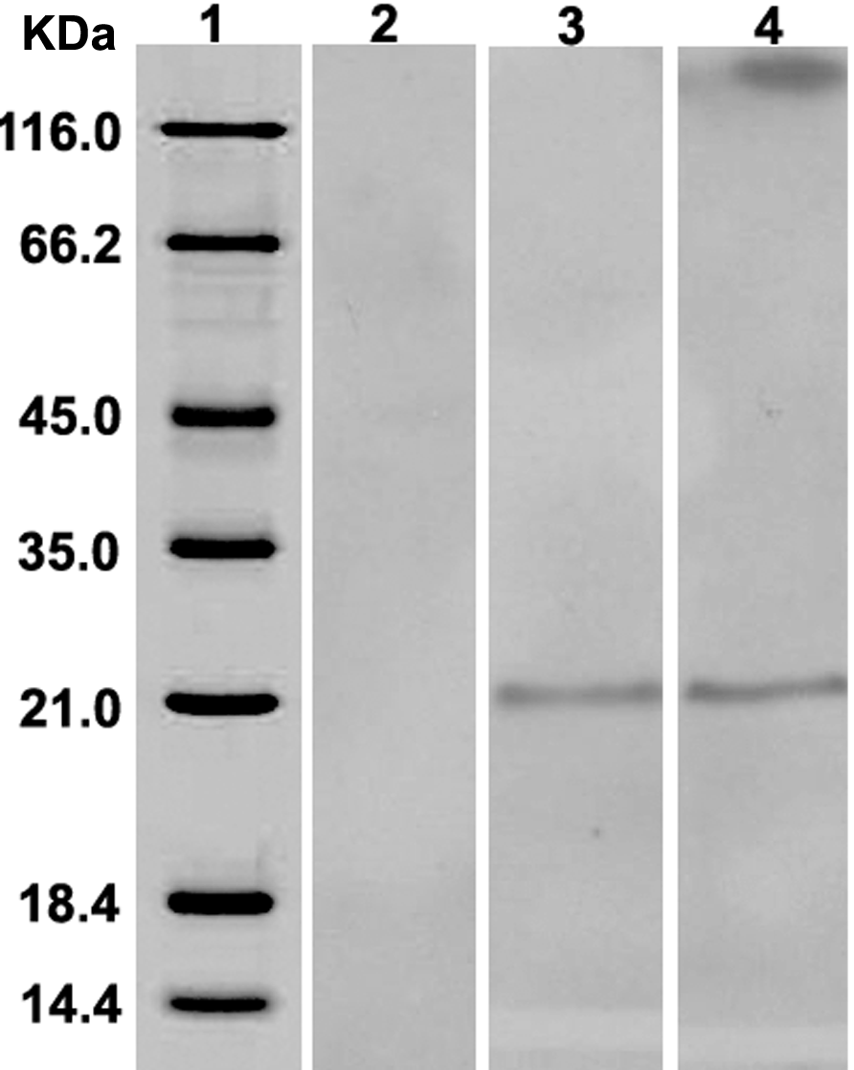

Figure 2. Western blot analysis showing the sera from mice immunized with pcDNA1 blank vector had no specific reactivity to SM21.7 protein (lane 1). Sera from mice immunized with SM21.7-pcDNA recognize native SM21.7 from SWAP on Black/6 and Swiss albino mice (Lane 3, 4). Lane (1) high molecular weight standards.

Worm Burden (Mean) in Immunized and Control Mice

Figure 3. Changes in worm burden % in immunized and control liver histopathology sections. Mice were vaccinated with pcDNA1/ SM21.7 and the control group was vaccinated with pcDNA1/Amp alone. The percentage of protection was calculated by perfusions of adult worms from the portal vein at 7 week post-challenge infection. The percentage of protection ranged from (41, 53%) in Swiss albino mice and C57 Bl/6 mice respectively (p<0.0001). Note [CONT=control and IMM = immunized] and the control groups were vaccinated with pcDNA1 1/Amp alone.

Changes in Ova Count (Mean eggs) Immunized Liver and Intestine Vessels and Control Mice

Figure 4. Changes in ova count in control and immunized livers and mesenteric. The percentage of degenerated ova in control group is much higher than immunized group in the two strains of mice (Swiss albino mice and C57 BL/6). There is highly significant difference from both control and immunized group P<0.0001. Note [L=liver and INT=intestine], and the control groups were immunized with pcDNA1 1/Amp alone.

3.4 Histopathological changes in granuloma
Liver sections of both immunized and control groups at 7 weeks post infection were studied for granuloma count and size. The histopathological examination showed a significantly greater number of egg granulomas in control group than in immunized group (Figure 5). The mean diameter of granuloma was significantly higher in control group compared to the immunized group (p∠0.001) as shown in (Figure 6). In addition the percentages of degenerated ova were higher in the immunized group compared to the control groups.
Sections of infected mice liver with S. mansoni cercariae and immunized with SM21.7-pcDNA1 showed, lesser number of smaller egg granuloma usually formed of central egg surrounded by lymphocytes, epithelioid histiocytes, fibroblasts and fewer peripherally located eosinophils and neutrophils. In contrast the control revealed greater number of larger egg granulomas formed of an ovum surrounded by large number of eosinophilis and neutrophils as well as some macrophages and focal area of eosinophilic necrosis (Figure 7). On the other hand, Masson’s trichrome staining showed more fribrocellular granuloma formed of central ova surrounded by more macrophages, lymphocytes, fibroblast and collagen fibers in the vaccinated group compared to the control (Figure 8).
The most striking feature regard the cellular profile of egg granulomas was the percentage of eosinophils and neutrophils was much greater in the granulomas of the control group than immunized group. The percentage lymphocytes and macrophages were greater in the immunized group than the control group. The percentage of ova containing degenerated miracidia was also greater in the immunized group compared to the control group.

Changes in Granuloma Count in Immunized and Control Mice
Figure 5. Changes in granuloma count between vaccinated and control infected. There was a remarkable decrease in the granuloma count in immunized group rather than control group. Significant difference between control and immunized is (P<0.001). Note [CONT=control, IMM=immunized] and the control group was immunized with pcDNA1/Amp alone.

Changes in Granuloma Diameter in Immunized and Control Mice

Figure 6. Changes in granuloma diameter (means 5 in microns) in immunized and control mice. There is a highly significant differences in immunized compared with control group. The mean diameter in control group is higher than immunized group (p<0.001). Note. [CONT=control and IMM=immunized], and the control group was vaccinated with pcDNA1 1/Amp alone.

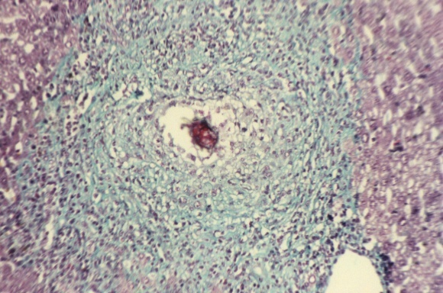
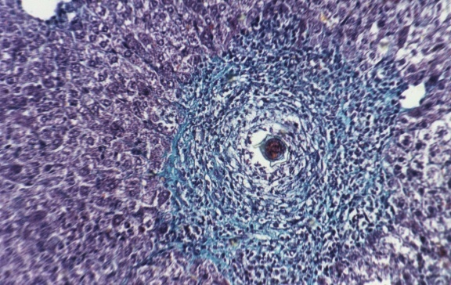
B
A

Figure 7. Histopathological examination of vaccinated control infected mice using Masson's stain. A: Section in mouse liver infected with S. mansoni showing a large egg-granuloma, formed of central ova surrounded by inflammatory cells and irregularly deposited collagen fibers (Masson’s trichrome stain, X200). B: Section in mouse liver infected by S. mansoni cercariae and vaccinated by using pcDNA/SM21.7, showing smaller fibrocellular granuloma formed of central ova, surrounded by histiocytes, lymphocytes, fibroblasts and concentric collagen fibers (Masson’s trichrome stain, X200).
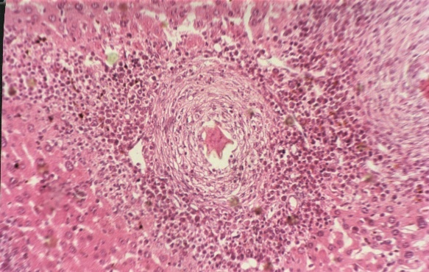
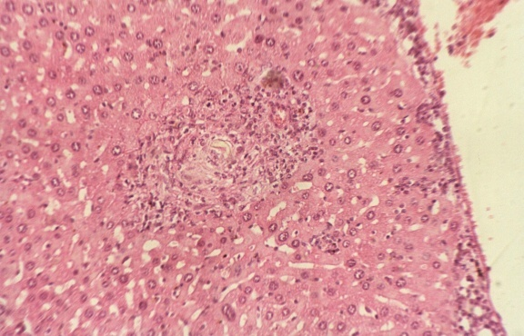
A
B

Figure 8. Histopathological examination of vaccinated and control infected mice using Haematoxylin and Eosin stain A: Section in mouse liver infected with S. mansoni showing a large portal egg-granuloma, formed of central ova surrounded by large number of eosinophils, neutrophils and histiocytes (Haematoxylin and Eosin stain, X200). B: Section in mouse liver infected by S. mansoni cercariae and vaccinated by using pcDNA/SM21.7, showing smaller egg granuloma formed around remnant of ova in the center, surrounded by some mononuclear inflammatory cells and few eosinophils (Haematoxylin and Eosin stain, X200).

4. Discussion
Nucleic acid immunization can be an effective vaccination technology that delivers DNA constructs encoding specific immunogens into host cells, inducing both antigen-specific humoral and cellular immune responses (Bergquist, 2002). Since the first demonstration of protective immunity against viral challenge induced by DNA vaccination using a plasmid DNA encoding influenza A nucleoprotein. Many trials with various degrees of success have been achieved (Ulmer et al., 1993), and the main methods of plasmid-DNA application are intramuscular injection and intradermal delivery into skin (Smahel, 2002). In the case of schistosomiasis, vaccination with DNA has been shows to induced immune responses in rats (Capron et al., 1997; Dupre et al., 1997), and partial protection against challenge in mice (Mohamed el al., 1998) underlining the potential of this method of vaccine delivery for this disease.
Previously, we developed a candidate vaccine against S. mansoni infection based on the SM21.7 tegument protein, isolated from an Egyptian S. mansoni strain liver worms cDNA library by immunoscreening using vaccinated rabbit sera. Intramuscular immunization with SM21.7 protein induced a strong immune response that resulted in a significant reduction in the number of adult worm 40 and 71% in Swiss Albino mice and C57BL/6 mice (Ahmed et al., 2001). In this study to evaluate the immunogenicity and protective efficacy of SM21.7 as a DNA vaccine. The ORF of SM21.7 Schsitosoma mansoni antigen was clones into the pcDNA 1/Amp vector. Vaccination with the naked DNA encoding SM21.7 induced significant levels of specific IgG antibody responses and it has been successful in inducing significant levels of protection in two strains of mice as being assessed histopathologically and parasitologically.
In this study the data are representative of three successive experiments and attempts were made in the current studies to maximize the level of response to the injected DNA. Firstly; Swiss albino and C57 BL/6 mice were chosen because these strains previously demonstrated a high level of protection against Schsitosoma mansoni using SM21.7 recombinant protein (Ahmed et al., 2001). The immunization with reSjc26GST in C57BL/6 mice elicited higher humoral and cellular immune responses in C57BL/6 mice than the BALB/c mice (Shuxian et al., 1998). Secondly, the direct intramuscular injection of plasmid DNA has been used to induce immune responses, and it has been found that a simple saline solution appears to be a suitable carrier resulting in transfection of between 1-5% of myofibrils in the vicinity of the injection site in the case of intramuscular administration (Wolff et al., 1990). Thirdly, the pcDNA1/Amp was chosen because it has been used by many of investigators successfully to obtain partial levels of protections (Dupre et al., 1997; Mohamed et al., 1998; Zhou et al., 1999).
To determine if the SM21.7-pcDNA vaccine conferred protection against Schistosoma mansoni, all groups were challenged with 100 cercariae 3 weeks after the last boost and, 7 weeks later, worm burdens were analyzed. In all cases, the SM21.7-pcDNA vaccine induced statistically significant levels of protection to Schsitosoma mansoni cercarial challenge infection. The administration of SM21.7-pcDNA1 by intramuscular inoculation in this study resulted in expression in vivo, which induced specific antibodies in Swiss albino and Black/6 mice, which could be detected by Western blot analysis (Figure 2) and ELISA (Figure 1).
The reduction in worm burden in animals immunized with SM21.7-pcDNA was significantly higher than in animals immunized with control. Our results demonstrated that the level of pcDNA-SM21.7 antibodies in immunized is significantly higher than the control group of mice (p< 0.001), at 6 and 9 weeks post immunization. The maximum peak was recognized at 7 weeks post-challenge infection in the two strains of mice (Figure 1). In addition vaccination of Swiss albino and C57 BL/6 mice conferred a significant level of protection (41 and 53%) in Swiss albino mice and C57 Black 6/mice against challenge infection (Figure 3).
The protection in the present study is much higher that obtained by Yu et al. (2002) with SjC 21.7-pcDNA3 in BALB/C mice. They reported the worm reduction rate was 29.9% and its egg reduction rate 13.8% in the test group; 31.9% and 28.0% respectively in the boost group. The egg reduction rate in the boost group was higher than that of the test group (P < 0.05). On the other hand, Hafalla et al. (1999), have been reported that, Schsitosoma japonicum molecule, Sj21.7, is a target of IgE antibodies from high-IgE/SWAP responders, indicating that it may be an important vaccine candidate against human schistosomiasis japonica.
Vaccination can be targeted towards the prevention of infection or to the reduction of parasite fecundity. A reduction in worm numbers is the "gold standard" for anti-schistosome vaccine development but, as schistosome eggs are responsible for both pathology and transmission, a vaccine targeted on parasite fecundity and egg viability also appears to be entirely relevant (Capron et al., 2002). The effective vaccine would prevent the initial infection and might reduce egg granuloma associated pathology (McManus et al., 1998). The histopathological examination in the present study of the liver revealed a decreased in the number and size of egg-granulomas in the liver, and intestine of vaccinated mice compared with blank vector injected mice. These findings pointed to significant reduction of parasite fecundity and egg viability, the latter directly affecting transmission potentialities of the disease.
Our results are in agreement with, Hassanein et al (1997), they have been reported that the reduction in granuloma number and size was associated with amelioration of pathological changes in SEA immunized group. The results present in this study are very close to the result of (Zhou et al., 199a), they have been reported, reduction in worm burden following exposure to infection or reinfection and reduction of pathology by a decrease in worm fecundity, directly affecting the transmission of S. japonicum C26GST recombinant protein.

5. Conclusion
We have shown that the intramuscular immunization with pcDNA /SM21.7 was able to induce the immune responses in C57BL/6 and Swiss albino mice. Sera from immunized mice could recognize the SM21.7 protein and the specific antibodies were able to mediate significant macrophages as effecter cells. In addition, our results suggested that the vaccination was able to confer a protective immunity efficacy in C57 BL/6 mice. In addition the pcDNA/SM21.7 showed potential as a DNA vaccine and anti-pathological vaccine. Further studies should yield more insight on the vaccine potential of this antigen and its mechanism of action.

Acknowledgement
We thank Dr. Joseph F. Leykam, Director of Genomics Technology Support Facility, Department of Biochemistry and Molecular Biology, Michigan State University for critical review of the manuscript.

Correspondence to:
Mahmoud Romeih
Associate Prof of Biochemistry and Molecular Biology
Biochemistry and Molecular Biology Department
Theodor Bilharz Research Institute, Giza, Egypt.
Email: romeih@msu.edu, romeihm@yahoo.com

5. References
[1] Ahmed HM, Romeih MH, Sheriff SA, Fathom FA, Saber MA. Protection against Schistosoma mansoni infection with recombinant schistosomula 21.7 kDa protein. Arab Journal of Biotechnology 2001;24:229-49.
[2] Alarcon JB, Waine GW, McManus DP. DNA vaccines: technology and application as anti-parasite and anti-microbial agents. Adv Parasitoly 1999;42:343-410.
[3] Bergquist NR. Schistosomiasis research funding: the TDR contribution. Mem Inst Oswaldo Cruz 1992;IV(87 Suppl):153–61.
[4] Bergquist NR. Schistosomiasis vaccine development: approaches and prospects. Mem Inst Oswaldo Cruz 1995;90(2):221-7.
[5] Bergquist NR. Schistosomiasis: from risk assessment to control. Trends Parasitol. 2002:18(7):309-14.
[6] Capron M, Torpier G, Capron A. In vitro killing of S. mansoni schistosomula by eosinophils from infected rats: role of cytophilic antibodies. J Immunol 1979:123(5):2220-30.
[7] Capron A, Riveau GJ, Bartley PB, McManus DP. Prospects for a schistosome vaccine. Curr Drug Targets Immune Endocr Metabol Disord 2002;2(3):281-90.
[8] Chisel L, Engels D, Montresor A. Savioli L. The global status of schistosomiasis and its control. Acta Trop 2000;77:41–51
[9] Da'dara AA, Skelly PJ, Wang MM, Harn D. AImmunization with plasmid DNA encoding the integral membrane protein, Sm23, elicits a protective immune response against schistosome infection in mice. Vaccine 2001;:20:359-69.
[10] Davis A, Wegner DH. Multicentre trials of praziquantel in human schistosomiasis: design and techniques. Bull World Health Organ 1979;57:767-71.
[11] Dupre L, Poulain-Godefroy O, Ban E, Ivanoff N, Mekranfar M, Schacht AM, Capron A, Riveau G. Intradermal immunization of rats with plasmid DNA encoding Schistosoma mansoni 28 kDa glutathione S-transferase. Parasite Immunol 1997;19(11):505-13.
[12] Dupre L, Kremer L, Wolowczuk I, Riveau G, Capron A, Locht C. Immunostimulatory effect of IL-18-encoding plasmid in DNA vaccination against murine Schistosoma mansoni infection. Vaccine 2001;19:1373-80.
[13] Duvall RH, DeWitt WB. An improved perfusion technique for recovering adult schistosomes from laboratory animals. Am J Trop Med Hyg 1967;16(4):483-6.
[14] Gurunathan S, Wu CY, Freidag BL, Seder RA. DNA vaccines: a key for inducing long-term cellular immunity. Curr Opin Immunol 2000;12:442-7.
[15] Hafalla JC, Alamares JG, Acosta LP, Dunne DW, Ramirez BL, Santiago ML. Molecular identification of a 21.7 kDa Schistosoma japonicum antigen as a target of the human IgE response. Mol Biochem Parasitol 1999;98(1):157-61
[16] He J, Hoffman SL, Hayes CG. DNA inoculation with a plasmid vector carrying the hepatitis E virus structural protein gene induces immune response in mice. Vaccine 1997;15(4):357-62.
[17] Hassanein H, Akl M, Shaker Z, El-Baz H, Sharmy R, Rabiae I, Botros S. Induction of hepatic egg granuloma hypo responsiveness in murine schistosomiasis mansoni by intravenous injection of small doses of soluble egg antigen. APMIS 1997;105(10):773-83.
[18] Hota-Mitchell S, Clarke MW, Podesta RB, Dekaban GA. Recombinant vaccinia viruses and gene gun vectors expressing the large subunit of Schistosoma mansoni calpain used in a murine immunization-challenge model. Vaccine 1999;17(11-12):1338-54.
[19] Kowalczyk DW, Ertl HC. Immune responses to DNA vaccines. Cell Mol Life Sci 1999;55:751-70.
[20] Laemmli UK. Cleavage of structural proteins during the assembly of the head of bacteriophage T4. Nature 1970;15:680.
[21] Liu S, Song G, Xu Y, Yang W, McManus DP. Immunization of mice with recombinant Sjc26GST induces a pronounced anti-fecundity effect after experimental infection with Chinese Schistosoma japonicum. Vaccine 1995;13(6):603-7.
[22] McManus DP, Liu S, Song G, Xu Y, Wong JM. The vaccine efficacy of native paramyosin (Sj-97) against Chinese Schistosoma japonicum. Int J Parasitol 1998;28(11):1739-42.
[23] McManus DP. DNA vaccine against Asian schistosomiasis: the story unfolds. Int J Parasitol 2000;30:265-71
[24] Mohamed MM, Shalaby KA, LoVerde PT, Karim AM. Characterization of Sm20.8, a member of a family of schistosome tegumental antigens. Mol Biochem Parasitol 1998; 96(1-2):15-25.
[25] Oliver L, Stirwalt MA. An efficient method for exposure of mice to cercariae S. mansoni. J Parasitology 1952;38:19-35.
[26] Ramsay AJ, Kent SJ, Strugnell RA, Suhrbier A, Thomson SA, Ramshaw I.A. Genetic vaccination strategies for enhanced cellular, humoral and mucosal immunity. Immunol Rev 1999; 171:27-44.
[27] Saiki RK, Gelfand DH, Stoffel S, Scharf SJ, Higuchi R, Horn GT, Mullis KB, Erlich HA. Primer-directed enzymatic amplification of DNA with a thermostable DNA polymerase. Science 1988;239(4839):487-91.
[28] Sambrook J, Fritsch EF, Maniatis T. in Molecular Cloning: A Laboratory Manual. Cold Spring Harbor Laboratory Press, NY, 1989; Vol. (1, 2, 3).
[29] Shuxian L, Yongkang H, Gung Chen S, Xing-Song L, Yuxin X, McManus DP. Anti-fecundity immunity to Schistosoma japonicum induced in Chinese water buffaloes (Bos buffelus) after vaccination with recombinant 26 kDa glutathione-S-transferase (reSjc26GST). Vet Parasitol. 1997;69(1-2): 39-47
[30] Shuxian L., Guangchen S., Yuxin X., McManus D.P, Hotez P.J. Progress in the development of a vaccine against schistosomiasis in China. Int J Infect Dis 1998:2(3):176-80.
[31] Smahel M. DNA Vaccine. Cas Lek Cesk 2002;22(141):26-32.
[32] Tuteja R. DNA vaccines: a ray of hope. Crit Rev Biochem Mol Biol 1999;34(1):1-24.
[33] Ulmer JB, Donnelly JJ, Parker SE, Rhodes GH, Felgner PL, Dwarki VJ, Gromkowski SH, Deck RR, DeWitt CM, Friedman A, et al. Heterologous protection against influenza by injection of DNA encoding a viral protein. Science 1993;259(5102) :1745-9.
[34] Waine GJ, Yang W, Scott JC, McManus DP, Kalinna BH. DNA-based vaccination using Schistosoma japonicum (Asian blood-fluke) genes. Vaccine 1997;15(8):846-8.
[35] World Health Organization (WHO). The Control of Schistosomiasis. Report of a WHO Expert Committee. WHO Technical Report Series 1985;728:113, Geneva.
[36] World Health Organization (WHO). The Control of Schistosomiasis. Second report of the WHO Expert Committee. WHO Technical Report Series 1993;830:86, Geneva.
[37] World Health Organization (WHO). The Prevention and Control of Schistosomiasis. and Soil-transmitted Helminthiasis. Report of the Joint WHO Expert Committees. 2002: WHO Technical Report Series (manuscript).
[38] Wynn TA, Cheever AW, Williams ME, Hieny S, Caspar P, Kuhn R, Muller W, Sher A. IL-10 regulates liver pathology in acute murine Schistosomiasis mansoni but is not required for immune down-modulation of chronic disease. J Immunol 1998;160(9):4473-80.
[39] Wolff J.A., Malone R.W., Williams P., Chong W., Acsadi G., Jani A., Felgner P.L. Direct gene transfer into mouse muscle in vivo. Science 1990; 247(4949 Pt 1):1465-8.
[40] Yang W, Waine G.J., McManus D.P. Antibodies to Schistosoma japonicum (Asian bloodfluke) paramyosin induced by nucleic acid vaccination. Biochem Biophys Res Commun. 1995;212(3): 1029-39.
[41] Yu CX, Zhu YC, Yin XR, Ren JG, Si J, Xu YL, Shen LN. Protective immunity induced by the nucleic acid vaccine of Sjc 21.7 in mice. Article in Chinese Zhongguo Ji Sheng Chong Xue Yu Ji Sheng Chong Bing Za Zhi. 2002;20(4):201-4.
[42] Zhang Y, Taylor MG, Bickle QD. Schistosoma japonicum myosin: cloning, expression and vaccination studies with the homologue of the S. mansoni myosin fragment IrV-5. Parasite Immunol 1998;20(12):583-94.
[43] Zhang Y., Taylor M.G., Johansen M.V., Bickle Q.D. Vaccination of mice with a cocktail DNA vaccine induces a Th1-type immune response and partial protection against Schistosoma japonicum infection.Vaccine 2001;207(5-6):24-730.
[44] Zhou S, Liu S, Song G, Xu Y. Studies on the features of protective immune response induced by recombinant Sjc26GST of Schistosoma japonicum. Zhongguo Ji Sheng Chong Xue Yu Ji Sheng Chong Bing Za Zhi. 1999a;17 (2):74-7.
[45] Zhou S, Liu S, Song G, Xu Y. Cloning, sequencing and expression of the full-length gene encoding paramyosin of Schistosoma japonicum in vivo. Zhongguo Ji Sheng Chong Xue Yu Ji Sheng Chong Bing Za Zhi 1999b;17(4):196-9.

