Research on Interference Verification and Simulation of Six DOF Parallel Kinematics Machine

Yonggeng Wei¹, Yong Shi², Zhixing Wang¹
1. School of Mechanical and Electrical Engineering, Harbin Institute of Technology, Harbin, Heilongjiang 150001, China; wyg_1972@163.com
2. School of Astronautics, Harbin Institute of Technology, Harbin, Heilongjiang 150001, China

Abstract: Parallel Kinematics Machine design is difficult because of many restriction conditions, design parameters and complicated motion procedure. All these lead to a longer design period. In this paper, the interference verification and its simulation of the six DOF Parallel Kinematics Machine were researched. Firstly, restriction condition was established, structural parameter of machine was calculated and interference verification was developed in theory. Secondly, 3D design was developed by Pro/E software, and interference verification and assembly were processed in 3D design. Finally, the 3D model was imported to Adams software and the corresponding simulation was processed, then the interference phenomena could be observed by the simulation. The project made the design more efficient and the design cost lower, and it also reduced the design period and has been applied to practice. [Nature and Science. 2006;4(1):27-33].

Keywords: Parallel Kinematics Machine (PKM); interference verification; workspace

1. Introduction
The fixing platform and the moving platform of the 6 DOF PKM based on Stewart are linked by six driving bars whose length is alterable through movement joints (huke joints or sphere joints). Tool fixed on the moving platform can machine all kinds of complicated surfaces by the alterability of the driving bar length. Its structure is shown in Figure 1.
Workspace is chief index of PKM capability in structural parameter design. However, traditional design means is: structure of PKM is designed from middle to both sides, from top to bottom. Because of unforeseen factors, it will lead to small workspace, interference between parts and has to be designed again. Designers waste a lot of time to do repeated work. There are virtual and simulative designs in some literatures. But the simulation is not real structure of PKM and cannot process dynamic interference verification to erose parts of PKM. The design method leads to low efficient, increased design cost, long design period and is unfit to market competition. This paper develops interference verification of 6 DOF PKM. Its design method is: through parametric design idea of Pro/E software, we can conveniently process 3D design of PKM, assembly check-up and interference verification. 3D model of PKM in Pro/E software is imported to Adams software for dynamic simulation. The dynamic simulation is real motion of PKM and resolves the problem that dynamic interference verification cannot be processed between erose parts of PKM.
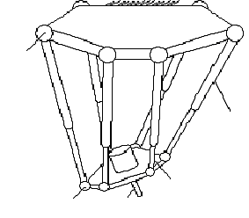

Figure 1. Structure of 6 DOF PKM
Driving bar
moving platform
tool
huke
fixing platform
huke

2. Structural parameter of 6 DOF PKM and its restriction condition
We designed 6 DOF PKM of crossed structure by the design project mentioned above. The PKM’s photo was shown in Figure 2. It was made up of the fixing platform, the moving platform and 6 driving bars whose length was alterable. The fixing platform and the driving bar were linked by 2 DOF huke joint. The moving platform and driving bar were linked by 2 DOF huke joint and 1 DOF rotation pair. We built the fixing coordinate system $O−\text{XYZ}$at the center of circle of the fixing platform huke joint points and built the moving coordinate system $O^{'}−X^{'}Y^{'}Z^{'}$ at the center of circle of the moving platform huke joint points. Its sketch is shown in Figure 3. In the Figure 3, the fixing platform huke joint points are allocated to inside circle and outside circle. Circle’s radiuses are $R_{f1}$ and $R_{f2}$. The moving platform huke joint points are also allocated to inside circle and outside circle, but there is height between two circles. Circle’s radiuses are $R_{m1}$ and . $φ_{f}$ and $φ_{m}$ are distributed angles of the fixing platform and the moving platform. Because close two huke joint points of the fixing platform and the moving platform are symmetrical, the position of all huke joint points can ensured by $φ_{f}$ and $φ_{m}$. So structural parameters of PKM are: $R_{f1}$, $R_{f2}$, $R_{m1}$, , $φ_{f}$, $φ_{m}$ and .
H1
B₅
B₃
A₆
A₅
A₃
A₁
Z′
Y′
X′
X
O
Z
Y
A₄
A₂
B₁
B₂
B₄
B₆
H
R_{f1}
R_{m1}
R_{m2}
R_{f2}
Figure 3. Structure of 6 DOF PKM

Workspace is chief index of PKM capability to design PKM. It is important to obtain the largest workspace by optimization and not to generate interference between the parts of PKM. However, chief factor to affect workspace is geometry restriction condition. Therefore geometry restriction condition has crucial effect to design PKM. There are four types of geometry restriction conditions:
- Length restriction of driving bar
Figure 2. 6 DOF PKM
It includes: maximal valve and minimal valve of length of driving bar, valve of subtracting factual travel length valve of driving bar from minimal valve of driving bar length. They shall meet below formula:
Length of driving bar shall meet between maximal valve and minimal valve of length of driving bar:
$l_{\text{min}}≤l_{i}≤l_{\text{max}}$ $i$=1，2，…，6 （1）
Factual travel length valve of driving bar is:
$l=l_{\text{max}}−l_{\text{min}}$
Valve of subtracting factual travel length valve of driving bar from minimal valve of driving bar length shall meet constant $L$:
Figure 4. Diagram of huke mechanism
$l_{\text{min}}−l≥L$ （2）
Thereinto, $L$ is obtained by design experiences.
- Limitation of angle of huke joint
It includes limitation of angle of huke joint of the fixing platform and the moving platform. Huke is made up of two level rotation pairs (Figure 4). One level rotation pair is linked directly with the fixing platform or the moving platform. Two level rotation pair is vertical to one level rotation pair. We build the coordinate system $n_{1}n_{2}n_{3}$ at huke joint point. The coordinate system is invariable to the machine system and $n_{1}n_{2}n_{3}$ is unit vector. We define vector of the driving bar as $n$, axis vector of one level rotation pair as $n_{1}$, axis vector of two level rotation pair as $n_{2}$. By right hand theory, we define $n_{3}$ as vector product of axis vector of one level rotation pair and axis vector of two level rotation pair shown as below:
$n_{3}=n_{1}×n_{2}$
Then, rotation angles of one level rotation pair and two level rotation pair may be expressed shown as below:
$θ_{1}={\text{arctan}}_{2}(\frac{n⋅n_{3}}{n⋅n_{2}})$ (3)
$θ_{2}=\text{arccos}(n⋅n_{1})$ （4）
$θ_{1}$ and $θ_{2}$ shall meet nether formula:
$\left\{\begin{matrix}θ_{1\text{min}}≤θ_{1}≤θ_{1\text{max}} \\ θ_{2\text{min}}≤θ_{2}≤θ_{2\text{max}}\end{matrix}\right.$ (5)
In fact, angle $θ_{1}$ is not limited if structure of PKM is reasonable.

- Interference between columned parts
It includes: minimal distance between two driving bars, minimal distance between two servo motors, minimal distance between motor principal axis and driving bar. The interferences may be summarized three types as below:
- Interference between surfaces of crossed two columned parts.
- Interference between surfaces of columned parts and circle plane of columned parts.
- Interference between circle planes of two columned parts.
- Interference between erose parts
It includes: interference between servo motor and frame of PKM, interference between the moving platform and frame of PKM, etc.
After restriction conditions have been built, we could calculate structural parameter of PKM. Firstly, we define workspace of PKM as a cylinder and define initialization of PKM. Initializations of PKM include: distributed angle and radius of circle of the fixing platform, distributed angle and radius of circle of the moving platform, distance between the fixing platform and the moving platform, distance between up circle and down circle of the moving platform huke joint point. We can obtain coordinate valve of the fixing platform huke joint point and the moving platform huke joint point from initialization of PKM. Second, it need obtain motion track of PKM. Interference usually occurs at border of workspace according to structure of PKM and character of workspace. So while to optimize structural parameters of PKM, all data of motion track of PKM is defined at border of workspace and distribution is average. Third, after motion track of PKM has been built, all data of length and vector of six driving bars can be calculated by inverse solution of PKM and at the same time all data of position and pose of tool can be recorded. And then, restriction condition can be obtained by calculating a series of border points of workspace. Such as maximal valve and minimal valve of length of driving bar, vector of driving bar at different position, center vector $n_{∘}$ of all track points of driving bar obtained by vector of driving bar (Figure 5), limitation of angle of huke joint of the fixing platform and the moving platform and so on. Then we can go on interference verification by restriction condition and obtain factual workspace. At last, if result is not satisfying, it is necessary to modify parameter and recalculate. Otherwise calculation is terminated. Thereinto, center vector $n_{∘}$ of all track points of driving bar is defined as: such as huke joint of the moving platform, track point of driving bar is defined as a cone and vertex of the cone lies to huke joint point of the moving platform. So center axis of the cone is center vector $n_{∘}$ of all track points of driving bar. $n_{∘}$ is also defined in the fixing platform in this way.

3. 3D design of 6 DOF PKM
Pro/E software provides capability of bidirectional relation by single database. The capability is accordant with concept of synchronous engineer in modern industry. In design, any data modified will be transmitted to all over relational files and data of relational files will be updated automatically. The design course is very simple, at the same time by single database, all dimensions in the middle of design is saved in the database and it is no longer difficult to modify CAD model. The designer only modifies 3D parts, then 2D drawing, 3D assembly and mold and so on can immediately be modified in according to change of dimension. Therefore, consistency of work to modify is guaranteed, mistake by people is avoided and time to modify drawing is reduced.
Adams is application software based on virtual prototyping technology. Virtual prototyping technology is a high technology that can resolve conflict between traditional design and manufacture. The designer can obtain virtual prototyping of machine system by physical and geometrical information of parts offered by CAD system. Then kinematics and dynamic analysis can be really simulated by system simulation software. Movement of parts can be observed and be experimented, at the same time design mistake can easily be modified on the computer, different project can be simulated. After project of optimization has been obtained by uninterrupted modification, physical prototyping may be manufactured. By design of virtual prototyping substituting physical prototyping, not only design period is shortened, but also quality and efficiency of design is gone up.
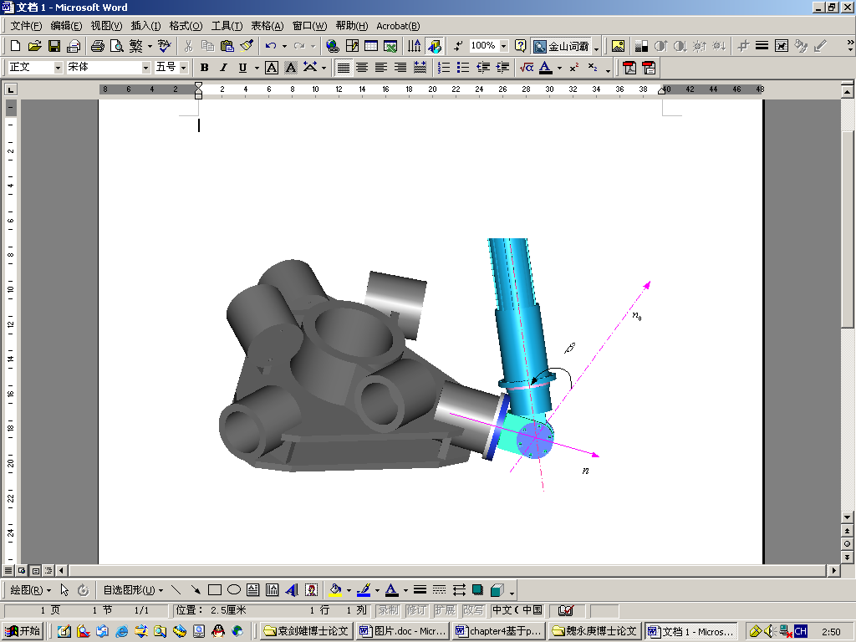
Figure 5. Interference verification of huke

3.1 Assembly check up based on Pro/E software
After all structural parameters of PKM have been calculated, we may design all the parts, assemble and intervene verification the parts in the Pro/E software. Parts of PKM are divided four types in the assembly: driving bar parts, the moving platform parts, the fixing platform parts, frame parts. Assembly sequence is shown as below:
1) Driving bar parts are assembled. It is the key parts of PKM and there are lots of parts to be checked such as switch of limitation position and sensor and so on.
2) The fixing platform huke is fixed on the fixing platform.
3) The fixing platform is fixed on the frame of PKM.
4) Driving bar is inserted in the huke of the fixing platform.
5) Driving bar is assembled with huke of the moving platform.
6) Huke of the moving platform is assembled with the moving platform.

3.2 Interference verification based on Pro/E software
There are four types restriction conditions mentioned above. First and second types restriction condition will be checked in the Pro/E software and the rest will be checked in the Adams software.
1) Length restriction of driving bar
First, we open assembly drawing of driving bar and adjust driving bar to maximal length. Second, we open “analysis” menu from “model analysis” menu and “model analysis” dialog box will appear. In the dialog box, we choose “integral interference” from “type” edit box and click “calculation” button. The system will automatically calculate whether the assembly is interferential. If it happens to intervene, part of interference will be red and name of the parts will be shown in the “result” edit box. Similarly we adjust driving bar to minimal length and check whether to intervene.
2) Limitation of angle of huke joint
According to traditional design method, dimension of huke joint is estimated by design experiment. However, it is very difficult to obtain movement relation between huke joint and driving bar because figure of parts is erose and it is possible to lead to intervene between huke joint and driving bar. The interference can be checked by Pro/E software.
Such as the moving platform, we have obtained center vector $n_{∘}$ of all track points of driving bar and corresponding position vector $n$ of cylinder of the moving platform huke joint through above. Because movement track of driving bar is cone, we define half of vertex angle of cone as $β$. Then, we assemble the moving platform with huke joint by angle $β$. The driving bar turns around on axis of $n_{0}$ and look dangerous position for assembling. It can be observed whether to intervene. If it happens to intervene shown as Figure 5, we modify dimension of part and until reasonable design.

4. Dynamic simulation based on Adams software^{[3][4]}
Modeling and assembly are main advantages of Pro/E software. But dynamic simulation is main advantage of Adams software. Then, we build model and assemble in the Pro/E software and simulate in the Adams software by importing model from Pro/E software.
It need simple the model before the assembly drawing is imported to Adams software from Pro/E software.
1) Define markers points
Movement relation between two close parts need be built by adding joint after assembly drawing has been imported to Adams software from Pro/E software. Orientation of joint is guaranteed by two markers. It is convenient to build markers in the Pro/E software before model is imported to Adams software from Pro/E software.
2) Delete unnecessary parts
Simulation goal based on Adams software is interference verification. Thus, it only need to guarantee shape dimension of PKM for reducing calculation and delete unnecessary parts such as bolt, bearing and so on..
3) Deal with assembly drawing
When PKM is assembled, the moving platform is localized the center and its pose angle is defined 0º. Simultaneity, it is noticed: if there is embranchment assembly drawing in the whole assembly drawing in the Pro/E software, embranchment assembly drawing which is imported to Adams software will be defined as a part.
We define function of position and pose of the moving platform of PKM as $U(x,y,z,α,β,γ)$. Thereinto, $x,y,z$ is center position coordinate of the moving platform and $α,β,γ$is pose of the moving platform. Angle $α$ expresses gradient orientation of the moving platform. Angle $β$expresses gradient range of the moving platform. Angle $γ$ is equal to angle $−α$. After restriction joint of PKM is given and the absolute coordinate system is obtained, we add movement function to the marker point of the moving platform and go on simulation. We design two movement functions to check third type restriction and fourth type restriction mentioned above: point movement function and circle movement function. Point movement function means: center of the moving platform localizes to a point of workspace, nutation $β$ is defined as constant, $α$ changes from 0º to360º surrounding the point. The function checks third type restriction. Circle movement function means: center of the moving platform localizes to a circle of workspace, nutation $β$ is defined as constant, $α$ changes from 0º to360º surrounding the circle. The function checks fourth type restriction. Figure 6 is 3D model of PKM.
We can observe the movement whether to intervene such as between motors, close driving bar and so on from different angle of view while PKM motions. Because the 3D model is real dimension of PKM, the movement is reappearance of movement of real PKM.
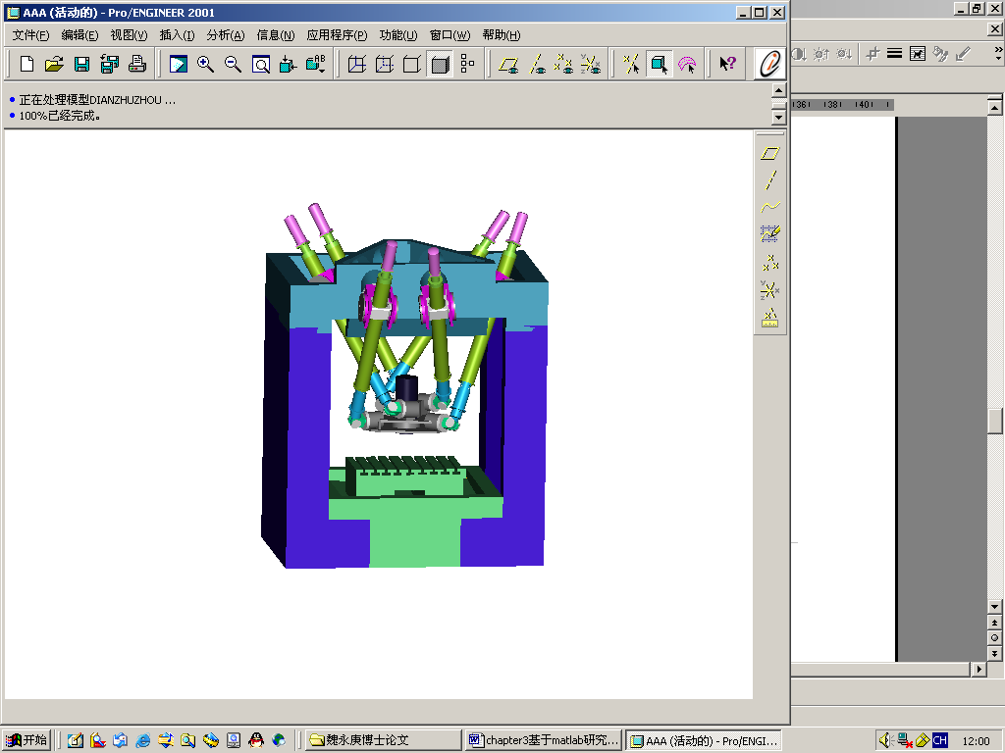
Figure 6. 3D model of PKM
5. Conclusion
The project develops 3D design and dynamic simulation from traditional 2D design, the project makes the design more efficient, and makes the design cost lower, it also reduces the design period. The project has been applied to practical engineering, and the application result is satisfying.

Correspondence to:
Yonggeng Wei
School of Mechanical and Electrical Engineering
Harbin Institute of Technology
Heilongjiang, China, 150001
Telephone: 01186-451-8641-3847
Mobile telephone: 01186-13936429157
Email: wyg_1972@163.com

References
- Liu Dejun, Ai Qinghui, Wang Jianlin, et al. Calibration of kinematics parameter and computer simulation of 3 DOF parallel coordinate measuring machine [J]. Mechanical Engineering Journal 2004;40(3):15-9.
- Liu Wentao. Analysis and study of capability of parallel machine tool [D]. Doctor Dissertation of Harbin Institute of Technology 2000;4:56-60.
- Fan Jinwei, Fei Renyuan, Tian Yue, et al. Movement space analysis and simulation study of parallel kinematics machine based on multi-body system kinematics theory [J]. Mechanical Engineering Journal 2001;37(1)32-6.
- Pritschow G. Systematic design of hexapods and other parallel link systems. CIRP Annals 1997;46(l):291-5.

