The Resurrection of the Light Conducting Medium for Modern Physics

Ken H. Seto

KHS Publishing, 260 Yorkshire Lane, Xenia, OH 45385, USA
kenseto@erinet.com; http://www.erinet.com/kenseto/book.html
Telephone: 937-3725298

Abstract: Physicists at the times of Isaac Newton and James Clerk Maxwell perceived that space is occupied by a light-conducting medium called 'aether.' The motions of objects in this medium are called absolute motions. However, when Michelson and Morley failed to detect this light-conducting medium with their famous MMX experiments, physicists began to doubt the existence of aether. This doubt was reinforced when Einstein developed his Special Theory of Relativity (STR). With STR, Einstein demonstrated that the need for an aether is 'superfluous' and that motions relative to it are not detectable. This led physicists to conclude that even if there is an aether occupying space it plays no role in the any of the processes of nature. This conclusion led physicists to resort to the non-physical mathematical constructs such as space-time, time dilation, rod contraction, duality, virtual particles, fields, probability waves, and curled up extra dimensions to explain the processes of nature. The irony is that these mathematical constructs are just thinly disguised aether effects. This method of doing physics has had severe adverse consequences. It led generations of physicists to develop a mind set against the aether concept. [Nature and Science. 2006;4(2):1-10]

Keywords: resurrection; light conducting medium; physics; aether

Contents

1. Introduction
2. The Current State of Our Universe
3. The Concept of Absolute Motion
4. Past Experiments Detected Absolute Motion
5. New Experiments to Detect Absolute Motion
6. Conclusions

1. Introduction
This paper describes a unique aether called the E-Matrix. The unique properties of the E-Matrix give new simple interpretations for the weird results of past famous quantum experiments. Also, they allowed me to develop two new experiments to detect its existence. The existence of the E-Matrix opens up new alternatives for doing physics. Most importantly, it gives us a new way to explain and unify all the forces of nature.
Quantum Mechanics and Relativity are the most successful theories of modern physics. However, these two pillars of modern physics are not compatible with each other at the fundamental level. The main point of incompatibility is that there is no viable theory of quantum gravity. In recent years there is a resurgent of interest in the aether approach for doing physics. This paper describes the successful development of a unique aether called the E-Matrix Ref. [1]. The unique structure of the E-Matrix is such that it explains the weird results of the following past famous experiments: the Compton Effect Experiment, the Photoelectric Experiment and the Double-Slit Experiment. Also the E-Matrix allowed me to design two new experiments that are capable of detecting the absolute motion of the observer in the E-Matrix. The following topics of discussion reveal the power of the E-Matrix concept.

2. The Current State of Our Universe
In the past, great advances were made when physicists encountered problems with their existing theories. A good example of this was Max Planck's discovery of the light quanta. At that time, light was considered to be continuous waves and this concept gave rise to the problem called the ultraviolet catastrophe. As it turned out, Max Planck's ideas not only were able to explain the ultraviolet catastrophe but they also started the revolution that led to quantum mechanics. Another example was Einstein's theory of relativity. Before relativity, Newton's laws of motion reigned. When physicists realized that Newton's theory could not properly describe light, they adapted Einstein's theory of relativity.
Today Quantum Mechanics (QM) and Relativity are two of the most successful theories in the history of physics. Yet, they can only be referred to as partial theories because each by itself is not capable of describing or uniting all the forces of nature. The problems of uniting all the forces of nature present a challenge similar to that of the pre-relativity and pre-quantum mechanics days. However, in spite of intense efforts for the past seventy years, all attempts to describe gravity using the quantum mechanical processes have failed. This could be a symptom that both QM and Relativity are fundamentally flawed. In other words, the state of the current universe as set forth by QM and Relativity may not be the true description of nature. This suggests that a new description of the current universe may be needed for us to get out of our present conundrum.
I developed an interest to develop a unify theory in the early 1980's. At first, I followed the conventional approach of building on top of current theories. However, after many years of fruitless efforts, I came to the conclusion that this approach is ultimately doomed to fail because QM and Relativity are not based on the true model of the current universe. In the late 1980's, I abandoned the conventional approach for doing physics and started using an approach called the Pyramid Techniques. As the name implies, the Pyramid Techniques assumes that there is only one description of the current universe that is capable of explaining all the processes of nature. This description is at the apex of the pyramid. The step-by-step procedure for the Pyramid Techniques is as follows:
- Search the literature and identify the major problems of relativity, quantum mechanics and modern cosmology.
- Formulate a group of theories that can account for these problems. The formulator is free to assume any model of the current state of the universe. The resulting group of theories must be capable of explaining all the processes of nature. During the formulation process, the formulator must adhere to the fundamental principle that all particles in the universe are dumb. However, their motions in space could give the appearance of them possessing 'intelligent' properties. I named the resulting group of theories Model Mechanics to emphasize the processes used to derive these theories.
- The next step is to check the consistency of the postulates of the formulated theories with past observations and experimental results. Specifically, include those results and observations that can support the new theories exclusively.
- Design realistic experiments that can confirm the newly formulated theories.
- Develop the equations based on the newly formulated theories. Except for Doppler Relativity Theory, Model Mechanics is at this stage of development.
- Perform the designed experiments for the final confirmation.
The Pyramid Techniques enabled me to go through a number of possible states of the current universe quickly. The first model that was somewhat successful posits that space is filled with a substance called the E-Matrix (the prefix "E" represents elastic). The E-Matrix exerts a repulsive force on all the matter particles within it. In other words, a particle in the E-Matrix is much like a droplet of oil emulsion in water--it feels the repulsive force of the water from all sides. When the E-Matrix is distorted, it will recover itself to the original non-distorted state quickly. Light is waves in the E-Matrix and time is absolute, not flexible, as postulated by the Special Theory of Relativity (STR). This model of the universe explains the propagation of light but it was not capable of explaining the various force interactions without resorting to abstract processes; therefore, it was not a successful model.
As a means of increasing the scope of this model, I visualized that the E-Matrix is composed of E-Strings. These E-Strings are three-dimensional elastic strings and they are oriented randomly in all directions. The motions of matter particles in the E-Matrix will distort the geometry of the E-Strings locally. On the other hand, matter particles will follow the local geometry of the E-Strings (due to orbital confinement) as they travel in the E-Matrix. This modified model brings General Relativity into the fold. However, it lacked the processes to describe the electromagnetic, nuclear weak and strong forces. It was evident that additional modifications were needed to explain these interactions. The next idea that I added to the above model is one of the most important ideas of Model Mechanics. This idea posits that all the forces of nature are the results of absolute motions between the interacting particles or particle systems. These modifications completed the modeling process and yield the following successful description of the current state of our universe:
A stationary substance called the E-Matrix occupies all of the pure-space in our universe. Subsequently, we perceive the E-Matrix as space. The E-Matrix, in turn, is composed of E-Strings. An E-String is a very thin three-dimensional elastic object. The diameter of an E-String is not defined. It is probably in the region of Planck length, which is defined as the smallest length that has any meaning. The length of an E-String is not defined. It could be a big loop and in that case the diameter of the loop is defined. Away from matter, E-Strings are oriented randomly in all directions, but near matter, E-Strings are more organized: some emanate from the matter, and the number of these passing through a unit area at a distance 'r' from the matter is inversely proportional to r². Matter particles will follow the local geometry of the E-Strings as they travel in the E-Matrix. In turn, the motions of matter particles in the E-Matrix will distort the geometry of the E-Strings locally. These provisions of the E-Matrix are responsible for the peculiar properties of the gravitational force. Also, it explains why the propagation of light and gravity obeys the inverse square law.
The E-Strings are repulsive to each other. This repulsive effect is fundamental. This means that there is a compacting force served to compact the E-Strings together to form the E-Matrix. This compacting force is also fundamental. The compacting force and the repulsive force between the E-Strings are in a delicate equilibrium and this equilibrium is self-restoring when the motion of particles in the E-Matrix disturbs it.
With this description of the E-Matrix, the next relevant question is: What is matter? The answer to this question is: All matter is making from a fundamental particle called the S-Particle. The different orbiting motions of the S-Particles around the E-Strings give rise to all the observable particles such as the electron and the different quarks. Also, the different orbiting motions of the S-Particles give rise to the extrinsic properties such as charge, spin and mass of the observable particles. The S-Particle is a 3-dimensional entity. Its internal structure is not defined. It has no intrinsic property. The diameter of an S-Particle is not defined but it is likely in the range of Planck length (10⁻³³ cm). The S-Particles and the E-Strings are exerting a repulsive force on each other and this force is fundamental. This allows the S-Particles to move unimpeded in the E-Matrix. The different directions of absolute motions of the S-Particles or S-Particle systems give rise to all the forces of nature.
The above Model Mechanical description of the current universe appears to be conflicting with the results of some past experiments. Specifically, it appears to be conflicting the null result of the Michelson and Morley experiment (the MMX). Physicists concluded that the null result of the MMX suggests that there is no light conducting medium (aether) occupying space. This is in direct conflict with the proposed E-Matrix, which is a form of aether. It turns out that the MMX results can be interpreted differently. This new interpretation leads to a new conclusion: Michelson and Morley did indeed detect the aether that they were seeking. The following is a description of this new interpretation.

A New Interpretation of the MMX
Maxwell's physics suggests that space is occupied by a light-conducting medium, which he called "aether." Michelson and Morley designed an experiment (the MMX) to find this aether. They use interferometer to compare the speed of light in the direction of the earth's 30-km/sec motion around the sun with that at right angles to this motion. To their surprise, they found no fringe shift, indicating that the speed of light was the same in all directions. This result is known as the MMX null result. In spite of the null result of the MMX, Michelson remained a firm believer in the existence of aether until his death. However, his belief did not stop other physicists from concluding that the MMX null result meant that there was no aether occupying space. For reasons developed below it is likely that this conclusion is erroneous.
Michelson and Morley made the following assumptions at the start of their experiment:
- The aether is a fluid and this fluid is flowing through their instruments.
- The relative motion between the earth and the sun was interpreted as the absolute motion of their instrument in the aether.
- Light travels slower against the direction of flow of this fluid (somewhat like moving against a head wind) and it travels faster in the transverse direction in this fluid.
- The different light speeds between the two right-angled directions will show up as a fringe shift.
Today, we know that assumptions 1, 2 and 3 are false. Assumption 1 assumed a structure of aether that is not compatible with the source-independence of light speed, which requires a stationary solid aether (the E-Matrix). Assumption 2 is wrong because the earth-sun system travels in the Milky-Way galaxy, and the galaxy travels in space. Assumption 3 is wrong because the speed of light has been proven experimentally to be independent of the state of motion of the source. This experiment was performed at CERN in 1964 with a stream of neutral pion subatomic particles. Light from the decay of pions at rest was found to have the same speed as light from the decay of pions moving at a speed close to that of light. The falsities of these assumptions suggest that the no-aether conclusion may have been false too.
If Michelson and Morley had known that light speed is independent of the state of motion of the source they might have concluded that they had found the aether that they were seeking. This alternate conclusion is based on the following analysis:
- The mirrors at the end of the arms were acting as sources. Due to the source-independence of the speed of light, pulses from these different sources travel with the same constant speed toward their common target, the half-silvered mirror that recombines them. This means that the light rays arrive at the common target in phase and thus give rise to the null result of the MMX.
- The MMX confirmed the source independence of the speed of light.
- Source-independence of the speed of light supports the idea that light is a wave pattern in a transmitting medium and that medium is called aether.
- The aether 'yes' interpretation of the MMX represents a support of the existence of the E-Matrix. We are now justified to use the E-Matrix and the absolute motion of S-Particles or S-Particle systems in the E-Matrix to explain all the processes of nature. Specifically, it provides us with a mean to unify all the forces of nature. It explains why the speed of light is constant in all inertial frames. It explains what is time dilation and length contraction. It gives the cause of gravity and explains the meaning of the observed action at-a-distance phenomenon of gravity.

3. The Concept of Absolute Motion
The idea of absolute motion within the observer's frame is hard to visualize. This is because our perceptions of objects surrounding us are stationery unless there is an external force acts upon them. We can get rid if this visualization problem by remembering that absolute motion is not relative to us but it is relative to the E-Matrix. The following is a list of five basic absolute motions that exist in our universe. These include the absolute speed of light and those absolute motions that are possessed by the various S-Particles in the E-Matrix. The interactions of these five basic absolute motions of particles in the E-Matrix give rise to all the other absolute motions that are observed in our universe.

1. The absolute speed of light in the E-Strings is maximum when it is determined using a defined absolute second in the E-Matrix.
2. The V_{bb} (Velocity Big Bang) motion is an absolute motion possessed by all the S-Particles in the E-Matrix. It is this motion that is responsible for the attractive component of gravity. The V_{bb} motion had its origin from the Big Bang. It is the slowest of all the absolute motions possessed by the S-Particles in the E-Matrix.
3. The V_{se} motion stands for the orbiting motion of the S-Particle of an electron. This motion is the fastest of all the motions possessed by the S-Particles in the E-Matrix. It is responsible for a full unit of electric charge. This motion also had its origin from the Big Bang.
4. The V_{suq} motion stands for the orbiting motion of the S-Particle of an up quark. This motion is the second fastest of all the motions possessed by the S-Particles in the E-Matrix. It has a value of 2/3 of that of V_{se} and thus it gives rise to a 2/3 unit of electric charge. This motion also had its origin from the Big Bang.
5. The V_{sdq} motion stands for the orbiting motion of the S-Particle of a down quark. This motion is the third fastest of all the absolute motions possessed by an S-Particle in the E-Matrix. It has a value of 1/3 of that of V_{se} and thus it gives rise to a 1/3 unit of electric charge. The absolute motion of the down quark's S-Particle is the product of annihilation of the S-Particle of an electron (V_{se}) and the S-Particle of an up-quark (V_{suq}) immediately after the Big Bang. In this process, the electron became a down quark and the up quark became a free S-Particle.

4. Past Famous Experiments Detecting Absolute Motion
Special Relativity Theory posits that the absolute motion of a body is not detectable within the frame of the body. This had led some physicists to conclude that absolute motion does not exist. This, in turn, had led these physicists to avoid the use of absolute motion at all cost in their formulation processes. However, the following new interpretations of the Compton Effects, the Double-Slit and the Photoelectric experiments suggest that absolute motion does indeed exist and that it was the cause of the weird results of these experiments.

The Compton Effect Experiment
The experimental set up for the Compton Effect Experiment is simple. It consists of an incident x-ray source that aims at a graphite target. The wavelengths of the scattered rays are measured at the various deflection angles. The results of this experiment showed that the scattered x-rays have intensities peaked at two wavelengths. One peaked at the same wavelength as the incident x-ray and the other peaked at a longer wavelength (red-shifted) than the incident x-ray. The difference between the two wavelengths is called the Compton Shift. Also, the Compton Shift increases as the scattering angle increases.

Current Interpretation of the Compton Experiment
The current interpretation of the Compton results is as follows: The peak that has the same wavelength, as the incident x-ray is the result of photons colliding with the combined electrons of the carbon atom. Each of these combined electrons has an effective mass of 22,000 electron mass. Therefore, a photon colliding with it will retain almost all of its energy after the collision. With this process the observed wavelength shift from the incident wavelength would be immeasurably small. Therefore, we have a peak that has approximately the same wavelength as the incident x-ray. The other peak represents the result of photons losing some of their energy by colliding with the free electrons. After the collisions, these photons would have lost some of their energy and resulted in their longer wave lengths and thus, they would appear as being red-shifted. These interpretations are considered to be the proofs of the particle nature of light.

New Interpretation of the Compton Experiment
The absolute motion of the graphite target relative to the incident beam causes the red shifted peak. The other peak is due to the normal absorption and re-emission process by the orbiting electrons. This immediately raises the question: Why is that the Compton experiment gives the same results regardless of the direction from which the incident x-ray beam is coming? The answer to this question is: On earth, all targets in the same horizontal plane have the same upward or downward receding absolute motion relative to the horizontal incident x-ray beam. This relationship between the targets and the incident light beam gives rise to the Lorentz Factor. Also, this is why all light propagation equations contain the Lorentz Factor. The other relevant questions and answers for this new interpretation are as follows:
- What is the process that causes the frequency shift? The answer to this question is: The red shifted peak is the reflection of the incident x-ray by the carbon nuclei that are in a state of upward or downward receding absolute motion. This process is the same as bouncing a radio beam off a receding object. The return beam is found to be red shifted.
- The electrons are also in the same state of absolute motion as the nuclei, why is the x-ray coming from them is not red shifted? The answer to this question is as follows: The processes of absorption and the re-emission of x-ray by an electron are not reflective processes. Each transition of an electron requires the absorption of a specific amount of energy from the E-Matrix surrounding it. The re-emission process is the reverse. The electron must give up the same amount of energy to return to the original energy state. These processes are not sensitive to the state of absolute motion of the electrons. This means that the re-emitted beam will have the same energy state as the incident beam and thus there is no frequency shift for the re-emitted beam.

The Double-Slit Experiment
The double-slit experiment is the most puzzling of all the quantum experiments. It has been said that if one understands the results of the double-slit experiment, one knows quantum mechanics. This experiment confirms the wave nature of particles and light. The apparatus set-up is simple. It consists of a light or particle source and the beam is directed at a double-slit opening. In the case of the electronic version of this experiment, the double-slit is in the form of an atomic crystal grating. The image of the fringes is recorded on a screen at a specific distance from the partition. In the case of using an electron beam the screen is composed of a bank of Geiger counters.
When this experiment was performed with light, the results were characteristic light and dark fringes on the screen. These results were obtained even if only one photon (a light packet) at a time is sent through the apparatus. When the electronic equivalent of this experiment was performed, the same results of characteristic light and dark fringes were obtained.

Current Interpretation of the Double-Slit Experiment
The current accepted interpretation of the results of the double-slit experiment is known as the Copenhagen Interpretation. The Copenhagen Interpretation is undoubtedly the most abstractive of all quantum mechanical processes. The results for a light beam are easy to understand. It is simply that light waves go through both slits and spread out--much like water waves spread out after they go through a narrow opening. A light fringe would be the result of those spread-out waves that were in phase and therefore they reinforced each other and showed up as a light fringe on the screen. A dark fringe would be the result of these spread-out waves that were out of phase with each other. Therefore, they interfered and canceled each other out and showed up as a dark fringe on the screen. The results for an electron beam are a little harder to understand. However, they are the same as that for the light beam except that the electrons must somehow become electron-waves when they go through the slits. These electron-waves reinforced or interfered with each other much like the light waves. However, after the interference processes, these electronic waves must reconstitute themselves back into the particle electrons before hitting the screen. This process is known as the collapse of the wave function.
The processes of fringe formation by a single photon or electron are much more complex and abstractive. The current interpretation is as follows: A photon or electron becomes a wave function of probability waves and goes through both slits. These probability waves interfere with each other--much like the water waves. These probability waves are mathematical constructs and therefore they have no physical meaning. After the interference processes, these probability waves re-collapse into a photon or electron and register as such on the screen. The characteristic light and dark fringes on the screen will become apparent after a large number of these experiments are performed.

New Interpretation of the Double-Slit Experiment
The fringe patterns formed by a double-slit are not interference fringes. The absolute motion of the partition and the screen relative to the light or electron beams forms them. The stationary E-Matrix and that lights are waves in the E-Matrix are needed for this new interpretation. Figure 1 shows a schematic diagram of the light profiles generated when the partition and the screen are in a state of absolute motion. It is noteworthy that if the double-slit experiment were performed in the absolute rest frame of the E-Matrix, the fringe pattern on the screen would simply consist of two bright fringes of the slits.
The processes of dark or light fringe formation by a double-slit are as follows: The absolute motion of the partition and thus the center partition strip between the two slit openings is continuously exposing new light-wave carrying E-Strings to the two slit openings. Before these E-Strings move into the two slit openings, those portions of E-Strings that are between the center strip and the screen are wave-less. The reason is that the source side of the center partition strip will have already absorbed the light waves in them. Therefore, these wave-less portions of E-Strings will become two dark fringes on the screen (one on each side of the center partition strip). When the light carrying E-Strings are exposed to the slit openings, the light waves in them will travel toward the screen. They will become two light fringes when they arrive at the screen (one on each side of the center partition strip). These processes of dark and light fringe formation continue and the absolute motion of the screen will spread them out to give the final fringe pattern on the screen.
There is one relevant question with this explanation of the double-slit experiment: If absolute motion of the partition and the screen caused the light and dark fringe pattern, why isn't the pattern orientation dependent? The answer to this question is as follows: On earth, the partition and the screen are in an upward or downward state of absolute motion relative to the light rays in the horizontal plane. This means that the partition and the screen will have the same state of absolute motion relative to all the light rays in the same horizontally plane. Therefore, no effect on the fringe pattern will be observed by changing the horizontal orientation.

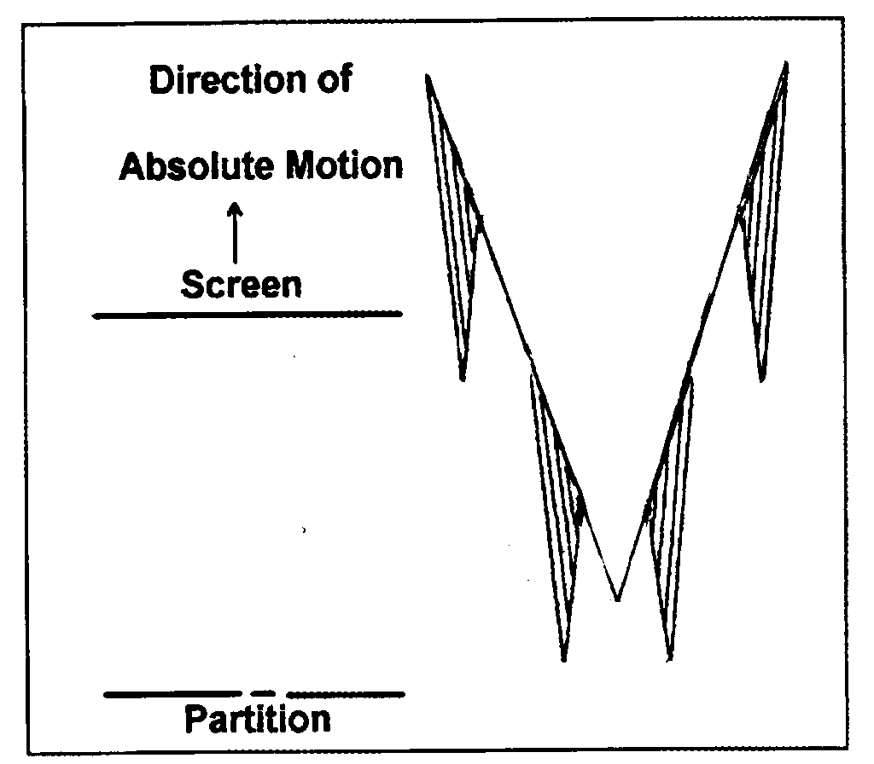
Figure 1. The light profile formed by a double-slit due tothe absolute motion of the partition and the screen relative to the light or electron beam.

The above description of fringe formation is valid for all intensities of light or electron. In other words, even if one photon or electron is used for each experiment, the light and dark fringes will emerge after the same experiment is repeated a large number of times. This interpretation of the double-slit experiment eliminates the abstractive and counterintuitive processes of the Copenhagen Interpretation. Also this interpretation will give physicists a simpler way of doing physics.

Re-Interpreting the Photoelectric Effect Experiment
The wave nature of light can be easily demonstrated with the diffraction phenomenon. However, the results of the photoelectric experiment are not easily explained if light is just plain old continuous waves. The continuous light wave concept gives rise to the ultraviolet catastrophe problem. This problem was resolved with Max Planck's light quanta. The experimental set up for the photoelectric experiment is simple. It consists of a light source of varying intensities and varying high frequencies shining on a metal surface. The photoelectrons that are boiled off at the various intensities and frequencies are collected and their energy is measured. The results were as follows:

1. The energy of the photoelectron is dependent only on the frequency of the incident light.
2. The intensity of light has no effect on the energy of the photoelectron
3. Increasing the intensity of light will increase the number of photoelectrons being boiled off the metal surface.

Current Interpretation of the Photoelectric Experiment
The results of the photoelectric experiment suggest that light comes in discrete units. This led Einstein to conclude that light exists in discrete units instead of continuous waves and he called the individual unit a photon of light. However, a photon is not a true particle because it does not have all the attributes of a particle. It is more accurate to describe a photon as a wave packet or a very short pulse of light. This description of light along with Max Planck's light quantum formed the foundation of quantum mechanics. What is the mechanism that causes light to come as wave packets? Current physics provides no explanation to this question.

New Interpretation of the Photoelectric Experiment
Model Mechanics agrees with the current explanation that all lights come as wave packets. The reason light comes in this peculiar form instead of continuous waves has its origin from the fact that all light sources are moving absolutely in the E-Matrix. In a short specific increment of time, a light source will appear to emit light that is continuous. After this incremental time, the light source will have moved to a new location due to its absolute motion. This cuts off the continuity of waves and gives rise to a wave-packet of light. What this new interpretation says is: a photon is consisted of short blocks of light waves in neighboring E-Strings. These blocks of light waves travel coherently towards a common target and this has the effect of a particle hitting the target. With this new interpretation, we have a way to explain why light appears to have duality properties.

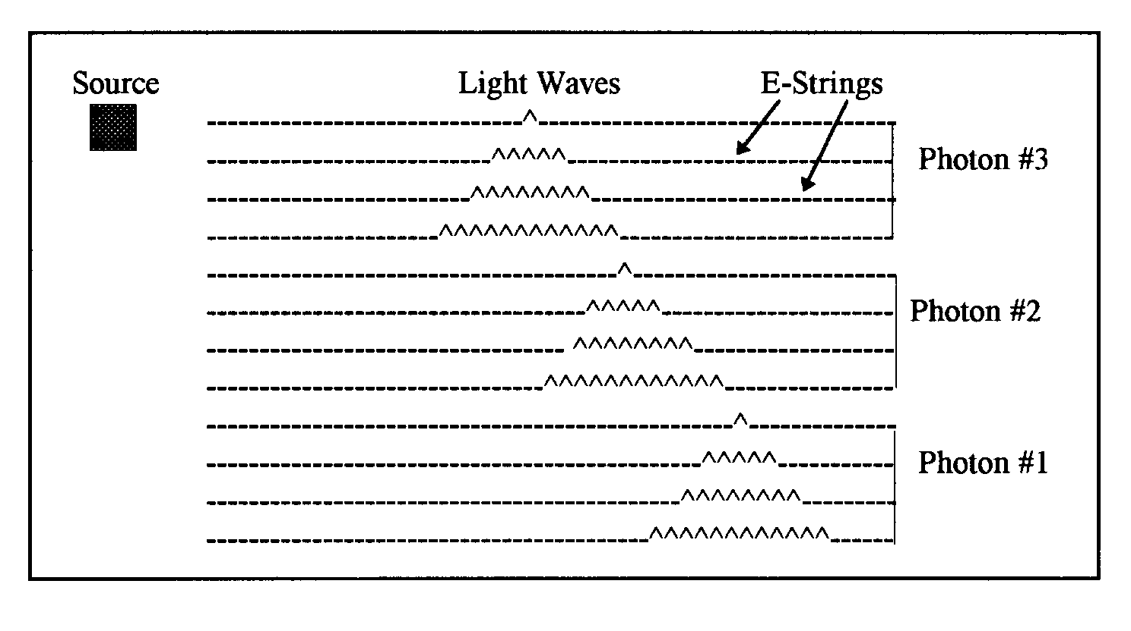
Figure 2. Schematic diagram of photon emission from a source that is in a state of absolute motion in the E-Matrix

Figure 2 describes the emission of three consecutive photons from an absolutely moving source. These photons are wave packets in different groups of neighboring E-Strings. They travel coherently and transversely towards the target. When a wave packet hits the target it will have the effect of a particle hitting the target. This explains why light appears to have the duality properties of a particle and a wave packet. This picture of photon emission from a source implies that a detector in the same frame will not be able to detect all the photons generated by the source. The reason is that by the time the first photon arrives at the original position of the detector it will have moved to a new location. In the section "The Consequences of Model Mechanics," I have demonstrated that such a motion of a detector in combination with the Pythagorean theorem gives rise to the Lorentz Factor ( ). This explains why all the processes of nature are Lorentz Invariant. Also, this explains why the Lorentz Factor appears in all the transform equations.

5. New Experiments to Detect Absolute Motion
The new interpretations of the past experiments support the concept of absolute motion. However, it would be more convincing if we can come up with new experiments that are specifically designed to detect absolute motion. The following one-way experiments are proposed for this purpose:

Proposed Experiment #1
This proposed experiment is exactly the same as the Compton Effect Experiment (Figure 3) except that the x-ray is not a continuous beam. It is chopped into pulses and a clock at the source location determines the pulse rate. A wavelength detector and a pulse rate detector are placed in the detector's location. The Model Mechanical predictions of this proposed experiment are listed below. If these predictions are confirmed, it will have confirmed the existence of absolute motion and indirectly it will have confirmed the existence of the E-Matrix.

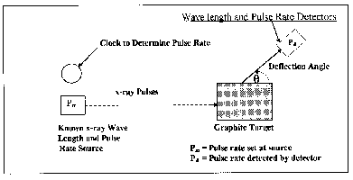
Figure 3. Experimental set-up for Proposed Experiment #1. This is a modified Compton Effect Experiment. It is designed to show that the red shifted peak is caused by the receding motion of the graphite target.

Expected Results
1. There will be two peaks detected at any deflection angle. The peak that has a wavelength the same as the incident x-ray is due to the absorption and re-emission of the incident x-ray. The receding absolute motion of the graphite target in the transverse direction causes the peak that has the wavelength that is red-shifted.
2. The peak that has the same wavelength as the incident x-ray will detect the same pulse rate as the incident x-ray. The peak that the wavelength is red-shifted will detect a pulse rate that is less than that of the incident x-ray. This specific prediction is in conflict with current physics that predicts that the detected pulse rate to be the same as the incident x-ray.
3. At any specific deflection angle, the pulse rate detected with the red-shifted x-ray will be less than that of the source rate. The greater is the scattering angle; the lower is the detected pulse rate. However, there is a maximum difference between the source pulse rate and the detected pulse rate. This is confirmed with the Compton Effect experiment that was found to have a maximum red shift of 2.43x10⁻¹² m or 2.43 pm. The lower pulse rate detected at the various scattering angles is due to the receding absolute motion of the graphite target. This receding motion is in the transverse direction relative to the incident x-ray. The maximum pulse rate difference will be detected at the scattering angle of 180⁰ from the incident x-ray. This pulse rate difference is caused by the full value of the absolute motion of the graphite target. This prediction is in conflict with current physics that predicts that the detected pulse rate at all scattering angles is equal to the pulse rate at the source.
4. The STR Predictions for this experiment:
P_{d} = P_{m} (2.16)
The Model Mechanical predictions for this proposed experiment:
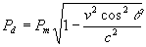(2.17)
5. After the values of P_{m} and P_{d} are determined experimentally, the absolute motion (V) of the graphite target can be calculated using the following equation:
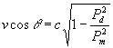(2.18)

Since the original Compton Effect experiment had confirmed that one of the peaks is red shifted this will guarantee that this modified Compton experiment will get the same result. In other words, the detected pulse rate will be less than the emitted pulse rate and the difference in rates is due to the state of absolute motion of the graphite target.

Proposed Experiment #2:
This proposed experiment is based on the Model Mechanical description of space and time. It is based on the assumption that all objects in the observer's frame are in a state of absolute motion and that this motion is detectable by this proposed experiment. The detection of absolute motion would refute the claims of Special Theory of Relativity (STR). Specifically it would refute the claim that all inertial frames of reference are equivalent and that no single frame is preferred. Also it would refute the claim that even if a preferred aether frame exists it is redundant and not detectable experimentally.
The step-by-step procedure for this proposed experiment is as follows:
- Two sets of cesium clocks A1, A2 and B1, B2 are located at the A location on one end of a 100 meter long rigid rod. The 100-meter distance is pre-determined using Einstein's procedure for measuring distance.
- Clocks A1 and B1 are not running and clocks A2 and B2 are running and are synchronized.
- Clocks B1 and B2 are slowly transported to the other end of the rod (B's location).
- A laser light source is at A's location and it emits a continuous light beam and a light pulse beam. It is equipped with a shutter. The opening and closing of the shutter will allow the continuous beam to activate and de-activates the clocks A1 and B1. The detection areas for the light beams at A1 and B1 are exactly 4 mm in diameter.
- Clock A1 is activated and de-activated by the continuous beam for exactly one second and identifies this value as T_{a} . The number of pulses detected during this period is recorded and identifies this value as N_{a} . Clock B1 is activated and de-activated by the continuous beam and identifies this elapsed time as T_{b} . The number of pulses detected B1during this period is recorded and identifies this value as N_{b} .
- Repeat steps 1 through 5 at different times of the day.
- Rotate the assembly to a different direction and repeat steps 1 to 6. This is designed to illustrate that the speed of light is the same in all directions.
- After all the experiments are completed, slow transport the B clocks (B1 and B2) to back to the A location and compare clocks A2 and B2 to see if they are still synchronized.
The STR predictions for these proposed experiments are as follows:
T_{a}=T_{b}=1 second
N_{a}=N_{b}
Clocks A2 and B2 are still synchronized.
If the aether frame exists, then the predictions for these proposed experiments are as follows:
T_{a}=1 second and T_{b}<1 second
N_{a}>N_{b}
Clocks A2 and B2 are still synchronized.
The relationship between Ta and T_{b} is as follows:
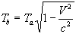(2.19)
Where V is the absolute motion of clock B1. After the value of T_{b} is determined, the absolute motion of clock B1 can be calculated as follows:
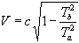(2.20)
The relationship between N_{a} and N_{b} is as follows:
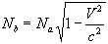(2.21)
Where V is the absolute motion of clock B1. After the value of is determined, the absolute motion of clock B1 can be calculated as follows:
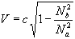(2.24)
The theory behind these aether frame predictions is as follows:
- The light beams are traveling horizontally while the clock B1 is moving vertically. This situation is analogous to the familiar light clock thought experiment which gives rise to the all important  Factor in all the STR equations.
- The absolute motion of clock B1 will cause the first batch of light pulses to miss the pulse counter. Similarly, it will cause the leading portion of the continuous beam to miss the detection area and thus delaying the activation of the clock B1. This delay in the activation of B1 is known time dilation..
- The number of pulses missing the pulse counter and the time delay of activation is dependent on the state of absolute motion of clock B1. The higher is the state of absolute motion the more pulses will miss the pulse counter. Similarly, it will cause a longer time delay on the activation of the clock B1. At the speed of light all the pulses will miss the pulse counter and no portion of the continuous beam will reach the detection area in time to activate the clock. This situation is known as that time stands still at the speed of light.
6. Conclusions
The unique structure of the E-Matrix and the absolute motion of objects in it enable us to explain the weird results of three past famous experiments. Two new experiments that are capable of detecting the motion of the observer in the E-Matrix frame are included. The detection of the E-Matrix frame will give us a new way to do physics. Also it will lead us to a viable unify theory for all the forces. Ref.[1].

Correspondence to:
Ken H. Seto
KHS Publishing
260 Yorkshire Lane
Xenia, OH 45385, USA
Telephone: 937-372-5298
Email: kenseto@erinet.com
http://www.erinet.com/kenseto/book.html

References
- Seto K.H. Unification of Physics. http://www.geocities.com/kn_seto/2005Unification.pdf.
- Seto KH, BS Chem. Engineer, 1962 Queen's University. Patentee: Two patents in the field of polymeric applications. Published papers in the field of fundamental physics. Author of two books: Model Mechanics: A New Interpretation of Nature; The Physics of Absolute Motion. Industrial experiences: Product Manager in the polymeric application field and consultant in the adhesive and seanlant field.
- Seto KH, The Physics of Absolute Motion, ISBN 0-9647136-1-6, KHS Publishing, pp 13-16; pp.110-126.
- Seto KH. The Physics of Absolute Motion. ISBN0-9647136-1-6, KHS Publishing, pp 57-70, http://www.erinet.com/kenseto/book.html.
- Seto KH. Unification of Physics. Journal of the Theoretics. pp 5-11, ttp://www.journaloftheoretics.com/Links/Papers/Seto.pdf.

