Properties of Recombinant Sulfolobus shibatae Maltooligosyltrehalose Synthase Expressed in HMS174

Wen Shen¹, Jin Wu², Jinfu Wang¹, Yanhe Ma², Ziyuan Duan², Yifeng Gong^{1*}

¹ Ministry of Education Key Laboratory of Xinjiang Endemic and Ethnic Disease, Shihezi University, Shihezi, Xinjiang 832003, China, altai_2003@163.com
² Institute of Microbiology, Chinese Academy Sciences, Beijing 100101, China

Abstract: A 2,187 bp DNA fragment encoding maltooligosyltrehalose synthase (MTS) was cloned from Sulfolobus shibatae, and expressed in HMS174. The recombinant enzyme had a molecular weight of about 74 kDa. The purified protein showed an almost absolute requirement for Mg^{2＋}, Mn^{2＋}, Co^{2＋}, and Ca^{2＋}, and was not very active with Cu^{2＋}and Zn^{2＋}. At the other hand, the enzyme was stable to heating at 80°C for up to 3 h and only caused a 20% loss of activity. Similarly, the enzyme was also stable from pH 4 to 7 when it was placed in a series of pH buffers. The final results also indicated that the protein encoded by MTS showed a maximum activity at 60°C or pH 5.5 when it was incubated with maltopentaose. [Nature and Science. 2006;4(2):52-57].

Key Words: Maltooligosyltrehalose synthase; trehalose; Sulfolobus shibatae

Introduction
Trehalose is a nonreducing disaccharide, and its two glucose molecules are linked together in an α, α-1, 1-glycosidic linkage, which has been found in various organisms, including bacteria, algae, fungi, yeasts, insects, nematodes, shrimps, and some plants (Alan, 2003). There are three possible anomers of trehalose, that is, α, β-1,1-, β, β-1,1-, and α, α-1,1-, only the α, α- trehalose has been isolated from and biosynthesized in living organisms. Many of these organisms produce and store trehalose, sometimes in amounts as high as 10% to 20% of their dry weight. In nature, trehalose serves not only as a carbohydrate reserve for energy and/or for the synthesis and preservation of cell membranes but also as an agent that protects against a variety of physical and chemical stresses, such as heat, cold, desiccation, and anoxia (Marielle, 2005). In addition, this sugar allows desert plants to tolerate naturally occurring stresses during cycles of dehydration and rehydration. So, trehalose has been used extensively as additives, stabilizers, and sweeteners that are quite useful in the food, cosmetic, and pharmaceutical industries.
One trehalose-producing pathway is mediated by maltooligosyltrehalose synthase (MTS) and maltooligo- syltrehalose trehalohydrolase (MTH). MTS converts α- 1.4-glycosidic linkage into α-1, 1 linkage to produce the intermediate of maltooligosyltrehalose. Then, MTH hydrolyzes the second α-1,4-glycosidic linkage of the intermediate to release free trehalose (Maruta, 1995).
S. shibatae, a thermoacidophilic crenarchaeon growing optimally at pH 2 and 80°C, was known to contain the enzymes of MTS and MTH that can synthe- size trehalose from maltooligosaccharides or soluble starch (Di Lernia, 1998). In the present study, we cloned a DNA fragment encoding MTS form S. shibatae. The gene was expressed in HMS174 and its recombinant products were characterized to determine their in vitro activities.

1. Materials and Methods
1.1 Bacterial strains and culture conditions
The E. Coli expression strain HMS174 was used for cloning and expression studies, which contains a chromosomal IPTG-inducible T7-RNA pol gene. Strain was cultured in L broth and on L agar supplemented with 100 ug/ml ampicillin at 37℃. S. shibatae was grown aerobically under continuous shaking in a medium at 78℃. Cells were grown to an OD₆₀₀ of 1.0 prior to harvesting and their extracts were prepared according to Hudepohl et al.

1.2 Reagents and materials
All DNA manipulation enzymes, including restriction endonucleases, polymerases, RNase, DNA ladders, protein markers, ligase, PCR reagents, and Wizard® SV Gel and PCR Clean-Up system were supplied by Promega. All other reagents were from reliable chemi- cal companies, and were of the best grade available.

1.3 Preparation of S. shibatae genomic DNA
To prepare DNA, S. shibatae was cultured and harvested. Cells were resuspended in TE (10 mM Tris, pH8.0/ 1 mM EDTA) containing 0.5% SDS, and proteinase K was added to 1mg/ml. After incubation for 2-4 h at 37℃ and extraction with phenol, DNA was precipitated with ethanol (Asthana, R.K. 2005).

1.4 Polymerase chain reaction
A 50 ul PCR mixture was carried out containing 5ul of 10×PCR buffer, 1 ul of deoxynucleoside triphosphates, 10 ul of each primer, 1 ul of template DNA, and 1 ul of Taq DNA polymerase. DNA was amplified under the following conditions: 5 min at 94℃, followed by 30 cycles of 1 min at 94℃, 1 min at 54℃, and 2 min at 72℃ and a final extension at 72℃ for 10 min. The MTS-specific primers used in this study were designed using DNAMAN according to the sequence S. shibatae unloaded from GenBank. The upstream and downstream primers, 5′-TCACATATGATAATAGGC ACATATAGGCT-3′and 5′-CAAGGATCCACTCCC TTTTTTCAGT-3′, were designed to contain the restriction sites of Nde I and Bam HI in the 5′(dash) ends, respectively.

1.5 Construction of expression plasmids
The 2,187 bp PCR product was digested with Nde I and Bam HI, and ligated with the Nde I- and Bam HI-digested expression plasmid pET21a to generate the plasmid p269A317. The identification and fidelity of the amplification were conformed by DNA sequencing. The p269A317 was transformed into the expression strain HMS174. The positive clones were screened by Blue/White color screening on Luria-Bertani plates containing the appropriate antibiotic, 0.1 mM IPTG and 40 ug/ml X-Gal incubating overnight at 37℃.

1.6 Purification of express product
The HMS174 transformed with p269A317 was grown in 2 liter Luria-Bertani medium containing ampicillin and induced by IPTG for 4 h at 37℃ with shaking. Cells were harvested by centrifugation, washed with phosphate-buffered saline. The cells were broken by subjecting the cell suspension to two 3-min pulses of sonication with a Braun probe sonicator at 80% of maximum setting. The broken cell suspension was then centrifuged at 40,000 × g for 15 min to remove unbroken cells and cellular debris, and the resulting supernatant liquid was applied to a nickel ion column eluting with imidazole for the following experiments.

2 Results
2.1 Trehalose from maltooligosaccharides
Enzymatic activities of the purified recombinant MTS proteins were analyzed by HPLC by using maltooligosaccharides as substrates. In the reaction with MTS, most of maltopentaose was converted to an intermediate. This intermediate has been identified as maltotriosyltrehalose (Figure 1).

2.2 Properties of the MTS
2.2.1 Optimum conditions of the MTS activity
Incubations were prepared at various pH values as shown in the figure. The pH optimum of this activity was 5.5 and had almost no activity at either pH 4 or 7 in contrast to many nonspecific acid or alkaline phosphatases that usually have the maximum activity at around pH 5.0 or 9.0 as shown in Figure 2,
The enzyme exhibited a maximum activity from 60 to 65℃ and had a higher activity from 50 to 80℃ than those at other temperatures when it was incubated with different temperatures form 35 to 90℃ as shown in Figure 3.

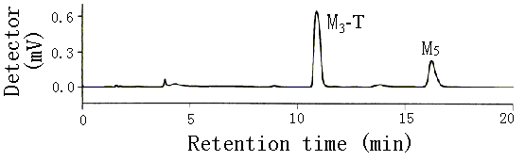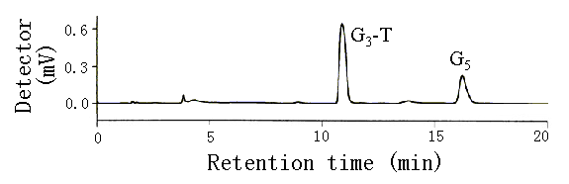

Figure 1. Production of trehalose from maltooligosaccharides. HPLC analyses of reaction products obtained from maltooligosaccharides by enzymatic activity of recombinant MTS proteins. A 0.1-µmol portion of maltopentaose was reacted with 5 pmol of purified recombinant enzyme MTS. Reaction was terminated after 3 h. M₅, maltopentaose; M₃-T, maltotriosyltrehalose.

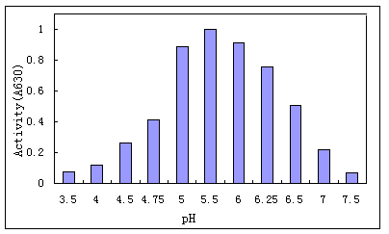
Figure 2. Effect of pH of incubation mixture on activity of recombinant MTS. Incubations were prepared as described in the text but contained buffers at various pH values as shown in the figure.
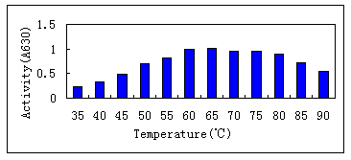
Figure 3. Optimum temperature of MTS activity. MTS proteins were incubated at various temperatures ranging from 35 to 90℃. Each sample was then tested for its activity to indicate the optimum temperature for the activity.

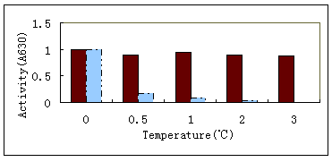
Figure 4. Heat stability of the recombinant MTS. MTS proteins were incubated at 80 and 90℃. Black was experiment at 80℃, azure was experiment at 90℃.
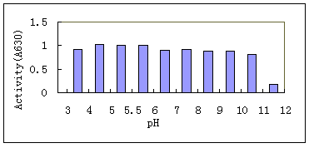
Figure 5. pH stability of recombinant MTS. MTS was incubated under various pH values at room temperature for 1 h.

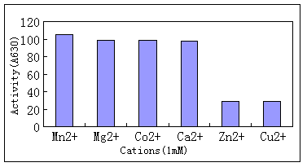
Figure 6. Effects of cation on MTS activity. Incubations were as described in the text but contained various cations at the concentration of 1 mM as indicated in the figure.

2.2.2 Stability of the MTS activity
MTS was incubated with a series of pH buffers for 1 h at room temperature to determine the stability of MTS. The result suggested that the enzyme was quite stable from pH 4 to 7 as shown in Figure 5.
When the enzyme was placed in a hot water bath at 80℃ and 90℃, the results indicated that the enzyme was quite stable to heating at 80℃ for 3 h, which only caused a 20% loss of activity. In fact, even at 90℃, the enzyme retained significant activity for several minutes and then lost activity as shown in Figure 4.

2.2.3 Effect of cations on the activity of MTS
MTS showed an almost absolute requirement for the cation of Mn^{2＋}, as shown in Figure 6. The data in this figure also showed that Ca^{2＋}, Mg^{2＋}, or Co^{2＋} worked to some extent, but was much less effectively than Mn^{2＋} at the concentration of cation of 1 mM. On the other hand, there was a great loss of activity caused by Cu^{2＋}, or Zn^{2＋} when it was added to the system individually with the concentration of 1 mM.

3 Discussion
Many studies indicated that trehalose has the extensive biological functions, and scientists have found at least three trehalose-producing pathways in the biological world. And, one of them is MTS and MTH-based pathway that can utilize many substrates, such as the maltooligosaccharides and soluble starch, the most abundant maltodextrin in nature. However, another main pathways for the synthesis of trehalose is the transfer of glucose from UDP/GDP-glucose to glucose-6-P to produce trehalose 6-phosphate where organisms must utilize GDP/UDP-glucose or other glucose nucleotides as glucosyl donors for trehalose synthesis (Maruta, 1995). The trehalose-producing genes of MTS had been found in many organisms, including S. solfataricus KM1, Arthrobacter sp. Strain Q36, Rhizobium sp. Strain M-11, M. tuberculosis, and B. helvolum (Yong, 2000), etc. In this study, we cloned and expressed S.shibatae MTS gene, a 2,187 bp fragment encoding 728 amino acids, in HMS174, and researched the properties of this recombinant protein the first time.
We tested the possibility of using longer maltooligosaccharides as substrates in the enzyme reaction for trehalose production and most of them were converted to an intermediate. This intermediate has been identified as maltotriosyltrehalose.
The purified recombinant protein was incubated with various pH values and temperatures, respectively. The final results indicated that the optimum pH value and temperature were 5.5 and 60℃ where the enzyme could exhibit the biggest activity, respectively. And what is more, the recombinant enzyme was quite stable when the enzyme was incubated with different pH values from 4 to 7 for 1 h, and had a 20% loss of activity for at least 3 h of heating at 80℃. However, the optimum pH value and temperature of the trehalose- producing enzyme from Pimelobacter sp. R48 was 7.5 and 20℃, respectively (Keiji, 1996). The identical enzyme from Arthrobacter sp. Q36 also had the optimum temperature of 35℃ (Nakada, 1995). The reason why they had the different temperatures for maximum enzymatic activity might be that S.shibatae is a thermoacidophilic crenarchaeon, which formed a specific enzymatic system under such a condition in the long evolutionary process. And other properties of MTS isolated form S.solfataricus KM1 were the stability in a series of pH values from 5.0 to 6.0 and a series of temperatures from 70 to 80℃ when it served as a catalyzer (Kobayashi, 1990). Based on BLAST analysis (http://www.ncbi.nlm.nih.gov/BLAST) of the predicted S. shibatae MTS nucleic acid and amino acid sequences, which share homology with those of S.solfataricus KM1 at 96% and 98% identity, respectively. At the other hand, the cations of Mn^{2＋}, Ca^{2＋}, Mg^{2＋}, or Co^{2＋} had a great impact on enzymatic activity. But, the cations of Cu^{2＋}, or Zn^{2＋}had a weaker impact than those the above cations had. These results caused by cations were identical with those produced by the trehalose-producing enzymes coming from Pimelobacter sp.R48 and M.smegmatis (Keiji, 1996).
Now, Despite the properties of the recombinant protein cloned form S.shibatae, very little is known about the mechanism of the protein that was quite stable when it was incubated with a more lower pH buffers and higher temperatures. We are currently designing experiments to explore these mechanisms that make the enzyme kept their activity under a specific condition.

Acknowledgment
This work was supported by a grant from the Institute of Microbiology of the Chinese Academy Sciences.

Correspondence to:
Yifeng Gong
Ministry of Education Key Laboratory of Xinjiang Endemic and Ethnic Disease
Shihezi University
Shihezi, Xinjiang 832003, China
Email: altai_2003@163.com

References
- Alan D, Elbein YT, Pan IP, David C. New insights on trehalose: a multifunctional molecule. Glycobiology 2003;13:17-7.
- Asthana RK, Srivastava S, Singh AP, Kayastha AM, Singh SP. Identification of maltooligosyltrehalose synthase and maltooligosyltrehalose trehalohydrolase enzymes catalysing trehalose biosynthesis in Anabaena 7120 exposed to NaCl stress. J Plant Physiol 2005;162(9):1030-7
- Chen W, Liu L, Sun P, Jin C. Cloning and expression of the gene encoding maltoologosyl trehalose synthase from Sulfolobus shibatae in E.coli.Wei Sheng Wu Xue Bao 2000; 40(1):57-61.
- Di Lernia I, Morana A, Ottombrino A, Fusco S, Rossi M, De RM. Enzymes from Sulfolobus shibatae for the production of trehalose and glucose from starch. Extremophiles. 1998;2(4):409-16.
- Keiji T, Tomoyuki N. Cloning sequencing of trehalose synthase gene from Pimelobacter sp. R48. Biochimicaet Biophysica Acta 1996;1290;1-3.
- Kobayashi K, Kato M, Miura Y, Kettoku M, Komeda T, Iwamatsu A. Gene cloning and expression of new trehalose-producing enzyme from the hyperthermophilic archaeum Sulfolobus solfataricus KM1. Biosci. Biotechnol Biochem 1990;60:1882-5.
- Marielle T, Xavier M, Andreas W, Henrike G, Sergey S, Mohamed C, Dietmar S, Reinhard K, Susanne M, Mamadou D. The Crucial Role of Trehalose and Structurally Related Oligosaccharides in the Biosynthesis and Transfer of Mycolic Acids in Corynebacterineae. J Biol Chem 2005;280:26573-5.
- Maruta K, Hattori K, Nakada T, Kubota M, Sugimoto T, Kurimoto M. Cloning and sequencing of trehalose biosynthesis genes from Rhizobium sp. M-11. Biosci Biotechnol. Biochem 1996;60:717–20.
- Maruta K, Hattori K, Nakada T, Kubota M, Sugimoto T, Kurimoto M. Cloning and sequencing of trehalose biosynthesis genes from Arthrobacter sp. Q36. Biochim Biophys Acta 1996;1289:10–3.
- Maruta K, Nakada T, Kubota M, Chaen H, Sugimoto T, Kurimoto M. Formation of trehalose from maltooligo- saccharides by a novel enzymatic system. Biosci Biotechnol Biochem 1995;59:1829–34.
- Naka T, Maruta K. Purification and properties of a novel enzyme, Maltooligosyltrehalose synthase, from Arthrobacter sp. Q36. Biosci Biotech Biochem 1995;59(12);2215-8.
- Yong HK, Tae KK, Sungsoon P, Hak SS, Jongjoo C, Chung HK, Jukon K, Jong SL, Yang DC. Trehalose Synthesis by Sequential Reactions of Recombinant Maltooligosyltrehalose Synthase and Maltooligosyltrehalose Trehalohydrolase from Brevibacterium helvolum Applied and environmental microbiology 2000;4620–4.

