Ten-minute DNA Release Kits

- A novel approach to obtain DNA easily in modern biological science

Huaijie Zhu *, **, Yucui Zhu *, **, Hongbao Ma ***, Jiesheng Lu *

* Jacksun Easy Biotech Inc., New York, NY, USA, hjz689@yahoo.com; www.jacksunbio.com
** Columbia University, New York, NY, USA, hz42@columbia.edu
*** Michigan State University, East Lansing, MI, USA, hongbao@msn.edu

Abstract: Genomic DNA study has been used widely in biology, genetics, reproduction, clinical medicine and clinical medicolegal. This article describes characterization and protocol of the new product 10-minute DNA Release Kit that provides a reliable, simple, and quick approach, by taking 10 minutes at 86˚C for DNA release and desired DNA extract obtaining. The product will save scientists’ time and give better result on the DNA extract. [Nature and Science. 2006;4(2):58-70].

Keywords: DNA; extract; knowledge; PCR

1. Introduction
Genomic DNA study has been used widely in biology, genetics, reproduction, clinical medicine and clinical medicolegal. It is very important for the genomics study to obtain the desired DNA extract easily and quickly. The 10-minute DNA Release Kit provides a reliable, simple, and quick approach, by taking 10 minutes at 86˚C for DNA release and desired DNA extract obtaining.
The 10-minute DNA Release Kit not only offers a wide range on the desired DNA extract (Figure 1), but also gives a good expression of multi-primers in polymerase chain reaction (PCR) (Figure 2). And, it is not only used for on genome expression by the analysis of PCR, but also used on mitochondrial DNA mutation for the diagnosis and treatment observation of mitochondrial disease, which can be done by the analysis of PCR/RFLP (Restriction Fragment Length Polymorphism) and point mutation (Figure 3).

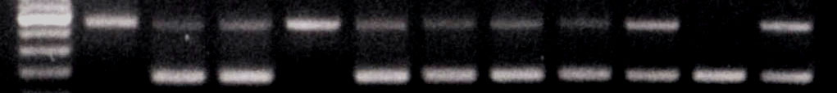
1 2 3 4 5 6 7 8 9 10 11
Figure 2. Genotyping the P53 transgenic mouse with 10 Minute DNA Kit
The expression of P53 +/+ at No. 1, 4;
P53 +/- at No. 2, 3, 5, 6, 7, 8, 9, 11;
P53 -/- at No. 10
600bp
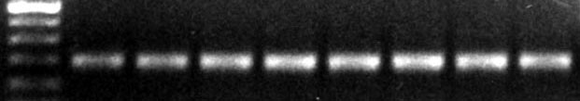
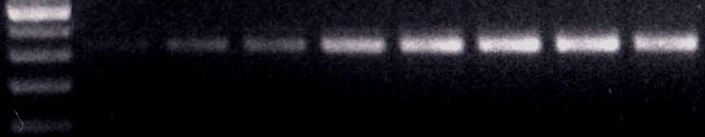
Figure 1. mGapdh and mActin expression on the DNA volume-dependent effective with the DNA Extract from mice tail
mActin
mGapdh
0.06 0.125 0.25 0.50 1.00 1.20 1.50 2.00 ul of DNA extract

Figure 3A. Primer expression on DNA volume-dependent Figure 3B. Primer expression on DNA colume-dependent
effective with the DNA extract from human bloodeffective with the DNA extract from human urine
Figure 3C. Primer expression on DNA volume-dependent Figure 3D. Primer expression on DNA volume-dependent
effective with the DNA extract from human Salivaeffective with the DNA extract from human Hair Follicle

Figure 3. Primer expression on DNA volume-dependent effective with the DNA extract

(1) Primer, Gapdh and Cyclin D1 are designed from human Genomic DNA Sequence.
Gapdh Start Sequence Size .
Left prime 108 GAA GGT GAA GGT CGG AGT CA 252bp
Right primer 359 TTG ATT TTG GAG GGA TCT CG
Cyclin D1
Left primer 2096 CCA TTC CAT TTC CAA GCA CT 236bp
Right primer 2331 TCA TCCTGG CAA TGT GAG AA .

(2) Primer mt3256 is designed from human mitochondrial DNA sequence.
This is to analyze myDNA mt3256 (C->T) mutation. Normally, mt3256 point is the C-Cytosine. The C is replaced with T-thymine when the 3256 point mutation occurred. The mt3256 mutation is associated with MELAS (Mitochondrial Encephalomyopathy, lactic Acidosis, and Strokelike Episodes).

Mt3256 Start Sequence Size .
Left primer 3230 GTT AAG ATG GCA GCG CCC GGT AAG CG 123bp
Right primer 3353 GCG ATT AGA ATG GGT ACA ATG .

PCR program: 33 cycles; 50 seconds at 95˚C; 50 seconds at 56˚C; 60 second at 72˚C.

2. The Kits 1-7 function description and protocols

2.1 Ten-minute DNA Release Kit-1, for mouse tail, ear-DNA-PCR. Cat# JZ-001.
From the mouse tail, ear and any organs tissue to obtain the desired DNA to run PCR for the transgenic mouse genetyping, PCR/RFLP-point mutation and any gene expression.

2.2 Ten-minute DNA Release Kit-2, for mouse tail and tissue–purified DNA-PCR and Southern etc. The catalogue number is Cat#JZ-002.
From the mouse tail or any tissue to obtain the purified DNA within 20 minutes after the DNA release. The ratio of DNA OD260/280 nm is higher than 1.70. With the purified DNA to run PCR and Southern for the transgenic mouse genetyping, PCR/RFLP-point mutation and any other gene expression.

2.3 Ten-minute DNA Release Kit-3, for blood-DNA-PCR. Cat# JZ-003.

2.4 Ten-minute DNA Release Kit-4, for urine-DNA-PCR. Cat# JZ-004.

2.5 Ten-minute DNA Release Kit-5, for saliva-DNA-PCR. Cat# JZ-005.

2.6 Ten-minute DNA Release Kit-6, for hair follicle-DNA-PCR. Cat# JZ-006.
From the blood, urine, saliva and hair follicle to obtain the desired DNA to run PCR for PCR/RLFP-point mutation and any other gene expression. The desired DNA extract shows the volume dependent effective on the different genomic DNA expression (Figure 3A,B,C,D).

2.7 Ten-minute DNA Release Kit-7, for culture cells-DNA-PCR-Southern etc. Cat# JZ-007.
From the cultured cells to obtain the purified DNA easily and quickly. The purified DNA could be used for any purpose on the genomic DNA expression.

3. Detail Descriptions of Ten-minute DNA Release Kits 1-7

3.1 Ten-minute DNA Release Kit-1
Ten-minute DNA Release Kit-1 is for mouse tail or ear-DNA-PCR, and for the smallest tissue, body liquid pellet and the material stained by biologic trace also. Catalogue number of Ten-minute DNA Release Kit-1 is JZ-001.

The preliminary protocol of Ten-minute DNA Release Kit-1 is as the following
3.1.1 Aim
3.1.1.1 It is easy and quick from mouse tail or ear to obtain the desired DNA to run PCR for transgenetic mouse genetyping.

3.1.1.2 It is also easy and quick to obtain the desired DNA extract form any organ tissue and body liquid pellet.

3.1.1.3 It is special to obtain the desired DNA extract from material which was stained by blood on any biologic body liquid.

3.1.1.4 For the detail of items b and c to see the protocols 5 and 6 on the purpose of Kit-1 gene expression, please read the Kit-1 protocol 5 first.

3.1.2 Have been ready for the equipments?
3.1.2.1 It is fine for this kit to have any type of thermo machine or water bath which could set up the constant temperature between 86-90˚C.

3.1.2.2 A room temperature eppendorf centrifuge machine with the speed 10,000-15,000 g should be available.

3.1.2.3 1.5 ml Eppendorf tubes, tips and micro-pipettor with the scalar 10-200 ul.

3.1.2.4 Vortex or mixture machine is available.

3.1.3 Contents Table (Table 1)

Table 1. Ten-minute DNA Release Kit-1 contents table

3.1.4 Work Table (Table 2)
Table 2. Ten-minute DNA Release Kit-1 work table

3.1.5 Treating for Another Organs Tissue:

3.1.5.1 Cut organ tissue to 1-3 mm3 (1-12 mg).

3.1.5.2 If the organ tissue is with blood or another dirty trace, please:

3.1.5.2.1 Rinse 2-3 times with PBS without Ca++ and Mg++.

3.1.5.2.2 Touch dry the tissue on the paper towel, then follow the work table.

3.1.5.3 If the organ tissue is clean, like skin etc, go to follow the work table.

3.1.5.4 For the other small tissue:

3.1.5.4.1 The tissue is punching from human skin, animal ear or any other organs

3.1.5.4.2 The tissue is obtained by laser punching or scrape from human or animal.

3.1.5.4.3 If the tissue is embedded by paraffin, you can scrap a few pieces to an eppendorf tube.

3.1.5.5 For the material that is stained by biologic trace: Cut the material to the smallest pieces and place the smallest pieces to an eppendorf tube, then follow the work table to process it like to do mouse tail.

3.1.5.6 For any deposit pellet which is from any body liquid: Place the body liquid to an eppendorf, centrifuge at 5000 g X 3, get rid of the supernatant, keep the pellet in the tube, and go to follow the work table.

3.1.6 Buffer Volume for the Another Organs Tissue
The ratio of Kit-1 B1 and Kit-1 B2 is 1:1.5, which means according to the tissue or liquid pellet size, if you choose to use 1 ul of Kit1-B, you need to use 1.5 ul of Kit1-B2.

3.2 Ten-minute DNA Release Kit-2
Ten-minute DNA Release Kit-2 is for mouse tail and tissue-purified DNA—PCR-Southern. It is for 100 samples. Its catalogue number is JZ-002.

The preliminary protocol of Ten-minute DNA Release Kit-2 is as the following:

3.2.1 Aim

3.2.1.1 It is easy and quick to obtain purified DNA from mice tail or any tissue after the DNA release within 20 minutes. The ratio of DNA OD260/280 nm is between 1.70-1.90. The purified DNA can be used to run PCR or Southern for the transgenic mice genetyping etc.

3.2.1.2 If you want to use the Kit to obtain purified DNA from any tissue for any purpose of gene expression, please read protocol Kit 2-6 first.

3.2.2 Have been ready for the equipments?

3.2.2.1 It is fine for this kit to have any type thermo-machine, or water bath if they can set up the constant temperature between 86-90˚C.

3.2.2.2 A room temperature eppendorf centrifuge machine with the speed 10,000-15,000 g is needed for the running.

3.2.2.3 1.5 ml eppendorf tubes, tips and micro-pipettor with the scalar of 10-200 ul are needed.

3.2.2.4 Vortex or mixture machine is needed.

3.2.3 The reagents are prepared by you

3.2.3.1 Isopropanol (2-propanol, molecular biology reagent, minimum 99%) is needed. This could be ordered from any chemical company.

3.2.3.2 0.1 x TE buffer that is made by 1/10 of 1 x TE plus 9/10 of distilled water.

To prepared 100 ml of 1 X TE Buffer (pH 7.3) following the below:

Reagents Final Concentration Volume Stock solution .
Tris-HCl 10 mM 1.0 ml 1 M Tris-HCl, pH 7.3
EDTA 1 mM 0.2 ml 0.5M EDTA, pH 8.0
Distilled water 98.8 ml .
Total volume 100 ml

3.2.4 Content Table (Table 3)
Table 3. Ten-minute DNA Release Kit-2 contents table

3.2.5 Work Table (Table 4)
Table 4. Ten-minute DNA Release Kit-2 work table
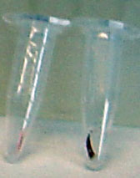
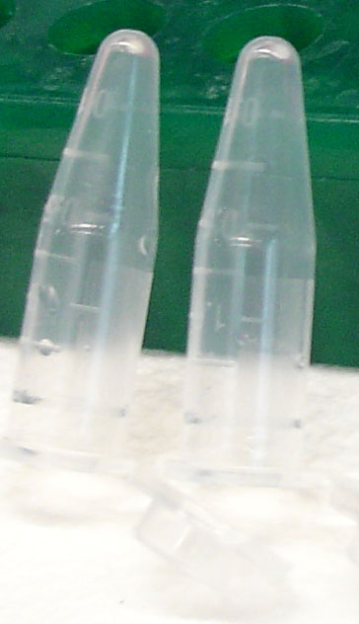

3.2.6 Treating for Another Organ Tissue:

3.2.6.1 Cut another organ tissue to 2-3 mm3 (6-20 mg).

3.2.6.2 If the organs tissue is with blood or another dirty trace, please do the following:

3.2.6.2.1 Rinse 2-3 times with PBS without Ca++ and Mg++.

3.2.6.2.2 Touch dry the tissue on the paper towel. Then, to follow the work table.

3.2.6.3 If the tissue isn’t adhered the blood etc., like the clean skin or muscle, it is fine to follow the work table to obtain the desired purified DNA extract.

3.3 Ten-minute DNA Release Kit-3
The Ten-minute DNA Release Kit-3 is for blood-DNA-PCR. The catalogue number is JZ-003.

The preliminary protocol of Ten-minute DNA Release Kit-3 is as the following:

3.3.1 Aim

3.3.1.1 With Ten-minute DNA Release Kit-3 it is easy and quick (5-6 minutes) to obtain desired DNA from blood to run PCR.

3.3.1.2 The DNA could be used for any gene expression to follow your purpose.

3.3.2 Have been ready for the equipments?
3.3.2.1 A room temperature eppendorf centrifuge machine with the speed 10,000-15,000 g setting up.

3.3.2.2 1.5 ml eppendorf tubes, tips and micro-pipettor with the scalar of 10-200 ul.

3.3.2.3 Vortex or mixture machine.

3.3.3 Content Table (Table 5)

Table 5. Ten-minute DNA Release Kit-3 content table

3.3.4 Work Table (Table 6)

Table 6. Ten-minute DNA Release Kit-3 work table

3.4 Ten-minute DNA Release Kit-4
The Ten-minute DNA Release Kit-4 is for urine-DNA-PCR. Its catalogue number is JZ-004.

The preliminary protocol of Ten-minute DNA Release Kit-1 is as the following:

3.4.1 Aim
3.4.1.1 It is easy and quick from urine to obtain desired DNA to run PCR.

3.4.1.2 The DNA can be used for any gene expression to follow your purpose.

3.4.2 Have been ready for the equipments?
3.4.2.1 It is fine for this kit to have any type of thermo-machine or water bath which can set up the constant temperature between 86-90˚C.

3.4.2.2 A room temperature eppendorf centrifuge machine with the speed 10,000-15,000 g.

3.4.2.3 1.5 ml eppendorf tubes, tips and micro-pipettor with the scalar of 10-200 ul.

3.4.2.4 Vortex or mixture machine which is fine to have or have not.

3.4.3 Content Table (Table 7)

Table 7. Ten-minute DNA Release Kit-4 content table
3.4.4 Work Table (Table 8)
Table 8. Ten-minute DNA Release Kit-4 work table

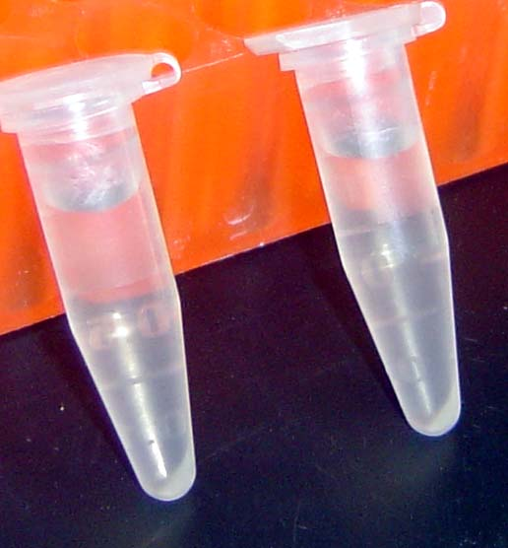

3.5 Ten-minute DNA Release Kit-5
The Ten-minute DNA Release Kit-5 is for Saliva-DNA-PCR. Its catalogue number is JZ-005.

The preliminary protocol of Ten-minute DNA Release Kit-5 is as the following:
3.5.1 Aim
3.5.1.1 It is easy and quick to obtain desired DNA from saliva to run PCR.

3.5.1.2 The DNA can be used for any gene expression for your purpose.
3.5.2 Have been ready for the equipments?
3.5.2.1 It is fine for this kit to have any type thermo-machine or water bath which can set up the constant temperature between 86-90˚C.

3.5.2.2 A room temperature eppendorf centrifuge machine with the speed 10,000-15,000 g.

3.5.2.3 1.5 ml eppendorf tubes, tips and micro-pipettor with the scalar of 10-200 ul.

3.5.2.4 Vortex or mixture machine is fine to have or have not.

3.5.3 The PBS is made by you
Making the 1 X, PBS without Ca++ and Mg++:
Reagents 1 x, working solution, pH 7.3± Weight
NaCl 137 mM 8.0 g
KCl 2.7 mM 0.2 g
Na₂ HPO₄-7H₂O 4.3 mM 1.15 g
KH₂PO₄ 1.4 mM 0.2 g .
Dissolved in 1000 ml of distilled water.

3.5.4 Content Table (Table 9)
Table 9. Ten-minute DNA Release Kit-5 content table
3.5.5 Work Table (Table 10)
Table 10. Ten-minute DNA Release Kit-5 work table

3.6 Ten-minute DNA Release Kit-6
Ten-minute DNA Release Kit-6 is for hair follicle-DNA-PCR. Its catalogue number is JZ-006.

The preliminary protocol of Ten-minute DNA Release Kit-1 is as the following:
3.6.1 Aim
3.6.1.1 It is easy and quick to obtain desired DNA from hair follicle to run PCR.

3.6.1.2 The DNA can be used for any gene expression for your purpose.

3.6.2 Have been ready for the equipments?
3.6.2.1 It is fine for this kit to have any type thermo-machine or water bath which could set up the constant temperature between 86-90˚C.

3.6.2.2 A room temperature eppendorf centrifuge machine with the speed 10,000-15,000 g.

3.6.2.3 1.5 ml eppendorf tubes, tips and micro-pipette with the scalar 10-200 ul.

3.6.2.4 Vortex or mixture machine which is fine to have or have not.

3.6.3 Content Table (Table 11)

Table 11. Ten-minute DNA Release Kit-6 content table

3.6.4 Work Table (Table 12)
Table 12. Ten-minute DNA Release Kit-6 work table
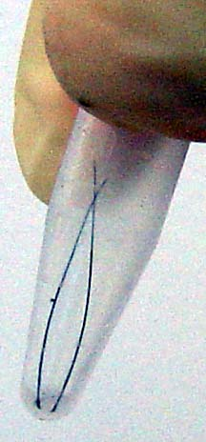

3.7 Ten-minute DNA Release Kit-7
Ten-minute DNA Release Kit-7 is for cells-DNA-PCR and Southern. The catalogue number is JZ-007.

The preliminary protocol of Ten-minute DNA Release Kit-7 is as the following:

3.7.1 Aim
3.7.1.1 It is easy and quick from the adhered culture cells to obtain purified DNA for PCR or Southern.

3.7.1.2 The DNA can be used for any gene expression for your purpose.

3.7.2 Have been ready for the equipments?
3.7.2.1 It is fine for this kit to have any type thermo-machine or water bath which can set up the constant temperature between 86-90˚C.

3.7.2.2 A room temperature eppendorf centrifuge machine with the speed 10,000-15,000 g.

3.7.1.3 1.5 ml eppendorf tubes, tips and micro-pipettor with the scalar of 10-200 ul.

3.7.1.4 Vortex or mixture machine which is fine to have or have not.

3.7.3 The PBS is made by yourself

Making the 1X, PBS without Ca++ and Mg++:

Reagents 1 x, working solution, pH 7.3± Weight .
NaCl 137 mM 8. 0 g
KCl 2.7 mM 0.2 g
Na₂HPO₄-7H₂O 4.3 mM 1.15 g
KH₂PO₄ 1.4 mM 0.2 g .
Dissolved in 1000 ml of distilled water.

3.7.4 Content Table (Table 13)

Table 13. Ten-minute DNA Release Kit-7 content table

3.7.5 Work Table (Table 14)

Table 14. Ten-minute DNA Release Kit-7 work table
4. Reference to the DNA Quantity to Match Your Action (Table 15, Figure 4)

30 ul
2.96
2.93-2.99
culture dish

70 ul
1.3
1-1.6
100 mm cell

32-36 ul
1.2
0.9-1.5
1 X 10⁶

32-36 ul
0.8
0.7-0.9
5 X 10⁵

32-36 ul
0.24
0.22-0.26
1 X 10⁵
1.7-2.0
32-36 ul
0.14
0.12-0.16
5 X 10⁴
260/280 nm
Volume/each
Average
Range
Cells
Ratio on

Concentration (ug/ul)

Table 15. Kit-7 DNA quantity on the cell amount dose-dependent effective with adhered cells

Figure 4. Kit-7 DNA quantity on the cell amount dose-dependent effective with the adhered cells

5. Troubleshooting
If you do not get a good result, please check the process you have done by following:

5.1 If the buffers are kept at 5-28°C?

5.2 If the sample is frozen sample? The samples must be thawed to the room temperature, then start the process following the protocol.

5.3 If you use the centrifuge that is below 4°C? You have to use the centrifuge at room temperature for your good result.

5.4 If the buffers are used wrongly?

5.5 If you use the incorrect temperature for DNA releasing? You must put the tube at 86-90°C, not shaking in any thermo-machine or water bath.

5.6 If the experimental steps are done following the protocol exactly?

References
- Lee TY, et al. Phylogenetic analysis by RFLP and sequencing of mitochondrial DNA in a Korean Popukation. Arch Oharm Res 2006;29(1):88-95.
- Chakraborty A, et al. Mplecular identification of hairtail speciec (Pisces: Trichiuridae) base on PCR-RFLP analysis the mitochondrial 16S rRNA gene. J Appl Genet 2005:46(4):381-5.
- Ren S, et al. A Simplified method to prepare PCR template DNA for screening of transgenic and knockout mice. Contemp Top Lab Anim Sci 2001;40(2):27-30.
- Hofstetter JR, et al. A comparison of recovery methods and tissue sources. Biochem Mol Med 1997;62(2);197-202.
- Malumbres M, et al. Isolation of high molecular weight DNA for reliable genotyping of transgenic mice. Bio Techniques 1997;22(6):1114-9.
- Anderson S, et al. Sequence and organization of human mitochondrial genome. Nature 1981;290(9):457-65.

Correspondence to:
Huaijie Zhu
Jacksun Easy Biotech Inc.
2316 Gunther Avenue
Bronx, NY 10469, USA
Telephone: (718) 513-0385
Email: hjz689@yahoo.com; jacksunbio@gmail.com
Website: www.jacksunbio.com

