Review

Study of Transmission Electron Microscopy (TEM) and Scanning Electron Microscopy (SEM)

Hongbao Ma *, Kuan-Jiunn Shieh **, Tracy X. Qiao ***

* Department of Medicine, Michigan State University, East Lansing, Michigan 48824, USA
Telephone: 517-303-3990; Email: hongbao@msu.edu

** Department of Chemistry, Chinese Military Academy, Fengshan, Kaohsiung, Taiwan 830, ROC.
Telephone: 011-886-7742-9442; Email: chemistry0220@gmail.com

*** University of Michigan, Ann Arbor, Michigan 48105, USA
Telephone: 734-623-9719; Email: xiaotan@umich.edu

Abstract: Scanning electron microscopy (SEM) and transmission electron microscopy (TEM) are widely used in material science, metallurgy sicence and life science researches. TEM is an imaging technique where a beam of electrons is focused onto a specimen causing an enlarged version to appear on a fluorescent screen or layer of photographic film. SEM is a technique of electron microscope to produce high resolution images of a sample surface. This article describes the basic principle of TEM and SEM, and their applications. [Nature and Science. 2006;4(3):14-22].

Keywords: electron; microscopy; scattering; transmission

1. Introduction
Transmission electron microscopy (TEM) is an imaging technique where a beam of electrons is focused onto a specimen causing an enlarged version to appear on a fluorescent screen or layer of photographic film. The first practical TEM was built by Albert Prebus and James Hillier at the University of Toronto in 1938 using concepts developed earlier by Max Knoll and Ernst Ruska (Wikipedia, 2006). Scanning electron microscope (SEM) is a technique of electron microscope to produce high resolution images of a sample surface. Due to the manner in SEM the image is created, its images have a characteristic three-dimensional appearance and are useful show the surface structure of the target sample.
TEM and SEM are widely used in material science, metallurgy sicence and life science researches. An electron passing through a solid could be scattered for once (single scattering), several times (plural scattering), or very many times (multiple scattering). Each scattering event might be elastic or inelastic. The scattered electron is most likely to be forward scattered but there is a small chance that it will be backscattered. The probability of scattering is either as an "interaction cross-section" or a mean free path.
Single scattering is an electron undergoes only one scattering event as it passes through a specimen. Plural scattering is an electron undergoes more than one scattering event but less than 20 as it passes through a specimen. Multiple scattering is an electron undergoes more than 20 scattering events as it passes through a specimen. Elastic scattering is the scattering of an electron if a negligible amount of energy is lost by the primary electron in the process. The direction of the electron may change, but the energy not. Inelastic scattering is a process by which the primary electron loses a significant amount of energy.
When the solid specimen is thicker than about twice the mean free path, plural scattering happens. This can be modelled using the Monte Carlo technique. The important features are the fraction of electron scattering forward and backwards and the volume of the specimen in which most of the interactions happen.

2. TEM Basic
The following is a brief description for the TEM techniques (Williams, 2000).
Many physical techniques rely on the interaction between high energy electrons and the atoms in a solid. There are many possible interactions and some of the more useful (in that they give rise to measurable effects) are simulated on the next page. In the simulations that follow, high energy electrons, typically 20 keV or higher, are allowed to interact, one by one, with a single atom of aluminium. This atom is assumed to be part of a solid metallic specimen and it contributes 3 electrons to a valence band or conduction band. In TEM a thin specimen is illuminated with electrons, the primary electrons. This section details some of the interactions between those electrons and the specimen.
After an inner shell excitation an atom has an energy above its ground state. It can relax and lose some of this energy in several ways. This simulation models the interaction of high energy electrons with atoms of aluminium. The incoming primary (red) electron can be elastically scattered, losing very little energy, or it can undergo an inelastic scattering process.
The interactions modelled include the excitation of inner shell electrons, the creation of plasmons and interactions with single valence electrons.
In the simulation, each incoming primary electron is shown separately after you click on the "Next electron" button. Subsequent relaxation of inner shell excited atoms may occur by the emission of an X-ray or an Auger electron.
Every electron microscope, of whatever type, must have a source of high energy primary electrons - an electron gun. The function of the gun is to produced a fine beam of electrons of precisely controlled energy (i.e. velocity) all coming from a small source region.
A thermionic electron gun is operated as follows: Select the accelerating potential (kV). Increase the current passing through the filament until the knee of the emission curve is reached (saturation), giving the best compromise between the beam current emitted (as high as possible) and the filament lifetime (as long as possible). Adjust the bias to give the desired combination of source size and beam current.
Here are two parameters which control the electron gun: (1) Filament current. The filament current controls the temperature of the filament and hence the number of electrons emitted or 'beam current'. Generally we want a large number of electrons emitted from a small region of the filament. This is done by saturating the filament - increasing the filament current until the beam current no longer rises. (2) Bias. The bias potential controls the size of the region of filament which emits electrons and hence it affects both the source size and the beam current. If the bias is too high no region of the filament will emit and the beam is said to be pinched off. The main reason to alter bias is to change the brightness of the beam.
Diffraction at an aperture (leading to Airy rings) limits the resolution of many optical systems. Use the simulation to show that the size of the central disc of illumination varies inversely with the size of the aperture (W).



where



(θ is the angular deflection of the beam at the aperture.)

16% of the intensity (electrons in the TEM) falls outside the central disc. Adjust the brightness in the simulation to see how low the intensity of the rings is compared to that of the central disc. The Rayleigh criterion for resolution indicates how close together two points can be brought together before they can no longer be distinguished as separate. Resolution (or strictly resolving power) is defined as the closest spacing of two points which can be resolved by the microscope to be separate entities. This simulation shows two sets of Airy rings showing the variation in light intensity across the rings.
The actual beam diameter results from the diameter of the original beam leaving the electron gun, d_{g} broadened by the effect of spherical aberation in the lenses d_{s} and diffraction at the aperture, d_{d}. These depend on the current, i, convergence angle, α, brightness, β, spherical aberation coefficient, C_{s}, and wavelength, λ, via

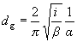
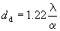

The total beam diameter is found by adding these three effects in quadrature i.e.

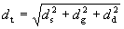

For best resolution in many applications we need to use the smallest beam diameter.
Electron lenses are the magnetic equivalent of the glass lenses in an optical microscope and to a large extent, we can draw comparisons between the two. For example the behaviour of all the lenses in a TEM can be approximated to the action of a convex (converging) glass lens on monochromatic light. The lens is basically used to do two things: (1) either take all the rays emanating from a point in an object and recreate a point in an image, (2) or focus parallel rays to a point in the focal plane of the lens.
A strong magnetic field is generated by passing a current through a set of windings. This field acts as a convex lens, bringing off axis rays back to focus. Click on 'Draw rays' to compare the action of an electromagnetic lens with an optical lens.
The image is rotated, to a degree that depends on the strength of the lens. Focal length can be altered by changing the strength of the current.
All electromagnetic lenses act like 'thin' convex lenses - their thickness can be ignored for most purposes. The most important property of a thin lens is its focal length f. Parallel rays entering the lens are brought to focus at the distance f shown in the diagram.
Try moving the object (red bar) along the optical axis noting size position, and orientation of the image. Simple geometry shows that the magnification M, of the lens:

.

u, v and f are related by the thin lens equation:



In microscopy, lenses are often used to demagnify (make smaller) the diameter of the beam. In this case it is more appropriate to draw the ray diagram as shown here.
The double condenser system or illumination system consists of two or more lenses and an aperture. It is used in both SEM and TEM. Its function is to control spot size and beam convergence.
Two or more lenses can act together (as shown here) and their ray diagrams can be constructed using the thin lens approximation for each of them.
The diagram opposite shows the ray diagram for the double condenser system. The black dots represent the focal point of each lens.
The condenser aperture controls the fraction of the beam which is allowed to hit the specimen. It therefore helps to control the intensity of illumination, and in the SEM, the depth of field. The objective lens forms an inverted initial image, which is subsequently magnified. In the back focal plane of the objective lens a diffraction pattern is formed. The objective aperture can be inserted here. The effect of inserting the aperture is shown on the next page.
The depth of field, D_{ob} is the range of distance along the optical axis in which the specimen can move without the image appearing to lose sharpness. This obviously depends on the resolution of the microscope.

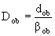

The depth of focus, D_{im} is the extent of the region around the image plane in which the image will appear to be sharp. This depends on magnification, M_{T}.

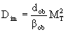

The use of two sets of deflection coils enable us to translate (scan) the beam across the specimen without apparently changing the angle of incidence or to tilt the beam without changing its position on the specimen.
An important microscope alignment involves the centering of the condenser aperture about the optical axis. If the aperture is off-centre the beam is displaced away from the axis as the condenser lens is focused.
Astigmatism in the condenser lenses distorts the beam to an elliptical shape either side of focus and prevents the beam being fully focused. It is corrected by applying two orthogonal correction fields in the x and y directions.
When we form images in TEM, we either form an image using the central spot, or we use some or all of the scattered electrons. The way we choose which electrons form the image is to insert an aperture into the back focal plane of the objective lens, thus blocking out most of the diffraction pattern except that which is visible through the aperture. We use the external drives to move the aperture so that either the direct electrons or some scattered electrons go through it. If the direct beam is selected we call the resultant image a bright-field image, and if we select scattered electrons of any form, we call it a dark-field image.
A Bright Field (BF) detector is placed in a conjugate plane to the back focal plane to intercept the direct beam while a concentric Annular Dark Field (ADF) detector intercepts the diffracted electrons. The signals from either detector are amplified and modulate the STEM CRT. The specimen (Au islands on a C film) gives complementary ADF and BF images as can be seen by clicking the button opposite.
The image of a hole in an amorphous carbon film illuminated with a parallel beam showing that with the objective lens underfocused (0-2) a bright Fresnel fringe is visible inside the hole; with the objective lens overfocused (4-6) a dark fringe is visible inside the hole; at exact focus (3) there is no fringe; the appearance of the image varies as the x and y correction (-, OK or +) is altered.
Electromagnetic lenses cause image rotation and therefore in many microscopes the image will rotate as the magnification is changed.
As the crystalline specimen is tilted slightly, the fundamental spot pattern remains but Kikuchi lines move across the pattern.
The imaging and characterization of dislocations is commonly carried out by thin foil TEM using diffraction contrast imaging. However, the thin foil approach is limited by difficult sample preparation, thin foil artifacts, relatively small viewable areas, and constraints on carrying out in situ studies. Electron channeling imaging of electron channeling contrast imaging (ECCI) offers an alternative approach for imaging crystalline defects, including dislocations. Because ECCI is carried out with field emission gun scanning electron microscope (FEG-SEM) using bulk specimens, many of the limitations of TEM thin foil analysis are overcome (Crimp, 2006).
According to Schaublin’s description, nanometric crystal defects play an important role as they influence, generally in a detrimental way, physical properties. For instance, radiation-induced damage in metals strongly degrades mechanical properties, rendering the material stronger but brittle (Schaublin, 2006).

3. SEM Basic
In a typical SEM electrons are thermionically emitted from a tungsten or lanthanum hexaboride (LaB₆) cathode and are accelerated towards an anode. Alternatively electrons can be emitted via field emission. Tungsten has the highest melting point and lowest vapour pressure of metals and this is important for electron emission. The electron beam with the energy of 100 - 50000 eV is focused by one or two condenser lenses into a beam with a very fine focal spot sized 1 -5 nm. The electron beam passes through scanning coils in the objective lens that deflect the beam in a raster fashion over a rectangular area of the sample surface. As the primary electrons strike the surface they are inelastically scattered by atoms in the sample. With the scattering the primary electron beam effectively spreads and fills a teardrop-shaped volume that extends less than 100 - 5000 nm into the surface. Interactions in this region lead to the subsequent emission of electrons which are then detected to produce an image. X-rays, which are also produced by the interaction of electrons with the sample, may also be detected in an SEM equipped for energy dispersive X-ray spectroscopy or wavelength dispersive X-ray spectroscopy.
The most common imaging mode monitors low energy secondary electrons that is less than 50 eV. Due to the low energy, these electrons originate within several nm from the surface. The electrons are detected by a scintillator-photomultiplier device and the resulting signal is rendered into a two-dimensional intensity distribution that can be viewed and saved as a Digital image and treated by a computer. The brightness of the signal depends on the number of secondary electrons reaching the detector. If the beam enters the sample perpendicular to the surface, the activated region is uniform about the axis of the beam and a certain number of electrons escape from samples. As the angle of incidence increases, the escape distance of one side of the beam will decrease and more secondary electrons will be emitted. The steep surfaces and edges tend to be brighter than flat surfaces, which results in images with a well-defined, three-dimensional appearance.
For SEM technique, backscattered electrons can also be detected. With backscattered we can detect contrast between areas with different chemical compositions. There are fewer backscattered electrons emitted from a sample than secondary electrons. The number of backscattered electrons leaving the sample surface upward might be significantly lower than those that follow trajectories toward the sides.
The spatial resolution of the SEM depends on the size of the electron spot which in turn depends on the magnetic electron-optical system which produces the scanning beam. The resolution is also limited by the size of the interaction volume, or the extent of material which interacts with the electron beam. The spot size and the interaction volume are both very large compared to the distances between atoms, so the resolution of the SEM is not high enough to image down to the atomic scale, as is possible in TEM. SEM has compensating advantages, though, including the ability to image a comparatively large area of the specimen; the ability to image bulk materials and the variety of analytical modes available for measuring the composition and nature of the specimen. The Scanning Electron Microscope is revealing new levels of detail and complexity in the amazing world of micro-organisms and miniature structures.
For SEM, Conventional light microscopes use a series of glass lenses to bend light waves and create a magnified image. SEM creates the magnified images by using electrons instead of light waves, and it shows very detailed 3-dimensional images at much higher magnifications than is possible with a light microscope. The images created without light waves are rendered black and white. Samples have to be prepared carefully to withstand the vacuum inside the microscope. Biological specimens are dried in a special manner that prevents them from shriveling. Because the SEM illuminates them with electrons, the samples also have to be made to conduct electricity. When start the measurement, the sample is placed inside the microscope's vacuum column through an air-tight door. After the air is pumped out of the column, an electron gun emits a beam of high energy electrons. This beam travels downward through a series of magnetic lenses designed to focus the electrons to a very fine spot. Near the bottom, a set of scanning coils moves the focused beam back and forth across the specimen, row by row. As the electron beam hits each spot on the sample, secondary electrons are knocked loose from its surface. A detector counts these electrons and sends the signals to an amplifier. The final image is built up from the number of electrons emitted from each spot on the sample. The resolution normally is 1 - 20 nm, and Resolutions of SEM can be less than 1 nm with a better instrument. It is easier to treat SEM images that to treat images of TEM. In our researches, we used SEM more than we used TEM in our researches.

4. JEOL Transmission Electron Microscopes and JEOL Scanning Electron Microscopes
JEOL has produced TEMs since 1949, and currently markets state-of-the-art instruments in the 100 keV to 1 MeV ranges designed to support all TEM applications. Also, JEOL has played a leading role in the development and evolution of scanning electron microscopy since the early 1960s. Over the past four decades, the SEM has become an indispensable tool in both advanced research and routine analysis for science and industry. JEOL has installed more than 8000 SEMs worldwide. The instrument we used in our experiments is the JEOL scanning electron microscope of Model JSM-6400V (Ma, et al, 2006).
Since 1949, the JEOL legacy has been one of outstanding innovation in developing instruments used to advance scientific research and technology. JEOL has more than 50 years of expertise in the fields of electron microscopy and mass spectrometry, and more than 20 years in e-beam lithography and defect analysis.
JEOL USA, Inc., a wholly-owned subsidiary of JEOL Ltd. Japan, was incorporated in the United States in 1962. The primary business of JEOL USA is sales of new instruments and peripherals and support of a vast installed base of instruments throughout the United States, Canada, Mexico, and South America (JEOL, 2006). The following gives JEOL TEM and SEM main products as the references for readers (Tables 1-7).

(1) Current JEOL TEM products

The Table 1, Table 2 and Table 3 are describing the JEOL TEM instruments currently available (Tables 1, 2, 3).

Table 1. 100 / 120 kV TEM
 | Resolution | Accelerating Voltage | Magnification
JEM-1011 | 0.2 nm Lattice | 40 to 100 kV | x50 to 1,000,000
JEM-1230 | 0.2 nm Lattice | 40 to 120 kV | x50 to 600,000

Table 2. 200 kV TEM/FEG TEM
 | Resolution | Accelerating Voltage | Magnification
JEM-2100F | 0.14 nm Lattice | 80 to 200 kV | x50 to 1,500,000
JEM-2100LaB₆ | 0.14 nm Lattice | 80 to 200 kV | x50 to 1,500,000
JEM-2200FS | Point-image  0.19 nm/0.23 nm/0.25 nm /0.28 nm (200 kV) | 80 to 200 kV | x100 to 1,500,000
JEM-2500SE | STEM, 0.2 nm Lattice  TEM, 0.14 nm Lattice | 80 to 200 kV | x100 to 20,000,000

Table 3. IVEM 300 kV TEM/FEG TEM
 | Resolution | Accelerating Voltage | Magnification
JEM-3100F | 0.14 nm Lattice | 100 to 300 kV | x60 to 1,500,000
JEM-3010 | 0.14 nm Lattice | 100 to 300 kV | x50 to 1,500,000
JEM-3200FS | 0.17 nm Lattice | 100 to 300 kV | x50 to 1,500,000
JEM-3200FSC | 0.204 nm Lattice | 100 to 300 kV | x50 to 1,500,000

(2) Current JEOL SEM products
The Table 4, Table 5, Table 6 and Table 7 are describing the JEOL SEM instruments currently available (Tables 4, 5, 6, 7).

Table 4. Conventional Tungsten High Vacuum SEMs
 | Resolution | Accelerating Voltage | Magnification | Stage
JSM-6390 | 3.0 nm | 0.3 to 30 kV | x5 to 300,000 | GS Type: X=20 mm, Y=10 mm  LGS Type: X=80 mm, Y=40 mm
JSM-6490 | 3.0 nm | 0.3 to 30 kV | x5 to 300,000 | X=125 mm, Y=100 mm

Table 5. Conventional Tungsten Low Vacuum SEMs
 | Resolution | Accelerating Voltage | Magnification | Stage
JSM-6390LV | HV 3.0 nm  LV 4.0 nm | 0.5 to 30 kV | x5 to 300,000 | GS Type: X=20 mm, Y=10 mm  LGS Type: X=80 mm, Y=40 mm
JSM-6490LV | HV 3.0 nm  LV 4.0 nm | 0.3 to 30 kV | x5 to 300,000 | X=125 mm, Y=100 mm

Table 6. Conventional Thermal Field Emission SEMs
 | Gun Type | Resolution | Accelerating Voltage | Magnification | Stage
JSM-7000F | in-lens thermal | 1.2 nm (30 kV)  3.0 nm (1 kV)  3.0 nm (15 kV) | 0.5 to 30 kV | x10 to 650,000 | Type I: X=50 mm, Y=70 mm  Type II: X=110 mm, Y=80 mm  Type III: X=140 mm, Y=80 mm

Table 7. Semi-in-Lens Cold Cathode Field Emission SEMs

 | Resolution | Accelerating Voltage | Magnification | Stage
JSM-6700F | 1.0 nm  2.2 nm (1 kV) | 0.5 to 30 kV | x25 to 650,000 | Type I: X=70 mm, Y=50 mm  Type II: X=110 mm, Y=80 mm  Type III: X=140 mm, Y=80 mm
JSM-7401F | 1.0 nm (15 kV)  1.5 nm (1 kV)  0.8 nm (30 k STEM) | 0.1 to 30 kV | x25 to 1,000,000 | Type I: X=70 mm, Y=50 mm  Type II: X=110 mm, Y=80 mm  Type III: X=140 mm, Y=80 mm
JSM-7500F | 1.0 nm (15 kV)  1.4 nm (1 kV)  0.6 nm (30 kV) | 0.1 to 30 kV | x25 to 1,000,000
JSM-7700F | 0.6 nm (5 kV)  1.0 nm (1 kV)  1.0 nm (15 kV)  0.7 nm (1 kV) | 0.1 to 30 kV | x25 to 2,000,000 | X=2.5 mm, Y=25 mm

5. TEM and SEM Research Examples
As examples, the following is what we have done in our rabbit atherosclerosis and thrombosis studies that see can see the handles and result comparisons of light microscopy, TEM and SEM (Ma, 2006):

- Light Microscopy
Rabbit arterial tissue specimen were embedded in paraffin, cut and mounted on glass slides. The sections were then stained with hematoxylin and eosin and Masson’s trichrome stains. Gross examination showed that white thrombi with attached fibrin rich thrombi could be seen on the intimal surface of the aorta in more than half the triggered rabbits, and light microscopy showed that platelet rich thrombi were noted overlying sites of eroded plaque surfaces, and other areas appeared to have had plaque disruption the thrombus site. The light microscopy result give a clear overview for the sample and it is useful for the anatomic view (Figure 1, Figure 2). White thrombi were noted to be firmly adherent to the arterial wall. These were cylindrical in shape and had rounded edges. This demonstrated areas of plaque disruption with super imposed platelet-rich thrombi. Also, commonly noted were areas of large lipid cores and thin caps. These lesions have great resemblance to the vulnerable human plaques. There was no visible difference in plaque morphology between the two atherosclerotic groups.

- Electron Microscopy (TEM and SEM)
The tissue samples were fixed overnight in 4% glutaraldehyde (Fisher Scientific, Pittsburgh, PA, USA) with 0.1 M phosphate buffer (pH 7.4). Rabbit arterial segments (5 mm long) were subjected to critical point drying in liquid CO₂, mounted on stubs and gold-coated in a sputter coater. The intimal surface was examined using a JEOL scanning electron microscope (JEOL Ltd, Model JSM-6400V, Tokyo, Japan). Tissue sections were obtained and processed routinely for ultrastructural examination. Thin sections were stained with uranyl acetate and lead citrate and then examined with a transmission electron microscope (BEI preamplifier, Au Evirotech Company, Germany). SEM showed that fissures of various lengths could be seen at the site where thrombus was present (Figure 3) and. TEM showed that white thrombi were composed of a dense platelet rich matrix (Figure 4).

  - Scanning Electron Microscopy: After triggering, the intimal surface of rabbit aorta and ilio-femoral arteries in atherosclerotic group had focal clusters of red blood cells and adherent platelets (Figure 3). The plaques had an irregular surface and ulceration with blood cells and fibrin.

B. Transmission Electron Microscopy: When compared with control rabbit, atherosclerotic rabbit arterial wall had increased elastin, degenerated organelles, lipid droplets, and bundles of microfibrils. The cytoskeletal and sub-cellular appearance of smooth muscle cells were altered with the atherosclerotic diet. The lipid distribution was mainly in the extracellular spaces with cholesterol crystal formation (Figure 4).

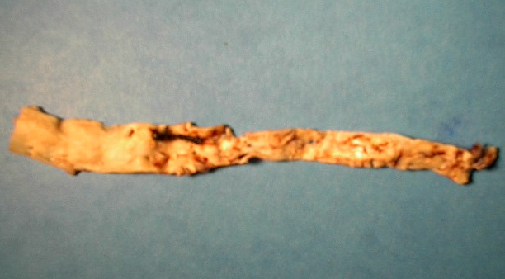

Figure 1. Gross examination: White thrombi with attached fibrin rich thrombi can be seen on the intimal surface of the aorta in more than half the triggered rabbits.

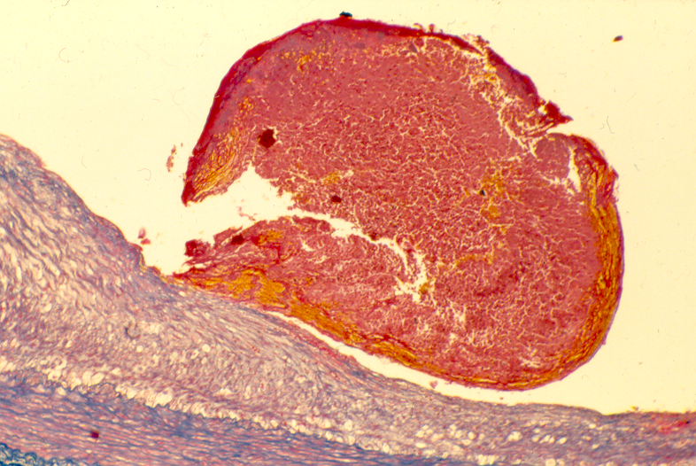

Figure 2. Light microscopy: Platelet rich thrombi were noted overlying sites of eroded plaque surfaces. Other areas appeared to have had plaque disruption the thrombus site.

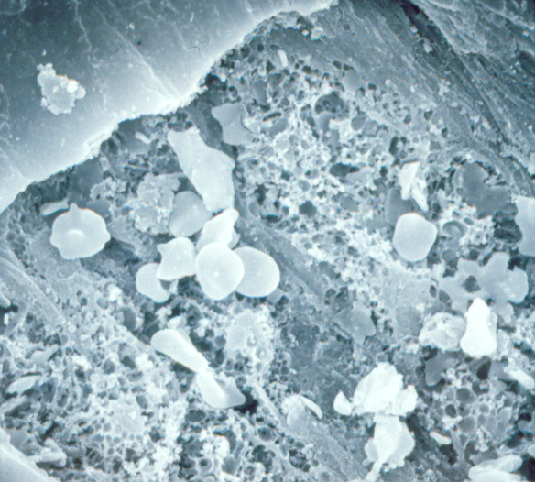

Figure 3. Scanning electron microscopy: Fissures of various lengths could be seen at the site where thrombus was present.

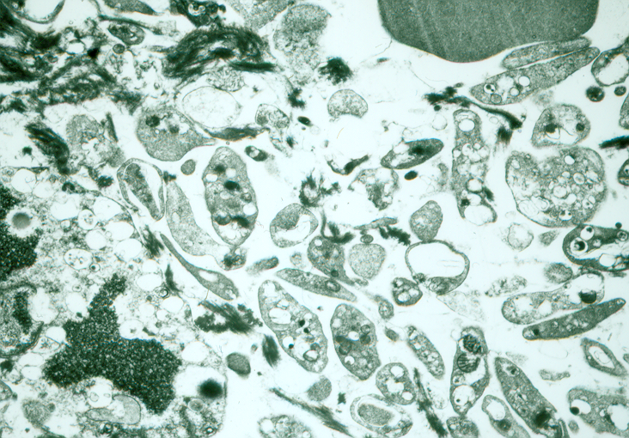

Figure 4. Transmission electron microscopy: White thrombi were composed of a dense platelet rich matrix.

6. Applications
Because electro microscopes use a beam of highly energetic electrons to examine objects on a very fine scale. The examination can provide the unique information. That includes, topography – the surface features of an object of the looks. Its texture, direct relation between these features and materials properties; morphology – the shape and size of the particles making up the object that related between these structures and material properties which character specially in the biological fields; composition the elements and compounds that the object is composed of and the relative amounts of them and to determent relationship between composition and materials properties; finally crystallographic information – the atoms arrangement of the object.
Along with SEM, TEM has been widely applied in life science studies. We have successfully used TEM and SEM in the atherosclerosis, therombosis and platelet function studies (Prieto, et al, 2002; Abela, et al, 2003; Ma, e al, 2006)
The basic procedures for TEM and SEM are well established, for biological and medical science that involves with sample collection, fixation and dehydration, embedding, ultrathin sectioning, staining o ultra thin section, magnification and resolution calibration while observation and recording the image, and last analysis the graphs. For SEM, beside preparation of particulate specimens which including freeze-fraction for biological sample, mounting and coating samples are commonly used.
Resentlly, Yucel et al used analyzed rats via TEM. Corneal autofluorescence measurements were also performed in all experimental groups. Their results showed: Electron microscopic evaluation revealed that aminoguanidine treatment in diabetic rats prevented the formation of intracellular spaces between neighbouring cells in the superficial corneal epithelium. Hyperglycemia-induced degeneration of intracellular organelles and formation of cytoplasmic vacuoles in the corneal stroma was also prevented with the treatment of AG. Corneal autofluorescence detected in the diabetic group (5.98 +/- 2.17 Fi/mg protein) was found to be significantly greater than the control (3.92 +/- 0.56 Fi/mg protein) and the AG-treated diabetic group (4.18 +/- 0.59 Fi/mg protein) (p < 0.05). Interpretation: The presented data provide evidence that AG is preventive against corneal alterations in experimental diabetes (Yucel, 2006).
With TEM technique, Prieto et al found that thrombostatin and aspirin treated rabbit atherosclerotic arteries had less platelet adhesion on the arterial surface when compared to balloon injured controls (Prieto et al, 2002).
In Koufakis et al experiments, conjunctival tissue specimens from seven normal subjects and eight patients with SS were obtained by bulbar conjunctival biopsy and examined by transmission electron microscopy. Their results demonstrated: The average number of microvilli per 8.3 microm epithelial length was significantly lower in the SS group than that in the control. The microvillus height and height-width ratio in the conjunctival epithelium in the SS group were significantly lower than those in normal individuals. They concluded that ultrastructural morphology of the apical conjunctival epithelium is altered in patients with SS and the findings suggest that an intact OSG may play a key role in the maintenance of a healthy ocular surface, possibly by preventing abrasive influences on the apical epithelial cells (Koufakis et al, 2006).
Energy filtering TEM (EFTEM) with modern spectrometers and software offers new possibilities for element analysis and image generation in plant cells. In the present review, applications of EFTEM in plant physiology, such as identification of light elements and ion transport, analyses of natural cell incrustations, determination of element exchange between fungi and rootlets during mycorrhiza development, heavy metal storage and detoxification, and employment in plant physiological experiments are summarized. In addition, it is demonstrated that EFTEM can be successfully used in more practical approaches, for example, in phytoremediation, food and wood industry, and agriculture (Lutz-Meindl, 2006).

Correspondence to:
Hongbao Ma
Michigan State University
East Lansing, MI 48824, USA
Telephone: 517-303-3990
Email: hongbao@msu.edu

Received: June 10, 2006.

References
- Abela GS, Huang R, Ma H, Prieto AR, Lei M, Schmaier AH, Schwartz KA, Davis JM. Laser-light scattering, a new method for continuous monitoring of platelet activation in circulating fluid. Journal of Laboratory and Clinical Medicine 2003;141(1):50-7.
- Crimp MA. Scanning electron microscopy imaging of dislocations in bulk materials, using electron channeling contrast. Microsc Res Tech 2006;69(5):374-81.
- Koufakis DI, Karabatsas CH, Sakkas LI, Alvanou A, Manthos AK, Chatzoulis DZ. Conjunctival surface changes in patients with Sjogren's syndrome: a transmission electron microscopy study. Invest Ophthalmol Vis Sci 2006;47(2):541-4.
- Lutz-Meindl U, Use of energy filtering transmission electron microscopy for image generation and element analysis in plant organisms. Micron. 2006.
- Ma H, Aziz KS, Huang R, Abela GS. Arterial wall cholesterol content is directly related to serum cholesterol and is a predictor of the development and severity of arterial thrombosis in atherosclerotic arteries. Journal of Thrombosis and Thrombolysis 2006;22(1):5-11.
- Prieto AR, Ma H, Huang R, Khan G, Schwartz KA, Hage-Korban EE, Schmaier AH, Davis JM, Hasan AA, Abela GS. Thrombostatin, a bradykinin metabolite, reduces platelet activation in a model of arterial wall injury. Cardiovasc Res 2002;53(4):984-92.
- Schaublin R. Nanometric crystal defects in transmission electron microscopy. Microsc Res Tech 2006;69(5):305-16.
- Wikipedia, the free encyclopedia. Transmission electron microscopy. 2006 http://en.wikipedia.org/wiki/Transmission_electron_microscope.
- Williams DB, Carter CB. Transmission Electron Microscopy (TEM). Humphreys and Beanland, 3rd Edition. The University of Liverpool Liverpool, L69 3GH, U.K. 2000.
- Yucel I, Yucel G, Akar Y, Demir N, Gurbuz N, Aslan M. Transmission electron microscopy and autofluorescence findings in the cornea of diabetic rats treated with aminoguanidine. Can J Ophthalmol 2006;41(1):60-6.
- JEOL. TEM and SEM. http://www.jeolusa.com. 2006.

