The Study of a Novel Microstrip Antenna Being Used for the Estimation of Sample Material Dielectric Coefficient under Electromagnetic Wave at 2.4 GHz

Yu-Min Li ¹, Chia-ching Chu ¹, Yuan-Tung Cheng ², Hsien-Chiao Teng ³, Shen Cherng ¹

³ Department of Electrical Engineering, Chinese Military Academy, Fengshan, Taiwan, 830 ROC
² Department of Elewctronics, Chengshiu University, Niaosong, Taiwan, 833 ROC
¹ Department of Electrical Engineering, Chengshiu University, Niaosong, Taiwan, 833 ROC

ABSTRACT: A new microstrip antenna named as jacket antenna is proposed for estimating the sample material dielectric coefficient under electromagnetic wave at 2.4 GHz. Clipping sample material to the jacket antenna will cause the changing of operation frequency and bandwidth that being sensitive to the dielectric coefficient of the clipping material. [Nature and Science. 2006;4(3):41-44].

Keywords: microstrip antenna; dielectric coefficient; operation frequency

- INTRODUCTION
A single structure of metal radiation patch microstrip antenna has been studied very well [1, 2]. In this article, a new microstrip antenna named jacket antenna is proposed for the use of estimating the sensitivity of dielectric coefficient of the clipping sample material to respond to the electromagnetic wave at 2.4 GHz. The patch of the antenna is slotted for adjusting the bandwidth to sense the loss tangent of the sample material dielectric coefficient [3, 4]. The antenna ground is sized to reduce the cross-polarization of the radiation pattern. Inexpensive FR4 substrate is used for convenience [5, 6]. Double side and single side metal-modified FR4 plates are provided as sample materials for being standardized the radiation pattern and the antenna gain. Extra check-shape radiator is connected to microstrip antenna for the direction gain adjustment. The measurement of the radiation pattern as well as HFSS simulation reveals the dispersive relation of the sample material to respond to the electromagnetic wave at 2.4 GHz.

2. ANTENNA DESIGN
The proposed design of a jacket antenna is depicted as in Figure 1. Sample material can be clipped on the slotted patch between end point of check-shape radiator and the substrate.
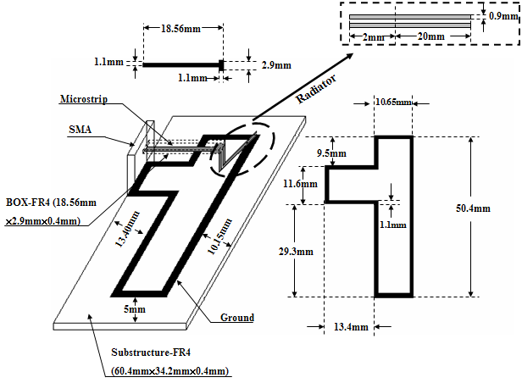
Figure 1. The geometry of the jacket antenna

T-type patch microstrip ground was printed on the 18.56 mm×2.9 mm×0.4 mm FR4 substrate. By using a small microstrip line as the transition between radiator and signal, SMA connector connected to a microstrip radiator. The most optimization of the radiator is 20 mm in length. The test sample materials were proposed and depicted in Figure 2.

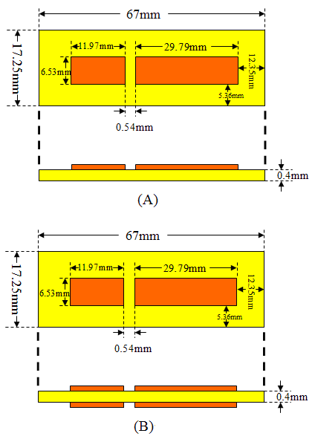
Figure 2. Design of test sample materials:
- single side FR4 plate with specific size of metal and slot line printed
- double side FR4 plate with specific size of metal and slot line printed

Since the effective dielectric coefficient of the test sample can be adjusted by microstrip printed on FR4 plates, standard material samples were designed for estimation of the dielectric coefficient of the interested materials.

- EXPERIMENTAL RESULTS AND
DISCUSSIONS
Figure 3 depicts the measurement for the return loss of the jacket antenna. The low band operation frequency of the jacket antenna is at 2.65 GHz. However, single side with microstrip printed test sample shifted the operation frequency to 2.4 GHz and increased the bandwidth (BW) from 4.91% to 12.58%. In comparison, the double side with microstrip printed test sample shifted the operation frequency to the same frequency at 2.4 GHz with increasing bandwidth (BW) from 4.91% to 13.81%. The effective dielectric coefficient of the test sample of single side microstrip moved to 3 and the loss tangent to1.5 being increased. In contrary, the effective dielectric coefficient of the test sample of double side microstrip moved to 3 also but being increased the loss tangent to 2.

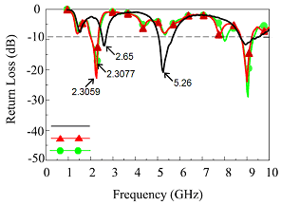
Jacket antenna
Jacket antenna + single side sample
Jacket antenna + double side sample

Figure 3. The return loss of the jacket antenna and that with clipped test samples

Table 1. The results of the antenna measurement
 | Operation frequency  GHz | DB | BW
Jacket antenna | 2.65 | -11.97 | 4.91%
with single side microstrip test A | 2.40 | -22.547 | 12.58%
with double side microstrip test B | 2.40 | -21.252 | 13.81%

The test sample material B can be regarded as a parallel plate waveguide but experimentally showing no significant effect to the operation frequencies. The radiation patterns at the two operation frequencies of the proposed jacket antenna and the jacket antenna with both clipped sample materials of A and B are plotted in Figure 4 and Figure 5. Table I listed the basic measurements. The gains of the jacket antenna and the antenna clipped with both sample materials A and B are shown in Figure 6. Different sample material clearly affected the gain levels of the jacket antenna operated at lower frequency band. The shift of the band frequency caused by clipped sample material indicated the altering of the electromagnetic wave propagation in sample material may be resulted from the changing of the current density on the check-shape reflector. The further study of the dispersive effect of the sample materials will be discussed in next publication.

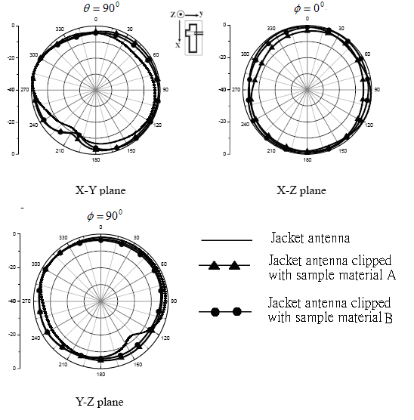

Figure 4. Measured radiation patterns of the E-Phi at 2.65 GHz of jacket antenna and 2.4 GHz of the clipped sample materials

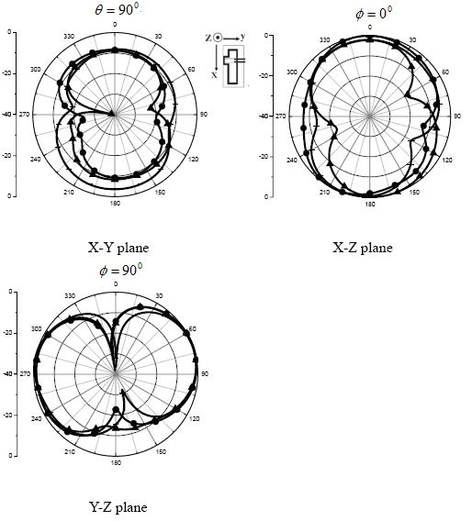
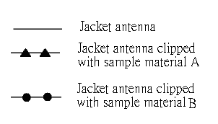

Figure 5. Measured radiation patterns of the E-Theta at 2.65 GHz of jacket antenna and 2.4 GHz of the clipped sample materials.

4. CONCLUSION
According to the measurement, the jacket antenna clipped sample material can significantly affect the operation frequencies and the antenna gains of the jacket antenna. The HFSS simulation of the dispersive dielectric coefficient of the sample material [7, 8] supports the loss tangent of the effective dielectric coefficient of the sample material is 2 which is 50% down of the FR4 plate.

Figure 6. The measurement of the antenna gain. (A) Jacket antenna (B) Jacket antenna with clipped sample material A (C) Jacket antenna with clipped sample material B.

Correspondence to:
Shen Cherng, P.E., Ph.D.
Associate Professor
Department of Electrical Engineering
Chengshiu University
Niausong, Kaohsiung, 833, Taiwan, ROC
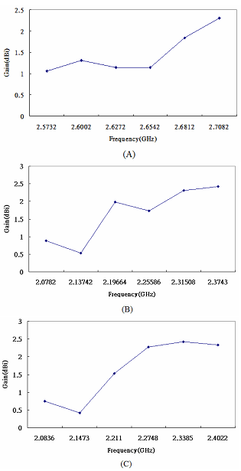
Phones: 011-886-7732-0480;
011-886-929-370-970 (cellular)
cherngs@csu.edu.tw
cherng@msu.edu

Received: August 1, 2006

References
- Tang CL, Chou JY, Wong KL. Broadband dual-frequency v-shape patch antenna. Microwave and Optical Technology Letters. 2000;25:121-123.
- Maci S, Gentili GB. Dual-frquency patch antennas. IEEE Antennas Propagat Mag 1999;39:13-20.
- Chu CC, Li YM, Teng HC, Cherng S. The permittivity frequency-dependent response of a ceramic material to electromagnetic waves at 2 GHz. in press 2006.
- Andersen JB, Vaughan RG. Transmitting, receiving, and scattering properties of antennas. IEEE Antennas and Propagation Magazine. 2003;45(4):93-98.
- Esselle, KP. A low-profile rectangular dielectric-rectangular antenna, IEEE Trans. Antennas Propagat. 1996;44:1296–1297.
- Mongia RK. Reduced size metalized dielectric resonator antennas, in IEEE Antennas Propagat.-S/URSI Symp. Digest, Montreal, Canada. 1997:2202–2205.
- Maeda T, Morooka T. Radiation efficiency measurement of electrically small antennas using radio waves scatterers. IEEE Antennas Propagat Int. Symp. Dig. 1988:324–327.
- Ansoft Corporation HFSS. http://www.ansoft.com/products/hf/hfss. 2004.

