An In Silico Investigation into the Discovery of Novel Cis-acting Elements within the Intronic Regions of Human PAX7
*Maika G. Mitchell ^{1,2}, Melanie Ziman ¹
¹ School of Exercise, Biomedical and Health Science, Edith Cowan University, Perth, Western Australia 6027, ²Email: blackmam@mskcc.org
² Sloan Kettering Institute (Memorial Sloan Kettering Cancer Center), New York City, New York 10021, USA

Abstract: PAX3 and PAX7 are homologous paired box family members expressed during early neural and myogenic development. Assays of mRNA expression have proven conclusively that PAX3 and PAX7 transcripts are present in embryonal and alveolar rhabdomyosarcoma, neuroblastoma, Ewing’s sarcoma, and melanoma cell lines; the tumor-specific expression patterns correspond to expression patterns in corresponding embryonic cell lineages. The intronic regions of the PAX7 gene were analyzed using computational DNA pattern recognition methods. Several potential cis-regulatory motifs were identified in this investigation and one in particular that was common to both PAX7 and PAX3 and also to NF1, could have implications for the role of PAX7 in Alveolar Rhabdomyosarcoma and may be the cornerstone to more exciting, unique scientific investigations. Methods: In Silico biology methods are currently used in the pharmaceutical industry as an antecedent to wet chemistry and bench work. Here we employed several public online and offline programs/databases as tools to investigate the nucleotide sequences of the PAX7 gene. Results: Several potential cis-acting elements within the intronic regions of PAX7 were discovered through in silico biological methods. Transcription factors that could bind to these elements have also been identified and their association with cancer ascertained. Interestingly one cis element is found within a 155 bp sequence in intron 8 of PAX7 that surprisingly, is also found within intron 10 of PAX3 and is also found conserved within intron 23 of the NF-1 gene. Discussion: The use of In Silico Biology methods represent new, faster, cost-efficient techniques to identify novel regulatory elements that provide areas for more in depth in vitro investigations to confirm their functional effects. [Nature and Science. 2006;4(3):69-85].

Keywords: PAX7; PAX3; cis regulatory elements; NF-1; conserved sequences; ERMS; ARMS

Abbreviations and notations: TSS, transcription start site; Cis-acting element; ARMS, alveolar rhabdomyosarcoma; ERMS, embryonal rhabdomyosarcoma; NF-1, Neurofibromatosis factor 1; bp, base pair; TF, Transcription Factor; RD, Rhabdomyosarcoma; TSS, transcription start site

INTRODUCTION
Pax genes derive their name from the paired box gene region which encodes a highly conserved Paired DNA binding domain. Paired domains are found in all members of the Pax family. There are four classes of PAX genes based not only on sequence but on genomic organization. Genes within a given class have intron/exon boundaries and encoding regions in common. Pax3 and Pax7 are closely related paired box family members expressed during early neural and myogenic development and have been implicated in the development of specific myogenic and neurogenic cell lineages (Glaser, et al., 1994; Relaix et al., 2004). Pax proteins are thought to function primarily by binding to enhancer DNA sequences and modifying the transcriptional activity of bound downstream target genes (Chi et al., 2002). Assays detailing human PAX7 and PAX3 mRNA expression show conclusively that transcripts of these genes are present in Alveolar Rhabdomyosarcoma, Embryonal Rhabdomyosarcoma, neuroblastoma, Ewing’s sarcoma, and melanoma cell lines and reveal tumor-specific expression patterns that correspond to those in corresponding embryonic cell lineages (Goulding, et al.,1991; Bennicelli et al., 1993; Macina et al., 1995; Schulte et al., 1997; Barr et al., 1999; Mercado et al., 2005).
The search for new regulatory elements in unreported regions of the PAX7 gene would lead to a better understanding of the oncogenic pathways that activate this gene. In this study, the eight introns of Homo sapiens PAX7 were scanned for new regulatory elements which may affect tumorigenesis in humans. We monitored the DNA repeat patterns of the eight introns in the time period from August 2005 to March 2006 to determine if updates to the NCBI database would affect the predicted outcomes for each query. The results for the eight introns of PAX7 remained consistent in several repetitions of the experiment. We analyzed the intronic regions of this gene using computational DNA pattern recognition methods. We report here that several potential cis-regulatory motifs were identified in this way. The possible significance of all identified cis motifs for the PAX7 gene were investigated using various web and offline databases that employ similar statistical tests and parameters. Moreover, transcription factors likely to bind to the elements were identified and the association of these transcription factors with tumour cell function determined.
Specifically, one newly identified cis element was found in a conserved region of intron 8 of PAX7; the same sequence containing the cis element (ctccaccc) was also found in alternative intron 10 of PAX3 and in the 3’ region (in intron 23) of the tumor suppressor gene Neurofibromatosis factor 1 (NF-1). The presence of this element has not previously been reported in association with the intronic regions of PAX7 up to the date of submission of this publication (June 2006). The region of the NF-1 gene that is present in intron 8 of PAX7 and identified here by in silico data mining methods, has recently been linked to Embryonal Rhabdomyosarcoma (ERMS) (Hadjistilianou et al., 2002; Oguzkan et al., 2006) and Alveolar Rhabdomyosarcoma (ARMS) (Woodruff et al., 1993; Dei Tos et al., 1997) and confirmed as a significant role player in carcinogenesis in a recent publication using fluorescent-labeled microsatellite markers. (Oguzkan et al., 2006).
The conserved sequence containing the cis regulatory element identified in intron 8 of PAX7, may have arisen by insertion of a regulatory element in all three chromosomal regions or by homologous recombination between chromosome 1 (PAX7), chromosome 2 (PAX3) and/or chromosome 17 (NF-1). As a result of the similarly conserved intronic sequences present in all three genes, it is possible that the genes are similarly regulated by common transcription factors (TFs) proposed to bind to the common cis elements. Experimentation and in vitro studies that may prove the biological importance of these gene sequences, is currently underway.

MATERIALS AND METHODS
DNA Data-mining
Definition of Cis Elements
Before collecting meaningful data for the basis of this research, the first course of action for data mining is to define a cis element and second, to test several software applications that can be used to find cis elements. A cis-acting element controls the initiation, or the rate of transcription and translation of genes that reside on the same chromosome as itself. Cis elements contain the following features (Park et al., 2003):
A short consensus sequence ( ≥ 8 base pairs long);
No fixed location but usually 100-200 bp upstream of the transcription start site or within 10 kb upstream or downstream or within intronic regions of a gene;
Can be located in a promoter or act as an enhancer or silencer;
It is assumed that a specific protein binds to the element and the presence of that protein is spatially and temporally regulated;
One consensus sequence is usually sufficient to confer a regulatory response but the sequence may be present as one of several consensus sequences close together or it may be present as tandem repeat units.
Knowledge of new cis elements in the intronic regions of PAX7 (theoretical cis elements to be validated later by in vitro studies), may lead to a better understanding of the factors that lead to over-expression of the gene with resultant increased tumorigenicity (Lewin et al., 2000).

The Selection of Databases used for the Computational Portion of the Research
Computational queries were performed against known, validated segments of sequences in order to quantitate a threshold of accuracy for all future evaluations of data. Automatic e-mail updates for the PAX7 sequences for Homo sapiens (as well as for the Homo sapiens PAX3 and NF-1 gene) was set up within the National Center for Biotechnology Information database (NCBI, http://www.ncbi.nlm.nih.gov ).

To determine functional significance, that is, biological properties of the newly identified cis elements, their position within sets of conserved sequences was determined by computational sequence alignment, a fundamental means of detecting biologically significant patterns in genes (Lewin et al., 2000). Multiple alignment methods were used to locate and align exons or introns of DNA in an attempt to locate and align similar subsequences. This approach has often been used to look for transcription factor binding sites in similarly regulated promoters (Liu et al., 1995; Frith et al., 2004; Chen et al., 2005).

Programs Used for In Silico Investigations
The introns of PAX7 were scrutinized for cis elements with eight separate programs which denote promoter areas, transcription factor binding sites and/or transcription start sites (TSS), DNA patterns, global and local nucleotide alignment and tandem repeats in submitted sequences. The names and functions of the programs used are:

1) Mreps: (http://bioweb.pasteur.fr/seqanal/interfaces/mreps.html) - Mreps is a software package for identifying tandem repeats ( patterns that appear >1x in a given sequence) in DNA sequences.
2) CLC Free Workbench version 2.2 by CLC bioA/S: (http://www.clcbio.com) - The alignment software illustrates the conservation of all sequence positions below aligned sequences. The height of the bars in the view reflects how conserved that particular position is in the aligned sequence. If one position is 100% conserved the bar will be at full height. The software uses a progressive alignment algorithm (Oguzkan et al., 2006) in order to create multiple alignments.
3) DNA Pattern Search – Softberry: (http://www.softberry.com/) - This program searches for significant patterns in the set of sequences.
4) PROSCAN Version 1.7 Web Promoter Scan Service: (http://bimas.dcrt.nih.gov/molbio/proscan/) - Predicts promoter regions based on homologies with putative eukaryotic Pol II promoter sequences. The site is serviced and maintained by Dr. Dan Prestridge at the Advanced Biosciences Computing Center, University of Minnesota.
5) Promoter 2.0 Prediction Server: (http://www.cbs.dtu.dk/services/Promoter/) – Promoter 2.0 predicts transcription start sites of vertebrate PolII promoters in DNA sequences. It has been developed as a frequently updated database of simulated transcription factors that interact with sequences in promoter regions. It builds on principles that are common to neural networks and genetic algorithms. The site is serviced and maintained by Steen Knudsen at The Center for Biological Sequence Analysis at the Technical University of Denmark.
6) TSSG - Recognition of human PolII promoter regions and transcription start sites from Softberry: (http://www.softberry.com/) - TSSG is the most accurate mammalian cis element prediction program.
7) CLC Gene Workbench v. 1.0.1 by CLC bioA/S: (http://www.clcbio.com) - Applying the Pattern Discovery helps identify unknown sequence patterns across single or multiple DNA and protein sequences. The discovery method is based on advanced hidden Markov models.
8) TRANSFAC® 7.0: (http://www.gene-regulation.com/pub/databases.html#transfac) - is a database of eukaryotic transcription factors, their genomic binding sites and DNA-binding profiles. This database was used to compare DNA patterns discovered during the data-mining stage of this research with known cis-acting elements and identify the transcription factors most likely to bind to them.
For each program, fasta files of the eight introns of PAX7 were pasted into each program. The output was saved into a word document and/or a portable data file (PDF) for scrutiny and review.

Results
1. Prediction of novel cis regulatory regions by computer scans of intronic regions of PAX7:
The list of novel cis-acting elements found in each intron of Homo sapiens PAX7 was created by analysis of:
1) The location of the cis-acting element in the sequence compared to the locality of known/previously identified cis-acting elements;
2) Comparison of the results from the different DNA patterning software programs;
3) Location of pattern to the proximity of start and stop codons or to exon/intron boundaries;
4) Comparisons of DNA patterns to those that exist for other cis-acting elements on the TRANSFAC Database v.5.0 (http://transfac.gbf.de/TRANSFAC/index.html).

Below are the results for each intron of PAX7 obtained as a result of scanning the intronic sequences of PAX7 using the software, databases and search criteria specified above. Table 9 contains a summary of the list of proposed cis elements for each intron of PAX7 and table 10 lists the transcription factors that bind to each proposed cis elements.

PAX7 IntroN Analysis: Intron 1
PAX7 intron 1 patterns found by Softberry Pattern Search Software: Found 5 pattern (s)
1) Pattern 1, Length = 10, 552bp - 561bp AAATAATAAT
2) Pattern 2, Length = 9, 552bp - 560bp AAATAATAA
3) Pattern 3, Length = 10, 553bp - 562bp AATAATAATT
4) Pattern 4, Length = 10, 554bp - 563bp ATAATAATTA
5) Pattern 5, Length = 10, 1322bp – 1331bp AATATAAAGT

Proscan: Version 1.7
Cis element region predicted on forward strand at 1094bp to 1344bp
TATA found at 1323bp, Est.TSS at 1353bp

Softberry TSSG:
2 promoter(s) are predicted .
Promoter position: 1350 LDF: TATA box at 1324bp TATAAAGT
Promoter position: 492 LDF: TATA box at 463bp TTTATATG

Promoter 2.0 Prediction Server:
Position (bp) Score Likelihood
600 0.638 Marginal prediction
1000 0.561 Marginal prediction
2000 0.629 Marginal prediction

CLC Gene Workbench v.1.0.1. Pattern Discovery Search (Table 1)

Table 1: CLC Gene Workbench v.1.0.1. Pattern Discovery Search

Figure 1

Figure 1: Cis regulatory region predicted by CLC Gene Workbench v. 1.0 – on forward strand at position 1094bp to 1344bp; Pattern found within this cis regulatory region.

PAX7 Intron Analysis: Intron 2
PAX7 intron 2 patterns found by Softberry Pattern Search Software: Found 5 pattern(s)
1) Pattern 1, Length = 10, Power: 1, 422bp - 431bp AAAGGATAAA
2) Pattern 2, Length = 10, Power: 1, 423bp - 432bp AAGGATAAAG
3) Pattern 3, Length = 10, Power: 1, 421bp - 430bp GAAAGGATAA
4) Pattern 4, Length = 9, Power: 1, 95bp - 103bp AGGAAAGTA
5) Pattern 5, Length = 9, Power: 1, 421bp - 429bp GAAAGGATA

Proscan: Version 1.7:
Processed Sequence: 572 bp. No cis element regions predicted.
Softberry programs:
0 promoter/enhancer(s) predicted
Promoter 2.0 Prediction Server:
No cis element predicted
CLC Gene Workbench v.1.0.1. Pattern Discovery Search ( Table 2)
Table 2: CLC Gene Workbench v.1.0.1. Pattern Discovery Search
Figure 2: No cis element predicted, but 1 pattern found within 400-500 bps by CLC Gene Workbench v. 1.0.
Figure 2
PAX7 Intron Analysis: Intron 3
PAX7 intron 3 patterns found by Softberry Pattern Search Software: No patterns found
Proscan: Version 1.7 No cis element regions predicted.
Softberry TSSG: No cis element regions predicted.
Promoter 2.0 Prediction Server:
Position Score Likelihood
200 0.557 Marginal prediction
Proscan: Version 1.7:
Processed Sequence: 996 Base Pairs. No cis element regions predicted.
Softberry programs:
0 promoter/enhancer(s) predicted.
Table 3a: CLC Gene Workbench v.1.0.1. Pattern Discovery Search
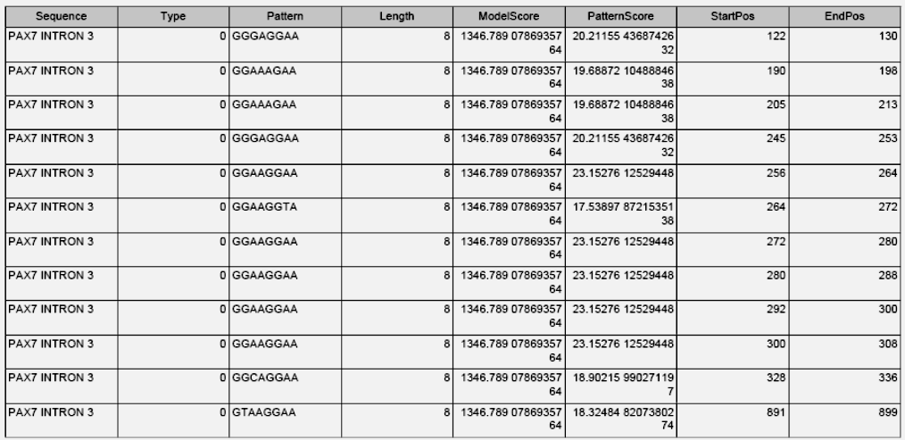
Table 3b: 1 CLC Gene Workbench v.1.0.1. Pattern Discovery Search

Figure 3

Figure 3: Cis regulatory region predicted by CLC Gene Workbench v. 1.0 on forward strand from 190-300bps; Several patterns found within this region.

PAX7 Intron Analysis: Intron 4
PAX7 intron 4 patterns found by Softberry Pattern Search Software: Found 5 pattern(s)
1) Pattern 1, Length = 9, Power: 1, 916bp - 924bp CTTTCTCCC
2) Pattern 2, Length = 10, Power: 1, 948bp - 957bp CCTCTGCTCC
3) Pattern 3, Length = 10, Power: 1, 942bp - 951bp CTCGCTCCTC
4) Pattern 4, Length = 10, Power: 1, 916bp - 925bp CTTTCTCCCA
5) Pattern 5, Length = 10, Power: 1, 946bp - 955bp CTCCTCTGCT

Proscan: Version 1.7:
Processed Sequence: 1002bp. No Cis regulatory regions predicted.
Softberry programs:
0 promoter/enhancer(s) predicted
Promoter 2.0 Prediction Server:
Position (bp) Score Likelihood
- 0.557 Marginal prediction;
CLC Gene Workbench v.1.0.1. Pattern Discovery Search (Table 4a & 4b)
Table 4a: CLC Gene Workbench v.1.0.1. Pattern Discovery Search
Table 3b:CLC Gene Workbench v.1.0.1. Pattern Discovery Search
Figure 4: Cis regulatory region predicted by CLC Gene Workbench v. 1.0 on forward strand from 200-300bps; Patterns found within this promoter region.
Figure 4

PAX7 Intron Analysis: Intron 5
PAX7 intron 5 patterns found by Softberry Pattern Search Software: Found 5 pattern(s)
1) Pattern 1, Length = 10, Power: 1, 5710bp - 5719bp TTTTTTTTTA
2) Pattern 2, Length = 10, Power: 1, 3023bp - 3032bp TATTTTTTTT
3) Pattern 3, Length = 10, Power: 1, 3024bp – 3033bp ATTTTTTTTT
4) Pattern 4, Length = 10, Power: 1, 50527bp – 50536bp TATTATTTTT
5) Pattern 5, Length = 10, Power: 1, 3760bp – 3769bp TATTTATTTT
From the four software programs used, many promoters were predicted (55382 bp).
Proscan: Version 1.7 : 100+ promoters predicted
Softberry TSSG: 23 promoter/enhancer(s) predicted
Promoter 2.0 Prediction Server: 45+ promoters predicted

CLC Gene Workbench v.1.0.1. Pattern Discovery Search (Table 5a & 5b)
Table 5a: CLC Gene Workbench v.1.0.1. Table 5b:CLC Gene Workbench v.1.0.1.
Pattern Discovery Search Pattern Discovery Search
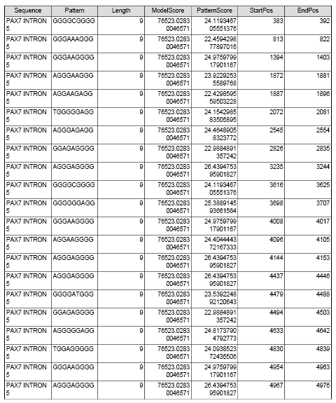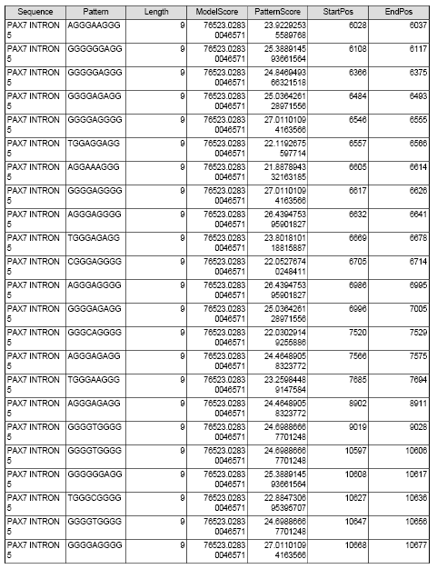
Table 5c: CLC Gene Workbench v.1.0.1. Table 5d: CLC Gene Workbench v.1.0.1.
Discovery Search Pattern Pattern Discovery Search

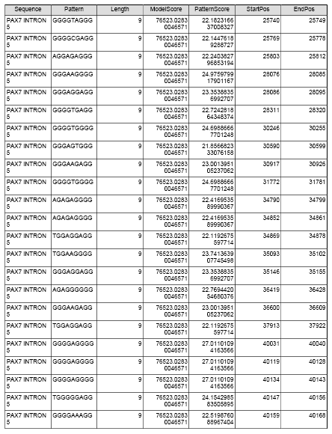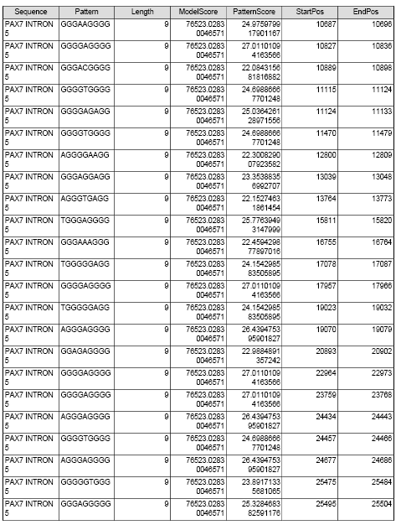
CLC Gene Workbench v.1.0.1. Pattern Discovery Search (Table 5e & 5f)
Figure 5

Figure 5: Cis regulatory region predicted by CLC Gene Workbench v. 1.0 on forward strand from 45000-46000bps; Patterns found within this cis regulatory region.

PAX7 Intron Analysis: Intron 6
PAX7 intron 6: patterns found by Softberry Pattern Search Software: No patterns found

Proscan: Version 1.7
Promoter region predicted on forward strand in 1456 to 1706bps
Promoter region predicted on forward strand in 1791 to 2041bps
Promoter 2.0 Prediction Server:
Position Score Likelihood
1000 1.021 Highly likely prediction
3600 1.084 Highly likely prediction
4000 0.584 Marginal prediction
5400 1.262 Highly likely prediction
6800 0.660 Marginal prediction
7400 0.666 Marginal prediction
Softberry TSSG: 2 promoter/enhancer(s) predicted
Promoter Pos: 893 LDF: TATA box at 863bp AATATATG
Promoter Pos: 5092 LDF: TATA box at 5062bp TATAAATA
Softberry programs:
Promoter Pos: 5092 LDF: TATA box at 5062bp TATAAATA

CLC Gene Workbench v.1.0.1. Pattern Discovery Search ( Table 6)
Table 6:CLC Gene Workbench v.1.0.1. Pattern Discovery Search

Figure 6
Figure 6: Cis regulatory region predicted by CLC Gene Workbench v. 1.0 on forward strand from 5000-5100bps; Pattern found within this cis regulatory region.

PAX7 Intron Analysis: Intron 7
PAX7 intron 7 patterns found by Softberry Pattern Search Software: Found 5 pattern(s)
1) Pattern 1, Length = 10, Power: 1, 1134bp – 1143bp CCCTCCCCCT
2) Pattern 2, Length = 10, Power: 1, 1133bp – 1142bp TCCCTCCCCC
3) Pattern 3, Length = 10, Power: 1, 870bp - 879bp CCCCCCACTC
4) Pattern 4, Length = 10, Power: 1, 2157bp – 2166bp CCTTCCCTCC
5) Pattern 5, Length = 10, Power: 1, 2156bp – 2165bp CCCTTCCCTC

Proscan: Version 1.7 No promoter regions predicted.
Softberry TSSG: 2 promoter/enhancer(s) predicted
Promoter Pos: 1015 LDF: TATA box at 985bp TATAAGAT
Promoter Pos: 333 LDF: TATA box at 304bp TAAAAATC
Promoter 2.0 Prediction Server:
Position Score Likelihood
600 0.670 Marginal prediction
1100 0.648 Marginal prediction
2000 0.661 Marginal prediction
Softberry programs:
Promoter Pos: 333 LDF: TATA box at 304bp TAAAAATC
CLC Gene Workbench v.1.0.1. Pattern Discovery Search (Table 7)
Table 7:CLC Gene Workbench v.1.0.1. Pattern Discovery Search

Figure 6
Figure 7: Cis regulatory region predicted by CLC Gene Workbench v. 1.0 on forward strand from 300 -600bps; Patterns found within this cis regulatory region.

Table 8a:CLC Gene Workbench v.1.0.1. Table 8b: CLC Gene Workbench v.1.0.1.
Pattern Discovery Search Pattern Discovery Search

CLC Gene Workbench v.1.0.1. Pattern Discovery Search (Table 8a & 8b)

PAX7 Intron Analysis: Intron 8
PAX7 intron 8 patterns found by Softberry Pattern Search Software: No patterns found
From the other four software programs used, many cis elements predicted (32335 bps).
Proscan: Version 1.7: Promoter region predicted on forward strand in 2557 to 2807
TATA found at 2792, Est.TSS = 2822
Table 8c:CLC Gene Workbench v.1.0.1. Table 8d:CLC Gene Workbench v.1.0.1.
Pattern Discovery Search Pattern Discovery Search

Softberry TSSG: No promoter regions predicted
Promoter 2.0 Prediction Server: 31 promoters predicted

CLC Gene Workbench v.1.0.1. Pattern Discovery Search (Table 8e)
Table 8e:CLC Gene Workbench v.1.0.1. Pattern Discovery Search

Figure 7
Figure 8: Cis regulatory region predicted by CLC Gene Workbench v. 1.0 on forward strand in 13487 to 13737bps; Patterns found within this cis regulatory region.

Table 9. SUMMARY OF MOST LIKELY CIS REGULATORY SEQUENCES PREDICTED FOR EACH INTRON OF PAX7.
Intron number | Pattern (cis element?) | Length(bp) | Start Position in intron | End Position in intron
PAX7 INTRON 1 | GAGGAGAG | 8 | 1284 | 1292
PAX7 INTRON 3 | GGAAAGAA | 8 | 190 | 198
PAX7 INTRON 4 | GGAAAGAA | 8 | 205 | 213
PAX7 INTRON 5 | AGGGGGAGG | 9 | 46054 | 46063
 | GGGGATGGG | 9 | 46164 | 46173
PAX7 INTRON 6 | AAAACTAAA | 9 | 5092 | 5101
PAX7 INTRON 7 | GTGAGTGCATGAGTGTGTG | 19 | 523 | 542
PAX7 INTRON 8 | CCCCACCC | 8 | 13072 | 13080
 | CCCCTGCC | 8 | 13137 | 13145
 | CTCCACCC | 8 | 13376 | 13384
 | CTCCTCCC | 8 | 13423 | 13431
The results shown in table 9 are the predicted cis-regulatory elements for PAX7 and were chosen from the results of computer scans and based on the four criteria listed above. Table 10 displays the transcription factors most likely to bind to these cis-elements with the exception of the cis-element in intron 5 for which no transcription factor was identified. Transcription factors were identified using the TRANSFAC database. The transcription factors previously identified as being associated with tumourigenesis are indicated in Table 10.

Table 10. SUMMARY OF MOST LIKELY CIS REGULATORY SEQUENCES PREDICTED FOR EACH INTRON OF PAX7 with corresponding transcription factors

Intron Number | Cis element | Binding Transcription factor from Transfactor ***
PAX7 INTRON 1 | GAGGAGAG | EBNA-1;RAR-gamma; R2; Zmhoxla
PAX7 INTRON 3 | GGAAAGAA | NP-TCII; NF-1; GT-IIA
PAX7 INTRON 4 | GGAAAGAA | NP-TCII; NF-1; GT-IIA
PAX7 INTRON 5 | AGGGGGAGG | Six-3: DR1; CACCC-BF; CAC-BF; Sp1; ADR1
PAX7 INTRON 5 | GGGGATGGG | NONE
PAX7 INTRON 6 | AAAACTAAA | SRY; PHO2
PAX7 INTRON 7 | GTGAGTGCATGAGTGTGTG | Zeste; GCN4; Zeste; MEP-1; MBF-I; Sp1; GHF-1; Pit-1a; RAP1/SBF-E/TUF; USF; TEF;TTF-1
PAX7 INTRON 8 | **CCCCACCC | TEF2;MIG1; ACCC-BF; AP-2; CAC-BF; Sp1
PAX7 INTRON 8 | *CCCCTGCC | AP-2; CAC-BF; Ttk;LVc
PAX7 INTRON 8 | **CTCCACCC | CACCC-BF; CAC-BF; Sp1
PAX7 INTRON 8 | *CTCCTCCC | CAC-BF; ADR1; Sp1
*Found in NF1 & PAX3;
** Found in PAX3
***Transcription factors in blue are associated with tumorigenesis. http://www.mdcberlin.de/forschung/schwerpunkte/cancer/rosenbauer.htm
2. Conservation of intron 8 region containing novel cis regulatory region indicating possible functional significance
To ascertain the possible functional significance of the putative cis-elements identified above, sequences surrounding these cis-elements were used to search for conservation of the regulatory region in other cancer related human genes, such as in human PAX3. Comparisons between DNA sequences of PAX3 and PAX7 can be used to determine the relationship between the gene sequences from which functional or regulatory regions can be ascertained which assist with identification of the functions of PAX7 and its role in tumorigenesis.

Figure 8
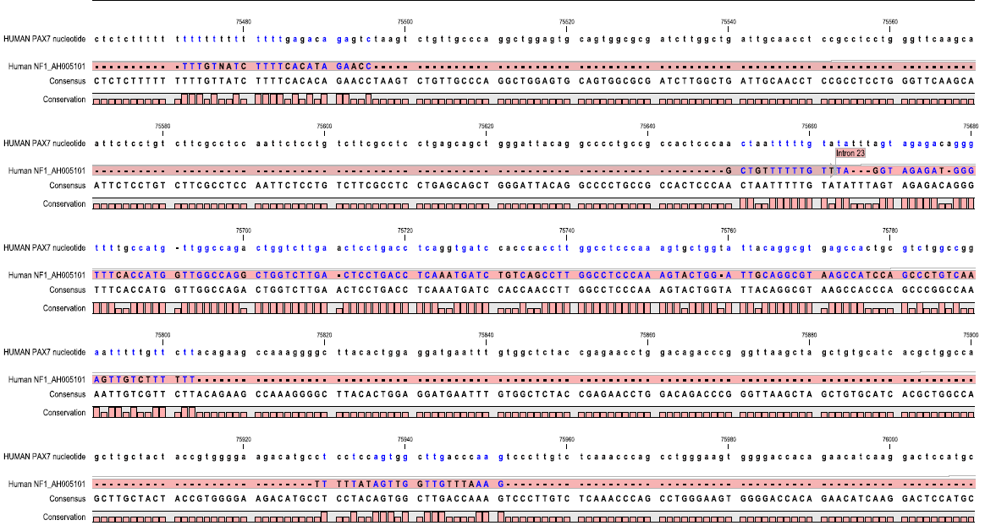

Figure 9: Conserved sequence in intron 8 of PAX7 also found in intron 23 of the human NF1 gene (GenBank Accession Number for NF-1 gene is AH005101). Conserved regions are shown by sequences coloured in blue. The novel cis-element identified in intron 8 of PAX7 is also found in this conserved sequence in intron 10 of PAX3 at nucleotide 71560 .
One cis-element identified in intron 8 was found to be located within a conserved sequence that is also present in alternative intron 10 of human PAX3 as well as within intron 23 of NF1 (sequence length ~100 bps.). The sequence, approximately 155 nucleotides in length is highly conserved between PAX7 and NF-1 (89% conserved) (Figure 9) and between PAX3 and NF1 (72% conserved) (Figure 10).
Figure 9
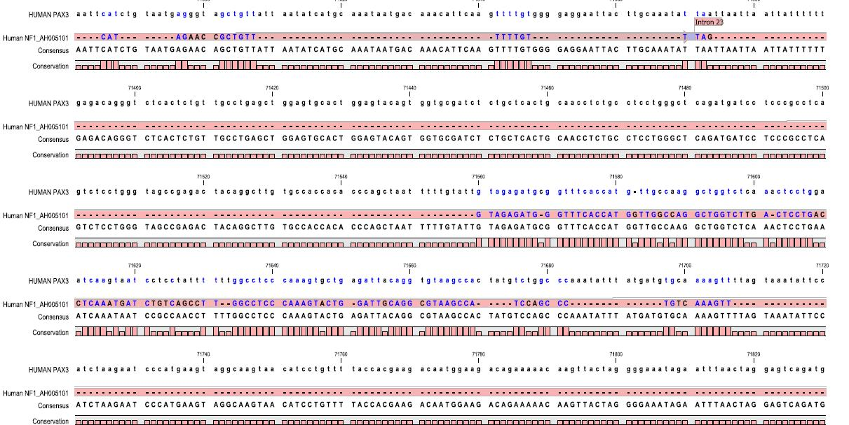

Figure10. Conserved sequence in intron 8 of PAX7 and intron 23 of NF-1 also found in alternative intron 10 of PAX3 (GenBank Accession Number for PAX3 gene is NM_013942 ). Conserved regions are shown by sequences coloured in blue.

DISCUSSION
In this paper we have identified novel cis-elements in intronic regions of human PAX7. We have also identified a conserved intronic region of PAX7 that is present in introns of PAX3 and NF-1. Moreover, the conserved region contains a newly identified PAX7 cis-element and the same cis element occurs in the conserved sequence in all three genes. These findings highlight the ability of in silico methodologies to uncover putative cis regulatory regions. In addition, the sequence alignments performed in this article confirm that patterns of conservation can be useful in identifying regulatory regions.
Cis elements are known to be important in upregulation of genes or in splicing of intronic regions (Pethe et al., 1999; Martin et al., 2004) and therefore crucial in the tumorigenic functions of a gene. The region we have identified in intron 8 of PAX7, also found in intron 23 of NF-1 and alternative intron 10 of PAX3 may contain regulatory functions common to all three genes and it seems probable that transcription factors and/or spliceosomes would act similarly on all three genes.
Recent experiments identify specific sequences in NF-1 as being associated with increased tumorigenicity in the childhood cancer, alveolar rhabdomyosarcoma (Dei Tos, et al., 1997). Similarly, PAX7 and PAX3 are associated with alveolar rhabdomyosarcoma (Sorensen, et al, 2002). The intronic sequence common to all there genes may be implicated in their tumorigenic properties.
The conserved sequence containing the cis regulatory element identified in intron 8 of PAX7, intron 10 of PAX3 and intron 23 of NF-1 may have arisen by insertion of a regulatory element in all three gene regions or by homologous recombination between chromosome 1 (PAX7), chromosome 2 (PAX3) and/or chromosome 17 (NF-1). The significance of this finding is currently being investigated further by in vitro studies.
Only in recent literature has there been a spark to delve into the intronic regions of genomic sequences (Oguzkan, et al, 2006). Historically, introns have been viewed as non-coding, nonsense "place holders" between the exons of a given gene (Bernett et al., 2003; de Roos et al, 2005). It was not until the great race for decoding the human genome that researchers realized that introns constitute a large portion of the regulatory regions of the genome (Davies, 2001; Patrinos, 2001). This can only lead one to believe that the once overlooked introns may play a significant role in regulation of cell functions such as cell cycle control, apoptosis, or aberrant cell cycle control as in tumorigenesis. The research performed in this paper represents a cornerstone in in silico research of gene sequences as it points the way for future bench work studies so that the findings can be verified and validated.
In conclusion, the results presented here may present significant findings that can be utilised ultimately for the development of therapeutics for the treatment of alveolar rhabdomyosarcoma and other cancers associated with PAX7. Furthermore, the methods and findings may have implications for other diseases and other genes. In silico biology is currently used by pharmaceutical companies to facilitate and hasten the development of new therapeutics for many diseases.

Acknowledgment
We would like to thank the Memorial Sloan Kettering Institute DNA Sequencing Core Facility Lab manager and technician (Dr. Diane Tabarini & Ms. Donna Wong, respectively) and Memorial Sloan Kettering Cancer Center’s Diagnostic Molecular Genetics Laboratory Director (Cindy Yee, PhD) and technologists (Mrs. Nilofer Kreonidis, Mr. Ruben Bacares and Ms. Nadia Shaukat) for their support and assistance for the clinical portions of this project. I would also like to extend my deepest gratitude to Mr. Geoffrey Jackson, of the Centers for Disease Control & Prevention (CDC) who provided the much needed equipment for this project.

Correspondence to:
Maika G. Blackman-Mitchell
Memorial Sloan Kettering Cancer Center
Rockefeller Research Laboratories
430 East 67th Street
4th Floor, Room 453
New York City, New York 10021, USA
Email: blackmam@mskcc.org

REFERENCES
- Glaser, T., Jepeal, L., Edwards, J. G., Young, S. R., Favor, J., and Maas, R. L. (1994). "PAX6 gene dosage effect in a family with congenital cataracts, aniridia, anophthalmia and central nervous system defects." Nat. Genet 7:463-471.
- Relaix, F., Rocancourt, D. et al. (2004). "Divergent functions of murine Pax3 and Pax7 in limb muscle development." Genes Dev. 18(9): 1088-1105.
- Chi, N., Epstein J.A. (2002). "Getting your Pax straight: Pax proteins in development and disease." Trends Genet. 18(1): 41-7.
- Barr, F. G., Fitzgerald, J. C. et al. (1999). "Predominant Expression of Alternative PAX3 and PAX7 Forms in Myogenic and Neural Tumor Cell Lines." Cancer Res. 59(21): 5443-5448.
- Mercado, G. E., Barr, F.G. (2005). "Looking Downstream of Sarcoma-Associated Chimeric Transcription Factors: When is a Target Really a Target?" Cancer Biol. Ther. 4(4): 456-8.
- Macina R. A., Barr F. G., Galili N., Riethman H. C. (1995). Genomic organization of the human PAX3 gene: DNA sequence analysis of the region disrupted in alveolar rhabdomyosarcoma. Genomics, 26: 1-8.
- Goulding M. D., Chalepakis G., Deutsch U., Erselius J. R., Gruss P.( 1991) Pax-3, a novel murine DNA binding protein expressed during early neurogenesis. EMBO J., 10: 1135-1147.
- Bennicelli J. L., Guerry D. I. (1993). Production of multiple cytokines by cultured human melanomas. Exp. Dermatol., 2: 186-190.
- Schulte T. W., Toretsky J. A., Ress E., Helman L., Neckers L. M. (1997) Expression of PAX3 in Ewing’s sarcoma family of tumors. Biochem. Mol. Med., 60: 121-126.
- Hadjistilianou T, Mastrangelo D, Gragnoli A, Capretti MC, De Francesco S, Galluzzi P. (2002) Letter to the editor: neurofibromatosis type 1 (NF 1) associated with embryonal rhabdomyosarcoma of the orbit. Med Pediatr Oncol.. 38. 6:449.
- Dei Tos AP, Dal Cin P. (1997) The role of cytogenetics in the classification of soft tissue tumours.
Virchows Arch. 431(2):83-94.
- Woodruff JM, Christensen WN. Glandular peripheral nerve sheath tumors. Cancer. (1993). 72. 12:3618-28
- Oguzkan, et al., (2006) Two neurofibromatosis type 1 cases associated with Rhabdomyosarcoma of bladder, one with a large deletion in the NF1 gene., Cancer Genetics and Cytogenetics 164, 159–163
- Park, Ben Ho and Vogelstein, Bert (2003) Cancer Medicine Volume 6. BC Decker Inc. Hamilton, London
- Lewin, Benjamin Genes VII. (2000). Oxford University Press
- Robson, Ewan J. D., He, Shu-Jie, (2006)A Panorama of PAX Genes in Cancer and Development., Nat Rev Cancer. 6(1):52-62
- Frith, et al.,(2004) Spouge3 and Zhiping Weng Finding functional sequence elements by multiple local alignment Nucleic Acids Research, , Vol. 32, No. 1 189±200
- Liu,J.S., Neuwald,A.F. and Lawrence,C.E. (1995) Bayesian models for multiple local sequence alignment and Gibbs sampling strategies. J. Am. Stat. Assoc., 90, 1156±1170.
- Chen, Jianjun, Sun, Miao, Rowley, Janet D, Hurst, Laurence D, (2005)The small introns of antisense genes are better explained by selection for rapid transcription than by ‘genomic design’, Genetics, 171(4):2151-5.
- Martin, Natalia, Patel, Satyakam, Segre, Julia (2004) A. Long-range comparison of human and mouse Sprr loci to identify conserved noncoding sequences involved in coordinate regulation. Genome Res. 14: 2430-2438
- Vaiju Pethe, and P. V. Malathy Shekhar (1999). Estrogen Inducibility of c-Ha-ras Transcription in Breast Cancer Cells. Identification of Functional Estrogen-Responsive Transcriptional Regulatory Elements in Exon 1/Intron 1 of the c-Ha-ras Gene. J. Biol. Chem. 274: 30969-30978.
- Dei Tos AP, Dal Cin P. (1997). The role of cytogenetics in the classification of soft tissue tumours. Virchows Arch. Aug;431(2):83-94. Review
- Sorensen, Poul H.B., Lynch, James C., Qualman, Stephen J., Tirabosco, Roberto, Lim, Jerian F., Maurer, Harold M., Bridge, Julia A., Crist, William M., Triche, Timothy J., Barr, Frederic G. (2002). PAX3-FKHR and PAX7-FKHR Gene Fusions Are Prognostic Indicators in Alveolar Rhabdomyosarcoma: A Report From the Children's Oncology Group J Clin Oncol . 20: 2672-2679
- Albert D. G. de Roos. (2005) Origins of introns based on the definition of exon modules and their conserved interfaces Bioinformatics Advance Access, DOI 10.1093/bioinformatics/bth475.Bioinformatics 21: 2-9.
- Bernett T. K. Lee, Tin Wee Tan, and Shoba Ranganathan (2003) MG AlignIt: a web service for the alignment of mRNA/EST and genomic sequences. Nucleic Acids Res.; 31(13): 3533–3536.
- Ari Patrinos. (2001). Initial sequencing and analysis of the human genome. The Genome International Sequencing Consortium."Nature 409, 860-921.
- Kevin Davies., (2001) Cracking The Genome: Inside The Race To Unlock Human DNA. Free Press, A division of Simon & Schuster, Inc.

