A contribution on myxosoma Infection in Cultured Oreochromis niloticus in Lower Egypt

A. E. Eissa^{1*}, I.M.K. Abu Mourad², T. Borhan²

¹ Department of Fish Diseases and Management, Faculty of Veterinary Medicine, Cairo University, Giza, Egypt, aeissa2005@gmail.com

² Department of Hydrobiology, National Research Centre, Dokki, Egypt

Abstract：Heavy infection with myxosoma spp. has been recorded among cultured Oreochromis niloticus from Sharkiya governorate at Lower Egypt. Prevalence of the infection exceeded 80 % of all examined fish. Head cysts and hole in the head like lesions have been recorded among all examined fish. The causative agent “myxosoma” has been identified using classical taxonomical and histopathological techniques. The genetic non-relatedness of the salmonid Myxosoma cerebralis to the African cichlid myxosoma spp has been confirmed using a polymerase chain reaction (PCR) involving a specific primer of the gene encoding 18-S ribosomal RNA of M. cerebralis. [Nature and Science. 2006;4(4):40-46].

KEYWORDS: Oreochromis niloticus, Myxosoma, Lower Egypt, Molecular Identification

Introduction
Myxosoma spp. is the best known of 1300 parasites grouped in the phylum Myxozoa and the first shown to possess a 2 host life cycle including fish and an aquatic oligochaete, Tubifex tubifex (Markiw & Wolf 1983, Wolf & Markiw 1984, Wolf et al. 1986). Myxosporean research in Africa dates back to the late 19th century with Gurley (1893) as one of the earliest authors referring to the continent. The African continent boasts over a 100 myxosporean species from freshwater, brackish and marine fishes of which 84 infect primarily freshwater fishes (Fomena and Bouix 1997) and this number is continuously growing. When comparing the known African myxosporeans to the more than 1,300 species described worldwide, it is evident that for a huge continent with such high fish diversity, a large gap exists in the knowledge on the occurrence and distribution of these parasites.
El-Mansy (2005) revised the taxonomy of myxosporean species, using specimens isolated from plasmodia situated in the infected cornea of Oreochromis aureus, O. niloticus or Tilapia zillii inhabiting the River Nile, Egypt. In addition, he described the histological effects of the parasite on the infected tissues. He also indicated that the spores of Myxobolus heterosporus had a variety of shapes expressing remarkable heteromorphism. He also, reported the presence of five main myxobolus like spore types and tailed-spores. In the same study, El-Mansy (2005) also indicated that light and electron microscopy supported that spores of a myxobolus-like morphology coexisted with so-called tailed-spores in one plasmodium and some transitional stages from myxobolus-like spore types to tailed-spores were observed. Therefore, he concluded that some tailed-spores may be simply heteromorphs of myxobolus.
Numerous species of myxosoma (formerly known as myxobolus) have been reported among different African tilapia species within the last few decades. Among these myxosporean species , the Myxobolus Bütschli, 1882 species from tilapia of the Okavango River and Delta, Myxobolus africanus Fomena, Bouix and Birgi, 1985 from the gills and fins of Hepsetus odoe (Bloch, 1794), Myxobolus camerounensis Fomena, Marqués and Bouix, 1993 from the gill arch of Oreochromis andersonii (Castelnau, 1861), Myxobolus hydrocyni Kostoïngue and Toguebaye, 1994 from the gills of Hydrocynus vittatus Castelnau, 1861, Myxobolus nyongana (Fomena, Bouix and Birgi, 1985) from the gills of Barbus poechii Steindachner, 1911, Myxobolus cf. tilapiae Abolarin, 1974 from the buccal cavity of Tilapia rendalli rendalli (Boulenger, 1896), Myxobolus etsatsaensis sp. n. from the gills of Barbus thamalakanensis Fowler, 1935, Myxobolus paludinosus sp. n. from the gills of Barbus paludinosus Peters, 1852. There are currently 11 myxobolus species parasitizing cichlids in Africa (Baker 1963, Abolarin 1974, Landsberg 1985, Faisal and Shalaby 1987, Sakiti et al. 1991, Fomena et al. 1993).
Despite the presence of numerous reports on the myxosporean affecting African cichlids as well as non cichlid fishes such as salmonid fishes worldwide, none of this reports described the pathological lesions as well as molecular work reported in the current study. The current study also presents a unique variety of diagnostic approaches used for the diagnosis of myxosoma infection in O. niloticus.

Materials and Methods
Fish
In the midsummer of 2006, 100 Oreochromis niloticus (average size 50 gm) were collected from an earthen pond at Abbasa Fish Farm, Sharkiya Governorate, Lower Egypt and brought alive to the Fish Diseases and Management Laboratory (FDML) at Faculty of Veterinary Medicine, Cairo University. Tilapias were kept in well-aerated, temperature adjusted water aquaria until examined.

Sampling and Sample processing.
Tilapias were euthanized with an overdose of MS 222 (Tricaine methane sulfonate, Finquel- Argent Chemical Laboratories, Washington) and visually inspected for any abnormalities before examination is adopted. Lesions were photographed and documented using Sony digital camera (Japan).
Skin, gill scraps were performed on all examined fish and photos for the plasmodial stage of the myxosoma spp. were taken and sketched then used for taxonomical identification of the myxosoma spp. Also, eyes of the fish were examined for the presence of any myxosporean spores within both cornea and lens. Further, the fish were cut open using the standard triangular dissection technique then impression smears from different organs including liver, spleen, kidneys, gall bladder were made. Stomach and intestinal scraps were also made from the examined fish. All samples were freshly examined using regular light microscope as well as dissecting microscope. Some samples required special staining using Giemsa stain.
Sections from the head cysts, head cartilages, eyes, gills, brain, liver, spleen, kidneys, intestine and gonads were stored in 10 % neutral formalin and sent for histopathology. Histopathology was performed on 1-5 μm sections of the above mentioned organs and stained with hematoxylin and eosin (H&E) and or special stain (Giemsa stain). Method and criteria used for histopathological examination was adopted from Baldwin et al. 2000.
Samples from the head cysts, head muscles, kidneys were collected into microfuge tubes and stored in -30 for PCR testing. The following method was adopted for DNA extraction: A total of 500 μl of phenol: chloroform: isoamyl alcohol (25:24:1) was added to each lysed myxospore preparation, and each preparation gently inverted several times to form an emulsion. The organic phase was separated from the aqueous phase by centrifugation at 1700 × g for 10 min at room temperature. The upper aqueous phase, containing DNA, was transferred to a new micro-centrifuge tube and an additional 500 μl of phenol: chloroform: isoamyl alcohol added. The solutions were mixed and centrifuged as before. The aqueous phase was again transferred to a new micro-centrifuge tube, 500 μl chloroform added, and the solutions mixed and centrifuged as before. The DNA was precipitated by adding 800 μl of ice-cold ethanol and incubating at –20°C for 1 h, followed by centrifugation at 12 000 × g for 10 min at 4°C. The supernatant was discarded and the DNA pellet permitted to air dry. The pellet was re-suspended in 50 μl of TE buffer (10 mM Tris, 0.1 mM EDTA, pH 8.0) and held overnight at room temperature. Samples were warmed to 65°C for 1 h to ensure solubilization and subsequently allowed to return to room temperature prior to use in the PCR reaction.
Primers used were adopted from that published by Andree et al. (1998) as (5’- GCATTGGTTTACGCTGATGTAGCGA- 3’) and (5’-GGCACACTACTCCAACACTGAATTTG- 3’). The standard reaction volume was 50 μl (45 μl of master mix and 5 μl of DNA template). The PCR master mix was comprised of PCR buffer (300 mM Tris, 75 mM ammonium sulfate, pH 9.0), 2.5 mM MgCl, 400 μM dNTPs, 20 pmol of each primer, and 2 U μl–1 taq DNA polymerase (Fisher Scientific). All reagents were stored at –20°C and kept on ice after thawing. Taq polymerase was the last reagent added. Amplifications were performed using a thermal cycler (Bio-Rad Laboratories, Hercules, CA, USA). A denaturation step in which samples were held at 95°C for 5 min took place before amplification cycles began. One complete cycle consisted of 1 min at 95°C, followed by 2.5 min at 65°C, followed by 1.5 min at 72°C. This cycle was repeated 35 times, after which an extended elongation step of 10 min at 72°C concluded the program. When necessary, amplified DNA samples were stored at 4°C.

Results & Discussion
Clinical examination of the examined tilapia revealed the presence of number of clinical abnormalities including, frontal head cysts (Figure1& 2) which usually progress to hole in the head in most of cases (Figure 3), skin erosions, fin rot, and corneal opacity. A relatively small % of the examined fish (5 %) revealed the presence of ring of cysts that surrounded the iris of the eye (Figure 4). Wet mount, Methylene blue and Giemsa stained slides examination of the affected eyes revealed the presence of high number of plasmodial stages of myxosoma spp. within each cyst. Such myxosoma spp. was sketched and further identified as M. heterosporus (Baker, 1963) according the recent revision published by El-Mansy (2005). However, there is a very close similarity between the plasmodial stage of the identified M. heterosporus and that of M. tilapiae. The polar capsules of M. heterosporus are, however, more pyriform, compared with the more spherical polar capsules of M. tilapiae. Histologically, H& E stained sections made from the corneal tissues of the eye revealed the presence of large number of the M. heterosporus plasmodial stages associated with localized inflammatory changes and mononuclear cell infiltration (Figure 5).
Clinical examination also revealed that over 80 % of the examined fish were associated with head cysts that usually proceed to hole in the head like lesion. Giemsa stained as well as non stained scraps made from these lesions together with impression smears made from muscles sections of the head cysts revealed the presence of the same type of myxosoma spp plasmodial spores (Figure 7) that presumptively identified as M. tilapiae with spore body oblong to oval with anterior and posterior ends bluntly rounded, 14.0-15.5 (15.0 ± 0.39) μm in length. Widest region of spore observed towards centre of spore body, 12.0-12.6 (12.3 ± 0.27) μm in width. Two almost spherical to pyriform polar capsules of equal size situated in anterior part of spore. Polar filaments have four to six coils within polar capsules. Interestingly another spp of myxosoma has been detected in impression smears made from kidneys and intestine of the affected fish (Figure 8). The vegetative sporogenic stage is relatively similar to that of M. etsatsaensis and Myxobolus sp. described by Obiekezie and Okaeme (1990) from the kidneys and spleen of various cichlid species.
An alternative to histologic examination a polymerase chain reaction (PCR) amplification of a DNA sequence unique to Myxobolus cerebralis (Andree et al. (1998) have been performed on the DNA extracts from the muscle sections from the head cysts, heavily infested eyes, and kidneys. Unfortunately, the characteristic 415 bp amplicon of the gene encoding 18S ribosomal RNA of M. cerebralis was not detected in any of the tested DNA extracts of the above mentioned tissues.
The results came in this study, was in full accordance with that of other myxosporean studies which previously described in details the taxonomy of numerous species of myxosoma (formerly myxobolus) affecting African cichlids. However, the unique aspect of this study is tightly associated to the great linkage between rarely recorded pathological finding associated with myxosporean invasion in Oreochromis niloticus as well as the usage of new techniques such as molecular tools utilized to confirm the classical taxonomical methods.
The high prevalence (more than 80 %) of myxosporean infection among the examined fish highly suggests that such infection is endemic in the ponds used for rearing of these fish. This suggests that the tubificid oligocheat worm which act as an IMH for the myxosoma spp is highly distributed in an active manner within the mud of such earthen ponds and that’s why more than one spp of myxosoma have been reported in this study. The presence of myxosporean plasmodial stages within external as well as internal organs as kidneys and intestine strengthen the same conclusion.
The myxosporean Myxosoma heterosporous detected in the cornea of 5 % of the affected fish and its associated histological changes were similar to those of the infected cornea of O. aureaus, O. niloticus and T. zilli described by El-Mansy (2005).
The more vigorous picture was the development of head cysts in the frontal and occipital areas in the affected tilapia. Such cysts were highly populated with large number of myxsporean Myxosoma tilapiae and or M. heterosporus. These cysts ultimately ruptured leaving a hole in the head like lesion in the frontal aspect of the head. The pathological sequence of such myxosporean invasion highly recommend the assumption that myxosporean parasites secretes certain kinds of proteolytic enzymes that liquefy the infected tissue and enables quick increase of the spores in each affected head cyst . The proteolytic enzymes might include some enzymes that digest the cement material between the connective tissue, skin, and other tissues. Thus a hole in the head like lesion is the ultimate fate of such myxosporean invasion has developed.
The measures of the myxosoma spp. reported in the current study coincides with those of M. tilapiae, M. heterosporus reported by Reed et al. (2002) and El- Mansy et al. 2005. While those detected in the kidneys, intestine were in accordance with that of M. etsatsaensis and Myxobolus sp. described by Obiekezie and Okaeme (1990) from the kidneys and spleen of various cichlid species.
Myxosoma cerebralis specific PCR has been used to detect the gene encoding for M. cerebralis 18 S ribosomal RNA within the DNA extracts of affected tilapia tissues. The aim was to confirm the specificity of such test to identify the myxosporean parasite to the species level and confirm close relatedness of M. cerebralis of salmonids to their closely related cichlid spp as those reported in this study. Unfortunately, the specific 415bp band was not obtained with any of the above tested tissues of O. niloticus which suggests two main facts. First, the cichlid myxosporean are genetically different from those of salmonids. Second, in vivo expression of the cichlid myxsporean genes are majorly different from that of salmonids.
In conclusion, this study is a unique mixture between classical and recent diagnostic tools through which prevalence and severity of myxosoma infection have been clearly presented and discussed. This study can be the first bead in the chain of new diagnostic approach for the myxosporean parasites affecting African cichlids.

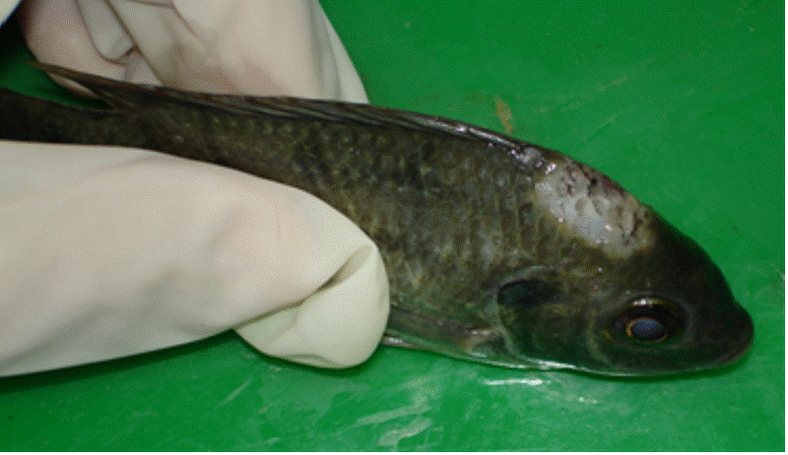
Figure 1. Oreochromis niloticus with frontal head cyst (Myxospoearn vegetative plasmodial stages were isolated from the cyst scrap).

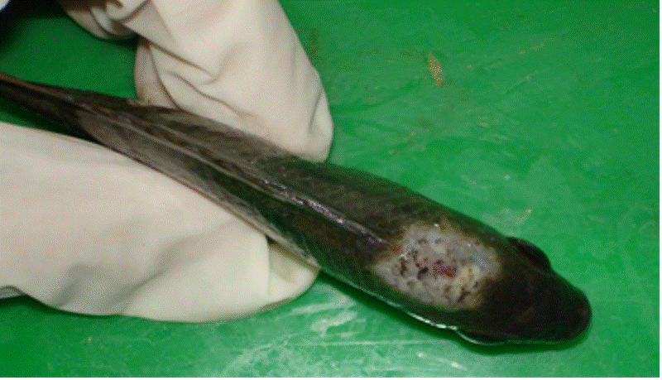
Figure 2. Oreochromis niloticus with more severe frontal head cyst (notice the progression of the lesion).

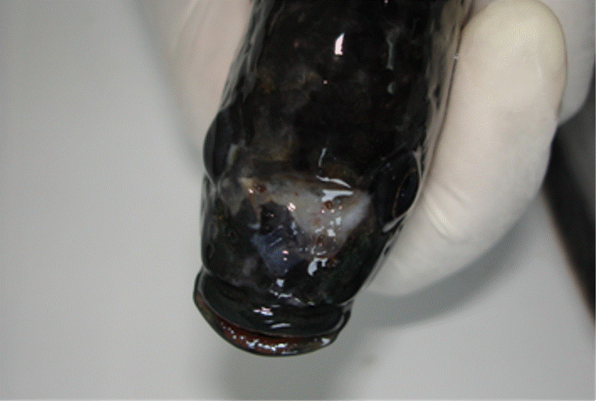
Figure 3. Oreochromis niloticus showing a ruptured head cyst leaving a hole in the head like lesion. M. tilapiae and M. heterosporus were isolated from the infection site.

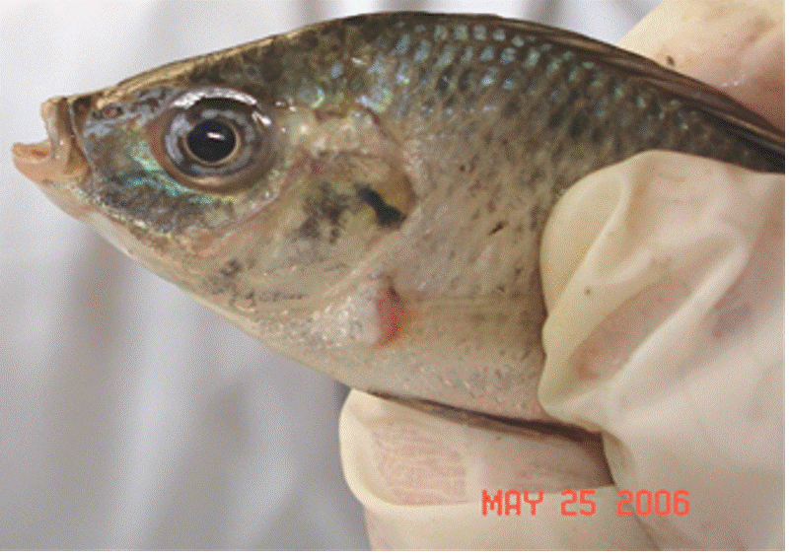
Figure 4 Oreochromis niloticus with a corneal myxosporean cyst ring surrounding the iris.

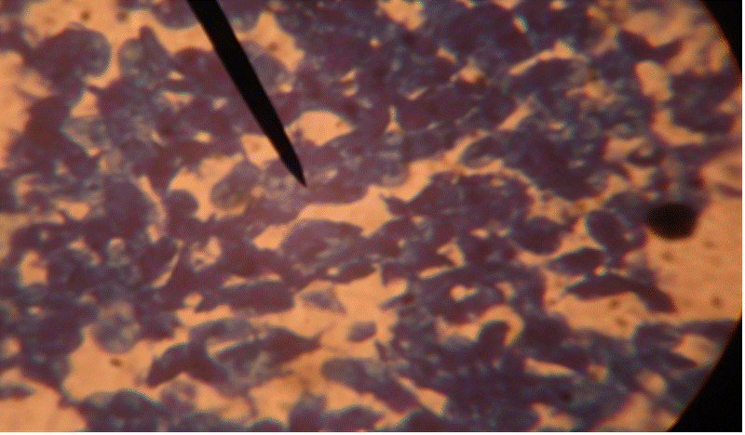
Figure 5. A Giemsa stained histopathological section of the eye (Cornea) showing heavy infiltration of the tissue with deeply stained myxosporean vegetative plasmodial stages.

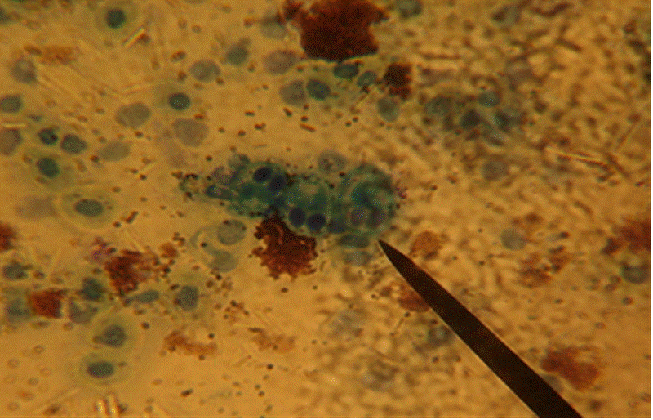

Figure 6. A Giemsa stained wet mount from the corneal cysts showing M. heterosporus plasmodial vegetative spores.

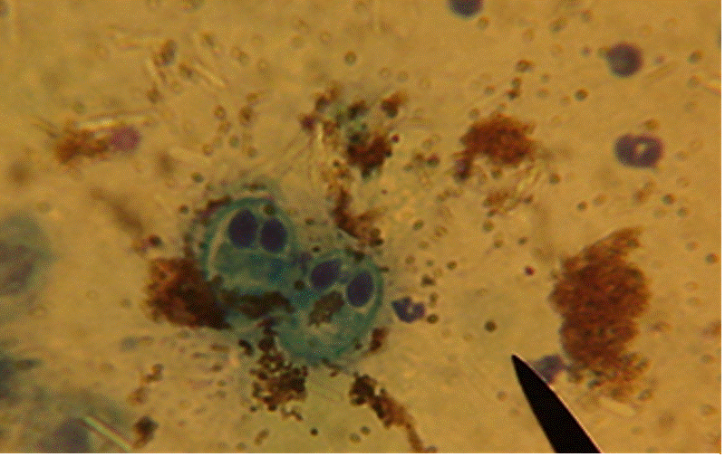

Figure 7. Vegetative plasmodial spore of M. tilapiae in Giemsa stained wet mount from the head cyst.

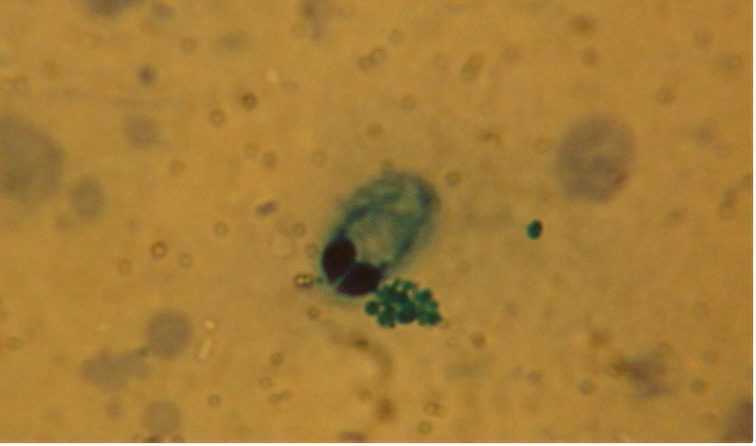

Figure 8. A Giemsa stained wet mount from the intestinal scrap showing deeply stained plasmodial vegetative stage of a myxosoma.

Acknowledgments
We are grateful to the CLAR as well as Abbassa fish farm for providing us with fish used in this study. We are also thankful to Dr. Mohamed Sayed Marzouk the head of Fish Diseases and Management, Faculty of Veterinary Medicine, for giving us the permission to use the aquaria and space at the FDM lab at the Department of FDM, Faculty of Vet Med, Cairo University.

Corresponding to:
A. E. Eissa
Department of Fish Diseases and Management
Faculty of Veterinary Medicine
Cairo University
Giza, Egypt
aeissa2005@gmail.com

Received: 11/20/06

References
- Abolarin, M.O. (1974): Myxobolus tilapiae sp. nov. (Protozoa: Myxosporida) from three species of freshwater tilapia in Nigeria. J. West Afr. Sci. Assoc. 19: 109-114.
- Andree, K.B., MacConnell, E. and Hedrick, R.P. (1998): A nested polymerase chain reaction for the detection of genomic DNA of Myxobolus cerebralis in rainbow trout Oncorhynchus mykiss. J Aquat Anim Health 34:145–154
- Baldwin, T.J., Vincent, E.R., Silflow, R.M. and Stanek, D. (2000): Myxobolus cerebralis infection in rainbow trout (Oncorhynchus mykiss) and brown trout (Salmo trutta) exposed under natural stream conditions. J Veterin Diagn Invest 12:312–321
- Baker, J.R. (1963): Three new species of Myxosoma (Protozoa: Myxosporidia) from East African freshwater fish. Parasitology 53: 285-292.
- Boulenger, G.A. (1911): Parental care in an African fish. The Field 118: 968.
- El-Mansy, A. (2005): Revision of Myxobolus heterosporus Baker, 1963 (syn. Myxosoma heterspora) (Myxozoa: Myxosporea) in African Records. Dis Aquat Organ. 63:205-14
- Faisal, M. and Shalaby, S.I. (1987): Myxosoma tilapiae as a new species (Myxosoma: Myxosporea) in wild Oreochromis niloticus in Lower Egypt. Egypt. J. Vet. Sci. 24: 73-86.
- Fomena, A. and Bouix, G. (1994): New Myxosporidea species (Myxozoa) from freshwater teleosts in southern Cameroon (Central Africa). J. Afr. Zool. 108: 481-491.
- Fomena, A. and Bouix, G. (1997): Myxosporea (Protozoa: Myxozoa) of the freshwater fishes in Africa: keys to the genera and species. Syst. Parasitol. 37: 161-178.
- Fomena, A., Bouix, G. and Birgi, É. (1985): Contribution à l’étude des Myxosporidies des poissons d’eau du Cameroun II. Espèces nouvelles du genre Myxobolus Bütschli, 1882. Bull. Inst. Fond. Afr. Noire 46: 167-192.
- Fomena, A., Marques, A. and Bouix, G. (1993): Myxosporidea (Myxozoa) of Oreochromis niloticus (Linnaeus 1757) (Teleost: Cichlidae) in fish farming pools at Melen (Yaounde)
- Kostoingue, B. and Toguebaye, B.S. (1994): Le genre Myxobolus (Myxozoa, Myxosporea) chez poissons d’eau douce du Tchad avec la description de trois nouvelles espèces. Bull. Inst. Fond. Afr. Noire 47: 63-71.
- Landsperg, J.H. (1985): Myxosporean infections in cultured Tilapias in Israel. J. Protozool. 32: 194-201.
- Markiw ME, Wolf K (1983): Myxosoma cerebralis (Myxozoa: Myxosporea) etiologic agent of salmonid whirling disease requires tubificid oligochaetes (Annelida: Oligochaetes) in its life cycle. J Protozool 30:561–564
- Obiekezie, A.I. and Okaeme, A.N. (1990): Myxosporea (Protozoa) infections of cultured Tilapias in Nigeria. J. Afr. Zool. 104: 77-91.
- Reed, C. C., Basson, L., and Van As, L.L (2002): Myxobolus species (Myxozoa), parasites of fishes in the Okavango River and Delta, Botswana, including descriptions of two new species. FOLIA PARASITOLOGICA 49: 81-88
- Sakiti, N., Blanc E., Marques, A. and Bouix, G. (1991): Myxosporidies (Myxozoa: Myxosporea) du genre Myxobolus Bütschli, 1882 parasites de poissons Cichlidae du lac Nokoué au Bénin (Afrique de l’Ouest). J. Afr. Zool.105: 173-186.
- Urley, R. R. (1893): On the classification of the Myxosporidia,a group of protozoan parasites infesting fishes. Bull. U.S. Fish. Comm. 11: 407-431.
- Wolf, K. and Markiw, M.E. (1984): Biology contravenes taxonomy in the Myxozoa: new discoveries show alternation of invertebrate and vertebrate hosts. Science 225:1449–1452.
- Wolf K., Markiw, M.E. and Hiltunen, J.K. (1986): Salmonid whirling disease: Tubifex tubifex (Muller) identified as the essential oligochaete in the protozoan life cycle. J Fish Dis 9:83–85.

