Study on the Genetic Transformation of Gentian by Gene Recombinant

Yan Yu Qing, Wang Yang, Xu Shu Hong, Xu Xiang Ling*

Biology Department, Harbin Normal University, Harbin, Heilongjiang, China, yanyq66@hotmail.com

Abstract：Transformation recombinant vector pMHL7133-Gus linked with rol gene which be cloned from Agrobacterium Rhizogenes R1000 through Agrobacterium tumefaciens LBA4404 into explant of gentian lamina, inducing rol gene express and producing hair root. Meanwhile, using the Agrobacterium Rhizogenes R1000 infect gentian directly as a comparison, we built two sets of transform system of Agrobacterium for hairy root through researching on all kinds of factors deeply and optimizing transform condition. As a result, the production rate of induced hairy root using Ti plasmid to mediated recombinant vector transforming Gentian is better than the hairy root mediated by Ri plasmid. [Nature and Science. 2006;4(4):60-67].

Keywords: gentian; Agrobacterium Rhizogenes; Agrobacterium tumefaciens; hairy root

1. Material and Method
1.1 Material
The seeds of gentian are processed by 0.25% gibberellin for 24 hours, and then wash them 3-5 times. Washing the seeds with the 70% alcohol and sterile water 3-4 times, and disinfect the seeds with 2% NaCIO for 15-20 mins. Washing them with sterile water 4-5 times, and inoculate on the MS culture medium in 25±2℃, 2000-2500 Lux light intensity, 16 h light period, and 8h dark condition for about 40 days. It can be used to transform when it grows to about 0.5-1 cm².

1.2 Activation of Agrobacterium
Pick single colony of Agrobacterium tumefaciens LBA4404 (with PMHL7133—rol plasmid) and Agrobacterium Rhizogenes R1000, inoculated respectively in a LB liquid medium with rifampicin (rif 50 mg/L) and kanamycin (the km 50 mgs/L) ,and the YEB culture medium with streptomycin (the smr 50 mgs/L) in 28 ℃ cultivations stay overnight.
Take out 1 ml seed liquid inoculated in the 100 ml LB and the YEB liquid medium respectively, the 150-180 rpms/mim amplification cultivation, till the mold liquid logarithmic phase (OD 600=0.4-0.6), centrifuge in 4000rpm/min 10min, leave up pure, and dilute to OD₆₀₀=0.05～0.2 with the MS liquid medium, used for a plant genetic transformation.

1.3 The induction of gentian hairy root
Shear the gentian euphylla with the ophthalmic scissors under the asepsis condition carefully, cultivated in the culture medium 0 h-48 h, then take out to soak into Agrobacterium tumefaciens liquid with different concentration 3min-6min, use the asepsis filter paper sucks away surplus the mold liquid, place on the co-culture medium 25±2℃ to cultivate for 24 h-60 h darkly. Flush the explants using the asepsis water 3-5 times, then soak them into the MS liquid medium which has 500 mg/L cef but without hormone for 10-15min, fluttering often and lightly. Flush with the asepsis water again after take out, transfer to the solid MS medium contains 300 mg/lcef (LBA4404) and 500 mg/l （R1000）cef without hormone to induce the hairy root under 25±2℃, 16 h light period, and 8h dark condition. Compare with the uninfected gentian.
In order to optimize the transform condition and exalt the transform efficiency, we made an L₁₆（4⁵）orthogonal experiment on four cardinal factors of the genetic transformation in two different species of Agrobacterium Rhizogenes. Put the hairy root induction rate that combine three duplication experiments output by each experiment as the evaluate index.

Table 2-5. Factors and levels of orthogonal experiment design L₁₆（4⁵）
Level Factor

advance cultivation time（h） concentrationOD₆₀₀ induce time（min） co-culture time（h）
A B C D
1 0h 0.05 3min 24h
2 24h 0.1 4min 36h
3 36h 0.15 5min 48h
4 48h 0.2 6min 60h

1.4 The amplification of gentian hairy root
Infected euphylla of Agrobacterium can outgrow hairy root at the petiole and the wound edge, and grow fast in the first 6 day, about 1-1.5 cm. When it grows to about 3cm, take the hairy root of the growth haleness, inoculate in the 1/2 MS solid medium, 25℃s cultivated darkly. Every 5-7 days subculture for once. 3 times after subculture, cultivated in the 1/2 MS liquid medium, each one puts one root. Observing growth circumstance after 20 days.

1.5 PCRs examine on transformed plants
Extract plant total DNA by using the method CTAB. Take 1 ul DNA as the PCR template, take the both ends sequence of the rol gene of the induction hairy root as a primer, carry on the PCR amplification. Meanwhile, check against by taking the plasmid DNA as positive compare and take uninfected hairy root DNA as negative compare.

2. Result
2.1 The study on main factors of the transform efficiency
We made an L₁₆（4⁵）orthogonal experiment on four cardinal factors of the genetic transformation. After 20 days, statistics the induction frequency of hairy root. Put the hairy root induction rate that combine three duplication experiments output by each experiment as the evaluate index.
The hairy root induction rate=the explants number of the creation hairy root/total explants number.

Table 2. Factors and levels of orthogonal experiment design L₁₆（4⁵）
Number | A | B | C | D | E | Induction rate %
1 | A1 | B1 | C1 | D1 | E1 | 34 27
2 | A1 | B2 | C2 | D2 | E2 | 28 17
3 | A1 | B3 | C3 | D3 | E3 | 8 4
4 | A1 | B4 | C4 | D4 | E4 | 0 0
5 | A2 | B1 | C2 | D3 | E4 | 44 30
6 | A2 | B2 | C1 | D4 | E3 | 26 15
7 | A2 | B3 | C4 | D1 | E2 | 12 7
8 | A2 | B4 | C3 | D2 | E1 | 4 0
9 | A3 | B1 | C3 | D4 | E2 | 22 12
10 | A3 | B2 | C4 | D3 | E1 | 38 21
11 | A3 | B3 | C1 | D2 | E4 | 17 11
12 | A3 | B4 | C2 | D1 | E3 | 7 4
13 | A4 | B1 | C4 | D2 | E3 | 60 35
14 | A4 | B2 | C3 | D1 | E4 | 51 38
15 | A4 | B3 | C2 | D4 | E1 | 10 6
16 | A4 | B4 | C1 | D3 | E2 | 6 0
（Ti）  T1  T2  T3  T4  X1  X2  X3  X4  R  （Ri）  T1  T2  T3  T4  X1  X2  X3  X4  R | 70  86  84  127  17.5  21.5  21  31.75  14.25  48  52  48  79  12  13  12  19.75  7.75 | 160  143  47  17  40  35.75  11.75  4.25  35.75  104  91  28  4  26  22.75  7  1  25 | 83  89  85  110  20.75  22.25  21.25  27.5  6.75  53  57  54  63  13.25  14.25  13.5  15.75  2.5 | 104  109  96  58  26  27.25  24  14.5  12.75  76  63  55  33  19  15.75  13.75  8.25  10.75 | 0  0  0  0  0  0  0  0  0  0  0  0  0  0  0  0  0  0

T: Sum of different factors at any level（n=1,2…n）
X: Mean of different factors at any level（n=1,2…n）
R: R=max｛x₁,x₂…x_{n}｝-min｛x₁,x₂…x_{n}｝

From Table 2 it is clear that in the experiment that mediated transform gentian by Agrobacterium tumefaciens, the average induction rate of the number 13 is the tallest, 60%. Number 4 is the lowest, 0%. The difference of each inheritance affects is R_{B}>R_{A}>R_{D}>R_{C,} the mold liquid concentration> the prepared cultivation time>the co-culture time>induce time. The influence of the mold liquid concentration is the biggest. The prepared cultivation time is 48h, the mold liquid concentration 0.05, induce time 6min, the co-culture 36h for the most suitable match.

2.2 The influence of getting the explants on the induction rate
The induction rate is closely related to the age of upgrowth time and the physiology state of the explants. The more tender of the tissue, the more easily infected by Agrobacterium. But the short age of the seedling is sensitive to the Agrobacterium, it is easily to die after infected. As figure 3 shows, the age of 45ds gentian euphylla seedling is the best to be the explant. The induction rate of the hairy root can increase to 60%.

20 30 40 45 50 60
Figure 3. Effect of seedling age on frequency of hairy root formation

2.3 The influence of the append AS concentration on induction rate
The usage of phenol material may raise the expression of the Vir region and the transform rate of the explants for medicine. But AS has the dissimilarities to induction rate of different kinds of hairy root. The most suitable AS concentration to different plant is different. As figure 4 shows, the AS usage promotes to the induction of the hairy roots, the best concentrate is 20 μｍ, but the rate only raised 10% compared with the one without AS. The effect wasn't obvious.
0 10 20 30 50 （μｍ）
Figure 4. Effect of AS on frequency of hairy root formation

2.4 The extraction of the gentian hairy root DNA
We use CTAB method to extract hairy roots DNA which inducted by Agrobacterium Rhizogenes and Agrobacterium tumefaciens (Figure 5).

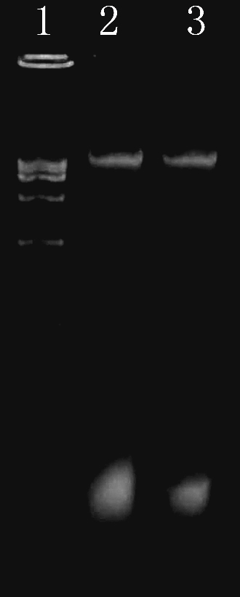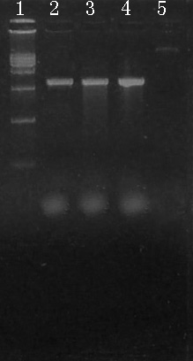
Figure 5. DNA amplification of regenerated Figure 6. Extraction of plant total DNA after
transformation test by PCR
1: DL 1,5000 marker 1: DL 1,5000 marker
2: Hairy root DNA of gentian induced by Ti Plasmid 2-3: PCR of Hairy root DNA of gentian
induced by Ti Plasmid
3: Hairy root DNA of gentian induced by Ri Plasmid 4: PCR of Hairy root DNA of gentian
induced by Ri Plasmid

2.5 PCR test on transformed gentian hairy root
We make PCR on the hairy roots DNA inducted by two kinds of Agrobacterium (use the system on 2.4.1), the amplified DNA has the same size with rol gene. We identify it is a transgene plant initially.

3. The influence of the factors in orthogonal experiment on gentian transformation

3.1 The influence of different kinds of Agrobacterium
We found in the experiment that the rate of hairy root inducted by the gentian mediated transform by LBA4404 Agrobacterium is reach to 60%, but the rate of hairy root inducted by the gentian mediated transform by R1000 is only 38%. It has two following reason: 1. Different Agrobacterium Rhizogenes has different transformation ability because of different plasmid feature. 2. LBA4404 can not induce to hairy root as Agroitbacterium tumefaciens by itself. The hairy root is formatted by the expression of rol gene controlled by plant expression vector promote regulation. So the high frequency of the transform rate is because of the plant expression vector that make the rol gene high express.

3.2 The usage of the hydroxybenzene
Some plant semaphore molecules urge the activation and efficiently express of Vir region,and it is necessary to the transform of T—DNA. It also can improve the transform rate and sensitive. Currently AS has already widely used in the genetic transformation system of the plant, but be
the plant also exists some phenol materials that has the same function. So the addition of AS is not for all the specieses. The addition of AS or high concentration of AS may cause the low transform rate. The reason of it is the over dose will generate poison to harm to the explants. In this experiment, a small quantity of AS can increase the induction frequency. The most suitable concentration is 20 ums. But the induction frequency only raised to 68% from original 60%. So we can conclude that the hydroxybenzene produced by explants itself make an important role in the process of vir region activation but not the environment influence. So we don’t have to append AS considering from the simplification of the test and the financial issue.

4. The morphological observation of hairy root
After the co-cultured explants switch to the culture medium which containing the bacteriostat, culturing in the scattering light for 8-16hours. It outgrows hairy root after infected 8-10 days. The hairy roots grow on the vein nerve of the lamina incision, minority of them grow on the incision boundary. One lamina can grow 1-3 roots generally. The velocity of the roots is fast in the first 4days. The average increase is about 0.4 cm everyday, and after 4 days it becomes 0.2cm per day. The outgrowth velocity of the hairy roots mediated by Agrobacterium tumefaciens is better than the roots mediated by Agrobacterium Rhizogenes. The roots lost the geotropism. They grow along the culture medium surface or grow stick the wall of the bottle. It appears lateral roots after 3 weeks. It performed a feature of lateral roots and much more root hairs. The explants haven’t infected can’t grow hairy root, and died gratully. So we can observe the transgene explants initial.

ly.

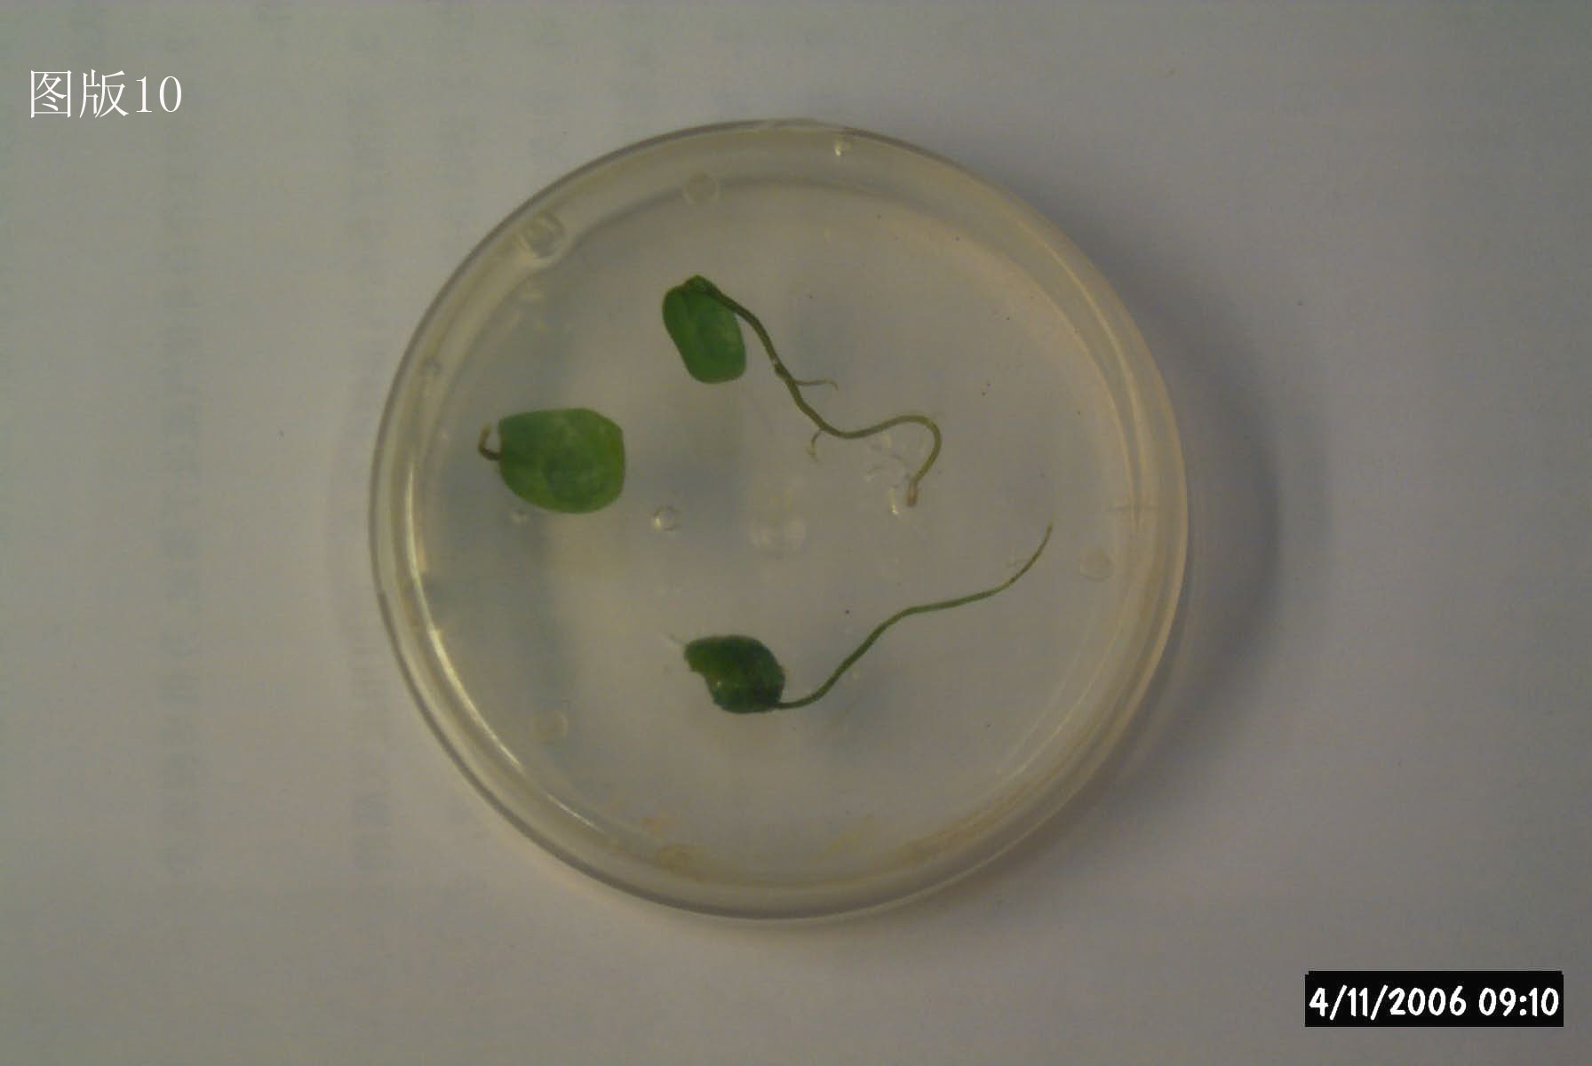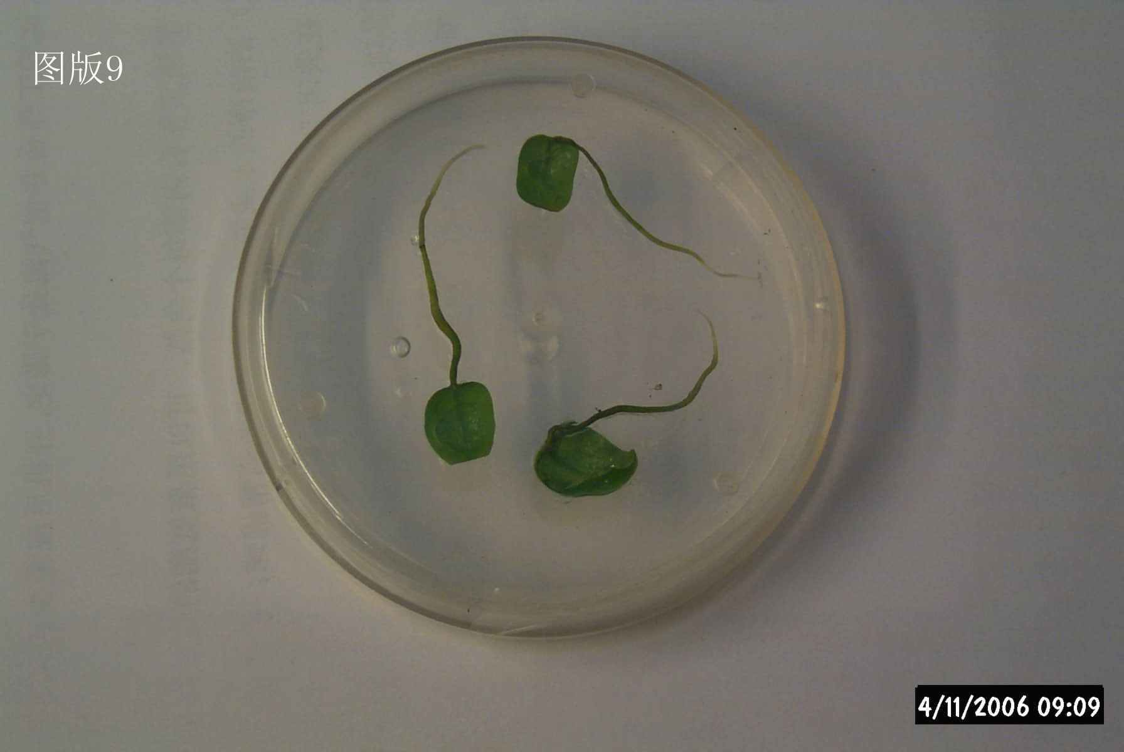
The hairy roots of transgene gentian The hairy root transformed by R1000
mediated by Ti
Figure 7. The hairy roots of transgene gentian mediated by Ti and the hairy root transformed by R1000

5. Study on induced hairy root mediated — transformed by Agrobacterium tumefaciens
Since the first time the scientists inserted the exogenous gene to Ti plasmid of Agrobacterium tumefaciens, and put them into plant cell to regenerate new plant in 1998, the plant genetic engineering technique got to a very fast speed development. During several decades, it has got a very successful achievement on the aspects of antivirus, antiherbicide, antiworm, antidrought, and anticold etc. It generated grate influence on agriculture production, medical hygiene, environment hygiene and food etc. At the same, the vector system mediated by Ti plasmid became mature. It became the most useful transform technology.
After 80’s, the Ti plasmid of Agrobacterium Rhizogenes became more and more valuable in the aspects of hairy roots induction and secondary metabolism production. People became to focus the research on getting the hairy roots transformed by Agrobacterium Rhizogenes and regenerating plants in hairy roots, and the aspect of getting plant transgene mediated-transformed by Ri plasmid vector. It was reported many times. In recent years, people began to make a deep research on four gene rolA-D related with the form of hairy root in Ri plasmid. They have already transformed rolA gene into tobacco mediated by Agrobacterium tumefaciens, and found some features like lower plant, lamina crimple, shorten anthotaxy, and lack of roots etc. The roots mediated-transformed by rolB can form into a great deal of hairy roots. The roots grow very fast, highly bifurcate, and inclining growth. After transformed the rolC gene into tobacco, potato, we found that the transformed plants had some features like lower, apical dominance and male sterility.
Meantime, there is few reports on transforming four induced hairy root genes at the same time into plants. But we were the first one used the medical plant gentian as vector, and induced the hairy roots taking Ti plasmid as plant vector to transform the rol gene successfully. We established the genetic transformation system of rol gene, and used Ri plasmid directly induced hairy roots as the compare. The experiment achieved the aim. We got the high transform rate and growth speed of hairy roots mediated by Ti plasmid. So we can conclude that the rolA-D genes controlled by Agrobacterium Rhizogenes could clone alone, and through the establish of the high efficiency plant expression vectors. We can get the more valuable and the higher produce hairy roots mediated-transformed by Agrobacterium tumefaciens. So this experiment has a practice value that has the theory innovation. Not only for the further researching, but also gave us a new way of thinking and work experience on getting a great deal of hairy roots.

Correspondence to:
Xu Xiang Ling
Biology Department
Harbin Normal University
Harbin, Heilongjiang, China
yanyq66@hotmail.com

Received: 11/14/2006

References
- ZhenDong Cheng, ZhiMing Wei, ZhiHong Xu. Transformation of brassica napus usingagrobac terium tumefaciens and regeneration of transgenic plants. Acta Botanica Sinica, 1994;36(9): 657-663.
- Zhong Hu, Jun Yang, GuangQin Guo et al. Establishment of transformed Lycium barbarum Line mediated with Agrobacterium rhizogenes and factors affecting transformation. Acta Botanica Boreali-occidentalia Sinica, 2000;20(5):767-771.
- HongRu Jiang, YiSheng Tu. Effects of culture conditions on the hairy roots growth of gentiana manshurica and gentiopicroside production. JiangXi Science 1997;615（2）.
- HongQing Li, MeiRU Li. The factors influence on plant transform by Agrobacterium. Plant physiology. 1999;35(2):145-151.
- ZhengKe Luo, ZhengSong Peng, LiMin Pu. Agrobacterium tumefaciens - mediated Transformation of medical plant. Biotechnology. 1991（2）18~22.
- Ji Liang, XiaoYang Chen, ShanZhi Lin, ZiangMing Xie. Advances in studies on rol gene of Ri plasmid from Agrobacterium rhizogenes and the application on forest development. Acta Botanica Sinica, 2002;19(6):650-658.
- WeiHua Li, XiangLing Xu, JiLin Li. The study on regenerating of hairy roots of gentian transformed by Agrobacterium Rhizogenes. Biotechnology. 1991（2）18~22.
- MingHong Qin, GuoZhen Li, Yue Yun, et al. The produce of southernwood inducted by Agrobacterium Rhizogenes and its cultivation. Acta Botanica Sinica. 1994;36(supplement):165.
- Min Sun, Hong Wang, Ying Wang, et al. Induction and Culture of Transformed Hairy Root in Catharanthus Roseus. Journal of Southwest China Normal University (Natural Science). 2002;27(4):549-552.
- Yi Wang, MeiPing Zhang, HeQun Guan, et al. The study on regenerating of hairy roots of gentian inducted by Agrobacterium Rhizogenes. Journal of JiLin Agriculture University. 1994;16（2）:107-110.
- Tie Feng Xu, Han Ming Zhang, Wei Zhang, et al. Establishing better lines and regenerating system of hairy roots of Isatis indigotica with Ri T-DNA. Academic Journal of Second Military Medical University. 2000;21(10):907-909.
- YueGang Zhou, SanGen Wang. Review of Studies on Rol Genes of Ri Plasmids from A grobacterium rhizogenes. Hereditas (BeiJing). 1997;19(6):45.
- Zhen Zhang, AiJun Sun, JingGui Fang, BingCheng Sheng. Study on Agrobacteriun mediated transformation of tobacco plant with rol C gene. Journal of Nanjing Agricultural University. 2001;24(1):25-29.
- KvmarA, Jones B, Davey MR. Transformation by Agrobacterium rhizogenes and regeneration of transgenics hoots of the wild soybean Glycineargyrea. Plant Cell Rep. 1991;10:135-138.
- Lamami M A. Sun L-Y, Douatl, Helgeson J and Tepfer D. Natural Genetic Transformation by Arogbacterium rhizogenes. Palnt physiology. 1998;118:543-550.
- Nilsson O, et al. Getting to the root: the role of the Agrobacterium rhizogens rol genes in the formation of hairy roots. Physiol Plant, 1997;100:463~473.
- Wei Zhi Ming. Kamad H, Harada H. Transformation of Solanum nigrum L. Protoplasts by Agrobacterium rhizogenes .Plant Cell Reports. 1986;5:93～96.

