LETTER TO EDITOR

The Application of Polyamine Stationary Phases on Hydrometallurgy

Sheau-Long Lee

Department of Chemistry, Chinese Military Academy, Taiwan, R.O.C
Leesheaulong@gmail.com

ABSTRACT: This article presents five polyamine stationary phases with PEDA-AC-CA-phase, PDTA-AC-CA-phase, PTTA-AC-CA-phase, PTPA-AC-CA-phase and PPHA-AC-CA-phase being applied to eight transition metals by the absorbable order of Hg(II) ≥ Cr(II) > Pb(II) > Cu(II) > Cd(II) > Co(II) ≥ Zn(II) > Ni(II) in the treatment of wastewater.

Key words: Polyamine Stationary Phases, Hydrometallurgy.

INTRODUCTION
Heavy metals are serious environmental pollutants. Detection and removal of heavy metals contaminated in the city water should be important in hydrometallurgy. A Kettrup et al. used acid amide bonded starch cellulose to absorb heavy metals [1]. A. Bolto et al. tried to separate the heavy metal in contaminated water [2] or seawater [3] by ion-exchange method. Due to the relatively complex capacity of nitrogen atom, amine group can be used a chelate ligand in the compounds. Most of the studies were focused on the metal ions absorbed by “free amines”, such as ethylendiamine for Ag⁺, Cu⁺², Zn⁺² [4] but Pb⁺² and Cd⁺² for different amines [5]. In this article, we designed several packing columns with the concept of combining the advantage of solid stationary phase and the strong absorption capacity of amine group to analyze series of transition metals. Five novel stationary phases by chemical bonded CA-phase [6] to a series of polyamines were applied to the absorption of eight transition metals, Cr(II), Co(II), Ni(II), Cu(II), Zn(II), Cd(II), Hg(II) and Pb(II). The series of polyamines are polymerized from five monomers, ethylendiamine (EDA), triethylenetetramine(TETA), tetra-ethylene-pentamine (TEPA), Penta-ethylenehexamine (PEHA). The synthesized stationary phases were hereafter noted as PEDA-AC-CA-phase, PDTA-AC-CA-phase, PTTA-AC-CA-phase, PTPA-AC-CA-phase and PPHA-AC-CA-phase respectively.

MATERIALS AND METHODS
Being suspension of 100 g CA-phase in 5 g Ethylenediamine, Diethylenetriamine, Tri-ethylenetetramine, Tetra-ethylenepentamine or Pentaethylenehexamine, 0.1 g Benzoyl peroxide was added into a 500ml beaker and the mixture beingheated at 110 ºC in an oil bath for 12 hours. After polymerization, the product was soxhlet-extracted with 500 ml toluene and acetone for 24 hours, followed by washing with 500 ml methanol and dried for 12 hours under vacuum. Finally, about 102 ~ 105 g of PEDA-AC-CA-phase, PDTA-AC-CA-phase, PTTA-AC-CA-phase, PTPA-AC-CA-phase or PPHA-AC-CA-phase were obtained as shown in figure 1. Different masses of stationary phase were added into a heavy metal-containing solution under thermostatically shaken at 25℃ for 24 hours. After reaction, the powder was dried and weighted and concentrations of metals in the solution can be determined by ICP method.

RESULTS
Table 1 shows the absorption of the eight transition metals on five stationary phases in comparison. Figure 2 depicted the bar chart. The absorption ability of polyamines to those stationary phase transition metal ions is as the order of Hg(II) ≥ Cr(II) > Pb(II) > Cu(II) > Cd(II) > Co(II) ≥ Zn(II) > Ni(II). This result is similar with the finding of Liu [6] via resin of strong amide group to adsorb transition metals. The absorption trend of all other ions are identical except for Ni(II) ≥Zn(II). In compare with the data of stabile coefficient from the publication of M.T.OMS [4], the order of absorption ability of Cu(II)、Ni(II)、Zn(II)、Cd(II)、Co(II) can explain why Cu(II) tend to form Tetrahedral Coordination with two EDA and other four kinds of ions tend to form six coordination with three EDA. Thus, Cu(II) has higher adsorption ability than the other four ions and the order of stability constant β of Ni(II)、Zn(II)、Cd(II)、Co(II) after being formed six Coordination are Ni(II)＞Co(II)＞Zn(II)＞Cd(II). Therefore, the order of forming six coordination with three EDA can be Ni(II)＞Co(II)＞Zn(II)＞Cd(II). The reason for Ni(II) having the lowest absorption ability is because of the highest consumption of EDA functional group. Less Ni(II) can be chelated by EDA in a unit area than Co(II), Zn(II) and Cd(II). This result is consistent with PEDA-AC-CA-phase absorption and the research of E. Jacobsen [5] that Pb(II) tends to form fourth coordination compound with triethylenetetramine (TETA), tetraethylenepentamine (TEPA). Since Cd(II) tends to form six coordination compounds, the amino group in unit area can absorb more Pb(II) than Cd(II). Nevertheless, polyamine stationary phases can have good absorption ability for Hg(II), Cr(II), Pb(II) and Cu(II). We can use them for Hydrometallurgy of transition metal ions and for specific transition metal ions adsorption in wastewater。

REFERENCES
[1]. Zhang B. W., Fischer K., Bieneik D. and Kettrup.A.,〝Synthesisof amidoxime containing modified starch and application for the removal of heavy metals〞Reactive Polymers 20:207 (1993)
[2]. Bolto B. A. and Pawlowski L. (1987) Wastewater treatment by Ion Exchange, Chapman and Hall, New York.
[3]. Li, Shanji. Jiaying University, Meizhou, Guangdong, Peop. Rep. China. Fenxi Ceshi Xuebao (2006), 25(5), 96-98. Publisher: Fenxi Ceshi Xuebao Bianjibu,
[4]. Oms M. T., Forteza, R., Cerda V. and Borrul F., 〝Thermometric Study of Metal Nitroge nated Ligand Complexes, I Ethylenediamine Complexes with Ag(I),Cu(II),Zn(II),Ni(II), Mn(II),Cd(II)and Co(II)〞 (1989) Thermoch imica Acta 138:1(1989)
[5]. Jacobsen,E.and Schroder,K., 〝Polarography of Lead and Cadmium Complexes with Tetra ethylenepentamine and Pentaethylenehexami ne 〞Acta Chemica Scandinavica, 16,1393
(1961).
[6]. Liu,C.Y., Chang,H.T.and Hu,C.C., 〝Complexation Reactions in a Heterogeneous System 〞,Inorganica Chimica Acta.,172,151
(1990).

Table 1
The absorbed amount (mg) of metals by stationary phases
Phase |  | Cr(II) | Co(II) | Ni(II) | Cu(II) | Zn(II) | Cd(II) | Hg(II) | Pb(II)
PEDA-AC-CA-phase | A | 4.53 | 23.19 | 23.68 | 14.13 | 22.97 | 22.38 | 10.21 | 8.98
 | B | 10.22 | 0.90 | 0.66 | 5.43 | 1.02 | 1.31 | 7.39 | 8.01
PDTA-AC-CA-phase | A | 4.92 | 23.21 | 23.82 | 21.93 | 22.47 | 22.47 | 4.63 | 9.05
 | B | 10.04 | 0.9 | 0.59 | 1.54 | 1.26 | 1.27 | 10.18 | 7.98
PTTA-AC-CA-phase | A | 12.31 | 21.73 | 22.95 | 5.56 | 21.71 | 21.75 | 3.60 | 11.47
 | B | 6.34 | 1.64 | 1.02 | 9.72 | 1.64 | 1.62 | 10.70 | 6.77
PTPA-AC-CA-phase | A | 9.09 | 22.31 | 22.15 | 13.40 | 22.15 | 21.95 | 9.73 | 9.37
 | B | 7.96 | 1.34 | 1.43 | 5.80 | 1.42 | 1.53 | 7.64 | 7.81
PPHA-AC-CA-phase | A | 9.55 | 21.64 | 20.84 | 13.17 | 21.01 | 22.10 | 8.39 | 10.51
 | B | 7.72 | 1.68 | 2.08 | 5.91 | 1.54 | 1.45 | 8.01 | 7.24
A: residual metal ion concentration in solution (ppm)
B: metal ion absorption weight on each gram powder phase(mg/g)

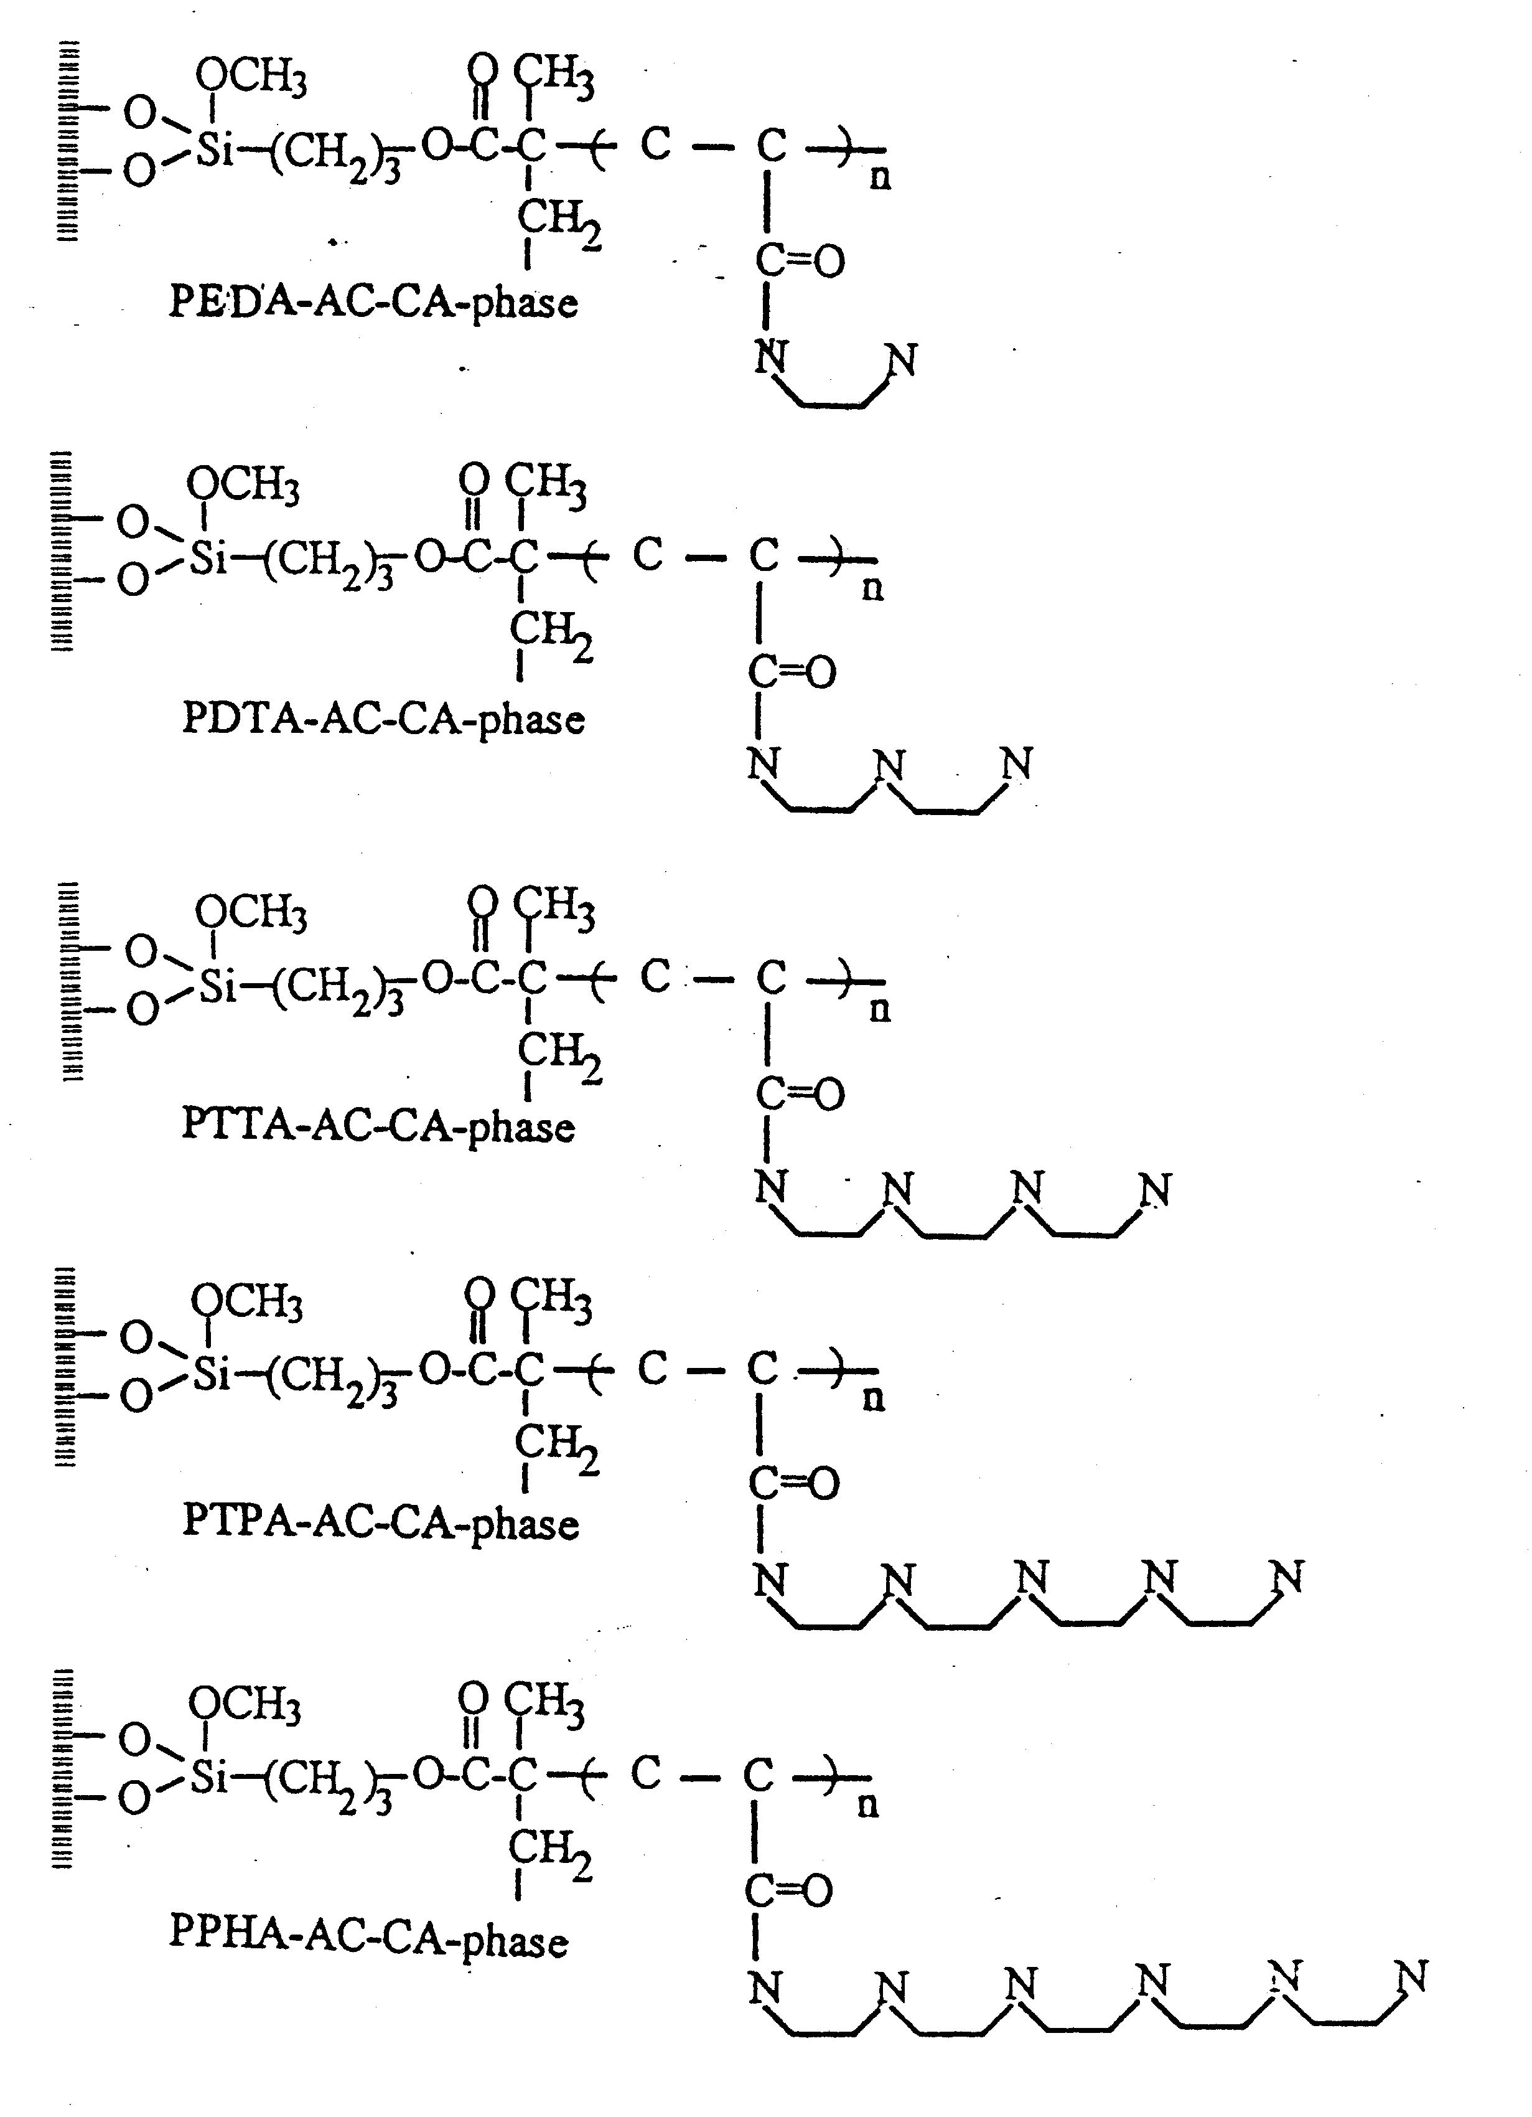

Figure 1 Figure 2
The structure of five Polyamine The absorption result of
Stationary Phases the eight transition metal on five stationary phases

