An International Journal

Nature and Science

ISSN 1545-0740

Volume 5 - Number 1 (Cumulated No. 13), March 30, 2007
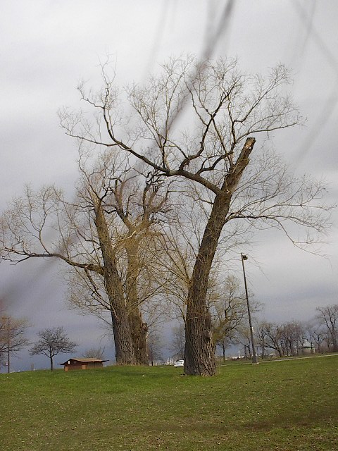

Marsland Press, Michigan, The United States

Nature and Science

ISSN 1545-0740
The Nature and Science is an international journal with a purpose to enhance our natural and scientific knowledge dissemination in the world under the free publication principle. Any valuable papers that describe natural phenomena and existence or any reports that convey scientific research and pursuit are welcome, including both natural and social sciences. Papers submitted could be reviews, objective descriptions, research reports, opinions/debates, news, letters, and other types of writings that are nature and science related.

1. General Information
(1) Goals: As an international journal published both in print and on internet, Nature and Science is dedicated to the dissemination of fundamental knowledge in all areas of nature and science. The main purpose of Nature and Science is to enhance our knowledge spreading in the world under the free publication principle. It publishes full-length papers (original contributions), reviews, rapid communications, and any debates and opinions in all the fields of nature and science.
(2) What to Do: Nature and Science provides a place for discussion of scientific news, research, theory, philosophy, profession and technology - that will drive scientific progress. Research reports and regular manuscripts that contain new and significant information of general interest are welcome.
(3) Who: All people are welcome to submit manuscripts in any fields of nature and science.
(4) Distributions: Web version of the journal is freely opened to the world, without any payment or registration. The journal will be distributed to the selected libraries and institutions for free. For the subscription of other readers please contact with: editor@americanscience.org or americansciencej@gmail.com or editor@sciencepub.net.
(5) Advertisements: The price will be calculated as US$400/page, i.e. US$200/a half page, US$100/a quarter page, etc. Any size of the advertisement is welcome.

2. Manuscripts Submission
(1) Submission Methods: Electronic submission through email is encouraged and hard copies plus an IBM formatted computer diskette would also be accepted.
(2) Software: The Microsoft Word file will be preferred.
(3) Font: Normal, Times New Roman, 10 pt, single space.
(5) Manuscript: Don’t use “Footnote” or “Header and Footer”.
(6) Cover Page: Put detail information of authors and a short title in the cover page.
(7) Title: Use Title Case in the title and subtitles, e.g. “Debt and Agency Costs”.
(8) Figures and Tables: Use full word of figure and table, e.g. “Figure 1. Annul Income of Different Groups”, Table 1. Annual Increase of Investment”.
(9) References: Cite references by “last name, year”, e.g. “(Smith, 2003)”. References should include all the authors’ last names and initials, title, journal, year, volume, issue, and pages etc.
Reference Examples:
Journal Article: Hacker J, Hentschel U, Dobrindt U. Prokaryotic chromosomes and disease. Science 2003;301(34):790-3.
Book: Berkowitz BA, Katzung BG. Basic and clinical evaluation of new drugs. In: Katzung BG, ed. Basic and clinical pharmacology. Appleton & Lance Publisher. Norwalk, Connecticut, USA. 1995:60-9.
(10) Submission Address: editor@sciencepub.net, Marsland Company, P.O. Box 21126, Lansing, Michigan 48909, The United States.
(11) Reviewers: Authors are encouraged to suggest 2-8 competent reviewers with their name and email.

2. Manuscript Preparation
Each manuscript is suggested to include the following components but authors can do their own ways:
(1) Title page: including the complete article title; each author’s full name; institution(s) with which each author is affiliated, with city, state/province, zip code, and country; and the name, complete mailing address, telephone number, facsimile number (if available), and e-mail address for all correspondence.
(2) Abstract: including Background, Materials and Methods, Results, and Discussions.
(3) Keywords.
(4) Introduction.
(5) Materials and Methods.
(6) Results.
(7) Discussions.
(8) Acknowledgments.
(9) References.

Journal Address:
ISSN 1545-0740

Marsland Company
P.O. Box 21126
Lansing, Michigan 48909
The United States
Telephone:(517) 349-2362
E-mail: editor@sciencepub.net;
naturesciencej@gmail.com
Websites: http://www.sciencepub.org

