The Chromatography of Nitro compounds on Poly(4-methyl-5-vinylthiazole) Stationary Phase

Sheau-Long Lee

Department of Chemistry, Chinese Military Academy, Taiwan, R.O.C
Leesheaulong@gmail.com

ABSTRACT: A novel poly (4-methyl-5-vinylthiazole ) stationary phase is presented by using γ-methacryloxypropyltri-methoxysilane as coupling agent which is chemically bonded to silica gel at one moiety and polymerized with 4-methyl-5-vinylthiazole on the other side of the target. The newly synthesized stationary phase can be considered as the alkyl chain of RP-18 having hydrophobic properties due to its polyalkyl chain. The thiazole ring in the novel stationary phsae is a heterocyclic aromatic ring and may undergo donor-acceptor complex interactions to varying strengths with acceptor solutes. Moreover, the thiazole group in this phase can accept a proton by one nitrogen atom to form hydrogen bond with other explosives, which may not be separable on the other commercial stationary phases such RP-8 and RP-18.

Key Words: Reversed phase, 4-Methyl-5-vinylthiazole, Nitro compound.

INTRODUCTION
In the field of efficient analysis of organic and explosive compounds, HPLC plays an important role on it. By monitoring different properties of stationary phase and then applying to the analysis of explosive compounds is the main research in our laboratory [1~4]. This paper is based on the existing experience to synthesize a novel stationary phase. The synthetic method is to use γ-Methacryloxypropyltrimethoxysilane as coupling agent and firstly react with 5μm silica gel, and then react with vinyl group of 4-methyl-5-vinylthiazole. With the aid of AIBN as initiator, polymeric reaction proceeds, and a thiazol-group containing stationary phase was thus formed. Owing to the fact that the stationary phase contains not only thiazol functional group but also alkyl chain with the latter similar to the hydrophobic property of RP-18 phase. Therefore, its characters includes not only partition mechanism but also charge transfer and hydrogen bonding mechanisms [5~6]. Base on this concept, the novel stationary phase is able to separate nitro-group containing compounds with different selectivities compared with RP-18 phase. Preliminary studies show that better performance achieved on PMV-CA-phase than on RP-18 phase.

2 Materials and Methods
All Nitroaromatic derivatives were prepared by standard methods or supplied by the Aresenal 203 (Kao-hsiung, Taiwan). LC grade Methanol and distilled water were used in the study.The total coverage of 4-methyl-5-vinylthiazole ligand on silica was estimated as 1.592 mmol/g; the columns (250mm × 4.6mm i.d.) used in this work were packed with modified LiChrosorb Si 100 (10μm, E. Merck). Nucleosil RP-18 (10μm, Marcherey-Nagel) was used for the purpose of comparison.
Instrumentation: HPLC was performed with Waters 600E liquid Chromatography equipped with a Waters model 481 UV detector and a Waters model 745 Data Module recorder. The injector, column and detector were thermostatted at 25°C and UV-detector was operated at 254 nm. Mobile phase used was methanol/water including 0.1% H3PO4.
Preparation of γ-methacryloxypropylisilyl phase (CA-phase): To a suspension of 12 g silica gel (LiChrosorb Si-100 ,10μm E. Merck) in 200ml methanol ,20 ml of γ-methacryloxypropyltrimethoxysilane were added. The mixture was stirred at room temperature for 6 hour. After reaction and filtration, the product was further washed with methanol (100 ml), methanol/water (50/50, 100ml) and finally with tetrahydrofuran ( 100 ml). The chemically bonded phase was dried at 70℃ for 12 hours under vacuum and eventually 13g of γ-methacryloxypropylsilyl phase (CA-phase) were then obtained. FT-IR: 2990, 2970, 2890, 1718, 1640, 1454, 1328, 1306, 1095 cm⁻¹. Solid state FT ⁻¹³C NMR(δ):167,137,122,67,22,16,8 ppm.Elemental analysis: %C: 6.10.
Preparation of poly(4-methyl-5-vinylthiazole) phase (PMV-CA-phase): To a suspension of 5 g γ-methacryloxypropylsilyl in 5 ml fresh 4-methyl-5- vinylthiazole, 0.1 g recrystallized 2,2’-Azobisisobutyronitrile (AIBN) was added into a 15 ml sealed tube. The mixture was heated at 120℃ in an oil bath for 12 hours. After polymerization, the product was soxhlet-extracted with 500 ml CHCl₃ for 24 hours, followed by washing with 500 ml methanol and dried for 12 hours under vacuum. Finally 5.8 g of poly(4-methyl-5-vinylthiazole) phase (PMV-CA-phase) were then obtained . FT-IR:2990, 2970, 2890, 1920, 1640, 1545, 1380cm ^{–1}. Solid state FT-¹³C NMR(δ):175,149,136,66,50,42,33,22, 14, 9 ppm. Elemental analysis: %C: 17.2, %N:2.23
Chromatography and Column packing:
The HPLC system employed consisted of a water 600E liquid chromatograph, a Waters Model 481 UV-detector and a Water 745 recorder. The injector,column and detector were thermostatted at 25 ℃. The silica used was LiChrosorb Si 100 (10μm, surface area: 282 m²/g). The stationary phase prepared (ca. 3 g) was packed into a 250 ×4 mm i.d. stainless column (E.Merck) by means of the slurry technique using 2-propanol as eluennt.
3. Results and discussion
Figure 1 shows the structure of PMV-CA phase and Figure 2 shows the retention behavior of benzene , naphthalene and anthracene on PMV-CA phase and RP-18 phase. The capacity factor (K') is increased with the number of aromatic rings in these aromatic compounds. Besides, the similar retention behavior of PMV-CA phase and RP-18 phase also indicates a common retention mechanism was involved, i.e. the larger the molecular weight, the longer the retention time.
This mechanism is also evident in Figure 3. Figure 3 shows the retention result of halogen-containing aromatic compounds on PMV-CA phase and RP-18 phase. The elution order is 1,2-Difluorobenzene < 1,2-Diclorobenzene < 1,2-Dibromobenzene < 1,2-Diiodobenzene. It is clear that as the molecular weight increased, the retention time is longer. This is again demonstrating that the retention mechanism on PMV-CA phase will be similar to that in RP-18 if no special interaction exist.
In order to understand the different chromatographic characters of PMV-CA phase and RP-18 phase, we chose different hydroxyl group-containing benzene compounds applied on PMV-CA-phase and RP-18 phase and the result is shown in Figure 4. It is obvious that the retention behavior is different between PMV-CA-phase and RP-18 phase. In RP-18 phase, the retention mechanism is still depends on the molecular weight. No special interaction is occurred between sample and RP-18 phase. However, in PMV-CA phase, as the number of hydroxyl group increased, the K' value become larger. This is mainly because of the hydrogen bonding interaction between sample and the PMV-CA phase. This is evident that “hydrogen bonding” will be a special retention mechanism in PMV-CA phase.
“π-π Complex” character is also another chromatographic character of PMV-CA phase. HPLC results of nitro group-containing toluene compounds on PMV-CA phase and RP-18 phase are shown in Figure 5. Again, for RP-18 phase, the retention mechanism only depends on the normal partition effect, the more nitro group inside the compounds, the more stronger attraction between mobile phase and samples, and thus resulted in a more shorter retention time. This indicates no special interaction is occurred between sample and RP-18 phase. Whereas, in PMV-CA phase, as the number of nitro group increased, the K' value become larger. This is because the “π-π complex” formed between sample’s π-acid group and PMV-CA phase’s π-base group. And the more nitro group, the stronger the “π-π complex” formed, and the larger k' value can be obtained.The above results show that “hydrogen bonding” and “π-π complex” interaction are the special HPLC chromatographic characters of PMV-CA phase.
Table 1 shows capacity factors of series explosives on PMV-CA phase and RP-18 phase using methanol/water(60/40~90/10) as mobile phase, Better selectivity and resolution can be obtained on PMV-CA phase as compared to that on RP-18 phase. According to the specific retention behavior of PMV-CA phase, it seems more convenient to use PMV-CA phase rather than RP-18 for the quantitative analysis of RDX in HMX[7]. The observed different elution order specially indicates that the retention mechanism of PMV-CA phase is different from RP-18 phase, Therefore, PMV-CA phase can work as a complementary column to the RP-18 phase in PLC analyses.

Conclusion
PMV-CA-phase shows not only classical properties in reversed phase liquid chromatography but also specific characters, π -

π complex interaction and/or hydrogen bonding, in separating Nitroaromatic derivatives. The main factor is that this phase has both hydrophobic alkyl chain and thiazole group and thus results in different chromatographic selectivities in comparison with RP-18.

References

- Lee.S.L., Lee.C.H and Den.T.G., 1987.,〝Stationary Phasen 4. Darstellung und Charakterisierung einer Safrol-gebundenen Phase fur die Hochdruck-Fussigkeits-Chromatographite〞, Fresenius Z Anal Chem.,328; P.41~45.
- Den.T.G., Lee.S.L., Shieh.G.J., Ho.C.M.,1988.Mar.,〝Stationary Phase 14: Preparation of 3-[1’-Methyl-2’,5’-dioxocyclopentyl] propylmethlsilyl Stationary Phase and its Application in the HPLC of Anilines〞CHEMISTRY (The Chinese Chem. Soc., Taipei )Vol.46, No.1, PP.9~16.
- Hseu.H.S., Chang.C.S., Shieh.G.J., Den.T.G and Lee.S.L.,1988.Jun.,〝Stationary Phase 20:Identification and Spectroscopic investigation of some Silica-immobilized Organic Ligands〞J. of C.C.I.T., Vol.17, No.1, P.75~81.
- Lee.S.L., Tasi.H.J., Huang.C.C.,and Den.T.G., 1992.Sep.,〝Stationary Phase 35:Preparation of Poly(isosafrole)Stationary Phase and Its Chromatographic Separation for Nitroaromatics〞,J.of Explosives and Propellants, R.O.C. Vol.8, No.3, P.45~54.
- R.Abdel-Hamid, A.A. El-Samahy. A-H. El-Taher, and H. El-Sagher, Can.J.Chem.65(1987)468.
- R. August, C. Davis, and R. Taylor, J. Chem. Soc. Perkin Trans. II (1986) 1256. Kuan-Jiunn Shieh and Sheau-Long Lee, Cheng Chang, Cheng-Hau Wen and Tschau-Gan Den., Propellants, Explosives, Pyrotechnics 22,242-244(1977)

Figure 1. The structure of PMV-CA-phase.

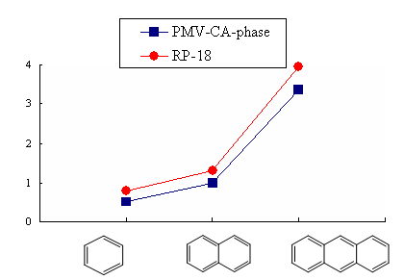

Figure 2. The K' values of different aromatic-ring containing aromatic compounds in PMV-CA-phase and RP-18 phase. (mobile phase: methanol/water=80/20).

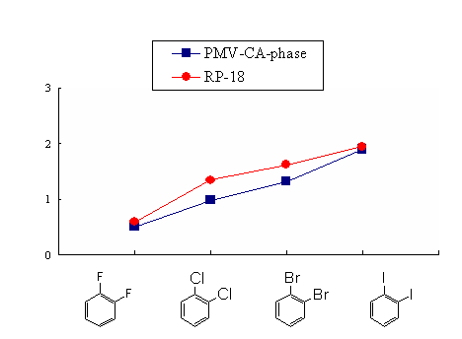

Figure 3. The K' values of different halogen-containing aromatic compounds in PMV-CA-phase and RP-18 phase. (Mobile phase: methanol/water=80/20).

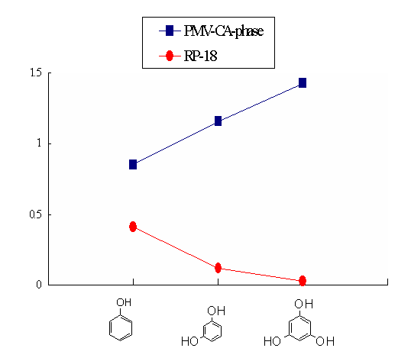
Figure 4. The K' values of different hydroxyl group containing aromatic compounds on PMV-CA-phase and RP-18 phase. (Mobile phase: methanol/water=80/20).

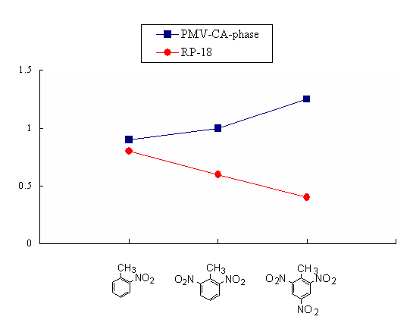
K'’
Figure 5. The K' values of different nitro group containing aromatic compounds on PMV-CA-phase and RP-18 phase. (Mobile phase: methanol/water=80/20).

Table 1. The Capacity Factors of Series nitro compounds on PMV-CA phase and RP-18

No. | Sample | PMV-CA-phase |  |  |  |  | RP-18
No. | Sample | MeOH/H₂O |  |  |  |  | MeOH/H₂O
 |  | 90/10 | 80/20 | 70/30 | 60/40 |  | 90/10 | 80/20 | 70/30 | 60/40
 |  | K₁ | K₂ | K₃ | K₄ |  | K₁ | K₂ | K₃ | K₄
1 | Nitrobenzene | 0.49 | 0.71 | 1.25 | 1.81 |  | 0.34 | 0.54 | 1.01 | 1.55
2 | 2-Nitrophenol | 0.59 | 0.89 | 1.67 | 2.34 |  | 0.29 | 0.48 | 0.96 | 1.37
3 | 4-Nitrophenol | 0.83 | 1.26 | 2.24 | 2.98 |  | 0.18 | 0.27 | 0.56 | 0.82
4 | 3-Nitrophenol | 0.83 | 1.32 | 2.44 | 3.35 |  | 0.18 | 0.33 | 0.62 | 0.89
5 | 2-Nitrotoluene | 0.50 | 0.87 | 1.46 | 2.33 |  | 0.39 | 0.77 | 1.45 | 2.34
6 | 2,6-Dinitrotoluene | 0.58 | 0.98 | 1.54 | 2.40 |  | 0.30 | 0.61 | 1.18 | 1.90
7 | 2,4,6-Trinitrotoluene | 0.76 | 1.22 | 1.85 | 2.73 |  | 0.20 | 0.45 | 0.88 | 1.39
8 | RDX | 0.95 | 1.83 | 2.50 | 3.00 |  | 0.14 | 0.24 | 0.41 | 0.69
9 | HMX | 2.28 | 3.65 | 6.03 | 10.17 |  | 0.02 | 0.08 | 0.16 | 0.25

RDX:Hexogen,Cyclotrimethylenetrinitramine HMX: Octogen,Cyclotetramethylenetetranitramine

