Wave Guide Astronomical Experiments for One Way Light Speed Isotropy Measurements

Dr. Adrian Sfarti

CS Dept – Soda Hall, UC Berkeley
adsar1@yahoo.com

Abstract: There is a rather small number of experiments designed to test one way light speed isotropy. The reason for the small number is the higher degree of difficulty in imagining and conducting such experiments. A very good analysis of such experiments is given by C.M.Will in ¹. The small number of such experiments¹⁰⁻¹² enhances the concern when one of them is proven incorrect. In the following paper we will analyze the experiment conducted by Gagnon². Our paper is a rather unusual and unique one: in the first part of the paper we will show that while the experimental method is valid, the theory behind the experiment is flawed. In the second half of the paper we will show how the corrected theoretical foundation can be used to recover this very valuable experiment. By correcting the theoretical foundation we managed to build a sound foundation of future one way light speed isotropy experiments based on astronomical observations. [Nature and Science. 2007;5(2):66-71] (ISSN: 1545-0740).

Keywords: One way light speed isotropy measurement, waveguide theory

1. Introduction
The Gagnon paper makes clever use of the Earth’s revolution around the Sun and of the Earth’s diurnal rotation. Let v_{R} represent the Earth revolution speed. Let Σ₀(ξ,ψ,ζ) represent a reference frame centered in CMBR. Let Σ(x,y,z) represent the frame centered in the center of the Earth and let Σ'(x’,y’,z’) represent the slowly rotating reference frame of the lab (fig 1). Two waveguides, A and B of different cutoff frequencies are aligned with the z-axis. A certain difference of phase Δφ is predicted by the test theory used by Gagnon , namely the “Generalized Galilean Theory” GGT ^{2,3,7,8} between the two waveguides. The transformations between Σ and Σ₀, for the infinitesimal portion of the trajectory where the coordinate axes are parallel such that the motion between Σ and Σ₀ appears to be a translation along z are shown below:

(1.1)

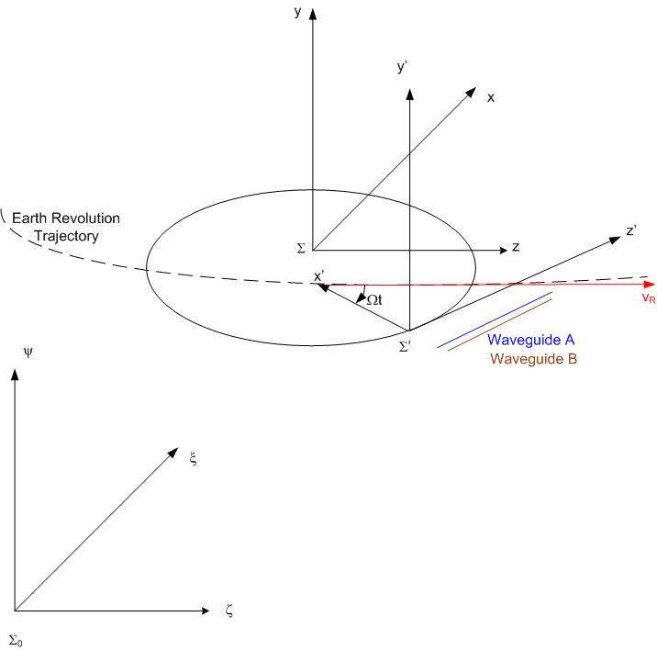
Figure 1. The Gagnon experiment setup

2. Analysis of the Gagnon paper – the error discovery process
In the following we will assume that the longitudinal axis of the waveguide is the z-axis, with x-axis perpendicular on it such that x and z determine a plane parallel with the Earth’s equatorial plane and with y pointing to one of the poles.
According to the authors, one of them (T.Chang)³ has derived the wave equation “in a reference frame moving with absolute velocity v”, i.e. in the lab frame Σ:

(2.1)
where <,> means the dot product and E=E(x,y,z,t)=u_{x}E_{x}+u_{y}E_{y}+u_{z}E_{z}
The authors proceed by looking only at the component along the z-axis. From wave theory we know that the solution is of the form:

E_{z}=X(x)Y(y)e^{i(kz-ωt)} (2.2)

with the boundary condition E_{z}(x=0)=E_{z}(x=a)=E_{z}(y=0)=E_{z}(y=b)=0 (2.3)
Let X(x) and Y(y) be two functions continuous with continuous second order derivatives.
The problem is now reduced to finding the solution for the differential equation

(2.4)

with the boundary conditions:

where:
Gagnon simply cancelled the real part of (2.4) obtaining an incorrect solution. The correct solution is derived below:

Let C= (2.5)
Assuming we can divide expression (2.4) by XY:

(2.6)

Since X(x) is a function only of x and Y(y) is a function only of y and since the left hand of (2.6) is a constant it results immediately that :

(2.7)

i.e. two differential equations of degree two with imaginary coefficients.

(2.8)

must have a solution of the type X(x)=e^{irx} (2.9)
producing the characteristic equation:

(2.10)

(2.11)
(2.12)
0=X(0)=C₁+C₂ implies C₂=-C₁ (2.13)
X(x)= (2.14)
0=X(a)= (2.15)
0=2i (2.16)
(2.17)
(2.18)
Analogously:

(2.19)

(2.20)
=C=-(α+β) (2.21)
(2.22)
(2.23)
where (2.24)
(2.25)
Solving (2.24) for k we obtain:
(2.26)
k is a real number if and only if , is the “cutoff pulsation” below which k becomes imaginary and the wave attenuates instead of propagating properly to the end of the waveguide. Waveguide theory⁴ uses the pulsation ω=2πf rather than the frequency f.

3. Physical interpretation of the results
(3.1)
Remembering that there is a second waveguide in the experiment, driven at the same pulsation ω but with a very different “cutoff” pulsation ω_{pq}, we can write immediately the electrical field:

(3.2)
where :

(3.3)
(3.4)
We have enough degrees of freedom in selecting the geometries of the wave guides such that:
(3.5)
Therefore:
(3.6)
where:

(3.7)

The phase difference between E_{z} and E_{z}’ is:

ΔΦ= (3.8)
We now consider the simple transformation from Σ to Σ’:

(3.9)
where R is the Earth radius. The phase difference does not depend on the Earth revolution speed. Let L be the common length of the two waveguides In the lab frame Σ’ the phase difference is determined by setting z’=L and x’=0 in (3.9) resulting into and :

(3.10)

Formula (3.10) shows the predicted GGT variation of phase difference in the lab frame Σ', expressed as a function of time. A quick sanity check shows that (3.10) is a-dimensional since a_{mn}, a_{pq} have dimensions of ω/c, that is, inverse of length.

4. Extensions to standard cavities
The standard experiments employ precision machined orthogonal cavities. We can easily extend the formalism described in the previous paragraph to orthogonal cavities by simply swapping the roles of x and z in (3.6):
(4.1)
In the lab frame Σ’ z’=L and x’=0 so and so:

(4.2)

5. Conclusions
The Gagnon experiment is one in a very short series^{5,6} of measurements of one way light speed isotropy. The experiment is extremely original and the experimental method based on waveguides is original and valid. We have uncovered some errors in the theoretical underpinnings. With the proper corrections, the experiment becomes a very valuable tool in proving the isotropy of light speed. During the process we have derived the correct theory for using waveguides as a means of detecting one way light speed anisotropy.

Correspondence to:
Dr. Adrian Sfarti
CS Dept – Soda Hall, UC Berkeley
adsar1@yahoo.com

References
- C.M.Will “Clock Synchronization and isotropy of one-way speed of light”, Phys.Rev. D, 45, 2 (1992)
- D.R.Gagnon, D.G.Torr, P.T.Kolen, T.Chang “Guided-wave measurement of the one-way speed of light”, Phys.Rev. A, 38, 4 (1988)
- T.Chang , “Maxwell’s equations in anisotropic space”, Phys.Lett, 70A, 1 (1979)
- S. Wentworth, Fundamentals of Electromagnetics with Engineering Applications (p338-355)
- T.Krisher, L.Maleki, G.Lutes, L.Primas, R.Logan, J.Anderson, C.Will, Phys. Rev. D, 42, 2, (1990)
- S. Herrmann, A. Senger, E. Kovalchuk, H. Müller, A. Peters: "Test of the isotropy of the speed of light using a continuously rotating optical resonator", Phys. Rev. Lett. 95, (2005)
- T. Chang, D. Torr, “Dual properties of spacetime under an alternative Lorentz transformation”, Found. Of Phys. Lett, 1, 4, (1988)
- T.Chang, D.Torr, D.Gagnon, “A modified Lorentz theory as a test theory of special relativity”, ”, Found. Of Phys. Lett, 1, 4, (1988)
- R. Mansouri, R.Sexl, “A test theory of special relativity: I. Simultaneity and clock synchronization “,Gen.Relativ.Gravit. , 8,(1977)
- S.Schiller, P.Antonini, M.Okhapkin “A precision test of the isotropy of the speed of light using rotating cryogenic optical cavities” Phys. Rev. Lett. 95, 150401 (2005)
- Lipa, J. A., Nissen, J. A., Wang, S., Stricker, D. A., and Avaloff, D. “A New Limit on Signals of Lorentz Violation in Electrodynamics” Phys. Rev. Lett. 90, 060403 (2003)
- Wolf, P., Bize, S., Clairon, A., Santarelli, G., Tobar, M. E., and Luiten, A. N. “Improved Test of Lorentz Invariance in Electrodynamics” Phys. Rev. D 70, 051902(R) (2004)
- A.Sfarti, “One Way Light Speed Measurement – Experimental Proof of Light Speed Isotropy”, Proceedings of the XI-th Marcel Grossman Conference, Berlin (2006)
- A.Sfarti, “Corrected Theory of the Reenactments of the Michelson-Morley Experiment in Non-Vacuum Media”, Rom.J.Phys, 52, 5-6, (2007)

