Modification of Carboxymethyl Starch as Nano Carriers for Oral Drug Delivery

Mohammad Reza Saboktakin *, Abel Maharramov *, Mohammad Ali Ramazanov *, Mehrdad Mahkam **

* Department of Chemistry, Baku State University, Baku, Azarbaijan
** Chemistry Department, Azarbaijan University of Tarbiat Moallem, Tabriz, Iran
saboktakin123@yahoo.com

Abstract: Received: 8/Natural polymers are considered high value polymeric materials because of their potential as biocompatible materials with medical applications. The chemical modification of natural polymers by grafting has received considerable attention in recent years because of the wide variety of monomers available. As the first part of a continued research on conversion of carboxymethyl starch (CMS) to useful biopolymer-based materials, large numbers of carboxylic functional groups were introduced onto CMS by grafting with poly methacrylic acid (PMAA). Free radical graft copolymerizations were carried out at 70°C, bis-acrylamide as a cross-linking agent and persulfate as an initiator. Equilibrium swelling studies were carried out in enzyme-free simulated gastric and intestinal fluids (SGF and SIF, respectively). This hydrogel converted to nano by freeze drying method and characterized by scanning electron microscopy, differential scanning calorimetry and FT-IR. Two anti-inflammatory model drugs, 5-aminosalicylic acid (5-ASA) and salicylic acid (SA) was entrapped in these nano gels and the in vitro release profiles were established separately in both enzyme-free SGF and SIF. The drug release was found to be faster in SIF. The drug-release profiles indicate that amount drugs release depends on their degree of swelling, and crosslinking. [Nature and Science. 2007;5(3):30-36]. (ISSN: 1545-0740).

Key words: Nano, Modification, CMS, pH-sensitive, Oral drug delivery

Introduction
Nano carriers have important potential applications for the administration of therapeutic molecules. The research in this area is being carried out all over the world at a great pace. Research areas cover novel properties that have been developed increased efficiency of drug delivery, improved release profiles and drug targeting. Although oral delivery has become a widely accepted route of administration of therapeutic drugs, the gastrointestinal tract presents several formidable barriers to drug delivery. To achieve successful colonic delivery, a drug needs to be protected from absorption of the environment of the upper gastrointestinal tract (GIT) and then be abruptly released into the proximal colon, which is considered the optimum site for colon-targeted delivery of drugs. One strategy for targeting orally administered drugs to the colon includes coating drugs with pH-sensitive hydrogels [1-6]. Polymer bonded drug usually contain one solid drug bonded together in a matrix of a solid polymeric binder. They can be produced by polymerizing a monomer such as methacrylic acid (MAA), mixed with a particulate drug, by means of a chemical polymerization catalyst, such as AIBN or by means of high-energy radiation, such as x-ray or gamma rays [7-9].
Natural polymers have potential pharmaceutical applications because of their low toxicity, biocompatibility, and excellent biodegradability. Starch is the most abundant, renewable biopolymer, which is very promising raw material, available at low cost for preparing of various functional polymers. Carboxymethyl starch (CMS) widely used in pharmaceuticals; however, it may need to be further modified for some special applications. Among diverse approaches that are possible for modifying polysaccharides, grafting of synthetic polymer is a convenient method for adding new properties to a polysaccharide with minimum loss of its initial properties [10]. Graft copolymerization of vinyl monomers onto polysaccharides using free radical initiation, has attracted the interest of many scientists. Up to now, considerable works have been devoted to the grafting of vinyl monomers onto the substrates, especially Starch and cellulose [11]. Existence of polar functionally groups as carboxylic acid need not only for bioadhesive properties but also for pH-sensitive properties of polymer [12, 13]. Because the increase of MAA content in the hydrogels provides more hydrogen bonds at low pH and more electrostatic repulsion at high pH.
It is as a part of our research program on CMS modification to prepare materials with pH-sensitive properties for uses as colon-specific drug delivery. The free radical graft copolymerization poly methacrylic acid onto CMS was carried out at 70 °C, bis-acrylamide as a cross-linking agent and persulfate as an initiator. The mixture modified hydrogel and 5-aminosalicylic acid (5-ASA) and salicylic acid (SA) as model drugs were converted to nano by freeze-drying method. The equilibrium swelling studies and in vitro release profiles were carried out in enzyme-free simulated gastric and intestinal fluids (SGF and SIF, respectively). The influences of different factors, such as content of MAA in the feed monomer and swelling were studied.

Experimental Materials
carboxymethyl starch (CMS) [degree of substitution (DS) = 0.49] was prepared by the method described in the literature [14]. Methacrylic acid (MAA) and bis-acrylamide were purchased from Merck Co. The solvents and reagents were obtained from Fluka. The IR spectra were recorded on a Shimadzu FT IR-408 spectrophotometer. The DSC curves were obtained on a TGA/SDTA 851 calorimeter at heating and cooling rates of 10º C/min under N₂. The amount of released drug was determined on a Philips PU 8620 UV spectrophotometer at the absorption maximum of the free drugs 5-ASA and SA in aqueous alkali) λmax = 205 nm) and) λmax = 235 nm) respectively, using a 1 cm quartz cell. Enzyme-free SGF (pH 1) or SIF (pH 7.4) were prepared according to the method described in the US Pharmacopeia [15].

Methods

Copolymerization: General Procedure
CMS with different molar ratios of methacrylic acid were polymerized at 60-70°C in a thermostatic water bath, bis-acrylamide as a cross-linking agent (CA), using persulfate as an initiator ([I] = 0.02 M) and water as the solvent (50 mL). All experiments were carried out in Pyrex glass ampoules. After the specific time (48 h), the precipitated network polymer was collected and dried in vacuum.

Preparation of nanoparticle
0.5 g of polymer bonded drugs (PBDs) containing 5-ASA or SA was dispersed with stirring in 25 ml deionised water. After approximately 180 min, the PBDs were sprayed into a liquid nitrogen bath cooled down to 77° K, resulting in frozen droplets. These frozen droplets were then put into the chamber of the freeze-dryer. In the freeze-drying process, the products are dried by a sublimation of the water component in an iced solution. Figure 1 show scanning electron microscope (SEM) of nano polymer bonded drugs.

Measurement of swelling ratio
The resulting network polymers swell and become soft in solvents such as H₂O and most organic solvents without dissolving. To measure the swelling, preweighed dry drug-free hydrogels were immersed in various buffer solutions (pH 7.4 and pH 1) at 37º C. After excess water on the surface was removed with the filter paper, the weight of the swollen samples was measured at various time intervals. The procedure was repeated until there was no further weight increase. The degree of swelling was calculated according the relation:
SW (%) = [(W_{s}-W_{d})/ W_{d}] ×100
Where, W_{s} and W_{d} represent the weight of swollen and dry samples, respectively. Time-dependent swelling behavior of cross-linked polymers in pH 1 and pH 7.4 at 37º C are plotted in figure 2.

Results and Discussion
To achieve successful colonic delivery, a drug needs to be protected from absorption of the environment of the upper gastrointestinal tract (GIT) and then be abruptly released into the proximal colon, which is considered the optimum site for colon-targeted delivery of drugs. These requirements have prompted the development of polymeric systems that swell minimally under acidic conditions but extensively in basic intestinal medium.
The composition of the polymer defines its nature as a neutral or ionic network and furthermore, its hydrophilic/hydrophobic characteristics. Ionic hydrogels, which could be cationic, containing basic functional groups or anionic, containing acidic functional groups, have been reported to be very sensitive to changes in the environmental pH. The swelling properties of the ionic hydrogels are unique due to the ionization of their pendent functional groups. The equilibrium swelling behaviour of ionic hydrogels containing acidic and/or basic functional groups is illustrated in Figure 3. Hydrogels containing basic functional groups is found increased swelling activity in acidic conditions and reduced in basic conditions but on the other hand pH sensitive anionic hydrogels shows low swelling activity in acidic medium but very high activity in basic medium. As shown in Figure 2, an increase in the content of MAA in the feed monomer mixtures resulted in less swelling in SGF but greater swelling in SIF. This is because the increase of MAA content in the hydrogels provides more hydrogen bonds at low pH and more electrostatic repulsion at high pH.

Characterization of hydrolysis product
Polymer–drug adduct (90 mg) was dispersed in 20 ml of pH 8 buffered solution. The reaction mixture was maintained at 37 ºC. After 24 h the hydrolysis solution was sampled and neutralized with 1 M HCl and the solvent was evaporated in vacuo. The resulting crude product was treated with 30 ml of ethyl ether and heated. The suspension was then filtered and the solvent was evaporated under reduced pressure. The residual solid was recrystallized from ethanol and characterized by UV and melting point measurements.

In vitro release studies
Nano and micro polymer bonded drugs (50 mg) were poured into 3 mL of aqueous buffer solution (SGF: pH 1 or SIF: pH 7.4). The mixture was introduced into a cellophane membrane dialysis bag. The bag was closed and transferred to a flask containing 20 mL of the same solution maintained at 37° C. The external solution was continuously stirred, and 3 mL samples were removed at selected intervals. The volume removed was replaced with SGF or SIF. Triplicate samples were used. The sample of hydrolyzate was analyzed by UV spectrophotometer, and the quantity of 5-ASA and SA were determined using a standard calibration curve obtained under the same conditions.

Compare of swelling ratio nano and micro:
It appears that the degree of swelling depends on their particle size. As shows in fig. 2, a decrease in the molecular size of carriers increased the swelling rate.

Thermal Behavior
The thermal behavior of a polymer is important in relation to its properties for controlling the release rate in order to have a suitable drug dosage form. The glass transition temperature (Tg) was determined from the DSC thermograms. The values are given in Table1. The higher Tg values probably related to the introduction of crosslinks, which would decrease the flexibility of the chains and the ability of the chains to undergo segmental motion, which would increase the Tg values [16]. On the other hand the introduction of a strongly polar carboxylic acid group can increase the Tg value because of the formation of internal hydrogen bonds between the polymer chains.

Drug Release by Hydrolysis of Polymer Bonded Drugs:
For learn of effect of the nature and size of the drug in drug delivery, we study drug release of the polymers containing nano and micro containing 5-ASA and SA as a pharmaceutically active compound as a function of time is shown in figures 4. The concentration of 5-ASA and SA released at selected time intervals was determined by UV spectrophotometry at 205 and 235 nm, respectively. In order to study potential application of PBDs containing 5-aminosalicylic acid and SA as pharmaceutically active compounds, we have studied the drug release behavior of the polymers under physiological conditions. The concentration of drugs released at selected time intervals was determined by UV spectrophotometry. Important parameter for increasing of diffusion coefficient is decreased of particle size. It appears that the degree of drug release polymers depends on their particle size. As shows in 4, a decrease in the molecular size increased the drug release rate. In odder hand, the chemical structure of the drug too is an important factor in hydrolytic behavior of polymeric prodrugs. As shown in Figure 4, High different hydrolysis rate for SA compared to 5-ASA at pHs 1 and 7.4 can be related to the functional groups along the drug. 5-ASA contains both amine (basic) and carboxylic acid (acidic) functional groups. This factor ultimately result in an increase hydrophilicity of 5-ASA in pHs 1 and 7.4, and reduce of different hydrolysis rate 5-ASA compared to SA at pHs 1 and 7.4.

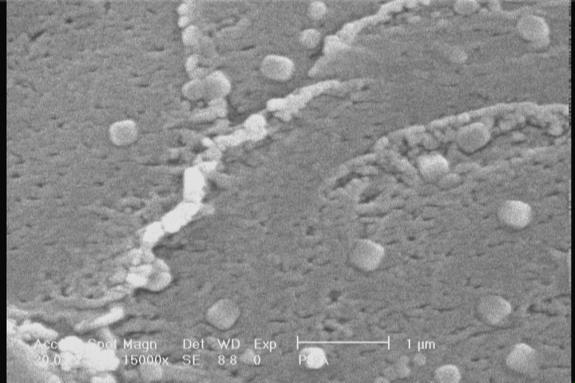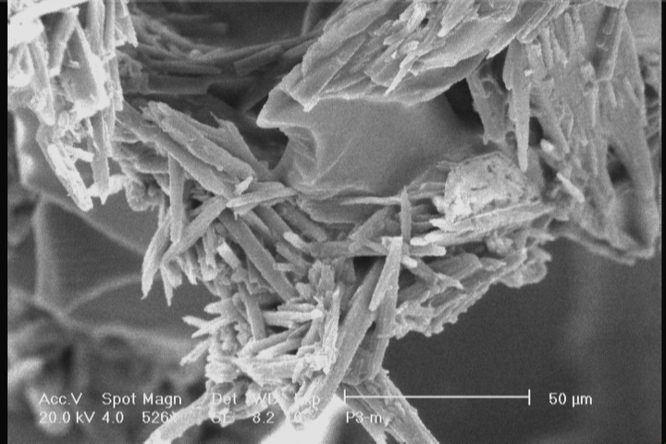

P-1+ 5-ASA PBDs-1S= P-1+ SA PBDs-1A=

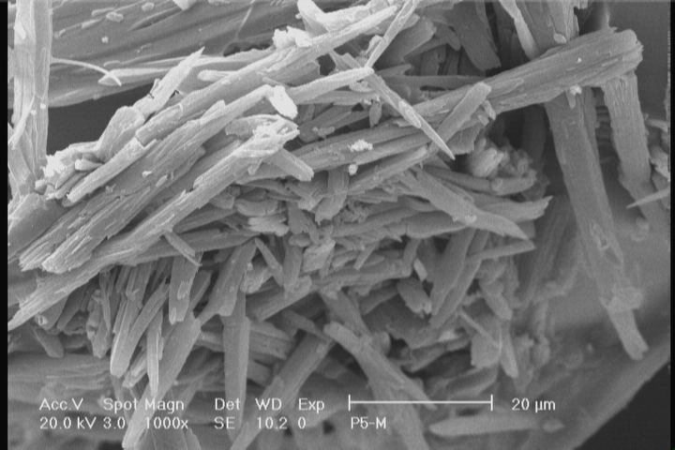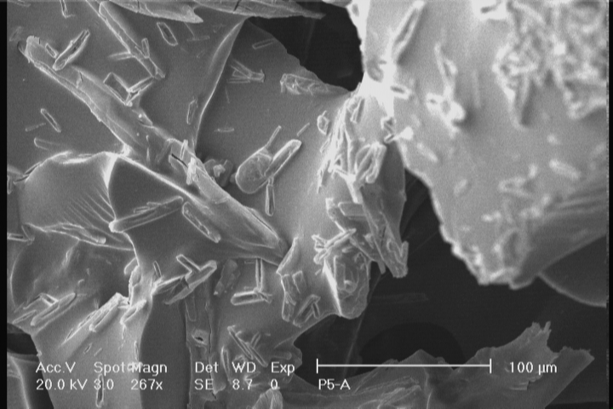

PBDs-2A= P-2+ 5-ASA PBDs-2S= P-2+ SA
Figure 1: SEM of nano polymer bonded drugs

Table 1. DSC data and composition of copolymers
Polymers | Molar composition of monomers in the feed  CMS (gr) MAA (gr) CA (gr) IN (gr) | Degree of  Substitution (DS) ¹ | Tg (º C)
P-1  P-2 | 1 3 0.05 0.05  1 2 0.05 0.05 | 0.49  0.49 | 130  142
1: the method described in the literature [14].

Figure 2. Time-dependent swelling behavior of micro and nano carriers as a function of time at 37ºC.

Figure 3. Equilibrium degree of swelling in response to pH

Figure 4. Release of drug from micro and nano polymeric carriers as a function of time at 37ºC.

Conclusion
The size and the nature of the incorporated drug play a very important role in determining the efficiency of its release from the carrier. An increase in the molecular size of the drug or PBDs reduces the drug release rate [17]. The swelling and hydrolytic behavior of the hydrogels was dependent on the content of MAA groups and caused a decrease in gel swelling in SGF or an increase in gel swelling in SIF. Modified CMS with different contents of MAA and CA by graft copolymerization reactions were carried out under microwave-radiation. The swelling of the hydrogels was dependent on the content of MAA groups and caused a decrease in gel swelling in SGF or an increase in gel swelling in SIF. Incorporation of MAA made the hydrogels pH-dependent and the transition between the swollen and the collapsed states occurred at high and low pH. The swelling ratios of the hydrogels increased at pH 7.4, but decreased at pH 1 with increasing incorporation of MAA. In odder hand, the drug release rate of the PBDs related to particle size of carrier and chemical structure of the drug in polymer. That increased by reducing of particle size. Based on the great difference in hydrolysis rate at pH 1 and 7.4, this modified natural polymer appears to be good candidates for colon-specific drug delivery.

Correspondence to:
Mehrdad Mahkam
Chemistry Department, Azarbaijan University of Tarbiat Moallem, Tabriz, Iran
mmahkam@yahoo.com

Received: 8/9/2007

References
- H. BrØndsted, J. Kopeček, Hydrogels for site-specific oral delivery, Proc. Int. Symp. Control. Rel. Bioact. Mater, 17, 128-129, 1990.
- 2. Mahkam, M.; Doostie, L.; the relation between swelling properties and cross-linking of hydrogels designed for colon-specific drug delivery; J. Drug Delivery. 2005, 12 (6), 343– 347.
- M. Mahkam, Using pH-sensitive hydrogels containing cubane as a crosslinking agent for oral delivery of insulin, Journal of Biomedical Materials Research (Applied Biomaterials), 15, 75B (1): 108-112, 2005.
- Krogars, K., Heinamaki, J., Vesalahti, J., Marvola, M., Antikainen, O., Yliruusi, J., Marvola, M. and Yliruusi, J., Extrusion-spheronization of pH-sensitive polymeric matrix pellets for possible colonic drug delivery. Int J Pharm, 199, 187-194, 2000.
- H. C. Chiu, G. H. Hsiue, Y. P. Lee, L. W. Huang, Synthesis and characterization of pH-sensitive dextran hydrogels as a potential colon-specific drug delivery system. J. Biomater. Sci. Polym. Ed, 10, 591-608, 1999.
- M. Mahkam, M. Allahverdipoor, R. Mohammadi, S. O. Ranaei-Siadat, M. R. Rashidi, S. Davaran, M. Barshan, and S. E. Ranaei-Siadat, An Oral Delivery System for Insulin. Journal of Bioactive and Compatible Polymers, 21: 135-148, 2006.
- G. Giammona, G. Pitarresi, G. Cavallora, G. Spadaro, New biodegradable hydrogels based on an acryloylated polyaspartamide crosslinked by gamma irradiation, J. Biomed. Sci. Polym. Ed, 10, 969-987, 1999.
- E. Jabbari, S. Nozari, Swelling behavior of acrylic acid hydrogels prepared by γ- radiation crosslinking of polyacrylic acid in aqueous solution, Eur. Polym. J, 36, 2685-2692, 2000.
- Mahkam, M.; controlled release of biomolecules from pH-sensitive hydrogels prepared by radiation polymerization; J. Bioact. Comp.Polym, 19(3) 209-220, 2004.
- Fanta G.F. and Doane W.M., Grafted Starches. In Modified Starches: Properties and Uses; Wurzburg, O.B., Ed., CRC, Boca Raton (Florida), 149-178, 1986.
- Athawale V.D. and Rathi S.C., Role and relevance of polarity and solubility of vinyl monomers in graft polymerization onto starch, React. Func. Polym., 34, 11-17, 1997.
- Peppas, N. A.; hydrogels in medicine and pharmacy, CRC Press: Boca Raton, FL. 1987.
- Lenaerts, V.; Couvreur, P.; Grislain, L.; Maincent, P.; bioadhesive drug delivery systems, CRC Press: Boca Raton, FL. pp 93-104, 1990.
- Honghua. Xu.; Tiejing. Li., The analysis of boundary functions of CMS reaction factors, J. Nature and Science, 3(2), 2005.
- US Pharmacopeial Convention, Inc. The United State Pharmacopeia, 24th ed. Rockvile, MD:US Pharmacopeial Convention, Inc.; 1999.
- Mahkam, M.; Sharifi, N.; Entezami, A. A.; regulation of controlled release of ibuprofen from crosslinked polymers containing cubane as a new crosslinking agent; J. Bioact. Comp. Polym. 15, 396-404, 2000.
- Ratner, B. D., Comprehensive Polymer Science– The Synthesis, Characterisation, Reactions & Applications of Polymers, Aggarwal, S. K., ed., vol 7, Pergamon Press, Oxford, pp. 201-247,1989.

