Morphological And Leaf Epidermal features of Capsicum Annum and Capsicum frutescens solanaceae.

Nwachukwu C.U. Department of Biology, Alvan Ikoku College of Education, Owerri, Imo State
Mbagwu F.N. Department of Plant Science and Biotechnology, Imo State University. Owerri, Imo State
Onyeji A. N. Department of Plant Science and Biotechnology, Imo State University, Owerri
nwachukwucu2005@yahoo.co.uk

ABTRACT: Studies on the morphological (vegetative and floral) and leaf epidermal features of Capsicum annum and Capsicum frutescens found in different parts of Imo State were investigated. This was with the main aim of evaluating their reliability as aid, in determining intraspecific relationship among these taxa. Morphological features among the two taxa studied include variation and in similarities, habit. The study show annual herb in capsicum annum and perennial herb in capsicum frutescens. Similarly the height of capsicum annum is 60cm, while capsicum frutescens is 72cm. Furthermore, the two taxa share common attributes as revealed in the stem, leaf and the floral morphology. The stem type, colour and bark shows that the two taxa are erect-branched from base, green and smooth respectively. The floral morphology furthers strengthens the Intraspecific relationship among these two taxa. The floral result reveals that the flower type, symmetry, Arrangement, Pedical Calyx and corolla colour and shapes are all the same in the two taxa studied. The leaf epidermal characters in the two taxa studied did not show much variation except in the number of stomata: 21 and 44 and 18 and 60 on he upper and lower surfaces of capsicum annum and capsicum frutescens respectively. The other attributes of stomata type, number of subsidiary cells, shape of epidermal cells and presence of trichome are the same for the two taxa hence this study confirms the values of morphological and leaf epidermal features in the systematics and biological consideration of capsicum annum and capsicum frutescens. [Nature and Science. 2007;5(3):54-60]. (ISSN: 1545-0740).

Keywords: Morphology; Leaf epidermis; Capsicum; Solanaceae; Systematics

INTRODUCTION
The genus capsicum belongs to the family solanaceae (Night shade). Members of the solanaceae family are mostly herbs or under herbs while some others are climbers. The family contains about 90 genera and nearly 3000 species (Vidyarth and Tripatha 2002, Stern 2000). The genus capsicum is further classified into the division Magnoliophyta, class magnoliopsida, order solanates and family solanaceae (Heiser and Smith 1953). Capsicum is a crop that is widely cultivated because of its spicy nature and nutritional value. The crop accounts for a large portion of vitamins A and C in many Nigerian diets. Capsicum annum and capsicum frutescens are the most common species in Nigeria. Heiser and Smith (1953) distinguished two capsicum species cultivated as vegetables while varieties are all froms of either capsicum annum or capsicum frutescens. Capsicum annum is not known in a wild state and species commonly cultivated are capsicum annum known as sweet pepper, bell pepper, cherry pepper and green pepper (Messraen 1992). Capsicum frutescens on the other hand occurs in the wild though became domesticated in many parts of the tropics. Species commonly cultivated is capsicum frutescens are known as bird eye pepper, red pepper and Tobasco pepper (Heiser and Smith 1953). Their economic importance has been discussed. In West Africa and in Nigeria in particular, capsicum annum and capsicum frutescens are third among the cultivated vegetables being utilized in the dry state as spice, capsicum content, an alkaloid that is a digestive stimulant is used in ointment for leaf of arthritic and neuropathic pains (Uzo 1982, Stern 2000). Capsicum species are rich in Vitamin A potency which is responsible for red colour in mature fruit, as well as ab out 50 - 280 Mg/100g of Vitamin C. Capsicum annum and capsicum frutescens are further used as pungent spices for domestic culinary purposes and by food manufacturing industries for seasoning of processed foods in the preparation of curry powder, hot sauce and in pickling (Tindall 1986). Capsicum species are mostly herbs with branched top roots. The stem is herbaceous, erect and hairy; leaves are alternate, opposite in flora region, simple and estipulate. The placentation is axile, ovules are numerous, style single terminating in a bilabed stigma. The fruit is a berry and the seed are minute endospermic with a straight or curved embryo (Esula 1977). The use of morphological and leaf epidermal features has been found to be of immense interest in taxonomy. An excellent review of the application of morphological features in systematic studies is shown in the works of Okwulehi and Okoli, 1999, Chakrabarty and Gupta, 1981 and Olowokudejo, 1990: Edeoga and Eboka 2000, Edeoga and ikem 2001 and Stern 2000. Furthermore, the use of leaf epidermal features (epidermal cell, stomata and trachoma) in systematics has become popular and distinctive and have been used as a great taxonomic tool at the levels of family, genus and species. The works of Paliwal (1967), Shah and Gopal (1972). Gill Karatela (1982), Edeoga (1991) Edeoga and Osawe (1996) are typical examples.
This study assesses the relevance of morphological and leaf epidermal features of capsicum annum and capsicum frutescens as well as to evaluate the reliability of these characters in the systematic consideration of the capsicum species studied.

MATERIALS AND METHODS
The laboratory was carried out at the plant Science and Biotechnology Department of University of Nigeria Nsukka between September and November, 2006. These studies were made on mature living fresh materials of capsicum annum and capsicum frutescens collected from the garden behind the Education trust fund Block 11, the staff nursery/primary school garden and the garden beside Saint Joseph Chaplaincy all within Imo State University, Owerri, Imo State.
For Moephological studies Twenty mature leaves of each taxa from the middle portion of the plants were collected length and width of the leaves were measured using a zoom meter rule. The length of the leaf was obtained by spreading the middle leaflet on a flat surface on the laboratory bench, while for the width the same media leaflet was chosen and measured to ensure uniformity Olowokudgo (1990). The seed number per pod was obtained by counting the number of seeds in the biggest pod of each taxa to ensure consistency. Photographs of the fresh materials were taking using ordinary camera and characters of the two taxa were divided into vegetative and floral morphology and tabulated.
For the leaf epidermal features, twenty samples of each species of capsicum studied were examined using light microscope. An area of about 1cm square was removed from a central standard position, always midway between the base and Apex of the mature and fresh leaves of the two taxa studied. Epidermal preparations were made by boiling the collected materials of each of two taxa in different test tubes containing 70% ethanol for 10min. These were allowed to cool and latter bleached in 8% sodium hydrochlorite (Naocl) for 5min.
Epidermal peals were stained with 1% ethanol safranin and temporarily mounted in aqueous glycerol solution (Cutler, 1978). Photo micrographs of the epidermal features were taken from the slides using a Leitz wetzlar ortholux microscope fitted with a vivitar v-35 camera.

RESULTS
The morphological (vegetative and floral) and leaf epidermal features of capsicum annum and capsicum frutescens investigated are summarized in Table 1, 2 and 3 for the morphology and Table $ for the leaf epidermis and illustrated in (Fig. 1a – b and 2a – b). The vegetative results of the two taxa studied showed that the habit and height of capsicum annum annual herb and 60cm while of the habit and height of capsicum frutescens is perennial herb and 72cm respectively. The habit still can from the herbecous nature of these taxa. The attribute of stem type, colour and bark are similar to both taxa. Similarly the leaf shape, leaf Apex, leaf base and leaf type equally revels similarity in both taxa except for leaf arrangement which is Alternate in capsicum annum and opposite in capsicum frutescens Table 2.
Furthermore, the floral result of the two taxa studied showed that the attribute of flower type, floral symmetry, pedicel, calyx colour, shape, corolla colour, fruit type are the same in the taxa. The difference in the floral result is observed in the flower arrangement: opposite in capsicum annum and Alternate in capsicum frutescens,: Corolla fusion: fused in capsicum annum and free in capsicum frutescens and fruit shape indicates ovoid in capsicum annum and linear in capsicum frutescens Table 3.
The result of the leaf epidermal features of capsicum annum and capsicum frutescens investigated are summarized in Table 4. The shape of the epidermal cells of the upper and lower surfaces is irregular and sinuous in both taxa studied. The two capsicum taxa were amphistomatic having stomata at both the adaxial (upper) and abaxial (lower) surface of the leaf. The distribution of stomata on both the upper and lower surface of the studied reveal anomocytic type of stomatal arrangement. The stomatal index range from 18% - 21% in the upper surface of two taxa studied respectively and from 44% in capsicum annum, 60% in capsicum frutescens in the lower surface respectively. This implies that the stomatal density is therefore highest on the lower epidermis and lowest on the upper epidermis. They were absence of trochomes in the capsicum taxa investigated.

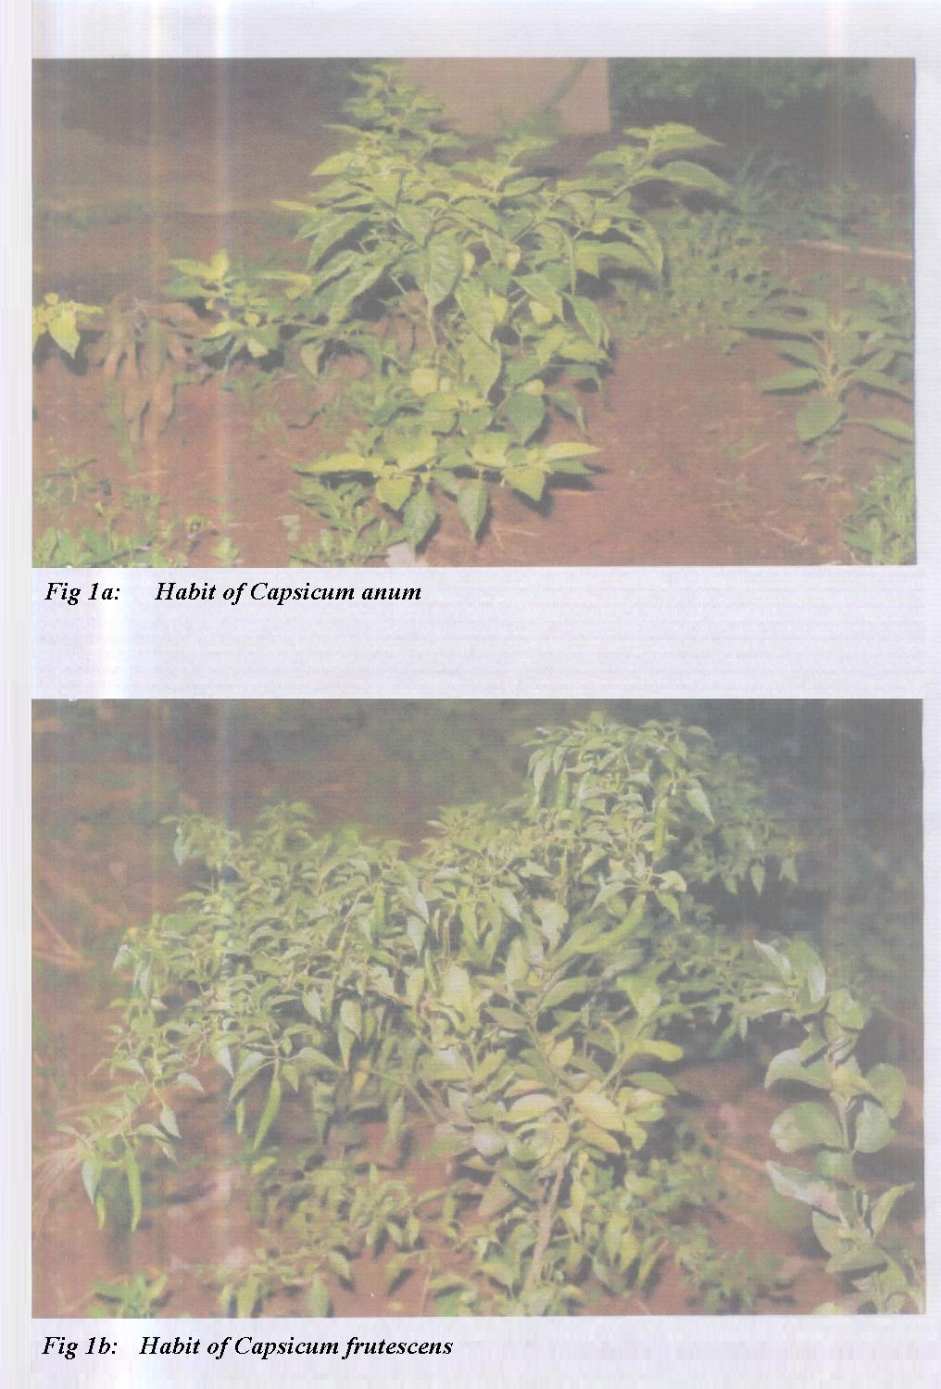

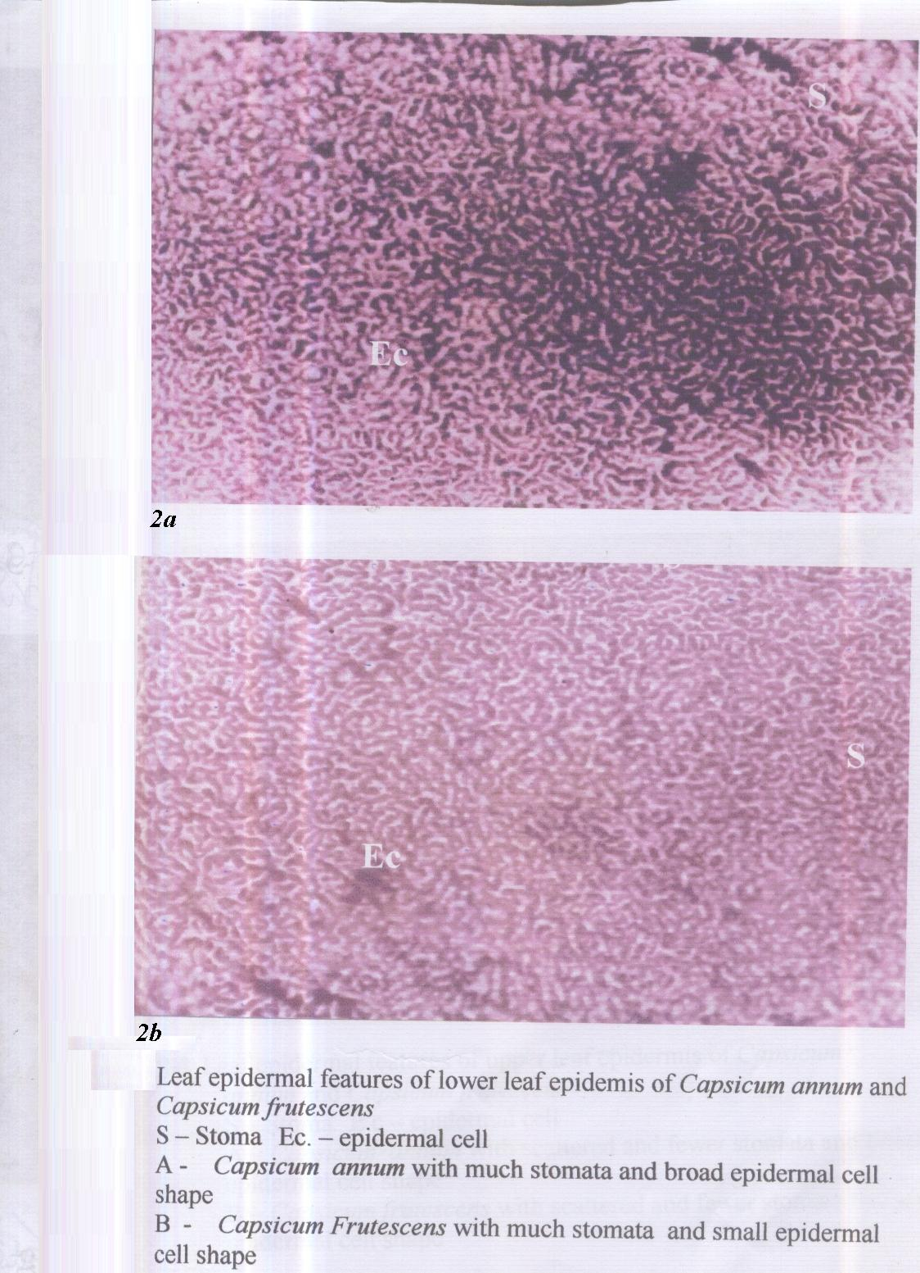

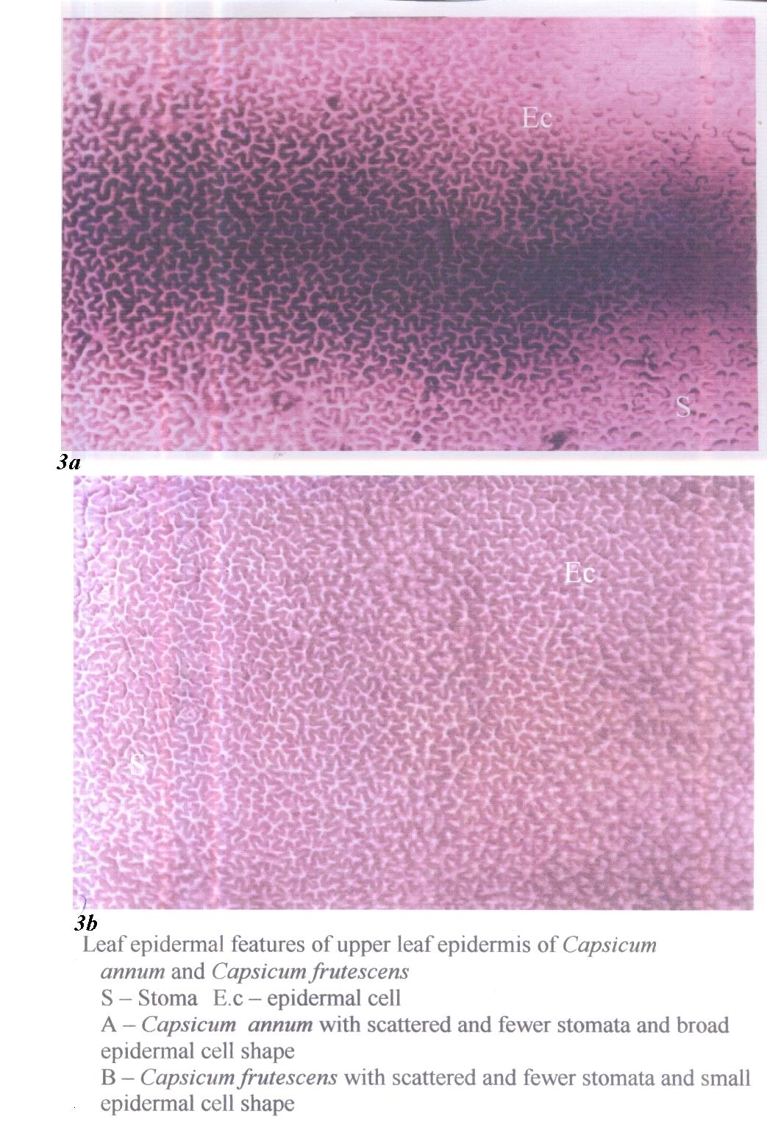

Table 1. Vegetative characters of the two Capsicum species studied

Character | Capsicum annum | Capsicum fructescens
Habit | Annual herb | Perennial herb
Height | 60cm | 72cm
Stem type | Erect branched from base | Erect branched from base
Colour | Green | Green
Bark | Smooth | Smooth
Leaf texture | Smooth | Smooth
Leaf arrangement | Alternate | Opposite
Leaf shape | Ovate | Ovate
Leaf apex | Mucronate | Mucronate
Leaf base | Round | Round
Leaf type | Simple | Simple
Length(cm) | 9.9± 1.13 | 5.35±0.15
Width (cm) | 4.9±0.8 | 4.2±1.1

Table 2. Floral morphological characters of the two Capsicum species studied

Character | Capsicum annum | Capsicum fructescens
Flower type | Auxillary cyme | Auxillary cyme
Floral symmetry | Actinomorphic | Actinomorphic
Arrangement | Opposite | Alternate
Pedicel | Erect | Erect
Calyx colour | Greenish white | Greenish white
Shape | Elliptic | Elliptic
Corolla colour | White | White
Corolla free/fused | Fused | Free
Fruit type | Pod | Pod
Fruit shape | Ovoid | Linear
Seed number per pod | 4 seeded | 6-8 seeded
Pod length(cm) | 1.5±0.11 | 5.35±0.15
Pod width(cm) | 2.65±0.25 | 4.15±0.35

Table 3. list of Capsicum species from which fresh materials were collected

Collection number | Taxa | Locality | Collector(s) | Place of deposition
001 | C .annum | Staff nursery/primary school garden  Garden behind education trust fund block ǁ  Garden beside St Joseph catholic chaplaincy | Onyeji Augustina Nwamaka  Ojimba Chioma  Akpaka Doris | IMSUH
002 | C. fructescens | Staff nursery/primary school garden  Garden behind education trust fund block ǁ  Garden beside St Joseph catholic chaplaincy | Iwuchukwu Ikechukwu  Iwu Jane  Ochiji Chidimma | IMSUH
IMSUH: Imo State University Herbarium

Table 4. Epidermal characteristics of the Capsicum species studied

Characters | C .annum |  | C .fructescens
Characters | Upper surface | Lower surface | Upper surface | Lower surface
Shape of epidermal cell | Irregular and sinuous | Irregular and sinuous | Irregular and sinuous | Irregular and sinuous
Stomatal type | Anomocytic | Anomocytic | Anomocytic | Anomocytic
% stomatal index | 21 | 60 | 18 | 44
Number of subsidiary cells | None | None | None | None
Trichomes | Absent | Absent | Absent | Absent

DISCUSSION
The result of the morphological and leaf epidermal features of capsicum annum and capsicum frutescens studied show some characteristic that could be used for taxonomic decision. Morphologically, the vegetative features of habit and height of capsicum annum separate it from capsicum frutescens. The observation is in line with earlier works of Okwulehi and Okoli, 1999, and Edeoga and Eboka 2000, who used comparative morphology of different species in establishing relation among various taxa. The result of leaf arrangement showed alternate shape in capsicum annum and opposite in capsicum frutescens. This observation is supported by the works of Edeoga and Eboka 2000, in Dissotis (Okeke and Nwachukwu 2001) in Euphorbiaceae but not in the genus capsicum.
The result of the leaf epidermal studied indicates that the shape of epidermal cells of the capsicum species studied are irregular and sinuous. Similarly, the two taxa are amphistomatic with more stomata on the lower surface (abaxial) than the upper surface (adaxial). The percentage stomatal index of the two taxa was highest on the lower epidermis 44% – 60% compared to the epidermis and 18% – 21%. The stomatal index result is not strange since Olowokudejo (1990) found stomatal index valuable and very reliable indistinguishing between the leaves of medicinal species of ocimum from non medicinal ones. The absence of irichome in the two taxa studied is not of taxonomic importance since Esua (1977) insisted that much reliability is not always accorded to trichomes alone for taxonomic conclusion due their similarity in different species. The anomocytic type of stomata found in the two capsicum species indicates that the species are phylogenetically related (Mbagwu 2005). The morphological (vegetative and floral) and leaf epidermal features of the taxa studied conforms the intraspecific relationship between capsicum annum and capsicum frutescens in their stem, leaf, flower, fruit, seed, stomatal type and index attributes hence the differences in leaf and flower arrangement, fusion of corolla and fruit shape are not enough to separate the two taxa studied. These distinguishing morphological and leaf epidermal features observed in this investigations are of systematic value because they are reasonably constant in the taxa stuied. Olowokudejo (1990) made similar observation in the genus Anonna. The purpose of this study is to show that application of morphological features has proven to be of immense assistance in interpreting problems related to pant classification. Thus the necessity of including the results from the morphological and leaf epidermis with data derived from other botanical disciplines remain vital when formulating conclusions on the systematic of the capsicum species.

Correspondence to:
Nwachukwu C.U.
Department of Biology,
Alvan Ikoku College of Education
Owerri, Imo State
nwachukwucu2005@yahoo.co.uk

Received: 9/14/2007

REFERENCES
- Baily O.S (1948) In Daniel O. 1960. Flora of Tropical Africa, vol.2, Reeve and Co. Convent Garden, London, Pp. 613.
- Chakrabarty T. and Gupta 1981. Morphological studies on three herbaceous species of railway tract. Proc. Int Aced. Sci. Pl. 90:305-315.
- Cutler D.F 1978. Applied Plant Anatomy. Longmans, London and New York. Pp. 2 – 9.
- Edeoga H.O 1991. Taxonomic studies on certain of Dioscorea L. (Dioscoreaceae) in Eastern Nigeria. Phd Thesis, University of Porthacourt, Nigeria.
- Edeoga H.O and Eboka A.U 2000. Morphology of the leaf epidermis and systematics in some Dissotis species Benth (Melastomataceae). Global J. pure and applied sci. 6:371-374.
- Edeoga H.O and Ikem C.L 2001. Comparative Morphology of the leaf epidermis in three species of Boehavia L Nyctagin inaceae. J.Pl. Anat Morph, 1:14-21.
- Edeoga H.O and Osawe P.I 1996 Cuticular studies on some Nigerian species of senna Tourn. Ex Mill (Syn cassia ex.L) Leguminosae-Caesalpinoideae. Acta Phyto tax Geobot 47:41-46.
- Esua K. 1977. Anatomy of seed plant (2nd Edition) Wiley, London, Pp: 83-97.
- Gill, Hs. Thakur P.C and Thakur T.C 1973. Combining ability in sweet pepper capsicum annum, J. Agric Science. 43 (10): 918-921.
- Gill, L.S and Karatela Y.Y 1982. Epidermal structure and stomatal ontogeny in some Nigerian curcubitaceae. Willdenowia 12:303-310.
- Heiser, C.B and Swith P.C 1953 the cultivated capsicum. Eco. Bot 1:214-227.
- Messiaen C.M 1992. The Tropical Vegetable Garden. Macmillian (London) Pp 235.
- Okeke S.E and Nwachukwu C.U 2001. Characterization of Maesobotra barterivar barteri. Nig. J. Bot. 13:70-80.
- Okwulehi I.C and Okoli B.E 1999. Morphological and Palynological studies in some species of Corchorus L. Tiliaceae, New Botanist: 25:87-101.
- Olowokudejo J.D 1990. Comparative Morphology of leaf epidermis in the genus Annona (Annonaceae) in West Africa, phytomorphol, 40:407-422.
- Paliwal G.S 1967. Structure and Ontogeny of stomata in some coryphylliaceae. Phytomorphology 16:533-532.
- Purseglove J.W 1987. Tropical Crop. Dicotyledons. Longman (Singapore) Pp 718.
- Shah G.L and Gopal B.V 1972. Some observation on the diversity of stomata and trichomes in some species of Dioscorae. Ann. Bot. 36:997-1004.
- Sterm K.R 2000. Introductory plant biology, Mac Graw Hill Company Inc. United Sataes of America. Pp 630.
- Tindall H.D 1986. Vegetables in the Tropics (afford) Pp 35-38.
- Vidyyarltie R.D and Tripathi S.C 2002. A text Book of Botany. S. chand and Company Ltd. 7361, Ram Nagar, New Delhi 1054 Pp.

