Synthesis and characterization of hybride polyaniline / polymethacrylic acid/ Fe₃O₄ nanocomposites

Mohammad Reza Saboktakin*, Abel Maharramov, Mohammad Ali Ramazanov

Department of Chemistry, Baku State University,Baku, Azarbaijan
* E-mail: saboktakin123@yahoo.com

Abstract: In this paper, we present the synthesis of Fe₃O₄ nano particles of hybrid for coating on metal or glass surfaces.The synthesis of the organic/inorganic nanocomposite is described. This nanocomposite is a water – dispersible polymeric complex of polymethacrylic acid and polyaniline.The water dispersible hybride material was coated on aluminum using a molecular layer – by – layer coating. The composites, Thus synthesized have been characterized by infrared spectroscopy and X-ray diffraction. The morphology of these samples was studied by scanning electron microscopy. [Nature and Science. 2007;5(3):67-71]. (ISSN: 1545-0740).

Keywords: Hybride nanocomposites, polyaniline , polymethacrylic acid

1. Introduction
Polymer nanocomposites constitute a class of hybrid materials composed of a polymer matrix and an inorganic component which has at least one dimention in the nanometer (<100 nm) size domain. Nanoparticles were first developed around 1970. The synthesis of metallic nanoparticles has become an extremely interesting topic in the field of material science , due to the wide range of optical and electronic properties that are accessible in the nanometer –size regime.Nanometer scale hybride materials is currently an area of active research.[1] These nanomaterials are hybride between organic and transition metals or rare earth oxides , for example cerium oxide , ferrous oxide ,… [2]. metallic nanocomposites have emerged as a new class of materials because of their unique electrical, optical and chemical properties[3].
The properties of a polymer – reinforced composite are mostly influenced by the size, shape,composition ,state of agglomeration, and degree of matrix inorganic component[4]. Decreasing the particle size to the nano-size dimension influence the macroscopic properties of the polymer because a breakdown of the common rule – of – mixture theory occurs[5]. This breakdown is caused by the amount of interfacial zone that gains importance with respect to the phase relative to bulk behavior[6].
Demonstrated application of such composites can be found ,among others, in the fields of optics, mechanics,iono-electronics,biosensors, flame retardants and membranes.
In this paper , we explore the synthesis of the new hybride material with the water- dispersible polyaniline /polymethacrylic acid as the organic component and the nano solution of Fe₃O₄ at the sodium dodecyl sulfate /H₂O as the inorganic component. The nano magnetic Fe₃O₄ has a diameter between 10 to 12 nm. We report the synthesis method of polyaniline and polymethacrylic acid nanocomposit with Fe₃O₄ nano particles. Since the organic / inorganic hybrid nanocomposites are dispersible in water, they are suitable for coating on glass or metal substrates.

2. Experimental
Materials
Nano particles of Fe₃O₄ were purchased from nanotechnology center of baku state university. The particles have an average of 10 - 12 nm. Methacrylic acid and aniline were purchased from Aldrich chemicals. Aniline was purified by distillation under vacuum.

Instruments
The images of nanoparticles were investigated using Philips XL30 scanning electron microscope. The Fourier transfer infrared (FTIR, Bruker) spectroscopy was used to identified the polymer on the Fe₃O₄ nano particles surface. Spectra were obtained in the wave number range of 400-4000 cm⁻¹. Spectra of the polyaniline / poly(methacrylic acid) modified Fe₃O₄ nanoparticles were recorded from KBr in 1:10 (wt/wt) ratio.

Synthesis of polyaniline: polymethacrylic acid complex
The organic component of this nanocomposite is an inter- polymer complex of conducting polymer[7] .Previously the method for synthesizing the molecular complexes PAN:PAA was reported[8]. This component consists of two polymer s that a double-strand molecular complex [9].The first strand is polyaniline (PAN) and second stand is polymethacrylic acid (PMAA).We use polymers PAN:PMAA as a short hand representation of the complex. Figure 1 show a structural representation for PAN:PMAA.

The several method for synthesizing the molecular complexes was previously reported [10] .This synthesis base involves two steps : In the first step , monomers of aniline are adsorbed onto the poly(methacrylic) backbone by molecular self –assembly. In the second step, the adsorbed aniline monomers are polymerized by an oxidant (potassium persulfate) to form polyaniline.

Adsorption of aniline on poly(methacrylic acid)
0.012 mole (3.5 gr) poly(methacrylic acid ) (90,000 MW ) dissolve in 25 grams distilled water. Stir for 2 hours. Then add 0.558 gram of aniline to solution, stir for 4 hours to allow equilibrium adsorption. The molar ratio of the PMAA component to the aniline is 2:1 .

Polymerization of aniline to form the polymer complex
Acidifiy the solutiom prepared by adding 4 ml 3M Nitric acid .Dissolve 0006 mol potassium persulfate with 10 ml distilled water. Mix these two solutions to start the polymerization reaction. The solution turned to dark green. Stir for 24 hours to obtain a homogeneous solution of the polymeric complex. The polymeric complex is a dispersion of particle of 100-200 nm in diameter. The infrared absorption spectra of the complex are consistent with the structure of a polymeric complex of polyaniline and poly(methacrylic acid ) .

The physical absorption of the polymeric complex and nano Fe₃O₄ particles
Stir Fe₃O₄ dispersive solution with sodium dodecyl sulfate / distilled water with mechanical stirring. A diluted solution of the PMAA: PAN complex is then mixed with Fe₃O₄ solution (25% Fe₃O₄) for 10 minutes. The average molar ratio of the components is PMAA:PAN:Fe₃O₄ = 2:1:2. The dispersion is stable with very small amount of precipitation.

3. Results and Discussion
Scanning electron micrography
SEM of polyaniline – poly(methacrylic acid) nanocomposite synthesized by chemical oxidative is shown in Figure 1(P3-A). PAN/PMAA nanocomposite is very sensitive to the temperature. Due to the intractionelectron and sample. Scanning electron micrography images were obtains from a diluted solution of the nanocomposite particle. The white spots are Fe₃O₄ nano particles. The SEM image shows the presence of spherical Fe₃O₄ particles in PAN/PMAA composite, which are homogenenously distributed throughout the composites, which is also confirmed from XRD studies[11].

X-ray diffraction
The crystallinity of the formed composites was followed with X-Ray diffraction(XRD) as s function of weight percent inorganic component. Figure 2a shows X-ray diffraction pattern of polyaniline – poly(methacrylic acid) complex ( 0 % Fe₃O₄) .Diffraction of PAN-PMAA have a broad peak at about 2Ө = 25.92 ˚ , which is a characteristic peak of PAN-PMAA (Wan et al 1994 , Wan and li 1998) . Studies on XRD patterns of PAN-PMAA are scarce in the literature (Rajendra Prasad and Muunichandriah 2002 ). Figure 2b shows the XRD pattern for PAN-PMAA-Fe₃O₄ (25% ). The diffraction pattern of PAN-PMAA- Fe₃O₄ nanocomposite shows a peak at about 2Ө = 26.89˚[12] .

Fourier transfer Infrared spectra
Figure 3 shows the FT-IR spectrum of polyaniline – poly(methacrylic acid) nanocomposite , where the % of transmittance is plotted as a function of wave number (cm⁻¹). The characteristic FT-IR peak at 1523 and 1485 cm⁻¹ are due to the presence of quinoid and benzenoid rings, respectively and are clear indication of these two states in the polymer chain. Also, The peaks at 1176, 1710 cm⁻¹ are due to the C-N, C=O bond stretching vibration ,respectively . Figure 4 shows the FT-IR spectrum of polyaniline – poly(methacrylic acid) composite with Fe₃O₄ nanopaticles. The FTIR spectra of PAN/PMMA composite in presence of Fe₃O₄ exhibite new adsoption peaks distinctly at 1562,1479,1295,1132 and 799 cm⁻¹ which are assignable to the presence of various metal oxide in the composite.

Fe₃O₄ nano particles

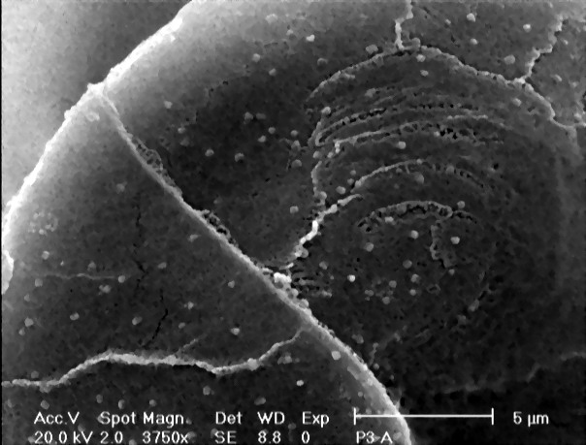

Figure 1. Scanning electron micrograph of PMAA:PAN:Fe₃O₄ nanocomposite

Figure2a. XRD spectra of polyaniline – poly(methcrylic acid ) complex

Figure 2b. XRD spectra of polyaniline/ poly(methcrylic acid )/Fe₃O₄ nanocomposit

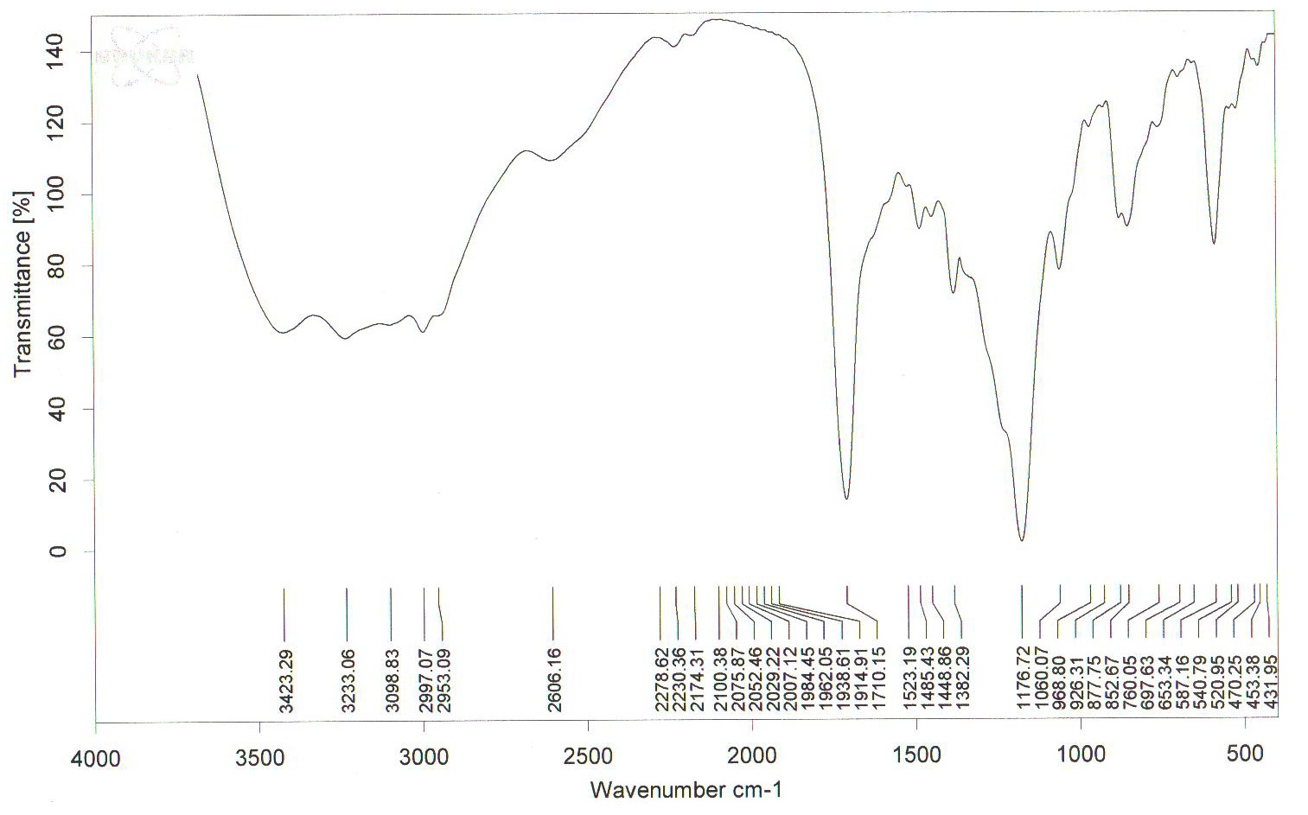

Figure 3. FT-IR spectra of polyaniline / poly(methacrylic acid) complex

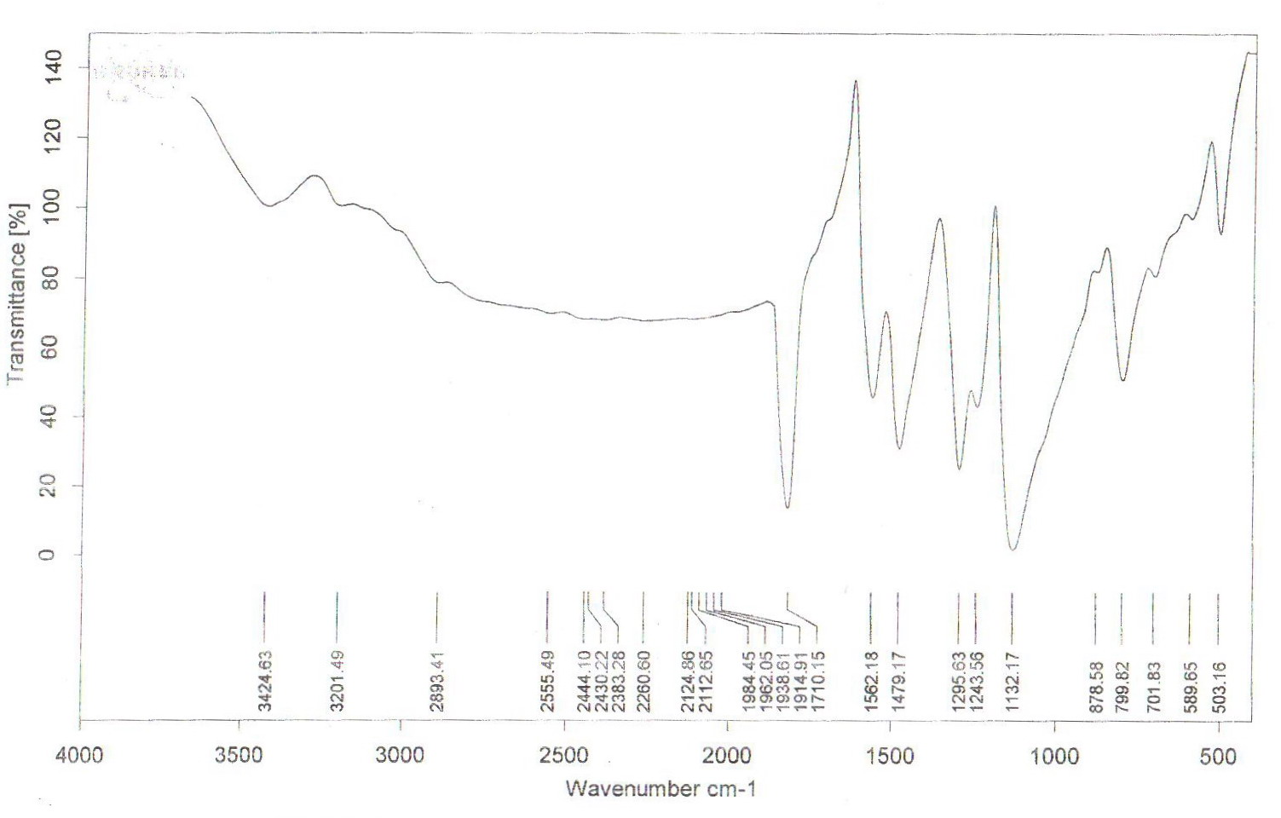

Figure 4. FT-IR spectra of polyaniline / poly(methacrylic acid) / Fe₃O₄ nanocomposite

4. Conclusions
We have synthesized new hybride polyaniline – poly(methacrylic acid) / Fe₃O₄ by in situ polymerization in the presence of Fe₃O₄ nano particles .This nanocomposite show semi-crystalline nature, whereas the PAN-PMAA synthezied is amorphous in nature. The SEM photograph of nanocomposite with 25% Fe₃O₄ show the presence of cenospheres.
These nanocomposites are suitable materials for high technology industries. The organic component is the hybride material have the dimention of 100-200 nm. One type of the composite is synthesized by preparing a precursor that contains the Fe₃O₄ nano particles, the poly(methacrylic acid) and the aniline monomers.
The composites were coated on glass and metal surfaces by the method of layer-by layer coating of self – assembled multi layers.

Acknowledgment
The authors Wish to thank M. Allahverdiev (Baku State University) for Valuable discussions.

References
- P.F.W. Simon , R. Ulrich, H.W. Spiess , U. Wiesner, Cem.Mater,13 , 3464, 2001.
- B.O’Regan,M.Gratzel, Nature,353,737,1991.
- A.J.Zarur,J.Y.Ying,Nature,403,65,2000.
- J.M.Liu and S.C.Yang, J.Chem.Soc.,Chem.Comm.,1529,1991.
- J.O.Stoffer,T.J.O’Keefe,X.Lin,E.Morris,P.Yu,S.P.Sitaram,US Patent 5,932,083.
- S.P.Sitaram, P.Yu, T.J.O’Keefe and J.O.Stoffer ,Polym.Mater.Sci.Eng.,75,354,1996.
- L.Sun,H.Liu,R.Clark,S.C.Yang,Syn.Met,85,67,1997.
- J.M.Liu,L.Sun,J.H.Hwang, S.C.Tang,H.L.Wang,Mat.Res. Soc.Symposium Proceeding, 247,601,1992.
- P.A.McCarthy,J.HuAng,S.C.Yang,H.L.Wang, Langmir,18,259,2002.
- Z.Tang ,N.Alvarez and Sze Yang , Mat.Res. Soc.Symposium Proceeding , 732,601,2003.
- S.C.Raghavendra.S.Khasim,M. Revanasiddappa,M.V.N. Ambika Prasad and A.B.KuKarni,Bull.Mater. Sci,26,7,2003.
- S.P.Armes, J.F. Miller,Synth. Met.22,385,2001.

