Ion implantation damage in GaN layers investigated by an ellipsometric method

B. Bouafia¹, Dj. Boubetra²

Optics Laboratory, Setif University 19000 Algeria, Centre Universitaire Bordj Bou Arreridj 34000 Algeria
E-mail: boubetra@gmail.com

Abstract: Ion beam damage in semiconductors is connected with marked changes in dielectric function. In the low energy range, the damage is localized to a thin surface layer and the optical properties are sensitive to the ion species and energy and to the dose implanted. This can be detected by ellipsometric measurements. To show this, a section of an Ar ion beam was recorded by scanning ellipsometry of GaN/GaAs and GaN/Si that had been exposed to 500 eV-3000 eV ion beam. For more detailed analysis, it is necessary to develop a suitable layer Model that can be fitted to the ellipsometric data. Such a procedure allows to restore the depth resolution, which is normally not an intrinsic feature of ellipsometry. [Nature and Science. 2007;5(4):29-33].

Keywords: Ion beam damage, Ellipsometry, Implantation, Amorphization

1. Introduction
Radiation damage theories are based on the assumption that a lattice atom struck by an energetic atom must receive an amount of energy to be displaced from its lattice site. Therefore, the deposited ion energy can be used as well as the number of the produced defects [1]. It is well know that the most used theory of ions transport in the matter is the LSS Theory [2]. According to this theory, the ion range has Gaussian distribution with projected range Rp, and projected range straggling R.
The investigation of implantation parameters (ranges, straggling, and damage distributions) requires methods with a depth resolution in the order of monolayers. Ellipsometry is such a method, even suited to enlighten details of the collision processes, because ion implantation often causes changes in the optical state of the target (especially in the case of semiconductors).
The amorphization of semiconductors crystal by ion implantation [3, 4, 5] or by deposition [6, 7] with marked changes of the dielectric function wich can be detected with a high sensitivity by ellipsometry. In the low-energy range, the damage is localized to a thin surface layer. For a more detailed analysis of ion target-interactions, it is necessary to develop suitable multi-layer model that can be fitted to the experimental data [5, 8-10]. Such a procedure allows to restore a depth resolution, which is normally not an intrinsic feature of ellipsometry.
It will be shown in the presented paper, that using special developed model [11] and ellipsometric measurements these changes can provide informations about relevant parameters of the amorphization process as the amorphization state and the critical concentration.
The method will be demonstrated here for the case of low-energy argon implantation in gallium nitride on gallium arsenide and on silicon. Gallium nitride on arsenide alloys and silicon is promising for optoelectronic devices working in the visible wavelength zone [12].

2. Experimental
Gallium nitride samples with GaN thicknesses of about 600 nm to 900 nm were implanted with argon ions from a Kaufman-type source with energies from 500eV to 3000eV. GaN layer thickness and ion energy have been adjusted that the maximum of the range distribution was located in the interface. The value of the ion dose determines the kind of the buried damaged layer (below or above the amorphous threshold, voids) and its extent in the depth.
The GaN films were fabricated by reactive magnetron sputtering in Ar 99,99% - N₂ 99,99% gas mixture. A 99,99% purity Ga was used as target. The start pressure was 10⁻³ Pa. The substrate was located at 50 mm downstream from the target. The films were deposited at 0,6Pa. The partial pressure N2/Ar was 1,75. The substrates used in these experimental work were quartz for transmission measurements and GaAs with (100) orientation, (n=2.10¹⁷cm⁻³) and Si with (111), orientation (n=1.10¹⁸cm⁻³) for ellipsometric investigations.
The structure of the sample was investigated by X-ray diffraction. The analysis shows an amorphous structure of the GaN layer at ambient temperature. The GaN Layer does not show a luminescence.
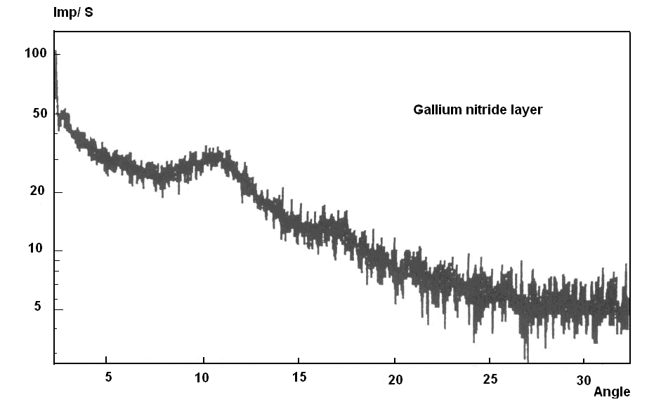
Figure 1. X-ray diffraction diagram of reactive sputtered GaN layer is the figure caption.

Experimental results of optical transmission as function of wavelength of GaN/quartz film with quartz substrate as reference is shown in Figure 2. The interferences maxima in spectra. Curves are located very closely. This indicates that GaN has very high transmission and possess low absorption in the visible a part of the spectrum (λ>400 nm). As indicated in Fig.2 the average transmittance of GaN film is about 85%.
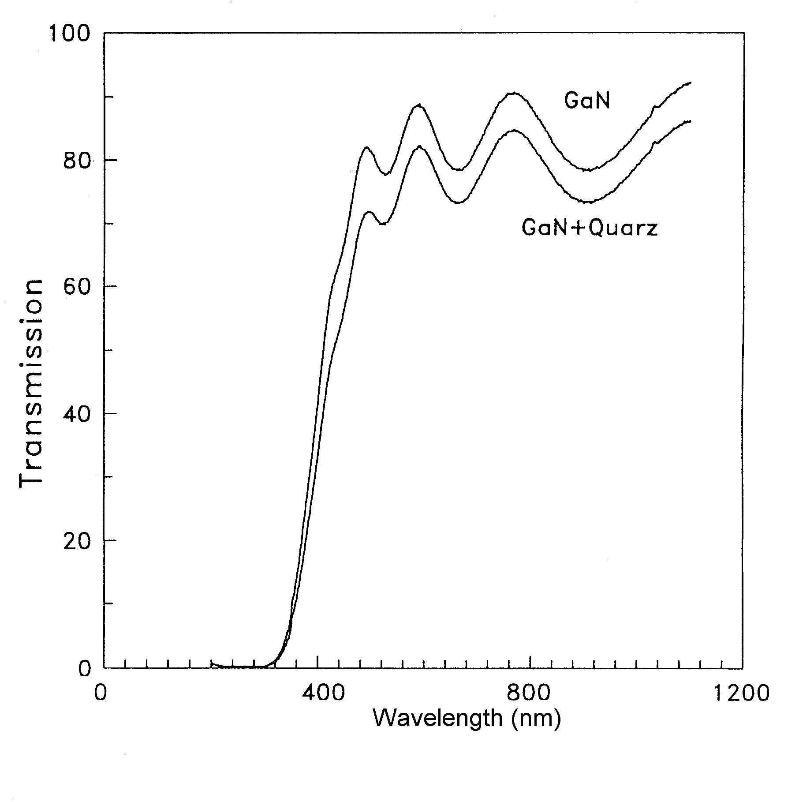
Figure 2. Optical transmission of gallium arsenide in dependence of the wavelength..

The ellipsometic measurements were accomplished using rotating analyzer ellipsometer (Sentech Instruments, Germany) with the fixed laser wavelength 632,8 nm (1,96eV). The angle of incidence has been chosen to 70° at this angle the laser spot is elliptical with an area of about 6 mm². Some measurements at other angles were only performed to verify the model. The measuring results of ellipsometry are available in the form of the ellipsometric angles ψ and Δ that are correlated with the amplitude and the phase of the complex reflectance ratio:
$ρ=\frac{r_{p}}{r_{s}}=\text{tan}{\text{ψe}}^{iΔ}$ (1)
where r_{p} and r_{s} are the reflection coefficients of the p- and s-polarized components.

3. Results and analysis
The amorphization behaviour has been analyzed by developed optical model. The model used here concerns the lower and medium dose range, I.e, doses below the threshold of Ar void formation. In the model, it will be assumed that the maximum of the damage depth distribution is located not far from the interface (for example GaN/GaAs) and that the distribution can be approximated by a Gaussian (Fig. 3). The first condition is well satisfied in the chosen energy range for GaN layer thicknesses. The approximation of the damage distribution by a Gaussian is quite good, because only the part in the GaAs respectively Si must be considered attributed to the missing optical influence of ion bombardment in the GaN.

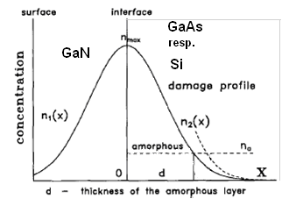
Figure 3. Schematic diagram of the damage distribution ray diffraction diagram of reactive sputtered GaN layer

Two regions can be distinguished (see fig.4). First, the region of highly damaged GaAs respectively Si above the amorphization threshold, which results in an optical homogeneous layer with the refractive index $\tilde{n}=n−\text{ik}$ for amorphous semiconductor, even though the argon ions and the displacement events are not homogeneously distributed. Second, the region that is influenced by the tail of the argon depth distribution. Since no complete amorphization is reached in this region, $\tilde{n}=n−\text{ik}$ will change depending on the depth [13].
The thickness d of the amorphous layer d is given by the parameters of the damage distribution. If the maximum of the assumed Gaussian damage distribution is exactly located in the interface, d² is simply given by:
$d^{2}=2δ^{2}\text{ln}\frac{n_{\text{max}}}{n_{a}}=2δ^{2}\text{ln}\frac{D}{D_{a}}$ (2)
while δ is the standard deviation of the damage depth distribution, n_{max} the maximum concentration of the defects, n_{a} the threshold defect concentration of (optical) amorphization, D the ion dose, and D_{a} the amorphization dose leading to n_{max} = n_{a}.

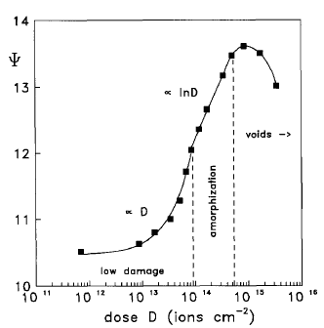
Figure 4. Measured Ψ values for the 1500 eV implantations in dependence on the Ar ion dose

From ψ and Δ values both the thickness and the complex refractive index $\tilde{n}=n−\text{ik}$ of the respective amorphous zone can be derived by fitting model calculations to the measure values. Concerning the amorphization behaviour, the thickness of amorphous GaAs has been found 8 nm. For amorphous GaAs the refractive index value $\tilde{n}=4\text{.}\text{30}−i0\text{.}\text{70}$ was an acceptable fit for all values investigated here.

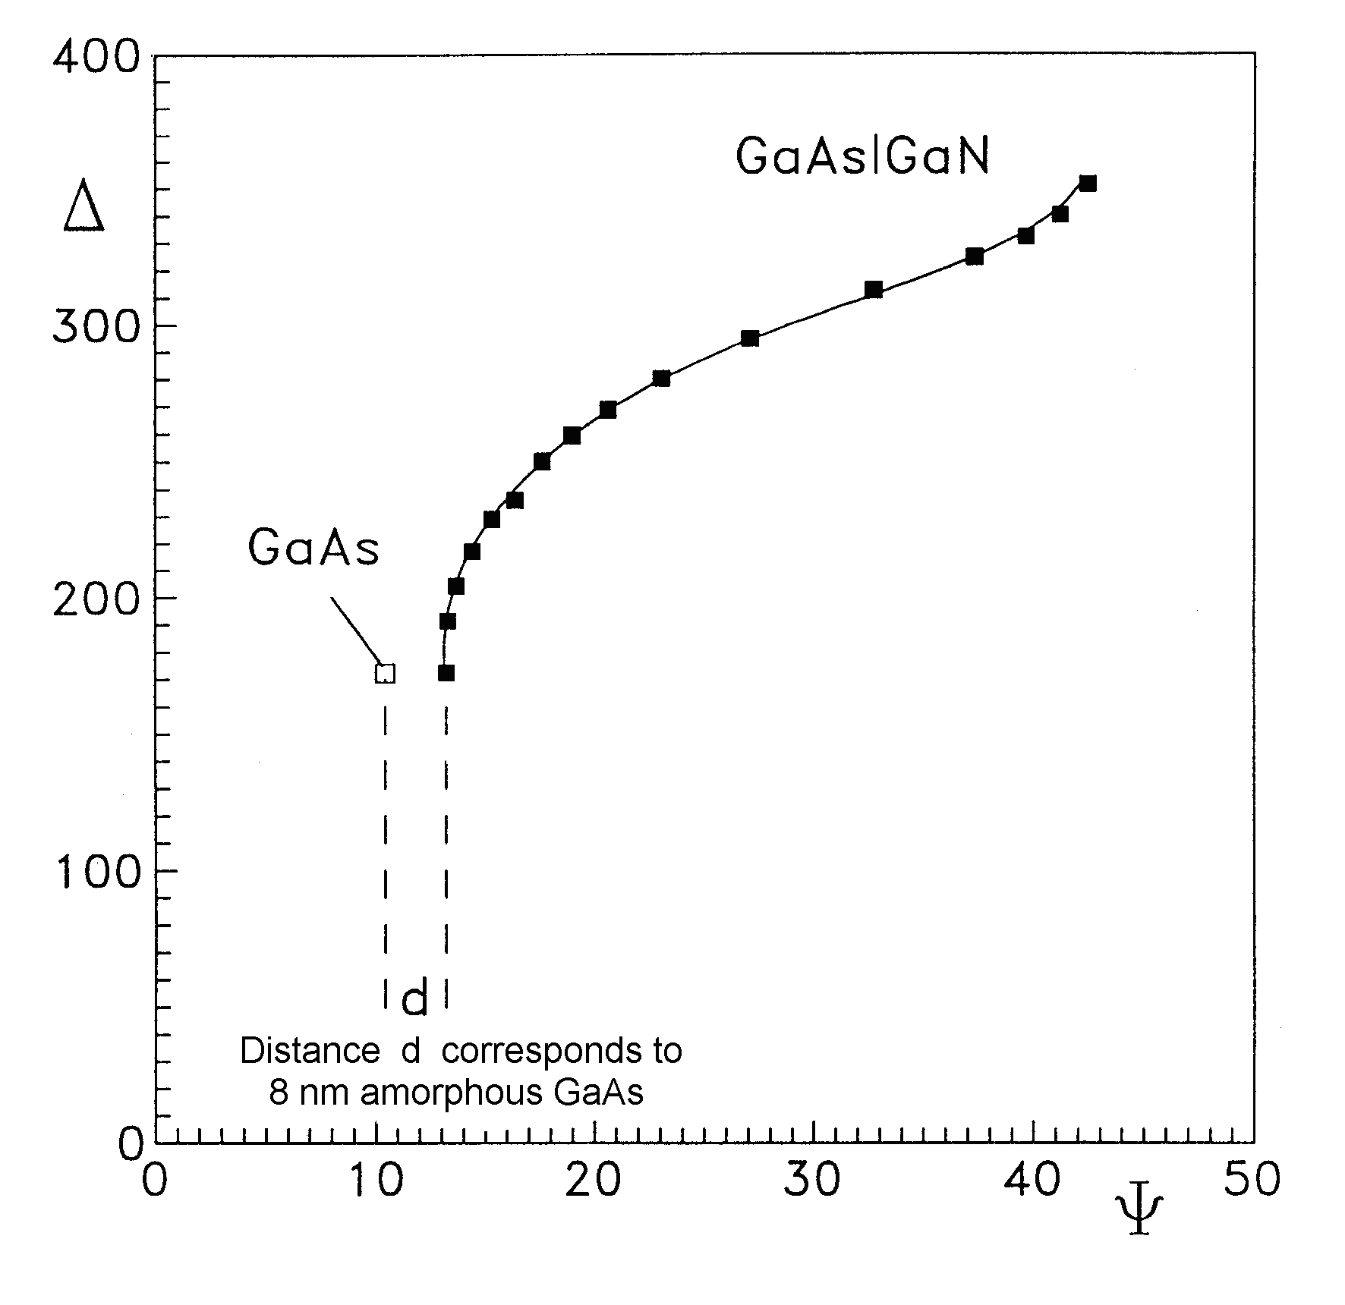
Figure 5. Experimental ellipsometric ψ and Δ curve

This complex refractive index is characterized by comparatively high n and k values compared with crystalline GaAs ($\tilde{n}=3\text{.}\text{85}−i0\text{.}\text{19}$), which are typical of amorphous GaAs created by ion damaged [14] or deposition [6]. The here found refractive index agrees within some percent with the reported values.

4. Conclusion
It has been shown that one wavelength ellipsometry has proved to be sufficient to characterize the amorphization by low energy, in contrast to methods that use spectroscopic ellipsometry. Statements to ion damage distributions and amorphization thresholds are possible in principle.
It was the intention of this paper to present a method consisting of ellipsometric measurements combined with a model that is easy to handle and that allows to determine ion implantation damage depth at low ion energies.

Acknowledgements
This work was supported in part by Deutsche Akademischer Austausch Dienst – Germany.

Correspondence Authors:
B. Bouafia, Dj. Boubetra
Optics Laboratory
Setif University 19000 Algeria
Centre Universitaire Bordj Bou Arreridj 34000 Algeria
E-mail: boubetra@gmail.com

Reveived: 11/10/2007

References
- H. Ryssel and I. Ruge, Ionenenimplantation,(GeestPortig K.- G, Leipzig, 1978).
- J.Lindhard, M.Scharff and H.E. Schiott, Range Concepts and Heavy Ion Ranges (Notes On Atomic Collisions, II)Mat. Fys. Medd. Dan. Vid. Selsk, 33 (1963).
- M. Fried., T. Lohner, W.A.M Aarnink, L.J. Hanekamp, and A. van Silfhout,.J. Appt. Phys. 71, 2835 ( 1992).
- T. M. Burns, S. Chongsawangvirod, J. W. Andrews, E.A. Irene, G. Mc.Guire, and S. A. Chevacharoeukul, J. Vac. Sci. Technol. 89, 41 (1991).
- Y.Z. Hu, J-W. Andrews, Li M. and E-A. Irene, In situ spectroscopic ellipsometric investigation of argon ion bombardment of single- crystal silicon and silicon dioxide films Nucl. Instr.. Methods Phys. Res. B59/60, 76. (1991).

X. M.Teng , H. T. Fan, , S. S. Pan, C.Ye, and G. H. Li,, Optical properties of amorphous GaAs_{1–x}N_{x} film sputtering with different N₂ partial pressures, Journal of Vacuum Science & Technology A:Vacuum, Surfaces, and Films -- September 2006 -- Volume 24, Issue 5, pp. 1714-1717 (2006).
- I. V. Rogozin, and A. N.Georgobiani,, Bulletin of the Lebedev Physics Institute 34, 114 (2007).
- T. Miyazaki and S. Adachi, Spectroscopic Ellipsometry Study of Si Surfaces Modified by Low-Energy Ar⁺-Ion Irradiation, Jpn. J. Appl. Phys. Part1 A32,4941 (1993).
- G.F. Feng, R. Zallen, J.M. Epp and J.G. Dillard, Raman-scattering and optical studies of argon-etched GaAs surfaces , Phys. Rev. B 43, 9678 (1991).
- M.Gal, P. Kraisingdecha and C,Shewe, SPIE Proc, 2141, 88 (1994).
- M. Bouafia, N. Moussaoui, Dj. Boubetra, L.Bouamama, and D.Bouzid, Mathematical modelling of amorphous layers growth by low energy ion implantation, Proc.OASIS,Algeria.(2006).
- S.Nakamura, , M.Senoh, , S.Nagahama, ,S. Iwasa, T.Yamada, , T.Matsushita, H.Kiyoku, and Y.Sugimoto, InGaN-Based Multi-Quantum-Well-Structure Laser Diodes Jpn. J. Appl. Phys. 35, L74 (1996).
- T.Motooka, K. Watanabe, Damage Profile Determination of Ion-Implanted Si Layers by Ellipsometry, J. Appl. Phys-- Volume 51, Issue 8, pp. 4125-4129 (1980).
- G.E. Jellison,. Optical functions of GaAs, GaP, and Ge determined by two-channel polarization modulation ellipsometry .Jr.OPT. MATER 1, 151 (1992).

