Growth studies of Pseudomonas fluorescens implicated in soft rot of purple variety of Onions in Southern Nigeria

O.O. Aboaba
Dept. of Botany and Microbiology
University of Lagos,
Lagos, Nigeria
simboaboaba@yahoo.com

Abstract: This is the growth studies of Pseudomonas fluorescens implicated in soft rot of purple variety of Onions in Southern Nigeria. As the conclusion, the initiation and development of rot can be prevented by controlling the temperature and relative humidity of the storage environment as well as reducing general inoculation level through adequate sanitary practices during storage and handling. [Nature and Science. 2007;5(4):75-80].

Keywords: Pseudomonas fluorescens; onions; Southern Nigeria; storage

INTRODUCTION
Many economic plant produce are highly prone to microbial diseases especially in storage. Bacteria and fungi are well known plant pathogens and therefore pose serious problems to farmers. Bacterial pathogens include Pseudomonas syringae on a variety of plants (Scortichini et al., 2005). Buckholderia gladioli on Orchids and Onion slices (Keith et al., 2005) and Xanthomonas campestris pv raphani causing leaf spot disease of Brassicas (Vicente et al., 2006).
Earlier work had revealed the role of Pseudomonas species in soft rot development of Onions (Buckholder, 1950; Cother et al., 1976; Oguntuyo, 1981).
It is well known that establishment of a pathogen in its host must be determined by factors such as presence of nutrients, pH, water activity, presence of antimicrobials, competing microorganisms, and external factors in the storage environment. Plant tissues contain food substances that enable the support and growth of microorganisms. Onions in particular contain soluble sugars 6.600%/g, amino acids 0.019%/g, lipids 0.530%/g and 91% water (Aboaba and Ekundayo, 2000).
They found that there was appreciable loss in the sugar content during spoilage by P. fluorescens. Starr (1959) found that the gross nutritive requirement for the growth of practically any bacterial phytopathogen could be met by organic substances present in the suitable host.
It has been established that the atmosphere of storage at the post harvest stage contributes to onset and rate of spoilage of farm produce. The extrinsic factors needed for rapid proliferation of microbial cells are usually temperature, relative humidity and accessibility of air. Robinson et al. (1975) suggested that commodities resistant to evaporation such as onions may be stored at lower humidities thus reducing microbial hazards. The warm humid tropical environment poses a lot of hazards to plant produce. In Nigeria, the bulbs are grown mainly in the northern part of the country from where they are packed in jute bags and transported to various parts of the country. The period from harvest to availability in the market may take several months.
The aim of this study was to investigate the physiological requirements of this organism (P. fluorescens) as a means of producing information for control strategies against extensive post harvest deterioration of Onions in Nigeria.

MATERIALS AND METHODS
Collection of Samples
The Onion bulbs were obtained from different markets in Lagos area in Southern Nigeria. The lyophilized cultures of the pathogen was obtained from Microbiology Research Laboratory of the University of Lagos.

Requirement for Carbon and Nitrogen Sources
The ability of the organism to use different carbon sources for growth was determined by culturing the 24 hr old culture on minimal salt medium containing galactose, lactose, maltose, mannitol, sucrose, sorbose, fructose and glucose. All the sugars had equal weight (0.4 g) of carbon. Growth was assessed using the turbidimetric method. The best carbon source was later used at different concentration for optimal growth requirement. The above procedure was used with Alanine, Glycine, Tyrosine, Sodium Nitrate, Ammonium Sulphate and Asparagine, each with 0.15g of nitrogen. The best nitrogen source was also used at different concentrations. The optical density values were plotted against log number of cells.

Growth in vitro
A known aliquot of the 24hr old bacterial suspension (9.2 x 10⁷ cfu) was inoculated on a variety of commercially produced nutrient medium for bacteria and Onion extract agar (Oguntuyo, 1981). The plates were incubated at 4°C, 29 ± °C and 37°C for maximum of three (3) days. The media were also prepared in the broth form and inoculated in the same manner. The cultures were placed in a rotary shaker at 4°C, 29 ± 2°C and 37°C for 30hrs. The bacterial number was determined every 2hrs using the turbidimetric method. Duplicate Optical Density readings were obtained for each analysis using the Photoelectric Colorimeter Model AE-11.

pH Effect in Onion Broth
Onion broth was prepared according to Oguntuyo (1981), 50ml each was placed in 250ml conical flask. The content each of the duplicate flasks was adjusted to pH2 with 6 N HCl. The same procedure was done to obtain pH 4, 6 and 8 using HCl and 2N NaOH The flasks were inoculated with 24hr old culture (10⁷) , incubated in a rotary shaker at 29 ± 2°C for 30 hours. The flasks containing sterile onion broth served as the control. The optical density readings were obtained every 2 hours.
T-test analysis was used to find the level of significance in the growth of the organisms in different t media, at different temperatures and pH values of growth medium.

Growth of Pathogen in Onion Bulb
Healthy onion bulbs were surface sterilized according to method of Booths, 1971. The bulbs were artificially inoculated into previously made openings (0.5cm diameter) with varying inoculum concentration of a 24hr old bacterial culture (10³ x 10⁹ cells). The bulbs were placed into sterile glass jars, incubated for seven (7) days at room temperature (29 ± 2°C). The tissue at the point of inoculation showing soft rot was removed with a sterile cork borer, weighed and homogenized with 100mls of sterile distilled water. The number of recovered cells per gramme was estimated using the dilution plate technique.
The diameter of rot tissue showing necrotic tissue at least 2mm beyond point of inoculation was measured in cm as this is considered evidence of infection for pathogenicity test. Control bulbs were inoculated with 1ml of sterile distilled water.

Environmental Conditions and Rot Development
The healthy onion bulbs were treated as above placed in sterile glass jars inoculated with 10⁹ cfu and incubated at different temperature regimes of 4°C, 29 ± 2C, 37°C and 44°C for 4 weeks. The extent of rot was determined by measuring the diameter of rot tissue around the point of inoculation every 24 hours.
The relative humidity effect was determined by incubating the inoculated bulbs in R.H Chamber adjusted to different relative humidity values. The relative humidity values were obtained by placing 100mls of appropriate saturated salt solution corresponding to between 95% and 50% at 29°C (Winston and Bates, 1960). All control bulbs were inoculated with same amount of sterile distilled water.

RESULT
In Vitro Studies
The pathogen had optimal growth in the presence of 1.5% (w/v) glucose, 1.06% (w/v), glycine, and temperature of 29 ± 2°C. Nutrient agar and onion extract agar supported growth at 29 ± 2°C and 37°C with population counts of 10⁷ cfu/m and 10³ cfu/ml at 4°C. However, growth could not be achieved in onion broth at 4°C. (Figs. 1 and 2).

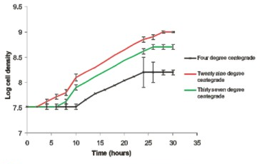
Fig. 1: Growth of P..flourescens in Nutrient broth at different temperature.

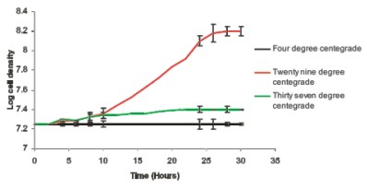

Fig. 2: Growth of P. flourescens on Onion broth at different temperatures.

In Vivo Studies
Soft rot development was initiated in the presence of the pathogen. The diameter of rot increased from as inoculated concentration increased and reached the peak 0.23cm on day 1 to 4.47 cm on day 7 at room temperature when inoculation concentration was 10⁹ cfu/ml.
There was corresponding increase in number of viable cells recovered in the rot tissues till the 5th day and then a slight decrease was observed by the 7th day. (Fig. 3 and Plate 1).

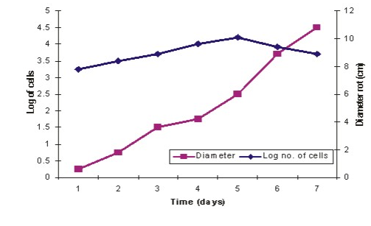
Fig. 3: Extent of rot development and growth of P. flourescens in the Onion bulbs

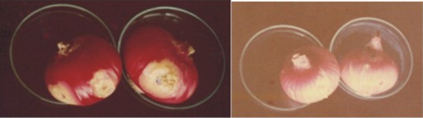

Plate 1: Artificially inoculated bulbs and control bulbs.

Environmental Effects and Rot Development
Diameter of rot tissue was optimal at 29 ± 2°C (4.36 cm) and at Relative Humidity 100% (4.53 cm) (Tables 1 and 2).

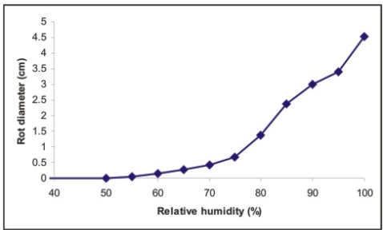

Fig. 4: Extent of rot development at different relative humidities

DISCUSSION
Pseudomonas fluorescens was implicated as a soft rot pathogen of onions as it conformed with Koch postulate (Aboaba and Ekundayo, 2000). In this study, the pathogen was able to utilize a wide variety of carbon and nitrogen sources when cultured in minimal salt medium. This is not surprising as Pseudomonas species are metabolically very active and excellent scavengers. Growth however was optimal with glucose and glycine. These simple forms of carbohydrate and protein were found to be present in healthy onion bulbs (Aboaba and Ekundayo, 2000). Microorganisms usually have preference for nutrients in their simple forms in any environment. It is also known that nutritive requirement for pathogens can be satisfied from the organic molecules present in the host tissue. This was confirmed by the in vivo studies.
The pathogen grew readily in all the commercial media used at room temperature. It was optimal in nutrient agar at all temperatures except 44°C and in onion extract agar at 29°C. Pseudomonas species generally grow on simple unenriched media such as Nutrient agar.
In vivo studies showed that the pathogen was able to initiate and proliferate in the onion tissue when healthy bulbs were artificially inoculated. The extent of rot development increased with increase in inoculum size as storage period increased at room temperature and 80 – 100% R.H. Buckholder (1948) had stated that optimal temperature requirement for most bacterial pathogen was 27°C. Cother et al. (1970) had also found that moist environment around onion bulbs after a heavy dew could be conducive to the maintenance and increase of bacterial population. This supports the fact that increase in rot development under these conditions was proportional to bacterial population recovered from affected tissue. The presence of readily available utilizable nutrients coupled with favourable environmental conditions favoured growth and proliferation of the pathogen. This made invasion of tissue easier manifesting in soft rot condition.
It is important therefore to store onion bulb under controlled environment. Robinson et al. (1975) had suggested that reduction in temperature should be complemented with the need to reduce evaporative losses. Onions however have minimal exposed surface per volume ratio as the dried scale leaves protect the fleshy succulent bulbs. It was suggested that the foliage especially in the neck region should be dried before storage as this shrivels and forms a seal which prevents ingress of pathogens (Jones, 1963).
In view of this, the bulbs should be stored at low relative humidity and temperature. It is important however that the bulbs must be used immediately after removal from the storage environment as they will be prone from microbial attack because of the high ambient relative humidity and temperature in Southern Nigeria. Long term storage may be in form of pickles as the pathogen cannot survive acidic conditions. This however may have huge financial implications.

CONCLUSION
The initiation and development of rot can be prevented by controlling the temperature and relative humidity of the storage environment as well as reducing general inoculation level through adequate sanitary practices during storage and handling.

Correspondence to:
O.O. Aboaba
Dept. of Botany and Microbiology
University of Lagos,
Lagos, Nigeria
simboaboaba@yahoo.com

REFERENCES
- Aboaba and Ekundayo. Microbial rotting of purple variety of Onions (Allium cepa. L.) in the Lagos area of Nigeria. Journal of Sci. Res. Dev, 5: 2000, 159-169.
- Cother, E.J; Derbyshire, B. and Brewer, J, Pseudomonas aeruginosa, cause of an internal brown rot of onion. Phytopathology 66: 1976, 828-834.
- Edens, D.G., Gitaitis, R.D., Sanders, F.H. and Nischwitz, C. First report of Pantoea agglomerans causing a leaf blight and bulb rot of onions in Georgia. Plant Diseases 90 (12): 2006, 1551.
- Jones, H.A. and Mann, L.K. In onions and their allies. Leonard Hill. 1963. 143.
- Keith, L.M.; Sewake, K.T. and Zee, F.T. Isolation and characterization of Burkholderia gladioli from orchids in Hawaii. Plant Diseases 89 (12): 2005,1273-1278.
- Lee, Y.A and Chan, C.W. Molecular typing and presence of genetic markers among strains of banana finger-tip rot pathogen, Buchholderia cenocepacia in Taiwan. Phytopathology 97 (2): 2007, 195-201.
- Molan, Y and Ibrahim, Y. First report of Tomato (Lycopersicon esculentum) pith necrosis caused by Pseudomonas flourescens and P. corrugata in the Kingdom of Saudi Arabia. Plant diseases 91 (1): 2007, 110.
- Oguntuyo, O.O. Studies of microbial spoilage of onions (Allium cepa L). PhD thesis. University of Lagos. Lagos.1981.
- Robinson, J.E.; Browne, K.M. and Burton, W.G. Storage characteristics of some vegetables and soft fruits. Ann .Appl Biol., 19: 1975, 399-408.
- Scortichini, M.; Rossi, M.P.; Loreti, S.; Bosco, A.; Fiori, M.; Jackson, R.W.; Stead, D.E..; Aspin, A.; Marchesi, U.; Zini, M. and Janse, J.D. Pseudomonas syringae pv. coryli, the causal agent of bacterial twig dieback of Corylus avellana. Phytopathology 95 (11): 2005,1316-1324.
- Starr, M. P. Bacteria as plant pathogens. Annual Review of Microbiology, 13: 1959, 211-238.
- Vincente, J.G; Everett. B and Roberts, S.J. Identification of isolates that cause a leaf spot disease of Brassicas as Xanthomonas carpestris pv raphani, pathogenic and genetic comparison with related pathovars. Phytophatology, 96 (7):2006, 735-745.
- Winston, P.W. and Bates, D.H. Saturated solutions for the control of humidity in biological research. Ecology, 41: 1960, 232-237.

